
VILNIUS GEDIMINAS TECHNICAL UNIVERSITY

FACULTY OF MECHANICS
DEPARTMENT OF INDUSTRIAL ENTERPRISE MANAGEMENT

Andrius Kubickas

INCREASING OF PRODUCTION EFFICIENCY IN METAL PROCESSING COMPANIES

GAMYBOS EFEKTYVUMO KELIMAS METALO APBIRBIMO ĮMONĖSE

Final Master Work

Studies‘ program: Industry Engineering and Management, State Code 62608T204
Science Course of Industry Engineering

Vilnius, 2010

VILNIUS GEDIMINAS TECHNICAL UNIVERSITY

FACULTY OF mechanICS
DEPARTMENT OF INDUSTRIAL ENTERPRISE MANAGEMENT

CONFIRM

Head of a depertment
______________________
(Signature)
_Rolandas Strazdas____
(Name, surname)
______________________
(Date)

Andrius Kubickas

INCREASING OF PRODUCTION EFFICIENCY IN METAL PROCESSING COMPANIES

GAMYBOS EFEKTYVUMO KELIMAS METALO APBIRBIMO ĮMONĖSE

Final Master Work

Studies‘ program: Industry Engineering and Management, State Code 62608T204
Science Course of Industry Engineering

Supervisor _____________________ _________ __________ (Science degree, name, surname) (Signature) (Date)

Vilnius, 2010

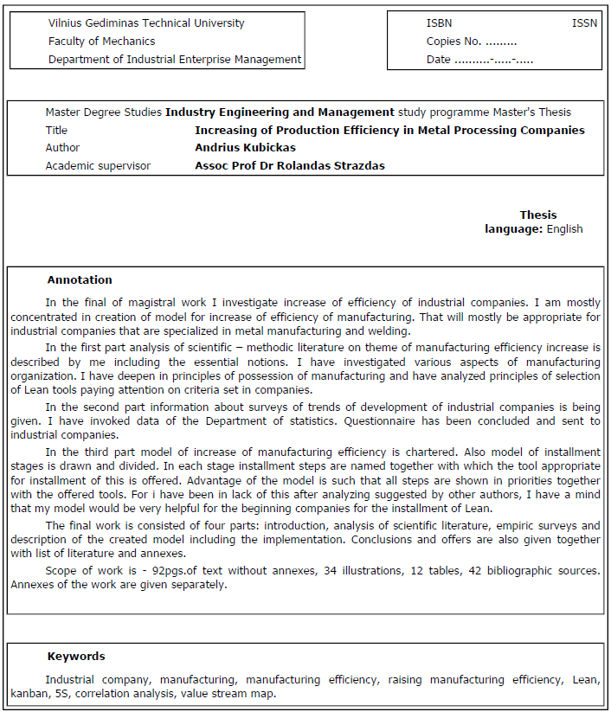
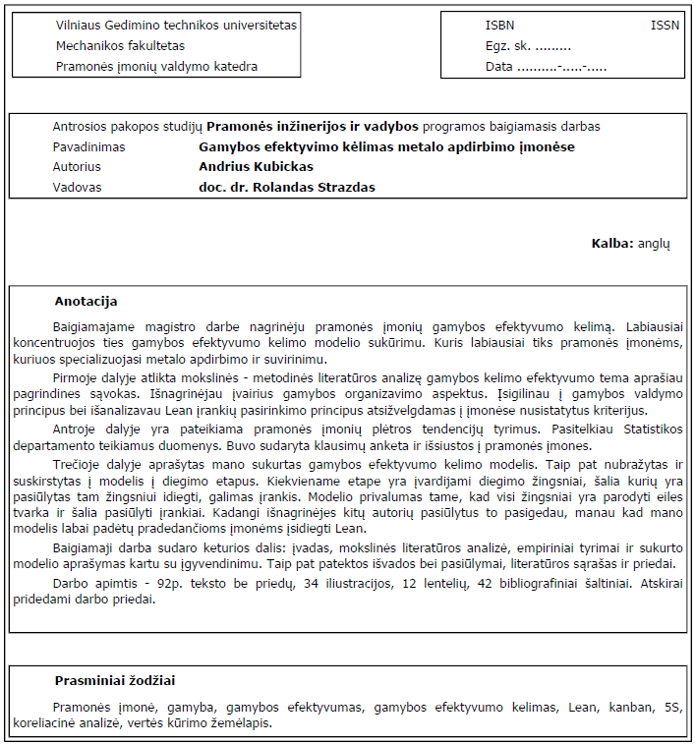
Contents
Introduction 9
1. Problem Definition, importance and relevance of the Lithuanian industrial companies 12
2. Production efficiency improvement in industry terms the theoretical studies 14
2. 1 Conception analysis and classification of the industrial company 14
2.2 Metal processing companies specific lineament and requirements 18
2.3. Theoretical aspects of the production efficiency raising 20
2.3.1 Main conception 20
2.3.2 Lean manufacturing 21
2.3.3 Kaizen Rapid Process 21
2.4 Manufacturing types classification and analysis 24
2.5 Production management models, analysis 28
2.6 Production management models, the selection criteria 29
2.7 Lean Manufacturing 30
2.8 Main Lean tools 32
2. 9 Identifications main manufacturing wastes 37
2.9.1 Waste removal inside value streams 39
2.10. Production variety funnel 40
2.10.1 VAT analysis 41
2.11 Theoretical model analysis of process improvement 43
2.11.1 Deming cycle 43
2.11.2 G. Halévy raising questions of the method of analysis of the development process 44
2.11.3 Theory of constraints 44
2.12 Model analysis of raising production efficiency 45
3. Production efficiency improvement in industry, empirical studies 47
3.1 Research methodology 47
3.2. Metal-processing sector trend analysis 48
3.2.1 Industrial production of statistical analysis 48
Statistical analysis of the structure of production, by market 49
3.3 Metal-processing sector, the number of enterprises trend analysis 50
3.4 Metal-processes industries sector research 56
3.4.1 Analysis of questionnaire results 57
3.4.2 Correlation analysis of the questionnaires 61
3.4.3 Conclusions and suggestions 65
4. Production efficiency increasing model for metal processing companies 66
4.1 Production efficiency increasing model 66
4.2.1 First stage for implementing model 67
4.2.2 Second stage for implementing model 68
4.2.3 Last stage for implementing model 70
4.2 Waste removal inside companies 70
4.3 Model testing on real company 72
4.4 Main problems and solutions 76
4.4.1 Reducing raw material inventory level 76
4.4.2 Implementing kanban 77
4.4.3 Reducing Lead Time 79
4.5 Curent value stream mapping 83
4.6 Calculate the cost of improvements and expected results 84
Conclusions and suggestions 86
References 89
Annexes 93

List of figures
Fig. 1 The Problem Tree 13
Fig. 2 Machinery and equipment industry structure 16
Fig. 3 Companies classification matrix 16
Fig. 4 Heijunka box 37
Fig. 5 Production variety funnel 41
Fig. 6 VAT structure 42
Fig. 7 Deming cycle 43
Fig. 8 Industrial production indexes 48
Fig. 9 Industrial production index, compared with base 49
Fig. 10 Statistical analysis of the structure of production, by market 50
Fig. 11 The number of firms by economic activity 51
Fig. 12 Companies' ability to compete in the domestic market change 52
Fig. 13 Companies ability to compete in the EU countries market change 53
Fig. 14 The product demand 54
Fig. 15 Production export demand changes 55
Fig. 16 Distribution of respondents by education level 58
Fig. 17 Distribution of respondents by duty position 58
Fig. 18 Distribution of respondents by knowledge about Lean 59
Fig. 19 Distribution of respondents by efficiency raising implementing Lean 60
Fig. 20 Distribution of respondents by difficulties to implementing Lean 60
Fig. 21 Distribution of respondents by selecting Lean tool 61
Fig. 22 Raising production efficiency model 66
Fig. 23 Raising production efficiency model stage I 67
Fig. 24 Raising production efficiency model stage I 68
Fig. 25 Production efficiency improvement model for stage III. 70
Fig. 26 Customers categories 73
Fig. 27 List of raw in ERP system Monitor 76
Fig. 28 Spageti diagram of parts moving 80
Fig. 29 Moving machines 80
Fig. 30 New layout 81
Fig. 31 Curent value stream mapping 83
Fig. 32 Savings on reduce inventory level 84
Fig. 33 Saving time using kanban 84
Fig. 34 Reduce distance 85

List of tables
table. 1 The industry classification of the various criteria 15
table. 2 Industrial production index, compared with the previous year,% 48
table. 3 Industrial production index, compared with base - 2005 year,% 49
table. 4 Statistical analysis of the structure of production, by market 49
table. 5 The number of firms by economic activity 50
table. 6 Companies' ability to compete in the domestic market change 51
table. 7 Companies ability to compete in the EU countries market change 52
table. 8 The product demand. Number of enterprises as a percentage 53
table. 9 Production export demand 54
table. 10 Respondents from the average expected values and the fluctuation characteristics 63
table. 11 Correlations matrix 63
table. 12 Lean tool selection matrix. 69

Introduction

Actuality of theme. Welfare of industrial companies is rather essential aspect of whole state‘s economics, for economical status of the state depending on number of companies and quantity per state can be depending and impacted of one of these companies as well. All the times biggest industrial companies used to generate biggest financial flows and profits. In these times of global competition ant market became more important as ever to keep high competence level of industrial companies. Constant hazard of overtake of production from such countries as India and China and as planned Africa in near future forces to improve own activity and improve company‘s indicators by reaching benefit in all meanings – as well in financial, increase of product‘s quality and creation of value added. I will research industrial companies working in metal manufacturing and waste reproduction areas in my work. I have chosen this area as prospective and improvement needed, for Lithuania has been well known for long time as producers of very qualified products and these traditions has been left till today as well as knowledge. Furthermore, number of companies specification of these is welding of steel constructions, cutting on steel plate, sector of mechanical manufacturing has became more interesting for analyzing and offer of improvements in Lithuania, for in mentioned sector rather meaning number of companies is acting being prospective, but they are to improve their activity, especially, increase of efficiency of production for becoming more competitive.
Problem. Situation of Lithuanian industrial companies specifying in metal manufacturing area is unique. Majority of companies manufacturing products of rather narrow spectrum that are unique mostly and adjustable to each client‘s individual fancies. At the same time, companies have part of devices that are being manufactured without big changes. For this difficulties in production organization rise, for universal models of production organization can not be adopted that would be appropriate for mass or solely and orderable production. We need individual way of solution matching metal manufacturing, welding sector paying attention on specifics of such companies, specific of Lithuanian market and various other aspects of production organization.
Hypothesis. Increase of efficiency of production has big impact on results of industrial companies’ activity and saving of their results in the times of global market.
Researches on theme. Problems of manufacturing organizing have been examined by many Lithuanian and foreign scientists: A. Sakalauskas, P. Vanagas, B. Martinkus, P. Hines, J, Womack, N. Rich, M. Rother and others. Although no one has presented simplified model of production control to the leaders of the company, which would be imbibed easily. Also divided by steps and necessary Lean tools offered for each step. These companies face with problems because their manufacturing is mixed, for this reason adaptation of any typical control models of production is complicated.
Object of the research. Object of the terminal task – is an efficiency of manufacturing development plan / model which can fit to group of the companies which are working in metalwork, welding sphere, which size is medium and which manufacturing unitary or serial products.
Aim. Aim of the terminal task – to prepare improvement model of manufacturing, when theoretical
Researches of manufacturing organizing are done, which is applied to industry companies, which are working in metalwork, welding sector and for those companies which are using mixed manufacturing: mass with unitary.
Tasks. Main goals of the terminal task are:
- To make an analysis of theoretical – methodical literature of manufacturing organizing and control topic.
- To make an analysis of theoretical aspects of manufacturing improvement models.
- To make researches of metalwork and welding sector development tendencies.
- To make researches of manufacturing improvement processes in the companies.
- To prepare manufacturing improvement model this can be applied to metalwork and welding sector.
Conception and methods of the research. To establish the importance of manufacturing improvement to industry companies, analysis of scientific literature will be made. To establish tendencies and group size of group industry companies’ witch we examine, data of Lithuanian statistical department will be used. To choose a model of manufacturing efficiency development questioning will be made in separate a company, which represents different profile activities. Questioning will be in use by questionnaire. Also interview will be used questioning personnel which are mostly connected with manufacturing. To analyze the results of research, comparative model and correlate analysis will be used.
Review of task structure. The terminal task consists of three parts. In the theoretical part analysis of theoretical manufacturing organizing model and conception is carrying out. Investigating different manufacturing organizing aspects.
In the analytic part empirical researches of the industry companies is carrying out. Carrying out manufacturing improvement models its necessities and defects and adaptation methods in group of industry companies which we examine. Also questioning using questionnaire and interview is in use, forthcoming results are used for analysis.

1. Problem Definition, importance and relevance of the Lithuanian industrial companies

Manufacturing - the economy has always been a driving force. Europe has a long tradition of manufacturing industry and has always known and still known for its products around the world creating high-quality, reliable and innovative product image. As the Lithuanian manufacturing future - it is difficult to imagine it as positive. Most production is carried out through the old models of governance, not the ever-fiercer competition, too little investment in development. In order to quickly respond to global changes, which may now seem more distant, but one day they may become insurmountable, must be flexible, innovative, modern.
Operation of industrial development is an important country-wide as the industry, as in every country, and in Lithuania, a considerable part of the economy. Industries employ many people and it generates by far the largest cash flows.
However, to improve the whole industry is an insurmountable task. As a result, their study concentrated on one industry sector - metal processing and metal welding. This made having regard to the organization of production planning models. Current production is coming towards it, may not be available to companies that produce consistently uniform products en masse. The market requires constant changes and rapid adaptation to evolving market conditions. As a result, companies are increasingly starting to produce a hybrid way - ie Y. of products which were produced in the past. the mass-produced, but an increasing number of products which require an individual set of decisions. Metal processing and metal welding sector companies operating in the most mixed and used in the production management model.
Underlining the relevance of my work can be said that this industry has a major impact on the whole viability of the industry in Lithuania. Department of Statistics, which will be submitted to the 3rd paragraph, the number of operators working in this sector in the beginning of 258 companies in the content business production contribution to the total industrial added value is very important considering the fact that these enterprises produced product is smart and new technology. However, as can be seen from the statistics, ability to compete in the internal market, as well as foreign markets have remained unchanged for more than a year. Because the market never does not stand still, and while there are more competitors in the future may be difficult to compete with newly created companies adjust innovative management and organizational techniques. What is more noticeable drop in demand in all markets, the downward trend, reflecting increasing industrial competitiveness, worsening all levels.
As shown, metal processing and metal welding sector can be sufficiently strongly associated with the entire industry can make a significant impact on the further development of Lithuanian industry. Because if the poor level of production efficiency, will suffer all the firms' production efficiency: costs will rise, leads to longer production cycle, the readjustment of the timing of new products as well as long, who will not allow a flexible response to market changes. All of this may also affect the quality of the products, which is very important to the company.
With low production efficiency of firms is powerless to compete in both domestic and foreign markets. All of these can significantly affect the total industry performance, which is not experiencing the best times, metal processing and metal welding sector is regarded as a highly innovative and technologically innovative. And only with the same or similar products can successfully compete.
However, if the sector's competitiveness is low and falling, and the whole industry's competitiveness.
Thus, the apparent absence of immediate action toward improving the organization of production can result in a chain reaction, gives the negative impact on the Lithuanian industry, which is a promoted actions given the current situation.
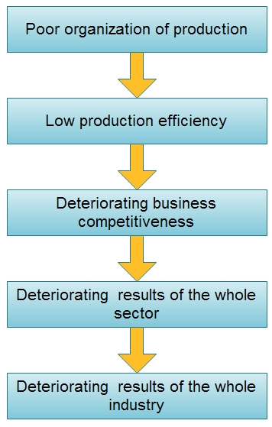
Fig. 1 The Problem Tree

2. Production efficiency improvement in industry terms the theoretical studies

2. 1 Conception analysis and classification of the industrial company

Company is characterized as a solid system in the point of organizing and economic view. However these characteristics not always come out. Today the company is often diversified (manufacturing heterogeneous production which requires different technologies), it can have units as in other cities, as in foreign countries, which often works very independently. For this reason the company is business entity which has a name, and which is founded by established order to do one or another commercial activity. Economic results of the activity are reached by optimal organizing the interaction between work objects (raw material stuff, material stuff), means of work (buildings, constructions), and work subjects (workers, employees). Now the human factor is much emphasized, there is no doubt that social aspects are not less important than material aspects, and often exactly they determine the economic results.
Similar companies can be grouped by one or few criterions. In the clear type of companies organizing and economical problems are solved easier: it is possible solutions like typical techniques, technological, manufacturing, work organizing and financing solutions. According to purpose of produced product, administrative subordination, concentrating, specialization level and so, every company we can ascribe to some group.
In my task i will comprehensively examine industry companies of the specific branches. In the companies of that type produced products are presented to customer by the company itself or through the service companies. Service companies do not produce products by themselves. They serve customers in different spheres.

table. 1 The industry classification of the various criteria
Criterion | Enterprise Groups
Work character | Manufacturing companies
Legal Type | Individual (personal), partnership, stock companies, join stock companies,
Use raw materials | Mining industries companies, manufacturing companies.
Finished production purpose | Raw material for manufacturing products, used for end customers.
Technological | Mechanical engineering, furniture, food and light industries.
Size | Small, medium and large enterprises
Level of Specialization | Technological, goods, details specialization
Independently | Independent enterprises included in a group, consortia, associations, and other compounds.

Very often to ascribe a company to concrete type is impossible, exception – juridical type, which is registered de jure. Companies of nowadays usually do not restrict themselves on producing one type of product, its activity is diversified – they do the heterogeneous manufacturing, trading, sometimes with services. Units of the diversified companies usually are specialized to manufacturing some kind of production, and they can be ascribed to some type of companies.
To ascribe company to small or medium is hard. Criterion by number of workers – till 100 workers fits only then when technological level in the company is low. At the same time automated, producing specialized production company is not small even if there works less then 100 workers.
In my task I have chosen these industry companies which were listed in the qualification group by the Ministry of agriculture – manufacturing machines and mechanisms [1]. These companies produces products like packing lines, sorting lines, technological lines of paper manufacturing, mechanisms for agriculture techniques, products for train industry and so on.
In Lithuania working many companies, like: ,, Arginta", "VAE Legetecha", "Vienybė", "Lietemas", "Karbonas", "Aldeva", "Utenos krosnis", "Kauno stakles", "Vingriai" etc.
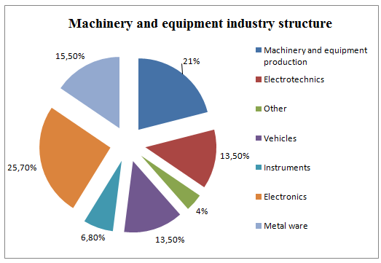
Fig. 2 Machinery and equipment industry structure

In its final paper will consider the medium-sized enterprises, which are distinguished by their product manufacturing phases. Which is the most popular metal and welding plants. Since most of these profiles, companies face the same problems, so my production efficiency model is designed to help solve quite a number of problems resulting from the company. This model is most tics to those firms which meet the criteria in the matrix marked.
Companies classified under:
- firm size;
- work and direction of movement of raw materials.
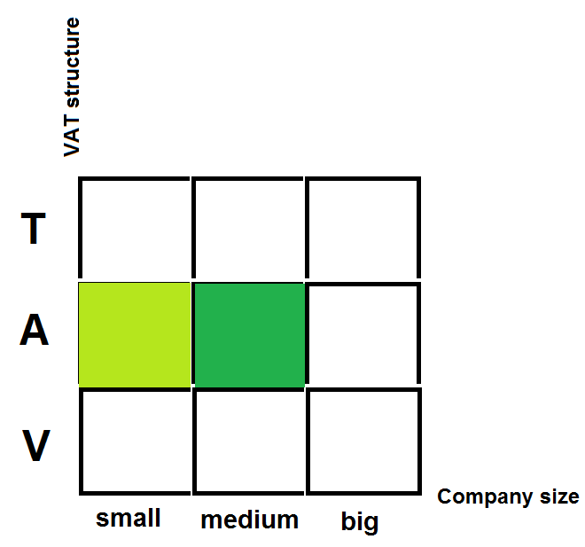
Fig. 3 Companies classification matrix
As can be seen from the matrix, the most improvement of production efficiency model is suitable for medium-sized enterprises, which blocks the movement of raw materials and the direction is a shape.
It is also possible to use large companies that also have blocks of raw materials and the movement direction of a form.

2.2 Metal processing companies specific lineament and requirements

Investigating companies of that type and products they manufacturing, we can say that those companies, except standard demands of good manufacturing and other demands, also some other specific demands is valid.
Since people work in such an important sphere as manufacturing of mechanisms, projection of mechanisms, welding of important structures, also with standard demands as quality management and so on, it needs that products for which specific demands are adjusted would satisfy the requirements of established standards. Also there is applied an exceptional verification of finished production for manufacturing also material traceability. Special attention is to quality of welding hems, quality of metal material, because products manufacturingd by company, are used in the enlarged risk mechanisms. Like high-speed electric trains, hull of the high voltage transformer.
Also with all technical demands, observing standards, audit of the customers is performed every year. Only when audit confirms that company works according definite demands, can manufacturing the production, which is realized by a customer. Special demands for quality are in the markets of Finland and Switzerland.
Also in every country there is a supervisory organization which is responsible for observation of standards of welding hems, safety of mechanisms and observation. In Europe European Federation for welding is established.
So manufacturing of products in this kind of branch is controlled strongly enough. For the company which wants to manufacturing and sell, needs to elucidate all demands and observe them. In another case company can make damage to its name which is very important in that kind of market.
Systematizing specifically demands for machines and sector of mechanism manufacturing, it is necessary and other part is desirable for seeking to compete in this market, it can be affirmed that that characteristic for this sector is:
- Observation of good manufacturing practice.
- BS EN ISO 9000 or higher quality management system series appliance.
- Periodical implementation of international audit.
- Specific standards:
- DIN EN ISO 3834-2:2006 (requirement on quality to welding)
- DIN 18800-7:2006-09 (steel structures);
- LVS ENV 1090-1:2005 - (production of metal constructions, towers, masts and metal containers)
- DIN 18800-7:2002-09 - International welding works certificate
- and others specific standards.
Apart from the generic requirements needed to observe specific requirements, standards for a specific product or equipment.
The key standards to be followed in selling the EU market is related to the CE marking icon, which indicates that the product observe all the requirements of the European Union. In order to affix the CE mark badge, that he must comply with Machinery Directive 98/37 EC.

2.3. Theoretical aspects of the production efficiency raising

2.3.1 Main conception

Manufacturing is the use of machines, tools and labor to make things for use or sale. The term may refer to a range of human activity, from handicraft to high tech, but is most commonly applied to industrial production, in which raw materials are transformed into finished goods on a large scale.
Economic efficiency is used to refer to a number of related concepts. A system can be called economically efficient if:
No one can be made better off without making someone else worse off.
More output cannot be obtained without increasing the amount of inputs.
Production proceeds at the lowest possible per-unit cost.
Manufacturing efficiency can be measured in any number of different ways, from the time it takes to complete a given task to the number of staff members needed to facilitate the production of a particular item. The most common measure for manufacturing efficiency, however, comes down to the amount of money a company has made at the end of the day. All other procedures for increasing efficiency funnel into the fulfillment of this central goal.
Industry is the manufacturing of a good or service within a category. Although industry is a broad term for any kind of economic production, in economics and urban planning industry is a synonym for the secondary sector, which is a type of economic activity, involved in the manufacturing of raw materials into goods and products.
Company is a form of business organization. The precise definition varies: in the United States, a company is a corporation—or, less commonly, an association, partnership, or union—that carries on an industrial enterprise. Generally, a company may be a "corporation, partnership, association, joint-stock company, trust, fund, or organized group of persons, whether incorporated or not, and (in an official capacity) any receiver, trustee in bankruptcy, or similar official, or liquidating agent, for any of the foregoing." In English law, and therefore in the Commonwealth realms, a company is a form of body corporate or corporation, generally registered under the Companies Acts or similar legislation. It does not include a partnership or any other unincorporated group of persons.
Industrial company is company is which manufacturing is dominant.

2.3.2 Lean manufacturing
Lean manufacturing is a business model that emphasizes eliminating waste while delivering quality 41products at the least cost to the manufacturer and customers. In the U.S., lean implementation began in the 1980's in the automotive and aerospace sectors. Today, lean initiatives are spreading rapidly in numerous manufacturing and service sectors.
Lean thinking focuses on three objectives:
- Reducing production resource requirements by minimizing inventory, equipment, storage and production space, and materials;
- Increasing manufacturing velocity and flexibility; and
- Improving quality and eliminate defects.
Lean methods create a continual improvement-based, waste elimination culture that involves workers at all levels of the organization. There are a variety of common lean methods, including Kaizen (Japanese for improvement) rapid improvement events, just-in-time manufacturing, value stream mapping, total productive maintenance, cellular production (or synchronous, single-piece flow manufacturing), and Six Sigma.

2.3.3 Kaizen Rapid Process
Kaizen, or rapid improvement processes, often is considered to be the "building block" of all lean production methods. Kaizen focuses on eliminating waste, improving productivity, and achieving sustained continual improvement in targeted activities and processes of an organization.
Lean production is founded on the idea of kaizen – or continual improvement. This philosophy implies that small, incremental changes routinely applied and sustained over a long period result in significant improvements. The kaizen strategy aims to involve workers from multiple functions and levels in the organization in working together to address a problem or improve a process. The team uses analytical techniques, such as value stream mapping and "the 5 whys", to identify opportunities quickly to eliminate waste in a targeted process or production area. The team works to implement chosen improvements rapidly (often within 72 hours of initiating the kaizen event), typically focusing on solutions that do not involve large capital outlays.
Periodic follow-up events aim to ensure that the improvements from the kaizen "blitz" are sustained over time. Kaizen can be used as an analytical method for implementing several other lean methods, including conversions to cellular manufacturing and just-in-time production systems.
Rapid continual improvement processes typically require an organization to foster a culture where employees are empowered to identify and solve problems. Most organizations implementing kaizen-type improvement processes have established methods and ground rules that are well communicated in the organization and reinforced through training. The basic steps for implementing a kaizen "event" are outlined below, although organizations typically adapt and sequence these activities to work effectively in their unique circumstances.
Phase 1: Planning and Preparation. The first challenge is to identify an appropriate target area for a rapid improvement event. Such areas might include: areas with substantial work-in-progress; an administrative process or production area where significant bottlenecks or delays occur; areas where everything is a "mess" and/or quality or performance does not meet customer expectations; and/or areas that have significant market or financial impact (i.e., the most "value added" activities).
Once a suitable production process, administrative process, or area in a factory is selected, a more specific "waste elimination" problem within that area is chosen for the focus of the kaizen event ( i.e., the specific problem that needs improvement, such as lead time reduction, quality improvement, or production yield improvement). Once the problem area is chosen, managers typically assemble a cross-functional team of employees.
It is important for teams to involve workers from the targeted administrative or production process area, although individuals with "fresh perspectives" may sometimes supplement the team. Team members should all be familiar with the organization's rapid improvement process or receive training on it prior to the "event". Kaizen events are generally organized to last between one day and seven days, depending on the scale of the targeted process and problem. Team members are expected to shed most of their operational responsibilities during this period, so that they can focus on the kaizen event.
Phase 2: Implementation. The team first works to develop a clear understanding of the "current state" of the targeted process so that all team members have a similar understanding of the problem they are working to solve. Two techniques are commonly used to define the current state and identify manufacturing wastes:
During the kaizen event, it is typically necessary to collect information on the targeted process, such as measurements of overall product quality; scrap rate and source of scrap; a routing of products; total product distance traveled; total square feet occupied by necessary equipment; number and frequency of changeovers; source of bottlenecks; amount of work-in-progress; and amount of staffing for specific tasks. Team members are assigned specific roles for research and analysis. As more information is gathered, team members add detail to value stream maps of the process and conduct time studies of relevant operations (e.g., takt time, lead-time).
Once data is gathered, it is analyzed and assessed to find areas for improvement. Team members identify and record all observed waste, by asking what the goal of the process is and whether each step or element adds value towards meeting this goal. Once waste, or non-value added activity, is identified and measured, team members then brainstorm improvement options. Ideas are often tested on the shop floor or in process "mock-ups". Ideas deemed most promising are selected and implemented. To fully realize the benefits of the kaizen event, team members should observe and record new cycle times, and calculate overall savings from eliminated waste, operator motion, part conveyance, square footage utilized, and throughput time.
Phase 3: Follow-up. A key part of a kaizen event is the follow-up activity that aims to ensure that improvements are sustained, and not just temporary. Following the kaizen event, team members routinely track key performance measures (i.e., metrics) to document the improvement gains. Metrics often include lead and cycle times, process defect rates, movement required, square footage utilized, although the metrics vary when the targeted process is an administrative process. Follow-up events are sometimes scheduled at 30 and 90-days following the initial kaizen event to assess performance and identify follow-up modifications that may be necessary to sustain the improvements. As part of this follow-up, personnel involved in the targeted process are tapped for feedback and suggestions. As discussed under the 5S method, visual feedback on process performance are often logged on scoreboards that are visible to all employees.

2.4 Manufacturing types classification and analysis

Depending on the volume of production is distinguished in three types: job, batch (small scale, medium and large series) and the mass production [20]. Some writers even as the type of production flow production, which is usually juxtaposed with mass production, but has its own specifics.
Company or any of its dependence on the structural unit of a certain type of production determines the whole complex of technical, organizational and economic characteristics: specialization in the manufacture, production, product nomenclature and its permanence, the nature of the equipment, process specification, qualification of workers and others. One of the ways the company or its individual structural unit is the dominant type of job specialization coefficient k_{ds}, calculated by the following formula:
(1)
Here: m_{do} - total unit is carried out in detail the number of operations; n_{dv} - general
structural unit of the number of jobs.

Production of various types are characterized by job specialization factors: mass production: 1-3, high batch: 4-10, batch: 11-20, the production of small scale - in the 20 domestic production in the workplace for certain operations not specialized: here the same transaction or recurs, if repeated, it is occasionally accidental.
It is understood that the various companies shops and bars may have a different job specialization ratios, and hence the production of different types. Then the whole of the general type of production is determined by the predominant production of the main job specialization coefficient [21].
2.4.1 Mass production

Mass production (also called flow production, repetitive flow production, series production, or serial production) is the production of large amounts of standardized products, including and especially on assembly lines. The concepts of mass production are applied to various kinds of products, from fluids and particulates handled in bulk (such as food, fuel, chemicals, and mined minerals) to discrete solid parts (such as fasteners) to assemblies of such parts (such as household appliances and automobiles). Mass production of assemblies typically uses electric-motor-powered moving tracks or conveyor belts to move partially complete products to workers, who perform simple repetitive tasks. It improves on earlier high-throughput, continuous-flow mass production made possible by the steam engine [17].
Mass production is capital intensive and energy intensive, as it uses a high proportion of machinery and energy in relation to workers. It is also usually automated to the highest extent possible. With fewer labor costs and a faster rate of production, capital and energy are increased while total expenditure per unit of product is decreased. However, the machinery that is needed to set up a mass production line (such as robots and machine presses) is so expensive that there must be some assurance that the product is to be successful to attain profits.
One of the descriptions of mass production is that the craftsmanship is in the workbench itself, not the training of the worker; for example, rather than having a skilled worker measure every dimension of each part of the product against the plans or the other parts as it is being formed, there are jigs and gauge blocks that are ready at hand to ensure that the part is made to fit this set-up. It has already been checked that the finished part will be to specifications to fit all the other finished parts - and it will be made more quickly, with no time spent on finishing the parts to fit one another. This is the specialized capital required for mass production; each workbench is different and each set of tools at each workbench limited to those necessary to make one part. As each of these parts is uniformly and consistently constructed, interchangeability of components is thus another hallmark of mass produced goods.[18]
Advantages and disadvantages
The economies of mass production come from several sources. The primary cause is a reduction of nonproductive effort of all types. In craft production, the craftsman must bustle about a shop, getting parts and assembling them. He must locate and use many tools many times for varying tasks. In mass production, each worker repeats one or a few related tasks that use the same tool to perform identical or near-identical operations on a stream of products. The exact tool and parts are always at hand, having been moved down the assembly line consecutively. The worker spends little or no time retrieving and/or preparing materials and tools, and so the time taken to manufacture a product using mass production is shorter than when using traditional methods.
The probability of human error and variation is also reduced, as tasks are predominantly carried out by machinery. A reduction in labour costs, as well as an increased rate of production, enables a company to produce a larger quantity of one product at a lower cost than using traditional, non-linear methods.
However, mass production is inflexible because it is difficult to alter a design or production process after a production line is implemented. Also, all products produced on one production line will be identical or very similar, and introducing variety to satisfy individual tastes is not easy. However, some variety can be achieved by applying different finishes and decorations at the end of the production line if necessary[17].
2.4.2 Unit production

Unit production company produced many different types of products, each name of the product output low. These same products a year, does not repeat or repeats periodically [20].
Most are produced unique products: the turbine, turbo, unique machines. Local production models also fit the experimental introduction of new products. This multi-use equipment, requires a lot of skilled labor.
Unit production is also associated with a unique, standardized goods that are produced in response to orders production. Unlike the production design, the products are low and production unit of production companies (like custom-made suits or sailboards). Unit production company is broken down by process. Consequently, the equipment performing the same or similar operations are grouped together and the product moves from one job to another. Versatile equipment is combined with highly skilled, flexible workforce. Unit production cost producers managed reserve holdings, because they do not have stocks of finished products, but they face other problems. Short periods of production constantly increases production costs. Specialized equipment will probably not be fully used and the delays between the operating ranges will mean that the total production time will be longer than the processing time.
Lithuanian industrial production unit was formed following the spread of assumptions [22]:
- large-scale, specialized industrial division of the privatization process into smaller and rapid new formation of small private companies;
- East markets, loss and lack of rapid deployment in the West;
- reduction of the internal market;
- lack of capital and high cost of new specialized equipment;
- In addition, there are activities where the individual - the unit production is the dominant type of production. This special production tools, manufacturing, construction and special vehicle production.
The production unit cannot be attributed only to the simple production, it is often difficult to manufacture than only under special projects, using advanced techniques and technology. Unfortunately, in Lithuania in the field of small businesses.
Lithuania, the reduction in demand for many types of products, definition now goes instability and lack of capital, a significant increase in unit production companies, rapidly responsive to changes in demand, especially in metalworking, the production of simple products, with production up is simple and does not require much time.
The unit is characterized by high production of manufactured goods nomenclature and a few names of products and long-term planned change of production [20].
Thus, production unit is characterized by high technical preparation of production work volume since starting on the production of each product to be more or less preparation. This is a significant increase in small quantities of products manufactured by the cost, but makes the specific needs of customers to pay for them accordingly.
Unit of production basis are usually online. Therefore, the production unit is characterized by supply, production planning and organization of orders, sales of the individual [22].
Unit cost of production and price acceptable to the customer in the following situations could arise: [23]
- Unit production manufactured products in terms of technology and construction are simple. In this case, can rely on high production craftsmen and workers' qualifications. They are, for example, according to rough sketches of small-scale technologies in addition to ordinary manufactured products.
- Unit production manufactured products according to the complexity of technical documentation to enable verification of its suitability for mass production. Then, higher unit manufacturing costs for subsequent mass production process.
- Technical documentation and preparation for production by a large company, the unit of production by the company only in the production function.
- Unit production company specializing in any one narrow field and this field is not only highly skilled workers, but also highly skilled designers, technologists (often the owner) who can perform skilled technical production specialist jobs training.
As shown, the unit of production cannot always be equated with a simple production. Workers skilled in terms of production it requires a highly skilled, but very often the same can be said of the engineering staff [20].
Unit production of very sophisticated work distribution and therefore a very important role of the master. Even today, the computerization of the production make it significantly streamline their work, the production of the manufacturing cycle unit production continually thwarted. Under these conditions, a very important initiative of the workers, they shall inform the managers about potential problems (lack of materials, ending the work possible defects, anomalies of Technology) .
Orderings manufacturing of production significantly increases the planning, account the amount of work. All costs are calculated to order, and therefore all materials, wages must be allocated to specific orders, let us assume that the jobs of more than 100. and each order must be 10 bolts and nuts. It is prescribed for every order 100 piece orders accounts after they are grouped according to consumption of materials (to be written off because the same material) and orders (because of the need to calculate the cost for each job). An analogous situation to pay. In this situation, it is necessary to choose one of the options: either to look for some indirect cost allocation methods, or introduction of planning and calculation of accounting techniques and thus solve the problem. [22]
Unit productions are difficult manufacture due to use workers' skills, which are usually high. Main - qualified - often workers themselves jobs (self-rule), because the unregulated supply of jobs, support workers are unevenly loaded, either not working, or too much. Therefore, very careful to be based on the number of auxiliary workers [20].

2.5 Production management models, analysis

Production models are innumerable. They can charge more than a century. However, those who are adapted to the specific situation is not much. Models can be classified according to type. Some models are of a technical nature, others - organizational and structural. Some models may focus on information technology. Some principles are derived from the practices of other theories. However, according to Gideon Halévy and James A. Jr.. proposed options, one can distinguish the following types of based on [17]:
• Organizational decisions;
• Development of information technology solutions;
• technological solutions, which needs hardware.
• philosophical decisions;
• other.

Towards improvement of production efficiency model is best to focus on the organization of decisions based on the models. They appeared over the years a lot. Some of its widespread use, others were intended for a narrower specialization, and operational profile of firms.
Gideon Halévy such a model variations based on the decisions of the organization [17]:
1) Agile Manufacturing;
2) Cellular manufacturing
3) Just-in-time manufacturing;
4) Kaizen Blitz;
5) Lean Manufacturing;
6) (out-sourcing;
7) Virtual Enterprises;
8) Time base competition;
9) House of Quality;
10) and others.

James A. Jr.. the similar patterns of variation, but also provide new and [17]:
1) "Kanban" system
2) Workflow management;
3) Product life cycle managemen);
4) Agent-driven approach;
5) Business Process Re-engineering;
6) Group Technology;
7) Value Engineering;
8) Total Quality Management;
9) and others.

Gideon, a comparison of Halévy and James A. Jr.. proposed models based on the decisions of the organization is to provide over 30 different models.

2.6 Production management models, the selection criteria

To choose the best production management model or models of a group of suit in one way or the other, one can use more than one choice of methodologies: one based on a model of governance to achieve the desired objectives, and the other based on functionality, which facilitates the production management model. In this case, I will analyzing then methodology, based on specific objectives.
Selection criteria addressed the authors Gideon Halévy and James A. Jr..
Gideon Halévy the more basic, standard criteria such as:
- To minimize the delivery times - production planning and control.
- reducing production costs;
- Reduced production time from presentation materials to clients - manufacturing;
- improve knowledge management and data processing - for communication;
- improve and enhance team collaboration;
- Other;

But James A. Jr., examines patterns of selection criteria for a little more. Examination of the material can be defined with the following criteria:
- Reduce production costs;
- quick response to market needs - product development;
- to achieve zero defects level - quality control;
- improve and enhance team collaboration;
- improve the integration of business - to improve global supply chain,
- continuous improvement;

2.7 Lean Manufacturing

Lean Manufacturing is a philosophy of production that emphasizes the minimization of the amount of all the resources (including time) used in the various activities of the enterprise. It involves identifying and eliminating non-value-adding activities in design, production, supply chain management, and dealing with the customers. Lean producers employ teams of multi-skilled workers at all levels of the organization and use highly flexible, increasingly automated machines to produce volumes of products in potentially enormous variety. It contains a set of principles and practices to reduce cost through the relentless removal of waste and through the simplification of all manufacturing support processes [33].
Lean brings action and intuition to the table. Based on the principals of the Toyota Production System and kaizen (continual improvement) breakthrough methodology, lean focuses on creating one-piece flow with just-in-time management of inventory and materials. Using five-day kaizen events, cross functional groups improve lead time and reduce inventory on the spot, attacking the kind of quality and flow issues identified as "low hanging fruit" [38].
The Toyota production system has been the model for many manufactures across the world. Toyota has established a culture of continuous improvement and change in the company, specifically in the manufacturing facilities. Processes and activities at Toyota are constantly being challenged and pushed to a higher level of performance. By empowering its people, creating teams that interact to meet objectives, and designing its production to optimize performance, Toyota is able to refine its processes and create
products that are superior to its competitors. These fundamental principles that have guided Toyota have also made them an example to other companies beyond the automotive industry [34].
"Waste elimination is one of the most effective ways to increase the efficiency of a production system. Waste is always the first and cheapest area to change because it usually doesn't require capital expenditures" [35]. Wastes such as overproduction, waiting, transporting, inappropriate processing, unnecessary inventory, excess motion, and creation of defects are reducing the efficiency of a work station [36]. The elimination or reduction of any of these wastes can have a direct effect on the productivity of an entire operation.
Evaluating the processes undertaken in a manufacturing process and identifying waste can also shorten the overall production time and profitability of a work area. Identifying non-value added processes in production and eliminating them can reduce the amount if time it takes to process an order and reduce the amount of labor or material required to complete a job [37].
Creating excess motion also slows down the production process. Designing work centers allows employees to complete their jobs with as little repositioning as possible makes production much more efficient. Acts such as reducing the amount the distance an employee has to walk to get supplies by placing common supplies in the work cells can reduce the time it takes to complete a job. Other work cell improvements such as the implantation of shadow boards to help make locating tools or equipment easier can reduce and create consistency in the amount of time it takes to complete work [37].
Visibility of a production system makes it possible for management and other key personnel to make decisions on the status of a work area and manufacturing processes. Key personnel must be able to identify if a work center is functioning properly and producing product as planned. Without visibility it is difficult to identify problems, waste, or root causes within a manufacturing system. Properly functioning work areas allow managers to compare the expected output of the work area against the current output to determine the performance of a work area. If the proper systems are not in place to allow this visibility it is difficult to prioritize resources to achieve desired objectives [39].

2.8 Main Lean tools

2.8.1 Metrics
Metrics are measurements used to determine whether a process is improving. Often, metrics are based on quality, productivity, cost, delivery, profitability, and safety. Good metrics are aligned through the organization in the form of strategic planning, starting from the corporation's goals, which are then linked to the plant's goals and then further linked to each department's goals [39].
"Takt time Sets the pace of production to match the rate of customer demand and becomes the heartbeat of any lean production system. It is computed as the available production time divided by the rate of customer demand" [33]. Determining the takt time of a value stream helps establish the amount of time is should take production cell to produce a finished good.
Associating time with all work helps the plant establish the amount of time a given job should take. By determining the amount of time it will take to complete a job, the production planners have a better opportunity to create a schedule that can folly utilize the production assets. Establishing production times also allows production and management to determine if a work unit is on track to meet the production objectives for the day. If the work unit falls behind, schedule management will know there are problems in the production system and can identify the problems to determine why the work area has fallen short of its goals and correct any problems that may exist [39].
In a job shop the scheduling of work orders is important because it reflects the operating plan of the entire work system. With several jobs being scheduled in a given day production planners need to know if capacity exists to complete the work due on a specific day. After determining the amount of time it will take production to complete the work due on a given day the production planners can then take action to react to capacity constraints. A good knowledge of the time it will take to complete work will allow planners to then optimize other metrics the effect the business such as work in process (WIP), inventory costs, and the speed of processing a customer's order [33].

2.8.2 Andon
Andon signals are an excellent way to visualize the status of a production area. The andon signals can be a number of different visual signals that easily let mangers and supervisors know if a problem exists in one of the production cells. At Toyota the tracking of andon signals is a key metric tracked to help management identify problems that are slowing production. Once the data Toyota collects on the andon signals is collected mangers will Pareto out the data to identify the common causes of production interruptions. The most common problems are then addressed by management to improve the entire system [40].

2.8.3 A3
One common problem with analyzing problems in business has been the over abundance of information and complication of combining information to create actions and drive results. Toyota's solution to this problem was to simplify the process into what they called an A3. The name A3 stands for the 11" x 17" sheet of paper that the important information regarding a problem is compiled on. In the A3 process mangers compile all the necessary information, graphs, and statistics to identify the problem, the current state, determining the root cause, suggested alternative solutions, suggested recommended solutions, and have a cost benefit analysis [40].

2.8.4 Value Stream Mapping
Value stream mapping, although it is not a complete flow analysis, is a graphical tool that uses symbols to show the flow of material and information within your business . Value stream mapping is an important process for any business seeking to improve their processes. According to Jared Lovelle, value stream mapping visually outlines the current and future state of a production system, allowing users to understand where they are and what wasteful acts need to be eliminated. The user then applies lean manufacturing principals to transition into the future state [41].
Once a value stream is mapped, it is easy to identify inefficiencies such as long setup times, poor uptime, disconnected operations, and long throughput times with large inventories between every step in the process [42]. Value steam mapping reduces cost by reducing lead time. The measurement for lead time is referred to as total product cycle time, which measures the longest path from the receipt of raw material until it is shipped as a finished good. It is clear that reducing the total product cycle time
has several benefits such as reduced inventory, shorter lead time, and better customer satisfaction [39].
Once the current state has been mapped, waste throughout the value stream must be identified and eliminated to shorten lead-time and improve the value added percentage - in other words, to transform the production system from a batch and push into a one- piece flow and pull system [41]. All of the 7 wastes of over-production can be identified by evaluating the current state map (if the wastes exist). Once the wastes are identified they must be addressed by countermeasure that can reduce or eliminate each waste [41].
After the current state is mapped and all wastes have been identified, the next step in the value stream mapping process is to create a future state map. Future state maps should include the improvements you believe are reasonable to target in the near future, for example, in the next three months . After the future-state map has been developed, an action plan and extended value stream plan must follow. An action plan is created to make the transition from the current state to the future state [41].

2.8.5 5S
A lean tool that promotes continuous problem solving and improvement, 5S (sort, stabilize, shine, standardize and sustain) is a series of activities for eliminating wastes that contribute to errors, defects, and injuries. In this improvement method, the fifth S, sustain, is arguably the hardest. It's the one that keeps the first four S's going by emphasizing the necessary education, training, and rewards needed to encourage workers to properly maintain and continuously improve operation procedures and the workplace environment. This effort requires a combination of committed management, proper
training, and a culture that makes sustaining improvement a habitual behavior from the shop floor to management [40].
One important part of creating consistency in a production environment is developing an environment that can produce consistent results. 5S programs have been implemented at Toyota and other manufacturers to maintain an environment free of waste and disorganization. A functioning 5S program looks at the following key characteristics of a manufacturing facility that when improved can create a more productive work environment.
- Sort - Look through a work area and keep only the items that are needed and eliminate any unnecessary items.
- Straighten - the motto is "a place for everything and everything in its place". Basically this means that everything in a work area has a designated location that it should be kept in unless it is being used.
- Shine - Keeping a clean work environment can improve the quality of products being produced by reducing contamination and identify anything that may be out of place in the work area.
- Standardize - Develop systems to maintain and monitor the first three S's.
- Sustain - Create management audits of the 5S system. Try to create consistency throughout the production area [40].

2.8.6 Kanban
A system of continuous supply of components, parts and supplies, such that workers have what they need, where they need it, when they need it. The word Kan means "visual" in Japanese and the word "ban" means "card". So Kanban refers to "visual cards".
Kanban is a signaling system to trigger action. As its name suggests, kanban historically uses cards to signal the need for an item. However, other devices such as plastic markers (kanban squares), balls (often golf balls), an empty part transport trolley, or simply a floor location can also be used to trigger the movement, production, or supply of a unit in a factory.
The need to maintain a high rate of improvements led Toyota to devise the kanban system. Kanban became an effective tool to support the running of the production system as a whole. In addition, it proved to be an excellent way for promoting improvements because reducing the number of kanban in circulation highlighted problem areas.[2]
2.8.7 Kaizen
Kaizen is a daily activity, the purpose of which goes beyond simple productivity improvement. It is also a process that, when done correctly, humanizes the workplace, eliminates overly hard work ("muri"), and teaches people how to perform experiments on their work using the scientific method and how to learn to spot and eliminate waste in business processes. In all, the process suggests a humanized approach to workers and to increasing productivity: "The idea is to nurture the company's human resources as much as it is to praise and encourage participation in kaizen activities." Successful implementation requires "the participation of workers in the improvement."[4]
People at all levels of an organization can participate in kaizen, from the CEO down, as well as external stakeholders when applicable. The format for kaizen can be individual, suggestion system, small group, or large group. At Toyota, it is usually a local improvement within a workstation or local area and involves a small group in improving their own work environment and productivity. This group is often guided through the kaizen process by a line supervisor; sometimes this is the line supervisor's key role. Kaizen on a broad, cross-departmental scale in companies, generates total quality management, and frees human efforts through improving productivity using machines and computing power. [3]
2.8.8 Poka yoke
Poka-yoke is a Japanese term that means "fail-safing" or "mistake-proofing". A poka-yoke is any mechanism in a lean manufacturing process that helps an equipment operator avoid (yokeru) mistakes (poka). Its purpose is to eliminate product defects by preventing, correcting, or drawing attention to human errors as they occur.[5] The concept was formalised, and the term adopted, by Shigeo Shingo as part of the Toyota Production System. It was originally described as baka-yoke, but as this means "fool-proofing" (or "idiot-proofing") the name was changed to the milder poka-yoke.
Poka-yoke can be implemented at any step of a manufacturing process where something can go wrong or an error can be made.
Shigeo Shingo recognized three types of poka-yoke for detecting and preventing errors in a mass production system: [6]
- The contact method identifies product defects by testing the product's shape, size, color, or other physical attributes.
- The fixed-value (or constant number) method alerts the operator if a certain number of movements are not made.
- The motion-step (or sequence) method determines whether the prescribed steps of the process have been followed.
2.8.9 Heijunka
A heijunka box is a visual scheduling tool used in heijunka, a Japanese concept for achieving a smoother production flow. Whilst heijunka refers to the concept of achieving production smoothing, the heijunka box is the name of a specific tool used in achieving the aims of heijunka.
The heijunka box is generally a wall schedule which is divided into a grid of boxes or a set of 'pigeon-holes'/rectangular receptacles. Each column of boxes representing a specific period of time, lines are drawn down the schedule/grid to visually break the schedule into columns of individual shifts or days or weeks. Coloured cards representing individual jobs (referred to as kanban cards) are placed on the heijunka box to provide a visual representation of the upcoming production runs.
The heijunka box makes it easy to see what type of jobs are queued for production and for when they are scheduled. Workers on the process remove the kanban cards for the current period from the box in order to know what to do. These cards will be passed to another section when they process the related job[7].
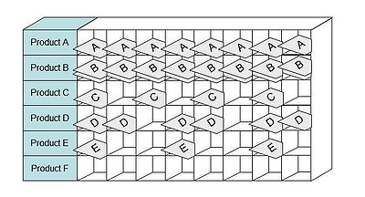
Fig. 4 Heijunka box

2. 9 Identifications main manufacturing wastes

Waste elimination is one of the most effective ways to increase the profitability of any business. Processes either add value or waste to the production of a good or service. The seven wastes originated in Japan, where waste is known as “muda." "The seven wastes" is a tool to further categorize “muda” and was originally developed by Toyota’s Chief Engineer Taiichi Ohno as the core of the Toyota Production System, also known as Lean Manufacturing. To eliminate waste, it is important to understand exactly what waste is and where it exists. While products significantly differ between factories, the typical wastes found in manufacturing environments are quite similar. For each waste, there is a strategy to reduce or eliminate its effect on a company, thereby improving overall performance and quality [8].
The seven wastes consist of:
1. Overproduction.
Simply put, overproduction is to manufacture an item before it is actually required. Overproduction is highly costly to a manufacturing plant because it prohibits the smooth flow of materials and actually degrades quality and productivity. The Toyota Production System is also referred to as “Just in Time” (JIT) because every item is made just as it is needed. Overproduction manufacturing is referred to as “Just in Case.” This creates excessive lead times, results in high storage costs, and makes it difficult to detect defects. The simple solution to overproduction is turning off the tap; this requires a lot of courage because the problems that overproduction is hiding will be revealed. The concept is to schedule and produce only what can be immediately sold/shipped and improve machine changeover/set-up capability.
2. Waiting
Whenever goods are not moving or being processed, the waste of waiting occurs. Typically more than 99% of a product's life in traditional batch-and-queue manufacture will be spent waiting to be processed. Much of a product’s lead time is tied up in waiting for the next operation; this is usually because material flow is poor, production runs are too long, and distances between work centers are too great. Goldratt (Theory of Constraints) has stated many times that one hour lost in a bottleneck process is one hour lost to the entire factory’s output, which can never be recovered. Linking processes together so that one feeds directly into the next can dramatically reduce waiting.
3. Transporting
Transporting product between processes is a cost incursion which adds no value to the product. Excessive movement and handling cause damage and are an opportunity for quality to deteriorate. Material handlers must be used to transport the materials, resulting in another organizational cost that adds no customer value. Transportation can be difficult to reduce due to the perceived costs of moving equipment and processes closer together. Furthermore, it is often hard to determine which processes should be next to each other. Mapping product flows can make this easier to visualize.
4. Inappropriate Processing
Often termed as “using a sledgehammer to crack a nut,” many organizations use expensive high precision equipment where simpler tools would be sufficient. This often results in poor plant layout because preceding or subsequent operations are located far apart. In addition they encourage high asset utilization (over-production with minimal changeovers) in order to recover the high cost of this equipment. Toyota is famous for their use of low-cost automation, combined with immaculately maintained, often older machines. Investing in smaller, more flexible equipment where possible; creating manufacturing cells; and combining steps will greatly reduce the waste of inappropriate processing.
5. Unnecessary Inventory
Work in Progress (WIP) is a direct result of overproduction and waiting. Excess inventory tends to hide problems on the plant floor, which must be identified and resolved in order to improve operating performance. Excess inventory increases lead times, consumes productive floor space, delays the identification of problems, and inhibits communication. By achieving a seamless flow between work centers, many manufacturers have been able to improve customer service and slash inventories and their associated costs.
6. Unnecessary / Excess Motion
This waste is related to ergonomics and is seen in all instances of bending, stretching, walking, lifting, and reaching. These are also health and safety issues, which in today’s litigious society are becoming more of a problem for organizations. Jobs with excessive motion should be analyzed and redesigned for improvement with the involvement of plant personnel.
7. Defects
Having a direct impact to the bottom line, quality defects resulting in rework or scrap are a tremendous cost to organizations. Associated costs include quarantining inventory, re-inspecting, rescheduling, and capacity loss. In many organizations the total cost of defects is often a significant percentage of total manufacturing cost. Through employee involvement and Continuous Process Improvement (CPI), there is a huge opportunity to reduce defects at many facilities [8].
In the latest edition of the Lean Manufacturing classic Lean Thinking, Underutilization of Employees has been added as an eighth waste to Ohno’s original seven wastes. Organizations employ their staff for their nimble fingers and strong muscles but forget they come to work everyday with a free brain. It is only by capitalizing on employees' creativity that organizations can eliminate the other seven wastes and continuously improve their performance.

2.9.1 Waste removal inside value streams

As the focus of the value stream includes the complete value adding (and nonvalue adding) process, from conception of requirement back through to raw material source and back again to the consumer’s receipt of product, there is a clear need to extend this internal waste removal to the complete supply chain. However, there are difficulties in doing this. These include lack of visibility
along the value stream and lack of the tools appropriate to creating this visibility. This paper aims to help researchers and practitioners remedy such deficiencies. The waste terminology described above has been drawn from a manufacturing environment, specifically from the automotive industry, and from a Japanese perspective. As a result some translation of the general terminology will be required to adapt it to a particular part of the value stream and to particular industries in non-Japanese settings. Consequently, a contingency approach is required to some extent. Such an approach has been the subject of considerable previous work at the Lean Enterprise Research Centre. This would include the application by Hines[10] of the kyoryoku kai (supplier association) to a range of UK-based industry sectors and the introduction by Jones[11] of the Toyota production
system philosophy to a warehouse environment. Jones has shown that the seven wastes required rewording to fit an after-market distribution setting. He therefore retiled the seven wastes as:
(1) faster-than-necessary pace;
(2) waiting;
(3) conveyance;
(4) processing;
(5) excess stock;
(6) unnecessary motion;
(7) correction of mistakes.

2.10. Production variety funnel

The production variety funnel is shown in Figure 5. This approach originates in the operations management area[28] and has been applied by New [27] in the textiles industry. A similar method is IVAT analysis which views internal operations in companies as consisting of activities that conform to I, V, A or T shapes[28]:
• “I” plants consist of unidirectional, unvarying production of multiple identical items such as a chemical plant.
• “V” plants consist of a limited number of raw materials processed into a wide variety of finished products in a generally diverging pattern.
• “V” plants are typical in textiles and metal fabrication industries.
• “A” plants, in contrast, have many raw materials and a limited range of finished products with different streams of raw materials using different facilities; such plants are typical in the aerospace industry or in other major assembly industries.
• “T” plants have a wide combination of products from a restricted number of components made into semi-processed parts held ready for a wide range of customer-demanded final versions; this type of site is typical in the electronics and household appliance industries.
Such a delineation using the production variety funnel (Figure 5) allows the mapped to understand how the firm or the supply chain operates and the accompanying complexity that has to be managed. In addition, such a mapping process helps potential research clients to understand the similarities and differences between their industry and another that may have been more widely researched. The approach can be useful in helping to decide where to target inventory reduction and making changes to the processing of products. It is also useful in gaining an overview of the company or supply chain being studied.

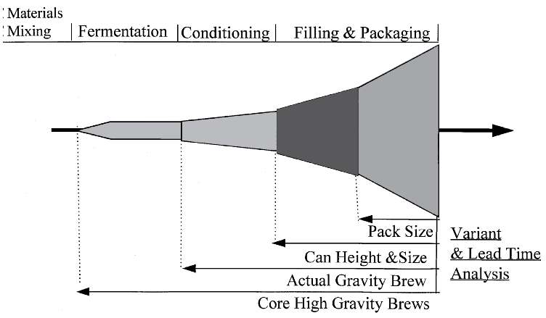
Fig. 5 Production variety funnel

2.10.1 VAT analysis

VAT analysis determines the general flow of parts and products from raw materials to finished products. It conceptualizes an organization in terms of the interaction of its individual component parts, both products and processes. Three general categories of production structures result from this standpoint, each necessitating a unique approach to management planning and control. The logical structure is the sequence of operations through which each product must pass in order to manufacture and assemble a product or product family. A V logical structure starts with one or a few raw materials, and the product expands into a number of different products as it flows through its routings. The shape of an A logical structure is dominated by converging points. Many raw materials are fabricated and assembled into a few finished projects. A T logical structure consists of numerous similar finished products assembled from common assemblies and subassemblies. The graph shows the general appearance of each structure. Once the general parts flow is determined, the system control points (gating operations, convergent points, divergent points, constraints, and shipping points) can be identified and managed. This determination focuses management's attention on a few control points where buffers can be used to protect and to maximize throughput. Five control points are used to manage the process: (1) the constraint, (2) the points of divergence (where a part or material is diverted to different routes in order to make different products), (3) the points of convergence (where two or more parts are combined in subassembly), (4) the gating operation (releases work into the shop), and (5) the shipping operation. [24]
The shape of the structure determines which control points are utilized to manage production. A T structure focuses attention on the constraint and the gating operation. The five-step focusing process is used to manage the constraint with a buffer placed before the constraint to absorb variations in the process. The output from the gating operation is tied to the constraint; that is, since the constraint controls the amount of throughput; the gating operation cannot process more than the constraint.
A V structure also uses a buffer to protect the constraint and the gating operation releases orders at the same rate as the constraint as seen in the T structure. However, an additional control point exists in the V structure, the divergent point. The divergent point is controlled by a schedule derived from the shipping schedule. This derivation prevents misallocation of material to a product not currently in demand.

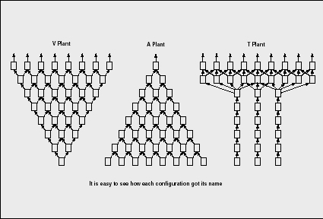
Fig. 6 VAT structure

The A structure also manages the constraint and gating operation in a fashion similar to the T structure. Any diverging points are scheduled in accordance with the shipping schedule. In addition, an assembly buffer is used to maintain the flow into the convergent points. An additional schedule based on the shipping schedule (similar to that used in the V structure) is used to keep capacity from being misallocated to the wrong order. By using VAT analysis, significant improvements in the production process can result.

2.11 Theoretical model analysis of process improvement

Process improvement is widely used in various manufacturing management. Process improvement forms and methods and is much different. It depends on different situations in each case. However, despite the uniqueness of situations and various process improvement models have potential, several typical workflow process improvement models.

2.11.1 Deming cycle

One of them could be based on the "Deming" cycle. One of the most common tools for improvement is the Deming (or Stewart) Cycle. This method is also known as Plan-Do-Check-Act (PDCA) or Plan-Do-Study-Act (PDSA) and it is well suited for many improvement projects. Originally known as PDCA, it was revised to PDSA in the early 1990’s to reflect misunderstandings of the intent of learning process.
Many quality practitioners believed that the check stage of the process meant to simply measure the improvement and move forward to the Act stage. Deming was stressing the importance of studying the data collected prior to acting upon it by changing the name of the stage to study. Use of the Deming Cycle is so widespread that ISO 9001 includes the methodology as a means of process improvement.
- PLAN: Design or revise business process components to improve results
- DO: Implement the plan and measure its performance
- CHECK: Assess the measurements and report the results to decision makers
- ACT: Decide on changes needed to improve the process

Deming's PDCA cycle can be illustrated as follows:
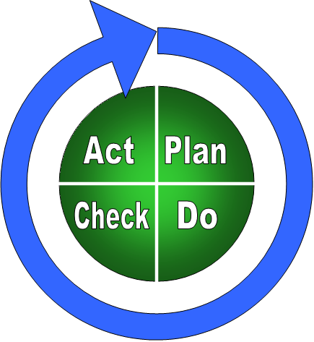
Fig. 7 Deming cycle

Deming's focus was on industrial production processes, and the level of improvements he sought were on the level of production. In the modern post-industrial company, these kinds of improvements are still needed but the real performance drivers often occur on the level of business strategy. Strategic deployment is another process, but it has relatively longer-term variations because large companies cannot change as rapidly as small business units. Still, strategic initiatives can and should be placed in a feedback loop, complete with measurements and planning linked in a PDCA cycle.

2.11.2 G. Halévy raising questions of the method of analysis of the development process

One of the foreign authors Gideon Halévy offers a bit more company covering the theoretical aspects of the organization development model. According to him, planning to improve the organization itself must raise 5 questions to help structure the development of programs. Also, these questions should provide a key to long-term processes, the subsequent improvement, whereas improvement as a separate process can be exhaustive.
These 5 can be questions are:
- The motive, the driving force - which is essential for business aspects leading to process improvement?
- The model - which of the following models of best practice in the organization?
- Model - how to quickly and effectively identify improvement opportunities?
- Leadership Change - What factors affect the improvement of delivery performance?
- Measurements - What are the major facts introduction of performance monitoring program?

2.11.3 Theory of constraints

The theory of constraints is a general manufacturing philosophy based on understanding the manufacturing processes and identifying its constraints. A constraint is anything that limits a system from achieving higher performance or meeting goals.
Initially the system was developed as a scheduling system called optimized production technology (OPT). OPT governs product flow in the plant. The rules of OPT are derived for the capacity constraints and especially bottlenecks.
Both capacity and market constraints should be handled by the logistical system. The nine rules of OPT are:
1. Do not balance capacity. The major objective is flow.
2. The level of utilization of a non-bottleneck is not determined by its own potential
but by other constraints within the system.
3. Activation and utilization are not synonymous.
4. An hour lost on bottleneck is an hour lost on the system.
5. An hour gained on a non-bottleneck is a mirage.
6. Bottlenecks govern both inventory and throughput.
7. The transfer batch may not be equal to the process batch.
8. The process batch should be variable, not fixed.
9. Schedules should be estimated by looking at all the constraints.

Lead times are results of a schedule and cannot be predetermined. OPT did not reveal the theory underlying the software, the firms that implemented OPT were forced to follow schedules generated by a ‘black box’. Supervisors found the schedules counter-intuitive and were reluctant to follow them. Following a fairly disastrous sortie into OPT scheduling software, the ideas on bottleneck management now run under the name of theory of constraints
(TOC). TOC has moved on slightly from OPT, however, the basic message is remarkably similar. TOC is claimed to be a useful approach to issues of project management and constraints in company policies. Independent experts say production is where the true value still lies. A lot of work is being done to see how you can apply manufacturing theory outside of manufacturing, but you always come up against the problem of environments that don’t even have the stability offered by manufacturing, where at least if something takes an hour to make, it takes an hour to make. Outside of manufacturing, there is so much scope for informal systems. TOC boils down to the argument that the throughput (that is, output which is sold) of an entire plant is the measure of success for any company; that it is nonsensical for individual departments to work on improving their performance locally since this will only result in stockpiles of inventory or workin- progress; and that there is always one weakest link in the chain, the point where improvement efforts should be focused first and whose limitations or constraints should inform all other steps. If you optimize already strong links without strengthening the weakest, all you do is heighten the imbalance – which translates into inventory.

2.12 Model analysis of raising production efficiency
Examination of the literature on the topic of his most appropriate for an author to choose. These are:
Jared Lovell;
K. A. Rosentrater;
Peter Hines and Nick Rich.

However, the authors model and the model description of the installation I am not happy because it was a lot of uncertainty and there was no consistency. And this is the most important criteria for a rapid and correct implementation of lean production system and improve efficiency.

Authors divides the whole model in the three main part, as follows:
- Start the map by drawing a factory icon and data box in the top right corner of the paper (Figure 1). Fill in the data box with a list of customer requirements (remember that the value stream is based upon product families, so be specific) such as units per day, number of shifts, complexity breakout, and other production information. Remember that the scope of a value-stream map encompasses much more than just the factory. It includes the entire value stream from raw material to shipment of finished product. Therefore, the best place to start is with the customer, since the customer is the only individual who can define the true value of the commodity at hand. (The customer icon on the map resembles a castle, representing the fact that the customer is king.)
- The next step is outlining the basic supplier production process. Use a process box on the left side of the map to represent suppliers. Usually, all suppliers cannot be listed, so the rule of thumb is to select the supplier of the most vital components or the company that supplies the most components by dollar amount. After the suppliers are drawn, list the production details of the operation in a data box. This information should be readily available from your purchasing department.
- The last step of the external map is to connect all the icons with information flow icons. Draw the appropriate icon based on the type of information flow. Figure 1 has electronic information flow, which is indicated with lines that appear as lightning bolts. Other types of flow make use of different types of lines. Below each information icon, draw a description box and fill in the frequency of information flow. The external map is now complete.

table. 2 Find models advantages and disadvantages
Authors | Advantages | Disadvantages
Jared Lovelle | Concentrate for creating flow. | Not present concrete problems decitions, only present how identify problems
K. A. Rosentrater | Very detailing resent how draw value stream maping | Presend decitions but not present how it implement.
Peter Hines and Nick Rich | Offering to find weaknesses in the use of seven waste method. | For identify and solve problems present very comlicated decitions.

3. Production efficiency improvement in industry, empirical studies

3.1 Research methodology

My issue is about raising the efficiency of production, and the selected branch - the metal-processing industry, which has its own specific characteristics, so that empirical research should start from the current situation in the overall market analysis. The aim is to find what is, the industry dynamics, enterprises in financial performance, sales, etc. Also the dynamics to be compared with the overall dynamics of industry in the country and then we will get current situation, how the industry evolves: the situation is upgrading or deteriorating.
Examination of the industries, the trend will pass to the analysis of a given business groups and their problems. Try to formulate a planned improvements set, which allows those companies to improve their production efficiency according to their market position and overall market trends.
Identify more precisely which of the already selected production efficiency improvement tools are best for my case and considers the undertakings concerned. This will result in survey, more qualitative than quantitative, focusing on the conduct of the survey method - an interview with the aim to maximize the views from various staff at both the lowest chain and executive positions.
Collected sufficient data, can we build models, raising the efficiency of production tools set, the most suitable for my case. This model should contribute to the metal-processing industry to become more competitive both in Lithuanian, European and global level. This is relevant due to the fact that in Lithuania the following industries production market is small, but in order to compete with foreign companies need to act quickly, innovatively and constantly strive to improve their business operations, product or service. In such an investigation will be to improve most focused.
Structuring study the challenges can be discerned from the two main tasks and it is broken down into subsidiary objectives:
1) A metal-processing sector development trends in research:
- Production structure analysis
- The number of enterprises of the sector trend analysis
- industry, general business trends analysis
2) A process of raising the efficiency of production in industry surveys.
- Correlation analysis.

3.2. Metal-processing sector trend analysis

The statistical analysis was used to provide the Department of Statistics data. In all examined in the following analyzes the industry to compare with my choice of industrial activities. It will also examine all the Lithuanian state and industry trends.

3.2.1 Industrial production of statistical analysis

table. 3 Industrial production index, compared with the previous year,% [9]
Economic activities | 2005 | 2006 | 2007 | 2008
All Industry | 107,0 | 106,5 | 102,4 | 105,5
Fabricated metal products | 119,9 | 130,2 | 126,3 | 71,0

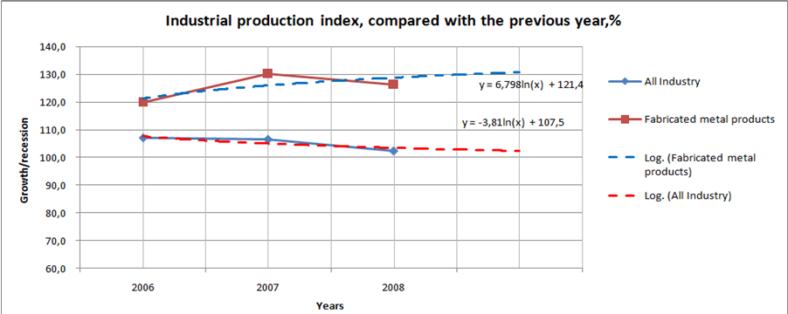
Fig. 8 Industrial production indexes [9]

The data provided shows that industries with minor corrections retained a fairly smooth growth. Fabricated Metal Products group of companies by 2006 had sufficiently high growth rates, but gradually fell in 2006. However, from 2007-2008, has fallen dramatically.
In summary it can be argued that since 2005 the total industry growth has been negative, but positive in 2008. However. Fabricated Metal Products group of companies from rapidly fallen during 2007. During the analysis of all 4-year period was 8.05% annual fall, and if we take the last 2 years, it will fall 55.3%. However, the figures are much picturesquely, when compared with some initial reference points, for example. 2005 year.
Further, this is what the table and looks - the rate of growth compared to the base - the year 2005.

table. 4 Industrial production index, compared with base - 2005 year,% [9]

Economic activities | 2006 | 2007 | 2008
All Industry | 114,0 | 116,7 | 123,1
Fabricated metal products | 156,1 | 197,2 | 140,0

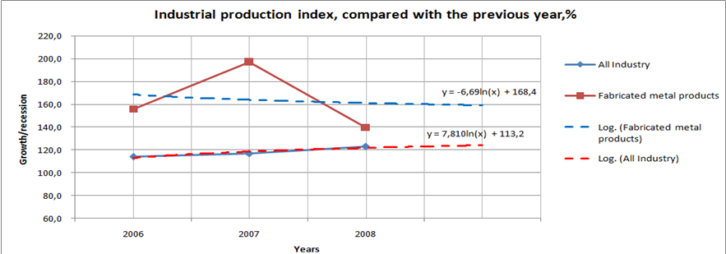
Fig. 9 Industrial production index, compared with base [9]

This curve shows that the all industry rate of growth slightly increasing, and fabricated metal products, theme of growth is declining. This shows that in Lithuania the operating profile of a growing market for up businesses, as well as effective competition.

Statistical analysis of the structure of production, by market

table. 5 Statistical analysis of the structure of production, by market (sold production = 100%)
 | 2006 | 2007 | 2008 | 2009
Lithuanian market | 36,8 | 37,2 | 31,2 | 28,4
foreign markets | 63,2 | 62,8 | 68,8 | 71,6

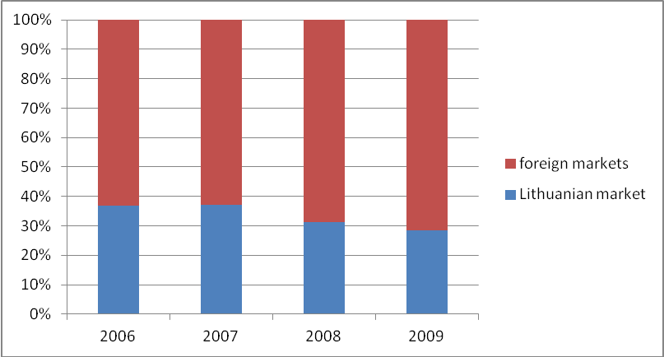
Fig. 10 Statistical analysis of the structure of production, by market (sold production = 100%) [9]

As can be seen from the data and how it was possible to expect every year except 2007, Lithuania declining sales and an increase of sales in foreign markets. This is due to the fact that this category of companies are generally attained a high technological level, they also produced products are usually sufficiently technologically sophisticated, and Lithuania, taking into account the size of the market is not very friendly country, which can be selected as the sole sales region. Technologically innovative company constantly looking for opportunities to sell more abroad, as there are customers paid on time it is opportunities to sell more. In addition, and competition becomes no longer a local but a global community. Then play to improve their performance. Through their work, I will try to show what is most needed to improve the industry.

Department of Statistics provide further comparative table which shows the production structure in relation to mining and manufacturing, the structure is taken as the base and is 100%

3.3 Metal-processing sector, the number of enterprises trend analysis

table. 6 The number of firms by economic activity [9]

Economic activities | 2002 | 2003 | 2004 | 2005 | 2006 | 2007 | 2008
Fabricated metal products | 507 | 557 | 592 | 627 | 662 | 688 | 686

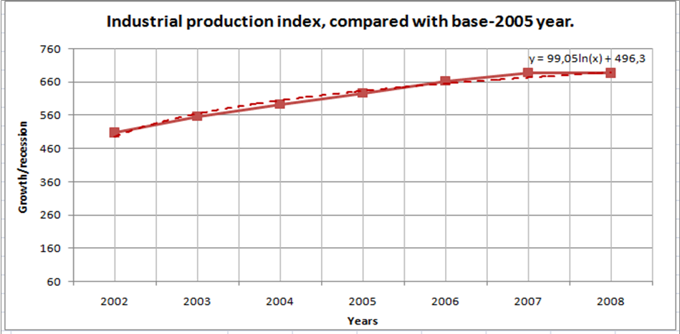
Fig. 11 The number of firms by economic activity [9]

As is clear from the statistics and in accordance with their timetable and the "trend" function for sheet metal processing enterprises sector is growing rapidly. This indicates an active growth in this sector as well as production demand increases.

Industry Analysis and Trends

table. 7 Companies' ability to compete in the domestic market change. Number of enterprises as a percentage. [9]

 | 2009 |  |  |  |  |  |  |  |  |  |  | 2010
 | I | II | IV | V | VI | VII | VIII | IX | X | XI | XII |  | I | II | III | IV | V
Improved | 10 | 8 | 11 | 8 | 11 | 12 | 11 | 10 | 11 | 6 | 7 |  | 8 | 9 | 10 | 11 | 6
Has not changed | 86 | 88 | 84 | 89 | 87 | 85 | 87 | 86 | 83 | 91 | 89 |  | 87 | 87 | 84 | 87 | 90
Deteriorated | 4 | 4 | 5 | 3 | 2 | 3 | 2 | 4 | 6 | 3 | 4 |  | 5 | 4 | 6 | 2 | 4
Balance | 6 | 4 | 6 | 5 | 9 | 9 | 9 | 6 | 5 | 3 | 3 |  | 3 | 5 | 4 | 9 | 2

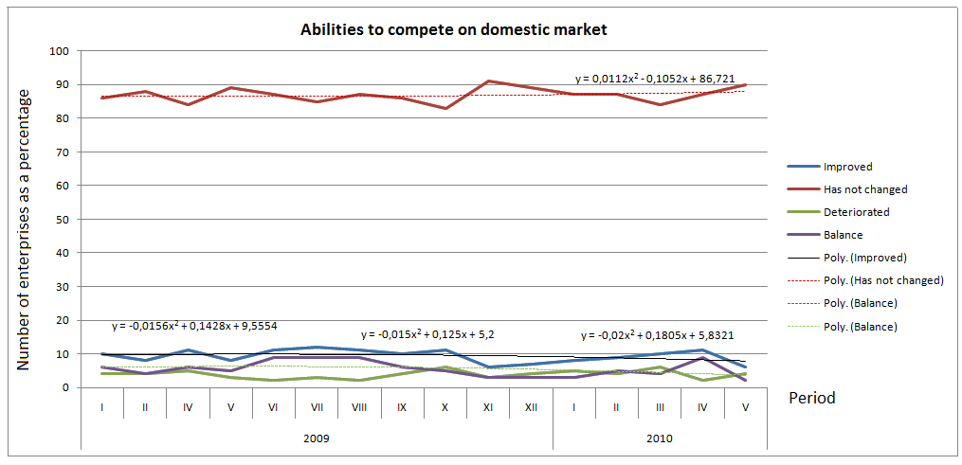
Fig. 12 Companies' ability to compete in the domestic market change

As is clear from these data, the internal market changes very little. Most of the companies responded that the situation is unchanged. A clear tendency. Thus one can assume that the whole industry is stagnating stage. This may be due to the fact that the local market is small and largely meet its needs in the long run should not change the situation.

table. 8 Companies ability to compete in the EU countries market change. Number of enterprises as a percentage [9]:

 | 2009 |  |  |  |  |  |  |  |  |  |  | 2010
 | I | II | IV | V | VI | VII | VIII | IX | X | XI | XII | I | II | III | IV | V
Improved | 11 | 9 | 11 | 13 | 14 | 13 | 12 | 8 | 8 | 6 | 5 | 6 | 6 | 7 | 6 | 6
Has not changed | 77 | 78 | 74 | 73 | 76 | 77 | 80 | 85 | 86 | 80 | 81 | 82 | 81 | 78 | 82 | 84
Deteriorated | 12 | 13 | 15 | 14 | 10 | 10 | 8 | 7 | 6 | 14 | 14 | 12 | 13 | 15 | 12 | 10
Balance | -1 | -4 | -4 | -1 | 4 | 3 | 4 | 1 | 2 | -8 | -9 | -6 | -7 | -8 | -6 | -4

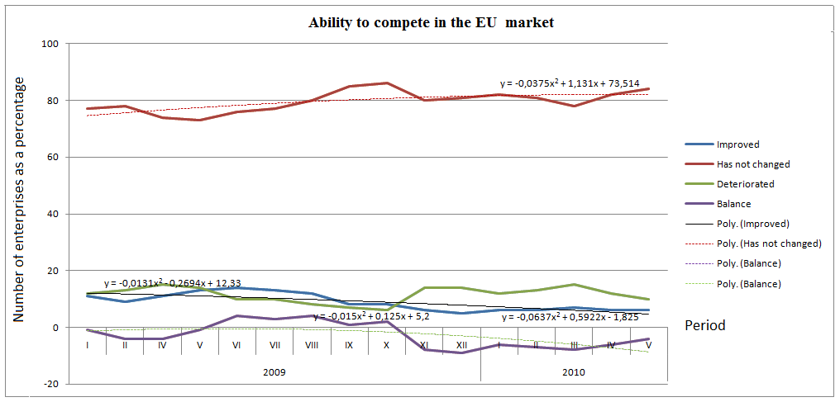
Fig. 13 Companies ability to compete in the EU countries market change

This analysis applies a similar rule as in the analysis of the ability to compete in the domestic market. Here, however, clearly visible to the negative trend in companies recognize that to compete in EU markets is becoming increasingly difficult. It confirmed my earlier predictions of metal-processing's sectors, exports need to implement modern manufacturing methods of organization to help organize its corporate structure to improve its operations and production management on what companies can successfully compete in foreign markets.

table. 9 The product demand. Number of enterprises as a percentage [9]:

 | 2009 |  |  |  |  |  |  |  |  |  |  |  | 2010
 | I | II | III | IV | V | VI | VII | VIII | IX | X | XI | XII | I | II | III | IV | V
Improved | 3 | 7 | 9 | 9 | 12 | 15 | 16 | 18 | 14 | 10 | 16 | 11 | 9 | 10 | 8 | 7 | 9
Has not changed | 79 | 69 | 65 | 76 | 73 | 67 | 67 | 62 | 67 | 69 | 72 | 73 | 64 | 59 | 60 | 60 | 63
Deteriorated | 18 | 24 | 26 | 15 | 15 | 18 | 17 | 20 | 19 | 21 | 12 | 16 | 27 | 31 | 32 | 33 | 28
Balance | -15 | -17 | -17 | -6 | -3 | -3 | -1 | -2 | -5 | -11 | 4 | -5 | -18 | -21 | -24 | -26 | -19

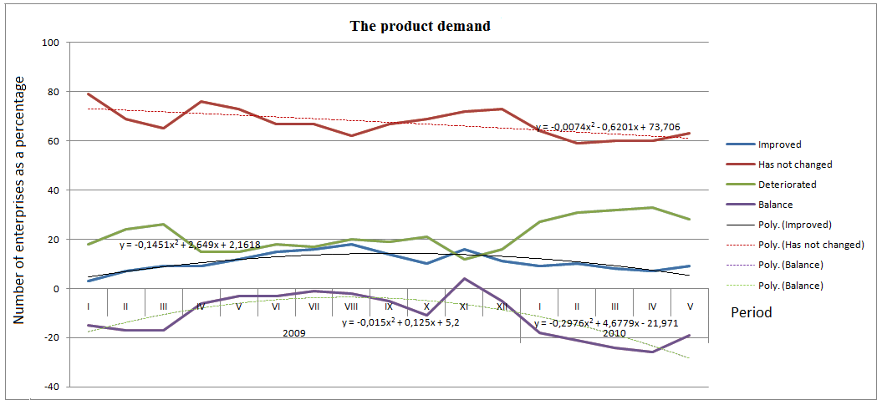
Fig. 14 The product demand

This analysis reflects the overall product demand trends across the industry. These data show that sentiment is negative, decreasing firms argue that demand is too high, what is essentially positive. At the same time increasing number of companies saying that demand is declining. This may be due to the fact that the market is growing more and more foreign manufacturers substitutes propellants our local products because local firms are unable to produce innovative, economically and quickly adapt to evolving market conditions.

table. 10 Production export demand [9]:
 | 2009 |  |  |  |  |  |  |  |  |  |  |  | 2010
 | I | II | III | IV | V | VI | VII | VIII | IX | X | XI | XII | I | II | III | IV | V
Improved | 4 | 23 | 30 | 32 | 31 | 32 | 36 | 36 | 34 | 36 | 33 | 30 | 14 | 1 | 1 | 2 | 1
Has not changed | 79 | 61 | 54 | 50 | 53 | 57 | 46 | 50 | 55 | 47 | 56 | 58 | 63 | 70 | 72 | 67 | 74
Deteriorated | 17 | 16 | 16 | 18 | 16 | 11 | 18 | 14 | 11 | 17 | 11 | 12 | 23 | 29 | 27 | 31 | 25
Balance | -13 | 7 | 14 | 14 | 15 | 21 | 18 | 22 | 23 | 19 | 22 | 18 | -9 | -28 | -26 | -29 | -24

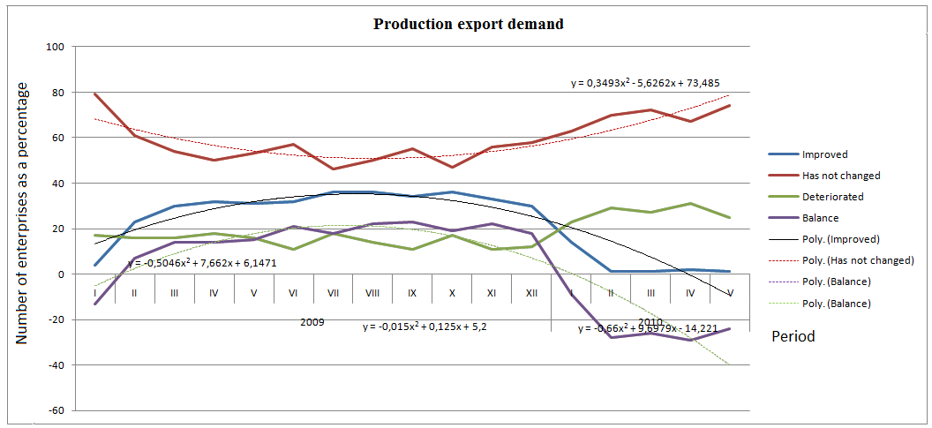
Fig. 15 Production export demand changes

According to this analysis shows a very negative trend - the demand for exports fall sharply, resulting in deterioration of all the country's foreign trade balance. Fall and the country of export is more difficult to pull money from foreign funds and rising borrowing become foreign debt balance may become negative. Also with regard to the entire industry, as well as metal-working sector can be said that the need to significantly raise the level of exports, increase the competitiveness of both sectors and all industries in foreign countries. This requires, as mentioned previously, to become more flexible, filed a governance structure to better organize production and to optimize use of resources.

Conclusions
Summarizing the statistical data shows that the issue of medical equipment, precision instruments and optical goods industry, Lithuania has a positive and improving. Sector showing no significant variations in terms of performance. You can read both positive and negative features. The negative is the fact that as a technological and innovative group of companies have these days of innovation and innovation to achieve better results than the market average. It also takes into account the fact that increasing the sales abroad. Export growth is a positive element, since the mutual benefits of exporting firms at both the national companies in the group: the country-wide improvements in foreign trade balance, and the group level - the company becomes more familiar in the world, increasing their brand, as well as abroad, they pose a level of understanding of those industries in which they operate, good situation in Lithuania. It also appears that the recent results of the group tend to improve faster than before. So with this, and given the fact that exports are increasing and exports high-tech products, companies must continually strive to improve their performance in order to remain competitive in the global market.
Increase the competitiveness of enterprises and improve the performance measures should be taken, and in particular the original chain - production. After all, if the product is not in line with market requirements, no longer have any means to achieve the desired objective because the product simply will not buy nothing. So it should be taken into account the organization of production and efforts to improve it. that there's production quality and decrease production cost.
Previously, theoretical part I looked at a number of production management models. They can serve as tools for improving the organization but should always be taken into the field-in this case, medical equipment and facilities and precise optics producing sector-specific requirements. So I will try to continue to consider a preliminary finding appropriate models and their application possibilities in our case.

3.4 Metal-processes industries sector research

The survey chose three companies that match my criteria in the investigation and located sufficiently operational profile.
First would be UAB "EMP recycling" the company assembles, buying, processing of electronic waste (household, office equipment, cables, wires) and automotive waste, sale of secondary raw materials for industry. In 1999 was established "Elektroniniu masinu perdirbimas" in 2007 company changed its name to "EMP recycling. Its refinery production capacity per year - 20,000 tones of electronics waste, up to 1,000 tons of wire and cable, about 500 tons of automobile catalytic converters.
The company will apply to both the principles of mass production, where some products are produced without nonstop long time, and also applies to the serial model in which the customer's request is produced is a different product. In each generation is creating more new jobs, which is taken up to form a unique product with part of the products. Commissioned a unique content of the final product.
Second would be JSC "Arginta" fields of activity is production of highly qualitative non-standard products, components and metal semi-products from steel, stainless steel, aluminum. We manufacture the products in accordance with customer's drawings. However, this job may be entrusted to our experienced designer.
Third company would be JSC "VAE Legetecha". UAB VAE Legetecha produces very high-precision components and a kit requiring assembly operations carried out in accordance with customer orders and drawings, switches, crossings, additional equipment for rail mounting, a segregated glue joints, replacement of worn parts of the spit repair. However, more specialization switch assembly, the components required for production.
I think that the three companies can, at least in part, reflect the situation in Lithuanian industrial market among companies that operate under a combined production which is not so easy to apply standard solutions to improve production and efficiency.
The survey was guided by the principle of non-quantitative, but qualitative survey. Most of the respondents were interviewed individually - interviews. Yes I did because I was able to gain access to people in person in each company, and most of them are willing to share their experiences and opinions, because in most cases it has proved far more exciting - the people at the hearing, and lack of communication.
Questionnaire is attached as Appendix 1. And then try to analyze questionnaire data and draw conclusions which will help choose the optimal organization of production improvement model.

3.4.1 Analysis of questionnaire results

A questionnaire was sent to 45 industrial companies, but only a few answered. So I decided to go into three of the companies that their products are different but similar in their production volumes.
Summary data can be made to the following conclusions. Total 84 persons were interviewed, 23 of them were UAB EMP Recycling personnel. 4 of which were carried out in the interview, the other 19 completed questionnaires on their own. UAB Arginta was interviewed 44. 10 of them interviewed former interview, 34 completed questionnaires on their own.
In VAE Legetecha was interviewed 17. 8 of them interviewed former interview, 9 completed questionnaires on their own.
Respondents divided equally by gender: 69 men's and 15 women's. Therefore a large part of her men's, in firms to work more engineering works, where men are able to work better than women.
The average age of respondents was 25 - 40 years.

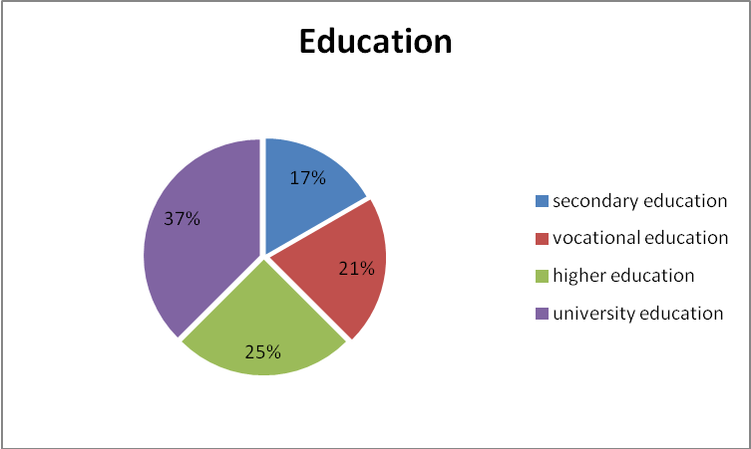
Fig. 16 Distribution of respondents by education level

We see that the dominant level of education is a university, so that the majority of respondents were from the technological, marketing and purchasing department. Most workers are with secondary and vocational educations it is 38 %.

Of the job distribution of respondents:
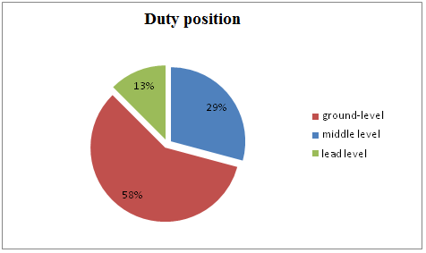
Fig. 17 Distribution of respondents by duty position

From 5 and 6 questions possible to determine how the company's employees and the company itself is ready to cope with more frequent product and product change. Most respondents argued that the introduction of a number of problems, but they quickly removed. Perhaps it is because the firm is sufficiently flexible and responsive to market changes as the market for some time is the reinforced enough. The company, which until now have not yet to the non-, is hardly likely to have engaged, or their flexibility is not relevant.
On the other hand, visible to both staff and company produce products as are used, as place of manufacture, use of facilities and so on. However, workers would be alright if the specialization of production would be upgraded. Because employees are often tired and poorly motivated to work in the same work and they had a positive attitude for the organization, grading of products in certain categories and their treatment under the categories. It is an interesting work, employees feel more responsibility for their work and to better see the result. It is built around a smaller team, which was not far larger workshops, it would allow more workers to communicate with each other and she would motivation and sense of responsibility for work-related.
In the higher-ranking workers in the organization of the production chain, as well as the enthusiasm seen in the case of closed bars ideas. According to them, production management should become operational, easier and faster.
However in the company "EMP" has raised concerns that it may be rather difficult to classify products into categories, product nomenclature is as large and they require a varied level of processing.

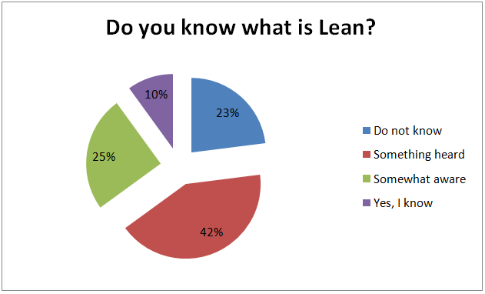
Fig. 18 Distribution of respondents by knowledge about Lean

From 9 and 10 questions possible to determine how the company's employees know about Lean, only 10% know what is Lean. Most of employees only heard about Lean but don't know why Lean need. 23% residents nothing heared about Lean and Lean tools.

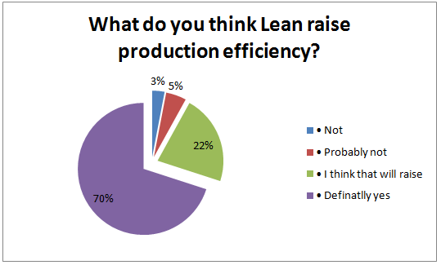
Fig. 19 Distribution of respondents by efficiency raising implementing Lean

From 11 question possible to determine what most of employees 70%, thing what implementing Lean really can raise production efficiency. Answered on this question when explained what is Lean, how is work and given examples from other companies.

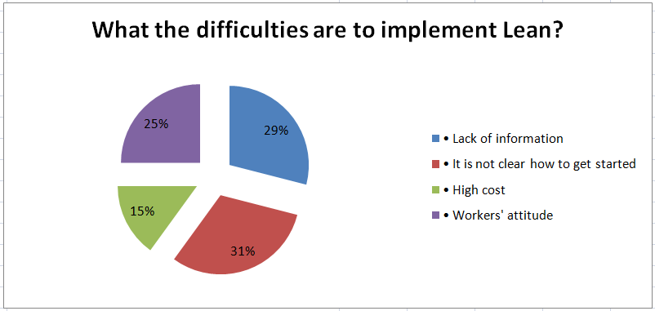
Fig. 20 Distribution of respondents by difficulties to implementing Lean

From 12 question possible to determine what most difficult are lack of information an not clear how to start implementing.

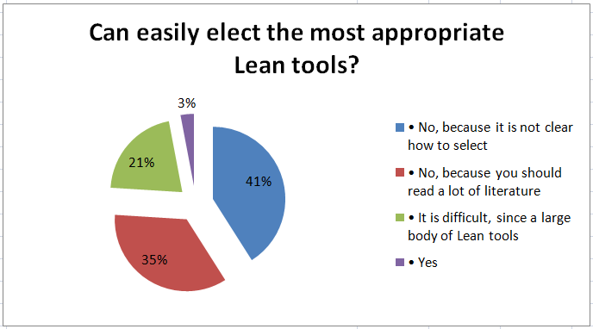
Fig. 21 Distribution of respondents by selecting Lean tool

From 13 question possible to determine what most difficult are select tools because is not clear how to select most appropriate tool. 35% respondents say what select difficult, because need are lack of information and need read a lot of literature, spend more time to reading. Only 3% residents say what select tools are not difficult, because they have experience from previous employment.
After the questionnaires analyze can say that most problems comes from choosing the right tool or a lack of information for start implementing Lean. Because its a big problem to companies which want implement Lean, in may work I will taken into account for development of production efficiency models.

3.4.2 Correlation analysis of the questionnaires

The examination of the questionnaire and collected data, there is a number of questions that they want to find the answers in terms of the link between the subject, it would be interesting to know how to rank or education about communication problems of a lack of inter-linkages with other aspects of each other, and so on. Whether by means of correlation What links.
To make sure that respondents reliability was calculated on the coefficient of variation, which are usually available for analysis of data reliability.
A statistical measure of the dispersion of data points in a data series around the mean. It is calculated as follows:
(2)
where:
V - coefficient of variation, %;
- standard deviation;
x - expected return;
The coefficient of variation represents the ratio of the standard deviation to the mean, and it is a useful statistic for comparing the degree of variation from one data series to another, even if the means are drastically different from each other.
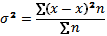 (3)
- dispersion;
x - expected return;
x - average expected return;
n - the observed number of cases.
Without knowing something about how data is dispersed, measures of central tendency may be misleading. Measures of dispersion provide a more complete picture. Dispersion measures include the range, average deviation, variance, and standard deviation. [12].
Standard deviation is calculated as follows:
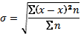 (4)
Standard deviation shows how much variation there is from the "average" (mean). It may be thought of as the average difference of the scores from the mean of distribution, how far they are away from the mean. A low standard deviation indicates that the data points tend to be very close to the mean, whereas high standard deviation indicates that the data are spread out over a large range of values. 11].
Set the coefficient of variation of different qualitative assessment:

Variance ration - measure of the randomness of a return series. Variance ratio is computed by dividing the variance of returns estimated from longer intervals by the variance of returns estimated from shorter intervals.
- To 10% - slight variation;
- 10 -25% - average variation;
- more than 25% - big variation.

The smallest possible variation in the reliability of answers. Taking advantage of Microsoft Excel was calculated for each variable on the average expected value, variance, standard deviation and coefficient of variation.
It appears that the coefficient of variation is large enough, but it is, however, that the survey responses were very diverse, and the same options were limited. But this does not prevent us to further analyze the particulars of the data and analysis to draw conclusions and generalizations.

table. 11 Respondents from the average expected values and the fluctuation characteristics
Variables | Average expected return | Dispersion | Deviation | Coefficient of variation
1) Gender | 1,5 | 0,24 | 0,51 | 33,9
2) Age | 2 | 0,87 | 0,95 | 23,7
3) Education | 3 | 2,01 | 1,44 | 72,1
4) Office, function | 2 | 1,50 | 1,28 | 28,0
5) Problems with new products | 1 | 0,90 | 0,92 | 46,1
6) Problems frequency | 3 | 0,45 | 0,63 | 63,0
7) Desired work | 4 | 1,21 | 1,10 | 36,8
8) Promotion | 3 | 2,80 | 1,72 | 42,9
9) Knowledge's | 2 | 0,84 | 0,94 | 31,2
10) Implementing | 2 | 0,89 | 0,95 | 47,5
11) Efficiency | 2 | 0,90 | 0,95 | 47,5
12) Difficulties in implementing | 2 | 0,83 | 0,91 | 45,5
13) Selection of tools | 2 | 0,80 | 0,95 | 47,3

Analyzing the correlation between the questionnaire where the subject is found in relationship

table. 12 Correlations matrix
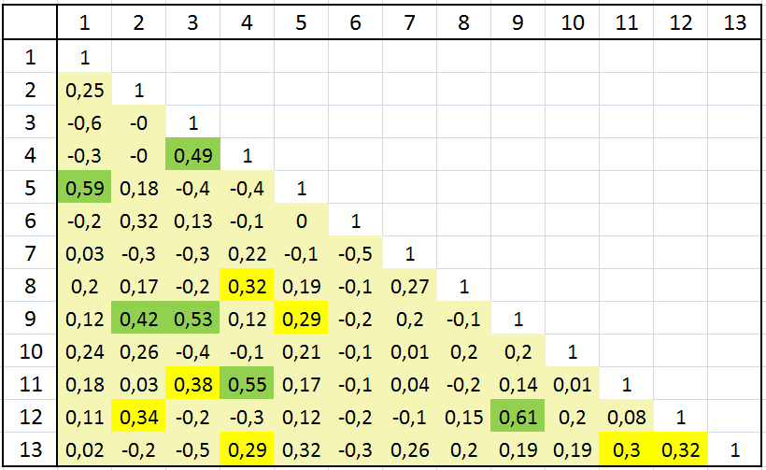

It appears that the first question on the correlation of gender with a 5 question, which were asked how often confronted with problems of coordination to another product. On this basis, it appears that women may have more difficulty when changing the productive technology, implementing new product and so on. Men quickly orient and accelerate take-up of developments. Also, women may have more problems because of the respondents; mostly women can work directly with the products, while most men work in the higher position, and therefore naturally face little with industrial problems.
In regards with the question 3 on the formation of noticeable correlation with the question of responsibility. This is natural and understandable, since most companies formed in practice in the higher positions in accepting people with higher education. And all this just confirms that the questionnaires have been answered more or less fairy and analyzing of our system is effective.
Furthermore, we can see that question 9, which is about implementing Lean, is correlated with the other issues, the respondents age and education. From this we can decide that the knowledge-based Lean depend of education and age. The higher the education level, the more respondents had heard about the badness. Also are similar to the age of the respondents. The ages of the respondents are over the less heard about Lean. It seems therefore, that older people do not have a lot of knowledge because the Lean was described in 1990 by Womack so most of the educational institutions have recently started to teach about Lean.
We see that questions 12 to 9 have a high correlation. This is an issue of the difficulties arising from the introduction and development of knowledge about Lean. The majority of the respondents are aware of that Lean can tell you more about the potential difficulties implement this system.
Dependence on the opinions of the duty also visible and whether they can raise production efficiency Lean. The dependence of the senior positions is growing. It seems, therefore, that universities teach about the production, organization, efficiency improvement. However, I tell the lower level of education of the respondents also answered that the introduction of Lean can increase the manufacturing efficiency.
There is a weak correlation between 3 and 11 issues, due to manufacturing efficiencies, and install Leann education. The higher the education level, the more claims that higher efficiency will be obtained.
Correlation is visible and between 2 and 13 subjects. Light-dependence between the estimated severity and age. It is obvious, since older people have more experience than the younger.

3.4.3 Conclusions and suggestions

According to the research objectives formulated in the beginning:
1) A metal-processing sector development trends in research:
- Production structure analysis;
- The number of enterprises of the sector trend analysis
- industry, general business trends analysis.;
2) A process of raising the efficiency of production in industry surveys.
- Correlation analysis of data.

can form some conclusions:
Industrial Condition deteriorated, and ability to compete in decline
It is clear from the data submitted by the Department of Statistics, based on this information need to wonder why is behaving. It is therefore necessary to consider the worst version of the industry's ability to compete in rapid decline and the appropriate action to restore Lithuanian industry can be an insurmountable task.
Observed a lack of employee motivation, arising from higher-ranking employee.
Account must be taken, because even if not installed already developed any innovative performance improvement model, they have motivated staff of this great era of competition is very important. Some staff are no reasons, in front of the quality of work, so suffer the undertakings. And this is very important for a high-tech companies.
Currently, most companies are only heard what is Lean, but knows little about how to implement, does not know how things are going. This is so that Lithuania is not very popular Lean system. Lean prosper seemingly hampered by the old, old tradition of manufacturing management and reluctance to change anything,
However, in these times, which offers enterprises and currently are implementing significant competitive advantages over those that are not heard about Lean system.

4. Production efficiency increasing model for metal processing companies

4.1 Production efficiency increasing model

Efficient manufacturing can be called such manufacturing using which the product will be manufactured in as shorter period, qualified and with the lowest usage of raw material.
After analysis of another authors literature as mentioned before, the most appropriate for the increase of efficiency of manufacturing are principles of Lean manufacturing. This is not enough having a wish to create model, so other tools are being used for this such as derived from Japan, Italy and other countries.
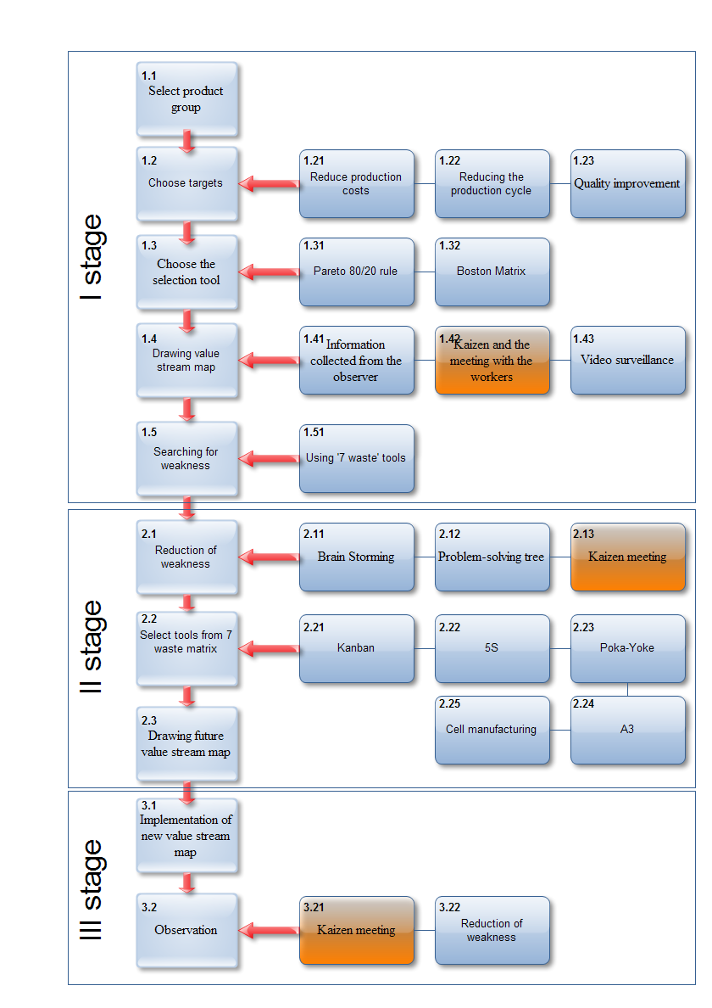
Fig. 22 Raising production efficiency model
Model of increase of efficiency of manufacturing consists of 3 stages
1) Analysis of present status (Fig. 23);
2) Future value stream map (Fig. 24);
3) Implementation (Fig. 25);

4.2.1 First stage for implementing model

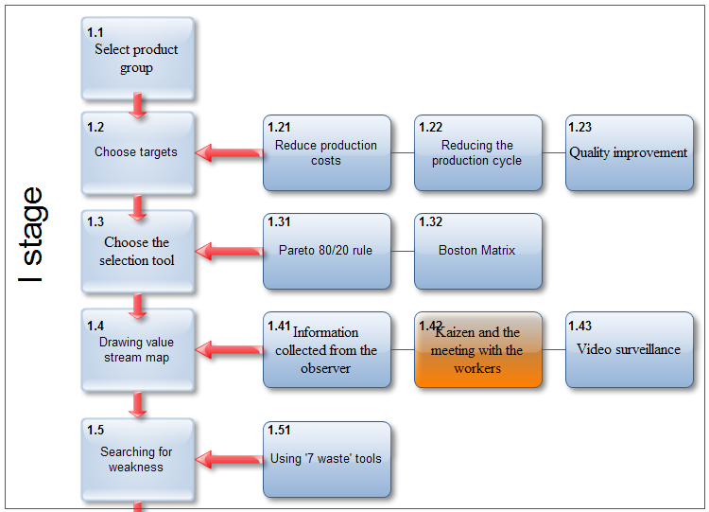
Fig. 23 Raising production efficiency model stage I

Present status is being analyzed in the first stage. Points segregated in this stage are such:
1.1. The products group is being composed, the whole produce manufactured by the company is being taken and the grouping is being done by appropriate features. The table should be done simply for this where products would be listed and their features above. In such a way putting crosses by each product we could separate groups of products easily.
1.2. We are choosing criteria under which we are separating the group of products. Three criteria are being given in this model, but other can also be chosen and it belongs on the target the company is reaching. It can be decrease of manufacturing costs, saving of manufacturing cycle or improvement of quality..
1.3. We are choosing the separation tool. Separation tool is for the reason that we could take off the products giving the biggest benefit as wish able and we are taking them off from the group of products. Some separation tools given are:
Parett‘s rule or 20/80 rule that says about 20% of efforts give 80% of results, and remaining 80% of efforts –20% of results only.
Boston matrix, after using we can group products into four categories: requiring a lot of efforts and giving minor result, a lot of efforts and giving majors result and vice versa.
1.4. We are drawing a future value stream map. For this reason we are to list operations in such a row in which the product of its purveyance goes through working centers. We are also to have times that are being got by measuring with the chronometer the time spent in each working center. In the same way the time of purveyances or detail road between working centers is being calculated. Three ways of collecting required data are being used for reaching this target:
- Information is being collected by surveyor from aside;
- Video survey is being used;
- Kaizen meeting with workers that are given the information by themselves.
1.5. The weakest grid is being started to be searched having a map. Fore ach person can understand different in such case 7 waste tools are being suggested to be used. As given in the table below.

4.2.2 Second stage for implementing model

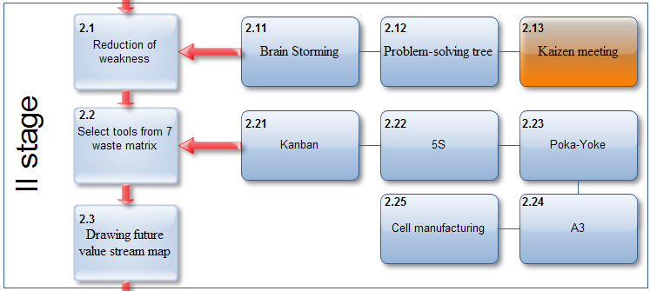
Fig. 24 Raising production efficiency model stage I

2.1. The weakest grid is under try to remove, we start that ideas generation, how to remove it. Method of brain storming, tree of problems solution or Kaizen meeting is offered to be used here.
2.2. We are choosing tools for removing the weakest grid. The matrix of suggestible tolls is composed for this reason.

table. 13 Lean tool selection matrix.
Wastes/structure | Kanban | 5S | Poka-Yoke | SMED | Cellular manufacturing | A3
Overproduction | H |  |  |  | L
Waiting | H |  | L | M | M
Transport | H | M |  |  | M
Inappropriate processing |  |  |  |  | M | H
Unnecessary inventory |  | H |  | L |  | M
Unnecessary motion | H |  |  |  |  | H
Defects |  | H | M
Overall structure | L |  |  |  | M

Notes:
H - High correlation and usefulness
M - Medium correlation and usefulness
L - Low correlation and usefulness

The typology of the seven new tools is presented in terms of the seven wastes already described. In addition the delineating of the overall combined value stream structure will be useful and will also be combined as shown in the left column in Table I. Thus, in order to make improvements in the supply chain it is suggested here that at least an outline understanding of the particular wastes to be reduced must be gained before any mapping activity takes place. At this point it should be stressed that several of the seven mapping tools were already well-known before the writing of this paper. At least two can be regarded as new, and others will be unfamiliar to a wide range of researchers and practitioners. Until now, however, there has been no decision support mechanism to help choose the most appropriate tool or tools to use.

4.2.3 Last stage for implementing model

2.3. The future value stream map is being drawn. Also the map with all changes of the present map is being drawn with icons of used tools.

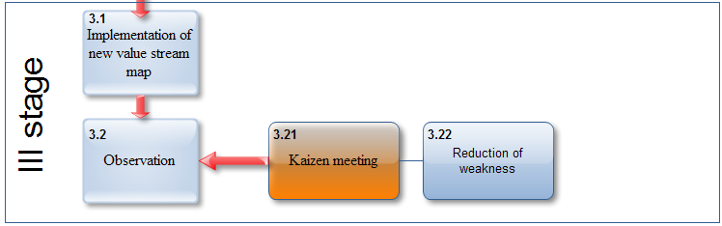
Fig. 25 Production efficiency improvement model for stage III.

3.1. Implementation of the new future value stream map (3 pic.). During this stage activities for implementation of the new future value stream map are being taken.
3.2. Supervision In this stage the supervision is being done on the newly created future value stream map Changes in the beginning of installment or even in the active process are possible Kaizen meeting is under preparation for this reason and ideas with generated improvement are being discussed here.

4.2 Waste removal inside companies

The rationale underlying the collection and use of this suite of tools is to help researchers or practitioners to identify waste in individual value streams and, hence, find an appropriate route to removal, or at least reduction, of this waste.
The use of such waste removal to drive competitive advantage inside organizations was pioneered by Toyota’s chief engineer, Taiichi Ohno, and sensei Shigeo Shingoand is oriented fundamentally to productivity rather than to quality. The reason for this is that improved productivity leads to leaner operations which help to expose further waste and quality problems in the system. Thus the systematic attack on waste is also a systematic assault on the factors underlying poor quality and fundamental management problems[8]. In an internal manufacturing context, there are three types of operation that are undertaken according to Monden[9]. These can be categorized into:
- non-value adding (NVA);
- necessary but non-value adding (NNVA); and
- value-adding (VA).
The first of these is pure waste and involves unnecessary actions which should be eliminated completely.
Examples would:
- include waiting time,
- stacking intermediate products
- double handling.
Necessary but non-value adding operations may be wasteful but are necessary under the current operating procedures. Examples would include:
- walking long distances to pick up parts;
- unpacking deliveries;
- transferring;
- a tool from one hand to another.
In order to eliminate these types of operation it would be necessary to make major changes to the operating system such as creating a new layout or arranging for suppliers to deliver unpacked goods. Such change may not be possible immediately. Value-adding operations involve the conversion or processing of raw materials or semi-finished products through the use of manual labour. This would involve activities such as:
- sub-assembly of parts,
- forging raw materials
- painting body work.

4.3 Model testing on real company
The best is to check is the model well for usage is the testing of it on real company. For grounding only with theory we can not to declare that the same comes out in realty. For this I have been looking for the solution how to check the activity of the model.
For the reason I am working in such profile company that fully matches criteria of model of increasing the efficiency of manufacturing created by myself, so I have decided to make model testing on company UAB "Arginta". It is even few year how Lean is under installment in the company, so Kaizen group is composed that is meeting each week and is solving problems risen in the manufacturing. As I have started my work in Arginta, I became very interested in the installment if Lean, so I have offered to implement the model created by myself in the company. I have succeeded to prove the manufacturing director and leader of manufacturing that this model will really increase the efficiency of manufacturing, so I have risen this target for myself.
I have started implementation of model of increase of manufacturing from the I stage and the step 1.1. positioned in this stage it means from the selection of the product or group of products.

1.1 Select product group
It is necessary to select group of products with which we will increase the efficiency of the product in this step. For the reason products under order is being manufactured in the company, so the list of all clients should have been done together with groups of products that are being produced to each of the clients.

The main clients of the company:
ABB – It is a concern of electricity industry companies that joins ABB plant located in various countries. ABB produces electricity transformers for high speed electric trains, high voltage electricity substations and etc. In Arginta mostly manufactured parts for substations, it is a body for transformers tanks, oil overflow conservators and covers of transformer tank. Also, transformers for the high speed trains are being manufactured.
Mansarps - This Company specialized in train manufacturing industry. Electric train snow cleaners are being manufactured in Arginta.
Silentor – company that designs and manufactures exhaust tubes being used in shipping industry. Products manufactured by it are being supplied to Rolls Royce plant. Arginta manufactures fully welded, semi painted and packed products that are being supplied to shipping plant directly without mediators.

Metso - giant of paper manufacturing. This company designs and constructs paper plants. Various details are being manufactured in Arginta including fully complied nets.
Clients listed above are the biggest composing the biggest overturns. There are a lot of other clients, but they are not as important as listed.
Using the paret‘s rule three categories of the clients have been composed including appropriate characteristics:
- A category contains clients the products of which compose 80 perc. of welding works in Arginta and 20 perc. of other type works in it. Also with achievable profitability of more than 10 percent. Number of orders that can attract overturn of 500.000,00 Eur..
- In B category listed clients in orders of which welding and gathering composes 80 perc. of works. Also as in A category profitability is to be higher than 10 perc. Annual overturn has to compose more than 500.000,00 Eur...
- To C category all other remaining clients are included that are not matching above mentioned categories.
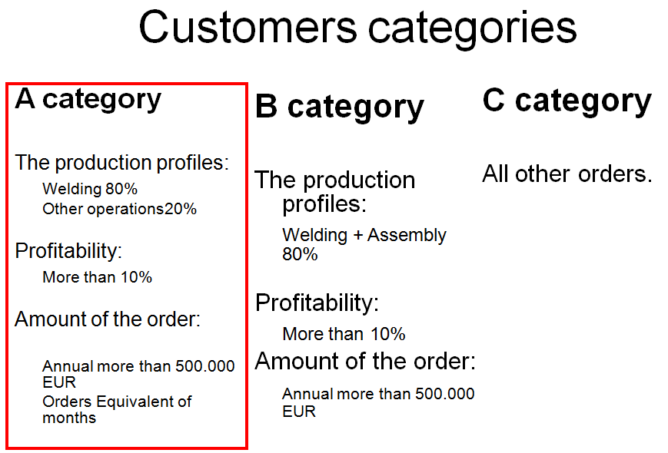
Fig. 26 Customers categories

For the reason clients of A category attracts most of benefit for the company, so i have chosen product of the client of this category. These are orders of concern ABB that are being made in projects. Three products compose one project it is:
Tank;
Conservator;
Cover.
1.2 step – to choose targets. The main reachable target is to be set in this stage There can be very many targets as decrease of manufacturing cycle, to reduce manufacturing residuals, reduce of raw materials, to improve quality of the product and etc..
As we see in model of increase of efficiency of manufacturing 3 offers are given, so we have adopted all these offers. It means:
- Reduce production costs;
- Reduce production cycle;
- Quality improvement.
To reduce production costs we have chosen for reduce of the costs increases profitability automatically..
To reduce production cycle we have chosen for the having higher competitive advantage. For the time of manufacturing of product is one of the most important questions for the client.
To improve the quality we have chosen for product tendered by the client is to be of very high quality for these will be used in high hazard devices.
1.3 Choice of the selection tools. Criteria grounded on which we will choose the product is to be chosen in this stage. For the3 classification of clients into categories has been composed in the company before, this stage has not been necessary to be done.
1.4 Drawing value stream map.
Value stream map is being drawn in this step. For the drawing of the map it is required to have appropriate information for getting which various methods can be used. The dimpliest method has been chosen for implementation of this model, so surveyors have been chosen for collection of the information, between which i have also been. The main information has been collected:
- Chronometry of times of operations means machine and preparative;
- Distance between working centers is being measured;
- The time needed for transmittance of purveyance from one working center to another is being calculated;
- Spageti made trace is being drawn;
- And other.
1.5 Searching weakness. In this step the weakest place has been searched – bottle necks. For this 7 waste tool has been used.
A lot of useless movements have been found. The biggest problem is movement of spageti between working centers for working centers are in big distance between each other. A lot of other wastes have been found, I will discuss them later.

When all 5 steps are implemented in the first stage, than we came over to the 2 stage, where problems are being solved.
2.1 Reduction of weakness. Kaizen team has been composed in this stage as used to solve how would be possible to remove problems or to minimize them. Kaizen team has been divided into three teams that have to make offer separately from each other about possibility of solution with the problems and to write it on leaf. Later all teams have been called and they described own ideas for solving the problems. All ideas have been written on stickers and these have been affixed on the blackboard. Fields with written problems have been marked din the blackboard. Later the best ideas have been chosen by using the Parett‘s rule 80/20.
2.2 7 Waste tool matrix has been also used for solution of the problems. In this step is offered which sort of the problem Lean tool matches the best. Paying attention on the problems raised before the majority of offered tolls has been chosen, as:
- Kanban;
- 5S
- Cell manufacturing;
2.3 Drawing future value stream map. In this step the future map has been drawn. All data has been inserted not like existing, but like planned or foreseen. It is not as easy to plan time as they should be for details to come from one working center to another.
When all 3 steps in the second stage are implemented, than we came over to the 3 stage, where ideas and improvements are being implemented.
3.1 Implementation of new value stream map. The drawn new future value stream map is being put under implementation. This part is the most difficult and this has been done:
working centers have been transmitted;
kanban shelving have been built;
details that have been put into kanban have been manufactured;
quantity of saving raw materials has been reduced.

4.4 Main problems and solutions

4.4.1 Reducing raw material inventory level

Problem:
1) It is difficult to manage the metal accounting. (Create a lot of steel sheets coding number, are many code number now not using);
2) Need more space for storage different code metal sheets.
3) Frozen money;
Offer:
1) Preview all using metal codes to elect the most frequently used, delete unnecessary.
2) If remove all unnecessary steel sheets, will consume less space.
3) Finding suppliers who could set up on consignment warehouse.

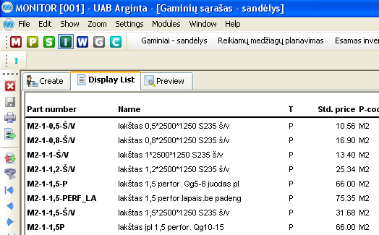
Fig. 27 List of raw in ERP system Monitor
table. 14 List of sheets metal
 | Now | Offer
Steel sheets codes | 151 | Reduce to 70
Stainless steel codes | 160 | Reduce to 50
Steel/Stainless steel bars codes | 324 | Reduce to 170
Steel/Stainless steel bands codes | 311 | Reduce to 150
Steel/Stainless steel tubes codes | 766 | Reduce to 200
Other used profiles codes | 176 | Reduce to 100
Total | 1888 | 740

Total Steel and stainless steel sheets area in stocks are:
New sheets + used sheets = 1795 m² + 567 m² = 2362 m²

If reduce material codes from 311 (151+160) to 130 (70+50), when will used total area :
987 m² it is only 42% from 2362 m²

Total frozen money in warehouse:
In metal sheets: 428,707 Lt.
Total : 500,573 Lt.

If suppliers set up consignment warehouse in Arginta, then we could reduce frozen Arginta metal sheets area, from 1795 m² to 420 m².

Then Arginta can safe money:
1795-420=1375 m².

Average 1 m² = 238 Lt/ m².

1375*238= 327,250 Lt.

Found company which can set up consignment warehouse:
- Be Group;
- Melesta;
- Italinox;

4.4.2 Implementing kanban

In one project consist:

table. 15 Parts in projects
 | Different parts in each project | In each project same parts
Tank | 34 | 13
Cover | 7 | 6
Conservator | 10 | 7

For assemble conservator need 10+7=17 different parts, total time of prepare parts to welding:

table. 16 List of parts in conservator
Part | Time | Unit
KZOKA100A50A02 | 3.18 | 1
KZOKA200A50A02 | 1.776 | 1
KZOKA300A50A02 | 3.324 | 1
KZKAC015248A5703 | 9 | 1
KZKAC015249A5703 | 9 | 1
KZKAC015250A5703 | 8.7 | 1
KZKAE015251A5703 | 4.3 | 2
KZAPL150BSA05 | 49 | 1
KZAPL150BUA03_A | 66 | 1
CZOXM015 | 5.324 | 2
KZAPL95BUA04 | 39.4 | 1
KZKAXY005 | 5.358 | 2
C400006_A | 8.622 | 2
KZKAG015255A5703 | 11.3 | 1
KZKAX003 | 6.144 | 1
KZKAG015256A5703 | 16.83 | 1
KZAPL550BUA02 | 38 | 1
 |  | 80.316
 |  | 223.188

Time for producing parts:
Parts from kanban + other manufactured parts = 80.316+223.188= 303.5min = 5 hours

If checked parts we put to kanban then we could prepare all parts to welding:

223.188 min = 3.72 hours , it is faster on 26.5%

table. 17 List of parts in cover
Part | Time | Unit
KZMK015185A5703 | 70 | 1
KZOKA300A50A02 | 13.71 | 1
KZAPL165BSA02 | 38.648 | 1
015198A5703.01 | 2 | 2
KZAPL165AUA06 | 29.034 | 1
KZMTR015430A5703 | 17.455 | 1
KZMTAF019869A5703 | 2.56 | 1
KZMTAF019871A5703 | 2.66 | 1
CZOXM015 | 5.324 | 4
KZMSAA10A02 | 51 | 1
KZMSAB30A10A04 | 22.393 | 1
C400006_A | 8.622 | 2
KZKAX523 | 8.622 | 1
 |  | 111.872
 |  | 148.102

111.872+148.102=259.97min = 4.33 hours

If checked parts we put to kanban then we could prepare all parts to welding:
148.102 min = 2.468 hours, it faster on 43%.

Tank
174.382+1281.299=1455.68min = 24hours
If checked parts we put to kanban then we could prepare all parts to welding:
174.382min= it faster on 12%.
For all project time: 1455.68+259.97+303.05=2018.7 min
Safe using CANBAN:174.382+148.102+80.316=402.8min
It is 402.8*100/2018.7 = 19.95% faster;

How much cost Kanban?
For one project parts from kanban safe 402.8 min. It's mean that for this parts produce are used 402.8 min = 6.713 hours.
One hour for producing cost 60Lt. (for worker payment, machine depreciation..);
6.713 x 60 =402.8 Lt for one project;
In one week approximately are 4 - 5 project, then:
402.8x5 =2014 Lt/week
For month are: 2014x4= 8056Lt.
For support CANBAN system in moth cost approximately: 500Lt.
But all project are not identical, in some project parts from kanban can be more using or less, then we put safety coefficient - 1.3.

Total frozen money using kanban:
8056*1.3+500=11.000Lt/month.

4.4.3 Reducing Lead Time

To reduce lead time we move some machine in new place:
- Turning machine;
- Milling;
- Drilling;
Change position:

- Bending machine;

- Rolling machine;

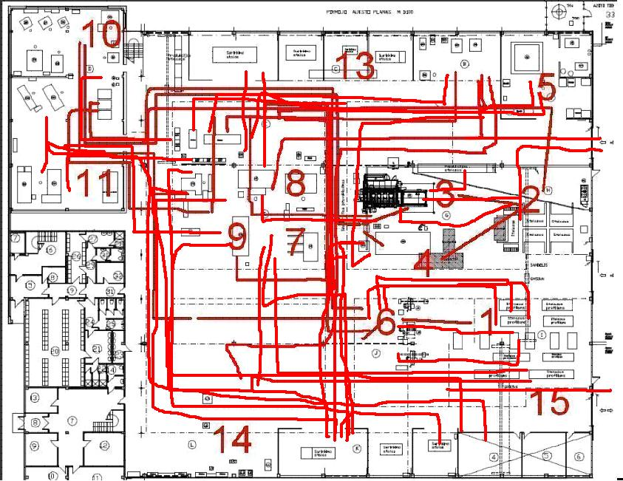
Fig. 28 Spageti diagram of parts moving

Moved some machines to new place:
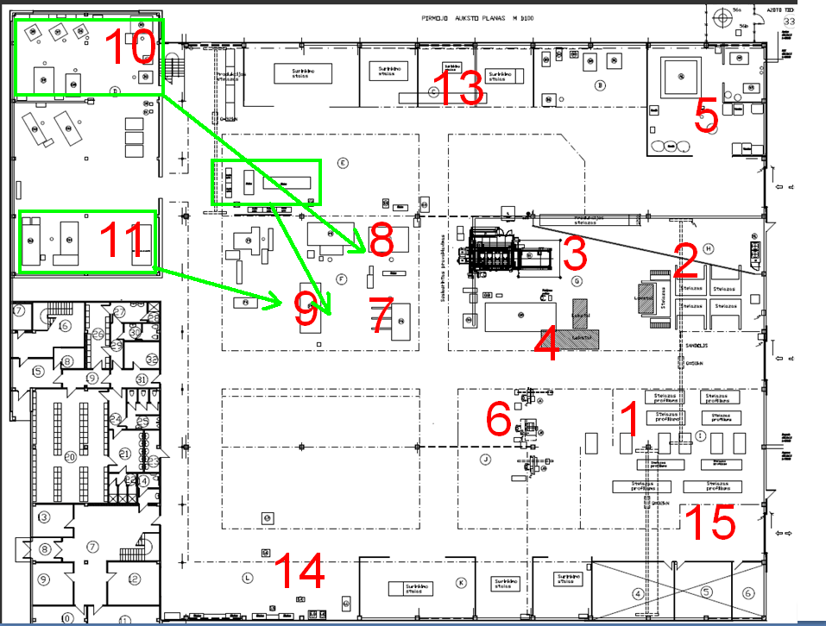
Fig. 29 Moving machines
All machines we put to one place for make stream production. All parts from laser, plasma and saw cutting machines goes to one line, when parts are finished they moved to parts buffer zone.
Some parts don't need finishing then from laser, plasma or saw cutting machine they directly moved to parts buffer.

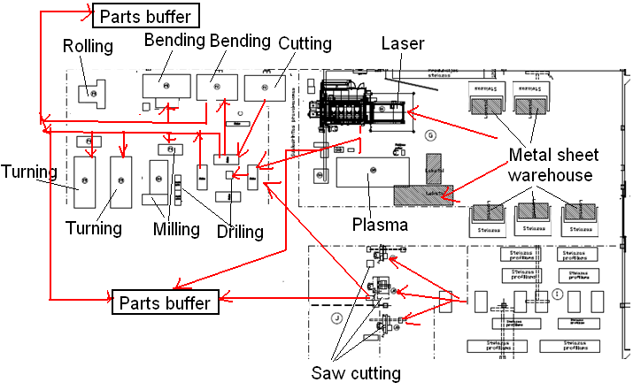
Fig. 30 New layout
Using new map, we reduce time for parts transportation. in old map, the seen that parts moving from one place to another workshop, whole all plant.
When one work center finished their job then part are moved to another workshop until part are finishes. Finished parts are stored in parts buffer. Form buffer all parts moved to Welding place.

With new plan, distance from laser to another work center:

table. 18 Distance between work centers
Work center | Was, meters | Now, meters | Save time, sec
Milling | 43 | 8 | 25
Turning | 38 | 7 | 22
Drilling | 27 | 5 | 16
Rolling | 10 | 9 | 1
Metal sheet warehouse | 12 | 9 | 3

Approximate speed of walking are 5km/h;
Then within one minute's walk the path are:
5000 (m/h) /60 (min)= 83(m/min)
Then save distance:
43-8 =35meters,
Save time:
35*60/83 = 25sec.
During the approximate one sift walking distance are: 10400 metes ~10.4km.
Using new map: 3040 meters;
Save: 7360 meters = 71% less.

If one worker hourly price - 60Lt., then one shift cost 60*8=480Lt.
If reduce walking distance up to 71% then company could save 340Lt/day or 6816Lt/month.

4.5 Curent value stream mapping

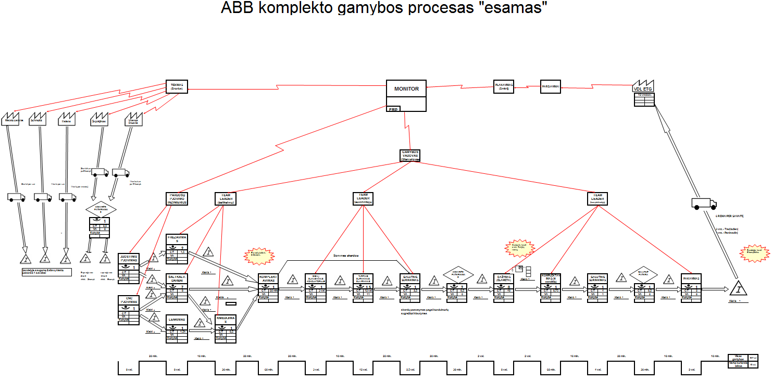
Fig. 31 Curent value stream mapping
4.6 Calculate the cost of improvements and expected results

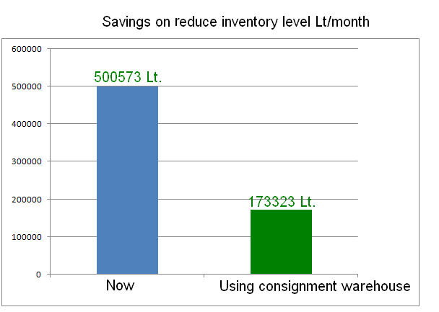
Fig. 32 Savings on reduce inventory level
In the diagrams shown above we can see in first column results that have been before the implementation of model of increase of manufacturing efficiency, and in the second – after the implementation. As we can see, the difference is clearly seen.
After reduction of quantity of storing raw material, it is possible to save from 500.573,00 LTL up to 173.323,00 LTL of frozen finances. This composes only 30% of all frozen finances, and remaining 70% can be used for other targets. In this case, efficiency of usage of finances in storage of raw material would increase by 2, 9 times.
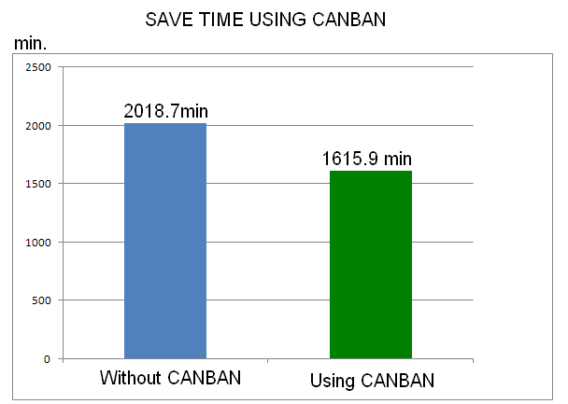
Fig. 33 Saving time using kanban
After using kanban, the cycle of details manufacturing would decrease from 2.018 min. till 1.615 min. It composes 80%, remaining 20% of time would decrease by 20% of manufacturing time. This saving of time can improve competitive advantage, company can also start the next order faster, so it can manufacture more products in shorter time that bring bigger profit.

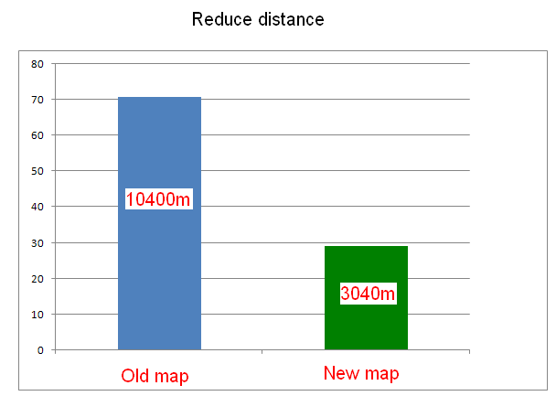
Fig. 34 Reduce distance

As we can see in picture, logist’s day trace in the plant would decrease from 10.400m. till 3.040. it is almost 3,5 times more efficient than before. After saving the trace of logist, it can make other works, so company can save up to 68.16,00 LTL per month. Also the possibility in details missing will become less.
Total: 334.066 Lt/month + 20% reduce time;

Conclusions and suggestions
- After making analysis of scientific – methodic literature in the theme of increase of efficiency of manufacturing I have described the main descriptions. I have analyzed various aspects of manufacturing organization, have deepen into principles of manufacturing possession and analyzed Lean tools choosing principles paying attention on criteria set in the companies. By applying the chosen system I have analyzed models that mostly match specific of the companies in case analyzed by me also the concrete improvable targets. I have analyzed these models in analytical part.
- After choosing the models mostly appropriate for the are of metal manufacturing companies, I have also describes methodic of the choice of the models under which i have chosen the most actual tools from the majority of Lean tools for the improvement of manufacturing process. Having made detail analysis of these chosen models, I have understood that no one is matching sector under my investigation for each has advantages as well as disadvantages.
- In the second part information about surveys of trends of industrial companies’ development is given. I have taken in an account data given by Department of Statistics. After totalizing statistic data, we can see that sector under analysis is acting positively and bettering in Lithuania. Sector is invisible with high variations speaking about activity results. We can find as positive as negative characteristics. Negative would be that being technologic and innovative group of companies should reach higher results than market average in this innovative and novelty time, also paying attention on the fact that foreign sales are increasing. Increase of export would be the positive element for the benefit when companies export is both sided also n sight of country also n the group of companies: Foreign merchandise balance is bettering in country size, and groups of companies becomes more known worldwide, their trade sign is coming stronger, also this is increasing the understanding abroad about well status of the branch they are working in Lithuania, as one can see, meaning time results of group of companies has a trend to improve better than before. So, using this and paying attention on the fact that export is bigger and high technical level products are being exported, companies are constantly to try to improve their activity reaching to stay competitive in global market.
- In the third part model of increase of manufacturing efficiency created by myself is described. Also the model is drawn and divided into installment stages. In each of the stages installment steps included offered tools for their implementation is named. Advantage of the model is that all steps are shown in priority together with offered tools. For i have missed this after analyzing ones suggested by other authors, i have a mind that my model would help much for the beginning companies in installment of Lean.
- Questionnaire has been concluded and sent to the industrial companies. Unfortunately, i have got to less of filled questionnaires back from respondents, so I have chosen three companies that match work area and have questioned them. 84 respondents have been questioned, 23 from UAB " "EMP recycling", 44 from UAB "Arginta" and 17 from UAB "VAE Legetecha". Respondents have been questioned in interview and in questionnaire. Surveys of questionnaire have shown that majority of respondents 37 % Having secondary education and also working in the lowest grid 58 % and only 13% in the high one. Respondents have been asked do they know what Lean is and only 10 % have answered they know it. Having explained what is Lean and about is activity, even 70 % Have answered that having implemented Lean efficiency of manufacturing will really increase. It can be stated from correlative questionnaire analysis that education and knowledge about Lean system is rather clear that as higher education, as much of knowing it. Moreover, one can mention that dependence between duties and Lean can increase the efficiency.
- In the final part i have described all installment of model of increase of manufacturing efficiency in metal manufacturing company "Arginta". Installment of model of increase of manufacturing efficiency has been implemented in 3 stages, as in the model created by myself. Steps and priority has been done as matching the created model, also offered tool for solution have been chosen. Each step that has been implemented solving the problems and suggestions that would help in solving the problems.
- Moreover, situation before installment of model of increase of manufacturing efficiency and after it has been under valuation. It has been calculated time of manufacturing of details composing the product and details repeating in each order have been separated. We have also identified what details are better to put into kanban storage. Knowing details that will be kept in kanban, monetary amount that will be frozen has been calculated. Furthermore, time of manufacturing of the product by taking some details from kanban has been calculated. By using kanban system the saving with each product will be 20 % By saving 20 % Company is able to start other orders and that increases efficiency of manufacturing with 20 % automatically.
- Also understood that problem about frozen money of storage of raw material has been found and solved. Ways of problem solving are given. Value of stored raw material money has been calculated, also area used for storing the raw material. Idea has been offered and implemented – to find suppliers of raw material that could establish consignation type storage. Calculated saving of money after implementation of offers. In such way only 70 % of finances that could take more benefit than laying in face of raw material are being frozen. Having solved the problem of frozen quantity efficiency would increase in 2,9 times.

- Another solid problem is solved, it is transmittance of purveyances and details from one working center into another. After supervisions are done, we have seen that pallets with purveyances and details are getting missed and some working centers are waiting for purveyances for long time. Map of logist‘s moving has been drawn, in this map the chaos of its moving is seen clearly. So, the offers has been made and implemented. Working centers have been repositioned each near to other by composing “U“ form cells by granting the flow of details moving in such a way. Also the distance that would be minimized by repositioning the working centers has been calculated. It comes clear that after implementation of the improvement, it is possible to save 70 % of time for transportation of details. After solving problem of frozen part of raw material, efficiency would increase by 3,5 times.

References

- Sakalas A.; Vanagas P.; Martinkus B.; Neverauskas B.; Prokopčiukas B.; Venskus R. Virvilaitė R. Ivaškienė A. 2000, Pramonės įmonių vadyba. Kauno technologijos universitetas, Kaunas: Technologija. 267 -270.
- Shingō, Shigeo (1989). A Study of the Toyota Production System from an Industrial Engineering Viewpoint. Productivity Press. pp. 228. ISBN 0915299178.
- Tozawa, Bunji; Japan Human Relations Association (1995). The improvement engine: creativity & innovation through employee involvement: the Kaizen teian system. Productivity Press. pp. 34.
- Laraia, Anthony C.; Patricia E. Moody, Robert W. Hall (1999). The Kaizen Blitz: accelerating breakthroughs in productivity and performance. John Wiley and Sons. pp. 26
- Robinson, Harry (1997). "Using Poka-Yoke Techniques for Early Defect Detection"
- Shingo, Shigeo; Andrew P. Dillon (1989). A study of the Toyota production system from an industrial engineering viewpoint. Portland, Oregon: Productivity Press. p. 22
- Heijunka, production leveling through an example, [watch 2010.05.02]. Access via the Internet: http://chohmann.free.fr/lean/heijunka2_us.htm
- Lean Manufacturing Consulting and Training, [watch 2010.05.02]. Access via the Internet: http://www.emsstrategies.com/dm090203article2.html
- Statistical departament, [watch 2010.01.25]. via the Internet: http://db1.stat.gov.lt/
- Coefficient of variation, [watch 2010.02.01]. Access via the Internet: http://www.answers.com/topic/coefficient-of-variation
- Wikipedia, [watch 2010.02.01]. Access via the Internet: http://en.wikipedia.org/wiki/Standard_deviation
- Quick MBA - Knowledge to Power Your Business, [watch 2010.04.01]. Access via the Internet: http://www.quickmba.com/stats/dispersion/
- Wikipedia, [watch 2010.02.01]. Access via the Internet: http://www.wikipedia.org
- Bright, J. E. H., & Hutton, S. (2000). The impact of competences statements on resumes for short-listing decisions International Journal of Selection and Assessment,
- Hough, L. M., & Oswald, F. L. (2000). Personnel selection: looking toward the future—remembering the past. Annual Review of Psychology, 51, 631–664
- I. Zabielavičinė. "Valdymo sprendimai įmonėje". 2001 m. Vilnius. Technika.
- Peter Hines, Nick Rich. "International Journal of Operations & Production Management".1997
- Womack, Jones, Roos; The Machine That Changed The World, Rawson & Associates, New York. Published by Simon & Schuster, 1990.
- Roaring Twenties - The Economy of the 1920s, http://www.spiritus-temporis.com/roaring-twenties/economy-of-the-1920s.html
- B. Martinkus, G. Vaičiūnas, R. Venskus. "Gamybos vadyba". 2000m.
- S. Stoškus, D. Beržinskienė. "Vadyba". 2005m.
- A. Sakalas, P. Vanagas, B. Martinkus. "Pramonės įmonių vadyba" 2000m.
- A. Bargelis. "Gamybos plėtros strategija". 2002m. Kaunas. Technologija.
- Noreen, Eric, Debra Smith, and James T. Mackey. The Theory of Constraints and its Implications for Management Accounting. Great Barrington, MA: The North River Press, 1995.
- Miles L. Techniques of Value Analysis and Wngineering, McGraw-Hill, New York, NY, 1961
- Imai, M., Kaizen: The Key to Japan's Competitive Success, McGraw- Hill, New York, NY, 1986
- Womack, J. and Jones, D., "From lean production to lean enterprise", Harvard Business Review, March-April 1994,pp. 93-103.
- New, C., "The use of througthput efficiency as a key perfomance measure for new manufacturing era", The International Journal of Logistics Management, Vol. 4 No. 2, 1993,pp 95-104.
- Japan Management Association, Kanban: Just in Time and Toyota, Productivity Preem Cambridge, MA, 1985.
- Quarterman, L.; Snyder, B. 2007. The strategos guide to value stream and process mapping: Genesis of manufacturing strategy, Enna products corporation, USA, 46–67.
- Rother, M; Shook, J: 2008. Learning to see: value stream mapping to create value and eliminate muda, One Cambridge center: USA, 3–7.
- Stevenson, W. 1990. Production/Operations managemet, Rochester Institute of technology , Boston: 190–200.
- Blackstone, J. & Cox, J. (2002). APICS Dictionary, 10th Ed., Alexandria, VA: APICS.
- Spear, S., Bowen, H.K. (1999). Decoding the DNA of the Toyota Production system. Harvard Business Review, 77(5), 96-106.
- Shinn, G. S. (2002). 15 Waste Scenarios "An effective change model must be followed in its entirety to ensure efficiency". Quality Progress, 35 (12), 67-73.
- McBride, D. (2003). The 7 Manufacturing Wastes retrieved on June 5, 2009 from http://www.emsstrategies.com/dm090203article2.html
- Ray, B., Ripley, P., Neal, D. (2006). Lean Manufacturing: A Systematic Approach to
  - Improving Productivity in the Prc-cast Concrete Industry. PCI Journal, 51, 62-71.
- Smith, B. (2003). Lean and Six Sigma- A One-Two Punch. Quality Progress, 36(4), 37- 41.
- Lane, G. (2007). Made To Order Lean: Excelling in a High-Mix, Low-Volume Environment. New York, NY: Productivity Press.
- Liker, J. K. (2004). The Toyota Way: 14 Management Principles from the World's Greatest Manufacturer. New York, NY: McGraw-Hill.
- Lovelle, J. (2001). Mapping the Value Stream. IIE Solutions, 33 (2), 26-33.
- Smalley, A. (2004). Creating Level Pull: A lean production-system improvement guide for production-control, operations, and engineering professionals. Brookline, MA: Lean Enterprise Institute.

ANEXES

Annexes
ANKETA

1) Lytis
- Vyras
- Moteris
2) Amžius
- iki 20m
- 20-30m
- 30-40m
- 40-50m
- 50 ir daugiau
3) Išsilavinimas
- Vidurinis
- Profesinis
- Aukštesnysis
- Aukštasis
- Kita
4) Pareigos
- Paprastas darbininkas
- Vidutinės grandies darbininkas
- Aukštesnės grandies darbininkas
- Vadovaujančios pareigos
- Kita
5) Kaip dažnai pasitaiko problemų kai tenka persiorientuoti nuo vieno produkto gamybos, prie kito?
- Dažnai
- Nedažnai
- Kita
6) Ar kylančios problemos yra pasikartojančios ar kiekvienam gaminiui skirtingos?
- Pasikartojančios
- Nuolat skirtingos
- Kita
7) Kaip Jūs labiau norėtumete dirbti:
- Darbas prie to paties proceso su įvairiais produktais;
- Darbas prie to paties gaminio naudojant skirtingas technologines priemones;
- Kita;
8) Ar esate skatinamas spręsti problemas ir siūlyti sprendimo variantus?
- Esu skatinamas
- Nei skatinamas, nei neskatinamas
- Neskatinamas
- Kita
9) Ar žinote kas yra Lean?
- Nieko apie tai nežinau
- Kažka girdėjau
- Tik numanau
- Taip, žinau
10) Ar diegiate Lean'ą?
- Ne
- Planuojame įsidiegti
- Taip
- Įsidiegem
11) Kaip manote ar Lean ir jo įrankių diegimas pakels įmonės gamybos efektyvumą?
- Negali Lean'as pekelti efektyvumo
- Tikriausiai ne
- Manau, kad pakels
- Tikrai esu įsitikinęs, kad pakels
12) Kaip manote kokie yra sunkumai norint įsidiegti Lean?
- Informacijos stoka
- Nėra aišku kaip pradėti
- Dideli kaštai
- Darbuotojų požiuris
13) Ar lengvai atsirenkate tinkamiausius Lean įrankius?
- Ne, nes neaišku kaip atsirinkti
- Ne, nes reikia perskaityti daug literatūros
- Sunku, nes didelė Lean įrankių visuma
- Taip

