MYKOLAS ROMERIS UNIVERSITY

Eglė Malinauskienė

ASSESSMENT OF DYNAMIC ORGANISATIONAL CAPABILITIES FOR INTEROPERABILITY IN CONTEXT OF DIFFERENT E-GOVERNMENT DEVELOPMENT STAGE

Doctoral Dissertation
Social Sciences, Management and Administration (03 S)

Vilnius, 2010
Doctoral Dissertation was prepared in 2006 – 2010 at Mykolas Romeris University.

Supervisor:

Prof. Dr. Rimantas Alfonsas Petrauskas (Mykolas Romeris University, Social Sciences, Management and Administration – 03 S)

Research Consultants:

Assoc. Prof. Dr. Anthony M. Cresswell (State University of New York at Albany (United States of America), Social Sciences, Educational Sciences – 07 S)

Prof. Dr. Sharon S. Dawes (State University of New York at Albany (United States of America), Social Sciences, Management and Administration – 03 S)
CONTENT

Introduction 11
1. E-government interoperability as a key dynamic organisational capability in public sector reform based on information and communication technologies 20
1.1. Evolution of information and communication technologies in the public sector: From silos to cross-organisational e-government systems 20
1.2. Defining e-government interoperability through the lenses of dynamic organisational capabilities theory 23
1.2.1. Approach of dynamic organisational capabilities and its role in the development of complex e-government initiatives 23
1.2.2. E-government interoperability as multidimensional dynamic organisational capability 29
1.3. The role of dynamic organisational capabilities for interoperability in e-government development models 32
1.3.1. Models of e-government evolution in stages 32
1.3.2. Critics of e-government evolution in stages: New generation of process-redesign and e-government interoperability oriented stage models 38
1.3.3. Other approaches to e-government development: Alignment-based maturity and architecture 43
1.3.4. Comparison of e-government development models: An integrated approach to reinforcement of capability for e-government interoperability 47
1.4. Chapter 1 conclusions 54
2. Tools for the development and assessment of dynamic organisational capabilities for e-government interoperability and their context-dependability 57
2.1. National interoperability frameworks and federal enterprise architecture: The main tools in e-government interoperability development process 57
2.2. Toolkit for assessment of dynamic organisational capabilities for e-government interoperability 63
2.3. Impact of context on practices of dynamic organisational capabilities for e-government interoperability 72
2.3.1. Contextualisation of organisational research 72
2.3.2. Context in evolution of dynamic organisational capabilities 74
2.3.3. The role of context in the development of e-government interoperability 80
2.4. Chapter 2 conclusions 91
3. Research on adoption of leading methods for assessment of interoperability capabilities in contexts of different e-government development stage 93
3.1. Methodology for the research on adoption of leading methods for assessment of interoperability capabilities in contexts of different e-government development stage 93
3.1.1. Overview of overall research methodology 93
3.1.2. Procedure for experts’ opinion validation of toolkit for assessment of dynamic capabilities for e-government interoperability in Lithuania 96
3.2. Research results on adoption of the leading methods for assessment of interoperability capabilities in contexts of different e-government development stage 100
3.2.1. Case study of e-government development process in the USA and Lithuania: Comparing invention and design contexts of the leading methods 100
3.2.1.1. Comparative analysis of policies and strategies for e-government development 100
3.2.1.2. Comparative analysis of e-government implementation processes and technologies 103
3.2.1.3. Comparative analysis of assessment techniques and results of e-government development 106
3.2.2. Experts’ validation of dynamic organisational capabilities for interoperability assessment toolkit in Lithuanian context 108
3.2.2.1. Results for environmental level of dimensions of e-government interoperability capabilities 108
3.2.2.2. Results for organisational level of dimensions of interoperability capabilities 115
3.2.2.3. Results for semantics and technological level of dimensions of interoperability capabilities 123
3.2.2.4. Ranking of dimensions of e-government interoperability capabilities 130
3.3. Chapter 3 conclusions 134
4. Recommendations for the integration of leading methods for assessment of dynamic capabilities for interoperability in e-government development process of Lithuania 138
4.1. Adoption of the toolkit for assessment of interoperability for the Lithuanian e-government development process 138
4.2. Recommendations for adoption of modified toolkit for assessment of interoperability to enhance strategic e-government planning process and minimise the risks of e-government initiatives in Lithuania 142
4.3. Integration of the modified toolkit for assessment of interoperability with the common tools of quality and performance management 145
4.4. Chapter 4 conclusions 149
conclusions 150
DINAMINIŲ ORGANIZACIJOS SĄVEIKUMO GEBĖJIMŲ VERTINIMAS SKIRTINGO E. VALDŽIOS IŠSIVYSTYMO LYGIO KONTEKSTE 154
References 174
Appendixes 186
Appendix 1: List of publications 186
Appendix 2: Research questionnaire – Lithuanian version 187
Appendix 3: Research questionnaire – English version 202
Appendix 4: Qualification characteristics of the experts who participated in the research 216
Appendix 5: Actual data for each dimension of e-government interoperability capability at the environmental level 222
Appendix 6: Actual data for each dimension of e-government interoperability capability at the organisational level 229
Appendix 7: Actual data for each dimension of e-government interoperability capability at the semantics and technological level 237
Appendix 8. Actual data for overall ranking of dynamic capabilities for e-government interoperability 247
Appendix 9. Recommended structure of the toolkit for the assessment of e-government interoperability to be used in Lithuanian context 248
Appendix 10. Indicators to be included in CAF from the toolkit for e-government interoperability assessment 251

LIST OF FIGURES

Figure 1. Logical structure of the work 19
Figure 2. Linkage between individual skills, routines, organisational capabilities, and learning 25
Figure 3. The complexity of e-government interoperability phenomena 30
Figure 4. Stages of growth model for fully functional e-government 33
Figure 5. Gartner‘s four phases of e-government model 36
Figure 6. Stage model for the development of citizen-centric e-government 37
Figure 7. Public Sector Process Rebuilding model 39
Figure 8. Growth stages of a joined-up government 41
Figure 9. Stage models of e-government interoperability: Comparing versions of 2008 and 2009 43
Figure 10. Alignment-based maturity model of e-government 45
Figure 11. Framework of e-government architecture 46
Figure 12. Integrated framework for the development of a joined-up government 53
Figure 13. Relationship between enterprise architecture and e-government interoperability 60
Figure 14. Four scenarios for development of e-government interoperability 60
Figure 15. Linkage between enterprise architecture and interoperability framework 61
Figure 16. Development process of e-government interoperability capability assessment toolkit in the context of justice information sharing 66
Figure 17. Structure of e-government interoperability capability assessment toolkit 68
Figure 18. Using the toolkit for the assessment of capabilities for e-government interoperability 69
Figure 19. Evolution of dynamic capabilities as organisational knowledge 76
Figure 20. Framework of microfoundations of dynamic organisational capabilities and business performance 78
Figure 21. Research framework for analysis of e-government strategies in developed and developing countries 83
Figure 22. Technology enactment framework 85
Figure 23. Guidelines for interoperability framework in Lithuania 105
Figure 24. Comparison of the USA and Lithuania rankings in e-government 107
Figure 25. Average rating of environmental level of dynamic capabilities 110
Figure 26. Ratings of indicators in „Leaders & Champions” dimension 111
Figure 27. Ratings of indicators in „Governance” dimension 112
Figure 28. Ratings of indicators in „Collaboration readiness” dimension 113
Figure 29. Ratings of indicators in „Organisational compatibility” dimension 114
Figure 30. Ratings of indicators in „Stakeholders identification and engagement” dimension 115
Figure 31. Average rating of organisational level of dynamic capabilities 117
Figure 32. Ratings of indicators in „Strategic planning” dimension 118
Figure 33. Ratings of indicators in „Performance evaluation” dimension 119
Figure 34. Ratings of indicators in „Project management” dimension 120
Figure 35. Ratings of indicators in „Resource management” dimension 121
Figure 36. Ratings of indicators in „Technology acceptance” dimension 122
Figure 37. Average rating of semantics and technological level of dynamic capabilities 124
Figure 38. Ratings of indicators in „Business model and architecture” dimension 125
Figure 39. Ratings of indicators in „Information policy” dimension 126
Figure 40. Ratings of indicators in „Technology knowledge” dimension 127
Figure 41. Ratings of indicators in „Technology compatibility” dimension 128
Figure 42. Ratings of indicators in „Data assets and requirements” dimension 129
Figure 43. Ratings of indicators in „Secure environment” dimension 130
Figure 44. Ranking results of dynamic capabilities for e-government interoperability 133
Figure 45. Using the assessment of interoperability capabilities in strategic e-government planning in Lithuania 144
Figure 46. Using assessment of capabilities for interoperability to minimise e-government project risks 145
Figure 47. Integration of traditional quality management methods with toolkit for e-government capability assessment 148
48 pav. Loginė darbo struktūra 161
49 pav. Kompleksinis e. valdžios plėtros modelis 164
50 pav. E. valdžios sąveikumo vertinimo įrankio struktūra 165
51 pav. Sąveikumo vertinimo vieta Lietuvos e. valdžios strateginio planavimo procese 169
52 pav. Rekomenduojama sąveikumo vertinimo vieta Lietuvos e. valdžios projektų įgyvendinimo procese 170
53 pav. Sąveikumo vertinimo įrankio integracijos su tradiciniais kokybės vadybos metodais scenarijus 170
Figure 54. The experts‘ level of education 216
Figure 55. Educational background of the experts 216
Figure 56. The experts‘ professional position 217
Figure 57. The experts‘ years of experience in public sector 217
Figure 58. The experts‘ year of experience in current institution 218
Figure 59. The experts‘ experience in other public agencies 218
Figure 60. The experts‘ experience in private sector 219
Figure 61. The experts‘ usage of ICTs solutions at work 219
Figure 62. Improvement of the experts‘ qualification abroad 220
Figure 63. The experts‘ participation in Lithuanian training programs for public servants 220
Figure 64. The experts‘ experience in projects 221

LIST OF TABLES

Table 1. The main aspects of the evolution of ICTs systems development in the public sector 21
Table 2. Comparison of e-government development models 48
Table 3. List of main enterprise architecture frameworks 59
Table 4. Stages of e-government interoperability development 62
Table 5. Dynamic capabilities used in the model of a joined-up government 64
Table 6. Descriptions of dynamic capabilities used in e-government capability assessment toolkit 66
Table 7. Overview of the methods for measurement of the level of dynamic organisational capabilities 70
Table 8. Contextualisation principles used in organisational research and research on dynamic capabilities 79
Table 9. Contextualisation of cross-national research on performance of government IT systems 81
Table 10. Overview of research on impact of context on development of e-government and its interoperability 87
Table 11. Institutional distribution of experts 97
Table 12. Policy and strategy of e-government development in the USA and Lithuania 103
Table 13. E-government implementation processes and technologies in the USA and Lithuania 106
Table 14. Assessment techniques and results of e-government development in the USA and Lithuania 108
Table 15. Ratings of environmental level dynamic capabilities dimensions 109
Table 16. Ratings of organisational level dynamic capabilities dimensions 116
Table 17. Ratings of semantics and technological level dynamic capabilities dimensions 124
Table 18. Distribution of dynamic capabilities for interoperability according to ranking position 131
Table 19. Pearson‘s coefficient of correlation for each dynamic capability of e-government interoperability 139
Table 20. Actual data of knowledge rating of „Leaders and Champions“ dimension 222
Table 21. Actual data of importance rating of „Leaders and Champions“ dimension 222
Table 22. Actual data of presence rating of „Leaders and Champions“ dimension 222
Table 23. Actual data of knowledge rating of „Governance“ dimension 223
Table 24. Actual data of importance rating of „Governance“ dimension 223
Table 25. Actual data of presence rating of „Governance“ dimension 223
Table 26. Actual data of knowledge rating of „Collaboration readiness“ dimension 224
Table 27. Actual data of importance rating of „Collaboration readiness“ dimension 224
Table 28. Actual data of presence rating of „Collaboration readiness“ dimension 225
Table 29. Actual data of knowledge rating of „Organisational compatibility“ dimension 226
Table 30. Actual data of importance rating of „Organisational compatibility“ dimension 226
Table 31. Actual data of presence rating of „Organisational compatibility“ dimension 227
Table 32. Actual data of knowledge rating of „Stakeholders identification and engagement“ dimension 227
Table 33. Actual data of importance rating of „Stakeholders identification and engagement“ dimension 228
Table 34. Actual data of presence rating of „Stakeholders identification and engagement“ dimension 228
Table 35. Actual data of knowledge rating of „Strategic planning“ dimension 229
Table 36. Actual data of importance rating of „Strategic planning“ dimension 229
Table 37. Actual data of presence rating of „Strategic planning“ dimension 229
Table 38. Actual data of knowledge rating of „Performance evaluation“ dimension 230
Table 39. Actual data of importance rating of „Performance evaluation“ dimension 230
Table 40. Actual data of presence rating of „Performance evaluation“ dimension 231
Table 41. Actual data of knowledge rating of „Project management“ dimension 231
Table 42. Actual data of importance rating of „Project management“ dimension 232
Table 43. Actual data of presence rating of „Project management“ dimension 232
Table 44. Actual data of knowledge rating of „Resource management“ dimension 232
Table 45. Actual data of importance rating of „Resource management“ dimension 233
Table 46. Actual data of presence rating of „Resource management“ dimension 234
Table 47. Actual data of knowledge rating of „Technology acceptance“ dimension 234
Table 48. Actual data of importance rating of „Technology acceptance“ dimension 235
Table 49. Actual data of presence rating of „Technology acceptance“ dimension 235
Table 50. Actual data of knowledge rating of „Business model and architecture“ dimension 237
Table 51. Actual data of importance rating of „Business model and architecture“ dimension 237
Table 52. Actual data of presence rating of „Business model and architecture“ dimension 237
Table 53. Actual data of knowledge rating of „Information policy“ dimension 238
Table 54. Actual data of importance rating of „Information policy“ dimension 238
Table 55. Actual data of presence rating of „Information policy“ dimension 239
Table 56. Actual data of knowledge rating of „Technology knowledge“ dimension 239
Table 57. Actual data of importance rating of „Technology knowledge“ dimension 239
Table 58. Actual data of presence rating of „Technology knowledge“ dimension 240
Table 59. Actual data of knowledge rating of „Technology compatibility“ dimension 241
Table 60. Actual data of importance rating of „Technology compatibility“ dimension 241
Table 61. Actual data of presence rating of „Technology compatibility“ dimension 242
Table 62. Actual data of knowledge rating of „Data assets and requirements“ dimension 242
Table 63. Actual data of importance rating of „Data assets and requirements“ dimension 242
Table 64. Actual data of presence rating of „Data assets and requirements“ dimension 243
Table 65. Actual data of knowledge rating of „Secure environment“ dimension 243
Table 66. Actual data of importance rating of „Secure environment“ dimension 244
Table 67. Actual data of presence rating of „Secure environment“ dimension 245
Table 68. Actual data for ranking of dynamic capabilities for interoperability 247
Table 69. Dynamic capabilities and their indicators to be used in Lithuania for e-government interoperability assessment 248
Table 70. Indicators to be included in CAF from e-government interoperability assessment toolkit 251

LIST OF TERMS

- Dynamic capability is the capacity of an organisation to purposefully create, extend, or modify its resource base (Constance E. Helfat et al., 2007).
- Electronic government (e-government) is the use of information and communication technologies in public administration combined with organisational change and new skills in order to improve public services and democratic processes and to strengthen support to public policies” (European Commission, 2003).
- E-government interoperability is the ability of disparate and diverse organisations to interact towards mutually beneficial and agreed common goals, involving the sharing of information and knowledge between the organizations via the business processes they support, by means of the exchange of data between their respective information and communication technology (ICT) systems” (European Communities, 2008). It is dynamic, multidimensional, and context-dependant organisational capability (T. A. Pardo & G. B. Burke, 2008a) of purposeful creation, extension, and modification of organisation’s resource base in order to successfully implement e-government initiatives.
- Integration is permanent or temporary formation of larger assembly of government units to merge business processes and/ or information sharing (Gottschalk & Solli-Saether, 2008).
- Organisational capability is appropriate knowledge, experience, and skills that are possessed by organisation in the form of routines and that make it able to perform a particular task or activity leading to the intended outcomes.
- Operational capability is organisational capability that enable organisation to earn a living in a present (Constance E. Helfat et al., 2007).
- Routine is repetitive pattern of activity in an entire organisation, or, as an adjective, the smooth uneventful effectiveness of such organisational performance (adopted from (R. R. Nelson & S. G. Winter, 1982).
LIST OF ABBREVIATIONS

- CAF – Common Assessment Framework
- CIO – Chief Information Officer
- CMM – Capability Maturity Model
- CRM – Customer Relationship Management
- EIF – European Interoperability Framework
- ICTs – Information and Communication Technologies
- IT – Information Technology
- ISO – International Organisation for Standardisation
- NEA – National Enterprise Architecture
- NIFO – National e-government Interoperability Framework
- NPM – New Public Management
- PMIS – Public Management Information Systems
Introduction
Relevance of the topic. Electronic government (e-government) is understood as the use of information and communication technologies (ICTs) in the public sector oriented towards its qualitative transformation through organisational change and development of new skills leading to improved public services and strengthened democratic processes (European Commission, 2003). In Lithuania as well as worldwide there are many ongoing e-government projects, varying from traditional electronic public services development to ambitious and complex ICTs based initiatives that are aimed at sufficient changes in government’s back-office structure and processes. These projects are considered successful if they are completed on time and within budget, reached their goals, were positively assessed by all stakeholders, and are actively used. However, according to the existing statistics only 15% of all such projects are considered successful, meanwhile the other 50% are partial failures, and 35% – total failures (Heeks, 2006). The reason is that traditionally all the attention is concentrated on the technological factors, whereas in the projects of this kind environmental and organisational factors are the critical ones. Such factors as legal regulation, unfavourable organisational culture, inflexible processes as well as the lack of leadership and conflicting interests of stakeholders are extraordinarily important in this context.
Usually, diverse public sector organisations participate in the implementation of contemporary e-government solutions, and this poses certain requirements for the interoperability of their business processes and ICTs systems. Therefore significance of new organisational capability for e-government interoperability is increasingly emphasized in many countries, and is gradually becoming a bottom line for establishing a new strategy for e-government development (European Commission, PEGSCO, 2009; Lallana, 2008; Ministerial declaration, 2009; Pardo & Burke, 2008a; United Nations, 2010). Interoperability starts inside the public sector organisation as the ability of its own subdivisions effectively interact with each other in the collective actions, and then extends outside the organisational boundaries in collaboration with other institutions on the national as well as international level. E-government interoperability makes it possible for public servants to access and use information gathered from various sources, fosters transformation in delivery of public services, increases effectiveness of public administration, and leads to the stable and viable development of economy (Pardo & Burke, 2008a, 2008b).
For this research, e-government interoperability is defined as the dynamic organisational capability to create and modify existing resources in order to successfully implement e-government initiatives through necessary changes (Cresswell, Pardo, & Canestraro, 2008). Capability is also multidimensional, consisting of various organisational capabilities which shortage is identified among major risks of e-government projects (ibid). Finally, e-government interoperability is context-dependant (ibid), and the success of e-government initiatives in the public sector of different countries might depend on different organisational capabilities.
Paradoxically, e-government projects aim to create a joined-up government, but can be successful only if participating public sector organisations already are at a certain level of interoperability that helps to establish close collaboration and effective information sharing among all project members. If the level of interoperability is insufficient, the risk of e-government project failure increases dramatically. So, development and assessment of e-government interoperability are last but not least means to mitigate project risks.
This is why it is important to learn how to assess interoperability in the implementation of e-government projects. Before initiating any e-government project it is necessary to identify the most important dimensions of dynamic capabilities, assess their level using appropriate indicators, and determine what is possible and what is not in the organisation with certain level of dynamic capabilities for interoperability. The purpose of this assessment is to find out the best way how to gain the necessary dynamic capabilities and to decide what part of available resources should be invested in the initiated project, and what part in the development of lacking capabilities.
Thereto researchers are searching for the relevant tools, and there are already some results of practical value in leading e-government countries. Analysis and evaluation of the possibilities to adopt these tools in countries where e-government development process is not settled yet and the context of formal tools application is less mature could speed-up their progress in e-government development.

Thus the research problem of this work is: How leading methods applied for assessment of e-government interoperability can be adopted in the context of countries in earlier stage of e-government development process?

Research object is the structure, functionality and adaptability of the toolkit that is used in leading e-government practices for assessment of capability for information sharing and interoperability.

Review of the research literature. The scientific literature related to the posed research problem can be divided into the several categories: The theory of dynamic organisational capabilities, research of e-government development process models, studies on e-government interoperability development and assessment tools, and analysis of the impact of context on the transferability of best practices in e-government and e-government interoperability development.
Theory of dynamic organisational capabilities is mainly developed by such researchers as S. G. Winter, D. J. Teece, G. Pisano, C. E. Helfat, and K. M. Eisenhardt. The dynamic capabilities approach has been applied by M. Janssen and B. Klievink in the research of e-government development process models, but other researchers (Layne and Lee, Hiller and Belanger, Wescott, Andersen and Henriksen, Davison, Gottschalk, and others) still exclude this perspective.
As e-government interoperability is increasingly recognized as one of the most critical success factors in the development of e-government, many researchers tend to analyse the tools that might enhance its development including L. Guijarro, Y. Charalabidis, M. Janssen, K. Hjort-Madsen. However, the research of e-government interoperability as dynamic organisational capability is only developing. It has been introduced by A. M. Cresswell, S. S. Dawes, T. A. Pardo, and others. These scholars have also proposed a comprehensive toolkit for the assessment of dynamic capabilities depicting e-government interoperability that is currently the only leading method available for this purpose.
Though the importance of context in transfer of e-government best practices is gradually admitted (e. g. by R. Heeks, P. Dunleavy, J. Fountain), its impact on the adoption of leading methods for e-government interoperability development was analysed only by K. Hjort-Madsen. The level of adaptability of the aforementioned toolkit for the assessment of e-government interoperability also has not been explored in other than its invention context yet.
In Lithuania R. Petrauskas, A. Augustinaitis, V. Rudzkienė, N. K. Paliulis, E. Chlivickas, R. Gatautis, A. Kaziliūnas, B. Melnikas, N. Jurkėnaitė, T. Limba have provided a valuable input into the research of e-government. They have studied e-government development policies and ongoing initiatives, tried to identify the main problems and challenges that are faced by e-government managers, and proposed possible e-government development models and scenarios for Lithuania. E-government interoperability in more detail was addressed by R. Gatautis and B. Kulvietis who have formulated the guidelines for Lithuanian e-government interoperability framework. Nonetheless, the lenses of dynamic organisational capabilities theory are still new for the e-government and its interoperability research in Lithuania as well as the in-depth studies of the take-up of respective leading methods in Lithuanian context.
Transferability and adoption of common management methods in Lithuanian public sector are broadly analysed by S. Puškorius, A. Guogis, A. Kaziliūnas, V. Domarkas, A. Raipa, T. Sudnickas, D. Gudelis, R. Vanagas, and others. However, these issues are not addressed particularly in the field of e-government as well as possible integration of traditional management methods with the methods specific for e-government.

Research aim is to analyse the role of leading methods applied for assessment of interoperability in a progressive e-government development process, and to provide the recommendations for their adoption in the context of Lithuania.

Research goals are:
- Examine the role of government interoperability in technologically enhanced public sector reform, and identify the main components of a progressive interoperable e-government development process.
- Analyse the leading methods applied for the development and assessment of e-government interoperability, and determine possible idiosyncrasies of their adoption in countries with different e-government development stage.
- Research the feasibility of adoption of leading methods applied for assessment of capabilities for e-government interoperability in contexts of different e-government development stage:
  - Carry out a case study of e-government development process in two countries (the USA and Lithuania).
  - Validate the structure, functionality and adaptability of the toolkit for the assessment of dynamic organisational capabilities for e-government interoperability in Lithuanian context.
- Based on theoretical and empirical evidence provide the recommendations how leading methods applied for assessment of interoperability could be adopted in Lithuanian e-government development process.

Originality of the research. Current research tends to scrutinize one particular aspect of e-government development, and usually does not aim to offer an integrated approach that would include all the components that were proved to be important in this process, such as strategy, processes, technologies, performance measurement, and organisational capabilities needed. Though e-government interoperability is gradually been recognized by the researchers as a critical dynamic organisational capability in e-government development, but these two research themes are still analysed separately from each other, the main focus still being on the instrumental part of the phenomenon. It usually leads to the analysis of individual skills of public servants important for e-government development, instead of examining how their individual knowledge combined into organisational collectively perform in e-government initiatives. Therefore, based on the extensive analysis of contemporary e-government development models and management methods used for their implementation, an integrated framework for the strategic planning, implementation, and research of e-government, grounded on the approach of dynamic organisational capabilities for interoperability and their assessment was proposed in this work.
Other original feature of this study is the focus on the adaptability of leading e-government development methods in the context of countries that are in the earlier e-government development process stage. Until now Lithuanian and researchers from other countries have infrequently addressed the issues related to the transfer of e-government best practices from mature into less mature settings. This research has examined how available leading methods for assessment of e-government interoperability capabilities can be adopted in the context of Lithuania. The toolkit for assessment of e-government interoperability developed by the USA researchers (Cresswell, Pardo, Canestraro, Dawes, & Juraga, 2005) served as the foundation for the whole research.
First of all, this toolkit has been applied as a part of the research method, and was used to develop the instrument for the assessment of perception, significance, and level of practice of dynamic organisational capabilities depicting e-government interoperability in a particular country. The toolkit was originally enhanced to be appropriate not only to measure the level of dynamic capabilities for e-government interoperability, but also to determine how e-government interoperability as dynamic capability is perceived by e-government experts in a particular country.
Secondly, based on the theoretical analysis and empirical data the structure of the toolkit was modified to meet the needs of current e-government development process in Lithuania, and foster its more rapid progress. The adopted structure of the toolkit is focused on the assessment of those dynamic capabilities for e-government interoperability whose ratings showed strong and significant correlation between experts’ knowledge, their perception of the importance and presence of a particular dynamic capability. Integrated usage of the research instrument proposed by this work as well as the modified structure of the toolkit for the development of core dynamic capabilities for e-government interoperability in Lithuania can foster the emergence of other capabilities that were proved as currently not applicable in Lithuanian context.
Thirdly, primal version of the toolkit has been used and researched only in the context of several e-government initiatives in the USA (Cresswell et al., 2008). In this work the possibilities to apply originally modified toolkit not only on the organisational, but also on the national level of e-government strategic planning and coordination were researched.
Finally, this work provides recommendations not only for the adoption of the developed research instrument and modified version of the toolkit for the assessment of e-government interoperability in Lithuania, but also recommendations for their integration with some other common performance and quality management methods. Practical application of these recommendations can be helpful in reducing the existing gap between strategic planning of public management development and e-government initiatives. Until now neither foreign, nor Lithuanian researchers haven’t addressed this issue. This proves existence of valuable results in this work not only for the domain of e-government, but also for the whole domain of public administration research and practice.

Research methodology. Research of this work has used general and empirical research methods and principles. General research methods include systemic analysis, deduction, comparative analysis, and generalisation. Two kinds of qualitative empirical research methods were used in this work: A case study and experts’ opinion assessment method.
Method of systemic analysis along with the comparative analysis and generalisation were used to establish a theoretical foundation for the overall research. They served in the characterisation of e-government interoperability as dynamic organisational capability phenomenon, identification of the main components of integrated e-government development process, classification of leading methods applied in e-government interoperability development and assessment, and determining the factors that might impact the adoption of these leading methods in different than their invention contexts.
Deduction was used to derive the main and additional research hypothesis from the analysis of the theory along with the major concepts and variables used in the empirical part of the study that was based on a case study and experts’ opinion assessment methods. The case study was conducted combining the methods of content analysis and participant observation. It aimed to examine e-government development process in the USA and Lithuania, and identify e-government development process stage in which each country is present. Experts’ opinion assessment method using multi-variant design was used to research how leading methods available for the assessment of e-government interoperability might be adopted in the context of Lithuania.
Empirical research data were analysed, and the conclusions and recommendations were made using the methods of mathematical statistics, comparative analysis, and generalisation. The principle of triangulation when the evidence is supported through various data sources and research methods was used to avoid research bias and shortages of one particular research method.

Work outcomes can be split into theoretical and practical results. Theoretical research results are:
- Characterisation of e-government interoperability as a dynamic organisational capability phenomenon through identification of its underlying principles, dimensions, development directions, and boundaries.
- Integrated framework for the strategic planning, implementation, and research of e-government, based on the approach of dynamic organisational capabilities and their assessment.
- Classification of the leading methods for e-government interoperability development and assessment.
- Identification of the factors that might have an impact on the adaptability of available leading methods for the assessment of e-government interoperability in different than their invention contexts.

Practical research results are:
- Research instrument for the assessment of perception, significance, and level of practice of dynamic organisational capabilities depicting e-government interoperability in a particular country.
- The modified version of the toolkit for the assessment of e-government interoperability that was developed and used in the USA, which meets the potential and needs of current e-government development process stage in Lithuania.
- Recommendations on how the developed research instrument and modified version of the toolkit for the assessment of e-government interoperability could be:
  - Applied in the strategic e-government development planning process in Lithuania, and minimise the risks of national e-government initiatives.
  - Integrated with some traditional quality and performance management methods to foster interoperability as an underlying value leading to transparent, effective, results and citizens oriented public administration in Lithuania.

Structure of the dissertation. The dissertation consists from introduction, four chapters, conclusions, reference list, dissertation’s summary in Lithuanian language, and appendixes. The overall logic of the work is shown in Figure 1 below where the structure of the main parts of the work is represented by the rounded rectangles, and the arrows indicates the relationships between each part of the work in terms of the input that each part provides to the other.
In introduction relevance and originality of the work are discussed, research aim and objectives are formulated, and a short overview of the methodology is given.
Chapter 1 aims to analyse the alterations in approaches towards information and communication technologies in public sector, and provide definitions of main concepts used in this work like dynamic organisational capabilities, e-government, and e-government interoperability. The place of interoperability as a dynamic organisational capability in contemporary e-government development models is examined by this part of the work. It ends-up with the propositions for an integrated approach to reinforcement of e-government in overall public sector reform.
Chapter 2 is dedicated to the analysis of interoperable government development tools like governance of information and communication technologies, national interoperability frameworks, and enterprise architecture. Leading method for assessment of e-government interoperability capabilities are studied in this chapter along with different factors that might have an impact on its adoption in different than invention context.
Chapter 3 provides a detailed description of the research methodology, and then presents the research results. First of all, a case study of e-government development process in the USA and Lithuania is presented. It identifies the discrepancies between these two countries in perceptions of e-government and its interoperability, existing elements and tools of e-government development, and actual results of the process. The last part of this chapter is dedicated for the results of experts’ opinion assessment research which validates the assessment toolkit for e-government capabilities in Lithuanian context. It reveals how Lithuanian experts perceive and rank the dimensions depicting capabilities for e-government interoperability that were found important in the USA.
Chapter 4 presents the recommendations for adoption of leading methods for assessment of e-government interoperability capabilities in the context of Lithuania as a country with less matured technological enforcement of democracy. The recommendations are formulated on the foundation of theoretical and empirical results of the work.
Finally, the conclusions concentrically summarise both theoretical and practical outcomes of the work.

Publication of the research results. Author has published 11 papers related to the topic of her dissertation: two chapters in the monograph by Lithuanian researchers, two chapters in the international monograph, four papers in scientific journals (two in Lithuanian and two in foreign journals), and three conference proceedings papers. Full list of publications is provided in Appendix 1.
INTRODUCTION
CONCLUSIONS
1. Development trends, definitions, and elements of progressive e-government development
2. Tools for e-government development and assessment, important contextual factors
1.1. Evolution of ICTs in public sector: from silos to cross-organisational e-government systems
1.2. Defining e-government interoperability through lenses of dynamic organisational capabilities theory
1.3. Role of dynamic organisational capabilities for interoperability in e-government development models
1. E-GOVERNMENT INTEROPERABILITY AS A KEY DYNAMIC
ORGANISATIONAL CAPABILITY IN PUBLIC SECTOR REFORM BASED ON ICTs
2.1. National interoperability frameworks and federal enterprise architecture: main tools in e-government interoperability development
2.2. Toolkit for assessment of dynamic organisational capabilities for e-government interoperability
2.3. Impact of context on practices of dynamic organisational capabilities for e-government interoperability
2. TOOLS FOR DEVELOPMENT AND ASSESSMENT OF DYNAMIC
ORGANISATIONAL CAPABILITIES FOR E-GOVERNMENT INTEROPERABILITY
AND THEIR CONTEXT-DEPENDABILITY
3.1. Methodology for the research on adoption of leading methods for assessment of interoperability capabilities in contexts of different e-government development stage
3.2. Research results on adoption of leading methods for assessment of interoperability capabilities in contexts of different e-government development stage
3. RESEARCH ON ADOPTION OF LEADING METHODS FOR ASSESSMENT
OF INTEROPERABILITY CAPABILITIES IN CONTEXTS OF DIFFERENT
E-GOVERNMENT DEVELOPMENT STAGE
Case study of the USA and Lithuania e-government development process
Experts‘ validation of toolkit for assessment of e-government interoperability
Research instruments
4.1. Adoption of leading methods structure and features to minimise e-government project risks
4.2. Integration of leading methods in strategic e-government planning process
4.3. Integration of leading methods with common tools of quality management
4. RECOMMENDATIONS FOR THE INTEGRATION OF LEADING METHODS FOR ASSESSMENT OF DYNAMIC CAPABILITIES FOR INTEROPERABILITY IN E-GOVERNMENT DEVELOPMENT PROCESS OF LITHUANIA
3. Research results
Figure 1. Logical structure of the work
Source: Composed by the author
- E-government interoperability as a key dynamic organisational capability in public sector reform based on information and communication technologies
Development and adoption of information and communication technologies (ICTs) are still more analysed from the perspective of private sector organisations. However, such benefits as effectiveness, efficiency, reduction of operational costs, or increased quality of decision-making are crucial for modern governments facing the challenges of various crises. It enforces to pay more attention towards the issues of ICTs development in the public sector which changed tremendously during the last two decades.
Currently more than ever there is a need for ICTs solutions that would support collaboration of public sector organisations on national as well as international level, and that would capacitate more citizen oriented service provision and decision-making in government. Yet the development of such ICTs systems requires many political, legal, organisational, semantics, and technological changes and innovations. Lack of dynamic capabilities to identify, promote and implement these changes within the boundaries of existing resources often becomes a serious obstacle for more rapid progress of this domain.

  - Evolution of information and communication technologies in the public sector: From silos to cross-organisational e-government systems
Information and communication technologies (ICTs) have been used in the public sector for several decades already (Kraemer & King, 2003; Rocheleau, 2006) their role and the complexity of development issues changing over time with the rise of new generation technologies offering novel possibilities for their application (see Table 1). Firstly, public management information systems (PMIS) were developed to automate and support highly transactional routine back-office services (e. g. financial management, accounting, documents’ storage/ retrieval, management control and evaluation, etc.) using mainframe systems (till 1980s), that were later on supplemented with the applications for personal computers and local area networks (starting from 1980s) with the aim to reduce paperwork and increase the internal efficiency and effectiveness of public managers (Yildiz, 2007; Dawes, 2008). Software applications have been designed and developed in the manner of “stovepipe” or “silos” to meet the needs of one single public agency in one particular functional area till the first attempts of their integration aiming to support the decision-making based on the data from different sources of information (ibid, (Weske, 2009). Business and ICTs development goals, mission and timetables were usually unsynchronised and poorly aligned (Tillmann, 2008). ICTs related decisions were taken either by the central information technology (IT) department using the centralised approach or by the individual organisational departments using the decentralised approach to overall IT governance due to the weak communication between IT staff and other units of the public agency (Heeks, 2006).
Table 1. The main aspects of the evolution of ICTs systems development in the public sector
Era and timeframe | Public management information systems | Public management information systems | E-government
Era and timeframe | Till 1980s | 1980s – 1990s | 1990s till now
Type of ICTs | - Mainframes | - Personal computers  - Local area networks | - Internet  - Electronic document interchange  - Mobile computing  - Digital television
Goals of ICTs development and usage in public sector | - Support and automate highly transactional routine back-office services | - Reduce paperwork  - Increased internal efficiency and effectiveness of public managers | - 24x7 availability of public services online  - Increased effectiveness and efficiency of public sector  - Redesign of business processes  - Reduction of red-tape  - Increased revenue growth  - Reduced costs of public administration  - Increased accountability and transparency  - Transformed relationships with citizens, businesses, and government itself
Level of integration | None  - Applications are developed in „stovepipe“ or „silos“ | Low  - Different information systems are integrated to support decision-making based on data from different sources | High  - Integration of information systems owned by different public agencies to support sectoral and cross-sectoral decision-making  - Development of one-stop shop portals
Level of interoperability needed | None  - Information systems are developed independently by public agencies and their own departments | Low  - Development of ICTs solutions is performed by each public agency independently, but requires interoperability between its own departments  - Mostly requires technological interoperability | High  - Diverse public agencies participate in the development and usage of the same ICTs solutions  - Requires technological as well as political, legal, and organisational interoperability  - Interoperability on national and international basis
Source: Composed by the author
The initial problems of systems’ integration, and ICTs and business alignment gained completely different character and importance with the introduction of the Internet in 1990s and worldwide start-up of public sector reforms with the ICTs usage as central foci that gradually was started to be called as electronic government (e-government). Up-to date analysis of the research perspectives and themes dominating in the field of e-government shows that it has been frequently conceptualised as the usage of Internet and other Web technologies for the access and delivery of public services online with the 24x7 availability at the official websites of public institutions or national one-stop shop portals (Codagnone & Wimmer, 2007; Scholl, 2007; Yildiz, 2007). This approach has led to tangible quantitative outcomes as many public institutions became present online and started to provide some of their services fully or partially via the Internet. The greatest progress was reached in the taxation and social security sectors that have taken an advantage and built their e-government systems on the basis of well-developed legacy infrastructure of PMIS (Dunleavy, Margetts, Bastow, & Tinkler, 2008; Scholl, 2006).
However, transition from the agency-oriented to the process-oriented delivery of public services via one-stop shop e-government portals in most countries is still at its infancy phase as well as achievement of qualitative goals like effectiveness, efficiency, redesign of business processes, reduction of red-tape, accountability and transparency, customer/citizen focus. All these issues were mostly accumulated from the New Public Management (NPM) movement making e-government as a main tool for their implementation and sometimes even indicate the emergence of a new paradigm for reinvention of the public sector (Navarra & Cornford, 2007; Schedler & Scharf, 2001; Dunleavy, Margetts, Bastow, & Tinkler, 2006). Hence e-government came to be perceived in a wider sense than merely the delivery of electronic public services. It is defined as a mean to “achieve better government” (OECD, 2005), assist effectiveness and efficiency (Pacific Council on International Policy, Working Group on eGovernment in the Developing World, 2002), acquire transparency, increase revenue growth, reduce costs of public administration, transform relationships with citizens, businesses, and government (Gartner Group, 2000; World Bank, 2009). Existing definitions of e-government sometimes are criticised for the strong focus on the Internet excluding other important technologies like mobile computing, digital television, telephones, electronic document exchange (Andersen & Henriksen, 2005), though some of the above analysed definitions (Gartner Group, 2000; OECD, 2005; Pacific Council on International Policy, Working Group on eGovernment in the Developing World, 2002; World Bank, 2009) determine e-government as the usage of all types of ICTs and media in the public sector.
In the dissertation definition of e-government proposed by the European Commission is used as it provides one of the most holistic characterisation of e-government as “the use of information and communication technologies in public administration combined with organisational change and new skills in order to improve public services and democratic processes and to strengthen support to public policies” (European Commission, 2003). By this definition e-government is not limited to one particular type of technology, and aims not just to improve public services, but also to enhance the democratic processes and to increase public trust in policy-making through the organisational change and development of new skills. The emphasis of “new skills” can be considered as the fundamental feature of this definition because competencies of individual public servants as well as of overall public sector organisations play an important role in the breakthrough of e-government initiatives.
Due to the changed development goals and issues of ICTs in the public sector, importance of new skills is emphasized in many research studies on the success and failure factors of e-government. E-government systems are distinguished as cross-organisational growing systems because usually they are not off-the-shelf solutions that can be simply acquired, installed and used, but those that require original analysis, design, implementation, continuous improvements and integration with other systems and processes within and outside the boundaries of organisation (Lee & Kim, 2007). E-government systems are also strongly dependant on the organisational and institutional contexts. They have not only to be consistent with a number of legal regulations and laws, but also be aligned with the needs and requirements of a variety of stakeholders residing in different institutions with diverse missions, goals, political interests, cultures and individual attitudes (Gil-Garcıa & Helbig, 2007; Gil-Garcıa & Pardo, 2005; Ebrahim & Irani, 2005).

  - Defining e-government interoperability through the lenses of dynamic organisational capabilities theory
    - Approach of dynamic organisational capabilities and its role in the development of complex e-government initiatives
Cross-organisational nature, high level of integrity and context dependence of e-government require from public institutions not only to improve their IT knowledge and skills but also to develop new organisational capabilities of collaboration, organisational compatibility and leadership in such fields as policy making, strategic planning, project management, finance and investment planning, resource management, performance evaluation (Gil-Garcıa & Helbig, 2007; Andersen, 2006; Lam, 2005). The statistics about the success and failure rates of e-government projects (OECD, 2001; Heeks, 2006) indicates that only 15 percent are successful, other being either total (35 percent) or partial failures (50 percent). These numbers lead to the considerations that government organisations not only lack abilities to work together in order to fulfil their mission and reach common goals, but also lack the ability to implement ICTs projects that would equip them with more powerful tools in doing so. For this reason, more concentrated analysis of what constitutes organisational capability and what might be its role in the implementation of complex e-government initiatives can provide us with the new insights about the organisation of e-government development. We can shift the strategic question from “What kind of e-government solutions do we need or have to develop in the nearest future?” to “How do we develop e-government solutions and what do we have and lack in order to be successful?” We can use the dynamic organisational capabilities approach that offers answers to why other organisations or even countries do well when we still struggle in this field (David J. Teece, 2009).
Term of “organisational capabilities” along with their own specific traits encompass the semantics of such concepts as individual skills, routines, or competence, and should not be used interchangeably as it is the case in the current literature sometimes (Dosi, Richard R. Nelson, & Sidney G. Winter, 2000). Seeking to avoid the ambiguity in terminology, clear boundaries have to be drawn between these different although similar concepts.
The linkage between individual skills, routines, and organisational capabilities is shown in Figure 2 that is presented a few sections bellow. In general, this research considers organisational capability to be manifest in knowing how to transform the initial intentions into concrete actions which then lead to the desired outcomes (Dosi et al., 2000). Currently organisational capability is defined as organisation’s “ability to perform a particular task or activity” (Constance E. Helfat et al., 2007), and originally was used by Richardson (Dosi et al., 2000) who defined it as “appropriate knowledge, experience, and skills” that determine organisation’s specialisation in actions when seeking competitive advantage (G. B. Richardson, 1972).
The definitions above do not clearly separate individual and collective knowledge, experience, and skills which is important to make in the context of organisational capabilities. This distinction can be achieved through the introduction of another term of organisational routine. Actually, individual knowledge, experience, and skills are a building block of routines (see Figure 2 bellow). Routine was made as a central element of the analysis of organisational and economic change by Nelson and Winter who proposed the theory of evolutionary economics (Becker, 2004; R. R. Nelson & S. G. Winter, 1982). Routines were compared with the computer program and referred to “repetitive pattern of activity in an entire organisation, to an individual skill, or, as an adjective, to the smooth uneventful effectiveness of such organisational or individual performance” (R. R. Nelson & S. G. Winter, 1982, p. 97). As genes are important element in surviving natural selection in Darwin’s theory of evolution, the same are routines for organisations in theory of evolutionary economics – they are genes of organisations, organisational memory where all knowledge reside, and management of activities’ routinisation is the way for organisations to survive in changing environment (ibid).
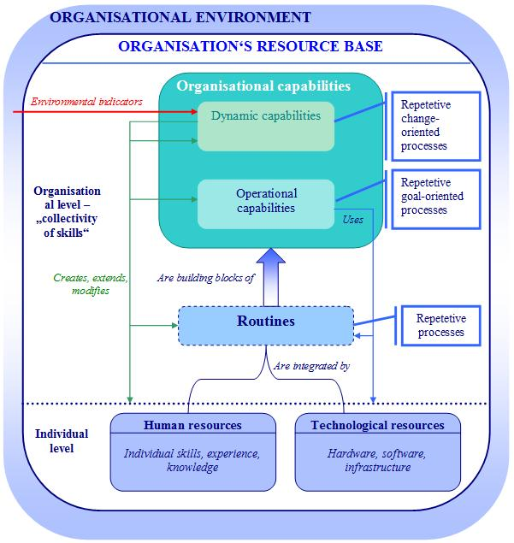
Figure 2. Linkage between individual skills, routines, organisational capabilities, and learning
Source: Composed by the author
Though in the initial definition of routine it was considered organisational as well as individual repetitive skill, almost two decades later the authors have suggested treating it merely as “skills of an organisation”, and, as it is shown in Figure 2 above, a tool to coordinate and integrate individual knowledge, experience, and skills into the “collectivity of skills” (Dosi et al., 2000). So, this work uses slightly modified original definition of routine, and explains it as repetitive pattern of activity in an entire organisation, or, as an adjective, the smooth uneventful effectiveness of such organisational performance.
It is worth emphasizing that some routines can be considered as being organisational capabilities if they are not only repetitive in nature, but also carries the elements of purpose and intended action. Nevertheless, as it is illustrated in Figure 2 above, routines usually are treated as one of the building blocks of organisational capabilities as they are rooted in contexts where actors treat them just as “the way things are done around here” (ibid).
Organisational capabilities also have links with such concepts as “distinctive competence” (Selznick, 1957), “core competence” (Prahalad & Hamel, 1990) or even individual competence (Dosi et al., 2000). The distinctive competence refers to some particular thing that the organisation is good at doing and this makes it unique in comparison with competitors. However, this term is more oriented towards the role of values rather than building blocks of the competence as in the case of organisational capabilities (ibid). Core competence is similar to the notion of organisational capabilities emphasizing that organisation can be good at a maximum of five or six areas, and that these competences are the foundation of firm’s competitive advantage (ibid). However, core competence is focused only on “hard” technology (“soft” competences such as management or marketing are not included) and do not analyse the structure of the competence itself which is the case of the organisational capabilities approach (ibid).
Summarizing all the above definitions, in this work we define organisational capability as appropriate knowledge, experience, and skills that are possessed by organisation in the form of routines and that make it able to perform a particular task or activity leading to the intended outcomes (see Figure 2 above). This definition makes a clear distintion between individual and organisational level of knowledge and skills by connecting them via routines, and thus distinguishing the routines from the organisational capabilities through the element of “intended outcomes” or purpose.
As it shown Figure 2 above, two types of organisational capabilities are identified by the research: Operational capabilities that “enable organisation to earn a living in a present” (Constance E. Helfat et al., 2007), and dynamic capabilities that are “concerned with change” (Constance E. Helfat et al., 2007; Collis, 1994; Sidney G. Winter, 2003). The notion of dynamic capabilities is linked to another similar concept of “combinative capabilities” (Kogut & Zander, 1992) that also emphasise the modification of the existing capabilities to create the new ones (Dosi et al., 2000).
Since the research problem and object of this work are closely related to the notion of dynamic organisational capabilities, this concept deserves a more thorough analysis. The original definition of dynamic capabilities defines them as “the firm’s ability to integrate, build, and reconfigure internal and external competences to address rapidly changing environments”, competences being organisational assets integrated into routines and processes that are used inside as well as outside of organisation, e. g. in alliances (David J. Teece, Gary Pisano, & Amy Shuen, 1997). This definition has been further elaborated by other researchers by adding into it such dimensions as organisational processes (Zott, 2003; Kathleen M. Eisenhardt & J. A. Martin, 2000), market dynamism (Kathleen M. Eisenhardt & J. A. Martin, 2000), organisational learning (Zollo & Sidney G. Winter, 2002), the role of managers and entrepreneurship (Galunic & K. M. Eisenhardt, 2001; Collis, 1994; Adner & C. Helfat, 2003), leadership as dynamic capability (Rosenbloom, 2000).
The latest and most comprehensive definition of dynamic capabilities that will be used in the dissertation describes them as “the capacity of an organisation to purposefully create, extend, or modify its resource base” (Constance E. Helfat et al., 2007). As it is shown in Figure 2 above, resource base covers tangible, intangible, and human assets of the firm, as well as operational and dynamic capabilities. Thus dynamic capabilities are not only about change in operational capabilities, but also about change in dynamic capabilities (ibid). The word “capacity” carries in itself the definition of organisational capability, meaning an ability to perform a particular activity in a repetitive manner or routine (ibid). The aspect of purposefulness reveals the difference between the routine and capability (see Figure 2 above), as capability is always performed with the purpose, e. g. to gain competitive advantage, change existing procedures in order to become more effective, etc. (ibid). This definition also makes a clear distinction between dynamic or high-level, and operational or zero-level capabilities (Sidney G. Winter, 2003) the main difference being in the purpose of capability (see Figure 2 above): Operational capabilities are about using organisation’s resource base to perform a particular task or activity, and they do not create, extend, or modify it as dynamic capabilities do (Constance E. Helfat et al., 2007).
The development of dynamic capabilities within the organisation is based on the learning mechanisms that it applies to modify the operating routines, mainly on co-evolution of tacit experience accumulation by each employee individually with explicit knowledge articulation and knowledge codification (Zollo & Sidney G. Winter, 2002). Knowledge articulation is deliberative process of individual experience and opinions exchange between members of organisations dedicated to improving the understanding of causal mechanisms between actions and performance of a particular task (ibid). Knowledge codification is the most important and expensive element in dynamic capabilities development, as it helps to document the individual experience and articulated knowledge, and store it in different manuals, decision support systems, project management software, etc. (ibid). If done properly, knowledge codification might help in not only forming a mental model of routine, but also to identify its strengths and weaknesses, and come to insights about what elements need to be modified or even what new routines have to be created (ibid).
This approach to the concept of dynamic capabilities is based on works of (Schumpeter, 1934), (Penrose, 1959), (Williamson, 1975, 1985), (Barney, 1986), (R. R. Nelson & S. G. Winter, 1982), (D. J. Teece, 1988), and (D. J. Teece & G. Pisano, 1994), and claims to become a new paradigm of strategic management where the main focus is not merely surviving the competition, but shaping the competitive environment through altering the existing organisational competences and acquiring the new ones as a reaction to the opportunities, threats, and changing requirements in the surrounding business ecosystem (David J. Teece et al., 1997). One can argue that dynamic capabilities exist or that they do not bring competitive advantage, but proponents of the approach disagree. They explain that dynamic capabilities can bring competitive advantage when they are difficult to imitate by others, are constantly practiced, applied in rapid changing environments by diversified and change-prone organisations when performing tasks of low-frequency, high heterogeneity and causal-ambiguity (Constance E. Helfat et al., 2007; David J. Teece, 2009; Zollo & Sidney G. Winter, 2002; Sidney G. Winter, 2003).
Almost all the available research on dynamic capabilities was carried out in the private sector so far, but this approach can be also applied in public and non-profit sectors (Constance E. Helfat et al., 2007). Dynamic capabilities approach can be especially valuable for the field of e-government for several reasons. Firstly, e-government projects are implemented in highly dynamic environments with frequent change of technologies, policies, legal frameworks, citizens demands and even more they have to deal with new emerging global threats as for example, financial recession. Secondly, e-government projects are usually implemented and used by diverse organisations though not always change-prone in their nature, but rather induced to change. Thirdly, each e-government project is unique and highly heterogeneous in nature, made from the blocks that are not practiced daily or still cannot be considered as operational routines of public sector organisations. Finally, current practices of problem solving in e-government implementation are “ad hoc” and similar to “fire fighting” (Sidney G. Winter, 2003), so, dynamic capabilities might bring more routinisation and learning into the field of e-government development, make this process more effective and lead to its higher return-on-investment.
    - E-government interoperability as multidimensional dynamic organisational capability
E-government interoperability is considered as a key tool for maximising the value of information that is the most critical resource of government, and achieving government transformation, better decision-making, coordination of government policy implementation and services, faster response to different national and international crisis like earthquakes, pandemic diseases, recessions, etc. (Pardo & Burke, 2008). Initially the term of e-government interoperability was understood from the technological standpoint as the ability of ICTs systems or their components to exchange the information and use the information that has been exchanged (Institute of Electrical and Electronics Engineers, 1990; Guijarro, 2007; United Nations, 2007). Though technological interoperability provides tools, and enables efficient and up-to-date information and knowledge sharing between public sector organisations in decision-making, program management and provision of public services, it is not possible without the ability and commitment for collaboration of all organisations involved (Gottschalk & Solli-Saether, 2008). Therefore e-government interoperability has been started to be treated as a property facilitating information systems and government organisations to work together (ibid), and perceived as the ability of different public organisations to share their information, integrate business processes and cooperate to reach common goals using a mix of relevant dynamic organisational capabilities (Lallana, 2008; H. J. Scholl, 2005; Petter Gottschalk & Solli-Saether, 2008; T. A. Pardo & G. B. Burke, 2008a; United Nations, 2007a).
Sometimes e-government integration and interoperability are used interchangeably though integration refers to the permanent or temporary formation of larger assembly of government units to merge business processes and/ or information sharing, meanwhile interoperability defines the ability of government organisations and their partners to work together in accordance with the beforehand agreed-upon standards (Gottschalk & Solli-Saether, 2008).
In the draft of the second version of European Interoperability Framework (EIF) e-government interoperability is defined as “the ability of disparate and diverse organisations to interact towards mutually beneficial and agreed common goals, involving the sharing of information and knowledge between the organizations via the business processes they support, by means of the exchange of data between their respective information and communication technology (ICT) systems” (European Communities, 2008). It will be used further in this work as this definition includes both non-technological as well as technological aspects of e-government interoperability. From the non-technological point of view interoperability is understood as the ability of organisations to act in a collaborative manner to reach common goals and create public value, and technological stance is included as the main tool to support these capabilities. As organisational capability, e-government interoperability is also defined as being dynamic, multidimensional, and context-dependant capability (T. A. Pardo & G. B. Burke, 2008a) of purposeful creation, extension, and modification of an organisation’s resource base in order to successfully implement e-government initiatives.
The holistic view of e-government used in the contemporary political documents and research studies defines it as a socio-technical system where government and its constituents interact with each other in a complex political, economical, legal, social, cultural and ethical environment (a social system) through the ICTs tools, methods and knowledge (a technological system) where technologies affect their operational environment, and vice versa (Codagnone & Wimmer, 2007). E-government interoperability, being a key capability in constructing the socio-technical system of e-government, also has to be perceived as multi-layered, bi-directional and cross-boundary phenomena with various types of interactions between government, citizens and businesses (see Figure 3).
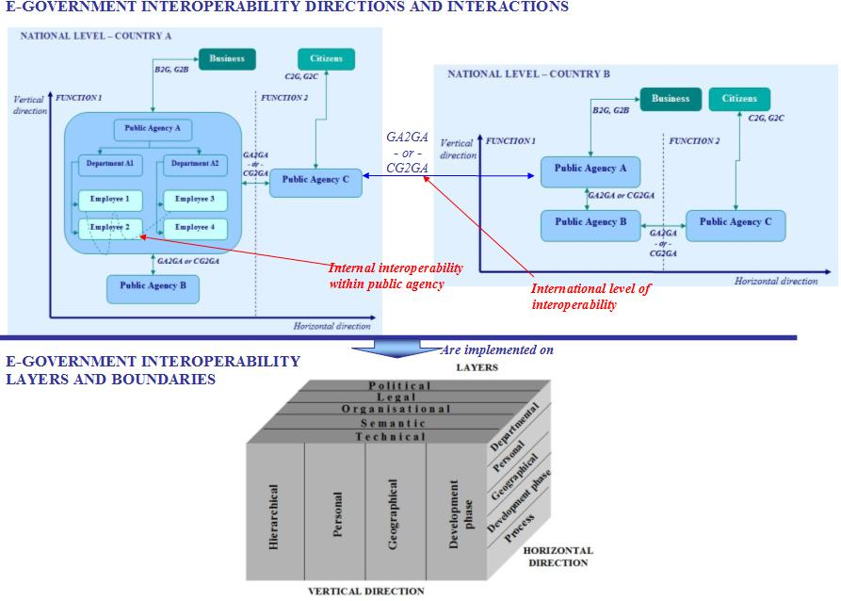
Figure 3. The complexity of e-government interoperability phenomena
Source: Composed by the author
E-government interoperability is made up of the layers of political, organisational, legal, semantic and technical interoperability to ensure that the mission, goals and business processes of different partners are properly aligned (see in Figure 3 above). There can be no legal barriers for the information sharing between the collaborating parties. All exchanged data must have the same meaning and there can be no obstacles in linking different computer systems and services (European Commission, PEGSCO, 2009).
Interactions important in e-government interoperability can be classified into 3 categories (Lam, 2005): (1) Government agency-to-Government agency (GA-2-GA in Figure 3 above) represents the collaboration of two government agencies in implementation of government programs or provision of services, (2) Central government-to-Government agency (CG-2-GA in Figure 3 above) illustrating the case when central government is acting as a coordinating and consultative body to other government agencies in the field of e-government interoperability development, (3) Government agency-to-government user (GA-2-GU in Figure 3 above) covering already known relationships of government-to-citizens (G2C) and government-to-business (G2B).
As it is shown in Figure 3 above, e-government interoperability can take vertical or horizontal direction (Zheng, Yang, Pardo, & Jiang, 2009). Vertical interoperability refers to the collaboration between different levels of government institutions within the same functional area or a particular cluster of public service (e.g. taxation, social security, healthcare). Horizontal interoperability means the cooperation between government agencies across different functions, services or policies (e.g. reacting to natural disasters, dealing with challenges caused by the recession, etc.) at the same level of government hierarchy.
Some research indicates that vertical interoperability is a predecessor of horizontal interoperability, and that it is easier to achieve (Layne & Lee, 2001). However, collaboration in each of these directions means passing through different boundaries with non-linear inter-relationships and consisting of a number of political, legal, organisational and technological barriers (Zheng et al., 2009). The problem caused by horizontal boundaries can also be embedded in the vertical boundaries, sometimes making it more complicated than the horizontal (ibid). As it could be seen from Figure 3 above, the vertical direction of interoperability has to deal with (1) hierarchical boundary between the central, regional and local government agencies when central government wants regional and local institutions to follow up its recommendations in the field of ICTs, and use ICTs tools developed on the central level, (2) personal boundary that is easier to deal with if leaders, managers or specialists in the higher hierarchical level of government have the work experience in the regional or local government, (3) geographical boundary means the collaboration between central and lower levels of government is more smooth when the regional and local level institutions are established near the central government agencies, (4) development phase boundary refers to the gaps of technological, managerial, personnel and economic capabilities between public agencies, the agencies with less internal capacity being more willing to collaborate with central government (ibid).
As Figure 3 above illustrates, the horizontal direction of interoperability is made up from (1) departmental boundary can be cross-unit, cross-departmental, and cross-ministry, the more types of departments being involved in the initiative, the higher its complexity becomes, (2) personal boundary that is easier passed it leaders, managers or specialists have work experience in different cluster of public service, (3) geographic boundary, (4) development phase boundary, (5) process boundary when information sharing between organisations having the same business processes is more likely to happen than between the organisations that do not share any business processes (ibid). It is worth of noting that geographical boundary may exist not only on the national level, but also on the international level, e. g. on the case of Pan-European Public Services.
Building and strengthening public sector’s capabilities of e-government interoperability make e-government the main tool to build networked public administration (Waksberg-Guerrini & Aibar, 2007), and require adjustment of the existing models of e-government development to this new approach.

  - The role of dynamic organisational capabilities for interoperability in e-government development models
    - Models of e-government evolution in stages
Evolution in stages is the largest, most elaborated and still actively researched category of e-government development models. There the development of e-government is divided into different stages of evolution, each stage representing certain organisational and technological maturity level of the process.
One of the first models in this category has been proposed by Layne and Lee who have identified four stages of e-government development (see Figure 4) based on their experience and observations of e-government initiatives in the United States (Layne & Lee, 2001). The need for interoperability as well as the requirements for the related capabilities increases with every stage of the model aiming for higher organisational and technological integration and complexity.
On the first stage of cataloguing government agencies create their official websites where the main information about their performance and public services is provided for citizens and businesses. Firstly the information about public services is indexed by the responsible agency and/ or department, and then is transited to the site where the information is organised by the type of services so that citizens do not have to know what agencies are responsible for which services.

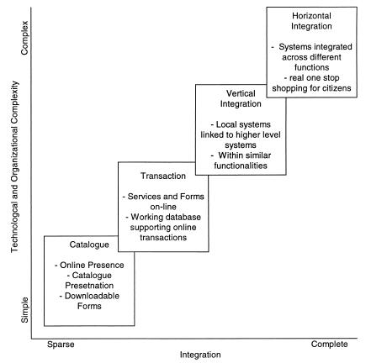
Figure 4. Stages of growth model for fully functional e-government
Source: (Layne & Lee, 2001)
The second stage of transaction offers citizens not only a possibility to download, fill and send the forms required to get a public service but also a chance to participate in the decision-making process through online forums. Though this stage is already considered as the one changing the relationship between citizens and government, the development of ICTs is still dedicated merely for the automation of the existing practices of service delivery. On this stage e-government interoperability is understood more from the technological point-of-view the main issues being the integration of legacy systems in the public sector.
Re-engineering of business processes and the need for e-government interoperability are the main issues of the vertical and horizontal integration stages of e-government development. At the third stage of vertical integration governments are trying to create online public service delivery systems that need the interaction of different agencies in a one functional area or silos. The last stage of horizontal integration is the most complex to achieve as it requires the integration of business processes and information systems within the different policy areas of government (e. g. emergency response needs the integration of police, social security and healthcare sectors).
The last two stages of e-government development are related not only with technological (e. g. data format compatibility, exposure level of internal systems with outside, authentication, etc.) but also with managerial issues of interoperability as business process integration, changes in the organisational structure of public agencies, exchange of information between the public institutions, etc.
Though capabilities needed to implement each stage of e-government evolution and progress to the higher stage of maturity are not explicitly stated in Layne and Lee model, the authors have tried to identify some competencies for each of the stages.
Technological capabilities of the web-site development are needed from the very first stage of cataloguing, and in other stages have to be supplemented with the knowledge in information systems development, integration and maintenance.
Non-technological capabilities include the resource allocation from the very first stage of e-government development when organizations need to find new or use the existing human resources for the maintenance of their web-sites’ content and functionality, answering the e-mails, overseeing the online process of service provision. The coordination of e-government development is an important issue from the very first stage and tends to remain so (though not clearly emphasized by the authors) in all the other stages as well. Vertical and horizontal integration are related to such capabilities as re-conceptualization of government services, cross-organisational information sharing, working outside the limits of usual functional responsibilities in more networked than hierarchical structures.
Stage models similar to Layne and Lee have been offered by Hiller and Belanger (Hiller & Bélanger, 2001), Wescott (Wescott, 2001), Capgemini (Capgemini, 2006, 2007), Gartner (Gartner Group, 2001), Accenture (Accenture, 2001, 2002, 2003, 2004), United Nations (United Nations, 2001, 2003a, 2003b, 2004).
According to the model of Hiller and Belanger e-government evolves through five stages such as information, two-way communication, transaction, integration and participation (Hiller & Bélanger, 2001). The main differences of this model in comparison with Layne and Lee model is that the authors have divided the cataloguing phase into two distinct phases of information (the information put by the government authorities can be accessed online by citizens) and two-way communication (citizens can download forms needed to get the desired public service). Another difference is that the stage of integration covers both vertical and horizontal integration of government. However, the main distinction of this model is a new stage of participation when citizens can vote via Internet or participate in online forums and discussions on policy-making issues. Though component of digital democracy was mentioned on the second stage in Layne and Lee model, Hiller and Belanger argues that it needs to be analysed as a separate phase due to specific issues of data privacy and security (ibid).
The stage of digital democracy can be also found in the model proposed by Wescott (Wescott, 2001). This model is different from other stage models in the way that it deals with front as well as back office issues when defining the stages of e-government evolution. The importance of interoperability and integration for better information sharing and e-government maturity is emphasized from the very first stage of the model. The information stage in the model is divided into two smaller phases of “setting up an e-mail and internal network”, and “enabling inter-organisational and public access to information”. The first maturity level is oriented merely to the internal needs of the institutions to communicate via e-mail, automate routine business processes, and integrate the existing siloed information systems into enterprise resource management systems on the level of one particular institution. The second informational stage of the model is already focused on public institutions going online and putting the public information on their websites. The vertical and horizontal integration is reached only on the last sixth stage of e-government evolution where joined-up government is functional in different geographical areas (ibid).
E-government stage models offered by the consulting organisations like Gartner, Accenture and Capgemini are used as a tool to benchmark the progress of e-government worldwide. Gartner’s four phases of e-government model is the first attempt to relate the e-government development stages with the particular needs of ICTs, business processes, people and strategy (see Figure 5). The evolution of e-government in Gartner’s model is analysed through the 3 different axes of value, time, and cost/complexity of the stage (Gartner Group, 2001). The issues of interoperability become important from the third stage of transaction when the integration of legacy systems has to be reached in order to offer transactional online services for citizens, and from the fourth stage of transformation interoperability it is needed for creation of innovative applications that offer new services for the public.
Gartner’s model uses the dimension of people to identify the organisational capabilities that are needed to implement each stage of e-government (ibid). The first stage of presence does not need any new capabilities and public institutions can manage with the existing human resources. The second stage of interaction already requires capabilities of content management, ICTs support and governance. The transaction and transformation phases need capabilities of interoperability to manage e-government portfolio, sourcing, analysis of business processes, performance management and implementation of multiple programs.
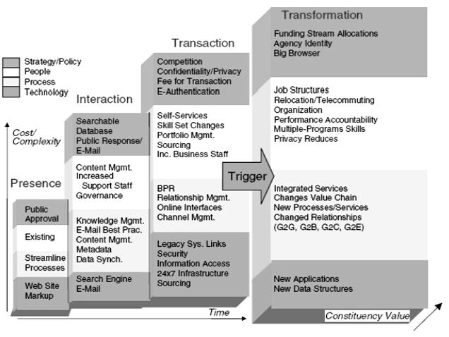
Figure 5. Gartner‘s four phases of e-government model
Source: (Gartner Group, 2001)
The distinguishing characteristics of Accenture’s e-government stage models are their focus on the citizen-centricity of electronic public services. In 2001-2002 Accenture benchmarked the development of e-government using two components of Service Maturity Breadth and Service Maturity Depth (Accenture, 2001, 2002). Service maturity breadth was analysed via three stages of publish, interact and transact each respectively referring to the passive/passive, active/passive and active/active type of communication of constituents and government. Service maturity depth was measured through five customer relationship management (CRM) capabilities of government: Insight (does government know its customers?), interaction (how many different services can citizen access via one portal?), organisation performance (are the portals of public services organised by the life events or by the providers?), customer offerings (what kind of online help is offered in the websites?), and networks (can I access non-governmental services via the e-government portal?).
In 2003 Accenture have offered a more elaborated e-government development model that was made from five stages: Online presence, basic capability, service availability, mature delivery and service transformation (Accenture, 2003). This model was different from its predecessors as it has provided the list of recommended actions that have to be taken by governments in each of the stage to migrate to the higher maturity stage. The capabilities for interoperability such as encouragement of agency cooperation, development of transactional capabilities, and standards for the implementation of electronic public services were also included in the list of the actions (ibid).
From 2001 to 2006 Capgemini has applied a four stage model to measure the progress of e-government in the member states of the European Union (Capgemini, 2006). This model comprises the stages of information, one-way interaction (downloadable forms), two-way interaction, and transaction (full electronic case handling) (ibid). In 2007 they have included the fifth level of e-government maturity (called “personalisation” or “targetisation”) to measure the degree of user-centricity of electronic public services through the evaluation of their automation and pro-activity (Capgemini, 2007). Since the fifth maturity level of e-government could be reached only through effective information sharing, and vertical and horizontal integration of front and back offices, the full online availability is reached through combining the fourth and fifth levels of e-government evolution in Capgemini models (ibid).
In comparison with Accenture, Capgemini has enriched their benchmarking with the measurements of user experience only in 2009. Based on the insights that were drawn from the results of the benchmark, they have proposed a new model for the development of citizen-centric e-government (Capgemini et al., 2009). They have identified five stages of government evolution: Administration centred, customer aware, customer engaged, government driven customer centricity, and customer driven customer centricity (see Figure 6). The maturity of government increases with the extent of citizens’ engagement in the process of electronic public service development and delivery being non-existent in the first two stages of the development, and then gradually involving citizens into the process through users’ segmentation, identification of service levels, participation of citizens in the design process of electronic public services.
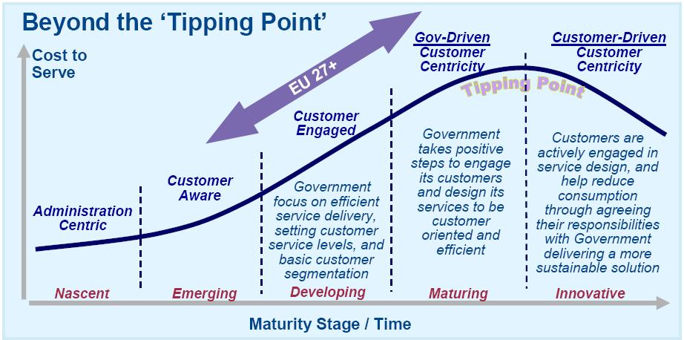
Figure 6. Stage model for the development of citizen-centric e-government
Source: (Capgemini et al., 2009)
United Nations uses e-government index to measure the progress of e-government in their member states. The exceptional feature of the UN benchmarking is that it takes into account the context of the analysed country integrating ICTs infrastructure and human capital indexes into e-government index together with the web presence index which is measured using four stage e-government model (United Nations, 2001, 2003a, 2003b). In 2003 e-government index was also supplemented with e-participation index made from three stages of e-information, e-consultation, and e-decision making (United Nations, 2003a, 2003b).
In 2004 United Nations offered the Access-For-Opportunity framework to measure the digital divide that gradually becomes a very important problem for both developed and developing countries. This model has taken into account such contextual factors as income divide, telecommunication access-divide, education and skill access-divide, language access divide, content access divide, and affordability divide (United Nations, 2004).
In 2008 United Nations emphasized that further expansion of electronic public services is not possible without knowledge management which could lead to reduced costs of information sharing, increased productivity, efficiency, innovation and quality of public service delivery (United Nations, 2008). However, practice of knowledge management has to deal with the human, technological, and process factors, and has to be supported through the set of capabilities like building trust among employees, establishing leadership to promote information sharing, foster innovation, develop communities of practice, using CRM, ensuring data confidentiality, integrity and availability (ibid). These capabilities also helps to implement the principle of connected governance which means “re-engineering of technology, processes, skills and mindsets of public officials” through the appropriate infrastructure, integration and transformation (ibid).
Finally, in 2010 United Nations has emphasized the role of e-government in fighting the financial and economic crisis, especially through government data exchange using open standards, and citizens’ participation in decision-making (United Nations, 2010). It also argued that some unified assessment framework of e-government performance and public sector capacity to implement e-government initiatives is needed, however, no concrete measures were proposed so far (ibid).

    - Critics of e-government evolution in stages: New generation of process-redesign and e-government interoperability oriented stage models
Andersen and Henriksen have criticised the models proposed by Layne and Lee, and United Nations as being merely the reflection of the traditional processes of ICTs development in government and thus supporting “better-safe-than-sorry” mentality of current e-government strategies that lack orientation on the citizen-centricity and re-engineering of business processes (Andersen & Henriksen, 2005). They have used Capability Maturity Model (CMM) and Stages of Growth Model from the information systems field, and Product Life Cycle concept from the business economics to further elaborate the existing e-government development stage models into the four stages model of Public Sector Process Rebuilding (ibid).
The maturity of e-government is defined by the number of activity centred applications and the level of their citizen-centricity (see Figure 7). Though e-government interoperability is not clearly emphasized in the model, ICTs integration activities go through every stage of the model.
The first cultivation phase covers the vertical and horizontal information integration, emergence of intranet usage and some front-office systems. However, the institutions are waiting for some full integration of data to proceed further with the more user-centric services and usually tend to serve the citizens in the traditional ways. At the stage of extension users are served online through specialized web-interfaces, however, the majority of the routines are unchanged and users are still re-directed to other institutions if needed. When e-government reaches the maturity stage organisations are already working in a more interoperable manner, intranet and internet solutions are merged and rather than re-directing the users to other institutions, the data are gathered from the various sources and provided to them via customizes web-interfaces. Finally, the revolution phase means data mobility, applications mobility and citizens owning their data. At this stage you can trace the actions of public sector employees when they are providing you with a service.
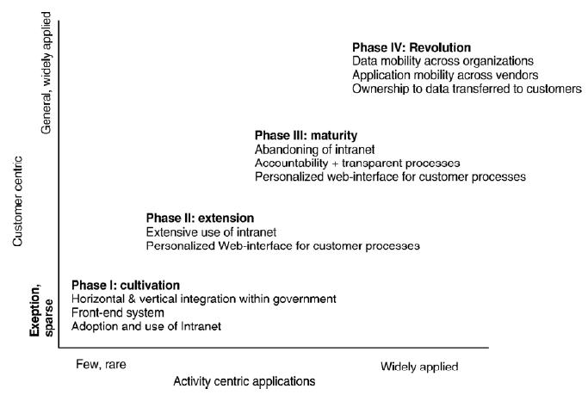
Figure 7. Public Sector Process Rebuilding model
Source: Andersen & Henriksen, 2005
Another critique of stage models has been provided by Coursey et al. who carried out three surveys in the USA local government in 2000, 2002 and 2004 aiming to test whether the stage models bring the expected results when applied in practice and were the stages correctly identified by the authors of the models. Based on the survey results, researchers have identified these weaknesses (Coursey & Norris, 2008):
- Specifications of the models do not include the analysis of the barriers that might occur in each stage, and do not offer tools for overcoming these barriers when trying to reach higher stage of e-government development.
- The models were created only on the basis of personal observations and experience of the authors, and do not refer to the former research in information systems, public administration and e-government.
- There is not enough empirical evidence about the cases where e-government development has reached the highest stage of maturity, hence it is not clear are the sequence of the stages accurate and relevant to the real organisational and technological changes that occur when a particular stage is completed.
- The models do not take into account that institutions or countries that are only at the beginning of e-government development might start from the higher stage due to learning from the best practice of the pioneers in the field. Since some agencies might be at the higher maturity level of e-government development than the others, policy makers often have to cope with the question how to assess the overall progress of e-government on the national level.
One of the latest stage models of e-government development, proposed by Klievink and Janssen, reflects the contemporary concept of e-government, emphasizes the importance of interoperability, and considers the critique which is usually put on the stage-type of e-government models. Firstly, the model has strong theoretical foundations as it is based on the former research in the field of evolutionary models, e-government, and dynamic organisational capabilities (Klievink & Janssen, 2009). Secondly, the model does not only provide the policymakers with the stages of e-government development, but also lists the organisational capabilities in the field of stakeholders involvement, technology, business process transformation, and demand-driven service delivery that have to be in place or need to be achieved for successful completion of each phase. This raise the awareness about capabilities that have to be developed or improved for each stage, to understand what e-government solutions are feasible to implement with the current set of capabilities, and how to exploit the existing infrastructure for the progress of organisational capabilities (ibid). Finally, in the contrast to previous models, this one is oriented towards the development of a joined-up government on the national as well as organisational level which is helpful in the design of national e-government infrastructure and tailoring information systems of different institutions for the integration into the nationwide portal (ibid). The focus on different types of interoperability would make it easy to add the sixth stage of an international joined-up government in the future (ibid).
In this model e-government evolves in five phases with each phase reaching a higher level of customer orientation and flexibility of systems’ architecture (see Figure 8). At the stovepipes stage each institution is functioning not as a part of a whole government, but as a single unit. Organisations tend to develop their own information systems without the need to share the information across their boundaries. The main organisational capabilities that are needed at this stage are merely technological, and refer to the development and design of information systems.
At the second stage of integrated organisations each institution develops its own portal for one-stop shopping electronic service delivery through the re-engineering of local business processes and integration of their information systems via such tools as enterprise architecture, service-oriented architecture, etc. This stage already requires not only technological capabilities of systems integration, but also capabilities for commitment and culture, networking and relationship management within organisations, system integration project management, enabling cooperation between different organisations, and management of integrated service delivery.
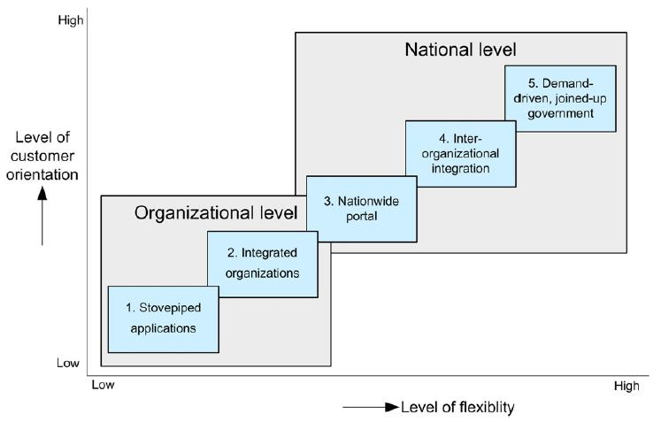
Figure 8. Growth stages of a joined-up government
Source: (Klievink & Janssen, 2009)
At the third stage, citizens can access public services using a nationwide portal that offers them a list of services and helps to communicate with each institution participating in the delivery chain of the chosen service. At this stage institutions can share the data and information about their customers using generic facilities of infrastructure (e. g. central tools for authentication), so that there will be no need for the citizen to get personal data from every single agency. Agencies have to develop such new capabilities as development and usage of central infrastructure, working on integration collaboration agreements, system project management, service and portfolio management, identification of users’ requirements and their engagement into the service development process.
The fourth stage of inter-organisational integration is reached when citizen requests the service from the initial organisation via the nationwide portal, this organisation locates other related stakeholders to prepare the final answer, and the last institution in the chain delivers the result for the citizen via the nationwide portal. This principle implements the one-stop shop and liberates users from the communication with various institutions in order to get one public service. However, this virtual government organisation might evolve into a very bureaucratic institution with complex layers and relationships between them. For this reason, the authors of the model proposed the fifth stage of demand-driven, joined-up government where instead of citizens having to find and request services, the portal would search the relevant services for them and make the recommendations. This would lead to the radical changes in organisational capabilities requiring new leadership competences, knowledge about transformation of government architecture, changing organisational structure, and culture.
Gottschalk and Solli-Saether have developed the stage model for e-government interoperability focused merely on the measurement of the improvements of interoperability of e-government (Petter Gottschalk & Solli-Saether, 2008). Later this model was further elaborated by Gottschalk alone by adding one additional stage, and was called model of maturity levels for interoperability in digital government (see Figure 9). This model is also strongly based on the previous research in the field of evolutionary models, e-business and e-commerce, knowledge management, IT outsourcing, and e-government (Petter Gottschalk, 2009). In the 2009 version of the model e-government interoperability evolves through five stages of computer interoperability, process interoperability, knowledge interoperability, value interoperability, and goal interoperability (see Figure 9).
Computer interoperability refers to the technological interoperability between different hardware and software systems. Process interoperability (former stage of work processes) is achieved when processes and their outcomes in one collaborating organisation participate in the processes and outcomes of other organization. Knowledge interoperability (former stage of knowledge sharing) means that knowledge from one organisation is useful and used in other organisation, and supplements its individual knowledge. Value interoperability (former stage of value creation) can have different value configurations in the organisations, like value-chain, value shop, and value network. The highest stage of interoperability is goal interoperability (former stage of strategic alignment) when the strategic goals and missions of organisations do not conflict with each other due to the benefits and lessons learned in previous interoperability stages (ibid).
This model can be very useful if integrated with other e-government development stage models through linking each stage of e-government development with a particular maturity of its interoperability.
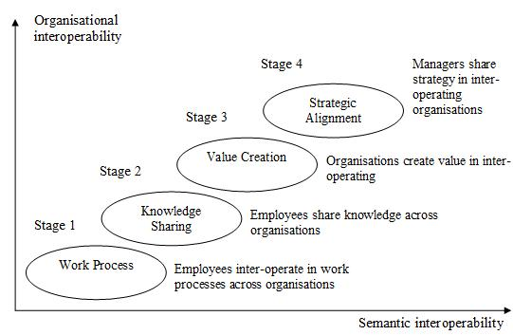 | 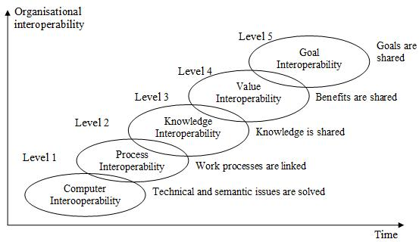
Source: Petter Gottschalk & H. Solli-Saether, 2008 | Source: Petter Gottschalk, 2009
Figure 9. Stage models of e-government interoperability: Comparing versions of 2008 and 2009
    - Other approaches to e-government development: Alignment-based maturity and architecture
Other researchers though referring on the stage models have proposed different approaches to the modelling of e-government development. Davison et al. in their alignment-based maturity model of e-government emphasize the importance of strategic business and IT alignment in the e-government based reform, and link the level of alignment with the outcomes of e-government initiatives through the analysis of the possible transition paths or scenarios from traditional government to e-government (Davison, Wagner, & Ma, 2005).
Based on the former research in the field of evolutionary models, e-government, and strategic ICTs and business alignment, the authors identify five stages of e-government evolution each made up of several different development scenarios referring to a certain level of business and IT alignment (see Figure 10).
The stage of e-government “rhetoric” means that government strategic planning based on ICTs is not in place. Governments are likely to declare the importance of ICTs and their plans to go online, however, these are more statements than some real actions.
Visionary stage consists of three possible scenarios to follow. The first scenario 2a “Strategic vision” means that e-government initiatives will follow after the government strategic planning step. Another scenario 2b “eGovernment vision” means that public administration strategies are not related to the ICTs strategy of public sector and ICTs strategy is created as a stand-alone document. Finally, the scenario 2c “Systems focus” means that ICTs solutions for public sector are developed without any thorough strategic planning. This scenario might cause problems of systems integration and meeting the changing strategic goals and objectives of the country later on.
Strategic alignment stage has three possible scenarios that a country might enter from the particular position of the previous stage. 3a scenario “Strategic plan” means that before any e-government infrastructure development the country first creates an e-government strategy to ensure the alignment between business and IT. However, it is possible to start implementing ICTs solutions based on the goals of government strategy without any e-government strategy (scenario 3b “IT planning gap”). Those governments that have e-government strategy in place can move to the development of e-government solutions without any attention to the government strategy (scenario 3c “eGovernment Automation”).
At the stage of e-government integration interoperability starts to play an important role as countries start to realise the need for the integration of government, e-government strategies and the developed ICTs solutions in order to ensure non-duplicate efforts and rational investments of government into ICTs. At this stage all governments have to reach alignment between their strategic and operational levels. It is important to notice that governments who begin e-government development simply from building their systems (scenario 2c) can face extreme difficulties to reach this fourth stage.
E-government transformation begins when there is a change in business processes and culture due to the use of technology. The relationships between citizens and government are also changed at this stage. The authors argue that the changes in organisational processes occur only in the final stage of transformation and if these changes occur earlier it could be considered as simple changes in traditional government.
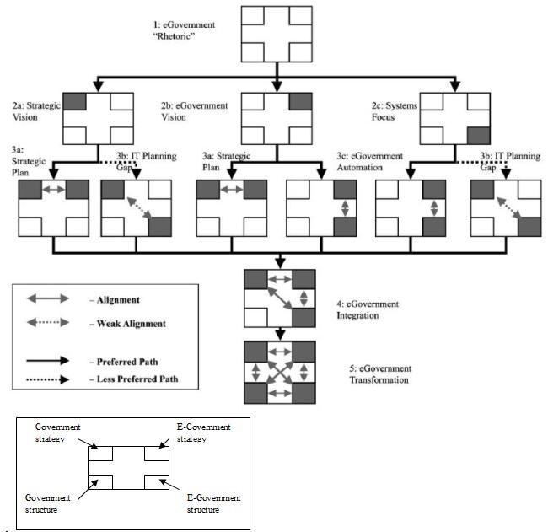
Figure 10. Alignment-based maturity model of e-government
Source: (Davison et al., 2005)

This model can be applied on the organisational as well as national level. However, national e-government planning has to take into account that the transition paths might be different in every public sector organisation and thus lead to the different outcomes at the national level (ibid). This alignment-based maturity model of e-government does not identify particular organisational capabilities for each of the stages of e-government development nor puts a strong emphasis on e-government interoperability. However its core idea, that successful transition from government to e-government can be successful only if public sector reform and ICTs investments are linked with each other, could strengthen the value of evolution in stages models that were analysed above.
Ebrahim and Irani have developed an e-government architecture framework describing the main actors, technological components, and barriers for the implementation of each layer of the national e-government system (Ebrahim & Irani, 2005). The framework does not explain the evolution process of every layer as it is done in the stage models of e-government development, but it provides a comprehensive view on the technologies which are necessary for the successful implementation of the stage models (see Figure 11).
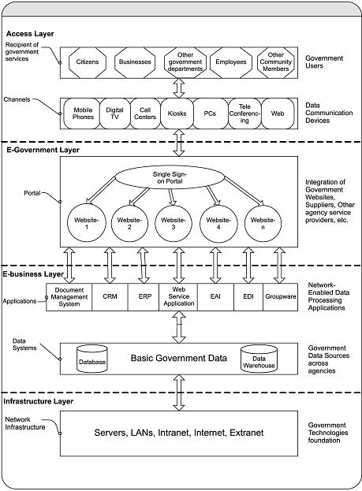
Figure 11. Framework of e-government architecture
Source: (Ebrahim & Irani, 2005)
Access layer illustrates who are the users of e-government services and what are the online and offline channels of access. The main function of this layer is to ensure the appropriate channel coordination, common look and feel across the channels, and compliance with technical standards.
E-government layer represents the national portal that integrates the services and information from different government agencies. Due to the complexity of overall government organisation it is difficult to understand which features and applications have to be integrated into the portal, and how to solve organisational and technological issues of the integration. Security is also an important element to this layer.
E-business layer integrates the front-office applications (that belong to the first two levels of the framework) with the back-end systems used by government institutions to process the requests and customer data. It ensures cost-sharing partnership among public institutions as government employees interact with other departments and agencies concerning human resource information, retirement plan, latest news releases, and drawing on the available resources in an optimal way.
Infrastructure layer focuses on technologies that should be in place before e-government services can be offered reliably and effectively to the public. This layer incorporates the security systems like public key infrastructure, firewalls, digital signature, encryption technologies, etc.

    - Comparison of e-government development models: An integrated approach to reinforcement of capability for e-government interoperability
Through the exploration of implementation processes of e-government initiatives worldwide and the analysis of their outcomes, research has come up with variety of e-government development models that offer politicians and public managers different approaches how to do strategic planning, coordination, implementation, monitoring, and performance measurement of e-government based reform in a conceptualised manner on the organisational, local, national and international levels. Existing models represent different perspectives on e-government development, are diverse in their structure, attitude towards e-government interoperability and organisational capabilities needed to achieve certain maturity level of e-government (see Table 2).

Table 2. Comparison of e-government development models
Approach | Characteristics  Model | Structure | Interoperability issues addressed | Organisational capabilities identified | Exceptional features
Evolution in stages | Layne & Lee (2001) | Four evolution stages | Interoperability issues are not directly related to each stage, but can be extracted from the model’s description:  - Integration of legacy PMIS  - Interaction of public agencies in one functional area  - Interaction of public agencies in different policy areas | Organisational capabilities are not directly identified and related to each stage, but can be extracted from the model’s description:  Technological:  - Web-site development  - Information system development  - Integration and maintenance of ICTs  Non-technological:  - Resource allocation  - Coordination of e-government development  - Re-conceptualisation of government services  - Cross-organisational sharing of information  - Working in networked structures | N/A
Evolution in stages | Hiller & Belanger (2001) | Five evolution stages | N/A | N/A | N/A
Evolution in stages | Wescott (2001) | Six evolution stages | Interoperability issues are not directly related to each stage, but can be extracted from the model’s description:  - Inter-organisational communication via e-mail and internal networks  - Integration of legacy PMIS to automate routine business processes  - Integration of legacy PMIS into enterprise resource management systems  - Workflow management | N/A | The role of geographical area in joined-up government is emphasized
Evolution in stages | Gartner Group (2001) | Four evolution stages | Interoperability issues are explicitly addressed in the layers of Process and Technology at each stage:  - Legacy systems integration  - Security  - Information access  - 24x7 infrastructure  - Sourcing  - Business Process Re-engineering  - Online interfaces  - Channel Management | Organisational capabilities are explicitly identified in the People layer:  - Content management  - Maintenance of ICTs solutions  - ICT governance  - Portfolio management  - Outsourcing management  - Performance assessment  - Multiple programs management | - Evolution of e-government is analysed through three axes: value, time, and cost/complexity.  - Each stage addresses four layers: Strategy/Policy, People, Process, Technology
Evolution in stages | Accenture (2001, 2002) | Two components:  1. Service maturity breadth (three evolution stages)  2. Service maturity depth (five evolution stages) | N/A | Customer relationship management organisational capabilities are measured through Service Maturity Depth component | Principles of CRM are used in Service Maturity Depth component.
Evolution in stages | Accenture (2003) | Five evolution stages | N/A | Organisational capabilities are not directly identified and related to each stage, but can be extracted from the actions allocated for each stage:  - Development of infrastructure  - Agency cooperation  - Transactional capabilities  - Citizens involvement | Each evolution stage was prescribed with specific actions that have to implemented
Evolution in stages | Capgemini (2007) | Five evolution stages | N/A | N/A | N/A
Evolution in stages | Capgemini (2009) | Five evolution stages | N/A | N/A | - User-centricity of e-government is addressed  - E-government performance is measured using two axes of time and cost to serve
Evolution in stages | United Nations (2010) | Three assessment indexes:  1. E-government index (4 evolution stages)  2. E-participation index (3 evolution stages)  3. E-inclusion index | N/A | Organisational capabilities are emphasized, but not explicitly measured:  - Trust  - Leadership to promote information sharing  - Customer relationship management  - Data confidentiality, integrity, and availability | Addresses e-government development context
Evolution in stages: Focus on business process redesign | Public Sector Process Rebuilding Model (Andersen & Henriksen, 2005) | Four evolution stages | N/A | N/A | N/A
Evolution in stages: Focus on interoperability | Growth stages of a joined-up government (Klievink & Janssen, 2009) | Five evolution stages: Two at organisational level and three on national level | Interoperability issues are not directly related to each stage, but can be extracted from the model’s description:  - Agency’s one-stop shop portal development  - Re-engineering of business processes  - Enterprise architecture  - Service-oriented architecture  - Development of nationwide portal by usage of central facilities of infrastructure  - Virtual government organisation | Organisational capabilities are explicitly identified and allocated for every evolution stage.  Types of organisational capabilities:  - Technology  - Stakeholder  - Transformation  - Service delivery  - Relationship | - Based on dynamic organisational capabilities approach  - Based on e-government interoperability
Evolution in stages: Focus on interoperability | Stage model of e-government interoperability (Gottschalk, 2009) | Five evolution stages | - Technological interoperability  - Business process interoperability  - Information and knowledge sharing  - Value creation through interoperability  - Alignment of missions and strategic goals of diverse public agencies | N/A | Merely dedicated for e-government interoperability
Strategic ICT and business alignment | Alignment-based maturity model of e-government (Davison et al., 2005) | Five evolution stages/ 12 evolution scenarios | N/A | N/A | - Identifies possible transition paths from government to e-government  - Focus on alignment of public administration development strategy and ICTs investments
Architecture | E-government architecture framework (Ebrahim & Irani, 2005) | Four architectural layers | N/A | N/A | Identifies ICTs solution core to the development of e-government
Source: Composed by the author

The analysed models provide the researchers and practitioners with important insights for the development of e-government and reaching tangible results with the ICTs based reform of public sector. However, if integrated into one uniform “all in one” framework covering maturity stages, levels of interoperability, architectural requirements, performance assessment indicators, organisational capabilities, and implementation tools, they could offer a more comprehensive roadmap for planning, development, and research of the joined-up government (see Figure 12).
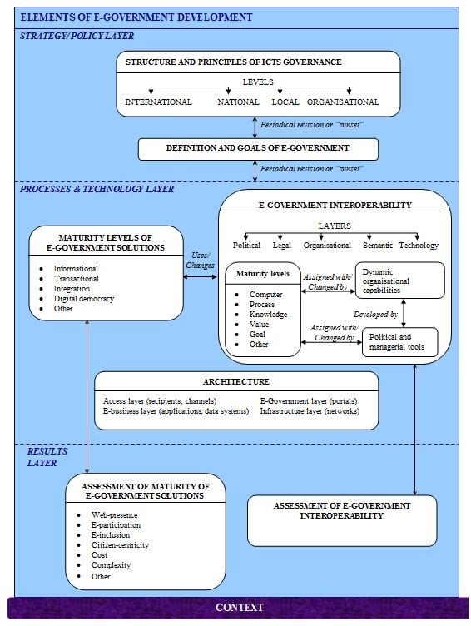
Figure 12. Integrated framework for the development of a joined-up government
Source: Composed by the author
The framework suggests only generic elements that have to be present in the process of e-government strategic planning, implementation and monitoring. Each user of the framework, be it a particular country or a single public agency, can elaborate each component of the framework according to its own needs and operational context. The usage of the framework can be also combined with the method of evaluation of e-government development alternatives proposed by Lithuanian researchers (Jurkėnaitė & Paliulis, 2010). This method is based on the assessment of three complex criterions for evaluation of e-government development alternatives: E-service, e-administration, and e-democracy (ibid). Thus it could be applied either for assessment of maturity of e-government solutions in the results layer of the framework proposed in this work, or it could be used in any other layers of the framework if supplemented with new indicators and criterions.
As the literature review provided in this chapter shows, e-government interoperability as dynamic capability and the respective managerial tools for its development and assessment are still very little addressed by the research community. Therefore the components of e-government interoperability and its assessment identified in the framework above as well as their context-dependability are chosen for further theoretical and empirical analysis of this work. The overall structure of this framework is also used in the empirical research of this work, as the tool to analyse and identify e-government development process level in different countries.

  - Chapter 1 conclusions
- If compared with the issues that were faced by public managers and software developers two decades ago, implementation of contemporary ICTs solutions involves participation of diverse public sector organisations, and integration of their different technological platforms. Investments to ICTs have to be aligned with organisational as well as national strategic goals.
- Effectiveness, efficiency, redesign of business processes, reduction of bureaucracy, accountability and transparency, quality of decision-making, and increased citizen focus are expected outcomes of technological progress in modern government.
- Conception of e-government used by practitioners as well as by research community has to address the challenges posed for development and adoption of modern ICTs solutions in the public sector. It has to take into account all available technologies not merely the Internet, and to be oriented towards improvement of public services as well as organisational change, development of new skills, and enhancement of democracy.
- Contemporary e-government development heavily relies on such capabilities of public sector organisations as collaboration, organisational compatibility, leadership, strategic planning, project management, finance and investment planning, resource management, performance evaluation, and other.
- These organisational capabilities are made up from routines or repetitive activities in an entire organisation, and could be classified into operational and dynamic ones. Operational capabilities enable organisation to perform its core functions, and dynamic capabilities are the capacity of an organisation to purposefully create, extend, or modify its resource base.
- Dynamic organisational capabilities are critical for success of e-government development that involve participation of diverse organisations, and is implemented in highly dynamic environments with frequent change of technologies, policies, legal frameworks, and citizen demands. Dynamic capabilities can bring more formalisation and knowledge management elements into e-government development process which is still more based on ad hoc decisions and activities.
- E-government interoperability is the most important dynamic capability if implemented ICTs solutions are to meet the needs of modern governments and societies. Though it is still often analysed merely from technological perspective, this narrow understanding does not fit into the current context of e-government development.
- Based on the approach of dynamic organisational capabilities, e-government interoperability is defined as dynamic, multi-dimensional, and context dependant capability of diverse organisations to work together in order to reach commonly beneficial and agreed goals in development and usage of various ICTs solutions for sharing needed information and knowledge between their business processes.
- E-government interoperability is made up from the layers of political, organisational, legal, semantic, and technical interoperability.
- E-government interoperability can take vertical either horizontal direction. Vertical direction addresses interoperability between different levels of e-government institutions within the same functional area or cluster of public service. Horizontal direction addresses interoperability between government agencies across different functions, services, or policies.
- Development and practice of capability for e-government interoperability passes through different hierarchical, departmental, personal, geographical, development, and process boundaries consisting through number of political, legal, organisational and technological barriers.
- E-government interoperability is mainly addressed by the models of e-government evolution in stages. Various issues of e-government interoperability are emphasized in these models such as integration of legacy PMIS, automation of routine business processes, development of enterprise resource management systems, interaction of public agencies in one functional or in different policy areas, development of one-stop-shop portals, management of different channels for provision of public services, business process re-engineering, development of infrastructure facilities by central government and their adoption by all public sector organisations. Dynamic organisational capabilities that are needed to implement each stage in any e-government development model were explicitly identified only in growth stages of a joined-up government model.
- Gradually e-government development models that exclusively focus on interoperability emerge, and identify such interoperability maturity levels as technological interoperability, business process interoperability, information knowledge and sharing, value creation through interoperability, and alignment of missions and strategic goals of diverse public agencies.
- Other types of e-government development models are focused on strategic business and ICTs alignment, or architectural layers supporting e-government development.
- Analysis of existing e-government development models has shown that e-government development process should follow a more integrated approach. Thus integrated framework for the development of a joined-up government was proposed in this chapter. It identifies such layers of e-government development as strategy, processes, technologies, and results assessment. In strategy layer structure and principles of ICTs governance on international, national, local, and organisational layers have to be defined along with the conception and goals of e-government. Processes and technology layer include maturity levels of e-government solutions, e-government interoperability development principles and tools, and architecture of e-government infrastructure. Results layer should identify methods and indicators for the assessment of maturity level of e-government solutions as well as maturity of e-government interoperability.
- The proposed framework for the development of a joined-up government serves as the foundation for further theoretical and empirical analysis of this work.
- Tools for the development and assessment of dynamic organisational capabilities for e-government interoperability and their context-dependability
Countries that are leading in development of ICTs in the public sector are continuously searching for methods and tools to improve this process, and reduce the risk of failure. At the beginning these methods and tools mostly addressed technological issues of ICTs projects. However, their application has not lead to the expected outcomes, especially, in implementation of complex electronic public services and back-office systems that involved several public sector organisations. Hence, the importance of non-technological factors has been increasingly realised.
Currently technological as well as non-technological issues are integrated into various methods used to enhance ICTs projects in the public sector that require high level of interoperability between participating parties and their infrastructure. The main methods include development of an interoperability framework and enterprise architecture. An interoperability framework offers the list of standards that have to be followed in ICTs projects. Enterprise architecture describes the relationships between organisational structure, business processes, data, and ICTs within single organisation. Using these tools for the development of e-government interoperability is a complex endeavour in itself, thus identification, assessment and development of dynamic capabilities for interoperability are crucial for their successful application.
Governments from the countries that are trying to achieve the breakthrough in public sector reform based on ICTs usually tend to use the same methods as the leading countries do. Yet these attempts often are unsuccessful due to the overlooked differences in institutional, cultural, and social contexts.

  - National interoperability frameworks and federal enterprise architecture: The main tools in e-government interoperability development process
Currently two approaches are mainly used by government for enforcement of e-government interoperability: Standards and architecture (Lallana, 2008). Standards approach is usually based on the development of national interoperability framework which is defined as a set of standards and guidelines that are recommended to be used by all participants of any e-government initiative (Charalabidis & Askounis, 2008; Charalabidis, Lampathaki, & Psarras, 2009; L. Guijarro, 2004; Overeem, Witters, & Peristeras, 2007; Saekow & Boonmee, 2009). The typical structure of national interoperability framework would include (Lallana, 2008):
- Description of context. It includes the main definitions, aims, objectives, principles, background, audience, benefits, and relationship with other initiatives and the framework.
- Technical content. It includes the list of standards addressing organisational, semantic and technological interoperability. The selection and revision criteria of the standards are also defined in this part of the framework.
- Description of development process. It defines actions that are used in the development of the framework, main participating actors and their responsibilities, and mechanisms for consultations with all stakeholders about the framework.
- Overview of tools supporting implementation of the framework.
- Compliance regimes that are used to ensure that all participants of e-government development would stick to the standards identified in the framework including interoperability indicators and responsibility of compliance.
Standards are at the core of national interoperability framework. Gradually usage of open standards in e-government are tried to be enforced through this tool. In contrast to proprietary standards, open standards are considered more suitable in the public sector for several reasons: They are easily accessible, were developed using a process where everyone can participate, and are not controlled by any specific vendor or group (ibid). Regardless of whether proprietary or open standards are included in national interoperability framework, rigid procedures accepted by all stakeholders have to be present for selection of standards, their periodical revision, and exclusion from the framework if needed (ibid).
An architectural approach towards enhancement of e-government interoperability is usually based on the development of a national enterprise architecture. Enterprise architecture is a strategic planning framework oriented towards alignment of business goals and ICTs investments (Luis Guijarro, 2007; Hjort-Madsen, 2006; Lallana, 2008; Valtonen, Seppänen, & Leppänen, 2009). It serves as a tool for formal description of relations between all elements of modern organisation such as structure, business processes, people, data, and ICTs (ibid).
Enterprise architecture is used as a guideline for decision-making in ICTs investments as it defines the current state of organisation, its vision, and the roadmap how to move from the current to the desired one (Janssen, 2009). Though enterprise architecture is usually used within the boundaries of a single organisation, its usage in the domain of e-government interoperability means that all levels of government and respective agencies are a part of the enterprise, and are included in the architecture (Hjort-Madsen, 2006).
There are many theoretical frameworks that can be used for development of enterprise architecture (see Table 3). The first enterprise architecture framework was proposed by John Zachman (Zachman, 1987), and it was used as a foundation for federal enterprise architecture framework developed by the USA federal government (Gregor, Hart, & N. Martin, 2007; Luis Guijarro, 2007). Another popular enterprise architecture framework offered by consulting is TOGAF which exceptional feature is that it is an open specification also suitable for adoption in public sector (TOGAF..., 2009). Many enterprise architecture frameworks are offered by governments that shows increasing popularity of this approach in public sector.
Table 3. List of main enterprise architecture frameworks
Frameworks developed by government, research, and consulting | Frameworks developed by private sector vendors | Miscellaneous
- DoDAF (Dept. of Defence Architecture Framework, USA)  - FEAF (Federal Enterprise Architecture Framework, USA)  - MoDAF (Ministry of Defence Architecture Framework, Great Britain)  - Gartner Enterprise Architecture Framework  - TOGAF (The Open Group Architecture Framework)  - Zachman | - E2AF (Extended Enterprise Architecture Framework of the Institute For Enterprise Architecture Development)  - Capgemini’s Integrated Architecture Framework | - NIH Enterprise Architecture Framework (National Institute of Health Enterprise Architecture Framework)
Source: Adopted from (Feurer, 2007)
The structure of an enterprise architecture determines the multi-layer approach towards interoperability. Each layer from enterprise architecture can have one or more links to the political, legal, organisational, semantic or technological interoperability (see Figure 13). These links mean that development of enterprise architecture on organisational level should follow the principles of interoperability declared within as well as outside the boundaries of enterprise. The business level of enterprise architecture uses the principles and guidelines from political, legal, organisational, and semantic interoperability. Systems layer is connected to legal, semantic, and technological levels of interoperability. Elements of technology layer are mostly related to technological interoperability.
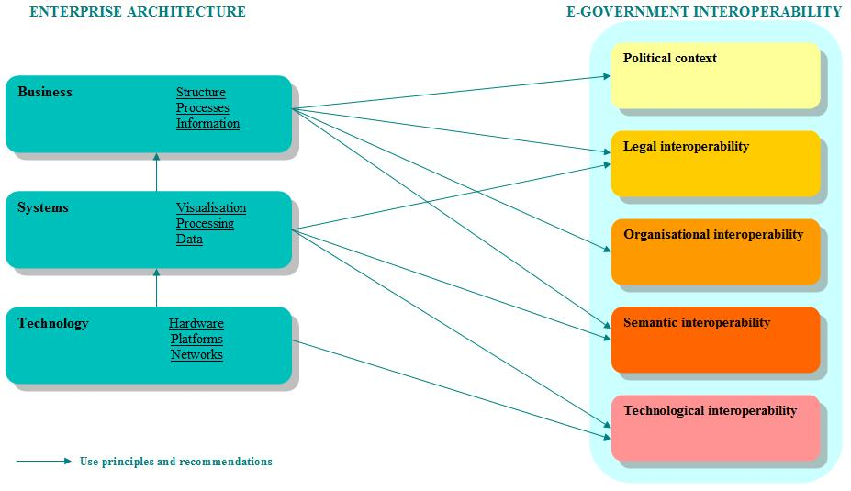
Figure 13. Relationship between enterprise architecture and e-government interoperability
Source: Composed by the author
As it is shown in Figure 14 there are four possible scenarios for development of e-government interoperability: A national interoperability framework oriented towards technological interoperability, a national interoperability framework consisting of all levels of interoperability, a hybrid approach using enterprise architecture along with a national interoperability framework, and a national enterprise architecture (Lallana, 2008). Which scenario has to be followed depends on goals, capabilities, and resources of a particular government (ibid).
Figure 14. Four scenarios for development of e-government interoperability
Source: (Lallana, 2008)
Countries with less experience in ICTs development in the public sector should start with the first scenario, and at least identify technological standards that have to be followed in all e-government initiatives. Then they could develop a multi-layered national interoperability framework (second scenario). Countries with a higher level of e-government development process maturity can choose between a hybrid approach or use only a national enterprise architecture that would include interoperability standards and guidelines within its specification (ibid). However, despite which scenario is chosen, it is recommended to have at least minimal description of an enterprise architecture, which possible linkage with national e-government interoperability framework is shown in Figure 15.
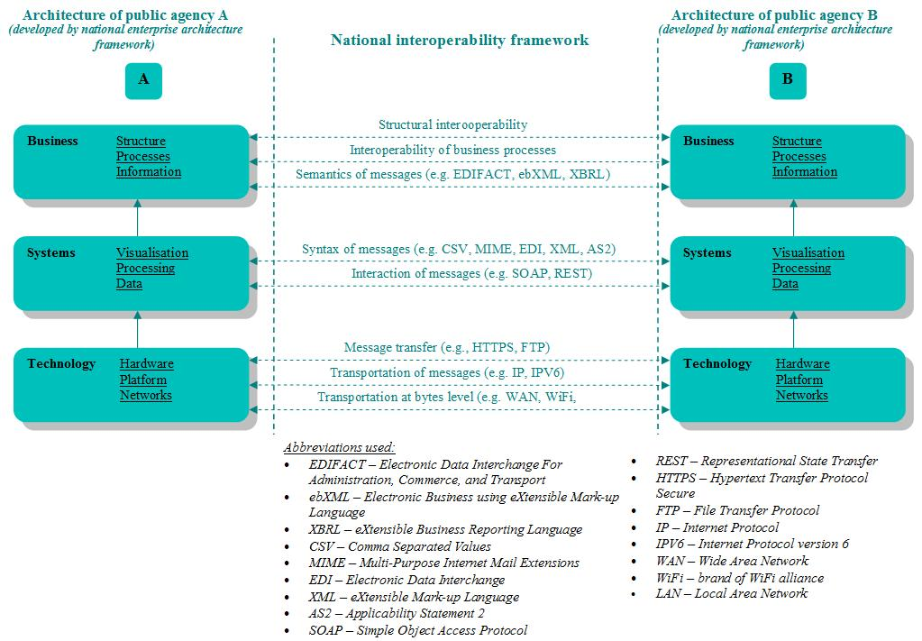
Figure 15. Linkage between enterprise architecture and interoperability framework
Source: Adopted from (Malotaux, Hahndiek, & Hazejager, 2009)
Several phases in e-government interoperability development can be identified (see Table 4). First of all, all relevant stakeholders and aims of interoperability have to be identified. Then structure for e-government interoperability development governance should be settled. It includes appointment of responsible authorities that would create and maintain national enterprise architecture or interoperability framework. Governance mechanisms should also define whether usage of standards and guidelines in enterprise architecture or interoperability framework will be enforced by law or optional. The third step is to select the framework for enterprise architecture description, and identify the main interoperability principles and guidelines. After publishing the first version of national enterprise architecture or interoperability framework, it should be continuously revised through selection of users’ feedback, assessment of benefits brought by the tool, and their usage outside the national borders.
Table 4. Stages of e-government interoperability development
No. | Stage | Description | Scenario of e-government interoperability development*
No. | Stage | Description | 1 | 2 | 3 | 4
1 | Policy, actors, and aims | - Identification of stakeholders  - Identification of goals, e. g. reduction of costs, effectiveness, reduction of bureaucracy | ✓ | ✓ | ✓ | ✓
2 | Governance structure | - It is one of the critical success factors in e-government interoperability development  - One or several institutions from central government are usually responsible for e-government interoperability development  - National enterprise architecture or interoperability framework can be mandatory or optional | ✓ | ✓ | ✓ | ✓
3 | Architecture frameworks | - Framework for description of enterprise architecture is selected |  |  | ✓ | ✓
4 | Principles and standards | - Identification of main principles (e.g. usage of open standards) and standards | ✓ | ✓ | ✓ | ✓
5 | Implementation | - First version of national enterprise architecture or interoperability framework is published and used  - Collecting of feedback, and release of new versions | ✓ | ✓ | ✓ | ✓
6 | Benefits | - Achieved benefits are measured and compared with initial aims of interoperability  - Modification of interoperability goals according to the achieved results | ✓ | ✓ | ✓ | ✓
7 | Assessment | - Usage of national enterprise architecture or interoperability framework outside the national borders | ✓ | ✓ | ✓ | ✓
*
1 – national interoperability framework oriented towards technological interoperability
2 – national interoperability framework consisting from all levels of interoperability
3 – hybrid approach using enterprise architecture along with national interoperability framework
4 – national enterprise architecture
Source: Adopted from (Janssen & Hjort-Madsen, 2007; Liimatainen, Hoffmann, & Heikkilä, 2007)
Gartner group according to the order of the European Commission has proposed a national interoperability framework observatory model. This model can be used to assess the maturity level of the process of e-government interoperability development, and compare your country in the context of other countries (Malotaux et al., 2009). The current state of e-government interoperability development is analysed through three perspectives: Context and principles, interoperability, and services support (ibid). The context and principles perspective defines the governance framework of the development of national interoperability framework. Interoperability perspective is used to identify the level of detail (e. g. number of standards used, list of principles and guidelines) of political, legal, organisational, semantic, and technological level of interoperability. The services support perspective describes tools that support the development and implementation of an interoperability framework. Based on the results of self-assessment, a presentation model of national interoperability framework is created. According to the results in interoperability, context, and principles each country can be positioned in one of four quadrants: Emerging, visionary or top-down, pragmatic and standards-oriented, or mature. Knowing its own position country can establish collaboration relationships in e-government interoperability development with those countries that are in the position which the original country wants to achieve.
Usage of such tools as enterprise architecture or interoperability frameworks for the development of e-government interoperability is a complex endeavour that faces various bureaucratic challenges and is often lead by the resistance to compliance with recommended standards and guidelines (Hjort-Madsen, 2007; Hjort-Madsen & Pries-Heje, 2009; Lallana, 2008; Veit & Parasie, 2009). Thus identification, assessment and development of dynamic capabilities for interoperability are crucial for successful application of these tools.

  - Toolkit for assessment of dynamic organisational capabilities for e-government interoperability
Though the most current definitions of e-government interoperability specify it as organisational capability, this aspect of the concept is still rarely addressed by the research. E-government interoperability is mainly perceived and analysed from the perspective of information systems development, the central issues being the choice of appropriate development model, avoidance of duplicate ICTs solutions in the public sector, and setting up the standards to ensure smooth interlink between different systems in diverse organisations. Meanwhile the aspect of organisational capability is usually overlooked or taken for granted as something that is already possessed by the public agencies but lacking ICTs sophistication.
Currently there are only a few studies attempting to identify what kind of dynamic organisational capabilities are needed to reach complex goals of e-government and improve interoperability of public administration on both technological and organisational levels. Klievink and Janssen have proposed the stage model for development of a joined-up government, and have identified five types of dynamic capabilities critical for its successful implementation: Technology, stakeholder, transformation, service delivery, and relationship (Klievink & Janssen, 2009). They have allocated certain dynamic capabilities for each of these layers (see Table 5) such as information systems development and design, systems integration, development of generic facilities, domain expertise, networking and relationship management, leadership, service portfolio management and other (ibid). However, the model does not offer any indicators for the assessment of the identified dynamic capabilities level.
Table 5. Dynamic capabilities used in the model of a joined-up government
Type of dynamic capability | Capability name | Short description of capability
Technology | Information system development and design | The ability to develop and design information systems to support processes and products
Technology | System integration | The ability to integrate disparate systems
Technology | System integration management | The ability to ensure business continuity, information quality and prevent data lost with networked system
Technology | Develop generic facilities | The ability to develop and exploit generic facilities which provides the building blocks for online service provisioning (e.g. a central authentication facility)
Technology | Domain expertise | Central organizations capability to apply and retain sufficient professional knowledge of the target process domain to meet user requirements
Technology | Architecture: integration and coordination | The ability to coordinate and integrate central facilities and local developments in a complex architecture
Stakeholder | Commitment and culture | The ability to create commitment of staff and a cooperative culture
Stakeholder | Networking and relationship management (within organisations) | The ability to network and build sustainable (e.g. trust based) relationship management within organizations
Stakeholder | Integration collaboration agreements | The ability to execute projects to integrate systems
Stakeholder | Motivation | The ability to motivate and manage people to deliver service with a ‘front office’ culture
Transformation | System integration project management | The ability to execute projects to integrate systems
Transformation | Enabling cooperation | The ability to overcome departmental differences and enable departments to cooperate to achieve a common goal
Transformation | External orientation | The ability to shift from an internal focus to a focus on developments for using it in their own service provisioning
Transformation | System project management | The ability to execute projects to integrate with central facilities
Transformation | Architecture: integration and coordination | The ability to coordinate and integrate central facilities and local developments in a complex architecture
Transformation | Architecture development and improvement | The ability to improve the current systems to fit within the enterprise architecture (this goes beyond integration)
Transformation | Planning | The ability to access resources required to create a plan for developing an integrated architecture
Transformation | Sourcing | The ability to support government organizations to  transform from a ‘build here’ approach to a ‘use’ approach
Transformation | Reconfiguration and transformation architecture | The ability to reconfigure and transform resources and assets, and the ability to share (modular) services with other agencies
Transformation | Leadership | The ability to overcome fragmentation and to achieve that (semi) autonomous organizations give up some of their own facilities
Transformation | Program management | The ability to initiate, prioritize and coordinate the series of inter-related change projects that are required for transformation
Service delivery | Service management | The ability to combine difference resources and systems for integrated service provisioning within the organization
Service delivery | Service and portfolio management | The ability to define service catalogues and portfolios
Service delivery | Identify user requirements | The ability to gain insight into user requirements concerning the services the users want and how the services should be offered
Service delivery | Controlling and education | The ability to transition users of an internally provided service to customers who make informed choices about service level, functionality and the costs they incur
Service delivery | Orchestration | The ability to orchestrate services provided by various parties into a single service end-user service
Service delivery | Orchestrate service delivery | The ability to manage and orchestrate service delivery across the entire government
Service delivery | Service governance | The ability of government organizations to define, track and assess the performance of central services over time
Relationship | Service level agreements | The ability to develop service level agreements with other organizations
Relationship | Central leadership | The ability to identify, communicate, and deliver the balance of activities required to achieve present and future success for both local and central governments
Relationship | Collaboration | The ability to collaborate closely with other organizations (public and private) to enable demand-driven service provisioning
Source: (Klievink & Janssen, 2009)
Since e-government initiatives are very complex and high risk projects, the assessment of capabilities can improve risk mitigation through the analysis of strengths and weaknesses of all collaborating organisations, and identification of the existing and missing capabilities crucial for the successful implementation of the endeavour (Cresswell, Pardo, Canestraro, & Dawes, 2005; Cresswell, Pardo, & Hassan, 2007). This would help policy makers to avoid currently too-ambitious e-government projects, and to invest into the programs with sufficient maturity level of capabilities herewith leading the organisations towards the improved capacity to implement more complex initiatives in the future (Pardo & Burke, 2008b).
Group of the USA researchers from the Center for Technology in Government has developed a comprehensive toolkit for the assessment of capabilities for e-government interoperability that identifies not only dynamic capabilities for e-government interoperability, but also offers criteria and methodology for their evaluation. The toolkit has been already tested in three different contexts of the public sector in the USA: Development of systems for access to electronic government information, information sharing and integration among criminal justice agencies, and digital preservation programs for born-digital government records (Cresswell et al., 2008). There are only slight differences between these three versions, the toolkit of digital preservation missing the dimension of “organisational compatibility”, and consisting of four additional context-specific capability dimensions: Obtaining digital material, maintaining comprehension and authenticity, accessibility of digital material, and digital content (Theresa A. Pardo et al., 2005).
The framework has undergone three phases of consultations with the experts in criminal justice information sharing that were accompanied by the approval stage before the release of its final version (see Figure 16).
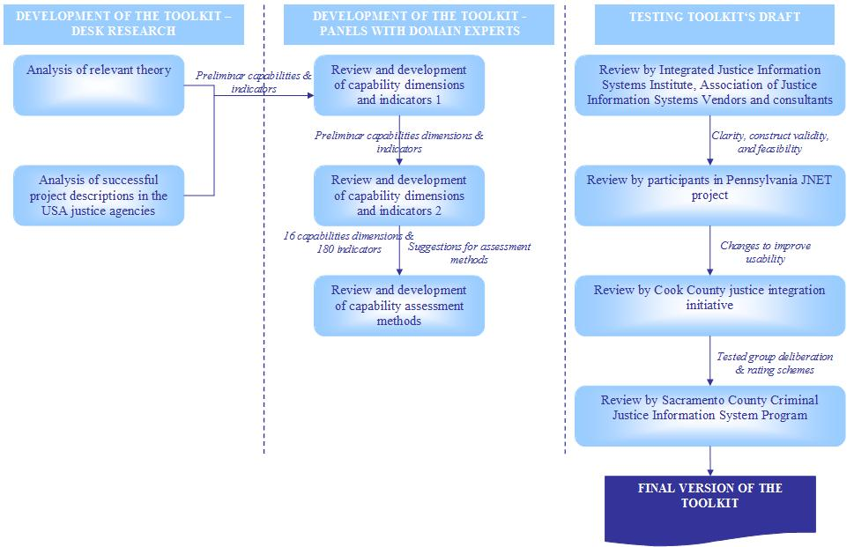
Figure 16. Development process of e-government interoperability capability assessment toolkit in the context of justice information sharing
Source: Adopted by author from (Cresswell et al., 2007)
Dynamic capabilities identified in the toolkit are different in nature, and could be classified into three types: Environment, organisation, semantics and technology. Thus this framework addresses not only technological, but also political and organisational aspects of e-government interoperability. There are 16 dynamic capabilities and 179 indicators for the assessment of the maturity level of each used in the toolkit (see Figure 17 and Table 6).
Table 6. Descriptions of dynamic capabilities used in e-government capability assessment toolkit
Type of dynamic capability | Name of dynamic capability | Short description of capability
Environment | Leaders and champions | The involvement of leaders and champions. Leaders motivate, build commitment, guide activities, encourage creativity and innovation, and mobilize resources; they see the goal clearly and craft plans to achieve it. Champions communicate a clear and persuasive vision for an initiative, provide the authority and legitimacy for action, and build support in the environment.
Environment | Governance | The existence of mechanisms to set policy and direct and oversee the information sharing initiatives that are planned or underway.
Environment | Collaboration readiness | The degree to which relationships among information users and other resources support collaboration; these include staff, budget, training, and technology, and prior successes or failures in collaborative activities.
Environment | Organisational compatibility | The degree to which the work styles and interpersonal relationships, participation in decision-making, levels of competition and collaboration, and styles of conflict resolution support information sharing.
Environment | Stakeholder identification and engagement | The extent of awareness of and interaction with the persons or groups with an interest in the information sharing initiative and capacity to influence it.
Organisation | Strategic planning | The quality and comprehensiveness of strategic plans and strategic planning processes, including resources and integration of strategic planning with other elements of governance and management.
Organisation | Performance evaluation | The presence of the skills, resources, and authority necessary to observe, document, and measure: (1) how well the initiative itself is developed and implemented, (2) whether information sharing goals are achieved, and (3) how the performance of the justice enterprise is improved.
Organisation | Project management | The availability and use of methods for goal setting, scheduling development and production activities, analyzing resource needs, managing interdependencies among activities and goals, and provisions to anticipate and respond to contingencies.
Organisation | Resource management | The extent of effective use of financial, human, and technical resources through budgeting, strategic plans, financial analyses, and accepted financial management procedures and practices.
Organisation | Technology acceptance | The extent of talk and actions expressing positive or negative attitudes toward workplace changes, trust of new tools and techniques, success or failure stories that are widely shared and believed, and enthusiasm for innovations.
Semantics and technology | Business model and architecture | The degree to which the initiative has developed business models and enterprise architectures that describe the service and operational components of the enterprise, how they are connected to each other, and what technologies are used to implement them.
Semantics and technology | Information policy | The level of development of policies that deal with the collection, use, dissemination, and storage of information as well as with privacy, confidentiality, and security.
Semantics and technology | Technology knowledge | The levels of knowledge about current and emerging technology for information sharing, including technical qualifications and experience of staff, records and documentation of technology assets, and the actions of staff in compiling, storing, and sharing such knowledge.
Semantics and technology | Technology compatibility | The presence of agreed-upon standards, the extent of connectivity among the persons and organizations seeking to share information, and the experiences of staff with information sharing activities.
Semantics and technology | Data assets and requirements | The extent of specification and identification of formal policies for data collection, use, storage, and handling, as found in documentation of databases and record systems; and in data quality standards and dictionaries.
Semantics and technology | Secure environment | The degree to which appropriate security protocols for data, systems, applications, and networks as well as systems, policies, training, and management practices are in place.
Source: (Cresswell et al., 2005)
In comparison with dynamic capabilities identified by Klievink and Janssen, dynamic capabilities for service delivery, development of generic facilities (e. g. unified solutions for authentication), program management, sourcing, and central leadership could be included in the toolkit in order to increase its comprehensiveness and applicability not only in case of particular e-government initiatives, but also for e-government planning on both national as well as international levels.
DIMENSIONS OF E-GOVERNMENT INTEROPERABILITY CAPABILITY
ENVIRONMENT
ORGANISATION
SEMANTICS & TECHNOLOGY
Leaders & Champions
Governance
Collaboration readiness
Organisational compatibility
Stakeholder Identification & Engagement
Strategic planning
Performance evaluation
Project management
Resource management
Technology acceptance
Business model & Architecture
Information Policy
Technology knowledge
Technology compatibility
Data assets & Requirements
Secure environment
LEVEL OF DIMENSION X
Figure 17. Structure of e-government interoperability capability assessment toolkit
Source: Adopted by the author from (Cresswell, Pardo, Canestraro, Dawes, & Juraga, 2005; Pardo & Burke, 2008b)
Theoretical foundations of the toolkit lie in the research on capability models, strategic management, information systems development, and theories of social practice (Cresswell, Pardo, & Canestraro, 2008; Cresswell et al., 2007). Concept of organisational capability for e-government interoperability was formulated referencing to resource-based and routine-based views on dynamic organisational capabilities (ibid). Levels of capability for e-government interoperability were identified using the principles of Capability Maturity Model Integration, Organisational Interoperability Maturity Model for C2, Interoperability Maturity Model, and other (ibid). Dimensions and indicators of capability for e-government interoperability are based on strategic management theory, information systems research, organisational science, and social practice theory (ibid).
The assessment of organisational capabilities for e-government interoperability can be split up into three stages (see Figure 18) of preparation, capability assessment, and usage of results (Cresswell et al., 2008; Cresswell, Pardo, Canestraro, Dawes, & Juraga, 2005).
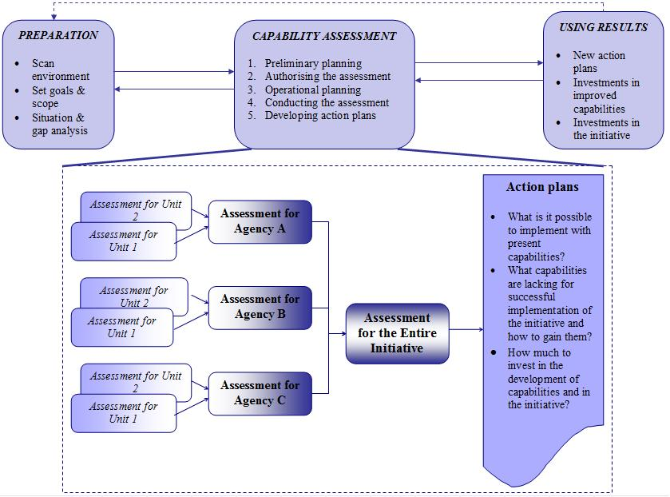
Figure 18. Using the toolkit for the assessment of capabilities for e-government interoperability
Source: Adopted by the author from (Cresswell et al., 2005)
During preparation phase the environment where the assessment will take place is analysed. Capability assessment phase consists of preliminary planning, authorization of the assessment, operational planning, conduction of the assessment, and development of action plans. During the preliminary planning all the participants are introduced to the toolkit, and have to tailor it to the specific needs of the initiative. The team of the assessment organisers and planners is established and taught how to conduct the assessment. The usage of the toolkit does not need the participation of the external consultants, except if the organization wants that. Finally the assessment’s business case is created and authorized by the leaders.
Operational planning is dedicated for the selection of people who will do the assessment according to their knowledge about the dimensions of capabilities. Then the dimensions are assigned to the participants. Some of them can rate only several dimensions, meanwhile the others will work with all sixteen (e. g. policymakers may not be aware about the technological issues, and technology people may not possess the knowledge about the organizational issues).
The assessment can be conducted on three different levels: Unit level of each participating organisation, organisational level, and the level of entire initiative. Each dimension is broken down into the sub-dimensions that are assessed by the participants. They have to assess each statement using the Likert scale (strongly agree “SA”, agree “A”, neutral “N”, disagree “D” and strongly disagree “SD”), then to provide the evidence for their opinion and according to the “depth” of evidence they have to identify what is their confidence in assessment. The confidence can be high (assessment is supported by the strong evidence), medium (assessment is supported by weak evidence) or low (there is no evidence).
Each capability dimension reveals the level of the organisational capabilities in that dimension, which can be somewhere in the continuum between high and low level ends. There are two ways how to measure the level of organisational capabilities in each dimension: Qualitative form and quantitative form (see Table 7).
Table 7. Overview of the methods for measurement of the level of dynamic organisational capabilities
Method | Form | Procedure | When to apply?
Visual summary | Qualitative | - Before the review meeting participants indicate their agreement level to each sub-dimensional statement based on their confidence and available evidence.  - During the review meeting group facilitator prepares special cards with the dimension name and agreement levels.  - Each participant based on their individual ratings puts a coloured dot into every card, green dot representing high agreement level, yellow dot – medium agreement level, and red dot – low agreement level.  - The overall rating for each dimension is decided after the common discussion, which takes into account individual ratings, confidence level of participants and the available evidence. | This method is good to foster the discussion about each dimension.
Summary scores | Quantitative | There are three ways to carry out summary scores method:  - Simple average score. Each answer to the sub-dimensional statement equals to some number (SA – 5, A – 4, N – 3, D – 2, SD – 1, Don’t Know – 0). The result of this dimension score is the simple average score, the average rounded to the nearest tenth. The Confidence and Evidence are not taken into account here.  - Weighted average score. Here each sub-dimension has its weight as some sub-dimensions can be considered as being more important than the others (weights are being decided during the discussion). Consider using weights from 1 (not important at all) to 10 (extremely important). The score for the dimension is then equal to: (Sub-Dimension Weight*Sub-Dimension Score)/Number of Sub-Dimensions.  - Average score using confidence. The simple or weighted average scores can be used in this method, and the reduction of the score due to the confidence must be specified. E. g. use 80 per cent of score if the confidence is Medium and 60 per cent of the rating if the confidence is Low. The scores are then multiplied by the reduction rate and the average for dimension is calculated. | This method is applied when numeric scores of e-government interoperability capability maturity are desired.
Source: Adopted by the author from (Cresswell et al., 2005)
Based on the results calculated for the entire initiative action, plans are created for the improvement of organisational capabilities, and proceeding further with the implementation of the initiative. Though the action plans are supposed to be prepared for the entire initiative, each participating unit/ agency can also develop its own action plans based on their individual assessment results in order to build some lacking capabilities or to strengthen the existing ones.
On the assessment’s final phase of using results the project plan of the initiative can be tailored to the current abilities of the participating institutions to implement it, investing in improvement of capabilities as well as on some actions of the initiative that can be already implemented with the existing capabilities. Using results have an impact on the performance of the initiative as well as on the organisational capabilities, so there is a feedback relation with the preparation phase, as well as the links between each of the assessment phases (see Figure 18).
Sometimes the assessment might not be very objective as the participants would like to show weaker than they really are in order to get new resources or other benefits, so it is really very important to select right participants, to ensure their trust, and willingness to extend the assessment as long as it is needed to achieve reliable results (Cresswell et al., 2005; Cresswell et al., 2005).

  - Impact of context on practices of dynamic organisational capabilities for e-government interoperability
    - Contextualisation of organisational research
Mark A. Griffin in the editorial of Journal of Organizational Behaviour has overviewed diverse approaches of organisational research contextualisation that could serve for the analysis of impact of various levels of context on a particular phenomena as well as for explanations how the context is shaped by the phenomena itself, herewith emphasizing that an agreement on some universal method for contextualisation is unlikely (Griffin, 2007). He defined the context as “the set of circumstances in which phenomena (e. g. events, processes or entities) are situated” and provided with opportunities as well as constraints (ibid).
Johns explains the context as “situational opportunities and constraints that affect the occurrence and meaning of organizational behaviour as well as functional relationships between variables” (Johns, 2006) by referring to the definitions of context by Cappelli and Sherer (Cappelli & Sherer, 1991), and Mowday and Sutton (Mowday & Sutton, 1993). The first researchers have characterised context as “the surroundings associated with phenomena which help to illuminate that phenomena, typically factors associated with units of analysis above those expressly under investigation” (Cappelli & Sherer, 1991) where individuals act upon some internal organisational factors and organisations operate under the external environmental conditions (Johns, 2006). Mowday and Sutton have described the context as “stimuli and phenomena that surround and thus exist in the environment external to the individual, most often at a different level of analysis” (Mowday & Sutton, 1993) and consisting of constraints and opportunities (Johns, 2006).
The variations of the above definitions of context are similar in a way that all of them describe context as a set of conditions (internal as well as external) in which a particular phenomenon exists, and that might constrain as well as enforce that phenomenon. Contextualisation of research is being aware of these conditions, and linking different kind of relevant information, events, processes, and attitudes to better understand and study the phenomenon by consequently improving the interpretation of research results (Rosseau & Fried, 2001; Johns, 2006). Contextualisation has to be an integral part of the overall research design starting from hypothesis building, sampling, choice of research methods, data gathering and analysis, and reporting (ibid).
Organisational research is gradually becoming international, and therefore it could be criticised for currently being too much de-contextualised due to the aims of generalisation of its results (Rosseau & Fried, 2001). Omitting the context or taking it for granted often leads to the studies that are difficult to interpret and replicate by other scholars, and might lead to the unpredictable distortions of “universal” theories when trying to apply them in different than the original contexts (Johns, 2006).
There are ways leading to better research contextualisation, and informing future researchers about what has been included and excluded from the particular inquiry as it is not possible to study all contextual factors in one piece of work (Rosseau & Fried, 2001). Rousseau and Fried have offered a 3 Tier approach to the contextualisation of organisational research (ibid):
- Tier 1: Rich description. It includes a rich description of research setting that embodies organisational factors (e. g. firm life cycle, structure, recent changes, current problems faced, relevant cultural factors like norms and values, etc.), worker-job factors (e. g. roles, performance criteria, demographics, etc.), external environment (economy, location, legal/ institutional, national culture, etc.). This tier recommends a comparison of contexts when doing literature review of prior research, and examining the meanings of certain concepts that might shift in different contexts. The role of time is also emphasized here as some events that have happened or are happening while doing the research, might affect the relationships among variables and their meaning.
- Tier 2: Direct observation and analysis of contextual effects. This tier is used when the aim of research is to study contextual impact on some phenomenon. Usually it involves direct assessment of contextual variables (e. g. including them into the survey), focusing on the events that have multilevel implications (e. g. organisational change initiatives) or examining the bundles of practices implemented across different settings.
- Tier 3: Comparative studies. This kind of research is oriented towards examination of phenomena in different institutional and cultural environments (e. g. cross-national studies). It is recommended to describe the phenomena in each setting separately, then identify common features, establish a framework for comparing functionality and significance in every context, define how the phenomena might vary across the settings, and choose appropriate methods for data gathering and analysis (e. g. use back translation to avoid misunderstandings of the concepts).
Johns has proposed to use the omnibus and discrete contexts analysis in the research (Johns, 2006). Omnibus context refers to the context in its broadest sense, meanwhile discrete context consist of concrete variables that have a direct impact on the object of study (ibid). Discrete context is nested in the omnibus context and serves as a mediator of its effects (ibid).
The analysis of omnibus context takes a journalism practice of telling a good story, and requires answering such questions (ibid):
- Who, or occupational and demographic context of participants and those who surround them;
- Where, or location of the research site (region, culture, industry, etc.);
- When, or time of research and events happening;
- Why, or rationale for conducting the research that might have an effect on such discrete context variable as accountability of respondents.
Discrete context is made up from task context (e. g. autonomy, uncertainty, accountability), social context (e. g. social density, social structure, social influence), and physical context (e. g. working equipment, working environment) (ibid). These suggestions for the contextualisation of research suggest that various contextual factors should be analysed in interaction. It might lead to more interesting insights and would be helpful in explaining the variations of contextual impacts impossible when analysing each factor in isolation (ibid).
These principles recommended to use in organisational research could be also applied in the studies on dynamic organisational capabilities and e-government interoperability when integrated with their own specific aspects of contextualisation that are analysed in the following sub-chapters.

    - Context in evolution of dynamic organisational capabilities
Theoretical roots of organisational capabilities lie in the evolutionary and behavioural theories of economics and management (Becker, 2004) where routines are considered as genes of organisation that help it to evolve, adapt to rapidly changing environment, and fulfil its mission. Routines being the building block of dynamic organisational capabilities, allow analysing the latter concept not merely as a context dependent processes of the firm, but also as a part of organisational context.
Recent research on micro-foundations of dynamic organisational capabilities (David J. Teece, 2009) as well as their initial framework (David J. Teece et al., 1997) reveal that classical contextual factors typically addressed by domain’s scholars as history of the firm, its operating environment, learning mechanisms, time, or organisational structure are not enough to deepen knowledge on how organisational capabilities are perceived, developed and practiced. More insights could be gained if the exceptional feature of dynamic organisational capabilities being highly process-oriented would be taken into account, and a new factor of processes used in evolution of dynamic organisational capabilities would be added to the traditional contextualisation.
Analysis of context in the research of organisational capabilities in private as well as public sector is also very important due to the replication and imitation competences crucial in the practice of dynamic organisational capabilities. Theory defines replication as redeploying your own capabilities to other economic setting, meanwhile imitation is understood as trying to use best practice of others inside your firm (David J. Teece et al., 1997; Dosi, Nelson, & Winter, 2000). In case of e-government, replication would be using own capabilities for the implementation of various e-government initiatives, and imitation would be trying apply the best practice of other institutions as well as countries. However, if one does not posses the understanding of its own processes, assets, and previous experience, replication and moreover imitation are going to be difficult to achieve.
When the original definition of dynamic capabilities was proposed in 1997, it went along with 3Ps approach of processes, asset positions, and paths (David J. Teece et al., 1997). It was used for the analysis of the evolution of dynamic capabilities, and further elaborated in 2000 and 2007 (Constance E. Helfat et al., 2007; Dosi et al., 2000). In this approach organisational and managerial processes are at the centre of the development of dynamic organisational capabilities, especially the processes of coordination and integration of internal and external assets and technologies, learning, and reconfiguration of resource base.
Learning processes are the most important because they allow increasing the dynamics of organisation, foster exchange of inter-organisational knowledge, and are considered as a source of dynamic capabilities. Zollo and Winter have described a cycle of dynamic capabilities evolution in terms of organisational knowledge (Zollo & Sidney G. Winter, 2002) constructed from 4 elements of generative variation, internal selection, replication, and retention (see Figure 19). Along with this cycle they identified three types of organisational learning processes – as experience accumulation, knowledge articulation, and codification – by emphasizing the importance of the explicitness in learning as it helps to build better and more evolutionary fitting dynamic capabilities (ibid). However, some researchers state that a high level of explicitness and routinisation brings competitive advantage only in moderately stable environments, and in high velocity or rapidly changing markets dynamic capabilities should rely more on simple, experimental and agile processes (Kathleen M. Eisenhardt & J. A. Martin, 2000).
Gary P. Pisano has identified two types of learning usually used for gaining or improving dynamic capabilities: Learning before doing and learning by doing (Gary P. Pisano, 2000). He stressed that some firms are better at the first approach; meanwhile the others are better at the second one.
Figure 19. Evolution of dynamic capabilities as organisational knowledge
Source: (Zollo & Sidney G. Winter, 2002)
Learning and knowledge management are very important in e-government projects, especially those that require a high level of interoperability. However, there is not much evidence of how public institutions develop or improve their dynamic organisational capabilities to implement complex ICTs projects by using different learning mechanisms identified above. It would be difficult to find evidence how public agencies accumulate and codify their experience, articulate knowledge inside and outside organisational boundaries, do they apply learning before doing or learning by doing approach.
Another element from 3Ps approach is asset position. Concerns over movements of asset value also put limits on the development of dynamic capabilities. Technological assets are related to intellectual property rights, and the better the technology that organisation possesses the better opportunities it has. Other assets include complementary assets, financial assets, reputation assets, structural assets, institutional assets, and organisational boundaries.
Paths are another constraint for dynamic capabilities evolution as where the firm can strategically go is limited to what it has learned or experienced in the past (Gary P. Pisano, 2000), as well as to the level of organisational imprint at the newborn organisation when capabilities are mostly assimilated from individuals with different backgrounds and working experiences (Narduzzo, Rocco, & Warglien, 2000; Argote & Darr, 2000). This is so called path-dependency that is already been shown to have a high impact on the decisions of leaders and executives when selecting or deselecting dynamic capabilities with the best evolutionary fit for their organisation (Constance E. Helfat et al., 2007). It was noticed that the effect of “negative transfer” used in psychology could be found in the strategic management of organisations when companies rely on their past success and think that the capabilities that worked well then will be perfectly suited for reaching future targets (ibid). This way of thinking leads to a tendency that executives can fail to react, even having all the data, to environmental changes, and can fail to take any actions to adapt their organisations to new operational circumstances on time (ibid).
The assessment of a firm’s dynamic organisational capabilities is a function of these 3Ps. Two yard-sticks are used to assess the dynamic capabilities: Technical fitness, and evolutionary or entrepreneurial fitness (Constance E. Helfat et al., 2007; David J. Teece, 2007). Technical fitness measures the effectiveness of capabilities functioning, and evolutionary fitness shows how well dynamic capabilities are helping for an organisation to survive and compete in changing environment (ibid).
These yardsticks and 3Ps approach are then used to analyse how micro-foundational dynamic capabilities of sensing, seizing, and managing threats (see Figure 20) are performed and what benefits do they bring for an organisation (David J. Teece, 2007, 2009; Augier & David J. Teece, 2006). Dynamic capability for sensing opportunities and threats is constructed from the processes of directing internal research and development, selecting new technologies to support business activities, monitoring exogenous science and technology inventions, following innovations by suppliers and competitors, and analysing environmental context to meet customer needs (ibid). This capability is inherent in learning processes within the organisation, and much influenced by institutional assets such as regulation, standard-setting bodies, laws, business ethics, and other contextual constraints (ibid). Sensing is closely related with organisation’s path formation: When new opportunities are noticed, there has to be an operative response from managers that would propose new evolutionary path that organisation has to take in order to benefit from emerging possibilities (ibid).
Dynamic capability of seizing opportunities is closely related with strategic decision making and execution skills, and consists of such processes as adjusting business model to new customer solutions, setting enterprise boundaries in order to implement new business model right, selecting decision-making protocols, and building loyalty and commitment for changes (ibid). Seizing opportunities depends not only on the technological assets that organisation possesses, but on institutional and organisational design as well. It plays an important role in successful implementation of new business models (ibid). This dynamic capability is very strongly influenced by path-dependency. The path-dependancy would be evident in cases where an enterprise sees an opportunity, but fails to benefit from it due to stronger support for current programs that limits investments in innovative proposals (ibid).

Figure 20. Framework of microfoundations of dynamic organisational capabilities and business performance
Source: (David J. Teece, 2007)
The capability of managing threats and reconfiguration deals with the processes of decentralization, co-specialization, governance, and knowledge management (ibid). This capability helps to overcome barriers created by path-dependency and existing asset inflexibility, such as hierarchical structures supporting stiff routines, assets that do not complement each other, governance principles hostile to creativity and innovation, and learning mechanisms that do not support knowledge sharing and know-how integration (ibid).
Contextualisation principles common to overall research on organisations and specific for dynamic organisational capabilities approach are summarized in Table 8.
Table 8. Contextualisation principles used in organisational research and research on dynamic capabilities
Contextualisation approach | Layers of context | Contextual factors | Applied in
Contextualisation approach | Layers of context | Contextual factors | Organisational research | Research on dynamic capabilities
3 Tier | Tier 1: Rich description | - Organisational factors  - Worker-job factors  - External environment  - Time | ✓ | ✓
3 Tier | Tier 2: Direct observation and analysis of contextual factors | Direct observation of:  - Factors from Tier 1  - Events with multilevel implications  - Bundle of practices implemented across different settings | ✓ | ✓
3 Tier | Tier 3: Comparative studies | - Institutional factors  - Cultural factors | ✓ | ✓
Omnibus and discrete contexts | Omnibus context | - Occupational and demographic factors  - Location  - Time  - Rationale for research that might affect the discrete context | ✓ | ✓
Omnibus and discrete contexts | Discrete context | - Task factors  - Social factors  - Physical factors | ✓ | ✓
3Ps | Processes | - Coordination and integration of internal and external assets and technologies  - Learning  - Reconfiguration of resource base |  | ✓
3Ps | Asset position | - Technological assets  - Complementary assets  - Financial assets  - Reputation assets  - Structural assets  - Institutional assets  - Organisational boundaries |  | ✓
3Ps | Path-dependency | – |  | ✓
Evaluation yardsticks | - Technical fitness  - Evolutionary fitness | – |  | ✓
Microfoundations of dynamic capabilities | Dynamic capabilities of:  - Sensing  - Seizing  - Managing threats/ Transforming | See Figure 20 above |  | ✓
Source: Composed by the author
Though the impact of context is addressed through general (e. g. operating environment, time, organisational structure) as well as specific (e. g. processes, assets, path-dependency) factors, the theory of dynamic capabilities still can be criticized as being too much oriented towards strategy formulation by top management only, and exclusive emphasis on the economic context (Regnér, 2008). Therefore it is increasingly suggested to complement the dynamic capabilities view with other approaches, such as strategy-as-practice, and consideration of creativity and imagination, social and cultural contexts, role of other organisational levels in formulation of strategy and management of organisational assets (ibid).

    - The role of context in the development of e-government interoperability
Usually a research on various issues of e-government development, including its interoperability, is carried out within the boundaries of a particular country, government agency or initiative but offers generalising results supposing they could be replicated by the researchers and applied by the practitioners from different environments. The classical examples might include vast majority of e-government development models, attempts to identify success and failures of e-government initiatives, studies of e-government interoperability frameworks, or research on alignment of ICTs and business goals in government through such tools as enterprise architecture.
Even if e-government research takes the form of a comparative study, it often would choose the objects with similar or the same political, economical, organisational, and societal characteristics as the units of analysis. For example, Janssen and Hjort-Madsen have used self-developed analysis framework to compare the adoption of national enterprise architecture in two similar countries like the Netherlands and Denmark (Janssen & Hjort-Madsen, 2007). Luis Guijarro has analysed the similarities and differences of the approaches towards e-government interoperability by examining the cases of United Kingdom, France, Germany, Denmark, and the USA (Luis Guijarro, 2007). United Nations in their handbook of e-government interoperability frameworks development attempt to address the audience from the developing as well as developed countries but also refers only to the best practice of seven countries with already several years of experience in the field like Australia, Brazil, Denmark, Germany, Malaysia, New Zealand, and the United Kingdom (United Nations, 2007b, 2007a). Yet recent, highly-contextualised and one of the largest available comparative studies on growth of e-government conducted by Dunleavy et al observes exclusively developed countries like the USA, Japan, the United Kingdom, Canada, Australia, Netherlands, and New Zealand (Dunleavy et al., 2008).
The aforementioned study by Dunleavy et al could be considered as a good illustration of e-government research contextualisation. Though oriented towards developed countries, it uses a context-oriented framework for comparative analysis that could be applied to explain singularities of e-government development in developing countries as well. It is grounded in theory of modern bureaucracy and NPM paradigm, and uses two explanatory variables of government institutional arrangements and the power of IT industry on government agencies, along with performance of government IT systems as dependant variable (Dunleavy et al., 2008). The operationalization of variables is provided in Table 9.
Table 9. Contextualisation of cross-national research on performance of government IT systems
Variable | Dimensions of variable
Government institutional arrangements (independent variable) | - Checks and balances in fundamental governance arrangements.  - The openness of bureaucratic culture to technical expertise.  - The openness to new public management reforms.  - Presence of strong, central, political-administrative support for e-government.
The power of IT industry on government agencies  (independent variable) | - The extent to which government IT contracting has moved away from effective competition.  - Strong market dominance by the top five firms.  - Government’s lack of in-house capabilities.
Performance of government IT systems (dependant variable) | - The scrap rate of government IT projects.  - The price comparability of public sector to private sector IT.  - The relative modernity of government IT systems.
Adopted from (Dunleavy et al., 2008)
Though the impacts of government institutional arrangements on performance of government IT systems were not as strong as it has been expected by the researchers, the influence of IT industry’s power has proved to be significant. The leading countries succeeded in maintaining the intense competition among their ICTs vendors, retained important capabilities for managing and developing ICTs solution, and avoided becoming dependant on big IT companies in the market (ibid).
Although such context-similar comparative analysis is unarguably valuable in searching for universal e-government development and implementation approaches, there is a tendency that e-government research findings and best practices are transferred from mature to less mature settings more frequently than vice versa (Heeks, 2004). Therefore more profound inquiries of the organisation and outcomes of transfer of e-government practices between essentially different contexts are needed.
Heeks has identified three inter-related layers of e-government context which affect the success of any e-government project: Invention context, design context, and deployment context (Heeks, 2004). The invention context represents the domain of various already-invented and re-usable e-government technologies. The design context represents the environment where there is an attempt to adopt an already existing technology or approach, and the deployment context is the context where designed technology is being utilized. The deployment context is changed by the technology, as well as its operation is constrained by the users (ibid).
The mechanisms of “global transfers” of e-government development approaches and technologies have also to be considered when analysing the context (ibid). They are classified into 4 categories: International donor agencies (e. g. United Nations, World Bank, EU), consultants, IT vendors, and Western-trained civil servants (ibid). Heeks also argues that the number of “public hybrids”, i.e. employees having education and expertise in both technological and business domain, positively effect the outcomes of e-government initiatives (Heeks, 2006).
Chen et al argued that the main differences between developed and developing countries lies in history and culture, technical staff, infrastructure, citizens, and government officers (Y. N. Chen, H. M. Chen, Huang, & Ching, 2006). Based on these differences they have proposed a framework for the analysis of e-government strategies in the developed and developing countries including the dimensions of national e-government infrastructure which is similar to the e-government readiness index used by the United Nations, culture, and society (see Figure 21).

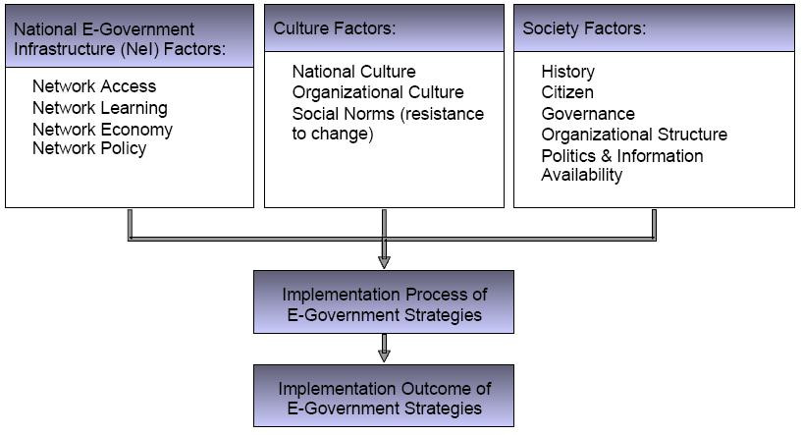
Figure 21. Research framework for analysis of e-government strategies in developed and developing countries
Source: (Y. N. Chen et al., 2006)
Ramaswamy and Selian based on the analysis of Armenia have identified 7 contextual differences between developed and post-communist countries that might affect e-government (Ramaswamy & Selian, 2007):
- Low level of information publicity and a high level of information possessiveness.
- Clarification and simplification of procedures are not considered as a priority.
- Highly centralised political culture.
- Absence or a weak role of IT departments in government agencies.
- Absence or weak evidence of collaborative networks and social capital for exploring every possibility to work together in order to achieve mutual goals.
- Financial barriers.
- Lack of interoperability and standardisation.
Other authors have more focused their research on the micro level factors impacting one particular aspect of e-government development. As well as Dunleavy et al (Dunleavy et al., 2008), in his research Scholl emphasized the role of government sourcing policy to the organisational capabilities for development of complex e-government systems (Hans Jochen Scholl, 2006). He concluded that e-government systems require a high level of integration with one another as well as with the internal systems of information management, interoperability being a central issue of government’s ICT sourcing policy (ibid). According to Scholl, the higher level of outsourcing, the higher possibility to achieve vendor lock-in and loose independence from the vendors. He suggested that at least a systems’ integration need to be done at least partially inside the agencies. Even if ICTs development can be seen as a commodity-type of good and be practiced in full outsourcing mode, the capabilities of planning, managing and adopting developed ICTs solutions be it PMIS or e-government systems, still needs to be practiced by public institution itself (ibid).
Hinnant and Welch have studied the linkage between individual perceptions of self-efficacy of public servants to use ICTs and their perception of ICTs effects on the overall operation of their institution (Hinnant & Welch, 2002). Their survey of 2000 USA state government program managers from across all 50 states has proved the positive linkage between computer self-efficacy and available training in ICTs within the organisation, the significance of ICTs to complete their managerial tasks, and perceptions of ICTs impacts on improvement of organisational processes (ibid). Meanwhile, manager’s prior experience working with ICTs and the level of their educations did not proved to be statistically important. The survey also revealed that public servants from some functional areas as education, environment, health, social services, and labour that heavily relies of ICTs solutions more positively perceive the impact of ICTs on the overall processes of their institutions. Quality of organisation’s ICTs strategic plans and management are also positively related to perceptions of ICTs (ibid).
Kim and Bretschneider argued that managerial capability of ICTs manager through the interaction with support from administrative authorities and financial support have an impact on overall ICTs capacity of local government agencies (H. J. Kim & Bretschneider, 2004). Their interviews with government managers revealed that managerial capabilities are not as important to overall ICTs capacity of municipality as are support from administrative authorities and finances. The latter can compensate the lack of managerial capabilities when in the meantime strong managerial capabilities cannot be compensated by the absence of financial support and interest of authorities in ICTs innovation (ibid). After the research, authors have also emphasized that municipalities with higher ICTs capacity see the recommendations from state government as a barrier for further progress, and less capable municipalities have treated the support from state government as an important contribution to foster e-government development (ibid). They have also stressed the importance of interpersonal and structural relationship between ICT managers and top administrators in municipality as a driving force to strengthen capabilities of ICTs manager (ibid).
Kim and Lee have studied the impact of organisational context and ICTs on knowledge sharing capabilities of private and public sector organisations in South Korea (S. Kim & H. Lee, 2006). The research survey proved the significance of social networking, centralisation, performance-based reward systems, and information technology to the knowledge sharing capabilities in both private and public sectors (ibid). Years of experience were positively correlated with knowledge sharing in public sector (ibid).
Another way for contextualisation of e-government research is through the lenses of institutional theory that is more and more often applied to analyse implementation, adoption, and usage of ICTs in public as well as private sectors (Teo, Wei, & Benbasat, 2003; Wanda J. Orlikowski & Bariey, 2001). Based on neo-institutional theory Jane Fountain has developed technology enactment framework (see Figure 22) for understanding the impact of the institutional arrangements existing in the public sector organisations on the perceptions, understanding, implementation, and usage of ICTs by the public managers (Jane E. Fountain, 2001).
Objective information technologies
Enacted technologies
Outcomes
Organisational forms

Bureaucracy networks
Institutional arrangements
Figure 22. Technology enactment framework
Source: (Jane E. Fountain, 2001)
Referring to the institutional theory, a clear distinction was made between organisation and institution in the framework that serve as a medium for the ICTs enactment. Organisational forms are treated here as instruments for the execution and control of the business processes of production or service provision. As more and more governmental programs are oriented towards several instead of a single agency, networked organisation is also included in the framework (ibid). Institutions are understood as rules, requirements, norms, and beliefs through which organisations receive their legitimacy and authorization to act. Organisations and institutions serve as a mechanism for the transformation of objective technologies (e. g. Internet, off-the-shelf software) into enacted technologies that reflect the perceptions of their users, are being shaped by the operational context, and might also change the organisational and institutional setting in which they are embedded as well as determine the character of the final outcomes (ibid).
Kaifeng Yang has criticized Fountain’s technology enactment framework as being too much focused on constrains of organisational and institutional factors, and failing to reveal how they could facilitate the development of e-government in a long term perspective (K. Yang, 2003). Yang has suggested concentrating more on the possibilities than constrains of institutions, and searching for new forms of strategic management that could help to reshape current institutional environment and fit it into the technological evolution (ibid).
Aby Jain has used Max Weber’s theory of bureaucracy that is also considered as a part of institutional theory (Scott, 2008) to examine two possible directions of e-government development (Jain, 2004). The first direction tends to see e-government as a tool to reform bureaucracy through challenging such bureaucratic elements as stove piped processes, organisation of information by the agency, poor collaboration and information sharing (ibid). The second direction considers the failure of e-government development due to the high level of bureaucracy that is not only linked to such negative factors as corruption, inefficiency, concentration on power, or poor decision-making, but also condition different complex institutional arrangements. For example, when practiced rules are the ends themselves, they become serious obstacles for public agencies to reach their goals (ibid). Sometimes some organisational sub-units tend to gain more power and put their goals to the first place before the goals of overall organisation (ibid). Often public managers are resistant to change as they feel safer by following the well-established rules instead of trying out something new (ibid).
Another example of e-government research using institutional theory is a study by Hjort-Madsen who has developed an analytical framework for the analysis of the adoption of federal enterprise architecture in the USA (Hjort-Madsen, 2007). The framework was made up from three components of institutional field, organisational isomorphism, and innovative forces. First of all, organisations operate within a specific institutional field that has its own regulations and norms followed by the key players, and where organisations are involved in the complex interactions with each other (ibid). Organisational isomorphism is defined through three elements of coercive isomorphism, normative isomorphism, and mimic isomorphism that were offered by DiMaggio and Powel (DiMaggio & Powel, 1983). Finally, the component of innovative forces defines the routines, social structures, and norms and values that guide the planning of ICTs development (ibid).
Using this framework, Hjort-Madsen has identified three types of enterprise architecture adopters in the USA federal agencies: Accepters, improvers, and transformers (ibid). Accepters are organisations that had only formally adopted enterprise architecture, usually with rich history and high autonomy. Improvers are the organisations that understand the benefits of enterprise architecture; however, it has not radically changed their daily activities and has just improved ICTs development process. Transformers are the organisations that suffered from some kind of external shock, and have chosen enterprise architecture as a tool to effective transformation of their business through the means of ICTs.
Contextual factors proved by research as having significant impact on the development of e-government and its interoperability are summarized in Table 10.

Table 10. Overview of research on impact of context on development of e-government and its interoperability
Study | Theoretical perspective of research | Research focus | Research findings on e-government context
Study | Theoretical perspective of research | Research focus | Contextual layers | Contextual factors | Other
(Jane E. Fountain, 2001) | Neo-institutional theory | Technology enactment in public sector | – | - Organisational forms (bureaucracy networks included)  - Institutional arrangements (rules, requirements, norms, beliefs) | –
(Hinnant & Welch, 2002) | Theory of reasoned action, social cognitivism, technology acceptance model | Linkage between individual perceptions of self-efficacy of public servants to use ICTs and their perception of ICTs effects on overall public agency | – | - Available training in ICTs within the organisation  - Significance of ICTs to complete managerial tasks (or functional domain)  - Quality of organisation’s ICTs strategic plans and management | –
(H. J. Kim & Bretschneider, 2004) | Organisation theory, PMIS research | ICTs capacities of local government agencies | – | - Support from administrative authorities  - Finances  - Interpersonal and structural relationships between ICTs managers and top administrators | Municipalities with higher ICTs capacity see recommendations from state government as a barrier for further progress, meanwhile less capable municipalities treat support from central government as an important force to foster e-government development
(Jain, 2004) | Neo-institutional theory (Max Weber‘s theory of bureaucracy) | Directions of e-government development | – | - High level of bureaucracy  - Rules are the ends themselves, and are serious obstacles for public agencies to reach their goals,  - Some organisational sub-units are more powerful and tend to put their goals to the first place before the goals of overall organisation  - Public managers are resistant to change as they feel more safe by following the well-established rules instead of trying out something new,  - Those who know how to play according the rules become more powerful than the others | Two directions of e-government development:  - E-government as a tool to reform bureaucracy  - The failure of e-government development due to the high level of bureaucracy
(Heeks, 2004, 2006) | E-government research | Transfer of e-government practices from developed into developing countries | - Invention context  - Design context  - Deployment context | Type of global transfers:  - International donor agencies  - Consultants  - IT vendors  - Western-trained civil servants  Number of public hybrids | –
(Y. N. Chen et al., 2006) | E-government research | E-government strategies in developed and developing countries | - National e-government infrastructure  - Culture factors  - Society factors | National e-government infrastructure:  - Network access  - Network learning  - Network economy  - Network policy  Culture factors:  - National culture  - Organisational culture  - Social norms  Society factors:  - History  - Citizen  - Governance  - Organisational structure  - Politics & Information Availability | –
(Hans Jochen Scholl, 2006) | E-government research, research of PMIS, transaction cost theory, sourcing frameworks | Impact of government sourcing policy on organisational capabilities for development of e-government systems | – | Government sourcing policy | - The higher level of ICT outsourcing, the higher possibility to achieve vendor lock-in, loose independence from IT vendors  - At least the organisational capabilities to integrate ICTs systems should be maintained inside public agency
(S. Kim & H. Lee, 2006) | Knowledge management and sharing, organisation theory, research on ICTs | Impact of organisational context on organisational capabilities for knowledge sharing in private and public sector organisations | - Organisational culture  - Organisational structure  - Information technologies | - Social networking  - Centralisation  - Performance-based reward systems  - Information technology  - Years of experience in the public sector | –
(Hjort-Madsen, 2007) | Neo-institutional theory | Adoption of enterprise architecture in federal public agencies in the USA | – | - Institutional field  - Organisational isomorphism (coercive, normative, and mimic)  - Innovative forces | 3 types of enterprise architecture adopters:  - Accepters  - Improvers  - Transformers
(Ramaswamy & Selian, 2007) | E-government research | Differences between developed and post-communist countries | – | - Low level of information publicity and high level of information possessiveness  - Clarification and simplification of procedures are not considered as a priority  - Highly centralised political culture  - Absence or a weak role of IT departments in government agencies  - Absence or weak evidence of collaborative networks and social capital for exploring every possibility to work together in order to achieve mutual goals  - Financial barriers  - Lack of interoperability and standardisation | –
(Dunleavy et al., 2008) | Neo-institutional theory (theory of modern bureaucracy) and NPM | Performance of government IT systems on national level | – | - Government institutional arrangements  - The power of IT industry on government agencies (the most significant factor)  - Performance of government IT systems | –
Source: Composed by the author

  - Chapter 2 conclusions
- Two approaches to e-government interoperability development are the most common in practice: Standards-based approach and architectural approach.
- Standards-based approach is implemented through national e-government interoperability frameworks that consist of principles, guidelines, and the list of standards to support legal, organisational, semantic and technological interoperability.
- Architectural approach is based on the development of enterprise architecture that defines relations between all the elements of modern organisation such as structure, processes, people, data, and ICTs. This is a strategic management tool used to align business goals with investments into ICTs, and to provide a roadmap for transition from present state of the organisation into its visionary state.
- According to experience and knowledge in ICTs development in public sector, a country can choose from four possible scenarios of e-government interoperability development. The first one is the development of national interoperability framework only on the technological level. The second one is to develop a multi-layered national interoperability framework. The third scenario is to take a hybrid approach, and develop both national interoperability framework and national enterprise architecture. The last scenario is to develop national enterprise architecture only. Despite which scenario is chosen, it is though recommended to have at least a minimal description of an enterprise architecture.
- Development of national interoperability framework or national enterprise architecture is a complex endeavour, and requires identification, assessment, and development of certain dynamic capabilities for interoperability.
- Currently there is only one comprehensive method for assessment of dynamic capabilities for e-government interoperability – a toolkit developed by the USA researchers. It identifies sixteen dimensions of dynamic organisational capabilities in environmental, organisational, and technological level, and offers 179 indicators to assess the maturity level of each dynamic capability. The purpose of the toolkit is to identify whether there are enough dynamic capabilities to successfully implement a particular e-government initiative by a network of public sector organisations. If some dynamic capabilities are missing, respective investments have to be made into their development before proceeding with e-government initiative.
- National interoperability framework, enterprise architecture, and the toolkit for assessment of dynamic organisational capabilities for e-government interoperability are mostly practiced in countries leading in the development of e-government. Countries with less mature settings are also trying to adopt the best practice in this field, but their attempts tend to end-up with failure or do not bring the expected results. Thus contextualisation of this research domain is very important as omitting the context might lead to the studies that are difficult to interpret and replicate by other scholars, produce unpredictable distortions of “universal” theories when they are applied in different than original context.
- Organisational research proposes to take these contextual factors into account: Organisational, external environment, time, ongoing events, bundle of practices, institutional, social, physical, and cultural.
- In the research of dynamic organisational capabilities three layers of context have to be taken into account: Processes, asset position, and path-dependency. In the analysis of processes dynamic capabilities of sensing, seizing, and managing threats should be included. All these three perspectives are measured by their evolutionary and technical fitness.
- It is important to analyse the contextual differences in invention, design, and deployment contexts of e-government solutions that are trying to be adopted in different than original settings. Such contextual factors as national e-government infrastructure, government institutional arrangements (including the level of bureaucracy), policy of outsourcing, and financing mechanisms are of a special importance for the field of e-government.
- Research on the structure, functionality and adaptability of the leading methods for the assessment of e-government interoperability should take into account three contextual layers important for dynamic capabilities, such as processes, asset position, and path-dependency as well as the main contextual factors that are important in the field of e-government.
- Research on adoption of leading methods for assessment of interoperability capabilities in contexts of different e-government development stage
Development of ICTs in the public sector embraces a variety of topics from different disciplines like management, public administration, economics, political sciences, law, computer science, and others. It poses new requirements for the research in the domain. It tends to become even more interdisciplinary, and include various quantitative and qualitative methods from diverse fields of science in the research design. Sometimes, even the modifications of the common research methods are required to meet the needs of the analysed research problem.
In order to answer the question “How do leading methods applied for assessment of e-government interoperability can be adopted in the context of countries less matured in technological enforcement of democracy” two aspects are especially important to explain. The first one is to compare how issues of development and adoption of ICTs for government are perceived in the countries using leading methods, and by the countries that are only planning to adopt them. The second one is how experts perceive and evaluate the method that is proposed to be integrated in the management processes of ICTs development. Qualitative research methods are best suitable in addressing these research questions. However, they need to be enhanced by the tools of data analysis used in quantitative research in order to achieve more reliable results.

  - Methodology for the research on adoption of leading methods for assessment of interoperability capabilities in contexts of different e-government development stage
    - Overview of overall research methodology
The literature review presented in the first and second chapters of the dissertation indicates evolution in e-government conception and goals putting interoperability in the centre of ICT-based public sector reform. This change is gradually reflected in the transformation of current e-government development models and supporting tools with increased emphasis on dynamic organisational capabilities for e-government interoperability.
Existing research defines e-government interoperability as multi-dimensional context-dependant dynamic capability, and offers a comprehensive toolkit to assess its maturity level in the network of public sector organisations. As the majority of models and tools analysed in previous chapters, this assessment toolkit was also designed and applied in e-government leading country (the USA) with highly developed political, economical, organisational, and social settings. Usually attempts to embed such best practices in less mature environments end-up with failure due to different contextual inconsistencies.
Therefore the main research question addressed by this work is: How leading methods applied for assessment of e-government interoperability can be adopted in the context of countries in earlier stage of e-government development process?
The research object is the structure, functionality and adaptability of the toolkit that is used in leading e-government practices for assessment of capability for information sharing and interoperability.
The main research question can be split into 3 sub-questions:
- How are the differences in country’s e-government development level related with its dynamic organisational capabilities for interoperability?
- How perception of dimensions depicting capabilities for e-government interoperability varies in the context of countries with different e-government development stage?
- Is it possible to rank dimensions depicting capabilities for e-government interoperability in the particular country?
The main research hypothesis is: Leading methods applied for assessment of e-government interoperability can be adopted in the context of countries in earlier stage of e-government development process.
Additional research hypothesis are:
H₁: Dynamic organisational capabilities for e-government interoperability are related to country’s e-government development process level.
H₂: In the context of countries at different e-government development process stage assessment of dimensions and indicators depicting capabilities for interoperability differs in perception, importance and idiosyncrasy.
H₃: Dimensions and methods for e-government interoperability assessment developed elsewhere can be adopted for use in Lithuania based on the degree to which local experts can understand and rank the applicability of the dimensions depicting capabilities for e-government interoperability.
The literature review has shown that currently the toolkit for the assessment of dynamic organisational capabilities for e-government interoperability overviewed in chapter 2.2 of this work is the only framework offered, and thus it is analysed as a leading assessment method in this research. The level or stage of e-government development is conceptualised in terms of e-government and its interoperability conception, the structure of existing e-government development model, the number of present legal, organisational and technological means supporting dynamic capabilities for interoperability, and overall progress in the domain.
The cases of two countries have been chosen for the research. The USA was selected for several reasons. First of all, it is the country where the aforementioned toolkit was developed and applied. Secondly, it is one of the world’s leading countries in e-government development. Lithuania was picked out as a country attempting to achieve a breakthrough in e-government but still considered as a democracy with low technological enhancement.
Research hypothesis were tested using a multi-method approach which is usually recommended in e-government research (Gil-Garcia & T. A. Pardo, 2006). It allows combining different qualitative and quantitative research methods to explore such complex, still very little researched, but herewith extensive theme as adoption of leading methods for assessment of capabilities for interoperability in countries with different level of e-government development process.
Two research methods were used in this work: A case study and experts’ opinion assessment method. A case study was conducted using documents’ analysis as the source of evidence to examine the stage of e-government development process in the USA and Lithuania. This method was selected because it allows investigating highly context dependant phenomena such as e-government development processes in-depth (Yin, 2009). The e-government development process and underlying contextual factors were analysed using the integrated framework for the development of a joined-up government (see Figure 12 in chapter 1.3.4). Data about every dimension was gathered using methods of content analysis, and participant observation.
Aim of the content analysis was to identify the level of e-government policy making, strategic planning and implementation management in the USA and Lithuania. Strategic documents, legal acts, practitioners’ manuals, reviews of main initiatives, and research studies related to e-government in these two countries were used in content analysis. In the analysis of Lithuanian e-government development process, relevant documents and initiatives executed on the level of the European Union were also included as having a significant impact on decisions at the national level. Data of United Nations and the European Union e-government benchmarking were used to compare e-government progress in the USA and Lithuania.
Participant observation was carried out in November 2008 – August 2009 when the author of this work has worked as a senior specialist in the E-government Services Division of Ministry of Interior of the Republic of Lithuania. Participant observation method helped to clarify some idiosyncrasies of e-government development process in Lithuania that cannot be clearly identified through the analysis of official public information.
Due to the complexity and large volume of the research object, experts’ opinion assessment method using multi-variant design and multiple criteria analysis was selected. More detailed description of experts’ opinion assessment procedure is given in the 3.1.2 chapter of this work. Expert’s opinion assessment methods are applied to examine the problem, process or a phenomenon which requires special knowledge and expertise possessed only by the limited number of people (Rudzkienė & Augustinaitis, 2009). Usually experts’ opinion assessment methods are considered as a qualitative research, and use such techniques as interviews, focus groups or Delphi (Babbie, 2005; Yin, 2009; Rudzkienė & Augustinaitis, 2009). However, sometimes the research problem might consist of multiple criteria to be evaluated by the experts, and provision of qualified answers requires thorough analysis of these criteria. At these cases opinions of experts are gathered using structured questionnaires that are briefly introduced to the expert and after that are filled-out by the expert independently (Rudzkienė & Augustinaitis, 2009). Data analysis is then performed combining quantitative methods of mathematical statistics, such as correlation analysis (ibid), with qualitative methods of text analysis based on the answers to the open-ended questions or results gathered during previous phases of the research. This kind of approach to experts’ opinion assessment method using multi-variant design and multiple criteria analysis is especially common to the domain of building life cycle (Zavadskas, Kaklauskas, & Kvederytė, 2001), but is gradually applied in e-government and related fields as well (Bilevičienė, 2009; Rudzkienė & Augustinaitis, 2009).

    - Procedure for experts’ opinion validation of toolkit for assessment of dynamic capabilities for e-government interoperability in Lithuania
The aim of experts’ opinion assessment method was to evaluate whether the toolkit for assessment of e-government interoperability could be adopted at the present level of Lithuanian e-government development process. Measurement of experts’ opinion of dynamic capabilities depicting e-government interoperability, and their significance ranking were chosen to measure the extent of transferability of the toolkit.
Research was carried out in 26th July – 27th August, 2010. Twenty eight experts working in the national e-government initiatives from 22 public sector organisations have participated in the research. Eight experts were from the institutions directly responsible for strategic e-government planning and management in Lithuania, two experts were from the municipal level of e-government planning and implementation, and others have represented agencies implementing e-government projects that in major part are included in the Action Plan of National Public Administration Development Strategy till 2010 like e-health, social insurance and benefits, taxation, etc. (see Table 11).
Table 11. Institutional distribution of experts
Role in e-government development process | No. | Institution | No. of experts
Strategic planning and management of e-government on national level | 1 | Government of the Republic of Lithuania | 3
 | 2 | Ministry of Interior of the Republic of Lithuania | 2
 | 3 | Information Society Development Committee under the Ministry of Transport | 3
Strategic planning and implementation of e-government on municipal level | 4 | Association of Local Authorities of Lithuania | 1
 | 5 | Kaunas municipality | 1
Implementation of national e-government initiatives | 6 | Lithuanian Parliament | 1
Implementation of national e-government initiatives | 7 | Information Technology and Communications Department under the Ministry of Interior | 1
Implementation of national e-government initiatives | 8 | SE Infostruktura | 2
Implementation of national e-government initiatives | 9 | Police Department under the Ministry of Interior | 1
Implementation of national e-government initiatives | 10 | Ministry of National Defence | 1
Implementation of national e-government initiatives | 11 | Ministry of Economy | 1
Implementation of national e-government initiatives | 12 | State Tax Inspectorate | 1
Implementation of national e-government initiatives | 13 | Ministry of Social Security and Labour | 1
Implementation of national e-government initiatives | 14 | State Social Insurance Fund Board | 1
Implementation of national e-government initiatives | 15 | Ministry of Health | 1
Implementation of national e-government initiatives | 16 | State Patient's Fund at Ministry of Health | 1
Implementation of national e-government initiatives | 17 | Vilnius University Hospital Santariškių Klinikos | 1
Implementation of national e-government initiatives | 18 | Public institution "Centro poliklinika" | 1
Implementation of national e-government initiatives | 19 | Directorate General of State Forests under the Ministry of Environment | 1
Implementation of national e-government initiatives | 20 | Center of Law Information | 1
Implementation of national e-government initiatives | 21 | Center of Information Technologies of Education | 1
Implementation of national e-government initiatives | 22 | National Control Commission for Prices and Energy | 1
TOTAL NO. OF EXPERTS: |  |  | 28
Source: Composed by the author
The experts for the research were selected using snowball sampling. First of all, the author has invited the experts from institutions that are directly responsible for e-government development in Lithuania (the Government, Ministry of Interior, the Information Society Development Committee, institutions from municipal level) to take part in the research. These experts were selected based on the author’s professional experience in Lithuanian public sector as well as in various international and national e-government research projects. After filling-out the questionnaire, these experts have suggested specialists from other institutions implementing e-government that could be included in the sample like SE Infostruktura, Ministry of Economy, State Tax Inspectorate, Ministry of Social Security and Labour, State Social Insurance Fund Board, State Patient's Fund at Ministry of Health, and Vilnius University Hospital Santariškių Klinikos. Experts from the rest of institutions were recommended by the researchers and business from Lithuanian e-government community.
The toolkit for assessment of e-government capabilities was validated using a structured self-administered questionnaire that was distributed and filled-out using a special online survey and questionnaire tool SurveyMonkey. Each expert has received an individual invitation to take part in the research. It shortly explained the aim of the research, provided the reference to the person who has recommended the expert (if any), gave the link to the questionnaire, and the deadline for submission of answers. The questionnaire was designed in a manner that a respondent could start answering the questions at one time and place, and finishing it at another. Each expert was given two weeks for filling-out the questionnaire completion of which lasted approximately four hours.
The research questionnaire was made up from three parts: Qualification characteristics of an expert, assessment of dimensions depicting dynamic capabilities of e-government interoperability, and overall significance ranking of each dimension. The full version of the questionnaire in Lithuanian and English are provided respectively in Appendix 2 and Appendix 3.
The first part of the questionnaire was dedicated to collecting data about the expert’s qualification. Usually it is not a common practice in experts’ opinion assessment methods. However, e-government interoperability in general as well as e-government interoperability as dynamic organisational capability is still very little analysed not only by the academia, but also by the practitioners’ community in Lithuania. Considering this, the expertise of e-government professionals in interoperability issues might vary in its depth, and have an impact on their evaluation of the toolkit. Thus it was decided to collect the data about the most important qualification characteristics identified during the literature review in this research. These include different aspects of educational background, experience in public and private sectors, participation in e-government initiatives, and improvement of qualification.
Detailed experts’ characteristics are provided in Appendix 4, but some important ones are worth of mentioning. Eighteen percent of the experts that participated in the research have a PhD degree (see Figure 54 in Appendix 4). The majority (36%) of questioned Lithuanian e-government experts has received their education in management, 25% in computer science and physics (see Figure 55 in Appendix 4). Fourty percent of the experts’ have five to ten years of experience in the public service, and others have 10 and more years (see Figure 57 in Appendix 4). Even 71% of the experts have worked at least in one public agency prior to their current workplace (see Figure 59 in Appendix 4), and 69% of the experts have at least five to ten years of experience in the private sector (see Figure 60 in Appendix 4). Seventy nine percent of the experts have raised their qualifications abroad in various conferences, special courses or visits in public agencies (see Figure 62 in Appendix 4). They have also taken various training programs in Lithuania, but these mainly include computer literacy courses and courses on the European Union (see Figure 63 in Appendix 4). Only one of the 28 experts has taken a course on ICTs project management, and two of the 28 experts had participated in data security courses. The majority of the experts (61%) have participated in two to five projects that lasted more than one year, were ICTs related, and involved different public agencies, research community, and consultancy (see Figure 64 in Appendix 4).
The second part of the questionnaire was used for the validation of the structure and features of the toolkit for assessment of e-government interoperability capabilities. The dimensions of dynamic capabilities for e-government interoperability, and their assessment indicators were taken from the official specification of the toolkit (Cresswell et al., 2005). Back translation was used to test whether the translation of the dimensions and indicators from English to Lithuanian is precise and correct, especially, in the usage of terms.
Experts were asked to assess every indicator in each dimension using three perspectives: Knowledge, importance, and presence. Using these three perspectives allowed to evaluate the technical and evolutionary fitness of the toolkit to Lithuanian e-government development process by taking into account the contextual layers of processes, asset position and even path-dependancy that are important in dynamic capabilities research.
The perspective of knowledge indicates expertise of the respondent about each indicator, and the reliability of importance and presence ratings of each indicator given by the respondent. Knowledge was measured using a three-point scale: 1 – the expert has no expertise about the indicator, 2 – the expert has only theoretical knowledge about the indicator, and three – the expert has both theoretical and practical knowledge.
The perspective of importance indicates the significance of each indicator for the outcomes of e-government initiatives that the expert was or is involved in. Typical five-level Likert scale was used to rate the importance.
The perspective of presence shows whether the indicator is common in current e-government initiatives in Lithuania. It is measured using a three-point scale: 1 – the indicator is not present, 2 – the indicator is partially used, and 3 – the indicator is fully present in Lithuanian institutions.
The experts were also provided with an opportunity to post comments about the indicators of each dimension in the format of an open-ended question. It helped to gather some qualitative information about dynamic capabilities for e-government interoperability that was used in the interpretation of data.
In the third part of the questionnaire experts were asked to identify the five most significant dimensions of dynamic organisational capabilities depicting dynamic organisational capabilities for e-government interoperability in Lithuanian context.
The collected data was analysed using methods of mathematical statistics, more particularly – the correlation analysis. Kendall’s coefficient was used to identify the concordance in experts’ opinion ratings of each indicator in every dimension of dynamic capabilities. Pearson’s coefficient was used to indicate the correlation between the ratings of knowledge, importance, and presence of indicators in every dimension. Spearman’s coefficient was used to analyse the correlation between the rankings of the five most relevant dimensions of dynamic capabilities in Lithuanian context. Such software applications as Microsoft Excel, Statistica, and SPSS (Statistical Package for the Social Sciences) were used for statistical data analysis and visualisation.

  - Research results on adoption of the leading methods for assessment of interoperability capabilities in contexts of different e-government development stage
    - Case study of e-government development process in the USA and Lithuania: Comparing invention and design contexts of the leading methods
      - Comparative analysis of policies and strategies for e-government development
Issues of ICTs development in public sector have been addressed by public sector organisations in the USA for more than two decades already, the principle laws and policies dating since 1966 (Dawes, 2008). These early laws include: Freedom of Information Act (1966), Privacy Act (1974), and Paperwork Reduction Act (1980) (ibid). Meanwhile the first official attempt to address ICTs issues in public administration by Lithuanian government can be considered the legislation of E-government Conception in 2002 (Augustinaitis & Petrauskas, 2002).
In the USA the Office of E-Government and Information Technology under the Office of Management and Budget, headed by the Federal Government’s Chief Information Officer is responsible for the development of e-government on federal level (Office of E-Government...). In comparison to the USA, untill the end of 2009 in Lithuania there were four main institutions responsible for the development of e-government: the Ministry of Interior, the Information Society Development Committee under Government, the Information Society development Committee under the Parliament, and the Information and Knowledge Society Development Commission under the Government (Rudzkienė & Augustinaitis, 2009). This governance structure has been proved to be inefficient due to the overlapping functions of the institutions, especially of the Ministry of Interior and the Information Society Development Committee (LR Valstybės kontrolė, 2007).
So, it was decided to sunset the current management structure of e-government development in Lithuania. First of all, the Ministry of Interior was appointed as being the only one institution responsible for e-government, and the Information Society Development Committee has been left with the function of coordination of ICTs development processes in Lithuania. Some minor structural changes have also been brought by transferring E-Government Unit under the Ministry of Interior from the Information Policy Department into the Public Management Policy Department under the same Ministry. This had to ensure more close collaboration between business and ICTs staff.
The Information Society Development Committee has been moved to the Ministry of Transport. The Information and Knowledge Society Development Commission under the Government has been closed. Currently there is one advisor of the Prime Minister for information society development. A new department for the issues of open government was established in Government. Other institutions have retained their own functions of control.
Despite the attempts to clarify the boundaries between e-government and information society coordination areas, some open questions of responsibilities still remain. These include such concerns as central tools of infrastructure as national e-government portal, electronic signature, or national e-government interoperability system are still under the control of the Information Society Development Committee.
Contemporary management of e-government in the USA is regulated by Clinger-Cohen Act of 1996, originally called Information Technology Management Reform Act (Clinger-Cohen Act, 1996). It regulates the procedures of acquisition and usage of ICTs in federal government agencies through the principle of business and ICTs strategic alignment, and is oriented towards reaching high return-on-investment in technologies (ibid). This act gave the momentum for the position of federal chief information officer (CIO) and development of federal enterprise architecture (J. E. Fountain, 2007; Goikoetxea, 2007). Main functions of federal CIO would include the development, maintenance, and facilitation of enterprise architecture, and advising authorities of public sector organisation on the ICTs innovations and their adoption possibilities in the institution (Clinger-Cohen Act, 1996). Enterprise architecture was seen as a tool for more effective ICTs investments planning in federal agencies (ibid).
In 2006 Conception for Management of State Information Resources was approved by Lithuanian Parliament (Dėl Lietuvos Respublikos valstybės informacinių išteklių valdymo įstatymo koncepcijos patvirtinimo, 2006). However, the law that had to be prepared according to this conception, and define how state information resources (including various ICTs solutions) would be developed, maintained, and disposed is still underway. This law should also define the coordination and management principles of ICTs in public sector agencies. At the moment, central government institutions usually have their own IT departments. However, the main function of these departments is administration of the technological infrastructure of the institution, not strategic planning of ICTs development and investment.
The main strategic documents that are directly related to the development of e-government in both countries are E-Government Act of 2002 in the USA (E-Government Act of 2002, 2002), and Public Administration Development Strategy till 2010 in Lithuania (Dėl viešojo administravimo plėtros iki 2010 metų strategijos patvirtinimo, 2010). It is worth of mentioning that untill the middle of 2009 strategic goals and actions of public administration development and e-government were done using two separate documents: Public Administration Development Strategy till 2010, and E-Government Conception of 2002 (Dėl elektroninės valdžios koncepcijos patvirtinimo, 2002) with respective action plans. In order to achieve the alignment between these two domains, it was decided to integrate all these documents.
E-Government Act in the USA uses a very wide definition of e-government that includes such goals as effective leadership in ICTs development in federal government, usage of Internet and other ICTs to provide more opportunities for citizens, promotion of cross-agency collaboration and integration of government processes in ICTs development and usage, improvement of agency’s performance goals, reduction of costs burdens for citizens and business, better decision by policy makers, usage of multiple-channels, transparency and accountability, usage of best practices of other public agencies and private sector organisations, protection of privacy and national security, e-inclusion (E-Government Act of 2002, 2002). Currently, its goals are supplemented by the Open Government Directive approved in 2009 that identifies the following goals for the development of open government: (1) publish government information online, (2) improve the quality of government information, (3) create and institutionalise the culture of open government, and (4) create an enabling policy framework for open government (Open Government Directive, 2009).
Though E-government Conception in Lithuania was adopted in the same year as E-Government Act in the USA, the definition of e-government was much narrower (Dėl elektroninės valdžios koncepcijos patvirtinimo, 2002). It was mostly focused on transferring public services online, effectiveness of public administration, and collaboration with private sector agencies in the development of e-government (ibid). Since 2009, when Public Administration Development Strategy and E-Government Conception were merged, has e-government definition reflected such issues as multi-channel, organisational process transformation, and ICTs role in democracy (Dėl viešojo administravimo plėtros iki 2010 metų strategijos patvirtinimo, 2010). However, more serious focus on these goals is still missing.
The main features of e-government strategy and policy in the USA and Lithuania are provided in Table 12.
Table 12. Policy and strategy of e-government development in the USA and Lithuania
 | STRATEGY & POLICY
 | No. of institutions for e-government coordination | Main strategic and legal documents | Goals of e-government
The USA | 1 | - Freedom of Information Act (1966)  - Privacy Act (1974)  - Paperwork Reduction Act (1980)  - Government Performance and Results Act (1993)  - Clinger-Cohen Act (1996)  - E-Government Act of 2002  - Open Government Directive (2009) | - Effective leadership in ICTs development  - Usage of Internet and other ICTs to provide more opportunities for citizens  - Promotion of cross-agency collaboration and integration of government processes  - Improvement of agency’s performance goals  - Reduction of costs burdens for citizens, business, and government  - Better decision making  - Multiple-channels  - Transparency and accountability  - Usage of best practices of other public agencies and private sector organisations  - Protection of privacy and national security  - E-inclusion
Lithuania | 4 | - Public Administration Development Strategy till 2010 and its action plan | - Online public services  - E-democracy  - E-inclusion
Source: Composed by the author
      - Comparative analysis of e-government implementation processes and technologies
E-government development in Lithuania is organised using five stages of information, one-way interaction, two-way interaction, transaction, and personalisation (Dėl viešojo administravimo plėtros iki 2010 metų strategijos patvirtinimo, 2010) that are used for e-government benchmarking in the European Union. Stages of e-government development in the USA are not so clearly identified, and overall development of e-government is more focused on the defined goals than the level of concrete services. Some researchers have criticized e-government development in Lithuania for being so strongly focused on reaching concrete stages via implementation of electronic public services that are included in national strategy (Adomėnas, Augustinaitis, Janeliūnas, Kuolys, & Motieka, 2007; Egidijus Barcevičius, 2007; Limba, 2004, 2009; Paliulis & Jurkėnaitė, 2007). This does not lead to change in the public administration performance, reveal the main problems that arise during the implementation process, and sometimes even does not increase the quality of public services itself (ibid).
The main e-government development initiatives in Lithuania include national e-government portal, electronic identity card, and development of various electronic public services. Though development of national e-government portal and online public services are also important in the USA, it also focuses the initiatives in the domain on more fundamental issues of the e-government development process as ICTs investment management, cyber security, open government, and e-government interoperability.
ICTs investment management initiative focuses on the development of special dashboard system for monitoring the effectiveness of ICTs performance in the public sector (Federal IT Dashboard....). It is used by Administration and Congress to make related policy and budget decisions based on comparison of spending types over time, spending throughout the portfolio, and throughout type of ICTs (ibid).
The aim of cyber security initiative is to reduce the federal government resilience to cyber incidents, and reduce cyber threats (Cybersecurity...). This initiative is mainly oriented toward the development of dynamic organisational capabilities in a secure environment. The initiative of open government is oriented towards an increase of transparency, participation and collaboration within public agencies, and between public agencies and citizens through ICTs (Open Government, 2010). This should help to reduce the current gap between government and its constituency.
Finally, e-government interoperability in the USA is developed through the federal enterprise architecture. It is viable for more than ten years already, and is supported through a variety of specifications including Federal Segment Architecture Methodology, FEA practice guidance, Practical Guide to Federal Service Oriented Architecture, variety of federal enterprise reference models, enterprise architecture assessment framework, and other (Federal Enterprise Architecture...).
E-government interoperability was started to be addressed in Lithuania only recently, and is mainly driven by such initiatives in the European Union as development of European Interoperability Strategy (European Commission Directorate General for Informatics, 2009a, 2009b), and European Interoperability Framework (European Commission, 2004; European Commission, PEGSCO, 2009). The main related initiatives are the development of national interoperability system integrated with e-government portal, development of national e-government interoperability strategy, and development of national e-government interoperability framework. National e-government interoperability initiative was started by Ministry of Interior and Lithuanian researchers. The main obstacles for interoperability in Lithuania were identified, and the guidelines for interoperability framework proposed. The main challenges faced by interoperability development in Lithuania are related to political context, legal, semantic, and technical issues (Gatautis, Kulvietis, & Vitkauskaitė, 2009). The proposed structure of national interoperability framework should consist from the layer of systems, standards and specifications, and coordination (see Figure 23). The interoperability layers include organisation, semantic, and technical interoperability (ibid). Legal issues are allocated in the political context (ibid).
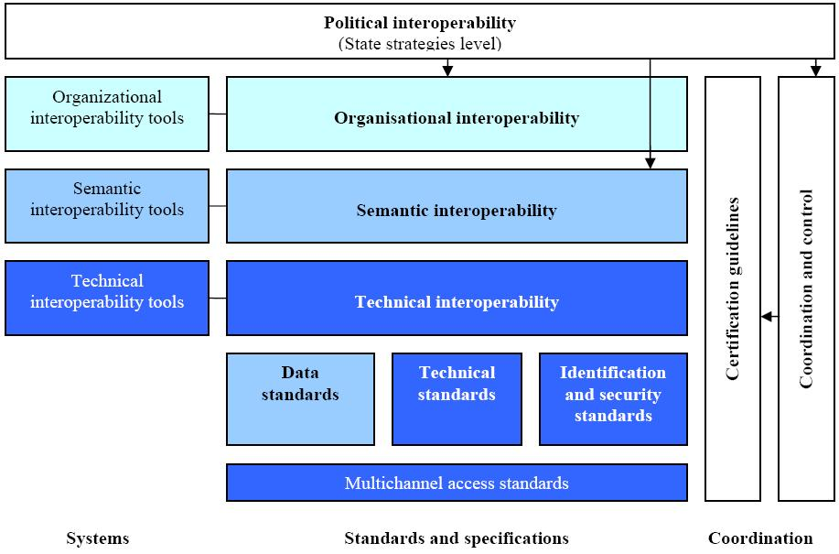
Figure 23. Guidelines for interoperability framework in Lithuania
Source: (Gatautis et al., 2009)
The main issues in e-government implementation processes and technologies in the USA and Lithuania are provided in Table 13.
Table 13. E-government implementation processes and technologies in the USA and Lithuania
 | IMPLEMENTATION PROCESSES AND TECHNOLOGIES
 | Stages of e-government development | E-government initiatives | E-government interoperability development
The USA | N/A | - National e-government portal  - Development of online public services  - IT investment management  - Cyber security  - Open government  - E-government interoperability | - Federal enterprise architecture  - Federal enterprise architecture reference models  - Federal enterprise architecture assessment tool
Lithuania | - Information  - One-way interaction  - Two-way interaction  - Transaction  - Personalisation | - National e-government portal  - Development of online public services  - Electronic identification card  - E-government interoperability | - National e-government interoperability system  - Project of national e-government interoperability strategy in accordance with the European Union interoperability strategy  - Guidelines for national e-government interoperability framework structure in accordance with the European Union interoperability framework
Source: Composed by the author
      - Comparative analysis of assessment techniques and results of e-government development
The USA is a leading country in e-government development according to the benchmarking of the United Nations (see Figure 24), and belongs to the first five countries in the world in this field. It could be explained by the fact that e-government development process in this country is more oriented towards qualitative (or performance) than quantitative (or number of online public services) results. The USA has a culture of government performance driven by the results since the enactment of Government Performance and Results Act in 1993 that required federal government agencies to engage in project management activities (Government Performance and Results Act of 1993, 1993). This approach is especially valuable in the field of e-government. In the USA national e-government initiatives are selected due to their priority that is identified through the evaluation of such indicators as improvement in service delivery, timeframe for development of initiative, risk of implementation, monetary and operational effectiveness benefits, and resource requirements (Executive Office of the President of the United States, 2002, 2003). E-government scorecard based on balanced scorecard technique was applied for monitoring the changes in e-government performance from 2003 (ibid), and has been replaced by ICTs dashboard in 2009. The last report for Congress on implementation of E-Government Act has used such perspectives for the assessment of performance as cost savings, transparency, participation, collaboration, ICTs management including enterprise architecture, and progress of implementation of e-government initiatives (Office of Management and Budget, 2010).
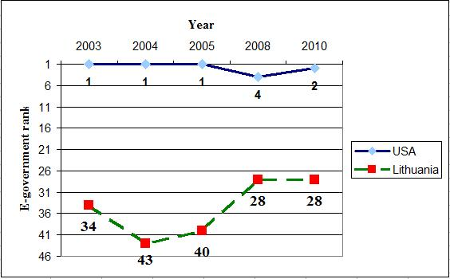
Figure 24. Comparison of the USA and Lithuania rankings in e-government
Source: Composed by the author using data from the United Nations
Annual Lithuanian national e-government performance assessment is based on the methodology used by the European Union to benchmark online availability of public services in the Member States (LR vidaus reikalų ministerija & BGI Consulting, 2007, 2009; LR vidaus reikalų ministerija & Socialinės ir ekonominės plėtros centras, 2008). It consists of measuring online sophistication of public services that are included in the Public Administration Development Strategy Action Plan, survey of citizens and business entities about the usage and quality of public services, and identification of the main obstacles for e-government development in the public agencies. However, the results of this benchmark are rarely reflected in the strategic decision-making and ICTs investment planning. The absence of leadership, collaboration, project management, return-on-investment, interoperability, and other issues critical for the performance of public administration as well as e-government in national benchmarking and decision-making (Chlivickas, 2007; Garuckas & Kaziliūnas, 2008; Gudelis, 2004; Guogis & Gudelis, 2009; Kaziliūnas, 2004; Melnikas, 2007; Puškorius, 2002, 2007; Ramūnas Vanagas, 2008; Sudnickas, 2005; Vanagas, 2007) put Lithuania in lower position of e-government rankings in the world (see Figure 24 above) as well as in the European Union.
The assessment techniques and results of e-government development in the USA and Lithuania are provided in Table 14.
Table 14. Assessment techniques and results of e-government development in the USA and Lithuania
 | ASSESSMENT TECHNIQUES AND RESULTS
 | E-government rankings | E-government performance assessment techniques
The USA | United Nations benchmarking:  - Year 2003 – 1  - Year 2004 – 1  - Year 2005 – 1  - Year 2008 – 4  - Year 2010 – 2 | Performance assessment perspectives:  - Cost savings  - Transparency  - Participation  - Collaboration  - IT management including enterprise architecture  - Progress of implementation of e-government initiatives  Monitoring tools:  - 2002 – 2009 E-government scorecard  - Untill 2009 – IT dashboard
Lithuania | United Nations benchmarking:  - Year 2003 – 34  - Year 2004 – 43  - Year 2005 – 40  - Year 2008 – 28  - Year 2010 – 28  European Union benchmarking:  - Year 2006 – 20  - Year 2007 – 25  - Year 2009 – 22 | Performance assessment perspectives:  - Online sophistication of public services using 5 stages of information, one-way interaction, two-way interaction, transaction, and personalisation for benchamarking  - Usage of public services by citizens and business  - Quality of public services (survey of citizens and business)  - Challenges for e-government development (identified by public agencies)  Monitoring tools:  - N/A
Source: Composed by the author
    - Experts’ validation of dynamic organisational capabilities for interoperability assessment toolkit in Lithuanian context
      - Results for environmental level of dimensions of e-government interoperability capabilities
The experts have validated five dimensions of dynamic capabilities that are part of environmental level of e-government interoperability:
- Leaders and champions – assesses whether e-government initiative has leaders and champions who could clearly communicate its vision and goals, would motivate and create trust among all project participants, and gain authorisation for its activities. Eight indicators are proposed to be used to assess the level of this dimension.
- Governance – shows whether organisation has mechanisms for effective control and coordination of existing or planned e-government initiatives. Six indicators are proposed to be used to assess the level of this dimension.
- Collaboration readiness – evaluates organisational capabilities for partnership with other organisations by sharing human, financial, knowledge, and technological resources. Eighteen indicators are proposed to be used to assess the level of this dimension.
- Organisational compatibility – assesses how differences between working methods, decision-making processes, and mindset in collaboration, competition and conflict solving that exist in participating organisations can impact the outcomes of e-government initiative. Ten indicators are proposed to be used to assess the level of this dimension.
- Stakeholder identification and engagement – shows organisational level of knowledge and methods used for engagement of stakeholders that could influence results of e-government initiative. Nine indicators are proposed to be used to assess the level of this dimension.
Rating results of every dimension in environmental level are provided in Table 15. As it could be seen experts’ opinions about every dimension of dynamic organisational capability for e-government interoperability were consistent. The experts indicated that they have theoretical expertise in every dynamic capability in this level, but sometimes lack practical experience, especially in collaboration and organisational compatibility. Only three dynamic capabilities were identified as important for e-government initiatives in Lithuania: Leadership, governance, and stakeholders’ involvement. Others were ranked as being neither important nor unimportant. Two of the dynamic capabilities that were ranked as important are only partially present at the moment. Meanwhile governance is not very typical in Lithuanian e-government projects. Dynamic capabilities directly related to interoperability of e-government like collaboration and organisational compatibility were not identified as important by the experts.
Table 15. Ratings of environmental level dynamic capabilities dimensions
Dimension of dynamic capability | Average knowledge | Average importance | Average presence | Kendall‘s coefficient of concordance
Leaders and champion | 2.79 | 4.58 | 2,22 | W = 0.75, p-level = 0.0025
Governance | 2.76 | 4.45 | 1,98 | W = 1, p-level = 0.0025
Collaboration readiness | 2.46 | 3.90 | 1,68 | W = 0.80, p-level = 0.0000
Organisational compatibility | 2.42 | 3.78 | 1,90 | W = 0.79, p-level = 0.0004
Stakeholder identification and engagement | 2.70 | 4.40 | 2,10 | W = 0.78, p-level = 0.0009
Knowledge rating scale: 1 – unknown, 2 – theoretical knowledge, 3 – theoretical and practical knowledge
Importance rating scale: 1 – very unimportant, 5 – very important
Presence rating scale: 1 – not present, 2 – partially present, 3 – present
Source: Composed by the author
In summary, environmental level of e-government interoperability was rated as important, and experts had at least theoretical knowledge in its dynamic capabilities. However, dynamic capabilities of this level are not currently present in Lithuanian public agencies (see Figure 25).
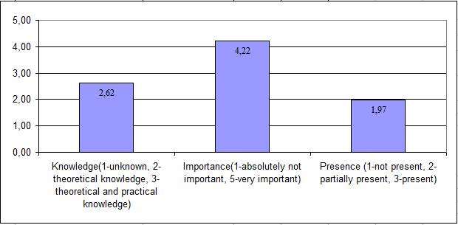
Figure 25. Average rating of environmental level of dynamic capabilities
Source: Composed by the author
Detailed results about from each dimension are analysed below.
Leaders and champions. The experts’ opinions in validation of overall dimension are consistent. Kendall’s coefficient of concordance W = 0.75 (p-level = 0.0025) shows strong and significant concordance.
There is a strong and significant correlation between ratings of knowledge and importance (Pearson‘s correlation coefficient r = 0.76, p-level = 0.0273), and ratings of importance and presence (Pearson‘s correlation coefficient r = 0.73, p-level = 0.0337). The correlation between ratings of knowledge and presence is non-significant (Pearson‘s correlation coefficient r = 0.60, p-level = 0.1185).
The overall rating of indicators that are a part of the leadership capability is shown in Figure 26 (see more details in Appendix 5, Table 20 – Table 22). All indicators in this dimension were rated as important, but only partially typical for Lithuanian public agencies. The indicator that project has a leader who promotes creativity and innovation was rated as usually not present in Lithuanian e-government initiatives.
Comments of the experts have shown that they see project leader and project manager being the same person. They have described several possible situations encountered during e-government initiatives. The first one is when a project really has a good manager, but he does not have any leverage to motivate people working in the initiative (e. g. cannot promise an extra payment without approval of executives). Usually a project manager is appointed from lower hierarchies of management. Thus project does not get any support from the authorities, or it is very difficult to get needed resources through many levels of hierarchy.
Figure 26. Ratings of indicators in „Leaders & Champions” dimension
Source: Composed by the author
Another situation described by the experts is a bit different. Momentum to start an e-government initiative comes from the authorities, however without any consultations with specialists from the institutions. This usually ends-up with an appointment of project manager who only formally supervises the project and does not have any project management skills.
Some experts have stressed that authorities often have a negative attitude towards innovations and ICT-based public sector reform. This case shows decisions in the domain are made by non-IT persons because ICT personnel working in the institution has insufficient qualifications and are not interested in ICTs innovations. Very often the opinions of consulting or external experts are trusted, but they tend to be more beneficial for the vendor than for the institution itself.
Governance. The experts’ opinions in validation of overall dimension are very consistent. Kendall’s coefficient of concordance W = 1.00 (p-level = 0.0025) shows strong and significant concordance.
The correlation is non-significant between ratings of knowledge and importance (Pearson‘s correlation coefficient r = 0.67, p-level = 0.1465), importance and presence (Pearson‘s correlation coefficient r = 0.58, p-level = 0.2243), and knowledge and presence (Pearson‘s correlation coefficient r = 0.65, p-level = 0.1629).
The overall rating of indicators that are a part of governance capability is shown in Figure 27 (see more details in Appendix 5, Table 23 – Table 25). All indicators were rated as important for successful e-government initiative, but not typical for Lithuanian public institutions in general.
According to the ratings of the indicators, the governance body established for the initiative does not have all the necessary support, its authority to proceed is not clear enough to the participating parties, which are not always effectively engaged in project’s governance. However, there are already some attempts to have at least a formal project charter that would define its governance structure and principles among all stakeholders.
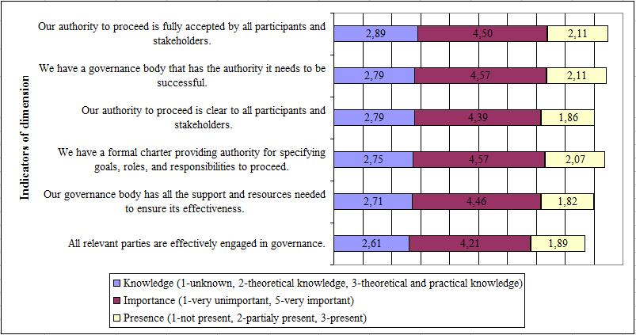
Figure 27. Ratings of indicators in „Governance” dimension
Source: Composed by the author
In their comments experts have stressed that all relevant stakeholders (especially, end-users) are rarely involved in project governance. Some experts have emphasized the problem that project manager rarely can use resources of overall institution. Usually, he has only those resources that are under his disposition.
Collaboration readiness. The experts’ opinions in validation of overall dimension are consistent. Kendall’s coefficient of concordance W = 0.80 (p-level = 0.0000) shows strong and significant concordance.
There is also a strong and significant correlation between ratings of knowledge and importance (Pearson‘s correlation coefficient r = 0.77, p-level = 0.0002), importance and presence (Pearson‘s correlation coefficient r = 0.78, p-level = 0.0001), and knowledge and presence (Pearson‘s correlation coefficient r = 0.89, p-level = 0.0000).
The overall rating of indicators that are a part of collaboration readiness capability is shown in Figure 28 (see more details in Appendix 5, Table 26 – Table 28). Even half of all indicators were rated as being neither important nor unimportant for the outcomes of e-government initiative. According to the experts only two of the indicators are at least partially present in Lithuanian public agencies – they do seek collaboration with other institutions and have an experience in cross-institutional projects.
Figure 28. Ratings of indicators in „Collaboration readiness” dimension
Source: Composed by the author
Some experts have expressed an opinion that there is no culture of collaboration in Lithuanian public sector. Public agencies are not willing to share the internal resources (human, financial, technological) because there is no system of motivation to do so. According to the experts, collaboration usually means no extra-payment, but higher working overload.
Another factor that might be an obstacle to more active collaboration between Lithuanian public institutions is already embedded in strategic action plans. In many strategic plans it is written that initiative will be implemented using internal resources of an agency, or if there is funding from the central government. Therefore, leading institution cannot freely reallocate available resources and motivate other participating organisations.
Organisational compatibility. The experts’ opinions in validation of overall dimension are consistent. Kendall’s coefficient of concordance W = 0.79 (p-level = 0.0004) shows strong and significant concordance.
There is a strong and significant correlation between ratings of knowledge and presence (Pearson‘s correlation coefficient r = 0.73, p-level = 0.0167). The correlation between ratings of knowledge and importance (Pearson‘s correlation coefficient r = 0.28, p-level = 0.4411), and importance and presence (Pearson‘s correlation coefficient r = -0.05, p-level = 0.8827) is non-significant.
The overall rating of indicators that are a part of organisational compatibility capability is shown in Figure 29 (see more details in Appendix 5, Table 29 – Table 31). The majority of indicators were rated as being neither important nor unimportant. The experts referred that in the development of strategic plans it would be important to take into account differences in centralisation among organisations, and differences in participation in decision making. Among all the indicators only two were rated as partially present in Lithuanian public sector: Similar organisational culture, practices, and competitive styles.
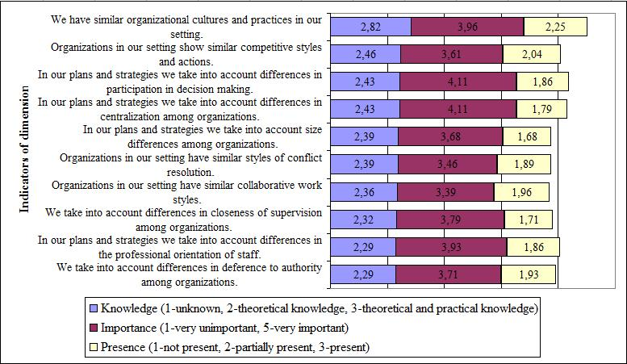
Figure 29. Ratings of indicators in „Organisational compatibility” dimension
Source: Composed by the author
Stakeholder identification and engagement. The experts’ opinions in validation of overall dimension are consistent. Kendall’s coefficient of concordance W = 0.78 (p-level = 0.0009) shows strong and significant concordance.
There is a strong and significant correlation between ratings of knowledge and presence (Pearson‘s correlation coefficient r = 0.73, p-level = 0.0260), and ratings of importance and presence (Pearson‘s correlation coefficient r = 0.72, p-level = 0.0298). The correlation between ratings of knowledge and importance is non-significant (Pearson‘s correlation coefficient r = 0.46, p-level = 0.2166).
The overall rating of indicators that are a part of stakeholder involvement capability is shown in Figure 30 (see more details in Appendix 5, Table 32 – Table 34). Though overall assessment of dimensions’ presence in Lithuanian public sector is partial, but some indicators were identified as being not typical in national e-government initiatives. At the moment analysis about the impact of stakeholders to the results of the project is not always performed, and the decisions are not always based on the information gathered during stakeholders’ analysis. According to the ratings of the experts, not all stakeholders groups are confident with future results of e-government project, and are willing to collaborate.
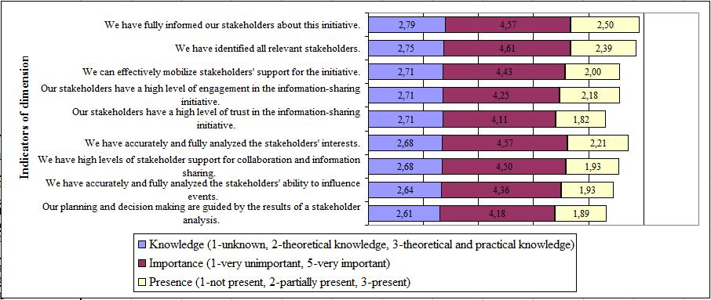
Figure 30. Ratings of indicators in „Stakeholders identification and engagement” dimension
Source: Composed by the author
Some experts have indicated that sometimes relevant stakeholders are not included in e-government project implementation intentionally, especially those who might loose their power or be liquidated as an outcome.
The experts have also indicated inefficient usage of informational resources (e. g. there is a resistance to establishing State Data Center, which would lead towards centralisation usage of state’s information resources, and reduce the costs of information exchange).
Some experts expressed an opinion that it is impossible to ensure support from all stakeholders to the high competition among e-government initiatives on the national level. They emphasized that there is no strategic management of e-government projects and their prioritisation. This leads to the competition between national strategic goals of e-government and local institutional or even personal interests. Hence, there are a lot of e-government initiatives with similar or identical goals that cost much more that implementation of single initiative on the central level.
      - Results for organisational level of dimensions of interoperability capabilities
The experts have validated five dimensions of dynamic capabilities that are part of organisational level of e-government interoperability:
- Strategic planning – reveals the level of comprehensiveness of strategic planning process and documents, including the alignment of strategic planning with overall governance of organisation. Nine indicators are proposed to be used to assess the level of this dimension.
- Performance evaluation – assesses whether organisation has enough skills, resources and authority for the evaluation of e-government initiative progress, achievement of its goals, and changes in business process after the completion of initiative. Twelve indicators are proposed to be used to assess the level of this dimension.
- Project management – shows whether organisation applies such project management principles as setting the goals, scheduling, resource planning, and risk management. Nine indicators are proposed to be used to assess the level of this dimension.
- Resource management – measures the effectiveness of allocation and usage of financial, human and technological resources. Fifteen indicators are proposed to be used to assess the level of this dimension.
- Technology acceptance – indicates the attitude of staff towards new technologies, new working methods and innovations. This dimension also assesses management actions in fostering positive ICTs acceptance. Thirteen indicators are proposed to be used to assess the level of this dimension.
Rating results of every dimension in organisational level are provided in Table 16.
Table 16. Ratings of organisational level dynamic capabilities dimensions
Dimension of dynamic capability | Average knowledge | Average importance | Average presence | Kendall‘s coefficient of concordance
Strategic planning | 2.59 | 4.47 | 1,86 | W = 0.90, p-level = 0.0003
Performance evaluation | 2.63 | 4.24 | 2,05 | W = 0.85, p-level = 0.0001
Project management | 2.66 | 4.20 | 2,04 | W = 0.90, p-level = 0.0003
Resource management | 2.77 | 4.43 | 2,15 | W = 0.84, p-level = 0.0000
Technology acceptance | 2.79 | 4.15 | 2,49 | W = 0.65, p-level = 0.0008
Knowledge rating scale: 1 – unknown, 2 – theoretical knowledge, 3 – theoretical and practical knowledge
Importance rating scale: 1 – very unimportant, 5 – very important
Presence rating scale: 1 – not present, 2 – partially present, 3 – present
Source: Composed by the author
As it could be seen the experts’ opinions about every dimension of dynamic organisational capability for e-government interoperability were consistent. The experts indicated that they have theoretical expertise in every dynamic capability in this level, but sometimes lack more practical experience, especially in dynamic strategic planning. All dynamic capabilities at this level were marked as important. Dynamic capabilities at this level are only partially present at the moment, and strategic planning that would be more oriented towards inter-organisational collaboration can be treated as missing..
In summary, the organisational level of e-government interoperability was rated as important, partially present, and experts had at least theoretical knowledge of its dynamic capabilities (see Figure 31).
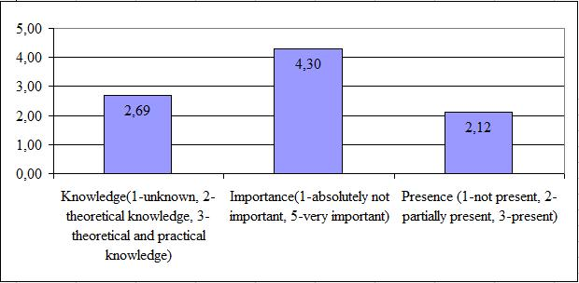
Figure 31. Average rating of organisational level of dynamic capabilities
Source: Composed by the author
Detailed results about from each dimension are analysed below.
Strategic planning. The experts’ opinions in validation of overall dimension are consistent. Kendall’s coefficient of concordance W = 0.90 (p-level = 0.0003) shows strong and significant concordance.
There is a strong and significant correlation between ratings of knowledge and importance (Pearson‘s correlation coefficient r = 0.82, p-level = 0.0071), and ratings of knowledge and presence (Pearson‘s correlation coefficient r = 0.72, p-level = 0.0028). The correlation between ratings of importance and presence is non-significant (Pearson‘s correlation coefficient r = 0.54, p-level = 0.1296).
The overall rating of indicators that are a part of strategic planning capability is shown in Figure 32 (see more details in Appendix 6, Table 35 – Table 37). Though all indicators in this dimension were rated as important, the majority of them were indicated as not being present in Lithuanian public agencies. Experts emphasized that overall process of strategic management is partially regulated, strategic goals are more or less clearly formulated and measurable, resources for the implementation of strategies are usually identified. However, this dynamic capability in Lithuanian public agencies lacks intensive involvement of stakeholders, risk assessment, alignment with other management methods, and strategic management skills still have to be enhanced.
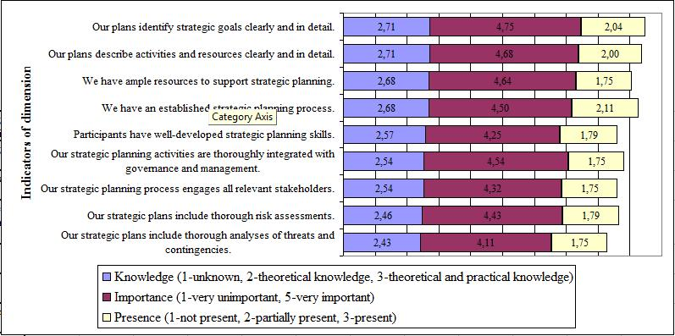
Figure 32. Ratings of indicators in „Strategic planning” dimension
Source: Composed by the author
Performance evaluation. The experts’ opinions in validation of overall dimension are consistent. Kendall’s coefficient of concordance W = 0.85 (p-level = 0.0001) shows strong and significant concordance.
There is a strong and significant correlation between the ratings of knowledge and importance (Pearson‘s correlation coefficient r = 0.89, p-level = 0.0002), the ratings of knowledge and presence (Pearson‘s correlation coefficient r = 0.76, p-level = 0.0065), and the ratings of importance and presence (Pearson‘s correlation coefficient r = 0.84, p-level = 0.0012).
The overall rating of indicators that are a part of performance evaluation capability is shown in Figure 33 (see more details in Appendix 6, Table 38 – Table 40). The experts rated all indicators in this dimension as important, except the indicator measuring the impact of the organisation itself on the results of the e-government initiative which is also currently not present in Lithuanian institutions. Though the average rating of indicator’s presence is indicated as being partial, but some indicators were identified as not practiced in national public institutions. The experts pointed out that there are not enough resources for effective usage of performance evaluation, and though being important the assessment how the outcomes of the project have increased the quality of information sharing among institutions is not carried out.

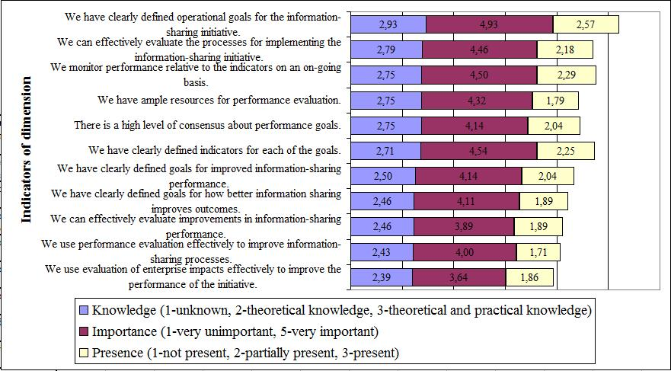
Figure 33. Ratings of indicators in „Performance evaluation” dimension
Source: Composed by the author
Some experts have stressed that each strategic goal usually has its indicators, but these indicators are identified and measured only on the formal basis. Another aspect mentioned by the experts is that every institution wants to show itself in a positive light and very often modifies its strategic plans accordingly.
Project management. The experts’ opinions in validation of overall dimension are consistent. Kendall’s coefficient of concordance W = 0.90 (p-level = 0.0003) shows strong and significant concordance.
There is a strong and significant correlation between ratings of knowledge and importance (Pearson‘s correlation coefficient r = 0.77, p-level = 0.0148), ratings of knowledge and presence (Pearson‘s correlation coefficient r = 0.79, p-level = 0.0119), and ratings of importance and presence (Pearson‘s correlation coefficient r = 0.80, p-level = 0.0099).
The overall rating of indicators that are a part of project management capability is shown in Figure 34 (see more details in Appendix 6, Table 41 – Table 43). Experts rated all indicators in the dimension as important, except two: Existence of project management methodology and usage of project management software. These two indicators were rated as being neither important nor unimportant, and usually not applied in Lithuanian public agencies. The indicators that were assessed as important, but currently not present include ample project management resources and continuous improvement of project management knowledge. Other indicators were reported to be only partially present.

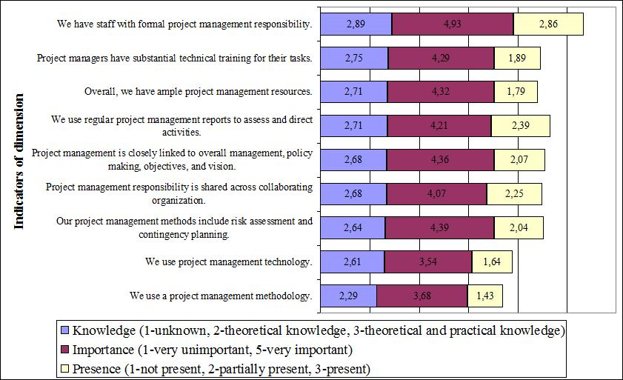
Figure 34. Ratings of indicators in „Project management” dimension
Source: Composed by the author
Some experts commented that project management methodologies are more important for e-government project vendors because public sector organisations are using a “bureaucratic management model”. Another problem identified from the comments of the experts is that due to recession there are not many possibilities to participate in special qualification improvement courses, except cases when the institution posses financial support from the European Union structural funds.
Resource management. The experts’ opinions in validation of overall dimension are consistent. Kendall’s coefficient of concordance W = 0.84 (p-level = 0.0000) shows strong and significant concordance.
There is a medium and significant correlation between ratings of knowledge and presence (Pearson‘s correlation coefficient r = 0.54, p-level = 0.0387). The correlation between ratings of knowledge and importance is non-significant (Pearson‘s correlation coefficient r = 0.32, p-level = 0.2494) as well as between ratings of importance and presence (Pearson‘s correlation coefficient r = 0.46, p-level = 0.0831).
The overall rating of indicators that are a part of resource management capability is shown in Figure 35 (see more details in Appendix 6, Table 44 – Table 46). All indicators except one were rated as being important. Having a plan for the outsourcing and subcontracting management was rated as being neither important nor unimportant, and not present in e-government initiatives implementation process. The majority of indicators were rated as being partially present. However, the attention has to be paid that such important indicator as return-on-investment plans are not prepared at the moment. The level of adequateness and effectiveness of public procurement procedures for e-government projects has also to be increased as it was rated as not typical. It is also worth of mentioning that the adequate experience in outsourcing, sub-contracting, and consulting management is still only partially present and needs to be improved.
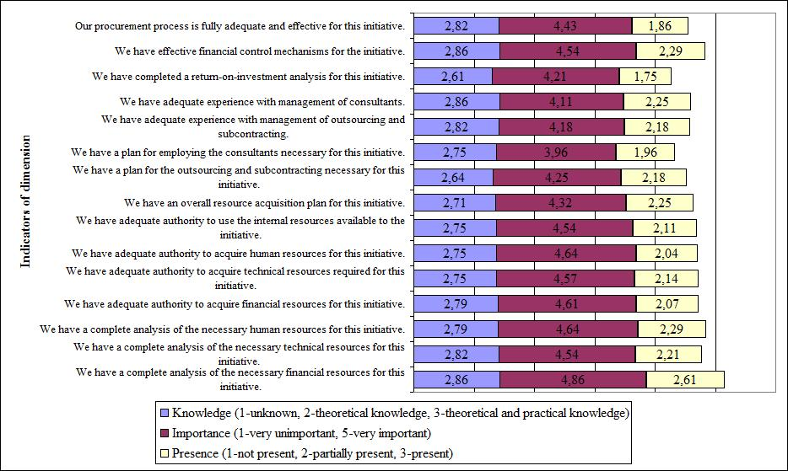
Figure 35. Ratings of indicators in „Resource management” dimension
Source: Composed by the author
In their comments the experts have stressed the ineffectiveness of public procurement procedures, especially in the case of e-government initiatives. Following strict public procurement procedures often overrides other project activities, or even worse – project implementation becomes only implementation of public procurement. Practice “done according to the procedure of public procurement” eliminates such important elements of every e-government project as effectiveness assessment or search for the best available solutions.
According to some experts current procedures for public procurement make it difficult to get high quality services, especially for consulting. Due to time consuming and inflexible public procurement procedures it is sometimes impossible to manage project risks, especially when the selected vendor does not meet deadlines or develops a product which does not meet identified requirements. Changing the vendor would lead towards extension of the project which is not tolerated.
Technology acceptance. The experts’ opinions in validation of overall dimension are consistent enough. Kendall’s coefficient of concordance W = 0.65 (p-level = 0.0008) shows medium and significant concordance.
There is a medium and significant correlation between ratings of importance and presence (Pearson‘s correlation coefficient r = 0.65, p-level = 0.0305). The correlation between ratings of knowledge and importance is non-significant (Pearson‘s correlation coefficient r = 0.34, p-level = 0.3126) as well as between ratings of knowledge and presence (Pearson‘s correlation coefficient r = 0.45, p-level = 0.1663).
The overall rating of indicators that are a part of technology acceptance capability is shown in Figure 36 (see more details in Appendix 6, Table 47 – Table 49). The experts rated all indicators of this dimension as being partially present, but not all of them were identified as important. The experts find that presence of support, opposition or trust of staff for new or improved ICTs solutions is neither important nor unimportant for the success of e-government initiative.
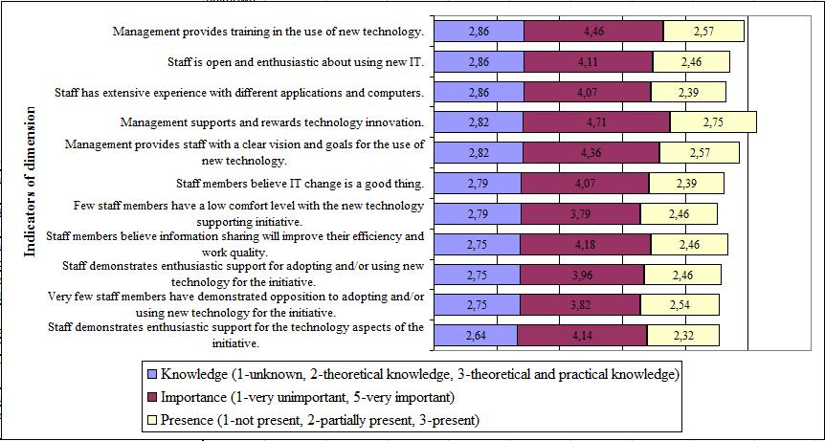
Figure 36. Ratings of indicators in „Technology acceptance” dimension
Source: Composed by the author
Some experts have expressed an opinion that enthusiastic engagement of staff is not possible in the system of our public administration due to the lack of relevant culture and traditions. They have emphasised that often staff has negative attitudes towards ICTs because they mean double work (when the same tasks are still performed on paper as well as using newly created software), changed working procedures, need to learn new things, etc.
Generally, the experts assessed the indicators in this dimension as too theoretical for Lithuanian level because there are no traditions to ask staff about technological solutions or if asked, the answers would lead more towards expressed needs of faster hardware or ergonomic office.
      - Results for semantics and technological level of dimensions of interoperability capabilities
The experts have validated six dimensions of dynamic capabilities that are part of semantics and technological level of e-government interoperability:
- Business model and architecture – shows whether a business model and enterprise architecture are present for the e-government initiative. Seven indicators are proposed to be used to assess the level of this dimension.
- Information policy – measures whether organisation has policy that ensures privacy, confidentiality and security of information gathering, usage, storage, and exchange. Seven indicators are proposed to be used to assess the level of this dimension.
- Technology knowledge – reveals the level of staff’s knowledge in new ICTs. It also indicates whether organisation has inventories about owned technologies, and actions that are taken to ensure that employers would have enough technological knowledge. Fourteen indicators are proposed to be used to assess the level of this dimension.
- Technology compatibility – identifies whether standards needed for smooth information exchange inside as well as outside organisational boundaries are present. Eight indicators are proposed to be used to assess the level of this dimension.
- Data assets and requirements – assesses whether there are policy for gathering, usage, storage and management of data to be used in e-government initiative. Fifteen indicators are proposed to be used to assess the level of this dimension.
- Secure environment – shows the maturity level of data, systems, and computer network security policy within the organisation. Twenty two indicators are proposed to be used to assess the level of this dimension.
Rating results of every dimension in semantics and technological level are provided in Table 17. As can be seen, the experts’ opinions about every dimension of dynamic organisational capability for e-government interoperability were consistent. The experts indicated that they have theoretical expertise in every dynamic capability in this level, but sometimes lack practical experience – especially in business model and architecture, data assets and requirements, and information policy. The dynamic capability for technology knowledge was rated as being neither important nor unimportant for e-government interoperability. Other dynamic capabilities were rated as important. Though dynamic capability for business model and architecture was rated as being important, but the experts indicated its absence in current e-government initiatives. Other dynamic capabilities rated as important are partially present and still need to be improved.
It has to be emphasized that Lithuanian experts have not had a clear opinion about the significance of technological knowledge capability, which is also not common in national public agencies.
Table 17. Ratings of semantics and technological level dynamic capabilities dimensions
Dimension of dynamic capability | Average knowledge | Average importance | Average presence | Kendall‘s coefficient of concordance
Business model and architecture | 2,55 | 4,21 | 1,99 | W = 0.76, p-level = 0.0051
Information policy | 2,63 | 4,21 | 2,00 | W = 0.88, p-level = 0.0023
Technology knowledge | 2,67 | 3,96 | 1,95 | W = 1.00, p-level = 0.0000
Technology compatibility | 2,81 | 4,52 | 2,29 | W = 0.89, p-level = 0.0008
Data assets and requirements | 2,61 | 4,25 | 2,00 | W = 0.84 (p-level = 0.0000)
Secure environment | 2,77 | 4,44 | 2,29 | W = 0.92 (p-level = 0.0000)
Knowledge rating scale: 1 – unknown, 2 – theoretical knowledge, 3 – theoretical and practical knowledge
Importance rating scale: 1 – very unimportant, 5 – very important
Presence rating scale: 1 – not present, 2 – partially present, 3 – present
Source: Composed by the author
In summary, the semantics and technological level of e-government interoperability was rated as important, partially mature, and the experts had at least theoretical knowledge in its dynamic capabilities (see Figure 37).
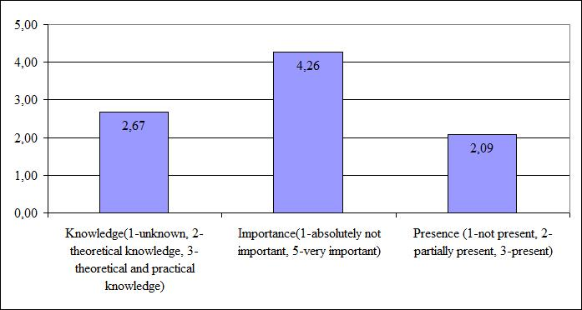
Figure 37. Average rating of semantics and technological level of dynamic capabilities
Source: Composed by the author
The detailed results about from each dimension are analysed below.
Business model and architecture. The experts’ opinions in validation of overall dimension are consistent. Kendall’s coefficient of concordance W = 0.76 (p-level = 0.0051) shows strong and significant concordance.
There is a strong and significant correlation between ratings of knowledge and importance (Pearson‘s correlation coefficient r = 0.86, p-level = 0.0131), and ratings between knowledge and presence (Pearson‘s correlation coefficient r = 0.76, p-level = 0.0471). Correlation between importance and presence is non-significant (Pearson‘s correlation coefficient r = 0.73, p-level = 0.0624).
The overall rating of indicators that are a part of the business model and architecture capability is shown in Figure 38 (see more details in Appendix 7, Table 50 – Table 52). All but one indicator were rated as important in this dimension: The experts have found it neither important nor unimportant for e-government initiative to have its business model which is also currently not present in practice. Only half of the indicators can be considered as being partially used in e-government initiatives. The identification of strategic goals for each activity as well as analysis and elimination of business processes discrepancies are not very common.
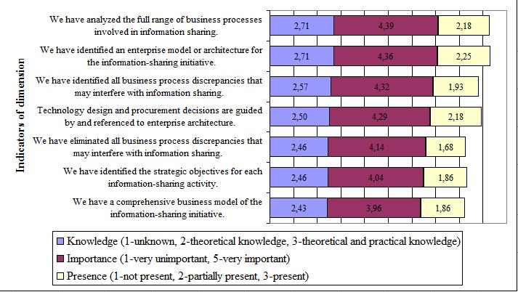
Figure 38. Ratings of indicators in „Business model and architecture” dimension
Source: Composed by the author
The experts’ comments show that the two main concepts used in this dimension – business model and enterprise architecture – are not familiar to them though the overall rating of knowledge in this dimension is quite high and equals to 2.55. The experts stressed that they understood the business model and enterprise architecture as the architecture of organisation’s activities.
Another comment worth of mentioning here is related to the indicator that procurement decisions are guided by enterprise architecture. Some experts stressed that they do not understand this indicator because public procurement decisions have to be done following the Law of Public Procurement.
Information policy. The experts’ opinions in the validation of overall dimension are consistent. Kendall’s coefficient of concordance W = 0.88 (p-level = 0.0023) shows strong and significant concordance.
There is no significant correlation between ratings of knowledge and importance (Pearson‘s correlation coefficient r = 0.12, p-level = 0.7953). The correlation between ratings of knowledge and presence (Pearson‘s correlation coefficient r = 0.62, p-level = 0.1360), and between importance and presence (Pearson‘s correlation coefficient r = 0.50, p-level = 0.2496) is non-significant.
The overall rating of indicators that are a part of information policy capability is shown in Figure 39 (see more details in Appendix 7, Table 53 – Table 55). All indicators were rated as important. The majority of them are only partially present in national e-government initiatives. According to the experts currently public agencies are struggling fully implement their information policies and align them with information policies in other institutions.
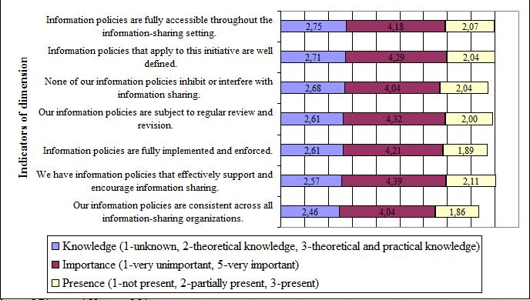
Figure 39. Ratings of indicators in „Information policy” dimension
Source: Composed by the author
The experts have indicated that information sharing principles are usually defined in the agreement: With vendors there are agreements of confidentiality, and with public agencies principles are defined by legal acts. Usually, information policies are not analysed in the context of a particular e-government initiative, and internal rules of institution are followed.
Technology knowledge. The experts’ opinions in validation of overall dimension are especially consistent. Kendall’s coefficient of concordance W = 1.00 (p-level = 0.0000) shows strong and significant concordance.
There is medium and significant correlation between ratings of knowledge and importance (Pearson‘s correlation coefficient r = 0.64, p-level = 0.0146), and knowledge and presence (Pearson‘s correlation coefficient r = 0.65, p-level = 0.0122). There is non-significant correlation between importance and presence (Pearson‘s correlation coefficient r = 0.50, p-level = 0.0673).
The overall rating of indicators that are a part of the technology knowledge capability is shown in Figure 40 (see more details in Appendix 7, Table 56 – Table 58). The majority of indicators in this dimension were rated as being neither important nor unimportant for overall e-government interoperability capability. The experts indicated that staff knowledge about the hardware, software, applications, and networks used in the initiative are important as well as its early assessment. However, according to the ratings to support this knowledge any formal codification in the form of inventories is not needed, except maybe from the perspective of software. The majority of indicators were rated as not common in current professional practices.
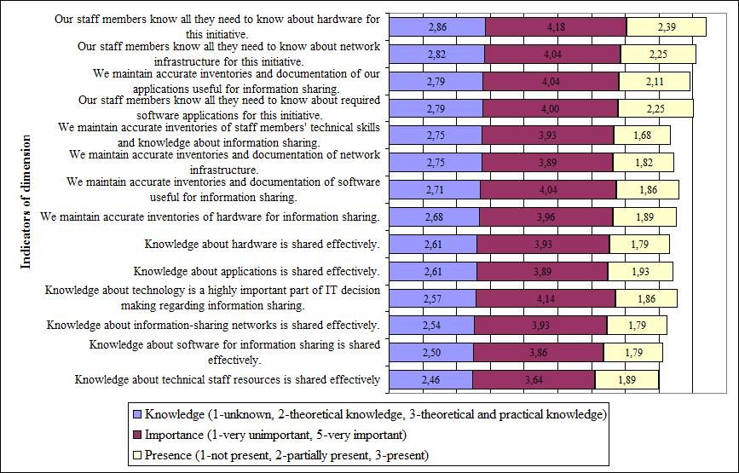
Figure 40. Ratings of indicators in „Technology knowledge” dimension
Source: Composed by the author

According to the comments of the experts there is no need for all project participants to have detailed knowledge about technology. This is usually left in the responsibility of subcontractors; meanwhile public servants have to know only basic things. The experts do not see the need to keep detailed and up-to-date inventories about technologies in the public sector organisation, and are inclined to trust unarticulated knowledge of technical personnel.
Technology compatibility. The experts’ opinions in validation of overall dimension are consistent. Kendall’s coefficient of concordance W = 0.89 (p-level = 0.0008) shows strong and significant concordance.
The correlation between ratings of knowledge and importance (Pearson‘s correlation coefficient r = 0.40, p-level = 0.3179), knowledge and presence (Pearson‘s correlation coefficient r = 0.58, p-level = 0.1348), and importance and presence (Pearson‘s correlation coefficient r = -0.16, p-level = 0.7039) is non-significant.
Overall rating of indicators that are a part of technology compatibility capability is shown in Figure 41 (see more details in Appendix 7, Table 59 – Table 61). All indicators in this dimension were rated as being important and partially present in current e-government initiatives. This proves that technical interoperability is quite mature in Lithuanian public sector, and that other non-technological dimensions should be taken into consideration.
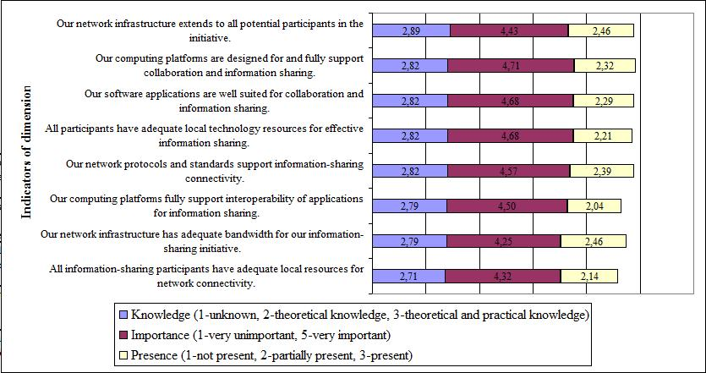
Figure 41. Ratings of indicators in „Technology compatibility” dimension
Source: Composed by the author
In their comments the experts emphasized the lack of technical interoperability culture, even in e-government initiatives that directly addresses this issue. They have also stressed that information standards, especially based on XML, are still very rarely used, and that the central government should take serious actions of their reinforcement.
Data assets and requirements. The experts’ opinions in validation of overall dimension are consistent. Kendall’s coefficient of concordance W = 0.84 (p-level = 0.0000) shows strong and significant concordance.
There is strong and significant correlation between ratings of knowledge and importance (Pearson‘s correlation coefficient r = 0.81, p-level = 0.0003), knowledge and presence (Pearson‘s correlation coefficient r = 0.76, p-level = 0.0009), and importance and presence (Pearson‘s correlation coefficient r = 0.78, p-level = 0.0006).
The overall rating of indicators that are a part of data assets and requirements capability is shown in Figure 42 (see more details in Appendix 7, Table 62 – Table 64). The experts rated all indicators as important, but find the presence of sufficient knowledge of staff in data exchange as neither significant nor non-significant factor. This dimension was assessed as not typical in Lithuanian public agencies, especially from the perspective of metadata, various standards for data storage, usage and quality, and the needs of diverse data users.
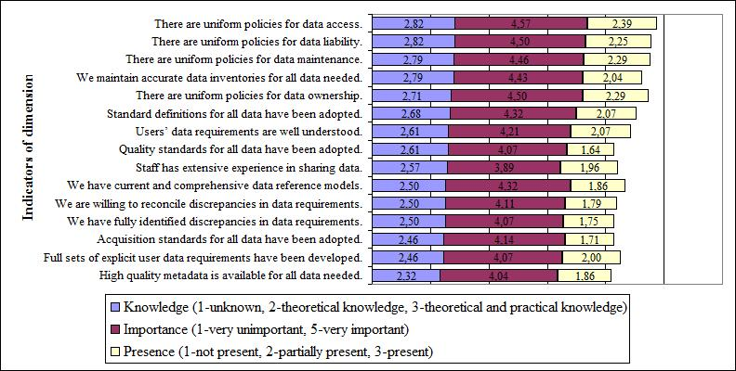
Figure 42. Ratings of indicators in „Data assets and requirements” dimension
Source: Composed by the author
Secure environment. The experts’ opinions in validation of overall dimension are consistent. Kendall’s coefficient of concordance W = 0.92 (p-level = 0.0000) shows strong and significant concordance.
There is a weak though significant correlation between ratings of knowledge and presence (Pearson‘s correlation coefficient r = 0.46, p-level = 0.0307). The correlation between knowledge and importance (Pearson‘s correlation coefficient r = 0.17, p-level = 0.4507), and importance and presence (Pearson‘s correlation coefficient r = 0.28, p-level = 0.2063) are non-significant.
The overall rating of indicators that are a part of secure environment capability is shown in Figure 43 (see more details in Appendix 7, Table 65 – Table 67). The experts rated all indicators as being important for e-government initiatives. However, all of them are only partially present at the moment.
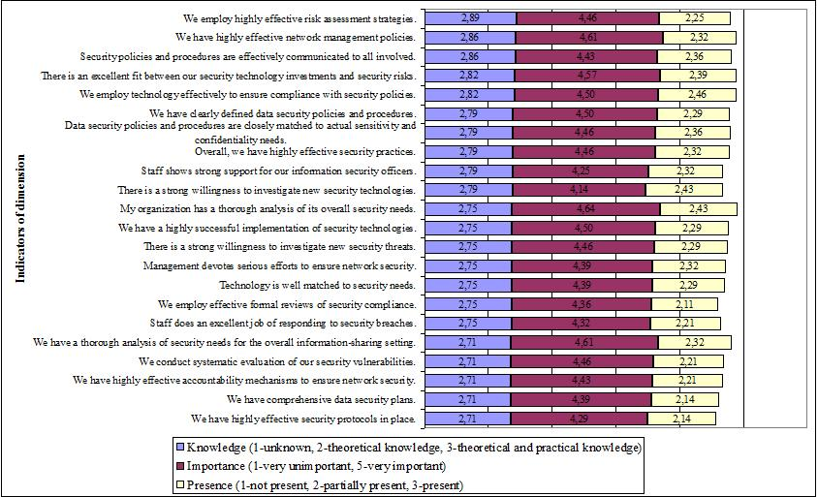
Figure 43. Ratings of indicators in „Secure environment” dimension
Source: Composed by the author
The experts commented that though the legal basis for a secure environment is sufficient and meets international standards, it is implemented only in a formal way and does not get enough attention from the executives of public institutions. Usually, there are not enough financial resources to keep technical basis on a high security level as well as to retain professional technical staff that usually choose to work in the private sector. Some experts have suggested outsourcing services of secure infrastructure maintenance because public organisations in Lithuania are not capable to ensure the relevant security requirements.
      - Ranking of dimensions of e-government interoperability capabilities
Kendall’s coefficient of concordance (W = 0.20, p-level = 0.4560) shows that experts’ opinions in identifying the five most important dimensions of dynamic organisational capabilities for e-government interoperability were not consistent.
Actual data of ranking of dimensions is provided in Appendix 8, Table 68. All dimensions were included in the ranking, and have received at least one ranking point from the experts. In Table 18 the distribution of dynamic capabilities according to the rankings from one to five is presented, where 1 is the most important dimension, and 5 least important.
As it could be seen governance was often put in the first place (32.1% of experts). The leader of the second place is strategic planning (32.1% of experts). Project management, and stakeholders’ identification and engagement have received the majority in the third place rankings (14.3% of experts). Stakeholders’ identification and engagement is also a leading dimension in the fourth ranking (17.9% of experts), and secure environment is the most popular dimension in the fifth position (21.4% of experts).
Analysis of Spearmans’ correlation coefficient for correlation between rankings of different dimensions showed that there is strong and significant correlation between rankings of leadership and governance (r_{s} = 0.90, p-level = 0.037), governance and project management (r_{s} = 0.98, p-level = 0.005), collaboration readiness and technological compatibility (r_{s} = 0.89, p-level = 0.044), stakeholders’ identification and engagement and resource management (r_{s} = 0.98, p-level = 0.005), performance evaluation and technology knowledge (r_{s} = 0.89, p-level = 0.044), performance evaluation and secure environment (r_{s} = 0.89, p-level = 0.044), resource management and information policies (r_{s} = 0.89, p-level = 0.044), technology knowledge and secure environment (r_{s} = 0.92, p-level = 0.026).
There is a strong and significant though negative correlation between rankings of governance and organisational compatibility (r_{s} = -0.95, p-level = 0.014), organisational compatibility and project management (r_{s} = -0.97, p-level = 0.005), stakeholders’ identification and engagement and business model and architecture (r_{s} = -0.89, p-level = 0.041), resource management and business model and architecture (r_{s} = -0.92, p-level = 0.028).
Table 18. Distribution of dynamic capabilities for interoperability according to ranking position
Ranking position | Dynamic capability | Experts’ votes received (%)
1 | Governance | 32.1
1 | Leaders & Champions | 25.0
1 | Project management | 21.4
1 | Collaboration readiness | 7.1
1 | Business model & architecture | 7.1
1 | Technology knowledge | 3.6
1 | Secure environment | 3.6
2 | Strategic planning | 32.1
2 | Leaders and champions | 14.3
2 | Stakeholders’ identification and engagement | 14.3
2 | Governance | 7.1
2 | Resource management | 7.1
2 | Collaboration readiness | 3.6
2 | Organisational compatibility | 3.6
2 | Project management | 3.6
2 | Business model and architecture | 3.6
2 | Information policies | 3.6
2 | Technology knowledge | 3.6
2 | Technology compatibility | 3.6
3 | Stakeholder identification & Engagement | 14.3
3 | Project management | 14.3
3 | Governance | 10.7
3 | Technology compatibility | 10.7
3 | Data Assets & Requirements | 10.7
3 | Business model & architecture | 7.1
3 | Resource management | 7.1
3 | Strategic planning | 7.1
3 | Collaboration readiness | 7.1
3 | Leaders & Champions | 7.1
4 | Stakeholder identification & engagement | 17.9
4 | Resource management | 14.3
4 | Technology knowledge | 10.7
4 | Data assets & requirements | 10.7
4 | Secure environment | 7.1
4 | Technology compatibility | 7.1
4 | Strategic planning | 7.1
4 | Leaders & champions | 3.6
4 | Governance | 3.6
4 | Collaboration readiness | 3.6
4 | Organisational compatibility | 3.6
4 | Performance evaluation | 3.6
4 | Project management | 3.6
4 | Information policies | 3.6
5 | Secure environment | 21.4
5 | Organisational compatibility | 10.7
5 | Technology knowledge | 10.7
5 | Technology compatibility | 10.7
5 | Collaboration readiness | 7.1
5 | Resource management | 7.1
5 | Technology acceptance | 7.1
5 | Business model & architecture | 7.1
5 | Data assets & requirements | 7.1
5 | Stakeholder identification & engagement | 3.6
5 | Strategic planning | 3.6
5 | Performance evaluation | 3.6
Source: Composed by the author
After counting total votes and their position weights dynamic capabilities have been positioned in the way that is shown in Figure 44. As it could be seen, the five most significant dynamic capabilities are governance, leaders and champions, project management, strategic planning, and stakeholders’ identification and engagement. Three of them are from environmental, and two from organizational layer of dynamic capabilities for e-government interoperability. Neither capabilities from semantics nor from the technology layer got into top-5 list.
Getting back to the results of each dimension ratings that are presented in chapter 3.2.2.1 and chapter 3.2.2.2 governance and strategic planning dynamic capabilities were rated as being important and not present in Lithuanian e-government initiatives. Other dimensions of leadership, stakeholders and project management were evaluated as being important and partially present. This means that improvement of these dynamic capabilities is especially important for the success of e-government in Lithuania.
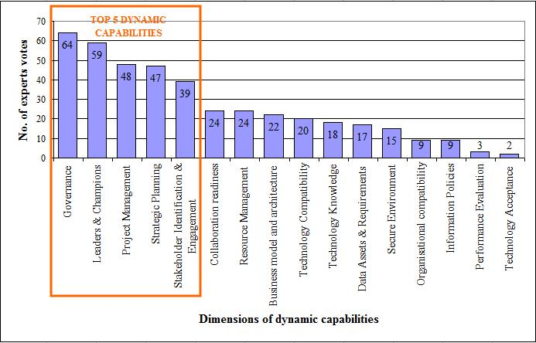
Figure 44. Ranking results of dynamic capabilities for e-government interoperability
Source: Composed by the author
After evaluation of every dimension, the experts were also asked to identify dynamic capabilities that are not a part of the current version of the toolkit, but that they find an important part of e-government interoperability. Though only a few experts have provided suggestions for new capability dimensions, they are really worth of considering and future research. According to the experts currently lacking dimensions are creativity and initiativeness. Creativity should be reflected from two perspectives: Creative leadership and creative problem solving. Though dynamic capabilities are more oriented towards reacting to changes in organisational environment, the dimension of activeness would enable to assess organisational capabilities to change that environment itself in the way favourable for an organisation.
Other experts have identified such capabilities as management of informal relationships between project members, and management of negative external impacts for a project. The experts also wanted more emphasis for semantic interoperability though it is partially reflected in dimension of data assets and requirements.
The experts also stressed that there should be a clear distinction between traditional management methods and dynamic capabilities. Some indicators of capabilities were found to be similar to the indicators used in other tools for the assessment of organisational performance. There were recommendations to select only those indicators that are directly related with organisations’ ability to change.

  - Chapter 3 conclusions
- Empirical research on adoption of leading methods for assessment of interoperability in context with different e-government development stage requires integration of qualitative and quantitative research methods into the overall design.
- This research was based on two qualitative research methods: A case study and experts’ opinion assessment method.
  - A case study method was selected to compare e-government development process in the USA and Lithuania, and has covered all the components of integrated framework for the development of a joined-up government that was proposed in the first chapter of this work. The case study has been conducted using the methods of content analysis and participant observation.
  - Aim of experts’ opinion assessment method was to evaluate whether the toolkit for assessment of e-government interoperability that was developed and used in the USA could be adopted in the context of Lithuanian e-government development process. Twenty eight expers working in national e-government initiatives from 22 public sector organisations have participated in the research. Due to the complexity and volume of the selected research object experts’ opinion assessment method has used a traditional survey questionnaire for data collection with open-ended questions where appropriate. The foundation of the questionnaire was the aforementioned toolkit for the assessment of e-government interoperability. It was used as a measurement scale of perception, significance, and level of practice of dynamic organisational capabilities depicting e-government interoperability among Lithuanian e-government experts’. Methods of mathematical statistics were used to analyse the data gathered during the experts’ opinion assessment research.
- The case study of e-government development process in the USA and Lithuania has shown that the USA e-government development process is based on the integrated approach to e-government development, and Lithuanian e-government development process is still more focused on the development of stand-alone electronic public services:
  - The USA was the first from 184 countries in e-government ranking carried out by the United Nations in 2003, 2004, and 2005. It was in the second place in the benchmarking of 2010.
  - Lithuania was 28th country in the United Nations e-government ranking from 184 countries in 2008 and 2010. In the European Union Lithuania scores 22nd position according to the online sophistication of public services.
  - There is only one institution responsible for e-government development in the USA on the federal level. Meanwhile, Lithuania has even four main bodies of the central government involved in this process.
  - Management of e-government development in the USA is enforced by legal acts that require every federal government institution to have a position of CIO, and use the federal enterprise architecture for the investments in ICTs. Lithuania has prepared a project of law for management of information resources in public sector. However, this act would not enforce each central government organisation to establish a position of CIO or apply formal tools to improve strategic ICTs and business alignment.
  - The definition of e-government used in the E-Government Act in the USA covers all aspects of ICTs usage in the public sector, starting from online public services and finishing with ICTs adoption to fulfil the mission of government. Though it is tried to broaden the concept of e-government in Lithuania, it is still more focused on the development of electronic public services.
  - Strategic alignment of public administration and e-government in Lithuania is tried to be achieved through the usage of one single strategic document and action plan. However, real integration of these two areas is still at the infancy phase.
  - The USA uses an extensive list of indicators to measure the progress of e-government that includes such aspects as cost saving, transparency, collaboration, ICTs management, online public services, and other. Special online system called IT Dashboard is used to monitor the return-on-investment on ICTs in public sector. Meanwhile, in Lithuania the main focus of national benchmarking is still on the quantity of online public services.
  - The USA uses federal enterprise architecture approach for the development of e-government interoperability for more than 10 years already. Lithuania tries to address e-government interoperability still more at the political and strategic level.
  - The USA and Lithuania both have one-stop-shop e-government portals. Other initiatives of e-government in the USA include IT investment management, cyber security, and open government. Lithuania is focusing on the improvement of its e-government portal and usage of electronic identity card in the provision of public services.
- The experts’ opinion assessment research has shown:
  - The experts’ opinions in rating each dimension of e-government interoperability were consistent with Kendall’s concordance coefficient varying from 0.7 to 1. Only four dimensions had strong and significant correlation between all ratings of knowledge and importance, knowledge and presence, and importance and presence. These include: Collaboration readiness, performance evaluation, project management, and data assets and requirements.
  - Lithuanian experts’ have more theoretical than practical knowledge in all environmental, organisational, and technological level of interoperability. This means that their theoretical knowledge still needs to be combined into organisational knowledge to collectively perform in e-government initiatives.
  - All three levels of e-government interoperability were rated as important by Lithuanian experts. Several dimensions (collaboration readiness, organisational compatibility, and technology knowledge) were indicated as being neither important, nor unimportant.
  - Majority of dynamic capabilities from the environmental level (e. g. governance, collaboration readiness, organisational compatibility) were found as not being present in Lithuanian public sector organisations and national e-government initiatives.
  - The dynamic capabilities from organisational and technological level were indicated as only partially present in Lithuanian public sector organisations and Lithuanian e-government development process.
  - Consequently, the first two additional research hypothesis H₁ (dynamic organisational capabilities for e-government interoperability are related to country’s e-government development process level) and H₂ (in the context of countries at different e-government development process stage assessment of dimensions and indicators depicting capabilities for interoperability differs in perception, importance and idiosyncrasy) were supported by the research.
  - The experts’ have ranked the five most important dimensions of e-government interoperability for Lithuanian context: Governance, leaders and champions, project management, strategic planning, and stakeholders’ identification and engagement. The experts have also suggested to include such dynamic capabilities as creativity, initiativeness, management of informal relationships between project members, and management of negative external impacts for a project into the further development of the toolkit.
  - However, analysis of the research results has shown that there is inconsistency between opinions of the experts in their attempts to identify the five most relevant dimensions, Kendall’s coefficient of concordance being 0.20. So, the third additional hypothesis H₃ (dimensions and methods for e-government interoperability assessment developed elsewhere can be adopted for use in Lithuania based on the degree to which local experts can understand and rank the applicability of the dimensions depicting capabilities for e-government interoperability) has been supported only partially by the research. This indicates that the experts’ ranking of these dimensions cannot yet serve as the grounding in forming the recommendations for the structure of the toolkit relevant for Lithuanian context. Hence, the better option is to modify the toolkit according to the correlation analysis of the experts’ ratings of each dimension of e-government interoperability.
- The empirical research results have supported the main hypothesis of this work: Leading methods applied for assessment of e-government interoperability can be adopted in the context of countries in earlier stage of e-government development process. Yet tangible simplification of the adopted method is applicable due to the gap between theoretical and practical readiness of the experts in these two countries.
- Recommendations for the integration of leading methods for assessment of dynamic capabilities for interoperability in e-government development process of Lithuania
The early assessment of dynamic capabilities for interoperability allows predicting whether the public sector organisation is capable enough to start or engage in ICTs project as well as to identify capabilities that have to be improved or gained for the project to be successful. It also helps to set priorities on national level, and select only those initiatives that would create the highest public value. What kind of dynamic capabilities would be the most critical to include in the assessment depends on e-government development stage in every country, and theoretical and practical readiness of its experts.
Implementation of ICTs projects in the public sector rely heavily on operational and dynamic capabilities that are possessed by the public sector organisation, and used in its daily activities. But every ICTs initiative also requires searching for new political and managerial methods as well as technologies that would best suit for reaching its goals. Very often implementation leads to close collaboration with private sector partners as well as other public sector organisations. Thus every ongoing or already completed project tends to change organisational capabilities through transformation of existing routines and creation of new organisational knowledge. Integration of common quality and performance management methods with tools for interoperability assessment could fill the existing gap of communication and collaboration between ICTs users and developers.

  - Adoption of the toolkit for assessment of interoperability for the Lithuanian e-government development process
The research of this work aimed at testing whether the leading methods for assessment of interoperability capabilities can be adopted in the context of country in lower stage of e-government development. The structure and features of the special toolkit developed by the USA researchers was taken as the research object, and validated in the context of Lithuania invoking national e-government experts. Analysis of the research data has shown that the current format of the toolkit is much too sophisticated, and has to be modified in order to be applied in e-government development in Lithuania effectively and increase public value of underlying processes.
The questionnaire used in the experts’ opinion assessment research included the part where the experts were asked to identify the five main dimensions of dynamic capabilities from the 16 possible dimensions that would be the most relevant in the context of Lithuania. The results have shown that there is inconsistency between opinions of the experts in their attempts to identify the five most relevant dimensions, and their assessment of each dimension using concrete indicators. Descriptive analysis of the experts’ ranking has shown that the experts find these five dynamic capabilities as the most critical for e-government projects: Governance, leaders and champions, project management, strategic planning, and stakeholder identification and engagement. However, the experts’ assessment of these capabilities using concrete indicators has shown that in all dimensions except one (i.e. project management) there is no strong and significant correlation between ratings of knowledge and importance, knowledge and presence, and importance and presence (see Table 19).
This indicates that the experts’ ranking of the dimensions cannot be reliable enough in forming the recommendations for the structure of the toolkit that would be relevant for current Lithuanian e-government development process. Hence, it was decided that the better option is to modify the toolkit according to the correlation analysis of the experts’ ratings in each dimension of dynamic capabilities for interoperability (see Table 19), and select those capabilities where Pearson’s coefficient shows strong and significant correlation between all three aspects of knowledge, importance, and presence. Four dynamic capabilities have met these criteria: Collaboration readiness, performance evaluation, project management, and data assets and requirements. It is worth mentioning that project management was ranked as third important dimension by the experts.
Also there were some capabilities with strong or medium correlation, but the correlation between some of the aspects (e. g. knowledge and presence, or importance and presence) has p-level more than 0.05. However, it was decided to include these capabilities as transitional into the recommendations as well. These capabilities are: Leaders and champions, strategic planning, and business model and architecture. The first two of them are a part of the experts’ ranking (second and fourth rankings respectively), and the last one fosters usage of an enterprise architecture which according to the literature review is one of the commonly used tools to ensure e-government interoperability.
Table 19. Pearson‘s coefficient of correlation for each dynamic capability of e-government interoperability
LAYER |  |  | DIMENSION  PEARSON‘S CORRELATION |  |  |  | Knowledge – Importance |  |  | Knowledge – Presence |  | Importance – Presence
ENVIRONMENT |  |  | Leaders and champions |  |  |  | Strong  r = 0.76 |  |  | Medium  r = 0.60 |  | Strong  r = 0.73
 |  |  |  |  |  |  | Significant  p-level = 0.0273 |  |  | Non-significant  p-level = 0.1185 |  | Significant  p-level = 0.0337
 |  |  | Governance |  |  |  | Medium  r = 0.67 |  |  | Medium  r = 0.58 |  | Medium  r = 0.65
 |  |  |  |  |  |  | Non-significant  p-level = 0.1465 |  |  | Non-significant  p-level = 0.2243 |  | Non-significant  p-level = 0.1629
 |  |  | Collaboration readiness |  |  |  | Strong  r = 0.77 |  |  | Strong  r = 0.78 |  | Strong  r = 0.89
 |  |  |  |  |  |  | Significant  p-level = 0.0002 |  |  | Significant  p-level = 0.0001 |  | Significant  p-level = 0.0000
 |  |  | Organisational compatibility |  |  |  | Strong  r = 0.73 |  |  | Non-significant  r = 0.28 |  | Negative non-significant  r = -0.05
 |  |  |  |  |  |  | Significant  p-level = 0.0167 |  |  | Non-significant  p-level = 0.4411 |  | Non-significant  p-level = 0.8827
 |  |  | Stakeholder identification and engagement |  |  |  | Strong  r = 0.73 |  |  | Weak  r = 0.46 |  | Strong  r = 0.72
 |  |  |  |  |  |  | Significant  p-level = 0.0260 |  |  | Non-significant  p-level = 0.2166 |  | Significant  p-level = 0.0298
ORGANISATIONAL |  |  | Strategic planning |  |  |  | Strong  r = 0.82 |  |  | Strong  r = 0.72 |  | Medium  r = 0.54
 |  |  |  |  |  |  | Significant  p-level = 0.0071 |  |  | Significant  p-level = 0.0028 |  | Non-significant  p-level = 0.1296
 |  |  | Performance evaluation |  |  |  | Strong  r = 0.89 |  |  | Strong  r = 0.76 |  | Strong  r = 0.84
 |  |  |  |  |  |  | Significant  p-level = 0.0002 |  |  | Significant  p-level = 0.0065 |  | Significant  p-level = 0.0012
 |  |  | Project management |  |  |  | Strong  r = 0.77 |  |  | Strong  r = 0.79 |  | Strong  r = 0.80
 |  |  |  |  |  |  | Significant  p-level = 0.0148 |  |  | Significant  p-level = 0.0119 |  | Significant  p-level = 0.0099
 |  |  | Resource management |  |  |  | Weak  r = 0.32 |  |  | Medium  r = 0.54 |  | Weak  r = 0.46
 |  |  |  |  |  |  | Non-significant  p-level = 0.2494 |  |  | Significant  p-level = 0.0387 |  | Non-significant  p-level = 0.0831
 |  |  | Technology acceptance |  |  |  | Weak  r = 0.34 |  |  | Weak  r = 0.45 |  | Medium  r = 0.65
 |  |  |  |  |  |  | Non-significant  p-level = 0.3126 |  |  | Non-significant  p-level = 0.1663 |  | Significant  p-level = 0.0305
SEMANTICS & TECHNOLOGY |  |  | Business model and architecture |  |  |  | Strong  r = 0.86 |  |  | Strong  r = 0.76 |  | Strong  r = 0.73
 |  |  |  |  |  |  | Significant  p-level = 0.0131 |  |  | Significant  p-level = 0.0471 |  | Non-significant  p-level = 0.0624
 |  |  | Information policy |  |  |  | Insignificant  r = 0.12 |  |  | Medium  r = 0.62 |  | Medium  r = 0.50
 |  |  |  |  |  |  | Non-significant  p-level = 0.7953 |  |  | Non-significant  p-level = 0.1360 |  | Non-significant  p-level = 0.2496
 |  |  | Technology knowledge |  |  |  | Medium  r = 0.64 |  |  | Medium  r = 0.65 |  | Medium  r = 0.50
 |  |  |  |  |  |  | Significant  p-level = 0.0146 |  |  | Significant  p-level = 0.0122 |  | Non-significant  p-level = 0.0673
 |  |  | Technology compatibility |  |  |  | Weak  r = 0.40 |  |  | Medium  r = 0.58 |  | Negative non-significant  r = -0.16
 |  |  |  |  |  |  | Non-significant  p-level = 0.3179 |  |  | Non-significant  p-level = 0.1348 |  | Non-significant  p-level = 0.7039
 |  |  | Data assets and requirements |  |  |  | Strong  r = 0.81 |  |  | Strong  r = 0.76 |  | Strong  r = 0.78
 |  |  |  |  |  |  | Significant  p-level = 0.0003 |  |  | Significant  p-level = 0.0009 |  | Significant  p-level = 0.0006
 |  |  | Secure environment |  |  |  | Non-significant  r = 0.17 |  |  | Weak  r = 0.46 |  | Non-significant  r = 0.28
 |  |  |  |  |  |  | Non-significant  p-level = 0.4507 |  |  | Significant  p-level = 0.0307 |  | Non-significant  p-level = 0.2063
Legend of strength of correlation:
 |  | Non-significant |  |  |  | Weak |  |  | Medium |  |  |  | Strong
Legend of p-level:
 | A | Non-significant |  |  | A | Significant
Source: Composed by the author
Based on the above explained correlation analysis, such recommendations for the structure of the toolkit for assessment of dynamic capabilities for e-government interoperability in Lithuania are proposed:
- Include these dynamic capabilities into the assessment of e-government interoperability:
  - Two dynamic capabilities from the environmental level: Leaders and champions, and collaboration readiness.
  - Three dynamic capabilities from the organisational level: Strategic planning, performance evaluation, and project management.
  - Two dynamic capabilities from the semantics and technology level: Business model and architecture, and data assets and requirements.
- Use the indicators to measure the level of each dynamic capability originally assigned in the toolkit (see Table 69 in Appendix 9).
- Development of the above mentioned dynamic capabilities should:
  - In the leadership dimension involve improvement of the process for the leaders’ selection for the project in order to avoid high level of hierarchy, and to appoint the leader with appropriate skills, especially in fostering innovation and creativity.
  - In the collaboration readiness dimension focus on the reinforcement of policies enabling sharing of various resources (human, financial, technical, etc.) among public institutions when implementing e-government initiatives.
  - Development of the strategic planning capability should cover further strengthening of the strategic management skills of the public managers, searching the instruments to involve all stakeholders into the strategic management process, and application of risk management techniques.
  - In the performance evaluation dimension more resources should be allocated for this capability, the quality of currently used indicators improved in terms of their measurability, and be oriented towards evaluation of e-government project outcomes to the overall performance of organisation.
  - In the project management dimension the usage of project management methodologies and technologies have to become not only a must-be-present practice in subcontracting organisations, but in the public sector institutions as well.
  - In the business model and architecture dimension overall understanding of these concepts should be enhanced among the specialists, as well as some common frameworks adopted on the organisational as well as national level.
  - In the data assets and requirements dimension a focus on identification, approval and implementation of special standards is needed.

  - Recommendations for adoption of modified toolkit for assessment of interoperability to enhance strategic e-government planning process and minimise the risks of e-government initiatives in Lithuania
In 2009 it was decided to integrate public administration development strategy, e-government conception and the respective action plans into one strategic document to ensure the alignment between strategic goals in public administration and e-government development. Therefore e-government is an integral part of overall public administration development, but real alignment of business and ICTs are still at its infancy phase. Hence, adoption of the modified toolkit for assessment of e-government interoperability might help to refine the situation: By improving dynamic capabilities for interoperability needed for successful implementation of ICTs projects in the public sector, and herewith overall capacity of Lithuanian public administration to work in the interoperable manner implementing different policies and programs.
The case study and the experts’ opinion assessment research have shown another shortage of e-government strategic planning in Lithuania – lack of formal procedures to set priorities for e-government initiatives before including them into the national strategic action plan. The modified toolkit can be also adopted for this purpose and serve to avoid initiatives that would generate low return-on-investment. It would be helpful to identify whether all public agencies initiating e-government project have enough dynamic capabilities to implement its goals, how the lacking capabilities would be compensated, and whether the project would improve existing capabilities or help to develop the new ones.
So, the following recommendations are formulated for the adoption of the toolkit in the strategic e-government planning process in Lithuania:
- Include the development of dynamic capabilities for interoperability from environmental and organisational level that were found relevant for Lithuanian context by the research (leaders and champions, collaboration readiness, strategic planning, performance evaluation, project management) into the strategic goals of the overall public administration development as well as the development of e-government.
- Include the development of dynamic capabilities for interoperability from semantics and technological level that were found relevant for Lithuanian context by the research (business model and architecture, and data assets and requirements) into the strategic goals of e-government development.
- Use the indicators originally assigned for the above dimensions (see Table 69 in Appendix 9) to measure the progress of the dynamic capabilities on national level.
- Introduce the practice of official proposals for e-government initiatives to be included in the action plan of the national public administration strategy (see Figure 45 for more details). The mandatory part of the proposal should be the results of the assessment of e-government interoperability capabilities in every responsible public agency as well as within their network. The dynamic capabilities for interoperability that were found relevant for Lithuanian context by the research and their relevant indicators (see Table 69 in Appendix 9) have to be used for the assessment.
- Proposals for e-government initiative to be included in the action plan of national public administration strategy have to meet these criteria:
  - Have sufficient dynamic capabilities for implementation of the project goals.
  - Include the plan how the lacking dynamic capabilities will be compensated to avoid the risk of failure.
  - Be oriented towards improvement of existing dynamic capabilities, and development of the new ones.
- Establish the national system of periodical benchmarking of dynamic capabilities for interoperability that would track changes in core capabilities identified by this research as well as changing perception of experts about the rest of dynamic capabilities in the original version of the toolkit. The research instrument for experts’ opinion assessment used in this work can be applied for this purpose. If the results in correlation between knowledge, importance and presence ratings would change in any of 16 dynamic organisational capabilities, corresponding changes in the assessment toolkit have to be made.
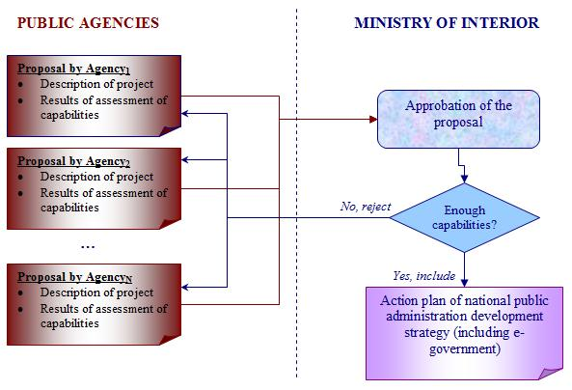
Figure 45. Using the assessment of interoperability capabilities in strategic e-government planning in Lithuania
Source: Composed by the author
Since the toolkit has also to be adopted on the organisational level in order to be viable on the national one, these recommendations are offered (see Figure 46 for more details):
- Make the assessment of e-government interoperability capabilities an integral part of every e-government project:
  - Carry out the assessment before proceeding with the implementation of e-government initiative in order to identify whether it is feasible to reach its aims with present dynamic capabilities, and to decide how much should be invested in the project itself, and how much into the lacking capabilities.
  - When e-government initiative is considered as finished, repeat the assessment of dynamic capabilities in order to determine the changes that occurred in improvement or lost of capabilities.
- Establish a system for gathering, storage and analysis of data from assessment of dynamic capabilities for e-government interoperability that would be integrated with the similar national system.
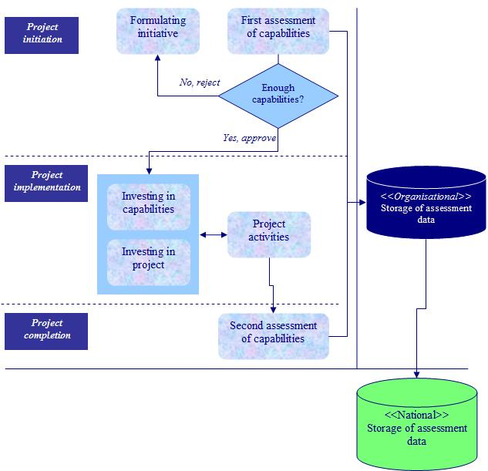
Figure 46. Using assessment of capabilities for interoperability to minimise e-government project risks
Source: Composed by the author

  - Integration of the modified toolkit for assessment of interoperability with the common tools of quality and performance management
Most recent study on quality management methods implementation in Lithuanian public sector institutions shows that though even 63% of organisations do not apply any quality management techniques in their operational activities, the interest in quality management slowly increases (LR vidaus reikalų ministerija & VšĮ Viešosios politikos ir vadybos institutas, 2008). The most popular quality management methods that are practiced in Lithuanian public sector organisations are ISO 9000 (International Organisation for Standardisation) quality standards series (applied by 14.7% of institutions), common assessment framework (applied by 8.3% of institutions), and balanced scorecard (applied by 2.6% of institutions) (ibid).
The family of ISO 9000 standards is oriented towards quality management in the organisation of any type or size (ISO...). The application of these standards consists of four phases: Plan, do (implementing the plans), check (measuring the results), and act (improvement of the plans) (ibid). ISO 9000 addresses eight principles of quality management: Customer focus, leadership, involvement of people, process approach, system approach to management, continual improvement, factual approach to decision making, mutually beneficial supplier relationships (ibid). As ISO 9000 series are not explicitly oriented towards ICTs development ISO has released a special interpretation called ISO 9000-3 aiming to interpret the standard ISO 9001 in the context of software development (ISO 9000-3:1997...). There is also a special standard for ICTs governance ISO/IEC 38500:2008 “Corporate Governance of Information Technology” (ISO/IEC 38500:2008...) that has already been approved as the national standard in Lithuania. However, its more active application is still at its infancy.
Common assessment framework (CAF) was developed on the basis of European Foundation for Quality Management Excellence Model and Speyer model (Bendrasis vertinimo modelis..., 2007). It aims are to promote usage of various quality management techniques in the public sector organisations, foster them to know their operational idiosyncrasies through self-assessment, and facilitate benchmarking of the public sector organisations (ibid). CAF application is made up from three phases: Planning self-assessment, carrying out self-assessment, and planning the improvement of organisation‘s work (ibid). CAF is oriented towards the improvement of enablers and results (ibid). Enablers include such perspectives as leadership, people, strategy, partnership and resources, and processes (ibid). Results are oriented towards the assessment of people results, citizen or customer orientation results, society results, and key performance results (ibid). Specification of CAF proposes some examples to measure every of these perspectives.
Balanced scorecard is a tool of strategic management widely used in the private as well as public sector (Dobrović, Tomičić, & Vrček, 2008) to measure the performance of organisations using a set of indicators developed from strategic vision and goals. It is oriented towards measuring financial as well as not-financial perspectives of business that include customer, internal business processes, learning and growth (Caplan & Norton, 1996). Currently this approach is supported by various non-technological tools as strategy mapping as well as special software products.
Though all these above mentioned techniques might be applied independently, in the specification of CAF it is proposed to integrate ISO 9000 and balanced scorecard to support assessment and improvement of all nine criteria (Bendrasis vertinimo modelis..., 2007). However, all of these methods are very little oriented towards ICTs development in the public sector organisations as well as to strengthening common and specific organisational capabilities to ensure that ICTs would bring expected benefits. Therefore integration of the toolkit for assessment of e-government capabilities with these common techniques for quality and strategic management might serve in reducing the gap between business and technology.
These four methods have similarities and differences. The structure and features of the toolkit for e-government interoperability assessment are mostly similar to CAF. Both tools are oriented to self-assessment and improvement of organisational capabilities based on the results of self-assessment. They exploit a multi-dimensional approach towards organisational capabilities; offer the list of possible indicators, and a comprehensive methodology for self-assessment. The main differences are that CAF lacks technological dimension, though some indicators addresses the usage of technology to support organisational business processes. Another difference is that CAF is oriented towards the assessment of overall quality of organisational performance; meanwhile the toolkit for e-government interoperability capability assessment addresses the capabilities of organisation to implement a specific e-government initiative using specific organisational capabilities. Finally, CAF is used in a single organisation, and the toolkit for e-government interoperability assessment measures the capabilities of the network of organisations.
Like ISO 9000 the toolkit also requires strong documentation and rigidity in the critical capabilities for interoperability. The main differences between ISO 9000 and the toolkit for e-government interoperability assessment is that ISO quality standards are mostly focused on operational capabilities, and the toolkit is exceptionally addressing the dynamism of organisation.
Based on the above analysis and the empirical evidence gathered during the research of this work, the following recommendations are proposed for the integration of the modified toolkit with common quality and performance management techniques (see Figure 47):
- The dimensions of leaders and champions, strategic planning, and collaboration readiness are also found in CAF criteria. Leaders and champions substitute leadership, collaboration readiness – partnership and resources. Thus it is recommended to include the missing indicators from the toolkit of e-government interoperability assessment into the respective examples in CAF criteria (see Table 70 in Appendix 10).
- Create national e-government dashboard consisting from indicators measuring the progress in dynamic capabilities for e-government interoperability.
- Establish a system of organisational capabilities development where e-government projects would be used as one of the main tools to improve or gain dynamic capabilities needed in other activities of the public sector organisation, and vice versa. Use CAF and ISO 9000 to identify and improve overall dynamic and operational capabilities that would consequently used in e-government projects. The modified toolkit for the assessment of e-government interoperability should be used to identify and invest in specific dynamic capabilities for interoperability in ICTs projects that would later be integrated in the overall capacity of organisation to fulfil its mission.
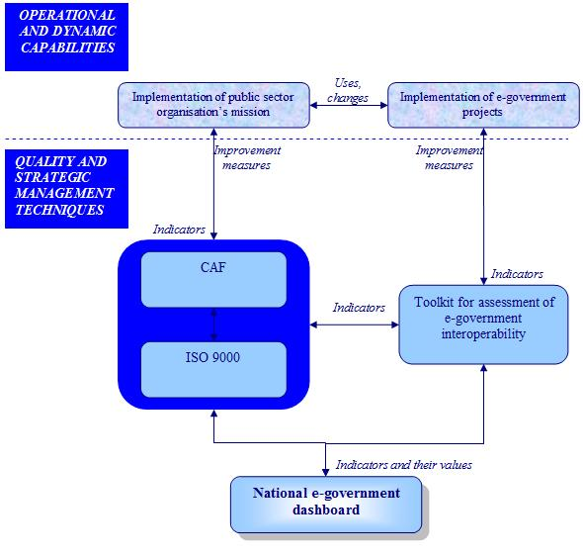
Figure 47. Integration of traditional quality management methods with toolkit for e-government capability assessment
Source: Composed by the author

  - Chapter 4 conclusions
- During the research the following six dynamic capabilities from environmental, organisational and technological categories were identified as being the most critical for e-government initiatives in Lithuania: Leadership, collaboration readiness, strategic planning, performance evaluation, project management, data assets and requirements, and business model and architecture. They should be used for the assessment of capabilities for e-government interoperability along with the indicators assigned in the specification of the original toolkit.
- Improvement of the dynamic capabilities in leadership, collaboration readiness, strategic planning, performance evaluation, project management, data assets and requirements, and business model and architecture has to be included in the strategic goals of overall development of public administration as well as e-government in Lithuania.
- Assessment of interoperability capabilities should be used in selection and prioritisation process of e-government initiatives of national importance in Lithuania.
- Assessment of interoperability capabilities should become an integral part of every e-government initiative. It should be used before start-up of a project and repeated after its completion. Early assessment would allow indicating the missing dynamic capabilities that are critical for the successful implementation of initiative, and deciding how much of allocated project resources should be invested into their development. Assessment after the completion of the project would indicate the changes in dynamic capabilities.
- Every public sector organisation should establish a system for gathering, storage and analysis of data of assessment of dynamic capabilities for e-government interoperability that would be integrated with the equivalent national system.
- Based on the research instrument used in this work for experts’ opinion assessment periodical benchmarking of dynamic capabilities for interoperability should be carried out on national level to track changes in core capabilities as well as changing perception of the experts about other capabilities from the original version of the toolkit. The list of relevant capabilities should be modified according to the results of the benchmarking.
- Integrate usage of traditional quality management methods such as CAF and ISO 9000 with the usage of toolkit for the assessment of e-government interoperability. This would allow improving or developing dynamic capabilities needed for core activities of public sector organisation via e-government projects, and vice versa.
- Use national level e-government dashboard to measure and monitor changes in dynamic organisational capabilities for interoperability.
conclusions
- Based on the extensive analysis of contemporary e-government development models and management methods used for their implementation, an integrated framework for the strategic planning, implementation, and research of e-government, grounded on the approach of dynamic organisational capabilities for interoperability and their assessment was proposed in this work. The proposed framework served as the basis for further theoretical analysis of e-government interoperability development and assessment tools, and was also used in the empirical part of this work. In this framework e-government development process is proposed to be divided into three different layers: (1) policy and strategy, (2) processes and technology, and (3) results assessment. In the policy and strategy layer conception and goals of e-government development are defined along with the principles of governance and coordination of e-government development on international, national, local, and organisational levels. It is recommended to periodically revise e-government definition, goals, and governance principles in order to take advantage from technological progress, and to react to constantly changing environmental challenges. Processes and technology layer defines the maturity levels of e-government solutions such as informational, transactional, integration, digital democracy, and other that are selected according to the needs of a particular country. These maturity levels are implemented using available e-government infrastructural architecture which offers different access channels, applications, portals, and networks. Results layer of the framework include various quantitative and qualitative indicators for periodical measurement of maturity of e-government solutions and their performance. E-government interoperability and its assessment are the crucial elements of the framework. The development of e-government solutions and supporting architecture heavily relies on the level of dynamic e-government interoperability capabilities of purposeful creation, extension and modification of resource base at political, legal, organisational, semantic and technology layers. These capabilities could be gained and developed more effectively if special managerial tools selected according to the contextual singularities of a particular country were used.
- According to the analysis of present research studies special managerial methods of enforcement and assessment are used for the development of dynamic capabilities for e-government interoperability in the majority of countries. E-government interoperability can be enforced using standards-based, architectural or hybrid approach, when the last one integrates the first two approaches into a single scenario. Standards-based approach is based on the creation of national interoperability framework that offers a set of standards and guidelines that have to be followed by all stakeholders of e-government development process. Architectural approach is oriented towards development of national enterprise architecture that formally describes relations between organisational structure, processes, people, data, and ICTs, and serves as a strategic planning framework for alignment of business goals and ICTs investments. Implementation of these methods of e-government interoperability enforcement as well as implementation of concrete e-government initiatives requires various dynamic organisational capabilities for interoperability. Special e-government interoperability capabilities assessment toolkit developed by the USA researchers offers a comprehensive list of dynamic organisational capabilities from the environmental, organisational, semantic and technological layer that are critical for interoperability, and indicators to measure their level. This toolkit aims to identify if there are enough dynamic capabilities to successfully implement a particular e-government initiative by a network of participating public sector organisations, and to support decisions what part of available resources have to be invested in missing capabilities, and what part to the initiative itself. Analysis of current research on development and implementation of leading methods used in e-government and its interoperability development has shown that their transfer to other than the invention context has to take into account underlying processes, asset position, and path-dependency of all participating public sector organisations. It would allow to evaluate the technical and evolutionary fitness of the adopted method.
- Original instrument was developed to research the feasibility of the toolkit for assessment of e-government interoperability that was developed by the USA researchers. The structure of the toolkit was taken as the foundation of the research instrument design where the dimensions of dynamic capabilities along with respective indicators were used to assess the perception of e-government interoperability by Lithuanian experts, and thus ensure the validity of the research design. All the indicators from each dimension were measured using the perspectives of knowledge, importance and presence to ensure the maximum reliability of experts’ estimations, that were further used to modify the original structure of the toolkit in Lithuanian context. The case study of e-government development process in the USA and Lithuania has showed that the USA e-government development process is mainly based on the integrated approach to e-government development, and is supported by the range of managerial and technological tools. Meanwhile, in Lithuania e-government development is still heavily focused on the creation of stand-alone online public services. However, the experts’ opinion assessment research results have proved the main hypothesis of this work: Leading methods applied for assessment of e-government interoperability can be adopted in the context of countries in earlier stage of e-government development process. Yet tangible simplification of the adopted method is applicable due to the gap between theoretical and practical readiness of the experts in these two countries. The empirical data gathered during the case study and the experts’ opinion assessment research proves the first additional hypothesis H₁: Dynamic organisational capabilities for e-government interoperability are related to country’s e-government development process level. The sophisticated e-government development process in the USA has lead to the identification of even 16 dynamic capabilities for e-government interoperability by their national experts. Since e-government development process is still framed in Lithuania, usage of only six dimensions from the initial list was proved statistically significant. However, applying even these six critical dimensions can lead to the breakthrough in Lithuanian e-government development process and allow omitting several burdening e-government development stages that the USA had to pass. Second additional hypothesis H₂ “In the context of countries at different e-government development process stage assessment of dimensions and indicators depicting capabilities for interoperability differs in perception, importance and idiosyncrasy” was also proved by the research. Lithuanian experts as well as the USA experts similarly perceive the importance of dynamic capabilities, but have less practical knowledge in their usage which is especially reflected in the ratings of presence of these dynamic capabilities in e-government initiatives: almost all dynamic capabilities were indicated as only partially present. Finally, additional hypothesis H₃ “Dimensions and methods for e-government interoperability assessment developed elsewhere can be adopted for use in Lithuania based on the degree to which local experts can understand and rank the applicability of the dimensions depicting capabilities for e-government interoperability” has been only partially proved. It is possible to identify the most critical dimensions for the context of a particular country, but instead of asking experts to indicate these dimensions, their detailed assessment using concrete indicators and three perspectives of knowledge, importance, and presence is needed.
- Based on theoretical studies on evolution of e-government instrumentation and results of empirical data research data the structure of the toolkit for e-government interoperability capability that was developed and used in the USA was modified for the context of Lithuania. Environmental, organisational, and technological dynamic organisational capabilities for interoperability as critical at the current e-government development stage in Lithuania were identified, and they include such capabilities as leadership, collaboration readiness, strategic planning, performance evaluation, project management, data assets and requirements, and business model and architecture. The indicators identified in the primary version of the toolkit are proposed to be used for the assessment of each dimension that was included in the modified version. Modified version of the toolkit and the research instrument developed in this work can serve for several purposes. It is recommended to integrate them into the strategic management process of e-government in Lithuania for the identification and prioritisation of national e-government initiatives that are feasible to implement using existing dynamic capabilities, and that also contribute for the development of existing as well as new dynamic capabilities of public sector organisations. Other recommendation is to use the outcomes of this work for reduction of the risk of e-government projects through making the modified toolkit an integral part of each project planning and performance assessment. Finally, the modified version of the toolkit and the research instrument used in this work to assess the perceptions of e-government interoperability can lead to the increased interoperability of Lithuanian government if integrated with some common performance and quality management techniques like CAF or ISO, and monitored through the national e-government performance dashboard system containing indicators that measure the progress of dynamic capabilities for interoperability from various perspectives. Implementation of these recommendations would lead towards the shift of e-government development process in Lithuania from its current stage towards the integrated approach to the joined-up government development which was proposed in the very beginning of this work.
Eglė Malinauskienė

DINAMINIŲ ORGANIZACIJOS SĄVEIKUMO GEBĖJIMŲ VERTINIMAS SKIRTINGO E. VALDŽIOS IŠSIVYSTYMO LYGIO KONTEKSTE

Santrauka

ĮVADAS

Temos aktualumas. Elektroninė valdžia (e. valdžia) apibrėžiama, kaip visuma viešojo sektoriaus veikloje diegiamų informacijos ir ryšių technologijų (IRT), siekiant tokių kokybinių šios srities pokyčių, kaip viešojo sektoriaus organizacijų našumas ir efektyvumas, jų veiklos skaidrumas ir atskaitomybė, lankstumas reaguojant į besikeičiančius aplinkos reikalavimus, orientacija į veiklos rezultatus, piliečius, demokratinių procesų ir viešosios politikos tobulinimą (European Commission, 2003).
Šiuo metu tiek Lietuvoje, tiek ir pasaulyje vykdoma daug e. valdžios projektų, pradedant nuo jau tradicinėmis tapusių elektroninių viešųjų ir administracinių paslaugų kūrimo ir baigiant ambicingomis, IRT pagrįstomis valdymo, veiklos ir struktūros pokyčių iniciatyvomis. Visų jų sėkmė vertinama pagal tai, ar projektas buvo užbaigtas laiku, neviršijo nustatyto biudžeto, pasiekė užsibrėžtų tikslų, sukurtą sistemą gerai įvertino visos suinteresuotosios grupės ir ji turi daug vartotojų. Deja, kaip rodo statistika, tik 15 proc. visų projektų baigiasi visiška sėkme, kai tuo tarpu 50 proc. jų laikomi dalinai, o 35 proc. – visiškai žlugusiais (Heeks, 2006). Viena priežasčių yra ta, kad tradiciškai dėmesys per daug koncentruojamas į technologinius, o ne aplinkos ir organizacinius faktorius. Ypatingą poveikį e. valdžios projektų rezultatams turi tokie faktoriai, kaip teisinis reguliavimas, nepalanki organizacinė kultūra, nelankstūs veiklos procesai, lyderystės stoka ir skirtingi suinteresuotųjų grupių interesai.
Įgyvendinant šiuolaikinius e. valdžios sprendimus dažniausiai dalyvauja nemažai skirtingų viešojo sektoriaus institucijų, todėl iškyla sąveikumo tarp jų veiklos procesų ir naudojamų IRT sistemų poreikis. Dėl šios priežasties, daugelyje valstybių vis labiau akcentuojama naujo organizacijos gebėjimo – e. valdžios sąveikumo (angl. e-government interoperability) – svarba, kur jis palaipsniui tampa pagrindiniu e. valdžios plėtros proceso elementu (European Commission, PEGSCO, 2009; Lallana, 2008; Ministerial declaration, 2009; Pardo & Burke, 2008a; United Nations, 2010).
Organizacijos sąveikumo gebėjimai visų pirma pasireiškia jos viduje kaip skirtingų struktūrinių padalinių sugebėjimas dirbti kartu, o tai įtakoja ir organizacijos bendradarbiavimą su kitomis institucijomis tiek šalies viduje, tiek ir tarptautiniu lygmeniu. Valdžios sąveikumas leidžia bet kurio valdymo lygmens valstybės tarnautojams tuo pačiu metu prieiti ir naudotis informacija surinkta iš daugelio šaltinių, skatina pokyčius viešųjų ir administracinių paslaugų teikimo srityje, sudaro sąlygas efektyviam viešojo sektoriaus institucijų darbui, ir prisideda prie stabilios bei gyvybingos ekonomikos plėtros (Pardo & Burke, 2008a, 2008b).
Šiame darbe e. valdžios sąveikumas yra apibrėžiamas kaip dinaminis organizacijos gebėjimas (angl. dynamic organisational capability) kurti ir keisti esamus resursus, bei atsisakyti netinkamų tam, kad vyktų tarp-institucinių IRT projektų sėkmingam įgyvendinimui reikalingi pokyčiai (Cresswell, Pardo, & Canestraro, 2008). Šis gebėjimas yra daugiamatis, t.y. sudarytas iš įvairių dinaminių gebėjimų, kurių trūkumas yra įvardijamas tarp pagrindinių į pokyčius orientuotų ir IRT pagrįstų projektų rizikų (ten pat). Pagaliau, e. valdžios sąveikumas yra priklausomas nuo konteksto, todėl vykdant skirtingus projektus skirtingų valstybių skirtingose institucijose jų sėkmę gali nulemti vis kiti organizacijos dinaminiai gebėjimai.
Paradoksalu, tačiau norint užtikrinti sėkmingą e. valdžios projektų, kurie dažniausiai yra orientuoti į viso valdžios aparato sąveikumo stiprinimą, įgyvendinimą būtina, kad viešojo sektoriaus organizacijos jau turėtų tam tikrą sąveikumo brandos lygį, kuris užtikrintų glaudų visų projekto dalyvių bendradarbiavimą ir efektyvų keitimąsi informacija. Taigi, e. valdžios sąveikumo plėtra ir vertinimas yra pagrindinis būdas išvengti arba sumažinti susijusių projektų įgyvendinimo rizikas, kurios esant nepakankamam sąveikumui išauga dramatiškai.
Dėl to, labai svarbu vykdant e. valdžios projektus išmokti matuoti e. valdžios sąveikumą, ir dar prieš inicijuojant projektą išskirti svarbiausias sąveikumo gebėjimų dimensijas bei įvertinti jų lygį pagal iš anksto identifikuotus rodiklius. Tai leidžia nustatyti, ką galima ir ko negalima įgyvendinti organizacijoje su esamu sąveikumo lygiu, kaip geriausia įgyti trūkstamų gebėjimų, kiek tiesiogiai investuoti į patį projektą, o kiek į jo įgyvendinimui reikalingų dinaminių gebėjimų plėtrą.
Šiuo metu mokslininkai ieško tinkamiausių sąveikumo vertinimo įrankių, ir e. valdžios srityje pirmaujančiose valstybėse jau yra pasiekę praktinę naudą teikiančių rezultatų. Moksliniai šių priešakinių metodų (angl. leading methods) ir jų adaptyvumo tyrimai valstybių, kurių e. valdžios plėtros procesas dar nėra pakankamai susiformavęs, kontekste leistų ženkliai paspartinti globalų e. valdžios plėtros procesą.

Taigi, šiame darbe keliama tokia mokslinė problema: Kaip e. valdžios sąveikumo vertinimui naudojami priešakiniai metodai gali būti adaptuoti valstybėse, esančiose ankstyvosiose e. valdžios plėtros proceso stadijose?

Tyrimo objektas – įrankio, kurį e. valdžios srityje pirmaujančios valstybės naudoja organizacijos sąveikumo dinaminiams gebėjimams vertinti, struktūra, funkcionalumas ir adaptyvumas.

Mokslinės problemos ištirtumo laipsnis. Visa mokslinė literatūra, susijusi su šiame darbe iškelta moksline problema, gali būti suskirstyta į keletą kategorijų: dinaminių organizacijos gebėjimų teorija, e. valdžios plėtros modelių moksliniai tyrimai, e. valdžios sąveikumo užtikrinimo ir vertinimo įrankių tyrimai, bei kontekstinių faktorių, turinčių įtakos e. valdžios plėtros ir sąveikumo gerosios patirties perėmimui, studijos.
Dinaminių organizacijos gebėjimų teoriją sukūrė ir toliau daugiausiai plėtoja tokie mokslininkai, kaip S. G. Winter, D. J. Teece, G. Pisano, C. E. Helfat, ir K. M. Eisenhardt. Olandų mokslininkai M. Janssen ir B. Klievink jau pritaikė dinaminių organizacijos gebėjimų teoriją e. valdžios plėtros modelių tyrimuose, tačiau kitų šioje srityje dirbančių mokslininkų (Layne ir Lee, Hiller ir Belanger, Wescott, Andersen ir Henriksen, Davison, Gottschalk, ir kt.) darbuose dinaminiai organizacijos gebėjimai tiesiogiai dar nėra akcentuojami.
Kadangi e. valdžios sąveikumas vis labiau pripažįstamas kaip vienas iš kritinių sėkmingos e. valdžios plėtros faktorių, daugelis mokslininkų nagrinėja jį užtikrinančius įrankius: L. Guijarro, Y. Charalabidis, M. Janssen, K. Hjort-Madsen ir kiti. E. valdžios sąveikumo, kaip dinaminio organizacijos gebėjimo, tyrimų kol kas pastebimos tik užuomazgos. Dinaminių organizacijos gebėjimų teorija e. valdžios sąveikumo srityje buvo pritaikyta ir toliau naudojama tokių mokslininkų kaip A. M. Cresswell, S. S. Dawes, T. A. Pardo, ir kitų. Šie mokslininkai yra pasiūlę išsamų dinaminių organizacijos gebėjimų, sudarančių e. valdžios sąveikumą, vertinimo įrankį, kuris šiuo metu yra vienintelis turimas priešakinis metodas šioje srityje.
Nors mokslininkai palaipsniui pripažįsta konteksto svarbą, siekiant sėkmingai perimti gerąją patirtį e. valdžios srityje (pvz., R. Heeks, P. Dunleavy, J. Fountain), tačiau konteksto įtaką e. valdžios sąveikumo užtikrinimui naudojamiems įrankiams kol kas nagrinėja tik pavieniai autoriai, pvz., K. Hjort-Madsen. Pažymėtina, kad aukščiau paminėto dinaminių organizacijos gebėjimų, sudarančių e. valdžios sąveikumą, vertinimo įrankio adaptyvumas taip pat nebuvo nagrinėtas kituose negu jo originalus kontekstuose.
Lietuvoje vertingą indėlį į e. valdžios mokslinius tyrimus įnešė tokie mokslininkai kaip R. Petrauskas, A. Augustinaitis, V. Rudzkienė, N. K. Paliulis, E. Chlivickas, R. Gatautis, A. Kaziliūnas, B. Melnikas, N. Jurkėnaitė, T. Limba. Jų darbai yra koncentruoti į e. valdžios plėtros politikos ir vykdomų projektų analizę, pagrindinių šio proceso problemų ir iššūkių identifikavimą, galimus e. valdžios plėtros modelius bei scenarijus Lietuvai. E. valdžios sąveikumą detaliau tyrinėjo R. Gatautis ir B. Kulvietis, kurie pasiūlė nacionalinių sąveikumo pagrindų gaires Lietuvai. Vis dėlto, dinaminių organizacijos gebėjimų teorinė perspektyva tebėra nauja Lietuvos mokslininkų darbuose, skirtuose e. valdžios ir jos sąveikumo tyrimams. Be to, trūksta ir nuodugnių studijų, nagrinėjančių priešakinių e. valdžios ir jos sąveikumo metodų įsisavinimą Lietuvoje.
Tradicinių vadybos metodų taikymą Lietuvos viešajame sektoriuje plačiai nagrinėja S. Puškorius, A. Guogis, A. Kaziliūnas, V. Domarkas, A. Raipa, T. Sudnickas, D. Gudelis, R. Vanagas, ir kiti. Vis dėlto, tradicinių vadybos metodų panaudojimo e. valdžios srityje galimybės, integruojant juos su specifiniais, tik šioje srityje taikomais įrankiais, Lietuvoje dar nėra plačiai analizuojamos.

Disertacinio darbo tikslas – išanalizuoti sąveikumo vertinimui naudojamų priešakinių metodų vaidmenį aukšto išsivystymo lygio e. valdžios plėtros procese, ir parengti šių metodų pritaikymo Lietuvos kontekste rekomendacijas.
Darbo tikslui pasiekti keliami šie uždaviniai:
- Išnagrinėti sąveikumo vaidmenį technologijų taikymu grindžiamoje viešojo sektoriaus reformoje, ir išskirti pagrindinius kompleksinio e. valdžios plėtros proceso komponentus.
- Išanalizuoti e. valdžios sąveikumo užtikrinimui ir vertinimui naudojamus metodus, ir nustatyti jų pritaikymo valstybėse, pasiekusiose skirtingą e. valdžios plėtros proceso lygį, ypatumus.
- Ištirti e. valdžios sąveikumo vertinimui naudojamų metodų adaptavimo galimybes skirtingo e. valdžios išsivystymo valstybių kontekste:
  - Atlikti dviejų valstybių (JAV ir Lietuvos) e. valdžios plėtros proceso atvejo studiją.
  - Įvertinti e. valdžios sąveikumo vertinimo įrankio struktūros ir funkcionalumo tinkamumo laipsnį Lietuvos kontekste.
- Remiantis atliktu teoriniu ir empiriniu tyrimais, parengti sąveikumo vertinimui naudojamų metodų pritaikymo Lietuvos e. valdžios plėtros procese rekomendacijas.

Mokslinio darbo naujumas. Dabartiniai moksliniai tyrimai dažniausiai analizuoja kurį nors vieną e. valdžios plėtros aspektą, ir nesiūlo holistinio požiūrio, apimančio visus šiame procese naudojamus bei vienodai jam svarbius komponentus, tokius kaip strategija, procesai, technologijos, gaunamų rezultatų stebėsena, bei reikalingi organizacijos gebėjimai. Nors e. valdžios sąveikumas yra vis labiau pripažįstamas mokslininkų, kaip kritinis e. valdžios plėtros faktorius, tačiau jis vis dar nagrinėjamas atsietai nuo viso e. valdžios plėtros proceso, didžiausią dėmesį skiriant instrumentinei šių reiškinių pusei. Dėl to, moksliniuose tyrimuose labiau pastebimos tendencijos analizuoti individualius valstybės tarnautojų įgūdžius, o ne tai, kaip jie galėtų būti apjungti į visos organizacijos gebėjimus ir kolektyviai taikomi įgyvendinant e. valdžios iniciatyvas. Dėl šių priežasčių, šiame darbe atliktos teorinės e. valdžios plėtros modelių ir naudojamų vadybinių instrumentų raidos analizės pagrindu, buvo pasiūlytas kompleksinis e. valdžios plėtros planavimo, įgyvendinimo ir mokslinių tyrimų modelis, paremtas atitinkamais dinaminiais organizacijos sąveikumo gebėjimais ir jų vertinimu.
Kitas išskirtinis šio darbo bruožas yra tas, kad jame nagrinėjamos priešakinių e. valdžios srityje naudojamų metodų adaptavimo galimybės valstybių, kurių e. valdžios plėtros procesas dar nėra iki galo susiformavęs, kontekste. Iki šiol tiek Lietuvos, tiek ir užsienio mokslininkai nedaug dėmesio skyrė gerosios patirties perėmimo e. valdžios srityje empiriniams tyrimams. Šiame darbe buvo ištirta, kaip e. valdžios sąveikumo gebėjimų vertinimui naudojami priešakiniai metodai gali būti adaptuoti Lietuvos kontekstui. Kol kas vienintelis toks metodas – JAV sukurtas e. valdžios sąveikumo vertinimo įrankis (Cresswell, Pardo, Canestraro, Dawes, & Juraga, 2005) – tapo viso tyrimo pagrindu.
Visų pirma, jis buvo panaudotas konstruojant e. valdžios sąveikumą sudarančių dinaminių gebėjimų suvokimo, svarbos ir praktikos lygį konkrečioje valstybėje leidžiantį įvertinti tyrimo instrumentarijų. Šiame darbe minėtas e. valdžios sąveikumo vertinimo įrankis buvo pirmą kartą panaudotas kaip tyrimo instrumentarijaus dalis, ir atitinkamai autorės patobulintas elementais, kurie leidžia ne tik nustatyti dinaminių organizacijos sąveikumo gebėjimų lygį, bet ir įvertinti, kaip konkrečios šalies ekspertai suvokia ir vertina e. valdžios sąveikumą sudarančius dinaminius organizacijų gebėjimus.
Antra, remiantis teorine analize ir atlikto empirinio tyrimo rezultatais, pasiūlyta modifikuota ir esamo Lietuvos e. valdžios plėtros proceso brandos galimybes atitinkanti JAV mokslininkų sukurto e. valdžios sąveikumo vertinimo įrankio versija, orientuota į tų dinaminių organizacijos sąveikumo gebėjimų vertinimą, kurie ekspertinio vertinimo metu buvo nustatyti kaip esantys statistiškai reikšmingais. Kompleksinis modifikuotos įrankio versijos ir darbe pasiūlyto tyrimo instrumentarijaus taikymas, siekiant sustiprinti šiuo metu reikšmingiausius dinaminius gebėjimus, gali įtakoti ir kitų, šiuo metu Lietuvos kontekste sunkiai pritaikomų, dinaminių gebėjimų atsiradimą.
Trečia, originali e. valdžios sąveikumo vertinimo įrankio versija buvo panaudota organizaciniame lygmenyje, įgyvendinant keletą konkrečių JAV e. valdžios projektų (Cresswell et al., 2008). Šiame darbe buvo nagrinėjamos jo adaptavimo galimybės ne vien organizaciniame, bet ir nacionaliniame e. valdžios plėtros strateginio planavimo ir koordinavimo lygmenyse.
Galiausiai, darbe pateiktos modifikuoto įrankio ir sukurto tyrimo instrumentarijaus tolimesnio taikymo Lietuvos e. valdžios plėtros procese rekomendacijos. Jų įgyvendinimas galėtų padėti sumažinti šiuo metu egzistuojantį atotrūkį tarp viešojo administravimo ir e. valdžios strateginio planavimo Lietuvoje. Iki šiol nei užsienio, nei Lietuvos mokslininkai šio aspekto nėra nagrinėję, ir tai parodo šio darbo rezultatų vertę ne vien tik e. valdžios, bet ir viso viešojo administravimo moksliniams tyrimams bei praktikai.

Mokslinio darbo metodologija. Šiame darbe buvo naudojami bendrieji ir empiriniai mokslinių tyrimų metodai. Bendrieji mokslinių tyrimų metodai apima sisteminę analizę, dedukciją, lyginamąją analizę ir apibendrinimą. Darbe buvo panaudoti du kokybiniai empirinio tyrimo metodai: atvejo studija ir ekspertinis vertinimas.
Sisteminės analizės metodas kartu su lyginamąja analize bei apibendrinimu buvo panaudoti nustatant svarbiausius e. valdžios sąveikumo bruožus, išskiriant pagrindinius kompleksinio e. valdžios plėtros proceso komponentus, klasifikuojant priešakinius e. valdžios sąveikumo užtikrinimui ir vertinimui naudojamus metodus, bei jų taikymą įtakojančius kontekstinius faktorius.
Dedukcijos metodo pagalba buvo iškeltos pagrindinė bei pagalbinės empirinio tyrimo hipotezės, apibrėžtos tyrime naudotos sąvokos ir konkretizuoti jo kintamieji. Atvejo studija buvo atlikta pasitelkiant turinio analizės bei dalyvavimu pagrįsto stebėjimo metodus. Jos metu buvo išanalizuotas e. valdžios plėtros procesas JAV ir Lietuvoje, bei įvertintas kiekvienos šalies e. valdžios plėtros proceso išsivystymo lygis. Ekspertinio vertinimo metodu buvo ištirta, kaip priešakiniai metodai, naudojami e. valdžios sąveikumui įvertinti, gali būti pritaikyti Lietuvos kontekste.
Empirinio tyrimo metu surinktų duomenų analizei, bei darbo išvadų ir rekomendacijų formulavimui naudoti matematinės statistikos, lyginamosios analizės ir apibendrinimo metodai. Siekiant užtikrinti gautų tyrimo duomenų analizės nešališkumą bei kompensuoti vieno kurio nors tyrimo metodo trūkumus, darbe buvo taikomas metodinės trianguliacijos principas.

Teoriniai darbo rezultatai yra:
- Išskirti esminiai e. valdžios sąveikumo kaip dinaminio organizacijos gebėjimo bruožai, identifikuojant pagrindinius jo principus, dimensijas, plėtros kryptis, bei ribas.
- Pasiūlytas kompleksinis e. valdžios plėtros planavimo, įgyvendinimo ir mokslinių tyrimų modelis, paremtas atitinkamais dinaminiais organizacijos sąveikumo gebėjimais ir jų vertinimu.
- Apibendrinti priešakiniai metodai, kurie naudojami e. valdžios sąveikumui užtikrinti ir vertinti.
- Nustatyti kontekstiniai faktoriai, kurie gali įtakoti priešakinių e. valdžios sąveikumo vertinimui taikomų metodų pritaikomumą valstybių, esančių ankstyvosiose e. valdžios plėtros proceso stadijose, kontekste.

Praktiniai darbo rezultatai yra:
- Sukurtas e. valdžios sąveikumą sudarančių dinaminių gebėjimų suvokimo, svarbos ir praktikos lygį konkrečioje valstybėje leidžiantis įvertinti tyrimo instrumentarijus.
- Pasiūlyta modifikuota JAV mokslininkų sukurto e. valdžios sąveikumo vertinimo įrankio versija, kuri atitinka esamo Lietuvos e. valdžios plėtros proceso brandos galimybes.
- Pateiktos rekomendacijos, kaip modifikuotas įrankis ir sukurtas tyrimo instrumentarijus galėtų būti:
  - Pritaikyti strateginio e. valdžios plėtros planavimo Lietuvoje procese, siekiant identifikuoti ir prioretizuoti nacionalines e. valdžios iniciatyvas, bei sumažinti e. valdžios projektų įgyvendinimo rizikas.
  - Naudojami kartu su kitais labiausiai paplitusiais veiklos ir kokybės vadybos metodais, siekiant sustiprinti viso valdžios aparato sąveikumą, ir užtikrinant viešojo administravimo Lietuvoje skaidrumą, efektyvumą ir orientaciją į veiklos rezultatus.

Disertacinio darbo struktūra. Disertacija yra sudaryta iš įvado, keturių skyrių, išvadų, literatūros sąrašo, ir priedų (žr. 48 pav.).
ĮVADAS
IŠVADOS
1. Brandaus e. valdžios plėtros proceso tendencijos ir komponentai
2. E. valdžios sąveikumo užtikrinimo ir vertinimo įrankiai, svarbiausi kontekstiniai faktoriai
1.1. IRT viešajame sektoriuje raida: perėjimas nuo pavienių prie tarp-institucinių e. valdžios sistemų kūrimo
1.2. E. valdžios sąveikumo bruožų nustatymas vadovaujantis dinaminių organizacijos gebėjimų teorija
1.3. Dinaminių organizacijos sąveikumo gebėjimų vaidmuo e. valdžios plėtros modeliuose
1. E VALDŽIOS SĄVEIKUMAS – SVARBIAUSIAS DINAMINIS ORGANIZACIJŲ GEBĖJIMAS IRT TAIKYMU PAGRĮSTOJE VIEŠOJO SEKTORIAUS REFORMOJE
2.1. E. valdžios sąveikumo pagrindai ir organizacijos architektūra: pagrindinės e. valdžios sąveikumo užtikrinimo priemonės
2.2. Dinaminių organizacijos e. valdžios sąveikumo gebėjimų vertinimo įrankis
2.3. Konteksto įtaka dinaminių organizacijos e. valdžios sąveikumo gebėjimų plėtrai ir joje taikomiems įrankiams
2. DINAMINIŲ ORGANIZACIJOS E. VALDŽIOS SĄVEIKUMO GEBĖJIMŲ UŽTIKRINIMO IR VERTINIMO ĮRANKIAI, BEI JŲ TAIKYMO SKIRTINGUOSE KONTEKSTUOSE YPATUMAI
3.1. E. valdžios sąveikumo vertinimui naudojamų priešakinių metodų pritaikymo skirtingo e. valdžios išsivystymo lygio kontekste tyrimo metodologija
3.2. E. valdžios sąveikumo vertinimui naudojamų priešakinių metodų pritaikymo skirtingo e. valdžios išsivystymo lygio kontekste tyrimo rezultatai
3. E. VALDŽIOS SĄVEIKUMO VERTINIMUI NAUDOJAMŲ PRIEŠAKINIŲ METODŲ PRITAIKYMO SKIRTINGO E. VALDŽIOS IŠSIVYSTYMO LYGIO KONTEKSTE TYRIMAS
JAV ir Lietuvos e. valdžios plėtros proceso atvejo studija
E. valdžios sąveikumo vertinimo įrankio ekspertinis vertinimas
Tyrimo instrumentarijus
4.1. E. valdžios sąveikumo vertinimo įrankio ir savybių adaptavimas Lietuvos kontekstui
4.2. E. valdžios sąveikumo vertinimo įrankio integracija į e. valdžios plėtros planavimo procesą
4.3. E. valdžios sąveikumo vertinimo įrankio integracija su tradiciniais kokybės vadybos metodais
4. REKOMENDACIJOS E. VALDŽIOS SĄVEIKUMO VERTINIMUI NAUDOJAMŲ PRIEŠAKINIŲ METODŲ INTEGRACIJAI Į E. VALDŽIOS PLĖTROS PROCESĄ LIETUVOJE
3. Tyrimo rezultatai
48 pav. Loginė darbo struktūra
DISERTACINIO DARBO REZULTATŲ APŽVALGA

Remiantis atlikta teorine e. valdžios plėtros modelių ir naudojamų vadybinių instrumentų raidos analize, pirmojoje darbo dalyje pasiūlytas kompleksinis e. valdžios plėtros planavimo, įgyvendinimo ir mokslinių tyrimų modelis, paremtas atitinkamais dinaminiais organizacijos sąveikumo gebėjimais ir jų vertinimu.
Įgyvendinant šiuolaikinius IRT sprendimus, dažnai dalyvauja skirtingos viešojo sektoriaus institucijos, yra integruojami jų veiklos procesai bei technologinės platformos (Yildiz, 2007; Dawes, 2008; Weske, 2009). Efektyvumas, našumas, veiklos procesų pertvarka, biurokratijos sumažinimas, atskaitomybė ir skaidrumas, priimamų sprendimų kokybė, ir išaugusi orientacija į piliečius yra pagrindiniai viešojo sektoriaus technologiniam progresui keliami tikslai. (Schedler & Scharf, 2001; OECD, 2005; Dunleavy, Margetts, Bastow, & Tinkler, 2006; Navarra & Cornford, 2007; Codagnone & Wimmer, 2007). Dėl to, e. valdžios samprata, kuri naudojama tiek praktikoje, tiek ir moksliniuose tyrimuose, turi apimti visus iššūkius, su kuriais susiduriama diegiant IRT sprendimus viešajame sektoriuje. Be to, ji turi būti orientuota į visas prieinamas technologijas, veiklos procesų pokyčius, naujų įgūdžių plėtrą, bei demokratinių procesų stiprinimą (European Commission, 2003).
Dabartinė e. valdžios plėtra itin priklauso nuo tokių organizacinių viešojo sektoriaus institucijų gebėjimų kaip bendradarbiavimas, organizacinis suderinamumas, lyderystė, strateginis planavimas, finansų ir investicijų valdymas, resursų valdymas, veiklos vertinimas (Gil-Garcıa & Helbig, 2007; Andersen, 2006; Lam, 2005). Šie organizaciniai gebėjimai yra sudaryti iš organizacijoje egzistuojančių rutininių procesų (angl. routines), ir gali būti suskirstyti į kasdienės veiklos bei dinaminius gebėjimus (Constance E. Helfat et al., 2007). Kasdienės organizacijos veiklos gebėjimai (angl. operational capabilities) įgalina organizaciją atlikti jos pagrindines funkcijas, tuo tarpu dinaminiai gebėjimai (angl. dynamic capabilities) yra organizacijos gebėjimai kurti, plėsti ir keisti savo turimų resursų bazę (Constance E. Helfat et al., 2007; Collis, 1994; Sidney G. Winter, 2003).
E. valdžios sąveikumas yra svarbiausias dinaminis organizacijų gebėjimas, siekiant užtikrinti, kad viešajame sektoriuje įgyvendinami IRT projektų tikslai ir rezultatai atitiktų šiuolaikinės valdžios ir visuomenės poreikius. Nors sąveikumas vis dar dažnai analizuojamas vien tik iš technologinės perspektyvos, šis siauras jo suvokimas jau ne itin tinkamas šiuolaikiniam e. valdžios plėtros kontekstui. Remiantis dinaminių gebėjimų teorija, e. valdžios sąveikumas apibrėžiamas kaip dinaminis, daugiamatis (angl. multi-dimensional) ir nuo konteksto priklausomas atskirų ir iš esmės skirtingų organizacijų gebėjimas bendradarbiauti siekiant abipusės naudos ir užsibrėžtų bendrų tikslų kuriant ir naudojant įvairias IRT sistemas, kurios užtikrintų sklandžius informacijos ir žinių mainus tarp atitinkamų jų veiklos procesų . E. valdžios sąveikumas yra sudarytas iš politinio, organizacinio, teisinio, semantinio ir technologinio lygmenų (European Commission, PEGSCO, 2009). Jo plėtra ir praktika susiduria su įvairiais hierarchiniais, struktūriniais, asmeniniais, geografiniais, plėtros ir proceso barjerais, kurie susideda iš nemažai politinių, teisinių, organizacinių ir technologinių kliūčių (Zheng et al., 2009).
E. valdžios sąveikumo klausimai daugiausiai yra akcentuojami e. valdžios pakopų modeliuose (Layne & Lee, 2001; Hiller & Belanger, 2001; Wescott, 2001; Gartner Group, 2001; Accenture, 2003; Capgemini, 2009; United Nations, 2010). Jie apima tokias problemas, kaip paveldėtųjų sistemų (angl. legacy systems) integracija, viešojo sektoriaus institucijų sąveika vienoje funkcinėje srityje arba skirtingose politikos sferose, vieno langelio principu veikiančių interneto portalų kūrimas, skirtingų viešųjų paslaugų teikimo kanalų valdymas, veiklos procesų pertvarka (angl. business process re-engineering) ir centralizuotų e. valdžios infrastruktūros įrankių kūrimas. Dinaminiai organizacijų gebėjimai, kurie reikalingi įgyvendinti kiekvieną iš e. valdžios plėtros pakopų, tiesiogiai buvo išskirti ir analizuoti į sąveikumą orientuotos e. valdžios plėtros modelyje (angl. growth stages of a joined-up government model) (Klievink & Janssen, 2009). Palaipsniui atsiranda ir modeliai, kurie yra išskirtinai orientuoti į e. valdžios sąveikumą. Juose išskiriami tokie sąveikumo lygiai kaip technologinis, veiklos procesų, informacijos ir žinių mainų, vertybinis, ir strateginių tikslų sąveikumas (Gottschalk, 2009). Kiti e. valdžios plėtros modeliai yra orientuoti į strateginį veiklos ir IRT tikslų suderinamumą (Davison et al., 2005), arba e. valdžios plėtrą palaikančios architektūros kūrimą (Ebrahim & Irani, 2005).
Išanalizuoti modeliai tiek mokslininkams, tiek ir praktikams pateikia nemažai vertingų rekomendacijų, kaip organizuoti e. valdžios plėtros procesą ir pasiekti apčiuopiamų rezultatų šioje srityje, tačiau kiekvienas jų skirtas tik kuriam nors vienam iš šio sudėtingo proceso elementų. Dėl to, šiame darbe jie buvo integruoti į kompleksinį e. valdžios plėtros planavimo, įgyvendinimo ir mokslinių tyrimų modelį (žr. 49 pav.), kuris tapo tolimesnės e. valdžios sąveikumo užtikrinimo ir vertinimo įrankių teorinės analizės pagrindu, bei svarbia empirinio tyrimo dalimi.

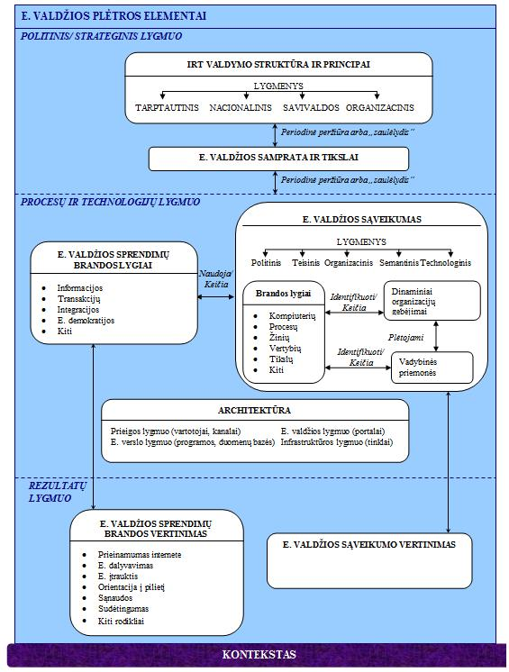
49 pav. Kompleksinis e. valdžios plėtros modelis

Antrojoje disertacinio darbo dalyje nagrinėjami e. valdžios sąveikumo užtikrinimui ir vertinimui naudojami įrankiai, bei jų taikymo skirtinguose kontekstuose ypatumai. Šiuo metu skiriami du požiūriai į e. valdžios sąveikumo užtikrinimą: standartais pagrįstas požiūris bei architektūrinis požiūris. Standartais pagrįstas požiūris yra realizuojamas kuriant nacionalinius e. valdžios sąveikumo pagrindus (angl. e-government interoperability framework). Juose nurodomi principai ir standartai, leidžiantys užtikrinti teisinį, organizacinį, semantinį ir technologinį sąveikumą projektuojant, įsigyjant ir įgyvendinant tarp-institucinius e. valdžios sprendimus (Charalabidis, Lampathaki, & Psarras, 2009; L. Guijarro, 2004; Saekow & Boonmee, 2009). Architektūrinis požiūris yra pagrįstas organizacijos architektūra (angl. enterprise architecture), kuri apibrėžia organizaciją sudarančių informacinių sistemų, procesų, struktūrinių padalinių ir žmonių, kaip vienos visumos, funkcionavimą (Luis Guijarro, 2007; Hjort-Madsen, 2006; Lallana, 2008). Organizacijos architektūra tarnauja kaip stateginio valdymo įrankis, leidžiantis užtikrinti strateginių veiklos tikslų ir investicijų į IRT tarpusavio suderinamumą (ten pat).
Tiek nacionalinių e. valdžios sąveikumo pagrindų, tiek ir organizacijos architektūros kūrimas yra sudėtingos iniciatyvos, kurios kaip ir bet kuris konkretus e. valdžios projektas, reikalaujančios iš anksto identifikuoti, įvertinti ir stiprinti tam tikrus dinaminius organizacijų sąveikumo gebėjimus. Šiuo metu yra pasiūlytas tik vienas detalus e. valdžios sąveikumo vertinimo įrankis, kurį sukūrė ir pasiūlė taikyti praktikoje JAV mokslininkai (žr. 50 pav.).
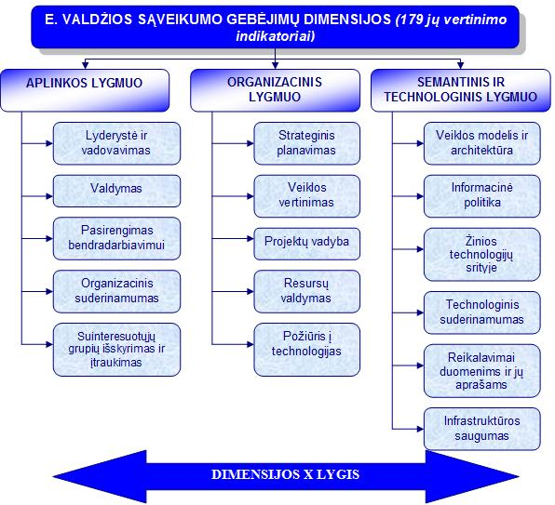
50 pav. E. valdžios sąveikumo vertinimo įrankio struktūra
Šaltinis: adaptuota autorės pagal (Cresswell, Pardo, Canestraro, Dawes, & Juraga, 2005; Pardo & Burke, 2008b)
Šiame įrankyje yra išskirti 16 dinaminių organizacijos sąveikumo gebėjimų aplinkos, organizaciniame bei technologiniame lygmenyse, ir pasiūlyti 179 rodikliai kiekvieno iš šių gebėjimų lygiui įvertinti (Theresa A. Pardo et al., 2005). Pagrindinis įrankio tikslas yra nustatyti, ar viešojo sektoriaus institucijos, ketinančios įgyvendinti tam tikrą e. valdžios projektą, turi tam pakankamai dinaminių gebėjimų (ten pat). Jeigu tam tikrų dinaminių gebėjimų trūksta, prieš pradedant vykdyti projektą, reikėtų investuoti į jų plėtrą (ten pat).
Nacionaliniai e. valdžios sąveikumo pagrindai, organizacijos architektūra bei e. valdžios sąveikumo vertinimo įrankis daugiausiai yra naudojami e. valdžios srityje pirmaujančiose valstybėse. Šalys, kurių e. valdžios plėtros procesas tebesiformuoja, dažniausiai stengiasi pasinaudoti lyderiaujančių valstybių patirtimi. Deja, tai dažnai baigiasi nesėkme arba neduoda lauktų rezultatų. Dėl to, yra labai svarbu įvertinti kontekstą, kuriame bus adaptuojami e. valdžios srityje taikomi priešakiniai metodai, jeigu šis labai skiriasi nuo jų sukūrimo ir dabartinio taikymo aplinkos (Heeks, 2004). Techninis ir evoliucinis dinaminių organizacijos sąveikumo gebėjimų tinkamumas paprastai vertinamas trijuose kontekstiniuose lygmenyse: procesų, resursų, bei organizacijos vystymosi kelio (angl. path-dependancy) (Constance E. Helfat et al., 2007; David J. Teece, 2007). Be to, į jų analizę derėtų įtraukti ir tokius e. valdžios sričiai svarbius faktorius, kaip nacionalinė infrastruktūra, institucinė sandara, darbų perdavimo privačiam sektoriui (angl. outsourcing) politika, bei finansavimo mechanizmai (Fountain, 2001; Scholl, 2006; Chen et al., 2006; Dunleavy et al., 2008). Visus šiuos aspektus buvo stengtasi įvertinti ir šio darbo empirinio tyrimo dalyje.

Trečioje darbo dalyje suformuluotos mokslinio tyrimo hipotezės, pagrįsta ir aprašyta empirinio tyrimo metodologija, bei pateikti empirinio tyrimo metu gauti rezultatai. Pagrindinė mokslinio tyrimo hipotezė yra: e. valdžios sąveikumo vertinimui naudojami priešakiniai metodai gali būti adaptuoti valstybių, esančių ankstyvosiose e. valdžios plėtros proceso stadijose, kontekste.
Pagalbinės tyrimo hipotezės yra:
H₁: Dinaminiai organizacijos e. valdžios sąveikumo gebėjimai yra susiję su valstybės e. valdžios plėtros proceso išsivystymo lygiu.
H₂: Skirtingo e. valdžios plėtros proceso išsivystymo lygio šalyse skiriasi sąveikumą sudarančių dinaminių organizacijos gebėjimų dimensijų ir jų matavimo rodiklių suvokimas, svarba ir praktika.
H₃: Kitose valstybėse taikomos dinaminių e. valdžios sąveikumo gebėjimų dimensijos ir jų vertinimo metodai gali būti pritaikyti Lietuvoje atsižvelgiant į tai, kaip vietiniai ekspertai suvokia ir gali pagal svarbą suranguoti šių dimensijų tinkamumą esamam e. valdžios plėtros proceso išsivystymo lygiui.
Iškeltos hipotezės buvo tikrinamos dviejų kokybinių tyrimo metodų pagalba: atvejo studijos ir ekspertinio vertinimo. Atvejo studija buvo pasirinkta e. valdžios plėtros proceso JAV ir Lietuvoje lyginamajai analizei, ir apėmė visus šiame darbe siūlomo kompleksinio e. valdžios plėtros proceso modelio (žr. 49 pav. viršuje) elementus. Atvejo studija buvo atlikta naudojant turinio analizės, bei dalyvavimu pagrįsto stebėjimo (angl. participant observatory) metodus. Ekspertinio vertinimo metu buvo siekiama ištirti, ar JAV mokslininkų sukurtas e. valdžios sąveikumo vertinimo įrankis gali būti adaptuotas Lietuvos e. valdžios plėtros proceso kontekste. Atsižvelgiant į tyrimo objekto sudėtingumą bei apimtį, ekspertinio vertinimo metu duomenų surinkimui buvo naudojamas apklausos anketavimo būdu metodas. Šio klausimyno pagrindą sudarė jau minėto JAV mokslininkų sukurto e. valdžios sąveikumo vertinimo įrankio struktūra (žr. 50 pav. viršuje), kiekvienos dimensijos matavimo rodiklį vertinant pagal jo aiškumą, svarbą ir būdingumą Lietuvos e. valdžios ekspertų tarpe. Be to, ekspertų buvo paprašyta išskirti penkias svarbiausias dinaminių sąveikumo gebėjimų dimensijas Lietuvai. Ekspertinio vertinimo metu surinktų duomenų analizei buvo panaudoti matematinės statistikos metodai.
E. valdžios plėtros proceso JAV ir Lietuvoje atvejo studija atskleidė, kad JAV egzistuoja integruotas požiūris į e. valdžios plėtros procesą, naudojami įvairūs vadybiniai bei technologiniai instrumentai. Tuo tarpu Lietuvos e. valdžios plėtros procesas yra orientuotas į pavienių elektroninių paslaugų kūrimą. E. valdžios plėtros proceso vadyba JAV yra įgalinta teisės aktų pagalba, kurie reikalauja centrinės valdžios institucijose turėti už IRT politiką ir investicijas atsakingo asmens poziciją (angl. Chief Information Officer), o strateginiam IRT plėtros planavimui naudoti nacionalinę organizacijos architektūrą. Lietuvoje ruošiamas valstybinių informacinių išteklių valdymo įstatymo projektas, kuriame kol kas nėra numatyta privaloma už IRT politiką ir investicijas atsakingo asmens pareigybė, bei formalių metodų taikymas tam, kad būtų užtikrintas IRT plėtros ir strateginių veiklos tikslų suderinamumas. E. valdžios samprata, naudojama JAV, apima visus IRT taikymo viešajame sektoriuje aspektus, pradedant nuo viešųjų paslaugų perkėlimo į elektroninę erdvę ir baigiant jų taikymu, siekiant įgyvendinti valdžios institucijų misiją. Nors Lietuvoje taip pat bandoma vartoti visą apimančią e. valdžios sampratą, vis dėlto, ji vis dar labiau akcentuota į konkrečių e. paslaugų kūrimą. Verta pastebėti, kad strateginio viešojo administravimo plėtros ir e. valdžios tikslų suderinamumą Lietuva siekia užtikrinti tam naudodama vieną strateginį dokumentą. Deja, šių dviejų sričių integracija vis dar yra užuomazgos stadijoje.
E. valdžios sąveikumui užtikrinti, JAV jau 10 metų naudojamas organizacinės architektūros metodas. Lietuvoje taip pat bandoma spręsti e. valdžios sąveikumo problemas: rengiama šios srities strategija ir nacionaliniai sąveikumo pagrindai. Be to, JAV naudojami tiek kiekybiniai, tiek ir kokybiniai e. valdžios progreso vertinimo rodikliai, tokie kaip sąnaudų mažinimas, skaidrumas, bendradarbiavimas, IRT valdymas, elektroninės paslaugos, ir kiti. Tuo tarpu Lietuvoje pagrindinis akcentas šioje srityje yra skiriamas viešųjų ir administracinių paslaugų, prieinamų internete, skaičiui.
Ekspertinis vertinimas buvo atliktas 2010 m. liepos mėn. 26 d. – 2010 m. rugpjūčio mėn. 27 d. Dvidešimt aštuoni e. valdžios ekspertai iš 22 valstybinių institucijų dalyvavo tyrime. Aštuoni ekspertai dirba valstybinėse institucijose, kurios yra tiesiogiai atsakingos už e. valdžios plėtros planavimą ir koordinavimą Lietuvoje. Du ekspertai atstovavo e. valdžios plėtros savivaldoje lygmenį, o kiti ekspertai priklauso institucijoms, kurios įgyvendina įvairias e. valdžios priemones, daugiausiai įtrauktas į Viešojo Administravimo Plėtros Strategijos iki 2010 m. veiksmų planą.
Ekspertų nuomonės vertinant kiekvieną e. valdžios sąveikumo dimensiją sutapo – buvo gautos Kendall konkordancijos koeficiento reikšmės intervale nuo 0.7 iki 1. Tyrimas parodė, kad dauguma Lietuvos ekspertų turi gerą teorinį pasiruošimą kiekvienoje e. valdžios sąveikumo dimensijoje, deja, viešojo sektoriaus organizacijoms derėtų labiau individualias savo specialistų žinias apjungti į bendrus organizacijos gebėjimus, ir labiau juos išnaudoti įgyvendinant e. valdžios projektus. Beveik visos aplinkos, organizacijos bei technologinio lygmens e. valdžios sąveikumo gebėjimų dimensijos ekspertų buvo įvertintos, kaip svarbios Lietuvos kontekstui, išskyrus bendradarbiavimo, organizacinio suderinamumo bei žinių technologijų srityje dinaminius gebėjimus. Dauguma aplinkos lygmens dinaminių gebėjimų (pvz., valdymas, pasirengimas bendradarbiavimui, organizacinis suderinamumas) buvo įvertinti, kaip nebūdingi Lietuvos viešojo sektoriaus organizacijoms ir jų vykdomoms e. valdžios iniciatyvoms. Dinaminiai organizacijų gebėjimai organizaciniame ir technologiniame lygmenyse ekspertų buvo įvertinti kaip dalinai būdingi Lietuvos e. valdžios plėtros procesui. Taigi, pirmos dvi pagalbinės mokslinio tyrimo hipotezės H₁ ir H₂ pasitvirtino.
Ekspertai išskyrė šias penkias svarbiausias e. valdžios sąveikumo dinaminių gebėjimų dimensijas Lietuvai: valdymas, lyderystė, projektų vadyba, strateginis planavimas, ir suinteresuotųjų grupių išskyrimas ir įtraukimas. Vis dėlto, tyrimo rezultatų analizė parodė, kad ekspertų nuomonė šiuo klausimu nesutapo – Kendall konkordancijos koeficiento reikšmė yra tik 0.20. Taigi, trečioji pagalbinė mokslinio tyrimo hipotezė H₃ pasitvirtino tik dalinai. Dėl to, JAV sukurtas e. valdžios sąveikumo vertinimo įrankis buvo modifikuotas remiantis atskirų dimensijų ekspertinio vertinimo rezultatais, o ne ekspertų pateiktais šių dimensijų reitingais.
Atliktas tyrimas patvirtino pagrindinę tyrimo hipotezę: e. valdžios sąveikumo vertinimui naudojami priešakiniai metodai gali būti adaptuoti valstybių, esančių esančių ankstyvosiose e. valdžios plėtros proceso stadijose, kontekste. Tačiau šie metodai turi būti atitinkamai supaprastinti, siekiant išvengti jų netinkamo panaudojimo, dėl esamo atotrūkio tarp teorinio ir praktinio šių valstybių ekspertų pasirengimo.

Ketvirtoje darbo dalyje pateikiamos rekomendacijos priešakinių e. valdžios sąveikumo vertinimo metodų pritaikymui Lietuvos kontekste. Remiantis teorine analize ir atlikto empirinio tyrimo rezultatais, pasiūlyta modifikuota ir esamo Lietuvos e. valdžios plėtros proceso brandos galimybes atitinkanti JAV mokslininkų sukurto e. valdžios sąveikumo vertinimo įrankio versija, kurią sudaro šios dinaminių organizacijos gebėjimų dimensijos: lyderystė, pasirengimas bendradarbiavimui, strateginis planavimas, veiklos vertinimas, reikalavimai duomenims ir jų aprašams, bei veiklos modelis ir architektūra. Rekomenduojama šią modifikuotą įrankio versiją bei darbe sukurtą tyrimo instrumentarijų panaudoti Lietuvos e. valdžios strateginio planavimo procese, siekiant identifikuoti ir prioretizuoti nacionalines e. valdžios iniciatyvas (žr. 51 pav.).
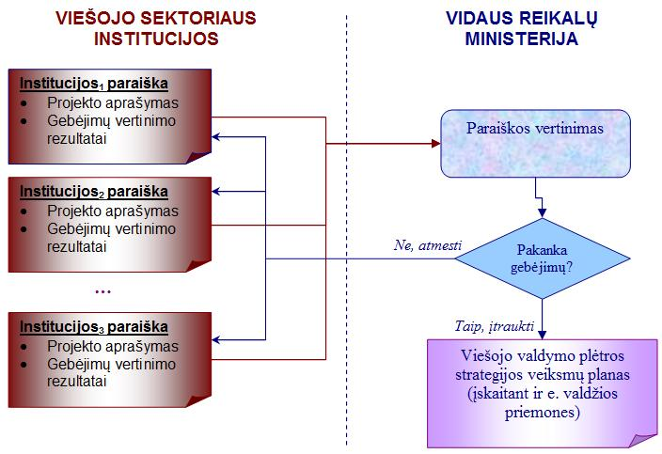
51 pav. Sąveikumo vertinimo vieta Lietuvos e. valdžios strateginio planavimo procese
Šio darbo rezultatai taip pat gali būti panaudoti siekiant sumažinti nacionalinių e. valdžios projektų įgyvendinimo rizikas, jeigu e. valdžios sąveikumo vertinimas taptų neatsiejama bet kurio tokio tipo projekto įgyvendinimo dalimi (žr. 52 pav.).
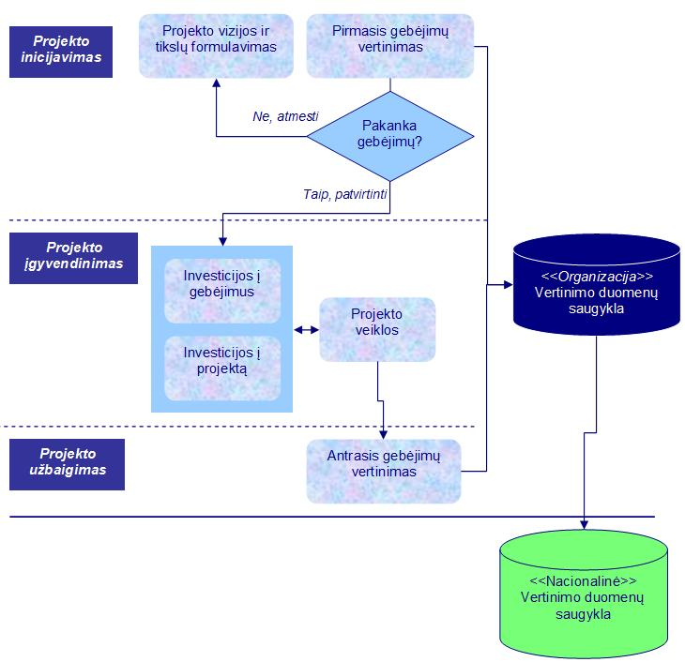
52 pav. Rekomenduojama sąveikumo vertinimo vieta Lietuvos e. valdžios projektų įgyvendinimo procese
Galiausiai, modifikuota įrankio versija ir darbe panaudotas tyrimo instrumentarijus galėtų padidinti viso Lietuvos valdžios aparato sąveikumą, jeigu jie būtų integruoti su kai kuriais labiausiai paplitusiais veiklos ir kokybės vadybos metodais, o jų panaudojimo procesas kontroliuojamas nacionalinio rodiklių stebėjimo portalo pagalba (žr. 53 pav.).
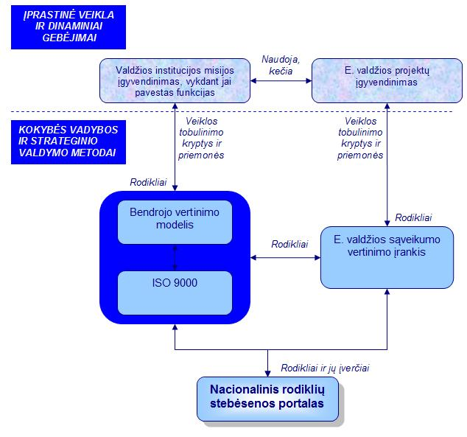
53 pav. Sąveikumo vertinimo įrankio integracijos su tradiciniais kokybės vadybos metodais scenarijus

IŠVADOS

- Atliktos teorinės e. valdžios plėtros modelių ir naudojamų vadybinių instrumentų raidos analizės pagrindu, pasiūlytas kompleksinis e. valdžios plėtros planavimo, įgyvendinimo ir mokslinių tyrimų modelis, kuris siūlo visą e. valdžios procesą išskaidyti į tris skirtingus sluoksnius: (1) politinį ir strateginį, (2) procesų ir technologijų, ir (3) rezultatų vertinimo. Politiniame ir strateginiame lygmenyje turi būti apibrėžta e. valdžios samprata ir tikslai, bei IRT valdymo ir koordinavimo principai tarptautiniu, nacionaliniu, savivaldos bei organizaciniame lygmenyse. Rekomenduojama periodiškai peržiūrėti ir koreguoti e. valdžios sampratą, tikslus ir valdymo principus tam, kad būtų galima maksimaliai išnaudoti technologinio proceso teikiamas galimybes bei tinkamai reaguoti į naujus aplinkos iššūkius. Procesų ir technologijų sluoksnis apibrėžia kuriamų e. valdžios sprendimų brandos lygmenis, kurie gali būti parenkami, atsižvelgiant į konkrečios šalies poreikius. Šie brandos lygiai yra įgyvendinami naudojantis egzistuojančiomis e. valdžios infrastruktūros architektūros elementais, tokiais kaip e. valdžios portalai, įvairūs paslaugų teikimo kanalai, kompiuterių tinklai ir kiti. Rezultatų sluoksnyje nustatomi kiekybiniai ir kokybiniai e. valdžios sprendimų pokyčius matuojantys rodikliai. Esminis šio siūlomo modelio komponentas yra e. valdžios sąveikumas ir jo vertinimas, nes e. valdžios plėtros srityje vykdoma politika, strateginis planavimas ir konkrečių iniciatyvų įgyvendinimas tiesiogiai priklauso nuo turimų dinaminių organizacijos gebėjimų tikslingai kurti, plėsti ir keisti turimą resursų bazę politiniame, teisiniame, organizaciniame ir technologijų lygmenyje. Šie gebėjimai galėtų būti greičiau įgyjami, jeigu būtų vertinami naudojantis specializuotais vadybiniais įrankiais, parinktais atsižvelgiant į kiekvienos valstybės kontekstą.
- Egzistuojančių mokslinių tyrimų analizė parodė, kad dinaminiai organizacijų e. valdžios sąveikumo gebėjimai yra užtikrinami ir vertinami naudojantis specializuotais vadybiniais įrankiais. E. valdžios sąveikumas gali būti užtikrinamas naudojantis į standartus orientuotą, architektūrinį arba mišrų požiūrį, integruojant pirmuosius du metodus į vieną bendrą scenarijų. Į standartus orientuotas požiūris naudoja nacionalinius e. valdžios sąveikumo pagrindus, kuriuose numatomi atitinkami standartai ir rekomendacijos visoms e. valdžios plėtros procese dalyvaujančioms suinteresuotosioms grupėms. Architektūrinis požiūris yra orientuotas į organizacijos architektūros sudarymą, kuri leidžia formaliai aprašyti ryšius tarp organizacijos struktūros, procesų, žmogiškųjų resursų, duomenų ir naudojamų IRT. Ji tarnauja kaip strateginio planavimo priemonė, leidžianti pasiekti didesnį strateginių veiklos tikslų ir investicijų į IRT suderinamumo laipsnį. Efektyvus išanalizuotų e. valdžios sąveikumui užtikrinti naudojamų metodų taikymas, kaip ir konkrečių e. valdžios projektų įgyvendinimas, reikalauja atitinkamų dinaminių organizacijos sąveikumo gebėjimų, kuriems įvertinimą objektyviai galima atlikti naudojant JAV mokslininkų pasiūlytą e. valdžios sąveikumo vertinimo įrankį. Norint užtikrinti maksimalų tokio tipo įrankio efektyvumą kitos valstybės kontekste, būtina išanalizuoti ir atsižvelgti į jos institucijose vykstančius procesus, turimų resursų galimybes, bei jų vystymosi eigą.
- Darbo metu buvo sukurtas e. valdžios sąveikumą sudarančių dinaminių gebėjimų suvokimo, svarbos ir praktikos lygį konkrečioje valstybėje leidžiantis įvertinti tyrimo instrumentarijus, kurio pagrindu tapo e. valdžios sąveikumo vertinimo įrankio, siūlomo JAV mokslininkų, struktūra. Siekiant užtikrinti naudojamo tyrimo instrumentarijaus validumą, minėtame įrankyje išskirtos dinaminių gebėjimų dimensijos ir jų matavimo rodikliai buvo pritaikyti e. valdžios sąveikumo suvokimo, svarbos ir praktikos įvertinimui Lietuvos e. valdžios ekspertų tarpe. Visi kiekvienos dimensijos rodikliai buvo vertinami iš aiškumo, svarbos bei būdingumo perspektyvų, siekiant maksimalaus ekspertinio vertinimo rezultatų patikimumo. Gauti ekspertinio vertinimo rezultatai buvo panaudoti modifikuojant originalaus įrankio struktūrą Lietuvos kontekstui. E. valdžios plėtros proceso JAV ir Lietuvoje atvejo studija atskleidė, kad JAV naudojamas integralus požiūris į e. valdžios plėtrą, pasitelkiant įvairius vadybinius bei technologinius įrankius. Tuo tarpu Lietuvos e. valdžios plėtra vis dar yra labiau orientuota į atskirų viešųjų ir administracinių paslaugų perkėlimą į elektroninę erdvę. Kaip ten bebūtų, atlikus empirinį tyrimą, pasitvirtino pagrindinė jo hipotezė (e. valdžios sąveikumo vertinimui naudojami priešakiniai metodai gali būti adaptuoti valstybių, esančių esančių ankstyvosiose e. valdžios plėtros proceso stadijose, kontekste), tačiau šie metodai turi būti atitinkamai supaprastinti, siekiant išvengti jų netinkamo panaudojimo dėl esamo atotrūkio tarp teorinio ir praktinio šių valstybių ekspertų pasirengimo. Empiriniai duomenys, surinkti atvejo studijos ir ekspertinio vertinimo metu taip pat patvirtino pirmąją pagalbinę tyrimo hipotezę H₁: dinaminiai organizacijos e. valdžios sąveikumo gebėjimai yra susiję su valstybės e. valdžios plėtros proceso išsivystymo lygiu. Aukšto brandos lygio e. valdžios plėtros procesas JAV leido mokslininkams išskirti net 16 kritinių e. valdžios sąveikumo dinaminių gebėjimų. Kadangi e. valdžios plėtros procesas Lietuvoje dar tebesiformuoja, turėtų būti naudojamos šešios iš 16 JAV išskirtų, labiausiai statistiškai reikšmingos, sąveikumo gebėjimų vertinimo dimensijos. Kryptingas dinaminių gebėjimų, nusakomų šiomis šešiomis dimensijomis, vystymas, gali sąlygoti e. valdžios plėtros proveržį Lietuvoje, aplenkiant tam tikrus patirties įgijimo etapus, kurie buvo neišvengiami JAV e. valdžios proceso plėtroje. Antroji pagalbinė tyrimo hipotezė H₂ „Skirtingo e. valdžios plėtros proceso išsivystymo lygio šalyse skiriasi sąveikumą sudarančių dinaminių organizacijos gebėjimų dimensijų ir jų matavimo rodiklių suvokimas, svarba ir praktika“ taip pat pasitvirtino tyrimo metu. Lietuvos, kaip ir JAV ekspertai, panašiai suvokia e. valdžios sąveikumo sričiai svarbius dinaminius gebėjimus, tačiau Lietuvos ekspertai turi mažiau praktinių šių gebėjimų panaudojimo galimybių, ir tai atsispindėjo kiekvienos iš dimensijų būdingumo vertinime. Galiausiai, trečioji pagalbinė tyrimo hipotezė H₃ “Kitose valstybėse taikomos dinaminių e. valdžios sąveikumo gebėjimų dimensijos ir jų vertinimo metodai gali būti pritaikyti Lietuvoje atsižvelgiant į tai, kaip vietiniai ekspertai suvokia ir gali pagal svarbą suranguoti šių dimensijų tinkamumą esamam e. valdžios plėtros proceso išsivystymo lygiui” pasitvirtino tik dalinai. Nors ir įmanoma išskirti konkrečios šalies kontekstui pačias svarbiausias e. valdžios sąveikumo dimensijas, tačiau tam kol kas būtina remtis ne ekspertų pateikiamais reitingais, bet atskirų dimensijų ekspertinio vertinimo rezultatais, panaudojant konkrečius rodiklius aiškumo, svarbos ir būdingumo perspektyvose.
- Remiantis teorine analize ir atlikto empirinio tyrimo rezultatais, pasiūlyta modifikuota ir esamo Lietuvos e. valdžios plėtros proceso brandos galimybes atitinkanti JAV mokslininkų sukurto e. valdžios sąveikumo vertinimo įrankio versija. Išskirti šie aplinkos, organizacinio ir technologinio lygmens dinaminiai organizacijų gebėjimai: lyderystė, pasirengimas bendradarbiavimui, strateginis planavimas, veiklos vertinimas, projektų vadyba, reikalavimai duomenims ir jų aprašams, bei veiklos modelis ir architektūra. Kiekvienos šios dimensijos matavimui siūloma naudoti originalioje įrankio versijoje pateikiamus rodiklius. Adaptuota šio įrankio versija ir darbe panaudotas tyrimo instrumentarijus gali būti pritaikytas siekiant keleto svarbių tikslų. Pirmiausiai, rekomenduojama juos integruoti į strateginį e. valdžios planavimo Lietuvoje procesą. Tai sudarytų sąlygas identifikuoti ir prioretizuoti tas nacionalines e. valdžios iniciatyvas, kurias įmanoma įgyvendinti su turimais dinaminiais gebėjimais, ir kurios prisidėtų tiek prie esamų dinaminių gebėjimų stiprinimo, tiek ir prie naujų viešojo sektoriaus organizacinių gebėjimų kūrimo. Kita rekomendacija būtų panaudoti šio darbo rezultatus, siekiant sumažinti nacionalinių e. valdžios projektų rizikas, jeigu e. valdžios sąveikumo vertinimas taptų neatsiejama kiekvieno projekto planavimo ir įgyvendinimo kontrolės dalimi. Galiausiai, modifikuota įrankio versija ir tyrimo instrumentarijus galėtų būti integruoti su kitomis veiklos ir kokybės vadybos priemonėmis, tokiomis kaip bendrojo vertinimo modelis arba ISO standartai, proceso stebėjimui sukuriant nacionalinį rodiklių stebėsenos portalą. Šių rekomendacijų įgyvendinimas sudarytų sąlygas pereiti nuo dabartinio e. valdžios plėtros proceso išsivystymo Lietuvoje lygmens prie kompleksinio sąveikios valdžios kūrimo proceso modelio, pasiūlyto šio darbo pradžioje.
References
- Accenture. (2001). eGovernment Leadership - Rhetoric vs. reality - closing the gap. Retrieved from http://www.epractice.eu/files/media/media_846.pdf
- Accenture. (2002). eGovernment Leadership - Realizing the Vision. Retrieved from http://www.accenture.com/xdoc/en/newsroom/epresskit/egov/realizing_vision.pdf
- Accenture. (2003). eGovernment Leadership: Engaging the Customer. Retrieved from http://www.accenture.com/xdoc/en/newsroom/epresskit/egovernment/egov_epress.pdf
- Accenture. (2004). eGovernment Leadership: High Performance, Maximum Value. Retrieved from http://www.govexec.com/pdfs/AccentureEGovStudy.pdf
- Adner, R., & Helfat, C. (2003). Corporate Effects and Dynamic Managerial Capabilities. Strategic Management Journal, 24, 1011-26.
- Adomėnas, M., Augustinaitis, A., Janeliūnas, T., Kuolys, D., & Motieka, E. (Eds.). (2007). Lietuvos tauta: būklė ir raidos perspektyvos. Vilnius: Pilietinės visuomenės institutas.
- Andersen, K. V. (2006). E-Government: Five Key Challenges for Management. The Electronic Journal of e-Government, 4(1), 1-8.
- Andersen, K. V., & Henriksen, H. Z. (2005). E-Government maturity models: Extension of Layne and Lee model. Government Information Quarterly, 23(2), 236-248.
- Argote, L., & Darr, E. (2000). Repositories of Knowledge in Franchise Organizations: Individual, Structural, and Technological. In The Nature and Dynamics of Organizational Capabilities, eds. Giovani Dosi, Richard R. Nelson, and Sidney G. Winter (p. 389). New York, USA: Oxford University Press Inc.
- Augier, M., & Teece, D. J. (2006). Understanding complex organization: the role of know-how, internal structure, and human behavior in the evolution of capabilities. Industrial and Corporate Change, 15(2), 395–416.
- Augustinaitis, A., & Petrauskas, R. (2002). The first steps of E-Governance in Lithuania: from theory to practice. In Electronic government. Proceedings of first international conference EGOV2002 (pp. 438-445). Springer, Berlin.
- Babbie, E. (2005). The Basics of Social Research (Third edition.). Canada: Thomson Wadsworth.
- Barney, J. B. (1986). Strategic factor markets: Expectations, luck, and business strategy. Management Science, 32(10), 1231-1241.
- Becker, M. C. (2004). Organizational routines: a review of literature. Industrial and Corporate Change, 13(4), 643-677.
- Bendrasis vertinimo modelis (BVM 2006): Organizacijos tobulinimas taikant įsivertinimą. (2007). . Lietuvos Respublikos vidaus reikalų ministerija. Retrieved from http://www.vakokybe.lt/lt/bendrojo-vertinimo-modelio-esme
- Benn, S. I., & Gaus, G. F. (1983). Public and private social life. New York: St. Martin's Press.
- Bilevičienė, T. (2009). Naujos neįgaliųjų profesinės reabilitacijos ir integracijos galimybės: nuotolinio darbo organizavimo modelis. Mykolas Romeris University, Vilnius.
- Bourdieu, P. (1980). The Logic of Practice. Stanford, CA: Stanford University Press.
- Capability Maturity Model Integration (CMMI). Retrieved August 27, 2010, from http://www.sei.cmu.edu/cmmi/start/faq/related-faq.cfm
- Capgemini. (2006). Online Availability of Public Services: How Is Europe Progressing?. Retrieved from http://ec.europa.eu/information_society/eeurope/i2010/docs/benchmarking/online_availability_2006.pdf
- Capgemini. (2007). The User Challenge Benchmarking The Supply Of Online Public Services. Retrieved from http://ec.europa.eu/information_society/eeurope/i2010/docs/benchmarking/egov_benchmark_2007.pdf
- Capgemini, Rand Europe, IDC, Sogeti, & DTI. (2009). Smarter, Faster, Better eGovernment: 8th Benchmark Measurement. Retrieved from http://ec.europa.eu/information_society/eeurope/i2010/docs/benchmarking/egov_benchmark_2009.pdf
- Caplan, R. S., & Norton, D. P. (1996). Using the Balanced Scorecard as a Strategic Management System. Harvard Business Review, (January/February), 75-85.
- Cappelli, P., & Sherer, P. D. (1991). The missing role of context in OB: The need for a meso-level approach. Research in Organizational Behavior, 13, 55-110.
- Charalabidis, Y., & Askounis, D. (2008). Interoperability Registries in eGovernment: Developing a Semantically Rich Repository for Electronic Services and Documents of the new Public Administration. In Proceedings of the 41th Hawaii International Conference on System Sciences. Presented at the 41th Hawaii International Conference on System Sciences, Computer Society Press.
- Charalabidis, Y., Lampathaki, F., & Psarras, J. (2009). Combination of Interoperability Registries with Process and Data Management Tools for Governmental Services Transformation. In Proceedings of the 42th Hawaii International Conference on System Sciences. Presented at the 42th Hawaii International Conference on System Sciences, Computer Society Press.
- Chen, H. (2002). Digital government: technologies and practices. Decision Support Systems, 34(3), 223-227.
- Chen, Y. N., Chen, H. M., Huang, W., & Ching, R. K. H. (2006). E-Government Strategies in Developed and Developing Countries: An Implementation
Framework and Case Study. Journal of Global Information Management, 14(1), 23-46.
- Chlivickas, E. (2007). Elektroninės valdžios projektų įgyvendinimas plėtojant viešąjį administravimą Lietuvoje. Viešasis administravimas, 3(15), 71-78.
- Cybersecurity | The White House. (2010). Retrieved September 20, 2010, from http://www.whitehouse.gov/administration/eop/nsc/cybersecurity
- Clinger-Cohen Act. (1996). . Retrieved from http://www.cio.gov/Documents/it_management_reform_act_Feb_1996.html
- Codagnone, C., & Wimmer, M. A. (Eds.). (2007). Roadmapping eGovernment Research: Visions and Measures towards Innovative Governments in 2020.
- Collis, D. J. (1994). Research note: how valuable are organizational capabilities? Strategic Management Journal, (Winter Special Issue 15), 143-152.
- Cook, M. A. (1996). Building enterprise information architectures. In Reengineering Information Systems. New Jersey, USA: Prentice Hall.
- Coursey, D., & Norris, D. F. (2008). Models of E-Government: Are They Correct? An Empirical Assessment. Public Administration Review, 68(3), 523-536.
- Cresswell, A. M., Pardo, T. A., & Canestraro, D. S. (2008). A Multi-Dimensional Approach to Digital Government Capability Assessment. Center for Technology in Government, University at Albany, SUNY. Retrieved from http://www.accenture.com/NR/rdonlyres/6DB947C9-DE11-4957-8D04-A9479F667E39/0/Accenture_Institute_Health_Public_Service_From_eGovernment_to_eGovernance.pdf
- Cresswell, A. M., Pardo, T. A., Canestraro, D. S., & Dawes, S. S. (2005). Why Assess Information Sharing Capability? Center for Technology in Government, University at Albany, SUNY. Retrieved from http://www.ctg.albany.edu/publications/guides/why_assess/why_assess.pdf
- Cresswell, A. M., Pardo, T. A., Canestraro, D. S., Dawes, S. S., & Juraga, D. (2005). Sharing Justice Information: A Capability Assessment Toolkit. Center for Technology in Government, University at Albany, SUNY. Retrieved from http://www.ctg.albany.edu/publications/guides/sharing_justice_info/sharing_justice_info.pdf
- Cresswell, A. M., Pardo, T. A., & Hassan, S. (2007). Assessing Capability for Justice Information Sharing. In The Proceedings of the 8th Annual International Digital Government Research Conference: Bridging Disciplines & Domains (pp. 122-130). Presented at the The Annual Conference of the Digital Government Society of North America, Philadelphia, Pennsylvania, USA: Digital Government Society.
- Daniel, E. M., & Wilson, H. N. (2003). The role of dynamic capabilities in e-business transformation. European Journal of Information Systems, 12(4), 282-296.
- David J. Teece, Gary Pisano, & Amy Shuen. (1997). Dynamic Capabilities and Strategic Management. Strategic Management Journal, 18(7), 509-533.
- Davison, R. M., Wagner, C., & Ma, L. C. (2005). From government to e-government: a transition model. Information Technology & People, 18(3), 280-299.
- Dawes, S. S. (2008). The Evolution and Continuing Challenges of E-Governance. Public Administration Review, 68(S1), S86-S102.
- Dėl elektroninės valdžios koncepcijos patvirtinimo. (2002). . Retrieved from http://www3.lrs.lt/pls/inter3/dokpaieska.showdoc_l?p_id=198184&p_query=&p_tr2=
- Dėl Lietuvos Respublikos valstybės informacinių išteklių valdymo įstatymo koncepcijos patvirtinimo. (2006). . Retrieved from http://www3.lrs.lt/pls/inter3/dokpaieska.rezult_l?p_nr=&p_nuo=&p_iki=&p_org=&p_drus=&p_kalb_id=1&p_title=informacini%F8%20i%F0tekli%F8%20valdymo&p_text=&p_pub=&p_met=&p_lnr=&p_denr=&p_es=0&p_rus=1&p_tid=&p_tkid=&p_t=0&p_tr1=2&p_tr2=2&p_gal=
- Dėl viešojo administravimo plėtros iki 2010 metų strategijos patvirtinimo. (2010). . Retrieved from http://www3.lrs.lt/pls/inter3/dokpaieska.showdoc_l?p_id=378840&p_query=&p_tr2=
- DiMaggio, P. J., & Powel, W. W. (1983). The iron cage revisited: Institutional isomorphism and collective rationality in organizational fields. American Sociological Review, 48(2), 147-160.
- Dobrović, Ž., Tomičić, M., & Vrček, N. (2008). Towards the Effective E-Government Implementation of Balanced Scorecard in Public Sector. Intellectual Economics, 1(3), 7-17.
- Dosi, G., Nelson, R. R., & Winter, S. G. (2000). Introduction: The Nature and Dynamics of Organizational Capabilities. In The Nature and Dynamics of Organizational Capabilities, eds. Giovani Dosi, Richard R. Nelson, and Sidney G. Winter (p. 389). United States, New York: Oxford University Press Inc.
- Dosi, G., Nelson, R. R., & Winter, S. G. (Eds.). (2000). The Nature and Dynamics of Organizational Capabilities. United States, New York: Oxford University Press.
- Dunleavy, P., Margetts, H., Bastow, S., & Tinkler, J. (2006). New Public Management Is Dead - Long Live Digital-Era Governance. Journal of Public Administration Research and Theory, (16), 467-494.
- Dunleavy, P., Margetts, H., Bastow, S., & Tinkler, J. (2008). Digital Era Governance: IT Corporations, the State, and E-Government. United States, New York: Oxford University Press.
- Earl, M. J. (2000). Evolving the e-business. Business Strategy Review, 11(2), 33-38.
- Ebrahim, Z., & Irani, Z. (2005). E-government adoption: architecture and barriers. Business Process Management Journal, 11(5), 589-611.
- Egidijus Barcevičius. (2007). Ką keičia informacinės technologijos? Elektroninės valdžios įtaka viešajam valdymui Lietuvoje (Doctoral dissertation). Vilnius University.
- E-Government Act of 2002. (2002). . Retrieved from http://thomas.loc.gov/cgi-bin/bdquery/z?d107:HR02458:|TOM:/bss/d107query.html|
- Eisenhardt, K. M., & Martin, J. A. (2000). Dynamic Capabilities: What are They? Strategic Management Journal, 21(10-11), 1105-1121.
- European Commission. (2003). The Role of eGovernment for Europe's Future. COM(2003) 567 final, Brussels. Retrieved from http://ec.europa.eu/information_society/eeurope/2005/doc/all_about/egov_communication_en.pdf
- European Commission. (2004). European Interoperability Framework For Pan-European eGovernment Services (EIF), version 1.0.
- European Commission Directorate General for Informatics. (2009a, May 20). Supporting the European Union Interoperability Strategy Elaboration, Final Report Phase 1.
- European Commission Directorate General for Informatics. (2009b, October 15). Supporting the European Union Interoperability Strategy Elaboration, Final Report Phase 2.
- European Commission, PEGSCO. (2009, October 22). European Interoperability Framework For European Public Services (EIF), version 2.0. Retrieved from http://ec.europa.eu/idabc/en/document/7728
- European Communities. (2008). Draft document as basis for EIF 2.0 (p. 85). Retrieved from http://ec.europa.eu/idabc/servlets/Doc?id=31597
- Executive Office of the President of the United States. (2002). Implementing the President’s Management Agenda for E-Government. E-Government Strategy: Simplified delivery of services to citizens. Retrieved from http://www.usa.gov/Topics/Includes/Reference/egov_strategy.pdf
- Executive Office of the President of the United States. (2003). E-Government Strategy: Implementing the President’s Management Agenda for E-Government. Retrieved from http://permanent.access.gpo.gov/lps36050/2003egov_strat.pdf
- Federal Enterprise Architecture (FEA) | The White House. (2010). Retrieved September 20, 2010, from http://www.whitehouse.gov/omb/e-gov/fea/
- Federal IT Dashboard. (2010). . Retrieved September 20, 2010, from http://it.usaspending.gov/
- Feeny, D. F., & Willocks, L. P. (1998). Core IS capabilities for exploiting information technology. Sloan Management Review, 39(3), 9-21.
- Feurer, S. (2007). Enterprise Architecture - An Overview. Feurer. Enterprise Architecture – An Overview, SAP Developer Network, 2007. Retrieved from http://www.sdn.sap.com/irj/sdn/go/portal/prtroot/docs/library/uuid/90a744a3-55d9-2910-96b9-8a1513fefb1f
- Fewell, S., & Clark, T. (2003). Organisational interoperability: Evaluation and Further Development of the OIM Model. In Proceedings of the 8th ICCRTS. National Defense University, Washington DC.
- Fountain, J. E. (2007). Bureaucratic Reform and E-Government in the United States: An Institutional Perspective. National Center for Digital Government. Retrieved from Bureaucratic Reform and E-Government in the United States: An Institutional Perspective
- Fountain, J. E. (2001). Building the Virtual State: Information Technology and Institutional Change. Washington, D. C.: Brookings Institution Press.
- G. B. Richardson. (1972). The Organisation of Industry. The Economic Journal, 82(327), 883-896.
- Galliers, R. D., & Sutherland, A. R. (1991). Information systems management and strategy formulation: The "stages of growth" model revisited. Journal of Information Systems, 1(2), 89-114.
- Galunic, D. C., & Eisenhardt, K. M. (2001). Architectural Innovation and Modular Corporate Firms. Academy of Management Journal, 44, 1229-49.
- Gartner Group. (2000). Key Issues in E-Government Strategy and Management. Research Notes, Key Issues.
- Gartner Group. (2001). Gartner's Four Phases of e-Government Model.
- Garuckas, R., & Kaziliūnas, A. (2008). E. valdžios ir viešojo sektoriaus sąveikos Lietuvoje analizė. Viešoji politika ir administravimas, (23), 59-67.
- Gatautis, R., Kulvietis, G., & Vitkauskaitė, E. (2009). Lithuanian eGovernment Interoperability Model. Engineering Economics, 2, 38-48.
- Gil-Garcia, J. R., & Pardo, T. A. (2006). Multi-method Approaches to Digital Government research: Value Lessons and Implementation Challenges. In Proceedings of the 39th Hawaii International Conference on System Sciences (pp. 1-11). IEEE.
- Gil-Garcıa, J. R., & Helbig, N. (2007). Exploring E-Government Benefits and Success Factors. In Encyclopedia of digital government, eds. A.-V. Anttiroiko, M. Malkia (pp. 803-811). Idea Group Reference, Hershey, PA.
- Gil-Garcıa, J. R., & Pardo, T. A. (2005). E-government success factors: Mapping practical tools to theoretical foundations. Government Information Quarterly, 22, 187-216.
- Goikoetxea, A. (2007). Enterprise Architectures and Digital Administration: Planning, Design, and Assessment. Singapore: World Scientific Publishing.
- Gottschalk, P. (2007). Information systems in police knowledge management. Electronic Government, an International Journal, 4(2), 191-203.
- Gottschalk, P., & Solli-Saether, H. (2006). Maturity model for IT outsourcing relationships. Industrial Management & Data Systems, 106(2), 200-212.
- Gottschalk, P., & Tolloczko, P. C. (2007). Maturity model for mapping crime in law enforcement. Electronic Government, an International Journal, 4(1), 59-67.
- Gottschalk, P. (2009). Maturity levels for interoperability in digital government. Government Information Quarterly, 26(1), 75-81.
- Gottschalk, P., & Solli-Saether, H. (2008). Stages of e-government interoperability. Electronic Government, an International Journal, 5(3), 310-320.
- Government Performance and Results Act of 1993. (1993). . Retrieved from http://thomas.loc.gov/cgi-bin/bdquery/z?d103:SN00020:|TOM:/bss/d103query.html
- Gregor, S., Hart, D., & Martin, N. (2007). Enterprise architectures: enablers of business strategy and
IS/IT alignment in government. Information Technology & People, 20(2), 96-120.
- Griffin, M. A. (2007). Specifying organizational contexts: systematic links between contexts and processes in organizational behavior. Journal of Organizational Behavior, 28, 859-863.
- Gudelis, D. (2004). Viešojo valdymo tobulinimas panaudojant veiklos vertinimo ir žinių vadybos priemones. Viešoji politika ir administravimas, (10), 21-26.
- Guijarro, L. (2004). Analysis of the Interoperability Frameworks in e-Government initiatives. In Electronic Government: Third International Conference, EGOV 2004, eds. R. Traunmuler (pp. 36-39). Presented at the DEXA EGOV 2004, Springer Berlin/Heidelberg, Germany.
- Guijarro, L. (2007). Interoperability frameworks and enterprise architectures in e-government initiatives in Europe and the United States. Government Information Quarterly, 24, 89-101.
- Guogis, A., & Gudelis, D. (2009). Viešojo administravimo ir verslo vadybos integracijos perspektyvos: viešojo ir privataus sektorių sąveikos modelis. Viešoji politika ir administravimas, (28), 23-28.
- Heeks, R. (2004). eGovernment as a Carrier of Context. Institute for Development Policy and Management, The University of Manchester. Retrieved from http://unpan1.un.org/intradoc/groups/public/documents/NISPAcee/UNPAN016519.pdf
- Heeks, R. (2006). Implementing and Managing eGovernment: An International Text. SAGE Publications.
- Helfat, C. E., Finkelstein, S., Mitchell, W., Peteraf, M. A., Singh, H., Teece, D. J., & Winter, S. G. (2007). Dynamic Capabilities: Understanding Strategic Change in Organizations. Wiley-Blackwell.
- Henderson, J. C., & Venkatraman, N. (1993). Strategic alignment: leveraging information technology for transforming organizations. IBM Systems Journal, 32(1), 4-16.
- Hiller, J. S., & Bélanger, F. (2001). Privacy Strategies for Electronic Government. The PricewaterhouseCoopers Endowment for The Business of Government.
- Hinnant, C. C., & Welch, E. W. (2002). Managerial Capacity and Digital Government in the States: Examining the Link Between Self-Efficacy and Perceived Impacts of IT in Public Organizations. In Proceedings of the 36th Hawaii International Conference on System Sciences (HICSS’03). Presented at the 36th Hawaii International Conference on System Sciences (HICSS’03), Hawaii: IEEE.
- Hjort-Madsen, K. (2006). Enterprise Architecture Implementation and Management: A Case Study on Interoperability. In Proceedings of the 39th Hawaii International Conference on System Sciences. Presented at the 39th Hawaii International Conference on System Sciences, Kauai: Computer Society Press.
- Hjort-Madsen, K. (2007). Institutional patterns of enterprise architecture adoption in government. Transforming Government: People, Process and Policy, 1(4), 333-349.
- Hjort-Madsen, K., & Pries-Heje, J. (2009). Enterprise Architecture in Government: Fad or Future? In Proceedings of the 42th Hawaii International Conference on System Sciences. Presented at the 42th Hawaii International Conference on System Sciences, Computer Society Press.
- Hodgkinson, S. (2002). Managing an e-government transformation program. In Working Towards Whole-of-Government online conference. Canberra.
- Housel, T., & Bell, A. H. (2001). Measuring and Managing Knowledge. New York, NY: McGrawHill Irwin.
- Institute of Electrical and Electronics Engineers. (1990). In IEEE Standard Computer Dictionary: A Compilation of IEEE Standard Computer Glossaries. New York, NY.
- ISO - Management standards. Retrieved September 18, 2010, from http://www.iso.org/iso/iso_catalogue/management_standards.htm
- ISO 9000-3:1997 - Quality management and quality assurance standards -- Part 3: Guidelines for the application of ISO 9001:1994 to the development, supply, installation and maintenance of computer software. Retrieved September 18, 2010, from http://www.iso.org/iso/catalogue_detail.htm?csnumber=26364
- ISO/IEC 38500:2008 - Corporate governance of information technology. Retrieved September 18, 2010, from http://www.iso.org/iso/catalogue_detail.htm?csnumber=51639
- Yang, K. (2003). Neoinstitutionalism and E-Government:
Beyond Jane Fountain. Social Science Computer Review, 21(4), 432-442.
- Yildiz, M. (2007). E-government research: Reviewing the literature, limitations, and ways forward. Government Information Quarterly, (24), 646-665.
- Yin, R. K. (2009). Case study research design and methods (Fourth Edition.). USA: SAGE Publications.
- Jain, A. (2004). Using the lens of Max Weber's Theory of Bureaucracy to examine E-Government Research. In 37th Hawaii International Conference on System Sciences (pp. 127-136).
- Janssen, M. (2009). Framing Enterprise Architecture: A meta-framework for analyzing architectural efforts in organizations. In Coherency Management: Architecting the Enterprise for Alignment, Agility and Assurance, eds. Gary Doucet, John Gøtze, Pallab Saha, and Scott Bernard. International Enterprise Architecture Institute.
- Janssen, M., & Hjort-Madsen, K. (2007). Analyzing Enterprise Architecture in National Governments: The cases of Denmark and the Netherlands. In Proceedings of the 40th Hawaii International Conference on System Sciences. Presented at the 40th Hawaii International Conference on System Sciences, Computer Society Press.
- Janssen, M., & Veenstra, A. F. V. (2005). Stages of Growth in e-Government: An Architectural Approach. The Electronic Journal of e-Government, 3(4), 193-200.
- Johns, G. (2006). The essential impact of contex on organizational behavior. Academy of Management Review, 31(2), 386-408.
- Jurkėnaitė, N., & Paliulis, N. K. (2010). Evaluation of e-government development. In 6th International Scientific Conference BUSINESS AND MANAGEMENT 2010 (pp. 842-848). Vilnius: Vilnius Gediminas Technical University.
- Kazanjian, R. K., & Drazin, R. (1989). An empirical test of a stage of growth progression model. Management Science, 35(12), 1489-1503.
- Kaziliūnas, A. (2004). Procesinis požiūris vadyboje ir viešajame administravime. Viešoji politika ir administravimas, (8), 37-47.
- Kim, H. J., & Bretschneider, S. (2004). Local Government Information Technology Capacity: An Exploratory Theory. In Proceedings of the 37th Hawaii International Conference on System Sciences - 2004 (pp. 1-10). Presented at the 37th Hawaii International Conference on System Sciences, Hawaii: IEEE.
- Kim, S., & Lee, H. (2006). The Impact of Organizational Context and Information Technology on Employee Knowledge-Sharing Capabilities. Public Administration Review, 66(3), 370-385.
- Klievink, B., & Janssen, M. (2009). Realizing joined-up government - Dynamic capabilities and stage models for transformation. Government Information Quarterly, 26(2), 275-284.
- Kogut, B., & Zander, U. (1992). Knowledge of the firm, combinative capabilities, and the replication of technology. Organization Science, 3, 383-397.
- Kraemer, K. L., & King, J. L. (2003). Information Technology and Administrative Reform: Will the Time After E-Government Be Different? Center for Research on Information Technology and Organizations, University of California, Irvine. Retrieved from http://crito.uci.edu/papers/2003/egovernment.pdf
- Layne, K., & Lee, J. (2001). Developing Fully Functional E-Government: A four stage model. Government Information Quarterly, 18, 122-136.
- Lallana, E. C. (2008). E-Government Interoperability. United Nations Development Programme e-Primers for the Information Economy, Society and Polity, ISBN: 978-974-13-3227-4. Retrieved from http://www.apdip.net/publications/iespprimers/eprimer-gif.pdf
- Lam, W. (2005). Barriers to e-government integration. The Journal of Enterprise Information Management, 18(5), 511-530.
- Lancaster, G., & Massingham, L. (1993). Marketing management. New York: McGrawHill.
- Lavie, D. (2006). Capability Reconfiguration: An analysis of incumbent responses to technological change. Academy of Management Review, 31(1), 153-174.
- Lee, J., & Kim, J. (2007). Grounded theory analysis of e-government initiatives: Exploring perceptions of government authorities. Government Information Quarterly, 24, 135-147.
- Leonard-Barton, D. (1992). Core Capabilities and Core Rigidities: A Paradox in Managing New Product Development. Strategic Management Journal, 13, 585-608.
- Liimatainen, K., Hoffmann, M., & Heikkilä, J. (2007). Overview of Enterprise Architecture work in 15 countries: Finnish Enterprise Architecture Research Project (No. Research reports 6b/2007) (p. 81). Ministry of Finance of Finland.
- Limba, T. (2004). Elektroninės valdžios priemonių įtaka viešosios vertės didinimui. Viešoji politika ir administravimas, (10), 46-49.
- Limba, T. (2009). Elektroninės valdžios paslaugų modeliai: jų taikymo galimybės Lietuvos savivaldybėse (Doctoral dissertation). Mykolas Romeris University.
- LR Valstybės kontrolė. (2007). Valstybės kontrolės audito ataskaita "Valstybinių institucijų informacinių sistemų valdymas elektroninės valdžios kontekste". Retrieved from http://www3.lrs.lt/pls/inter/w5_show?p_r=5628&p_k=1
- LR vidaus reikalų ministerija, & BGI Consulting. (2007). Viešųjų paslaugų, teikiamų informacinėmis technologijomis, esamos būklės analizė 2007. Retrieved from http://www.vrm.lt/index.php?id=1267
- LR vidaus reikalų ministerija, & BGI Consulting. (2009). Viešųjų paslaugų, teikiamų informacinėmis technologijomis, esamos būklės analizė 2008. Retrieved from http://www.vrm.lt/index.php?id=1267
- LR vidaus reikalų ministerija, & Socialinės ir ekonominės plėtros centras. (2008). Viešųjų paslaugų, teikiamų informacinėmis technologijomis, esamos būklės analizė 2008. Retrieved from http://www.vrm.lt/index.php?id=1267
- LR vidaus reikalų ministerija, & VšĮ Viešosios politikos ir vadybos institutas. (2008). Kokybės vadybos metodų diegimo viešojo administravimo institucijose stebėsena. Retrieved from http://www.vakokybe.lt/lt/kokybes-vadybos-metodu-diegimo-viesojo-administravimo-institucijose-ir-istaigose-stebesena
- Malotaux, M., Hahndiek, F., & Hazejager, S. (2009, May 5). A Report for European Commission Directorate General for Informatics - NIFO project - Final report. Gartner.
- Meyer, M. W. (1982). Bureaucratic" vs. "Profit" Organizations. Greenwich, CT: JAI Press.
- Melnikas, B. (2007). Globalizacija, žiniomis grindžiama visuomenė ir e. valdžia: saugumo problemos. Viešasis administravimas, 3(15), 53-64.
- Ministerial declaration on e-government. (2009). . Retrieved from how leading methods applied for assessment of interoperability could be adopted in Lithuanian e-government development process.
- Montealegre, R. (2002). A Process Model of Capability Development: Lessons from the Electronic Commerce Strategy at Bolsa de Valores de Guayaquil. Organization Science, 13, 514-531.
- Mowday, R. T., & Sutton, R. I. (1993). Organizational behavior: Linking individuals and groups to organizational contexts. Annual Review of Psychology, 44, 195-229.
- Nardi, P. M. (2006). Doing Survey Research: A Guide to Quantitative Methods (Second Edition.). United States of America: Pearson Education, Inc.
- Narduzzo, A., Rocco, E., & Warglien, M. (2000). Talking about Routines in the Field: The Emergence of Organizational Capabilities in a New Celllular Phone Network Company. In The Nature and Dynamics of Organizational Capabilities, eds. Giovani Dosi, Richard R. Nelson, and Sidney G. Winter (p. 389). New York, USA: Oxford University Press Inc.
- National E-Health Transition Authority (NEHTA). (2007). Interoperability Maturity Model. Version 2.0. Sydney, Australia: National E-Health Transition Authority Ltd.
- Navarra, D. D., & Cornford, T. (2007). The State, Democracy and the Limits of New Public Management: Exploring Alternative Models of Egovernment. Information Systems Group, London School of Economics and Political Science: working paper series 155. Retrieved from http://is2.lse.ac.uk/wp/pdf/WP155.PDF
- Nelson, R. R., & Winter, S. G. (1982). An Evolutionary Theory of Economic Change. Cambridge, MA: Belknap Press/Harvard University Press.
- Nolan, R. L. (1979). Managing the crises in data processing. Harvard Business Review, 57 (March/April), 115-126.
- OECD. (2001). Hidden Threat to E-Government: Avoiding Large Government IT failures. Retrieved from http://www.oecd.org/dataoecd/19/12/1901677.pdf
- OECD. (2005). E-Government for Better Government. Retrieved from http://www.oecd.org/document/45/0,3343,en_2649_34129_35815981_1_1_1_1,00.html
- Office of E-Government & Information Technology | The White House. Retrieved September 19, 2010, from http://www.whitehouse.gov/omb/e-gov/
- Office of Management and Budget. (2010). FY 2009 Report to Congress on the Implementation of The E-Government Act of 2002. Retrieved from http://www.whitehouse.gov/sites/default/files/omb/assets/egov_docs/2009_egov_report.pdf
- Open Government. (2010). . Retrieved September 20, 2010, from http://www.whitehouse.gov/open/about
- Open Government Directive. (2009). . Retrieved September 20, 2010, from http://www.whitehouse.gov/sites/default/files/omb/assets/memoranda_2010/m10-06.pdf
- Orlikowski, W. J. (2000). Using Technology and Constituting Structure: A Practice Lens for Studying Technology in Organizations. Organization Science, 11(4), 404-428.
- Orlikowski, W. J., & Bariey, S. R. (2001). Technology and Institutions: What Can Research on Information Technology and Research on Organizations Learn From Each Other? MIS Quarterly, 25(2), 145-165.
- Overeem, A. V., Witters, J., & Peristeras, V. (2007). An Interoperability Framework for Pan-European E-Government Services (PEGS). In Proceedings of the 40th Hawaii International Conference on System Sciences. Presented at the 40th Hawaii International Conference on System Sciences, Kauai: Computer Society Press.
- Pacific Council on International Policy, Working Group on eGovernment in the Developing World. (2002). E-Government in the Developing World: 10 Questions E-Government Leaders Should Ask Themselves. Retrieved from http://www.pacificcouncil.org/pdfs/e-gov.paper.f.pdf
- Paliulis, N. K., & Jurkėnaitė, N. (2007). Elektroninės valdžios plėtros Lietuvoje problemos ir tendencijos. Viešasis administravimas, 3(15), 79-85.
- Pardo, T. A., & Burke, G. B. (2008a). Government Worth Having: A briefing on interoperability for government leaders. Center for Technology in Government, University at Albany, SUNY. Retrieved from http://www.ctg.albany.edu/publications/reports/government_worth_having/government_worth_having.pdf
- Pardo, T. A., & Burke, G. B. (2008b). Improving Government Interoperability: A capability framework for government managers. Center for Technology in Government, University at Albany, SUNY. Retrieved from http://www.ctg.albany.edu/publications/reports/improving_government_interoperability/improving_government_interoperability.pdf
- Pardo, T. A., Cresswell, A. M., Dawes, S. S., Burke, B., Dadayan, L., Embar, S., & Kwon, H. (2005). Building State Government Digital Preservation Partnerships: A Capability Assessment and Planning Toolkit. Version 1.0. Center for Technology in Government, University at Albany, SUNY. Retrieved from http://www.ctg.albany.edu/publications/guides/digital_preservation_partnerships/digital_preservation_partnerships.pdf
- Paulk, M. C., Curtis, B., Chrissis, M. B., & Weber, C. V. (1991). Capability Maturity Model for Software (Technical report CMU/SEI-91-TR-24). Pittsburgh, PA: Software Engineering, Carnegie Mellon University.
- Penrose, E. (1959). The Theory of the Growth of the Firm. London: Basil Blackwell.
- Perry, J. L., & Rainey, H. G. (1988). The Public-Private Distinction in Organization Theory: A Critique and Research Strategy. Academy of Management Review, 13, 182-201.
- Pisano, G. P. (2000). In Search of Dynamic Capabilities: The Origins of R&D Competence in Biopharmaceuticals. In The Nature and Dynamics of Organizational Capabilities, eds. Giovani Dosi, Richard R. Nelson, and Sidney G. Winter (p. 389). New York, USA: Oxford University Press Inc.
- Prahalad, C. K., & Hamel, G. (1990). The core competence of the corporation. Harvard Business Review, May, 79-91.
- Puškorius, S. (Ed.). (2002). Viešojo sektoriaus institucijų administravimas. Vilnius: Lietuvos teisės universitetas.
- Puškorius, S. (2007). Bendradarbiavimo efektyvumas. Viešoji politika ir administravimas, (20), 24-31.
- Ramaswamy, M., & Selian, A. N. (2007). e-Government in Transition Countries: Prospects and Challenges. In Proceedings of the 40th Hawaii International Conference on System Sciences.
- Ramūnas Vanagas. (2008). Naujosios viešosios vadybos diegimas Lietuvos Respublikos vietos savivaldos sistemoje (Doctoral dissertation). Mykolas Romeris University.
- Rao, S. S., & Metts, G. (2003). Electronic commerce development in small and medium sized enterprises: A stage model and its implications. Business Process Management, 9(1), 11-32.
- Regnér, P. (2008). Strategy-as-practice and dynamic capabilities: Steps towards a dynamic view of strategy. Human Relations, 61(4), 565-589.
- Robson, W. (1997). Strategic management and information systems. London: Pitman Publishing.
- Rocheleau, B. (2006). Public Management Information Systems. United States of America, United Kingdom: Idea Group Publishing.
- Rosenbloom, R. S. (2000). Leadership, capabilities, and technological change: the transformation of ncr in the electronic era. Strategic Management Journal, 21(10-11), 1083–1103.
- Rosseau, D. M., & Fried, Y. (2001). Location, location, location: contextualizing organizational research. Journal of Organizational Behavior, 22, 1-13.
- Rudzkienė, V., & Augustinaitis, A. (Eds.). (2009). Lietuvos e. valdžios gairės: ateities įžvalgų tyrimas. Vilnius: Mykolo Romerio universitetas.
- Saekow, A., & Boonmee, C. (2009). Towards a Practical Approach for Electronic Government Interoperability
Framework (e-GIF). In Proceedings of the 42th Hawaii International Conference on System Sciences. Presented at the 42th Hawaii International Conference on System Sciences, Computer Society Press.
- Schedler, K., & Scharf, C. (2001). Exploring The Interrelations Between Electronic Government and The New Public Management: A Managerial Framework For Electronic Government. In 13E Conference Zurich (pp. 775-788).
- Scholl, H. J. (2005). Interoperability in E-Government: More than Just Smart Middleware. In Proceedings of the 38th Hawaii International Conference on System Sciences. Presented at the 38th Hawaii International Conference on System Sciences (HICSS'05) - Track 5, Island of Hawaii (Big Island): Computer Society Press.
- Scholl, H. J. (2007). Central research questions in e-government, or which trajectory should the study domain take? Transforming Government: People, Process and Policy, 1(1), 67-88.
- Scholl, H. J. (2006). Electronic government: Information management capacity, organizational capabilities, and the sourcing mix. Government Information Quarterly, 23, 73–96.
- Schumpeter, J. A. (1934). Theory of Economic Development. Harvard University Press, Cambridge, MA.
- Scott, W. R. (2008). Institutions and Organizations: Ideas and Interests (Third.). United States of America: SAGE Publications.
- Selznick, P. (1957). Leadership in Administration: A Sociological Interpretation. Evanston, Ill.: Row, Peterson & Co.
- Sudnickas, T. (2005). Subalansuotų rodiklių sistemos taikymo aspektai Lietuvos viešajame sektoriuje. Viešoji politika ir administravimas, (12), 38-45.
- Teece, D. J. (1988). Technological change and the nature of the firm. In G. Dosi, C. Freeman, R. Nelson, G. Silverberg, & L. Soete (Eds.), Technical Change and Economical Theory (pp. 256-281). New York: Pinter Publishers.
- Teece, D. J., & Pisano, G. (1994). The dynamic capabilities of firm: An introduction. Industrial and Corporate Change, 3(3), 537-556.
- Teece, D. J., Pisano, G., & Shuen, A. (1997). Dynamic capabilities and strategic management. Strategic Management Journal, 18(7), 509-533.
- Teece, D. J. (2007). Explicating Dynamic Capabilities: The Nature and Microfoundations of (Sustainable) Enterprise Performance. Strategic Management Journal, 28(13), 1319-1350.
- Teece, D. J. (2009). Dynamic Capabilities and Strategic Management. Oxford University Press.
- Teo, H. H., Wei, K. K., & Benbasat, I. (2003). Predicting Intention to Adopt Interorganizational Linkages: An Institutional Perspective. MIS Quarterly, 27(1), 19-49.
- Tillmann, G. (2008). The Business-Oriented CIO: A Guide to Market-Driven Management. John Wiley & Sons, Inc.
- TOGAF Version 9. (2009). . Retrieved September 19, 2010, from http://www.opengroup.org/togaf/
- United Nations. (2001). Benchmarking E-government: A Global Perspective. Retrieved from http://unpan1.un.org/intradoc/groups/public/documents/un/unpan021547.pdf
- United Nations. (2003a). World Public Sector Report 2003: E-Government at the Crossroads. A United Nations Publication. Retrieved from http://unpan1.un.org/intradoc/groups/public/documents/un/unpan012733.pdf
- United Nations. (2003b). UN Global E-government Survey 2003. Retrieved from http://unpan1.un.org/intradoc/groups/public/documents/un/unpan016066.pdf
- United Nations. (2004). Global e-government readiness report 2004: Towards access for opportunity. Retrieved from http://unpan1.un.org/intradoc/groups/public/documents/un/unpan019207.pdf
- United Nations. (2007a). E-Government Interoperability: Guide. United Nations Development Programme e-Primers for the Information Economy, Society and Polity, ISBN: 978-974-13-1616-8. Retrieved from http://www.apdip.net/projects/gif/GIF-Guide.pdf
- United Nations. (2007b). E-Government Interoperability: A Review of Government Interoperability Frameworks in Selected Countries. United Nations Development Programme e-Primers for the Information Economy, Society and Polity, ISBN: 978-974-13-1624-3. Retrieved from http://www.apdip.net/projects/gif/GIF-Review.pdf
- United Nations. (2008). UN E-Government Survey 2008: From E-Government to Connected Governance. Retrieved from http://unpan1.un.org/intradoc/groups/public/documents/un/unpan028607.pdf
- United Nations. (2010). United Nations E-Government Survey 2010: Leveraging e-government at the time of financial and economic crisis. Retrieved from http://unpan1.un.org/intradoc/groups/public/documents/UN-DPADM/UNPAN038853.pdf
- Valtonen, K., Seppänen, V., & Leppänen, M. (2009). Government Enterprise Architecture Grid Adaptation in Finland. In Proceedings of the 42th Hawaii International Conference on System Sciences. Presented at the 42th Hawaii International Conference on System Sciences, Computer Society Press.
- Vanagas, R. (2007). Naujosios viešosios vadybos taikymo prielaidos Lietuvos Respublikos savivaldos sistemoje. Viešoji politika ir administravimas, (20), 58-69.
- Veit, D. J., & Parasie, N. P. (2009). Can National E-Government Standards find Acceptance? In Proceedings of the 42th Hawaii International Conference on System Sciences. Presented at the 42th Hawaii International Conference on System Sciences, Computer Society Press.
- Waksberg-Guerrini, A., & Aibar, E. (2007). Towards a Network Government? A Critical Analysis of Current Assessment Methods for E-Government. In 6th International Conference, EGOV 2007, eds. M. A. Wimmer, J. Scholl and A. Gronlund (pp. 330-341). Presented at the DEXA EGOV 2007, Springer Berlin/Heidelberg, Regensburg, Germany.
- Wescott, C. G. (2001). E-Government in Asia-Pasific Region. Asian Journal of Political Science, 9(2), 1-24.
- Weske, M. (2009). Business Process Management: Concepts, Languages, Architectures. Springer Berlin/Heidelberg, Germany.
- Williamson, O. E. (1975). Markets and Hierarchies. New York: Free Press.
- Williamson, O. E. (1985). The Economic Institutions of Capitalism. New York: Free Press.
- Winter, S. G. (2003). Understandind Dynamic Capabilities. Strategic Management Journal, 24(10), 991–995.
- World Bank. (2009). e-Government - Definition of E-Government. Retrieved October 14, 2009, from http://web.worldbank.org/WBSITE/EXTERNAL/TOPICS/EXTINFORMATIONANDCOMMUNICATIONANDTECHNOLOGIES/EXTEGOVERNMENT/0,,contentMDK:20507153~menuPK:702592~pagePK:148956~piPK:216618~theSitePK:702586,00.html
- Zachman, J. (1987). A framework for information systems architecture. IBM Systems Journal, 26(3), 276-292.
- Zavadskas, E. K., Kaklauskas, A., & Kvederytė, N. (2001). Multivariant Design and Multiple Criteria Analysis of a Building Life Cycle. INFORMATICA, 12(1), 169–188.
- Zheng, L., Yang, T., Pardo, T., & Jiang, Y. (2009). Understanding the “Boundary” in Information Sharing and Integration. In Proceedings of the 42nd Hawaii International Conference on System Sciences. Presented at the 42nd Hawaii International Conference on System Sciences (HICSS'09), Waikoloa, Big Island, Hawaii.
- Zollo, M., & Winter, S. G. (2002). Deliberate Learning and the Evolution of Dynamic Capabilities. Organization Science, 13(3), 339-351.
- Zott, C. (2003). Dynamic Capabilities and the Emergence of Intraindustry Differential Firm Performance: Insights From a Simulation Study. Strategic Management Journal, 24, 97-125.

Appendixes
Appendix 1: List of publications

- Augustinaitis A., Malinauskienė E., Žilionienė I. E. valdžia ir viešojo valdymo pertvarka. Kolektyvinė monografija: Lietuvos e. valdžios gairės: ateities įžvalgų tyrimas (atsakingieji redaktoriai: Vitalija Rudzkienė, Arūnas Augustinaitis). ISBN 978-9955-19-160-5, p. 63-99.
- Augustinaitis A., Malinauskienė E., Žilionienė I. E. valdžios strategijos ir politika. Kolektyvinė monografija: Lietuvos e. valdžios gairės: ateities įžvalgų tyrimas (atsakingieji redaktoriai: Vitalija Rudzkienė, Arūnas Augustinaitis). ISBN 978-9955-19-160-5, p. 100-131.
- Petrauskas R., Malinauskienė E., Paražinskaitė G., Vegytė N. Elektroninis dalyvavimas ir Lietuvos atstovaujamoji valdžia. Viešoji politika ir administravimas, ISSN 1648-2603. 2009 Nr. 27, p. 45-53
- Augustinaitis A., Malinauskiene E., Wankel C. Lifelong learning as the highway to global competitiveness for Lithuania: a bumpy road. In University and Corporate Innovations in Lifelong Learning (eds. Charles Wankel and Robert DeFillippi). A volume in Research in Management Education and Development. Information Age Publishing, Inc. Charlotte, North Carolina, 2008. ISBN 978-1-59311-809-9
- Malinauskienė E., Vegytė N., Petrauskas R. E-participation in Lithuanian representative power. In Proceedings of the 6th Eastern European eGov Days, Austrian Computer Society, 2008. ISBN 978-3-85403-234-2.
- Malinauskienė E., Petrauskas R. Elektroninės valdžios moksliniai tyrimai: Lietuva pasaulio kontekste. Teorinis ir praktinis žurnalas „Viešasis administravimas“. Vilnius, 2007, Nr. 3 (15). ISSN 1648-4541. p. 65–70
- Malinauskiene E., Augustinaitis A., Ennals R., Petrauskas R. eRedesigning of Society: Towards Experiential Connectivity of Generations in Lithuania. AI&Society, , Springer London, Online First, 2007-09-05. ISSN: 0951-5666 (Print), 1435-5655 (Online).
- Pucihar A., Bogataj K., Wimmer M. A., Janssen M., Malinauskiene E., Bicking M., Petrauskas R., Klein M., Ma X., Amadori G., Traunmüller R. Gap analysis: the process and gap storylines. In: Roadmapping eGovernment Research: Visions and Measures towards Innovative Governments in 2020. / Eds. Cristiano Codagnone and Maria A. Wimmer. Printed in Italy – MY Print snc di Guerinoni Marco & C, Via San Lucio 47, 24023 Clusone (BG), 2007. ISBN 978-88-95549-00-2, p. 85-121
- Wimmer M. A., Bicking M., Bogataj K., Bowern M., Codagnone C., Dawes S., Janssen M., Klein M., Ma X., Malinauskiene E., Pucihar A. Research themes and roadmap charts. In: Roadmapping eGovernment Research: Visions and Measures towards Innovative Governments in 2020. / Eds. Cristiano Codagnone and Maria A. Wimmer. Printed in Italy – MY Print snc di Guerinoni Marco & C, Via San Lucio 47, 24023 Clusone (BG), 2007. ISBN 978-88-95549-00-2, p. 123-147
- Malinauskienė E., Augustinaitis A., Ennals R., Petrauskas R. eRedesigning of Society: Towards Experiential Connectivity of Generations in Lithuania. In: IST-Africa 2007 Conference Proceedings. / Eds. Paul Cunningham and Miriam Cunningham. IIMC International Information Management Corporation, 2007. ISBN: 1-905824-04-1.
- Malinauskienė E., Petrauskas R. Elektroninės valdžios plėtros gairės: ateities scenarijai ir tyrimų kryptys. Informacinės Technologijos 2007. Konferencijos pranešimų medžiaga. ISSN 1822-6337, 2007, p. 147-151
Appendix 2: Research questionnaire – Lithuanian version

A DALIS. INFORMACIJA APIE RESPONDENTĄ

- Jūsų išsilavinimas (nurodykite aukščiausią įgytą laipsnį):
Aukštasis neuniversitetinis
Bakalauras
Magistras
Mokslų daktaras

- Nurodykite sritį(-is), kurioje(-se) esate įgyję išsilavinimą (galimi keli atsakymo variantai):
Teisė
Vadyba ir administravimas
Ekonomika
Politikos mokslai
Sociologija
Komunikacija ir informacija
Informatika
Matematika Statistika
Fizika
Kita (nurodykite):

- Institucijos, kurioje dirbate, pavadinimas:
Informacinės visuomenės plėtros komitetas prie LR Susisiekimo ministerijos
LR vidaus reikalų ministerija
Informatikos ir ryšių departamentas prie LR vidaus reikalų ministerijos
LR Vyriausybė
LR Seimas
Krašto apsaugos ministerija
Socialinės apsaugos ir darbo ministerija
Sveikatos apsaugos ministerija
Valstybinė ligonių kasa prie Sveikatos apsaugos ministerijos
Centro poliklinika
VUL Santariškių klinikos
Teisingumo ministerija
Ūkio ministerija
Sodra
Valstybinė mokesčių inspekcija
Policijos departamentas prie LR vidaus reikalų ministerijos
VĮ „Infostruktūra“
VĮ „Regitra“
Valstybinė kainų ir energetikos kontrolės komisija
Švietimo informacinių technologijų centras
Generalinė miškų urėdija prie Aplinkos ministerijos
Lietuvos savivaldybių asociacija
Kauno miesto savivaldybė
Teisinės informacijos centras
Centrinė projektų valdymo agentūra
LR Valstybės kontrolė

- Jūsų užimamos pareigos yra:
Institucijos vadovas
Institucijos vadovo pavaduotojas
Institucijos vadovo patarėjas
Departamento direktorius
Departamento direktoriaus pavaduotojas
Viršininkas
Viršininko pavaduotojas
Skyriaus vedėjas
Skyriaus vedėjo pavaduotojas
Vyriausiasis specialistas
Vyresnysis specialistas
Specialistas
Vyriausiasis tyrėjas
Vyresnysis tyrėjas
Tyrėjas
Inspektorius
Kita (nurodykite):

- Kokia yra Jūsų darbo valstybės tarnyboje patirtis?
Mažesnė negu 1 metai
1 – 5 metai
5 – 10 metų
10 – 15 metų
15 metų ir daugiau

- Kokia yra Jūsų darbo dabartinėje darbovietėje patirtis?
Mažesnė negu 1 metai
1 – 5 metai
5 – 10 metų
10 metų ir daugiau

- Ar Jums yra tekę dirbti kitoje valstybės institucijoje prieš įsidarbinant dabartinėje darbovietėje?
Taip
Ne

Jeigu atsakymas į klausimą yra Taip, tuomet pereikite prie 8 klausimo. Priešingu atveju, pereikite prie 9 klausimo.

- Keliose valstybės institucijose Jums yra tekę dirbti prieš įsidarbinant dabartinėje darbovietėje (nurodykite)?

- Ar Jums yra tekę dirbti privačiame sektoriuje?
Taip
Ne

Jeigu atsakymas į klausimą yra Taip, tuomet pereikite prie 10 klausimo. Priešingu atveju, pereikite prie 11 klausimo.

- Kiek metų Jums yra tekę dirbti privačiame sektoriuje?
Mažiau negu 1 metai
1 – 5 metai
5 – 10 metų
10 – 15 metų
15 metų ir daugiau

- Įvertinkite šių informacinių technologijų naudojimo intensyvumą atliekant Jūsų dabartines pareigas:
 | Naudoju labai dažnai | Naudoju dažnai | Nei naudoju, nei nenaudoju | Naudoju retai | Naudoju labai retai
E. paštas
Interneto naršyklė
Teksto redaktorius
E. skaičiuoklė
Prezentacijų rengimo programinė įranga
Projektų vadybos programinė įranga
Finansų valdymo sistema
Geografinė informacinė sistema
Dokumentų valdymo sistemą (popieriniu dokumentų registravimas, skanavimas)
Elektroninių dokumentų valdymo sistema (elektroniniu dokumentų registravimas, skaitymas, rengimas)
Internetinio portalo palaikymo sistema
Strateginio planavimo sistema
Žmogiškųjų išteklių valdymo sistema
Išduotų licencijų ir leidimų sistema
Kita (nurodykite):

- Ar Jums yra tekę kelti savo kvalifikaciją užsienyje?
Taip
Ne

Jeigu atsakymas į klausimą yra Taip, tuomet pereikite prie 13 klausimo. Priešingu atveju, pereikite prie 14 klausimo.

- Kaip Jūs kėlėte savo kvalifikaciją užsienyje (galimi keli atsakymo variantai):
Dalyvavau konferencijose
Lankiausi kitose organizacijose
Dalyvavau specialiuose mokymuose (kursuose)
Kurį laiką dirbau užsienio valstybės institucijoje(-se)
Kita (nurodykite):

- Kuriuos iš Lietuvoje organizuojamų mokymo programų valstybės tarnautojams Jums yra tekę išklausyti?
Mokymo apie Europos Sąjungą programos
Europos Sąjungos struktūrinės paramos valdymo programos
Kompiuterinio raštingumo programa (pagal ECDL)
Viešojo administravimo institucijų valdymo programa
Asmeninių vadybinių gebėjimų tobulinimo programa
Žmogiškųjų išteklių vadybos programa
Personalo valdymo viešojo administravimo įstaigose programa
Organizacijų lyderių mokymo programa (OLYMP)
Tęstinė organizacijų lyderių mokymo programa (OLYMP PLIUS)
Valstybės politikų mokymo programa
Politikų patarėjų mokymo programa
Kursas organizacijos vadybai stiprinti (KUOVADIS)
Efektyvus skyriaus veiklos organizavimas (ESKO)
Kita (nurodykite):

- Keliuose projektuose iki šiol Jums yra tekę dalyvauti?
Projektuose dalyvauti iki šiol nėra tekę
Dalyvavau 1 projekte
Dalyvavau 2 – 5 projektuose
Dalyvavau 5 ir daugiau projektų

Jeigu pažymėtas pirmas atsakymo variantas „Projektuose dalyvauti iki šiol nėra tekę“, pereikite prie klausimyno B dalies. Priešingu atveju, pereikite prie 16 klausimo.

- Kuo pasižymėjo bent vienas projektas, kuriame Jums yra tekę dalyvauti (galimi keli atsakymo variantai)?
Tęsėsi ilgiau negu 1 metus
Buvo diegiamos informacinės technologijos
Dalyvavo keli mūsų institucijos padaliniai
Dalyvavo keletas kitų valstybinių institucijų
Dalyvavo Lietuvos mokslininkai
Dalyvavo užsienio mokslininkai
Dalyvavo Lietuvos konsultacinės bendrovės
Dalyvavo tarptautinės konsultacinės bendrovės
Kita (nurodykite):

B DALIS. DETALUS DINAMINIŲ PAJĖGUMŲ BEI JŲ MATAVIMO RODIKLIŲ VERTINIMAS

- Lyderystė ir vadovavimas (angl. Leaders & Champions)

Įvertinkite žemiau pateiktus rodiklius, kur:
- Aiškumas nurodo, ar rodiklio esmė Jums yra pakankamai aiški, ir yra vertinamas skalėje: 1 – neaiškus (apie rodiklį neturite nei teorinių, nei praktinių žinių), 2 – dalinai aiškus (rodiklį žinote teoriškai, bet neteko jo taikyti savo darbo praktikoje), 3 – aiškus (apie rodiklį žinote tiek teoriškai, tiek ir iš savo darbo praktikos);
- Svarba nurodo, kaip Jūs vertinate rodiklio svarbą Jūsų įgyvendinamam arba koordinuojamam projektui(-ams), ir yra vertinama skalėje: 1 – visai nesvarbus, 2 – nesvarbus, 3 – nei svarbus, nei nesvarbus, 4 – svarbus, 5 – labai svarbus;
- Teiginio būdingumas nurodo, ar vertinamo rodiklio teiginys yra būdingas Jūsų institucijai šiuo metu, ir yra vertinamas skalėje: 1 – nebūdingas, 2 – dalinai būdingas, 3 – būdingas.

 |  | Aiškumas | Svarba | Teiginio būdingumas
 | Projektas turi lyderį, kuris sugeba užtikrinti projektui vadovybės palaikymą ir vykdomų darbų teisėtumą. | 1 2 3 | 1 2 3 4 5 | 1 2 3
 | Projektas turi lyderį, kuris sugeba puikiai motyvuoti projekto dalyvius. | 1 2 3 | 1 2 3 4 5 | 1 2 3
 | Projektas turi lyderį, kuris sugeba užtikrinti projekto dalyvių norą dirbti ir sėkmingai įgyvendinti projektą. | 1 2 3 | 1 2 3 4 5 | 1 2 3
 | Projektas turi lyderį, kuris sugeba efektyviai vadovauti ir koordinuoti projekto veiklas. | 1 2 3 | 1 2 3 4 5 | 1 2 3
 | Projektas turi lyderį, kuris sugeba skatinti projekto dalyvių kūrybiškumą ir inovatyvumą. | 1 2 3 | 1 2 3 4 5 | 1 2 3
 | Projektas turi lyderį, kuris sugeba aiškiai ir suprantamai pristatyti projekto viziją. | 1 2 3 | 1 2 3 4 5 | 1 2 3
 | Projektas turi lyderį, kuris sugeba užtikrinti projektui visų suintersuotųjų grupių palaikymą. | 1 2 3 | 1 2 3 4 5 | 1 2 3
 | Apskritai, projektas turi puikius lyderius. | 1 2 3 | 1 2 3 4 5 | 1 2 3

- Valdymas (angl. Governance)

Įvertinkite žemiau pateiktus rodiklius, kur:
- Aiškumas nurodo, ar rodiklio esmė Jums yra pakankamai aiški, ir yra vertinamas skalėje: 1 – neaiškus (apie rodiklį neturite nei teorinių, nei praktinių žinių), 2 – dalinai aiškus (rodiklį žinote teoriškai, bet neteko jo taikyti savo darbo praktikoje), 3 – aiškus (apie rodiklį žinote tiek teoriškai, tiek ir iš savo darbo praktikos);
- Svarba nurodo, kaip Jūs vertinate rodiklio svarbą Jūsų įgyvendinamam arba koordinuojamam projektui(-ams), ir yra vertinama skalėje: 1 – visai nesvarbus, 2 – nesvarbus, 3 – nei svarbus, nei nesvarbus, 4 – svarbus, 5 – labai svarbus;
- Teiginio būdingumas nurodo, ar vertinamo rodiklio teiginys yra būdingas Jūsų institucijai šiuo metu, ir yra vertinamas skalėje: 1 – nebūdingas, 2 – dalinai būdingas, 3 – būdingas.

 |  | Aiškumas | Svarba | Teiginio būdingumas
 | Oficialiai patvirtinti projekto įgyvendinimo nuostatai, kurie suteikia įgaliojimus nustatyti projekto tikslus, dalyvių roles bei atsakomybes. | 1 2 3 | 1 2 3 4 5 | 1 2 3
 | Egzistuoja projekto valdymo struktūra su pakankamais įgaliojimais, užtikrinančiais sėkmingą jos funkcionavimą. | 1 2 3 | 1 2 3 4 5 | 1 2 3
 | Projekto valdymo struktūros veikla yra palaikoma visos institucijos mastu ir disponuoja visais resursais, kurie reikalingi jos veiklos efektyvumui užtikrinti. | 1 2 3 | 1 2 3 4 5 | 1 2 3
 | Projekto įgyvendinimui suteikti įgaliojimai yra aiškūs visiems jo dalyviams ir suinteresuotosioms grupėms. | 1 2 3 | 1 2 3 4 5 | 1 2 3
 | Projekto įgyvendinimui suteikti įgaliojimai yra priimtini visiems jo dalyviams ir suinteresuotosioms grupėms. | 1 2 3 | 1 2 3 4 5 | 1 2 3
 | Visos suinteresuotosios grupės yra pilnai įtrauktos į projekto valdymą. | 1 2 3 | 1 2 3 4 5 | 1 2 3

- Pasirengimas bendradarbiavimui (angl. Collaboration readiness)

Įvertinkite žemiau pateiktus rodiklius, kur:
- Aiškumas nurodo, ar rodiklio esmė Jums yra pakankamai aiški, ir yra vertinamas skalėje: 1 – neaiškus (apie rodiklį neturite nei teorinių, nei praktinių žinių), 2 – dalinai aiškus (rodiklį žinote teoriškai, bet neteko jo taikyti savo darbo praktikoje), 3 – aiškus (apie rodiklį žinote tiek teoriškai, tiek ir iš savo darbo praktikos);
- Svarba nurodo, kaip Jūs vertinate rodiklio svarbą Jūsų įgyvendinamam arba koordinuojamam projektui(-ams), ir yra vertinama skalėje: 1 – visai nesvarbus, 2 – nesvarbus, 3 – nei svarbus, nei nesvarbus, 4 – svarbus, 5 – labai svarbus;
- Teiginio būdingumas nurodo, ar vertinamo rodiklio teiginys yra būdingas Jūsų institucijai šiuo metu, ir yra vertinamas skalėje: 1 – nebūdingas, 2 – dalinai būdingas, 3 – būdingas.

 |  | Aiškumas | Svarba | Teiginio būdingumas
 | Aktyviai siekiama bendradarbiavimo su kitomis institucijomis galimybių. | 1 2 3 | 1 2 3 4 5 | 1 2 3
 | Turima didelė rezultatyvaus bendradarbiavimo su kitomis institucijomis patirtis. | 1 2 3 | 1 2 3 4 5 | 1 2 3
 | Turima efektyvų bendradarbiavimą su kitomis institucijomis užtikrinanti politika. | 1 2 3 | 1 2 3 4 5 | 1 2 3
 | Taikomi efektyvų bendradarbiavimą tarp institucijų palaikantys vadybos metodai. | 1 2 3 | 1 2 3 4 5 | 1 2 3
 | Taikomos standartinės efektyvų bendradarbiavimą tarp institucijų užtikrinančios veiklos procedūros. | 1 2 3 | 1 2 3 4 5 | 1 2 3
 | Jeigu reikia, noriai dalijamasi savo resursais su kitomis institucijomis. | 1 2 3 | 1 2 3 4 5 | 1 2 3
 | Turimi mechanizmai, kurie leidžia efektyviai dalintis resursais (žmogiškaisiais, finansiniais, technologiniais ir kt.) su kitomis institucijomis. | 1 2 3 | 1 2 3 4 5 | 1 2 3
 | Projekte dalyvauja aukščiausio rango asmuo/ institucija, daug pasiekusi tarp-institucinio bendradarbiavimo srityje. | 1 2 3 | 1 2 3 4 5 | 1 2 3
 | Visos projekte dalyvaujančios suinteresuotosios grupės noriai bendradarbiauja. | 1 2 3 | 1 2 3 4 5 | 1 2 3
 | Oficialiai patvirtinta sutartis/ susitarimas, kuris užtikrina efektyvų dalijimąsi kompiuterine įranga su visais projekto partneriais. | 1 2 3 | 1 2 3 4 5 | 1 2 3
 | Oficialiai patvirtinta sutartis/ susitarimas, kuris užtikrina efektyvų dalijimąsi kompiuterinių tinklų ištekliais su visais projekto partneriais. | 1 2 3 | 1 2 3 4 5 | 1 2 3
 | Oficialiai patvirtinta sutartis/ susitarimas, kuris užtikrina efektyvų dalijimąsi programine įranga ir taikomosiomis programomis su visais projekto partneriais. | 1 2 3 | 1 2 3 4 5 | 1 2 3
 | Oficialiai patvirtinta sutartis/ susitarimas, kuris užtikrina efektyvų dalijimąsi informacinių technologijų specialistais su visais projekto partneriais. | 1 2 3 | 1 2 3 4 5 | 1 2 3
 | Kada beprireiktų, projekto partneriai gali lengvai pasinaudoti vienas kito turima kompiuterine įranga. | 1 2 3 | 1 2 3 4 5 | 1 2 3
 | Kada beprireiktų, projekto partneriai gali lengvai pasinaudoti vienas kito turimais kompiuterinių tinklų ištekliais. | 1 2 3 | 1 2 3 4 5 | 1 2 3
 | Kada beprireiktų, projekto partneriai gali lengvai pasinaudoti vienas kito turima programine įranga ir taikomosiomis programomis. | 1 2 3 | 1 2 3 4 5 | 1 2 3
 | Kada beprireiktų, projekto partneriai gali lengvai pasinaudoti vienas kito informacinių technologijų specialistais. | 1 2 3 | 1 2 3 4 5 | 1 2 3
 | Kompiuterinių tinklų infrastruktūra yra pritaikyta bendradarbiavimui ir informacijos mainams. | 1 2 3 | 1 2 3 4 5 | 1 2 3

- Organizacinis suderinamumas (angl. Organisational compatibility)

Įvertinkite žemiau pateiktus rodiklius, kur:
- Aiškumas nurodo, ar rodiklio esmė Jums yra pakankamai aiški, ir yra vertinamas skalėje: 1 – neaiškus (apie rodiklį neturite nei teorinių, nei praktinių žinių), 2 – dalinai aiškus (rodiklį žinote teoriškai, bet neteko jo taikyti savo darbo praktikoje), 3 – aiškus (apie rodiklį žinote tiek teoriškai, tiek ir iš savo darbo praktikos);
- Svarba nurodo, kaip Jūs vertinate rodiklio svarbą Jūsų įgyvendinamam arba koordinuojamam projektui(-ams), ir yra vertinama skalėje: 1 – visai nesvarbus, 2 – nesvarbus, 3 – nei svarbus, nei nesvarbus, 4 – svarbus, 5 – labai svarbus;
- Teiginio būdingumas nurodo, ar vertinamo rodiklio teiginys yra būdingas Jūsų institucijai šiuo metu, ir yra vertinamas skalėje: 1 – nebūdingas, 2 – dalinai būdingas, 3 – būdingas.

 |  | Aiškumas | Svarba | Teiginio būdingumas
 | Tarp mūsų aplinkos organizacijų vyrauja panaši organizacinė kultūra (darbuotojų patirtis, jų požiūris į darbą, moralinės vertybės, elgesio normos, kt.) ir darbo metodai. | 1 2 3 | 1 2 3 4 5 | 1 2 3
 | Rengiant strateginius planus įvertinamas skirtingas į juos įtraukiamų institucijų centralizacijos laipsnis. | 1 2 3 | 1 2 3 4 5 | 1 2 3
 | Rengiant strateginius planus įvertinamas skirtingas įvairaus rango darbuotojų įtraukimo į sprendimų priėmimo procesą laipsnis. | 1 2 3 | 1 2 3 4 5 | 1 2 3
 | Rengiant strateginius planus įvertinama tai, kad skirtingose organizacijose projektai prižiūrimi skirtingai. | 1 2 3 | 1 2 3 4 5 | 1 2 3
 | Rengiant strateginius planus įvertinamas skirtingas į juos įtrauktų institucijų dydis. | 1 2 3 | 1 2 3 4 5 | 1 2 3
 | Rengiant strateginius planus įvertinamas į juos įtrauktų institucijų personalo išsilavinimas (pvz., vyrauja teisininkai arba programuotojai). | 1 2 3 | 1 2 3 4 5 | 1 2 3
 | Organizacijų bendradarbiavimo su kitomis institucijomis stilius yra panašus. | 1 2 3 | 1 2 3 4 5 | 1 2 3
 | Organizacijos tarpusavio konkurencijai (pvz., siekdamos gauti didesnį biudžeto finansavimą) taiko panašius metodus. | 1 2 3 | 1 2 3 4 5 | 1 2 3
 | Organizacijos taiko panašius konfliktų sprendimo metodus. | 1 2 3 | 1 2 3 4 5 | 1 2 3
 | Įvertinta, kad skirtingose organizacijose vyrauja skirtingas požiūris į vadovybės nuomonę. | 1 2 3 | 1 2 3 4 5 | 1 2 3

- Suinteresuotųjų grupių išskyrimas ir įtraukimas (angl. Stakeholder Identification & Engagement)

Įvertinkite žemiau pateiktus rodiklius, kur:
- Aiškumas nurodo, ar rodiklio esmė Jums yra pakankamai aiški, ir yra vertinamas skalėje: 1 – neaiškus (apie rodiklį neturite nei teorinių, nei praktinių žinių), 2 – dalinai aiškus (rodiklį žinote teoriškai, bet neteko jo taikyti savo darbo praktikoje), 3 – aiškus (apie rodiklį žinote tiek teoriškai, tiek ir iš savo darbo praktikos);
- Svarba nurodo, kaip Jūs vertinate rodiklio svarbą Jūsų įgyvendinamam arba koordinuojamam projektui(-ams), ir yra vertinama skalėje: 1 – visai nesvarbus, 2 – nesvarbus, 3 – nei svarbus, nei nesvarbus, 4 – svarbus, 5 – labai svarbus;
- Teiginio būdingumas nurodo, ar vertinamo rodiklio teiginys yra būdingas Jūsų institucijai šiuo metu, ir yra vertinamas skalėje: 1 – nebūdingas, 2 – dalinai būdingas, 3 – būdingas.

 |  | Aiškumas | Svarba | Teiginio būdingumas
 | Išskirtos visos projektu suinteresuotosios grupės (t.y. institucijos, žmonės, privataus sektoriaus organizacijos ir kt., kurios gali turėti įtakos projekto baigčiai bei galutiniams rezultatams). | 1 2 3 | 1 2 3 4 5 | 1 2 3
 | Atlikta išsami projektu suinteresuotųjų grupių poreikių analizė (t.y. išanalizuota, kokią naudą projektas atneš kiekvienai iš suinteresuotųjų grupių; kaip jos turės pakoreguoti savo veiklos procesus dėl naujų technologinių sprendimų, ir kokie konfliktai gali kilti jų institucijų viduje arba tarp skirtingų suintersuotųjų grupių). | 1 2 3 | 1 2 3 4 5 | 1 2 3
 | Detaliai išanalizuota, kaip kiekviena projektu suinteresuotoji grupė gali įtakoti projekto veiklas ir galutinius rezultatus. | 1 2 3 | 1 2 3 4 5 | 1 2 3
 | Projekto planavimas ir sprendimų priėmimas vykdomas atsižvelgiant į projektu suintersuotųjų grupių analizės rezultatus. | 1 2 3 | 1 2 3 4 5 | 1 2 3
 | Galima veiksmingai užsitikrinti visų suintersuotųjų grupių palaikymą savo vykdomam projektui. | 1 2 3 | 1 2 3 4 5 | 1 2 3
 | Visos suinteresuotosios grupės buvo supažindintos su projektu. | 1 2 3 | 1 2 3 4 5 | 1 2 3
 | Visos suinteresuotosios grupės yra pilnai įtrauktos ir aktyviai dalyvauja projekte. | 1 2 3 | 1 2 3 4 5 | 1 2 3
 | Visos suinteresuotosios grupės jaučia pasitikėjimą projektu ir jo rezultatais. | 1 2 3 | 1 2 3 4 5 | 1 2 3
 | Visos suinteresuotosios grupės noriai bendradarbiauja ir sutinka keistis informacija, reikalinga projektui įgyvendinti bei tolimesniam sukurtos sistemos funkcionavimui užtikrinti. | 1 2 3 | 1 2 3 4 5 | 1 2 3

- Strateginis planavimas (angl. Strategic Planning)

Įvertinkite žemiau pateiktus rodiklius, kur:
- Aiškumas nurodo, ar rodiklio esmė Jums yra pakankamai aiški, ir yra vertinamas skalėje: 1 – neaiškus (apie rodiklį neturite nei teorinių, nei praktinių žinių), 2 – dalinai aiškus (rodiklį žinote teoriškai, bet neteko jo taikyti savo darbo praktikoje), 3 – aiškus (apie rodiklį žinote tiek teoriškai, tiek ir iš savo darbo praktikos);
- Svarba nurodo, kaip Jūs vertinate rodiklio svarbą Jūsų įgyvendinamam arba koordinuojamam projektui(-ams), ir yra vertinama skalėje: 1 – visai nesvarbus, 2 – nesvarbus, 3 – nei svarbus, nei nesvarbus, 4 – svarbus, 5 – labai svarbus;
- Teiginio būdingumas nurodo, ar vertinamo rodiklio teiginys yra būdingas Jūsų institucijai šiuo metu, ir yra vertinamas skalėje: 1 – nebūdingas, 2 – dalinai būdingas, 3 – būdingas.

 |  | Aiškumas | Svarba | Teiginio būdingumas
 | Strateginio planavimo procesas yra aiškiai reglamentuotas. | 1 2 3 | 1 2 3 4 5 | 1 2 3
 | Strateginio planavimo procese dalyvauja visos suinteresuotosios grupės (pvz., profsąjungos, kitos valstybinės institucijos, piliečiai). | 1 2 3 | 1 2 3 4 5 | 1 2 3
 | Visi strateginio planavimo procese dalyvaujantys specialistai turi gerai išvystytus strateginio planavimo įgūdžius. | 1 2 3 | 1 2 3 4 5 | 1 2 3
 | Strateginiuose veiksmų planuose yra pateikiama strategijos įgyvendinimo rizikos įvertinimas. | 1 2 3 | 1 2 3 4 5 | 1 2 3
 | Strateginiuose veiksmų planuose yra pateikiama detali strategijos įgyvendinimo grėsmių ir nenumatytų atvejų analizė. | 1 2 3 | 1 2 3 4 5 | 1 2 3
 | Strateginiuose veiksmų planuose iškelti tikslai yra suformuluoti aiškiai ir detaliai. | 1 2 3 | 1 2 3 4 5 | 1 2 3
 | Strateginiuose veiksmų planuose visos veiklos ir joms įgyvendinti reikalingi resursai yra aiškiai įvardinti ir detaliai aprašyti. | 1 2 3 | 1 2 3 4 5 | 1 2 3
 | Turima pakankamai strateginiam planavimui reikalingų resursų (finansinių, žmogiškųjų, technologinių). | 1 2 3 | 1 2 3 4 5 | 1 2 3
 | Strateginio planavimo proceso veiklos glaudžiai siejasi su organizacijos valdymu ir taikomais vadybos metodais. | 1 2 3 | 1 2 3 4 5 | 1 2 3

- Veiklos vertinimas (angl. Performance Evaluation)

Įvertinkite žemiau pateiktus rodiklius, kur:
- Aiškumas nurodo, ar rodiklio esmė Jums yra pakankamai aiški, ir yra vertinamas skalėje: 1 – neaiškus (apie rodiklį neturite nei teorinių, nei praktinių žinių), 2 – dalinai aiškus (rodiklį žinote teoriškai, bet neteko jo taikyti savo darbo praktikoje), 3 – aiškus (apie rodiklį žinote tiek teoriškai, tiek ir iš savo darbo praktikos);
- Svarba nurodo, kaip Jūs vertinate rodiklio svarbą Jūsų įgyvendinamam arba koordinuojamam projektui(-ams), ir yra vertinama skalėje: 1 – visai nesvarbus, 2 – nesvarbus, 3 – nei svarbus, nei nesvarbus, 4 – svarbus, 5 – labai svarbus;
- Teiginio būdingumas nurodo, ar vertinamo rodiklio teiginys yra būdingas Jūsų institucijai šiuo metu, ir yra vertinamas skalėje: 1 – nebūdingas, 2 – dalinai būdingas, 3 – būdingas.

 |  | Aiškumas | Svarba | Teiginio būdingumas
 | Projektas turi aiškiai suformuluotus tikslus. | 1 2 3 | 1 2 3 4 5 | 1 2 3
 | Galima efektyviai įvertinti projekto įgyvendinimo procesą. | 1 2 3 | 1 2 3 4 5 | 1 2 3
 | Iškelti konkretūs tikslai, kaip turi pagerėti apsikeitimas informacija įgyvendinus projektą. | 1 2 3 | 1 2 3 4 5 | 1 2 3
 | Galima efektyviai įvertinti, kaip pakito (pagerėjo arba pablogėjo) apsikeitimas informacija įgyvendinant projektą. | 1 2 3 | 1 2 3 4 5 | 1 2 3
 | Iškelti konkretūs tikslai, kaip apsikeitimas informacija turi pagerinti veiklos rezultatus. | 1 2 3 | 1 2 3 4 5 | 1 2 3
 | Kiekvienam iš projekto tikslų yra nustatyti konkretūs jo vertinimo rodikliai. | 1 2 3 | 1 2 3 4 5 | 1 2 3
 | Pagal nustatytus rodiklius, periodiškai atliekama projekto stebėsena ir vertinimas. | 1 2 3 | 1 2 3 4 5 | 1 2 3
 | Visi projekto partneriai vieningai pritaria projektui iškeltiems tikslams. | 1 2 3 | 1 2 3 4 5 | 1 2 3
 | Turima pakankamai veiklos vertinimui reikalingų resursų (finansinių, žmogiškųjų, technologinių). | 1 2 3 | 1 2 3 4 5 | 1 2 3
 | Maksimaliai išnaudojami veiklos vertinimo rezultatai tam, kad būtų pagerinti apsikeitimo informacija procesai. | 1 2 3 | 1 2 3 4 5 | 1 2 3
 | Vertinama pačios organizacijos įtaka projekto eigai. | 1 2 3 | 1 2 3 4 5 | 1 2 3

- Projektų vadyba (angl. Project Management)

Įvertinkite žemiau pateiktus rodiklius, kur:
- Aiškumas nurodo, ar rodiklio esmė Jums yra pakankamai aiški, ir yra vertinamas skalėje: 1 – neaiškus (apie rodiklį neturite nei teorinių, nei praktinių žinių), 2 – dalinai aiškus (rodiklį žinote teoriškai, bet neteko jo taikyti savo darbo praktikoje), 3 – aiškus (apie rodiklį žinote tiek teoriškai, tiek ir iš savo darbo praktikos);
- Svarba nurodo, kaip Jūs vertinate rodiklio svarbą Jūsų įgyvendinamam arba koordinuojamam projektui(-ams), ir yra vertinama skalėje: 1 – visai nesvarbus, 2 – nesvarbus, 3 – nei svarbus, nei nesvarbus, 4 – svarbus, 5 – labai svarbus;
- Teiginio būdingumas nurodo, ar vertinamo rodiklio teiginys yra būdingas Jūsų institucijai šiuo metu, ir yra vertinamas skalėje: 1 – nebūdingas, 2 – dalinai būdingas, 3 – būdingas.

 |  | Aiškumas | Svarba | Teiginio būdingumas
 | Paskirti darbuotojai, tiesiogiai atsakingi už projekto vadybą. | 1 2 3 | 1 2 3 4 5 | 1 2 3
 | Atsakingi už projekto vadybą darbuotojai savo įgūdžius nuolat tobulina specialiuose mokymuose. | 1 2 3 | 1 2 3 4 5 | 1 2 3
 | Pasirinkta projekto vadybos metodologija (pvz., krioklio, evoliucinis, agile, PRINCE2). | 1 2 3 | 1 2 3 4 5 | 1 2 3
 | Naudojama speciali projektų vadybai skirta programinė įranga (pvz., Microsoft Project). | 1 2 3 | 1 2 3 4 5 | 1 2 3
 | Projekto vadyba yra glaudžiai susieta su organizacijos valdymo principais, vykdoma politika, veiklos tikslais ir vizija. | 1 2 3 | 1 2 3 4 5 | 1 2 3
 | Sudaromos projekto įgyvendinimo ataskaitos, kurios leidžia įvertinti tarpinius projekto rezultatus ir jeigu reikia, pakoreguoti tolimesnę projekto eigą. | 1 2 3 | 1 2 3 4 5 | 1 2 3
 | Projekto vadybos funkcijos (pvz., laiko planavimas, resursų valdymas, rizikų vertinimas) paskirstytos visiems projekto partneriams. | 1 2 3 | 1 2 3 4 5 | 1 2 3
 | Atliktas projekto rizikos įvertinimas bei numatyta, kokiomis priemonėmis riziką būtų galima sumažinti arba jos visiškai išvengti. | 1 2 3 | 1 2 3 4 5 | 1 2 3
 | Apskritai, projekto vadybai reikalingų resursų (finansinių, žmogiškųjų, technologinių) pakanka. | 1 2 3 | 1 2 3 4 5 | 1 2 3

- Resursų valdymas (angl. Resource Management)

Įvertinkite žemiau pateiktus rodiklius, kur:
- Aiškumas nurodo, ar rodiklio esmė Jums yra pakankamai aiški, ir yra vertinamas skalėje: 1 – neaiškus (apie rodiklį neturite nei teorinių, nei praktinių žinių), 2 – dalinai aiškus (rodiklį žinote teoriškai, bet neteko jo taikyti savo darbo praktikoje), 3 – aiškus (apie rodiklį žinote tiek teoriškai, tiek ir iš savo darbo praktikos);
- Svarba nurodo, kaip Jūs vertinate rodiklio svarbą Jūsų įgyvendinamam arba koordinuojamam projektui(-ams), ir yra vertinama skalėje: 1 – visai nesvarbus, 2 – nesvarbus, 3 – nei svarbus, nei nesvarbus, 4 – svarbus, 5 – labai svarbus;
- Teiginio būdingumas nurodo, ar vertinamo rodiklio teiginys yra būdingas Jūsų institucijai šiuo metu, ir yra vertinamas skalėje: 1 – nebūdingas, 2 – dalinai būdingas, 3 – būdingas.

 |  | Aiškumas | Svarba | Teiginio būdingumas
 | Projektui parengta išsami jo įgyvendinimui reikalingų finansinių išteklių analizė. | 1 2 3 | 1 2 3 4 5 | 1 2 3
 | Projektui parengta išsami jo įgyvendinimui reikalingų technologinių išteklių analizė. | 1 2 3 | 1 2 3 4 5 | 1 2 3
 | Projektui parengta išsami jo įgyvendinimui reikalingų žmogiškųjų išteklių analizė. | 1 2 3 | 1 2 3 4 5 | 1 2 3
 | Įgaliojimų gauti visus projektui reikalingus finansinius išteklius pakanka. | 1 2 3 | 1 2 3 4 5 | 1 2 3
 | Įgaliojimų gauti visus projektui reikalingus technologinius išteklius pakanka. | 1 2 3 | 1 2 3 4 5 | 1 2 3
 | Įgaliojimų gauti visus projektui reikalingus žmogiškuosius išteklius pakanka. | 1 2 3 | 1 2 3 4 5 | 1 2 3
 | Įgaliojimų gauti visus projektui reikalingus vidinius resursus pakanka. | 1 2 3 | 1 2 3 4 5 | 1 2 3
 | Projektui parengtas detalus jam reikalingų išteklių įsigyjimo planas. | 1 2 3 | 1 2 3 4 5 | 1 2 3
 | Projektui parengtas sub-rangos planas, kuriame numatyta, kurios veiklos bus įgyvendinamos institucijos viduje, o kurios bus perduotos atlikti privačiam sektoriui. | 1 2 3 | 1 2 3 4 5 | 1 2 3
 | Projektui parengtas konsultacinių bendrovių paslaugų įsigyjimo planas. | 1 2 3 | 1 2 3 4 5 | 1 2 3
 | Pakankama sub-rangos darbų valdymo patirtis. | 1 2 3 | 1 2 3 4 5 | 1 2 3
 | Pakankama rezultatyvaus darbo su konsultacinėmis bendrovėmis patirtis. | 1 2 3 | 1 2 3 4 5 | 1 2 3
 | Projektui atliktas investicijų grąžos (angl. return-on-investment) įvertinimas. | 1 2 3 | 1 2 3 4 5 | 1 2 3
 | Projektas turi efektyvius finansinių išteklių kontrolės mechanizmus. | 1 2 3 | 1 2 3 4 5 | 1 2 3
 | Viešųjų pirkimų procedūros yra pakankamai efektyvios ir nesudaro kliūčių sėkmingam projekto įgyvendinimui. | 1 2 3 | 1 2 3 4 5 | 1 2 3

- Požiūris į technologijas (angl. Technology Acceptance)

Įvertinkite žemiau pateiktus rodiklius, kur:
- Aiškumas nurodo, ar rodiklio esmė Jums yra pakankamai aiški, ir yra vertinamas skalėje: 1 – neaiškus (apie rodiklį neturite nei teorinių, nei praktinių žinių), 2 – dalinai aiškus (rodiklį žinote teoriškai, bet neteko jo taikyti savo darbo praktikoje), 3 – aiškus (apie rodiklį žinote tiek teoriškai, tiek ir iš savo darbo praktikos);
- Svarba nurodo, kaip Jūs vertinate rodiklio svarbą Jūsų įgyvendinamam arba koordinuojamam projektui(-ams), ir yra vertinama skalėje: 1 – visai nesvarbus, 2 – nesvarbus, 3 – nei svarbus, nei nesvarbus, 4 – svarbus, 5 – labai svarbus;
- Teiginio būdingumas nurodo, ar vertinamo rodiklio teiginys yra būdingas Jūsų institucijai šiuo metu, ir yra vertinamas skalėje: 1 – nebūdingas, 2 – dalinai būdingas, 3 – būdingas.

 |  | Aiškumas | Svarba | Teiginio būdingumas
 | Vadovybė supažindina darbuotojus su naujų informacinių technologijų diegimo vizija ir tikslais. | 1 2 3 | 1 2 3 4 5 | 1 2 3
 | Vadovybė palaiko ir skatina inovacijas technologijų srityje. | 1 2 3 | 1 2 3 4 5 | 1 2 3
 | Vadovybė užtikrina, kad visi darbuotojai būtų apmokyti dirbti su naujai diegiamomis informacinėmis technologijomis. | 1 2 3 | 1 2 3 4 5 | 1 2 3
 | Darbuotojai įsitikinę, kad diegiant informacines technologijas įvyks teigiami pokyčiai. | 1 2 3 | 1 2 3 4 5 | 1 2 3
 | Darbuotojai entuziastingai nusiteikę ir linkę naudotis naujomis informacinėmis technologijomis. | 1 2 3 | 1 2 3 4 5 | 1 2 3
 | Darbuotojai mano, kad keitimasis informacija tiek institucijos viduje, tiek ir su kitomis žinybomis gali pagerinti jų darbo efektyvumą ir kokybę. | 1 2 3 | 1 2 3 4 5 | 1 2 3
 | Darbuotojai turi didelę darbo su įvairia technine ir programine įranga patirtį. | 1 2 3 | 1 2 3 4 5 | 1 2 3
 | Darbuotojai pritaria projekto metu priimtiems technologiniams sprendimams. | 1 2 3 | 1 2 3 4 5 | 1 2 3
 | Darbuotojai labai teigiamai vertina, kad dabar jų naudojamos informacinės technologijos bus pakeistos arba papildytos naujais sprendimais. | 1 2 3 | 1 2 3 4 5 | 1 2 3
 | Tik nedaugelis darbuotojų prieštarauja, kad dabar jų darbe naudojamos informacinės technologijos bus pakeistos arba papildytos naujais sprendimais. | 1 2 3 | 1 2 3 4 5 | 1 2 3
 | Tik nedaugelis darbuotojų yra linkę nepasitikėti naujomis informacinėmis technologijomis, kurios bus įdiegtos projekto metu. | 1 2 3 | 1 2 3 4 5 | 1 2 3

- Verslo modelis ir architektūra (angl. Business model and architecture)

Įvertinkite žemiau pateiktus rodiklius, kur:
- Aiškumas nurodo, ar rodiklio esmė Jums yra pakankamai aiški, ir yra vertinamas skalėje: 1 – neaiškus (apie rodiklį neturite nei teorinių, nei praktinių žinių), 2 – dalinai aiškus (rodiklį žinote teoriškai, bet neteko jo taikyti savo darbo praktikoje), 3 – aiškus (apie rodiklį žinote tiek teoriškai, tiek ir iš savo darbo praktikos);
- Svarba nurodo, kaip Jūs vertinate rodiklio svarbą Jūsų įgyvendinamam arba koordinuojamam projektui(-ams), ir yra vertinama skalėje: 1 – visai nesvarbus, 2 – nesvarbus, 3 – nei svarbus, nei nesvarbus, 4 – svarbus, 5 – labai svarbus;
- Teiginio būdingumas nurodo, ar vertinamo rodiklio teiginys yra būdingas Jūsų institucijai šiuo metu, ir yra vertinamas skalėje: 1 – nebūdingas, 2 – dalinai būdingas, 3 – būdingas.

 |  | Aiškumas | Svarba | Teiginio būdingumas
 | Projektas turi savo verslo modelį. | 1 2 3 | 1 2 3 4 5 | 1 2 3
 | Kiekvienai apsikeitimo informacija proceso veiklai yra iškelti konkretūs strateginiai tikslai. | 1 2 3 | 1 2 3 4 5 | 1 2 3
 | Projektas turi savo organizacijos architektūrą. | 1 2 3 | 1 2 3 4 5 | 1 2 3
 | Išanalizuoti visi veiklos procesai, kurių metu vyks apsikeitimas informacija. | 1 2 3 | 1 2 3 4 5 | 1 2 3
 | Identifikuotos visos veiklos procesų grandys, kurios gali kliudyti efektyviam apsikeitimui informacija. | 1 2 3 | 1 2 3 4 5 | 1 2 3
 | Pašalinti visi tarp veiklos procesų egzistuojantys prieštaravimai, kurie gali kliudyti efektyviam apsikeitimui informacija. | 1 2 3 | 1 2 3 4 5 | 1 2 3
 | Informacinių technologijų sprendimų projektavimas bei viešieji pirkimai yra vykdomi vadovaujantis organizacijos architektūros specifikacija. | 1 2 3 | 1 2 3 4 5 | 1 2 3

- Informacinė politika (angl. Information Policies)

Įvertinkite žemiau pateiktus rodiklius, kur:
- Aiškumas nurodo, ar rodiklio esmė Jums yra pakankamai aiški, ir yra vertinamas skalėje: 1 – neaiškus (apie rodiklį neturite nei teorinių, nei praktinių žinių), 2 – dalinai aiškus (rodiklį žinote teoriškai, bet neteko jo taikyti savo darbo praktikoje), 3 – aiškus (apie rodiklį žinote tiek teoriškai, tiek ir iš savo darbo praktikos);
- Svarba nurodo, kaip Jūs vertinate rodiklio svarbą Jūsų įgyvendinamam arba koordinuojamam projektui(-ams), ir yra vertinama skalėje: 1 – visai nesvarbus, 2 – nesvarbus, 3 – nei svarbus, nei nesvarbus, 4 – svarbus, 5 – labai svarbus;
- Teiginio būdingumas nurodo, ar vertinamo rodiklio teiginys yra būdingas Jūsų institucijai šiuo metu, ir yra vertinamas skalėje: 1 – nebūdingas, 2 – dalinai būdingas, 3 – būdingas.

 |  | Aiškumas | Svarba | Teiginio būdingumas
 | Organizacijos informacinė politika numato priemones, kurios palaiko ir skatina efektyvų apsikeitimą informacija. | 1 2 3 | 1 2 3 4 5 | 1 2 3
 | Informacinės politikos nuostatos, kuriomis reikia vadovautis projekte, yra aiškiai išdėstytos. | 1 2 3 | 1 2 3 4 5 | 1 2 3
 | Visi projekto partneriai yra pilnai supažindinti su organizacijos informacine politika. | 1 2 3 | 1 2 3 4 5 | 1 2 3
 | Visos informacinės politikos nuostatos yra pilnai įgyvendintinos ir vykdomos. | 1 2 3 | 1 2 3 4 5 | 1 2 3
 | Vykdoma informacinė politika nesudaro kliūčių ir netrukdo efektyviam apsikeitimui informacija. | 1 2 3 | 1 2 3 4 5 | 1 2 3
 | Informacinė politika yra suderinama su kitų projekte dalyvaujančių institucijų informacine politika. | 1 2 3 | 1 2 3 4 5 | 1 2 3
 | Organizacijos informacinė politika nuolat peržiūrima ir tobulinama. | 1 2 3 | 1 2 3 4 5 | 1 2 3

- Žinios technologijų srityje (angl. Technology Knowledge)

Įvertinkite žemiau pateiktus rodiklius, kur:
- Aiškumas nurodo, ar rodiklio esmė Jums yra pakankamai aiški, ir yra vertinamas skalėje: 1 – neaiškus (apie rodiklį neturite nei teorinių, nei praktinių žinių), 2 – dalinai aiškus (rodiklį žinote teoriškai, bet neteko jo taikyti savo darbo praktikoje), 3 – aiškus (apie rodiklį žinote tiek teoriškai, tiek ir iš savo darbo praktikos);
- Svarba nurodo, kaip Jūs vertinate rodiklio svarbą Jūsų įgyvendinamam arba koordinuojamam projektui(-ams), ir yra vertinama skalėje: 1 – visai nesvarbus, 2 – nesvarbus, 3 – nei svarbus, nei nesvarbus, 4 – svarbus, 5 – labai svarbus;
- Teiginio būdingumas nurodo, ar vertinamo rodiklio teiginys yra būdingas Jūsų institucijai šiuo metu, ir yra vertinamas skalėje: 1 – nebūdingas, 2 – dalinai būdingas, 3 – būdingas.

 |  | Aiškumas | Svarba | Teiginio būdingumas
 | Darbuotojai, dalyvaujantys projekte, turi visas reikiamas žinias apie jame naudojamą kompiuterinę įrangą. | 1 2 3 | 1 2 3 4 5 | 1 2 3
 | Darbuotojai, dalyvaujantys projekte, turi visas reikiamas žinias apie jame naudojamą kompiuterinių tinklų infrastruktūrą. | 1 2 3 | 1 2 3 4 5 | 1 2 3
 | Darbuotojai, dalyvaujantys projekte, turi visas reikiamas žinias apie jame naudojamą programinę įrangą. | 1 2 3 | 1 2 3 4 5 | 1 2 3
 | Darbuotojai, dalyvaujantys projekte, turi visų jame naudojamų taikomųjų programų aprašus bei dokumentaciją. | 1 2 3 | 1 2 3 4 5 | 1 2 3
 | Sudaryti ir nuolat atnaujinami kompiuterinės įrangos, kuri naudojama informacijos mainuose, aprašai. | 1 2 3 | 1 2 3 4 5 | 1 2 3
 | Sudaryti ir nuolat atnaujinami kompiuterinių tinklų infrastruktūros, kuri naudojama informacijos mainuose, aprašai. | 1 2 3 | 1 2 3 4 5 | 1 2 3
 | Sudaryti ir nuolat atnaujinami programinės įrangos, kuri naudojama informacijos mainuose, aprašai. | 1 2 3 | 1 2 3 4 5 | 1 2 3
 | Turima ir nuolat atnaujinama informacija apie darbuotojų technologines žinias ir įgūdžius. | 1 2 3 | 1 2 3 4 5 | 1 2 3
 | Projekto partneriai efektyviai keičiasi žiniomis apie naudojamą kompiuterinę įrangą. | 1 2 3 | 1 2 3 4 5 | 1 2 3
 | Projekto partneriai efektyviai keičiasi žiniomis apie naudojamą kompiuterinių tinklų infrastruktūrą. | 1 2 3 | 1 2 3 4 5 | 1 2 3
 | Projekto partneriai efektyviai keičiasi žiniomis apie naudojamą programinę įrangą | 1 2 3 | 1 2 3 4 5 | 1 2 3
 | Projekto partneriai efektyviai keičiasi žiniomis apie savo techninį personalą. | 1 2 3 | 1 2 3 4 5 | 1 2 3
 | Projekto partneriai efektyviai keičiasi žiniomis apie taikomąsias programas (pvz., kompiuterinių tinklų protokolus). | 1 2 3 | 1 2 3 4 5 | 1 2 3
 | Organizacija, priimdama sprendimus informacinių technologijų ir informacijos mainų su kitomis institucijomis srityje, visada įvertina savo personalo žinias technologijų srityje. | 1 2 3 | 1 2 3 | 1 2 3

- Technologinis suderinamumas (angl. Technology Compatibility)

Įvertinkite žemiau pateiktus rodiklius, kur:
- Aiškumas nurodo, ar rodiklio esmė Jums yra pakankamai aiški, ir yra vertinamas skalėje: 1 – neaiškus (apie rodiklį neturite nei teorinių, nei praktinių žinių), 2 – dalinai aiškus (rodiklį žinote teoriškai, bet neteko jo taikyti savo darbo praktikoje), 3 – aiškus (apie rodiklį žinote tiek teoriškai, tiek ir iš savo darbo praktikos);
- Svarba nurodo, kaip Jūs vertinate rodiklio svarbą Jūsų įgyvendinamam arba koordinuojamam projektui(-ams), ir yra vertinama skalėje: 1 – visai nesvarbus, 2 – nesvarbus, 3 – nei svarbus, nei nesvarbus, 4 – svarbus, 5 – labai svarbus;
- Teiginio būdingumas nurodo, ar vertinamo rodiklio teiginys yra būdingas Jūsų institucijai šiuo metu, ir yra vertinamas skalėje: 1 – nebūdingas, 2 – dalinai būdingas, 3 – būdingas.

 |  | Aiškumas | Svarba | Teiginio būdingumas
 | Kompiuterinė platforma pilnai pritaikyta bendradarbiavimui ir apsikeitimui informacija. | 1 2 3 | 1 2 3 4 5 | 1 2 3
 | Naudojama programinė įranga pilnai pritaikyta bendradarbiavimui ir apsikeitimui informacija. | 1 2 3 | 1 2 3 4 5 | 1 2 3
 | Naudojami kompiuterinių tinklų protokolai ir standartai pilnai pritaikyti bendradarbiavimui ir apsikeitimui informacija. | 1 2 3 | 1 2 3 4 5 | 1 2 3
 | Kompiuterinės platformos pilnai palaiko skirtingos programinės įrangos ir taikomųjų programų tarpusavio suderinamumą (interoperabilumą). | 1 2 3 | 1 2 3 4 5 | 1 2 3
 | Kompiuterinio tinklo pralaidumas tenkina vykdomo projekto poreikius. | 1 2 3 | 1 2 3 4 5 | 1 2 3
 | Kompiuterinio tinklo infrastruktūros pralaidumas yra pakankamas sėkmingam projekto įgyvendinimui užtikrinti. | 1 2 3 | 1 2 3 4 5 | 1 2 3
 | Visų projekto partnerių kompiuterinių tinklų tarpusavio sujungimas yra pakankamas. | 1 2 3 | 1 2 3 4 5 | 1 2 3
 | Visų projekto partnerių naudojamos technologijos užtikrina efektyvų apsikeitimą informacija. | 1 2 3 | 1 2 3 4 5 | 1 2 3

- Reikalavimai duomenims ir jų aprašams (angl. Data Assets & Requirements)

Įvertinkite žemiau pateiktus rodiklius, kur:
- Aiškumas nurodo, ar rodiklio esmė Jums yra pakankamai aiški, ir yra vertinamas skalėje: 1 – neaiškus (apie rodiklį neturite nei teorinių, nei praktinių žinių), 2 – dalinai aiškus (rodiklį žinote teoriškai, bet neteko jo taikyti savo darbo praktikoje), 3 – aiškus (apie rodiklį žinote tiek teoriškai, tiek ir iš savo darbo praktikos);
- Svarba nurodo, kaip Jūs vertinate rodiklio svarbą Jūsų įgyvendinamam arba koordinuojamam projektui(-ams), ir yra vertinama skalėje: 1 – visai nesvarbus, 2 – nesvarbus, 3 – nei svarbus, nei nesvarbus, 4 – svarbus, 5 – labai svarbus;
- Teiginio būdingumas nurodo, ar vertinamo rodiklio teiginys yra būdingas Jūsų institucijai šiuo metu, ir yra vertinamas skalėje: 1 – nebūdingas, 2 – dalinai būdingas, 3 – būdingas.

 |  | Aiškumas | Svarba | Teiginio būdingumas
 | Aukštos kokybės metaduomenys yra prieinami visiems duomenims. | 1 2 3 | 1 2 3 4 5 | 1 2 3
 | Atlikta visų reikiamų duomenų inventorizaciją. | 1 2 3 | 1 2 3 4 5 | 1 2 3
 | Sudarytas aktualus ir išsamus informacijos apie savo duomenis kaupimo modelis, kuriame nurodomi duomenų aprašymo standartai, duomenų mainų organizavimo principai bei kontekstinė informacija (kokiuose veiklos procesuose kokie duomenys yra naudojami). | 1 2 3 | 1 2 3 4 5 | 1 2 3
 | Egzistuoja vieninga priėjimo prie duomenų politika. | 1 2 3 | 1 2 3 4 5 | 1 2 3
 | Egzistuoja vieninga duomenų nuosavybės politika. | 1 2 3 | 1 2 3 4 5 | 1 2 3
 | Egzistuoja vieninga duomenų priežiūros politika. | 1 2 3 | 1 2 3 4 5 | 1 2 3
 | Egzistuoja vieninga duomenų patikimumą užtikrinanti politika. | 1 2 3 | 1 2 3 4 5 | 1 2 3
 | Įdiegti duomenų aprašų rengimo standartai (pvz., XML). | 1 2 3 | 1 2 3 4 5 | 1 2 3
 | Įdiegti duomenų kokybę užtikrinantys standartai (pvz., ISO 8000). | 1 2 3 | 1 2 3 4 5 | 1 2 3
 | Įdiegti standartai visų tipų duomenų surinkimui. | 1 2 3 | 1 2 3 4 5 | 1 2 3
 | Darbuotojai turi didelę darbo patirtį duomenų mainų srityje. | 1 2 3 | 1 2 3 4 5 | 1 2 3
 | Atlikta išsami reikalavimų vartotojų duomenims analizė. | 1 2 3 | 1 2 3 4 5 | 1 2 3
 | Reikalavimai vartotojų duomenims yra gerai suprantami. | 1 2 3 | 1 2 3 4 5 | 1 2 3
 | Identifikuoti visi prieštaravimai, egzsistuojantys tarp skirtingų reikalavimų vartotojų duomenims. | 1 2 3 | 1 2 3 4 5 | 1 2 3
 | Pasirengta pašalinti visus prieštaravimus, egzsistuojančius tarp skirtingų reikalavimų vartotojų duomenims. | 1 2 3 | 1 2 3 4 5 | 1 2 3

- Infrastruktūros saugumas (angl. Secure Environment)

Įvertinkite žemiau pateiktus rodiklius, kur:
- Aiškumas nurodo, ar rodiklio esmė Jums yra pakankamai aiški, ir yra vertinamas skalėje: 1 – neaiškus (apie rodiklį neturite nei teorinių, nei praktinių žinių), 2 – dalinai aiškus (rodiklį žinote teoriškai, bet neteko jo taikyti savo darbo praktikoje), 3 – aiškus (apie rodiklį žinote tiek teoriškai, tiek ir iš savo darbo praktikos);
- Svarba nurodo, kaip Jūs vertinate rodiklio svarbą Jūsų įgyvendinamam arba koordinuojamam projektui(-ams), ir yra vertinama skalėje: 1 – visai nesvarbus, 2 – nesvarbus, 3 – nei svarbus, nei nesvarbus, 4 – svarbus, 5 – labai svarbus;
- Teiginio būdingumas nurodo, ar vertinamo rodiklio teiginys yra būdingas Jūsų institucijai šiuo metu, ir yra vertinamas skalėje: 1 – nebūdingas, 2 – dalinai būdingas, 3 – būdingas.

 |  | Aiškumas | Svarba | Teiginio būdingumas
 | Žinomi visos organizacijos infrastruktūros saugumo poreikiai. | 1 2 3 | 1 2 3 4 5 | 1 2 3
 | Projektui yra parengta infrastruktūros saugumo poreikių analizė. | 1 2 3 | 1 2 3 4 5 | 1 2 3
 | Naudojami didelio efektyvumo saugumo protokolai (pvz., kriptografija). | 1 2 3 | 1 2 3 4 5 | 1 2 3
 | Atliekama sisteminga saugumo požiūriu pažeidžiamiausių infrastruktūros komponentų analizė. | 1 2 3 | 1 2 3 4 5 | 1 2 3
 | Egzistuoja efektyvi kompiuterinių tinklų priežiūros politika. | 1 2 3 | 1 2 3 4 5 | 1 2 3
 | Vadovybė itin daug dėmesio skiria kompiuterinio tinklo saugumo užtikrinimui. | 1 2 3 | 1 2 3 4 5 | 1 2 3
 | Apskritai, vykdoma efektyvi infrastruktūros saugumo užtikrinimo politika. | 1 2 3 | 1 2 3 4 5 | 1 2 3
 | Darbuotojai noriai bendradarbiauja su specialistais, kurie atsakingi už infrastruktūros saugumo užtikrinimą. | 1 2 3 | 1 2 3 4 5 | 1 2 3
 | Egzistuoja efektyvūs asmeninės atskaitomybės mechanizmai, leidžiantys užtikrinti kompiuterinių tinklų saugumą. | 1 2 3 | 1 2 3 4 5 | 1 2 3
 | Naudojamos efektyvios infrastruktūros saugumo rizikos valdymo priemonės. | 1 2 3 | 1 2 3 4 5 | 1 2 3
 | Investicijos į saugumo technologijas yra orientuotos į žinomų grėsmių infrastruktūros saugumui sumažinimą. | 1 2 3 | 1 2 3 4 5 | 1 2 3
 | Sėkmingai diegiamos saugumą užtikrinančios technologijos. | 1 2 3 | 1 2 3 4 5 | 1 2 3
 | Darbuotojai puikiai sugeba eliminuoti infrastruktūros saugumui iškylančias grėsmes. | 1 2 3 | 1 2 3 4 5 | 1 2 3
 | Visi susiję asmenys yra supažindinti su infrastruktūros saugumą užtikrinančia politika ir procedūromis. | 1 2 3 | 1 2 3 4 5 | 1 2 3
 | Egzistuoja aiški duomenų apsaugos politika ir procedūros jos įgyvendinimui. | 1 2 3 | 1 2 3 4 5 | 1 2 3
 | Duomenų apsaugos politika ir procedūros atitinka realius saugumo ir konfidencialumo poreikius. | 1 2 3 | 1 2 3 4 5 | 1 2 3
 | Parengti detalūs planai, skirti duomenų apsaugai užtikrinti. | 1 2 3 | 1 2 3 4 5 | 1 2 3
 | Efektyviai atliekamos formalios infrastruktūros saugumo patikros, kurių metu galima nustatyti, ar esama situacija ir naudojamos priemonės atitinka saugumo politikos nuostatas. | 1 2 3 | 1 2 3 4 5 | 1 2 3
 | Efektyviai išnaudojamos turimos technologijos infrastruktūros saugumo užtikrinimo politikai įgyvendinti. | 1 2 3 | 1 2 3 4 5 | 1 2 3
 | Naudojamos technologijos atitinka infrastruktūros apsaugos poreikius. | 1 2 3 | 1 2 3 4 5 | 1 2 3
 | Domimasi naujomis infrastruktūros saugumą užtikrinančiomis technologijomis. | 1 2 3 | 1 2 3 4 5 | 1 2 3
 | Nuolat analizuojamos naujos infrastruktūros saugumui iškylančias grėsmės. | 1 2 3 | 1 2 3 4 5 | 1 2 3

C DALIS. APIBENDRINTAS DINAMINIŲ PAJĖGUMŲ DIMENSIJŲ ĮVERTINIMAS

- Iš visų žemiau pateiktų dinaminio pajėgumo dimensijų, išrinkite 5 Jūsų manymu svarbiausias, suteikdami kiekvienai iš jų reitingą nuo 1 iki 5, kur 1 – pati svarbiausia dimensija, 5 – mažiausiai svarbi dimensija:

[ ] | Lyderystė ir vadovavimas (angl. Leaders & Champions)
[ ] | Resursų valdymas (angl. Resource Management)
[ ] | Valdymas (angl. Governance)
[ ] | Suinteresuotųjų grupių išskyrimas ir įtraukimas (angl. Stakeholder Identification & Engagement)
[ ] | Projektų vadyba (angl. Project Management)
[ ] | Požiūris į technologijas (angl. Technology Acceptance)
[ ] | Veiklos vertinimas (angl. Performance Evaluation)
[ ] | Žinios technologijų srityje (angl. Technology Knowledge)
[ ] | Strateginis planavimas (angl. Strategic Planning)
[ ] | Informacinė politika (angl. Information Policies)
[ ] | Organizacinis suderinamumas (angl. Organisational compatibility)
[ ] | Technologinis suderinamumas (angl. Technology Compatibility)
[ ] | Verslo modelis ir architektūra (angl. Business model and architecture)
[ ] | Reikalavimai duomenims ir jų aprašams (angl. Data Assets & Requirements)
[ ] | Pasirengimas bendradarbiavimui (angl. Collaboration readiness)
[ ] | Infrastruktūros saugumas (angl. Secure Environment)

- Įvardinkite, kokių dinaminio pajėgumo dimensijų Jūs pasigedote pildydami klausimyną:

Ačiū už Jūsų skirtą laiką ir atsakymus!
Appendix 3: Research questionnaire – English version

PART A. INFORMATION ABOUT EXPERT

- What is your highest degree of education?
Higher education
Bachelor
Master
PhD

- What is your educational background (you can select several answers):
Law
Management and administration
Economics
Political sciences
Sociology
Communication and information
Computer science
Mathematics and Statistics
Physics
Other (please indicate):

- Your institution:
Information Society Development Committee under the Ministry of Transport
Ministry of Interior
Information Technology and Communications Department under the Ministry of Interior
Government of the Republic of Lithuania
Lithuanian Parliament
Ministry of National Defense
Ministry of Social Security and Labour
Ministry of Health
State Patient's Fund at Ministry of Health
Public institution "Centro poliklinika"
Vilnius University Hospital Santariškių Klinikos
Ministry of Justice
Ministry of Economy
State Social Insurance Fund Board
State Tax Inspectorate
Police Department under the Ministry of Interior
SE Infostruktura
SE Regitra
National Control Commission for Prices and Energy
Center of Information Technologies of Education
Directorate General of State Forests under the Ministry of Environment
Association of Local Authorities of Lithuania
Kaunas municipality
Center of Law Information
Central Project Management Agency
National Audit Office of Lithuania

- What is your position?
Head of Institution
Deputy Head of Institution
Advisor of Head of Institution
Head of Department
Deputy Head of Department
Chief Commander
Deputy Chief of Commander
Head of Unit
Deputy Head of Unit
Chief specialist
Senior specialist
Specialist
Chief investigator
Senior investigator
Investigator
Inspector
Other (please indicate):

- What is your working experience in public sector?
Less than 1 year
1 – 5 years
5 – 10 years
10 – 15 years
15 years and more

- What is your working experience in the current institution?
Less than 1 year
1 – 5 years
5 – 10 years
10 years and more

- Have you ever worked in another public agency?
Yes
No

If an answer is “Yes”, go to question No. 8. Otherwise, go to question No. 9.

- How many public agencies have you worked in before (indicate)?

- Have you worked in private sector?
Yes
No

If an answer is “Yes”, go to question No. 10. Otherwise, go to question No. 11.

- How many years have you worked in private sector?
Less than 1 year
1 – 5 years
5 – 10 years
10 – 15 years
15 years and more

- Indicate the intensity of use of the following ICTs in your current position:
 | Using very often | Using often | Neither | Using rarely | Using very rarely
E-mail
Internet browser
Word processor
Spreadsheet
Presentations software
Project management software
Finance management software
Geographical information system
Documents management software
Electronic document management software
Web portal support software
Strategic planning software
Human resource management software
Licenses and permits system
Other (please indicate):

- Have you enhanced your qualification abroad?
Yes
No

If an answer is “Yes”, go to question No. 13. Otherwise, go to question No. 14.

- How have you enhanced your qualification abroad (several answers are possible):
Participated in conferences
Visited other public agencies
Participated in special courses
Worked in the public agencies abroad for some time
Other (please indicate):

- Which Lithuanian training programs for public servants have you attended?
Training programmes on the European Union
Management of the European Union structural assistance programmes
Computer literacy program (according ECDL)
Management of public sector institutions
Development of personal management skills
Human resources management
Personnel management in bodies of public administration
Training programme for leaders of organisations (OLYMP)
Continuous training programme for leaders of organisations (OLYMP PLIUS)
Training programme for state politicians
Training programme for political advisers
Training course for strengthening the management of an organisation (KUOVADIS)
Effective organisation of activities of structural unit (ESKO)
Other (please indicate):

- How many projects have you taken part in?
I haven’t participated in any projects so far
In 1 project
In 2 – 5 projects
In 5 and more projects

If an answer is „I haven’t participated in any projects so far“, go to B part of questionnaire. Otherwise, go to question No. 16.

- What are the features of at least one project you have taken part in (several answers are possible)?
Project lasted more than 1 year
ICTs were implemented
Several units from our agency have participated
Several other public agencies have participated
Lithuanian researchers have participated
Researchers from other countries have participated
Lithuanian consulting has participated
International consulting has participated
Other (please indicate)

B PART. DETAILED VALIDATION OF DYNAMIC ORGANISATIONAL CAPABILITIES AND INDICATORS FOR THEIR ASSESSMENT

- Leaders & Champions

Evaluate indicators identified below where:
- Knowledge indicates whether the essence of indicator is clear enough for you, and is rated according to this scale: 1 – unknown (you have neither theoretical nor practical knowledge), 2 – theoretical knowledge (you have only theoretical knowledge about indicator, but haven’t used it in practice), 3 – theoretical and practical knowledge (you have theoretical knowledge about indicator and have used it in practice);
- Importance indicates how you evaluate the significance of indicator for e-government projects that you implement or coordinate, and is rated according to this scale: 1 – very unimportant, 2 – unimportant, 3 – neither important nor unimportant, 4 – important, 5 – very important;
- Presence indicates whether the processes measured by indicator are currently practiced in your institution, and is rated according to this scale: 1 – not present, 2 – partially present, 3 – present.

 |  | Knowledge | Importance | Presence
 | Leadership in this initiative effectively establishes the authority and legitimacy for work to proceed. | 1 2 3 | 1 2 3 4 5 | 1 2 3
 | Leadership in this initiative effectively motivates participants. | 1 2 3 | 1 2 3 4 5 | 1 2 3
 | Leadership in this initiative effectively builds commitment among participants. | 1 2 3 | 1 2 3 4 5 | 1 2 3
 | Leadership in this initiative effectively guides and coordinates activities. | 1 2 3 | 1 2 3 4 5 | 1 2 3
 | Leadership in this initiative effectively promotes creativity and innovation. | 1 2 3 | 1 2 3 4 5 | 1 2 3
 | Leadership in this initiative effectively articulates a vision for the effort. | 1 2 3 | 1 2 3 4 5 | 1 2 3
 | This initiative has a champion who effectively generates support among the stakeholders. | 1 2 3 | 1 2 3 4 5 | 1 2 3
 | Overall we have excellent leadership for this initiative. | 1 2 3 | 1 2 3 4 5 | 1 2 3

- Governance

Evaluate indicators identified below where:
- Knowledge indicates whether the essence of indicator is clear enough for you, and is rated according to this scale: 1 – unknown (you have neither theoretical nor practical knowledge), 2 – theoretical knowledge (you have only theoretical knowledge about indicator, but haven’t used it in practice), 3 – theoretical and practical knowledge (you have theoretical knowledge about indicator and have used it in practice);
- Importance indicates how you evaluate the significance of indicator for e-government projects that you implement or coordinate, and is rated according to this scale: 1 – very unimportant, 2 – unimportant, 3 – neither important nor unimportant, 4 – important, 5 – very important;
- Presence indicates whether the processes measured by indicator are currently practiced in your institution, and is rated according to this scale: 1 – not present, 2 – partially present, 3 – present.

 |  | Knowledge | Importance | Presence
 | We have a formal charter providing authority for specifying goals, roles, and responsibilities to proceed. | 1 2 3 | 1 2 3 4 5 | 1 2 3
 | We have a governance body that has the authority it needs to be successful. | 1 2 3 | 1 2 3 4 5 | 1 2 3
 | Our governance body has all the support and resources needed to ensure its effectiveness. | 1 2 3 | 1 2 3 4 5 | 1 2 3
 | Our authority to proceed is clear to all participants and stakeholders. | 1 2 3 | 1 2 3 4 5 | 1 2 3
 | Our authority to proceed is fully accepted by all participants and stakeholders. | 1 2 3 | 1 2 3 4 5 | 1 2 3
 | All relevant parties are effectively engaged in governance. | 1 2 3 | 1 2 3 4 5 | 1 2 3

- Collaboration readiness

Evaluate indicators identified below where:
- Knowledge indicates whether the essence of indicator is clear enough for you, and is rated according to this scale: 1 – unknown (you have neither theoretical nor practical knowledge), 2 – theoretical knowledge (you have only theoretical knowledge about indicator, but haven’t used it in practice), 3 – theoretical and practical knowledge (you have theoretical knowledge about indicator and have used it in practice);
- Importance indicates how you evaluate the significance of indicator for e-government projects that you implement or coordinate, and is rated according to this scale: 1 – very unimportant, 2 – unimportant, 3 – neither important nor unimportant, 4 – important, 5 – very important;
- Presence indicates whether the processes measured by indicator are currently practiced in your institution, and is rated according to this scale: 1 – not present, 2 – partially present, 3 – present.

 |  | Knowledge | Importance | Presence
 | We actively seek opportunities for collaboration. | 1 2 3 | 1 2 3 4 5 | 1 2 3
 | We have a substantial record of successful collaboration across organizational boundaries. | 1 2 3 | 1 2 3 4 5 | 1 2 3
 | We have policies that effectively support collaboration. | 1 2 3 | 1 2 3 4 5 | 1 2 3
 | We have management practices that effectively support collaboration. | 1 2 3 | 1 2 3 4 5 | 1 2 3
 | We have standard operating procedures that effectively support collaboration. | 1 2 3 | 1 2 3 4 5 | 1 2 3
 | We are willing to commit resources (staff, finances, technology, etc.) across boundaries. | 1 2 3 | 1 2 3 4 5 | 1 2 3
 | We have effective mechanisms to commit resources across boundaries. | 1 2 3 | 1 2 3 4 5 | 1 2 3
 | We have an executive level champion of collaborative activities. | 1 2 3 | 1 2 3 4 5 | 1 2 3
 | We have high levels of stakeholder support for collaboration. | 1 2 3 | 1 2 3 4 5 | 1 2 3
 | We have an effective agreement for hardware sharing. | 1 2 3 | 1 2 3 4 5 | 1 2 3
 | We have an effective agreement for network resource sharing. | 1 2 3 | 1 2 3 4 5 | 1 2 3
 | We have an effective agreement for software and application sharing. | 1 2 3 | 1 2 3 4 5 | 1 2 3
 | There is an effective agreement for sharing technical staff. | 1 2 3 | 1 2 3 4 5 | 1 2 3
 | Whenever needed, hardware resources are easily shared | 1 2 3 | 1 2 3 4 5 | 1 2 3
 | Whenever needed, network resources are easily shared. | 1 2 3 | 1 2 3 4 5 | 1 2 3
 | Whenever needed, software and application resources are easily shared | 1 2 3 | 1 2 3 4 5 | 1 2 3
 | Whenever needed, technical staff resources are easily shared. | 1 2 3 | 1 2 3 4 5 | 1 2 3
 | Our network infrastructure fully supports collaboration and information sharing. | 1 2 3 | 1 2 3 4 5 | 1 2 3

- Organisational compatibility

Evaluate indicators identified below where:
- Knowledge indicates whether the essence of indicator is clear enough for you, and is rated according to this scale: 1 – unknown (you have neither theoretical nor practical knowledge), 2 – theoretical knowledge (you have only theoretical knowledge about indicator, but haven’t used it in practice), 3 – theoretical and practical knowledge (you have theoretical knowledge about indicator and have used it in practice);
- Importance indicates how you evaluate the significance of indicator for e-government projects that you implement or coordinate, and is rated according to this scale: 1 – very unimportant, 2 – unimportant, 3 – neither important nor unimportant, 4 – important, 5 – very important;
- Presence indicates whether the processes measured by indicator are currently practiced in your institution, and is rated according to this scale: 1 – not present, 2 – partially present, 3 – present.

 |  | Knowledge | Importance | Presence
 | We have similar organizational cultures and practices in our setting. | 1 2 3 | 1 2 3 4 5 | 1 2 3
 | In our plans and strategies we take into account differences in centralization among organizations. | 1 2 3 | 1 2 3 4 5 | 1 2 3
 | In our plans and strategies we take into account differences in participation in decision making. | 1 2 3 | 1 2 3 4 5 | 1 2 3
 | We take into account differences in closeness of supervision among organizations. | 1 2 3 | 1 2 3 4 5 | 1 2 3
 | In our plans and strategies we take into account size differences among organizations. | 1 2 3 | 1 2 3 4 5 | 1 2 3
 | In our plans and strategies we take into account differences in the professional orientation of staff. | 1 2 3 | 1 2 3 4 5 | 1 2 3
 | Organizations in our setting have similar collaborative work styles. | 1 2 3 | 1 2 3 4 5 | 1 2 3
 | Organizations in our setting show similar competitive styles and actions. | 1 2 3 | 1 2 3 4 5 | 1 2 3
 | Organizations in our setting have similar styles of conflict resolution. | 1 2 3 | 1 2 3 4 5 | 1 2 3
 | We take into account differences in deference to authority among organizations. | 1 2 3 | 1 2 3 4 5 | 1 2 3

- Stakeholder Identification & Engagement

Evaluate indicators identified below where:
- Knowledge indicates whether the essence of indicator is clear enough for you, and is rated according to this scale: 1 – unknown (you have neither theoretical nor practical knowledge), 2 – theoretical knowledge (you have only theoretical knowledge about indicator, but haven’t used it in practice), 3 – theoretical and practical knowledge (you have theoretical knowledge about indicator and have used it in practice);
- Importance indicates how you evaluate the significance of indicator for e-government projects that you implement or coordinate, and is rated according to this scale: 1 – very unimportant, 2 – unimportant, 3 – neither important nor unimportant, 4 – important, 5 – very important;
- Presence indicates whether the processes measured by indicator are currently practiced in your institution, and is rated according to this scale: 1 – not present, 2 – partially present, 3 – present.

 |  | Knowledge | Importance | Presence
 | We have identified all relevant stakeholders. | 1 2 3 | 1 2 3 4 5 | 1 2 3
 | We have accurately and fully analyzed the stakeholders' interests. | 1 2 3 | 1 2 3 4 5 | 1 2 3
 | We have accurately and fully analyzed the stakeholders' ability to influence events. | 1 2 3 | 1 2 3 4 5 | 1 2 3
 | Our planning and decision making are guided by the results of a stakeholder analysis. | 1 2 3 | 1 2 3 4 5 | 1 2 3
 | We can effectively mobilize stakeholders' support for the initiative. | 1 2 3 | 1 2 3 4 5 | 1 2 3
 | We have fully informed our stakeholders about this initiative. | 1 2 3 | 1 2 3 4 5 | 1 2 3
 | Our stakeholders have a high level of engagement in the information-sharing initiative. | 1 2 3 | 1 2 3 4 5 | 1 2 3
 | Our stakeholders have a high level of trust in the information-sharing initiative. | 1 2 3 | 1 2 3 4 5 | 1 2 3
 | We have high levels of stakeholder support for collaboration and information sharing. | 1 2 3 | 1 2 3 4 5 | 1 2 3

- Strategic Planning

Evaluate indicators identified below where:
- Knowledge indicates whether the essence of indicator is clear enough for you, and is rated according to this scale: 1 – unknown (you have neither theoretical nor practical knowledge), 2 – theoretical knowledge (you have only theoretical knowledge about indicator, but haven’t used it in practice), 3 – theoretical and practical knowledge (you have theoretical knowledge about indicator and have used it in practice);
- Importance indicates how you evaluate the significance of indicator for e-government projects that you implement or coordinate, and is rated according to this scale: 1 – very unimportant, 2 – unimportant, 3 – neither important nor unimportant, 4 – important, 5 – very important;
- Presence indicates whether the processes measured by indicator are currently practiced in your institution, and is rated according to this scale: 1 – not present, 2 – partially present, 3 – present.

 |  | Knowledge | Importance | Presence
 | We have an established strategic planning process. | 1 2 3 | 1 2 3 4 5 | 1 2 3
 | Our strategic planning process engages all relevant stakeholders. | 1 2 3 | 1 2 3 4 5 | 1 2 3
 | Participants have well-developed strategic planning skills. | 1 2 3 | 1 2 3 4 5 | 1 2 3
 | Our strategic plans include thorough risk assessments. | 1 2 3 | 1 2 3 4 5 | 1 2 3
 | Our strategic plans include thorough analyses of threats and contingencies. | 1 2 3 | 1 2 3 4 5 | 1 2 3
 | Our plans identify strategic goals clearly and in detail. | 1 2 3 | 1 2 3 4 5 | 1 2 3
 | Our plans describe activities and resources clearly and in detail. | 1 2 3 | 1 2 3 4 5 | 1 2 3
 | We have ample resources to support strategic planning. | 1 2 3 | 1 2 3 4 5 | 1 2 3
 | Our strategic planning activities are thoroughly integrated with governance and management. | 1 2 3 | 1 2 3 4 5 | 1 2 3

- Performance Evaluation

Evaluate indicators identified below where:
- Knowledge indicates whether the essence of indicator is clear enough for you, and is rated according to this scale: 1 – unknown (you have neither theoretical nor practical knowledge), 2 – theoretical knowledge (you have only theoretical knowledge about indicator, but haven’t used it in practice), 3 – theoretical and practical knowledge (you have theoretical knowledge about indicator and have used it in practice);
- Importance indicates how you evaluate the significance of indicator for e-government projects that you implement or coordinate, and is rated according to this scale: 1 – very unimportant, 2 – unimportant, 3 – neither important nor unimportant, 4 – important, 5 – very important;
- Presence indicates whether the processes measured by indicator are currently practiced in your institution, and is rated according to this scale: 1 – not present, 2 – partially present, 3 – present.

 |  | Knowledge | Importance | Presence
 | We have clearly defined operational goals for the information-sharing initiative. | 1 2 3 | 1 2 3 4 5 | 1 2 3
 | We can effectively evaluate the processes for implementing the information-sharing initiative. | 1 2 3 | 1 2 3 4 5 | 1 2 3
 | We have clearly defined goals for improved information-sharing performance. | 1 2 3 | 1 2 3 4 5 | 1 2 3
 | We can effectively evaluate improvements in information-sharing performance. | 1 2 3 | 1 2 3 4 5 | 1 2 3
 | We have clearly defined goals for how better information sharing improves outcomes. | 1 2 3 | 1 2 3 4 5 | 1 2 3
 | We have clearly defined indicators for each of the goals. | 1 2 3 | 1 2 3 4 5 | 1 2 3
 | We monitor performance relative to the indicators on an on-going basis. | 1 2 3 | 1 2 3 4 5 | 1 2 3
 | There is a high level of consensus about performance goals. | 1 2 3 | 1 2 3 4 5 | 1 2 3
 | We have ample resources for performance evaluation. | 1 2 3 | 1 2 3 4 5 | 1 2 3
 | We use performance evaluation effectively to improve information-sharing processes. | 1 2 3 | 1 2 3 4 5 | 1 2 3
 | We use evaluation of enterprise impacts effectively to improve the performance of the initiative. | 1 2 3 | 1 2 3 4 5 | 1 2 3

- Project Management

Evaluate indicators identified below where:
- Knowledge indicates whether the essence of indicator is clear enough for you, and is rated according to this scale: 1 – unknown (you have neither theoretical nor practical knowledge), 2 – theoretical knowledge (you have only theoretical knowledge about indicator, but haven’t used it in practice), 3 – theoretical and practical knowledge (you have theoretical knowledge about indicator and have used it in practice);
- Importance indicates how you evaluate the significance of indicator for e-government projects that you implement or coordinate, and is rated according to this scale: 1 – very unimportant, 2 – unimportant, 3 – neither important nor unimportant, 4 – important, 5 – very important;
- Presence indicates whether the processes measured by indicator are currently practiced in your institution, and is rated according to this scale: 1 – not present, 2 – partially present, 3 – present.

 |  | Knowledge | Importance | Presence
 | We have staff with formal project management responsibility. | 1 2 3 | 1 2 3 4 5 | 1 2 3
 | Project managers have substantial technical training for their tasks. | 1 2 3 | 1 2 3 4 5 | 1 2 3
 | We use a project management methodology. | 1 2 3 | 1 2 3 4 5 | 1 2 3
 | We use project management technology. | 1 2 3 | 1 2 3 4 5 | 1 2 3
 | Project management is closely linked to overall management, policy making, objectives, and vision. | 1 2 3 | 1 2 3 4 5 | 1 2 3
 | We use regular project management reports to assess and direct activities. | 1 2 3 | 1 2 3 4 5 | 1 2 3
 | Project management responsibility is shared across collaborating organization. | 1 2 3 | 1 2 3 4 5 | 1 2 3
 | Our project management methods include risk assessment and contingency planning. | 1 2 3 | 1 2 3 4 5 | 1 2 3
 | Overall, we have ample project management resources. | 1 2 3 | 1 2 3 4 5 | 1 2 3

- Resource Management

Evaluate indicators identified below where:
- Knowledge indicates whether the essence of indicator is clear enough for you, and is rated according to this scale: 1 – unknown (you have neither theoretical nor practical knowledge), 2 – theoretical knowledge (you have only theoretical knowledge about indicator, but haven’t used it in practice), 3 – theoretical and practical knowledge (you have theoretical knowledge about indicator and have used it in practice);
- Importance indicates how you evaluate the significance of indicator for e-government projects that you implement or coordinate, and is rated according to this scale: 1 – very unimportant, 2 – unimportant, 3 – neither important nor unimportant, 4 – important, 5 – very important;
- Presence indicates whether the processes measured by indicator are currently practiced in your institution, and is rated according to this scale: 1 – not present, 2 – partially present, 3 – present.

 |  | Knowledge | Importance | Presence
 | We have a complete analysis of the necessary financial resources for this initiative. | 1 2 3 | 1 2 3 4 5 | 1 2 3
 | We have a complete analysis of the necessary technical resources for this initiative. | 1 2 3 | 1 2 3 4 5 | 1 2 3
 | We have a complete analysis of the necessary human resources for this initiative. | 1 2 3 | 1 2 3 4 5 | 1 2 3
 | We have adequate authority to acquire financial resources for this initiative. | 1 2 3 | 1 2 3 4 5 | 1 2 3
 | We have adequate authority to acquire technical resources required for this initiative. | 1 2 3 | 1 2 3 4 5 | 1 2 3
 | We have adequate authority to acquire human resources for this initiative. | 1 2 3 | 1 2 3 4 5 | 1 2 3
 | We have adequate authority to use the internal resources available to the initiative. | 1 2 3 | 1 2 3 4 5 | 1 2 3
 | We have an overall resource acquisition plan for this initiative. | 1 2 3 | 1 2 3 4 5 | 1 2 3
 | We have a plan for the outsourcing and subcontracting necessary for this initiative. | 1 2 3 | 1 2 3 4 5 | 1 2 3
 | We have a plan for employing the consultants necessary for this initiative. | 1 2 3 | 1 2 3 4 5 | 1 2 3
 | We have adequate experience with management of outsourcing and subcontracting. | 1 2 3 | 1 2 3 4 5 | 1 2 3
 | We have adequate experience with management of consultants. | 1 2 3 | 1 2 3 4 5 | 1 2 3
 | We have completed a return-on-investment analysis for this initiative. | 1 2 3 | 1 2 3 4 5 | 1 2 3
 | We have effective financial control mechanisms for the initiative. | 1 2 3 | 1 2 3 4 5 | 1 2 3
 | Our procurement process is fully adequate and effective for this initiative. | 1 2 3 | 1 2 3 4 5 | 1 2 3

- Technology Acceptance

Evaluate indicators identified below where:
- Knowledge indicates whether the essence of indicator is clear enough for you, and is rated according to this scale: 1 – unknown (you have neither theoretical nor practical knowledge), 2 – theoretical knowledge (you have only theoretical knowledge about indicator, but haven’t used it in practice), 3 – theoretical and practical knowledge (you have theoretical knowledge about indicator and have used it in practice);
- Importance indicates how you evaluate the significance of indicator for e-government projects that you implement or coordinate, and is rated according to this scale: 1 – very unimportant, 2 – unimportant, 3 – neither important nor unimportant, 4 – important, 5 – very important;
- Presence indicates whether the processes measured by indicator are currently practiced in your institution, and is rated according to this scale: 1 – not present, 2 – partially present, 3 – present.

 |  | Knowledge | Importance | Presence
 | Management provides staff with a clear vision and goals for the use of new technology. | 1 2 3 | 1 2 3 4 5 | 1 2 3
 | Management supports and rewards technology innovation. | 1 2 3 | 1 2 3 4 5 | 1 2 3
 | Management provides training in the use of new technology. | 1 2 3 | 1 2 3 4 5 | 1 2 3
 | Staff members believe IT change is a good thing. | 1 2 3 | 1 2 3 4 5 | 1 2 3
 | Staff is open and enthusiastic about using new IT. | 1 2 3 | 1 2 3 4 5 | 1 2 3
 | Staff members believe information sharing will improve their efficiency and work quality. | 1 2 3 | 1 2 3 4 5 | 1 2 3
 | Staff has extensive experience with different applications and computers. | 1 2 3 | 1 2 3 4 5 | 1 2 3
 | Staff demonstrates enthusiastic support for the technology aspects of the initiative. | 1 2 3 | 1 2 3 4 5 | 1 2 3
 | Staff demonstrates enthusiastic support for adopting and/or using new technology for the initiative. | 1 2 3 | 1 2 3 4 5 | 1 2 3
 | Very few staff members have demonstrated opposition to adopting and/or using new technology for the initiative. | 1 2 3 | 1 2 3 4 5 | 1 2 3
 | Few staff members have a low comfort level with the new technology supporting initiative. | 1 2 3 | 1 2 3 4 5 | 1 2 3

- Business model and architecture

Evaluate indicators identified below where:
- Knowledge indicates whether the essence of indicator is clear enough for you, and is rated according to this scale: 1 – unknown (you have neither theoretical nor practical knowledge), 2 – theoretical knowledge (you have only theoretical knowledge about indicator, but haven’t used it in practice), 3 – theoretical and practical knowledge (you have theoretical knowledge about indicator and have used it in practice);
- Importance indicates how you evaluate the significance of indicator for e-government projects that you implement or coordinate, and is rated according to this scale: 1 – very unimportant, 2 – unimportant, 3 – neither important nor unimportant, 4 – important, 5 – very important;
- Presence indicates whether the processes measured by indicator are currently practiced in your institution, and is rated according to this scale: 1 – not present, 2 – partially present, 3 – present.

 |  | Knowledge | Importance | Presence
 | We have a comprehensive business model of the information-sharing initiative. | 1 2 3 | 1 2 3 4 5 | 1 2 3
 | We have identified the strategic objectives for each information-sharing activity. | 1 2 3 | 1 2 3 4 5 | 1 2 3
 | We have identified an enterprise model or architecture for the information-sharing initiative. | 1 2 3 | 1 2 3 4 5 | 1 2 3
 | We have analyzed the full range of business processes involved in information sharing. | 1 2 3 | 1 2 3 4 5 | 1 2 3
 | We have identified all business process discrepancies that may interfere with information sharing. | 1 2 3 | 1 2 3 4 5 | 1 2 3
 | We have eliminated all business process discrepancies that may interfere with information sharing. | 1 2 3 | 1 2 3 4 5 | 1 2 3
 | Technology design and procurement decisions are guided by and referenced to enterprise architecture. | 1 2 3 | 1 2 3 4 5 | 1 2 3

- Information Policies

Evaluate indicators identified below where:
- Knowledge indicates whether the essence of indicator is clear enough for you, and is rated according to this scale: 1 – unknown (you have neither theoretical nor practical knowledge), 2 – theoretical knowledge (you have only theoretical knowledge about indicator, but haven’t used it in practice), 3 – theoretical and practical knowledge (you have theoretical knowledge about indicator and have used it in practice);
- Importance indicates how you evaluate the significance of indicator for e-government projects that you implement or coordinate, and is rated according to this scale: 1 – very unimportant, 2 – unimportant, 3 – neither important nor unimportant, 4 – important, 5 – very important;
- Presence indicates whether the processes measured by indicator are currently practiced in your institution, and is rated according to this scale: 1 – not present, 2 – partially present, 3 – present.

 |  | Knowledge | Importance | Presence
 | We have information policies that effectively support and encourage information sharing. | 1 2 3 | 1 2 3 4 5 | 1 2 3
 | Information policies that apply to this initiative are well defined. | 1 2 3 | 1 2 3 4 5 | 1 2 3
 | Information policies are fully accessible throughout the information-sharing setting. | 1 2 3 | 1 2 3 4 5 | 1 2 3
 | Information policies are fully implemented and enforced. | 1 2 3 | 1 2 3 4 5 | 1 2 3
 | None of our information policies inhibit or interfere with information sharing. | 1 2 3 | 1 2 3 4 5 | 1 2 3
 | Our information policies are consistent across all information-sharing organizations. | 1 2 3 | 1 2 3 4 5 | 1 2 3
 | Our information policies are subject to regular review and revision. | 1 2 3 | 1 2 3 4 5 | 1 2 3

- Technology Knowledge

Evaluate indicators identified below where:
- Knowledge indicates whether the essence of indicator is clear enough for you, and is rated according to this scale: 1 – unknown (you have neither theoretical nor practical knowledge), 2 – theoretical knowledge (you have only theoretical knowledge about indicator, but haven’t used it in practice), 3 – theoretical and practical knowledge (you have theoretical knowledge about indicator and have used it in practice);
- Importance indicates how you evaluate the significance of indicator for e-government projects that you implement or coordinate, and is rated according to this scale: 1 – very unimportant, 2 – unimportant, 3 – neither important nor unimportant, 4 – important, 5 – very important;
- Presence indicates whether the processes measured by indicator are currently practiced in your institution, and is rated according to this scale: 1 – not present, 2 – partially present, 3 – present.

 |  | Knowledge | Importance | Presence
 | Our staff members know all they need to know about hardware for this initiative. | 1 2 3 | 1 2 3 4 5 | 1 2 3
 | Our staff members know all they need to know about network infrastructure for this initiative. | 1 2 3 | 1 2 3 4 5 | 1 2 3
 | Our staff members know all they need to know about required software applications for this initiative. | 1 2 3 | 1 2 3 4 5 | 1 2 3
 | We maintain accurate inventories and documentation of our applications useful for information sharing. | 1 2 3 | 1 2 3 4 5 | 1 2 3
 | We maintain accurate inventories of hardware for information sharing. | 1 2 3 | 1 2 3 4 5 | 1 2 3
 | We maintain accurate inventories and documentation of network infrastructure. | 1 2 3 | 1 2 3 4 5 | 1 2 3
 | We maintain accurate inventories and documentation of software useful for information sharing. | 1 2 3 | 1 2 3 4 5 | 1 2 3
 | We maintain accurate inventories of staff members' technical skills and knowledge about information sharing. | 1 2 3 | 1 2 3 4 5 | 1 2 3
 | Knowledge about hardware is shared effectively. | 1 2 3 | 1 2 3 4 5 | 1 2 3
 | Knowledge about information-sharing networks is shared effectively. | 1 2 3 | 1 2 3 4 5 | 1 2 3
 | Knowledge about software for information sharing is shared effectively. | 1 2 3 | 1 2 3 4 5 | 1 2 3
 | Knowledge about technical staff resources is shared effectively | 1 2 3 | 1 2 3 4 5 | 1 2 3
 | Knowledge about applications is shared effectively. | 1 2 3 | 1 2 3 4 5 | 1 2 3
 | Knowledge about technology is a highly important part of IT decision making regarding information sharing. | 1 2 3 | 1 2 3 | 1 2 3

- Technology Compatibility

Evaluate indicators identified below where:
- Knowledge indicates whether the essence of indicator is clear enough for you, and is rated according to this scale: 1 – unknown (you have neither theoretical nor practical knowledge), 2 – theoretical knowledge (you have only theoretical knowledge about indicator, but haven’t used it in practice), 3 – theoretical and practical knowledge (you have theoretical knowledge about indicator and have used it in practice);
- Importance indicates how you evaluate the significance of indicator for e-government projects that you implement or coordinate, and is rated according to this scale: 1 – very unimportant, 2 – unimportant, 3 – neither important nor unimportant, 4 – important, 5 – very important;
- Presence indicates whether the processes measured by indicator are currently practiced in your institution, and is rated according to this scale: 1 – not present, 2 – partially present, 3 – present.

 |  | Knowledge | Importance | Presence
 | Our computing platforms are designed for and fully support collaboration and information sharing. | 1 2 3 | 1 2 3 4 5 | 1 2 3
 | Our software applications are well suited for collaboration and information sharing. | 1 2 3 | 1 2 3 4 5 | 1 2 3
 | Our network protocols and standards support information-sharing connectivity. | 1 2 3 | 1 2 3 4 5 | 1 2 3
 | Our computing platforms fully support interoperability of applications for information sharing. | 1 2 3 | 1 2 3 4 5 | 1 2 3
 | Our network infrastructure has adequate bandwidth for our information-sharing initiative. | 1 2 3 | 1 2 3 4 5 | 1 2 3
 | Our network infrastructure extends to all potential participants in the initiative. | 1 2 3 | 1 2 3 4 5 | 1 2 3
 | All information-sharing participants have adequate local resources for network connectivity. | 1 2 3 | 1 2 3 4 5 | 1 2 3
 | All participants have adequate local technology resources for effective information sharing. | 1 2 3 | 1 2 3 4 5 | 1 2 3

- Data Assets & Requirements

Evaluate indicators identified below where:
- Knowledge indicates whether the essence of indicator is clear enough for you, and is rated according to this scale: 1 – unknown (you have neither theoretical nor practical knowledge), 2 – theoretical knowledge (you have only theoretical knowledge about indicator, but haven’t used it in practice), 3 – theoretical and practical knowledge (you have theoretical knowledge about indicator and have used it in practice);
- Importance indicates how you evaluate the significance of indicator for e-government projects that you implement or coordinate, and is rated according to this scale: 1 – very unimportant, 2 – unimportant, 3 – neither important nor unimportant, 4 – important, 5 – very important;
- Presence indicates whether the processes measured by indicator are currently practiced in your institution, and is rated according to this scale: 1 – not present, 2 – partially present, 3 – present.

 |  | Knowledge | Importance | Presence
 | High quality metadata is available for all data needed. | 1 2 3 | 1 2 3 4 5 | 1 2 3
 | We maintain accurate data inventories for all data needed. | 1 2 3 | 1 2 3 4 5 | 1 2 3
 | We have current and comprehensive data reference models. | 1 2 3 | 1 2 3 4 5 | 1 2 3
 | There are uniform policies for data access. | 1 2 3 | 1 2 3 4 5 | 1 2 3
 | There are uniform policies for data ownership. | 1 2 3 | 1 2 3 4 5 | 1 2 3
 | There are uniform policies for data maintenance. | 1 2 3 | 1 2 3 4 5 | 1 2 3
 | There are uniform policies for data liability. | 1 2 3 | 1 2 3 4 5 | 1 2 3
 | Standard definitions for all data have been adopted. | 1 2 3 | 1 2 3 4 5 | 1 2 3
 | Quality standards for all data have been adopted. | 1 2 3 | 1 2 3 4 5 | 1 2 3
 | Acquisition standards for all data have been adopted. | 1 2 3 | 1 2 3 4 5 | 1 2 3
 | Staff has extensive experience in sharing data. | 1 2 3 | 1 2 3 4 5 | 1 2 3
 | Full sets of explicit user data requirements have been developed. | 1 2 3 | 1 2 3 4 5 | 1 2 3
 | Users’ data requirements are well understood. | 1 2 3 | 1 2 3 4 5 | 1 2 3
 | We have fully identified discrepancies in data requirements. | 1 2 3 | 1 2 3 4 5 | 1 2 3
 | We are willing to reconcile discrepancies in data requirements. | 1 2 3 | 1 2 3 4 5 | 1 2 3

- Secure Environment

Evaluate indicators identified below where:
- Knowledge indicates whether the essence of indicator is clear enough for you, and is rated according to this scale: 1 – unknown (you have neither theoretical nor practical knowledge), 2 – theoretical knowledge (you have only theoretical knowledge about indicator, but haven’t used it in practice), 3 – theoretical and practical knowledge (you have theoretical knowledge about indicator and have used it in practice);
- Importance indicates how you evaluate the significance of indicator for e-government projects that you implement or coordinate, and is rated according to this scale: 1 – very unimportant, 2 – unimportant, 3 – neither important nor unimportant, 4 – important, 5 – very important;
- Presence indicates whether the processes measured by indicator are currently practiced in your institution, and is rated according to this scale: 1 – not present, 2 – partially present, 3 – present.

 |  | Knowledge | Importance | Presence
 | My organization has a thorough analysis of its overall security needs. | 1 2 3 | 1 2 3 4 5 | 1 2 3
 | We have a thorough analysis of security needs for the overall information-sharing setting. | 1 2 3 | 1 2 3 4 5 | 1 2 3
 | We have highly effective security protocols in place. | 1 2 3 | 1 2 3 4 5 | 1 2 3
 | We conduct systematic evaluation of our security vulnerabilities. | 1 2 3 | 1 2 3 4 5 | 1 2 3
 | We have highly effective network management policies. | 1 2 3 | 1 2 3 4 5 | 1 2 3
 | Management devotes serious efforts to ensure network security. | 1 2 3 | 1 2 3 4 5 | 1 2 3
 | Overall, we have highly effective security practices. | 1 2 3 | 1 2 3 4 5 | 1 2 3
 | Staff shows strong support for our information security officers. | 1 2 3 | 1 2 3 4 5 | 1 2 3
 | We have highly effective accountability mechanisms to ensure network security. | 1 2 3 | 1 2 3 4 5 | 1 2 3
 | We employ highly effective risk assessment strategies. | 1 2 3 | 1 2 3 4 5 | 1 2 3
 | There is an excellent fit between our security technology investments and security risks. | 1 2 3 | 1 2 3 4 5 | 1 2 3
 | We have a highly successful implementation of security technologies. | 1 2 3 | 1 2 3 4 5 | 1 2 3
 | Staff does an excellent job of responding to security breaches. | 1 2 3 | 1 2 3 4 5 | 1 2 3
 | Security policies and procedures are effectively communicated to all involved. | 1 2 3 | 1 2 3 4 5 | 1 2 3
 | We have clearly defined data security policies and procedures. | 1 2 3 | 1 2 3 4 5 | 1 2 3
 | Data security policies and procedures are closely matched to actual sensitivity and confidentiality needs. | 1 2 3 | 1 2 3 4 5 | 1 2 3
 | We have comprehensive data security plans. | 1 2 3 | 1 2 3 4 5 | 1 2 3
 | We employ effective formal reviews of security compliance. | 1 2 3 | 1 2 3 4 5 | 1 2 3
 | We employ technology effectively to ensure compliance with security policies. | 1 2 3 | 1 2 3 4 5 | 1 2 3
 | Technology is well matched to security needs. | 1 2 3 | 1 2 3 4 5 | 1 2 3
 | There is a strong willingness to investigate new security technologies. | 1 2 3 | 1 2 3 4 5 | 1 2 3
 | There is a strong willingness to investigate new security threats. | 1 2 3 | 1 2 3 4 5 | 1 2 3

C PART. OVERALL RATING OF DIMENSIONS OF DYNAMIC ORGANISATIONAL CAPABILITIES

- Identify 5 dimensions of dynamic organisational capabilities that you find as the most significant in Lithuanian context, where 1 is the most important dimension, 5 – least important dimension:

[ ] | Leaders & Champions
[ ] | Resource Management
[ ] | Governance
[ ] | Stakeholder Identification & Engagement
[ ] | Project Management
[ ] | Technology Acceptance
[ ] | Performance Evaluation
[ ] | Technology Knowledge
[ ] | Strategic Planning
[ ] | Information Policies
[ ] | Organisational compatibility
[ ] | Technology Compatibility
[ ] | Business model and architecture
[ ] | Data Assets & Requirements
[ ] | Collaboration readiness
[ ] | Secure Environment

- Identify what kind of dimensions of dynamic capabilities you have missed and would like to include:

Thank you for your time and answers!
Appendix 4: Qualification characteristics of the experts who participated in the research

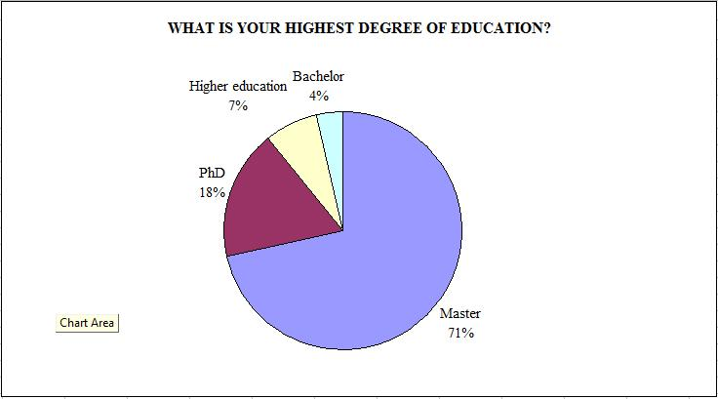
Figure 54. The experts‘ level of education
Source: Composed by the author

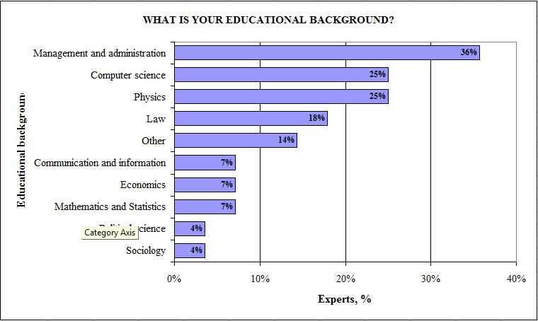
Figure 55. Educational background of the experts
Source: Composed by the author

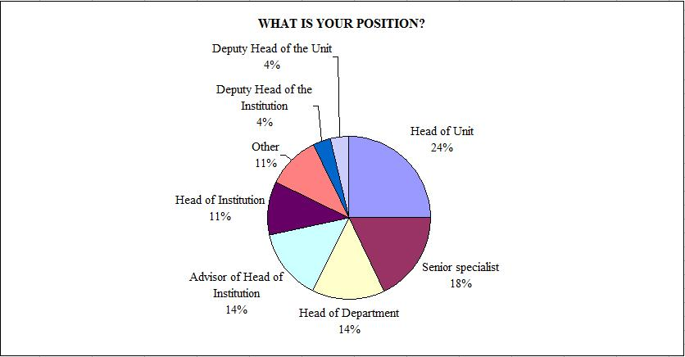
Figure 56. The experts‘ professional position
Source: Composed by the author

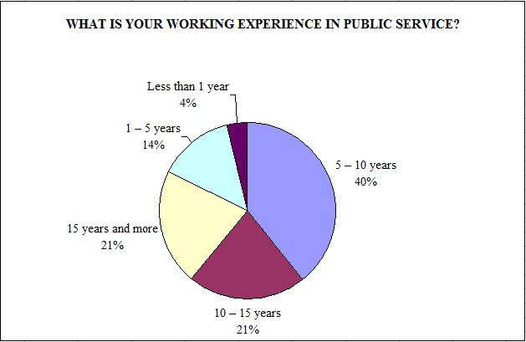
Figure 57. The experts‘ years of experience in public sector
Source: Composed by the author

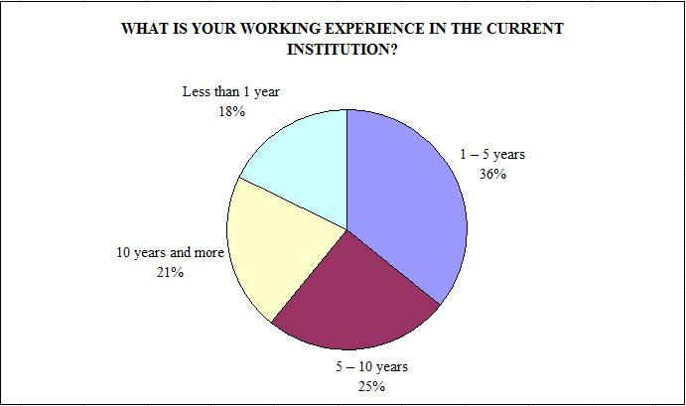
Figure 58. The experts‘ year of experience in current institution
Source: Composed by the author

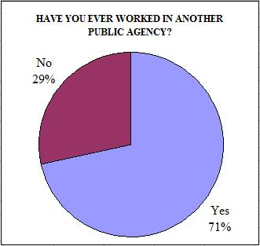 | 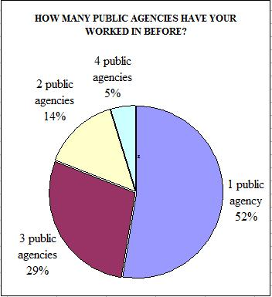
Figure 59. The experts‘ experience in other public agencies
Source: Composed by the author

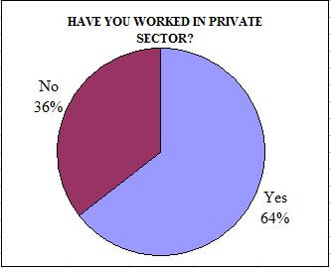 | 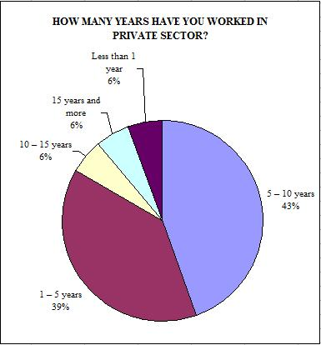
Figure 60. The experts‘ experience in private sector
Source: Composed by the author

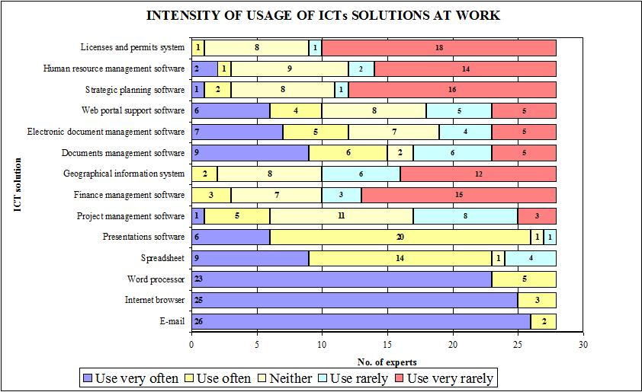
Figure 61. The experts‘ usage of ICTs solutions at work
Source: Composed by the author

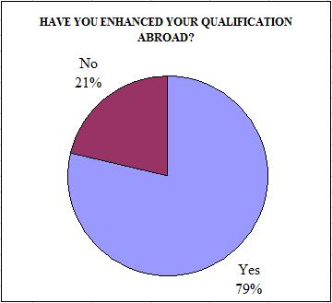 | 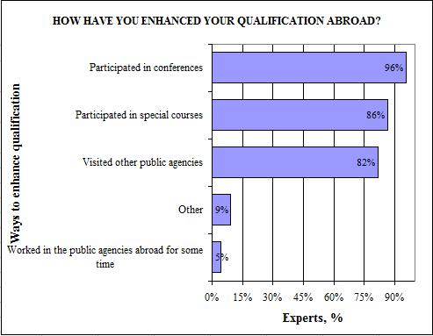
Figure 62. Improvement of the experts‘ qualification abroad
Source: Composed by the author

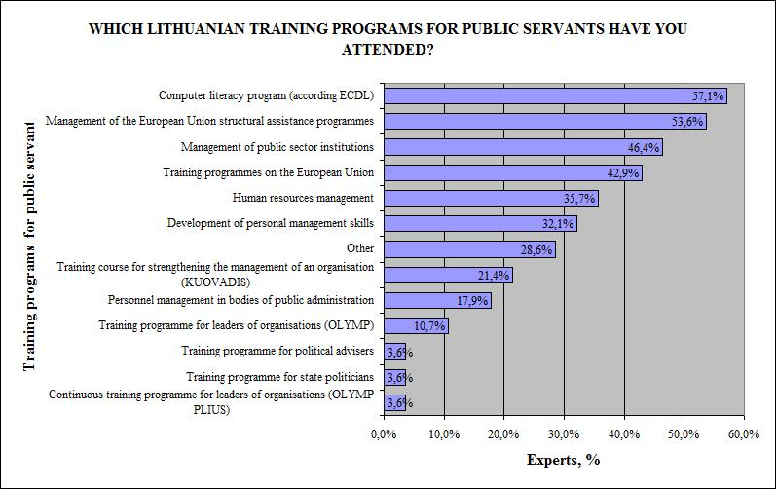
Figure 63. The experts‘ participation in Lithuanian training programs for public servants
Source: Composed by the author

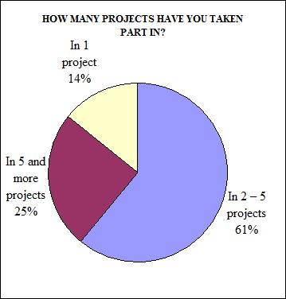 | 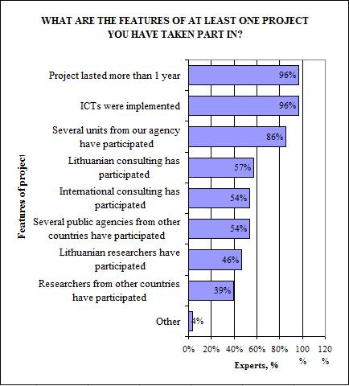
Figure 64. The experts‘ experience in projects
Source: Composed by the author
Appendix 5: Actual data for each dimension of e-government interoperability capability at the environmental level

LEADERS AND CHAMPIONS
Table 20. Actual data of knowledge rating of „Leaders and Champions“ dimension
Source: Composed by the author
Indicator | 1 | 2 | 3 | Response count
Leadership in this initiative effectively establishes the authority and legitimacy for work to proceed. | 0 | 1 | 27 | 28
Leadership in this initiative effectively motivates participants. | 0 | 6 | 22 | 28
Leadership in this initiative effectively builds commitment among participants. | 0 | 7 | 21 | 28
Leadership in this initiative effectively guides and coordinates activities. | 1 | 0 | 27 | 28
Leadership in this initiative effectively promotes creativity and innovation. | 1 | 6 | 21 | 28
Leadership in this initiative effectively articulates a vision for the effort. | 0 | 2 | 26 | 28
This initiative has a champion who effectively generates support among the stakeholders. | 0 | 5 | 23 | 28
Overall we have excellent leadership for this initiative. | 5 | 5 | 18 | 28
Knowledge rating scale: 1 – unknown, 2 – theoretical knowledge, 3 – theoretical and practical knowledge

Table 21. Actual data of importance rating of „Leaders and Champions“ dimension
Source: Composed by the author
Indicator | 1 | 2 | 3 | 4 | 5 | Response count
Leadership in this initiative effectively establishes the authority and legitimacy for work to proceed. | 0 | 0 | 0 | 2 | 26 | 28
Leadership in this initiative effectively motivates participants. | 0 | 0 | 2 | 5 | 21 | 28
Leadership in this initiative effectively builds commitment among participants. | 0 | 0 | 1 | 8 | 19 | 28
Leadership in this initiative effectively guides and coordinates activities. | 0 | 0 | 1 | 6 | 21 | 28
Leadership in this initiative effectively promotes creativity and innovation. | 0 | 0 | 6 | 11 | 11 | 28
Leadership in this initiative effectively articulates a vision for the effort. | 0 | 0 | 1 | 10 | 17 | 28
This initiative has a champion who effectively generates support among the stakeholders. | 0 | 0 | 0 | 8 | 20 | 28
Overall we have excellent leadership for this initiative. | 0 | 0 | 7 | 7 | 14 | 28
Importance rating scale: 1 – very unimportant, 5 – very important

Table 22. Actual data of presence rating of „Leaders and Champions“ dimension
Source: Composed by the author
Indicator | 1 | 2 | 3 | Response count
Leadership in this initiative effectively establishes the authority and legitimacy for work to proceed. | 2 | 12 | 14 | 28
Leadership in this initiative effectively motivates participants. | 3 | 18 | 7 | 28
Leadership in this initiative effectively builds commitment among participants. | 3 | 16 | 9 | 28
Leadership in this initiative effectively guides and coordinates activities. | 0 | 19 | 9 | 28
Leadership in this initiative effectively promotes creativity and innovation. | 7 | 16 | 5 | 28
Leadership in this initiative effectively articulates a vision for the effort. | 1 | 16 | 11 | 28
This initiative has a champion who effectively generates support among the stakeholders. | 3 | 17 | 8 | 28
Overall we have excellent leadership for this initiative. | 2 | 19 | 7 | 28
Presence rating scale: 1 – not present, 2- partially present, 3 – present

GOVERNANCE
Table 23. Actual data of knowledge rating of „Governance“ dimension
Source: Composed by the author
Indicator | 1 | 2 | 3 | Response count
We have a formal charter providing authority for specifying goals, roles, and responsibilities to proceed. | 2 | 3 | 23 | 28
We have a governance body that has the authority it needs to be successful. | 0 | 6 | 22 | 28
Our governance body has all the support and resources needed to ensure its effectiveness. | 0 | 6 | 22 | 28
Our authority to proceed is clear to all participants and stakeholders. | 0 | 3 | 25 | 28
Our authority to proceed is fully accepted by all participants and stakeholders. | 1 | 9 | 18 | 28
All relevant parties are effectively engaged in governance. | 3 | 2 | 23 | 28
Knowledge rating scale: 1 – unknown, 2 – theoretical knowledge, 3 – theoretical and practical knowledge

Table 24. Actual data of importance rating of „Governance“ dimension
Source: Composed by the author
Indicator | 1 | 2 | 3 | 4 | 5 | Response count
We have a formal charter providing authority for specifying goals, roles, and responsibilities to proceed. | 0 | 1 | 2 | 5 | 20 | 28
We have a governance body that has the authority it needs to be successful. | 0 | 0 | 1 | 10 | 17 | 28
Our governance body has all the support and resources needed to ensure its effectiveness. | 0 | 0 | 4 | 9 | 15 | 28
Our authority to proceed is clear to all participants and stakeholders. | 0 | 0 | 2 | 10 | 16 | 28
Our authority to proceed is fully accepted by all participants and stakeholders. | 0 | 0 | 5 | 12 | 11 | 28
All relevant parties are effectively engaged in governance. | 0 | 0 | 1 | 13 | 14 | 28
Importance rating scale: 1 – very unimportant, 5 – very important

Table 25. Actual data of presence rating of „Governance“ dimension
Source: Composed by the author
Indicator | 1 | 2 | 3 | Response count
We have a formal charter providing authority for specifying goals, roles, and responsibilities to proceed. | 7 | 12 | 9 | 28
We have a governance body that has the authority it needs to be successful. | 7 | 11 | 10 | 28
Our governance body has all the support and resources needed to ensure its effectiveness. | 9 | 14 | 5 | 28
Our authority to proceed is clear to all participants and stakeholders. | 4 | 17 | 7 | 28
Our authority to proceed is fully accepted by all participants and stakeholders. | 7 | 17 | 4 | 28
All relevant parties are effectively engaged in governance. | 8 | 17 | 3 | 28
Presence rating scale: 1 – not present, 2- partially present, 3 – present

COLLABORATION READINESS
Table 26. Actual data of knowledge rating of „Collaboration readiness“ dimension
Source: Composed by the author
Indicator | 1 | 2 | 3 | Response count
We actively seek opportunities for collaboration. | 0 | 4 | 24 | 28
We have a substantial record of successful collaboration across organizational boundaries. | 0 | 8 | 20 | 28
We have policies that effectively support collaboration. | 4 | 9 | 15 | 28
We have management practices that effectively support collaboration. | 3 | 11 | 14 | 28
We have standard operating procedures that effectively support collaboration. | 2 | 15 | 11 | 28
We are willing to commit resources (staff, finances, technology, etc.) across boundaries. | 1 | 11 | 16 | 28
We have effective mechanisms to commit resources across boundaries. | 5 | 7 | 16 | 28
We have an executive level champion of collaborative activities. | 4 | 7 | 17 | 28
We have high levels of stakeholder support for collaboration. | 2 | 5 | 21 | 28
We have an effective agreement for hardware sharing. | 4 | 8 | 16 | 28
We have an effective agreement for network resource sharing. | 3 | 10 | 15 | 28
We have an effective agreement for software and application sharing. | 5 | 9 | 14 | 28
There is an effective agreement for sharing technical staff. | 4 | 10 | 14 | 28
Whenever needed, hardware resources are easily shared | 4 | 11 | 13 | 28
Whenever needed, network resources are easily shared. | 3 | 12 | 13 | 28
Whenever needed, software and application resources are easily shared | 4 | 12 | 12 | 28
Whenever needed, technical staff resources are easily shared. | 3 | 11 | 14 | 28
Our network infrastructure fully supports collaboration and information sharing. | 2 | 8 | 18 | 28
Knowledge rating scale: 1 – unknown, 2 – theoretical knowledge, 3 – theoretical and practical knowledge

Table 27. Actual data of importance rating of „Collaboration readiness“ dimension
Source: Composed by the author
Indicator | 1 | 2 | 3 | 4 | 5 | Response count
We actively seek opportunities for collaboration. | 0 | 0 | 1 | 11 | 16 | 28
We have a substantial record of successful collaboration across organizational boundaries. | 0 | 0 | 5 | 12 | 11 | 28
We have policies that effectively support collaboration. | 0 | 1 | 6 | 11 | 10 | 28
We have management practices that effectively support collaboration. | 0 | 0 | 5 | 13 | 10 | 28
We have standard operating procedures that effectively support collaboration. | 0 | 0 | 8 | 15 | 5 | 28
We are willing to commit resources (staff, finances, technology, etc.) across boundaries. | 0 | 1 | 6 | 11 | 10 | 28
We have effective mechanisms to commit resources across boundaries. | 0 | 1 | 4 | 15 | 8 | 28
We have an executive level champion of collaborative activities. | 0 | 0 | 8 | 9 | 11 | 28
We have high levels of stakeholder support for collaboration. | 0 | 1 | 2 | 8 | 17 | 28
We have an effective agreement for hardware sharing. | 1 | 3 | 12 | 7 | 5 | 28
We have an effective agreement for network resource sharing. | 0 | 3 | 11 | 10 | 4 | 28
We have an effective agreement for software and application sharing. | 0 | 3 | 14 | 7 | 4 | 28
There is an effective agreement for sharing technical staff. | 1 | 1 | 12 | 9 | 5 | 28
Whenever needed, hardware resources are easily shared | 1 | 2 | 10 | 12 | 3 | 28
Whenever needed, network resources are easily shared. | 0 | 2 | 11 | 13 | 2 | 28
Whenever needed, software and application resources are easily shared | 1 | 1 | 13 | 11 | 2 | 28
Whenever needed, technical staff resources are easily shared. | 1 | 1 | 8 | 13 | 5 | 28
Our network infrastructure fully supports collaboration and information sharing. | 0 | 0 | 2 | 9 | 17 | 28
Importance rating scale: 1 – very unimportant, 5 – very important

Table 28. Actual data of presence rating of „Collaboration readiness“ dimension
Source: Composed by the author
Indicator | 1 | 2 | 3 | Response count
We actively seek opportunities for collaboration. | 6 | 13 | 9 | 28
We have a substantial record of successful collaboration across organizational boundaries. | 7 | 11 | 10 | 28
We have policies that effectively support collaboration. | 11 | 12 | 5 | 28
We have management practices that effectively support collaboration. | 12 | 10 | 6 | 28
We have standard operating procedures that effectively support collaboration. | 7 | 16 | 5 | 28
We are willing to commit resources (staff, finances, technology, etc.) across boundaries. | 11 | 9 | 8 | 28
We have effective mechanisms to commit resources across boundaries. | 14 | 11 | 3 | 28
We have an executive level champion of collaborative activities. | 11 | 13 | 4 | 28
We have high levels of stakeholder support for collaboration. | 8 | 14 | 6 | 28
We have an effective agreement for hardware sharing. | 20 | 3 | 5 | 28
We have an effective agreement for network resource sharing. | 18 | 5 | 5 | 28
We have an effective agreement for software and application sharing. | 18 | 6 | 4 | 28
There is an effective agreement for sharing technical staff. | 20 | 6 | 2 | 28
Whenever needed, hardware resources are easily shared | 21 | 5 | 2 | 28
Whenever needed, network resources are easily shared. | 19 | 8 | 1 | 28
Whenever needed, software and application resources are easily shared | 19 | 7 | 2 | 28
Whenever needed, technical staff resources are easily shared. | 15 | 11 | 2 | 28
Our network infrastructure fully supports collaboration and information sharing. | 8 | 13 | 7 | 28
Presence rating scale: 1 – not present, 2- partially present, 3 – present

ORGANISATIONAL COMPATIBILITY
Table 29. Actual data of knowledge rating of „Organisational compatibility“ dimension
Source: Composed by the author
Indicator | 1 | 2 | 3 | Response count
We have similar organizational cultures and practices in our setting. | 0 | 5 | 23 | 28
In our plans and strategies we take into account differences in centralization among organizations. | 2 | 12 | 14 | 28
In our plans and strategies we take into account differences in participation in decision making. | 2 | 12 | 14 | 28
We take into account differences in closeness of supervision among organizations. | 2 | 15 | 11 | 28
In our plans and strategies we take into account size differences among organizations. | 2 | 13 | 13 | 28
In our plans and strategies we take into account differences in the professional orientation of staff. | 3 | 14 | 11 | 28
Organizations in our setting have similar collaborative work styles. | 4 | 10 | 14 | 28
Organizations in our setting show similar competitive styles and actions. | 2 | 11 | 15 | 28
Organizations in our setting have similar styles of conflict resolution. | 4 | 9 | 15 | 28
We take into account differences in deference to authority among organizations. | 4 | 12 | 12 | 28
Knowledge rating scale: 1 – unknown, 2 – theoretical knowledge, 3 – theoretical and practical knowledge

Table 30. Actual data of importance rating of „Organisational compatibility“ dimension
Source: Composed by the author
Indicator | 1 | 2 | 3 | 4 | 5 | Response count
We have similar organizational cultures and practices in our setting. | 0 | 0 | 10 | 9 | 9 | 28
In our plans and strategies we take into account differences in centralization among organizations. | 0 | 1 | 6 | 10 | 11 | 28
In our plans and strategies we take into account differences in participation in decision making. | 0 | 0 | 6 | 13 | 9 | 28
We take into account differences in closeness of supervision among organizations. | 0 | 1 | 10 | 11 | 6 | 28
In our plans and strategies we take into account size differences among organizations. | 1 | 2 | 10 | 7 | 8 | 28
In our plans and strategies we take into account differences in the professional orientation of staff. | 0 | 2 | 5 | 14 | 7 | 28
Organizations in our setting have similar collaborative work styles. | 2 | 3 | 10 | 8 | 5 | 28
Organizations in our setting show similar competitive styles and actions. | 0 | 0 | 15 | 9 | 4 | 28
Organizations in our setting have similar styles of conflict resolution. | 1 | 2 | 12 | 9 | 4 | 28
We take into account differences in deference to authority among organizations. | 1 | 2 | 7 | 12 | 6 | 28
Importance rating scale: 1 – very unimportant, 5 – very important

Table 31. Actual data of presence rating of „Organisational compatibility“ dimension
Source: Composed by the author
Indicator | 1 | 2 | 3 | Response count
We have similar organizational cultures and practices in our setting. | 5 | 11 | 12 | 28
In our plans and strategies we take into account differences in centralization among organizations. | 10 | 14 | 4 | 28
In our plans and strategies we take into account differences in participation in decision making. | 8 | 16 | 4 | 28
We take into account differences in closeness of supervision among organizations. | 13 | 10 | 5 | 28
In our plans and strategies we take into account size differences among organizations. | 13 | 11 | 4 | 28
In our plans and strategies we take into account differences in the professional orientation of staff. | 10 | 12 | 6 | 28
Organizations in our setting have similar collaborative work styles. | 8 | 13 | 7 | 28
Organizations in our setting show similar competitive styles and actions. | 9 | 9 | 10 | 28
Organizations in our setting have similar styles of conflict resolution. | 9 | 13 | 6 | 28
We take into account differences in deference to authority among organizations. | 8 | 14 | 6 | 28
Presence rating scale: 1 – not present, 2- partially present, 3 – present

STAKEHOLDERS IDENTIFICATION AND ENGAGEMENT
Table 32. Actual data of knowledge rating of „Stakeholders identification and engagement“ dimension
Source: Composed by the author
Indicator | 1 | 2 | 3 | Response count
We have identified all relevant stakeholders. | 1 | 5 | 22 | 28
We have accurately and fully analyzed the stakeholders' interests. | 2 | 5 | 21 | 28
We have accurately and fully analyzed the stakeholders' ability to influence events. | 1 | 8 | 19 | 28
Our planning and decision making are guided by the results of a stakeholder analysis. | 1 | 9 | 18 | 28
We can effectively mobilize stakeholders' support for the initiative. | 0 | 8 | 20 | 28
We have fully informed our stakeholders about this initiative. | 1 | 4 | 23 | 28
Our stakeholders have a high level of engagement in the information-sharing initiative. | 0 | 8 | 20 | 28
Our stakeholders have a high level of trust in the information-sharing initiative. | 0 | 8 | 20 | 28
We have high levels of stakeholder support for collaboration and information sharing. | 1 | 7 | 20 | 28
Knowledge rating scale: 1 – unknown, 2 – theoretical knowledge, 3 – theoretical and practical knowledge

Table 33. Actual data of importance rating of „Stakeholders identification and engagement“ dimension
Source: Composed by the author
Indicator | 1 | 2 | 3 | 4 | 5 | Response count
We have identified all relevant stakeholders. | 0 | 0 | 0 | 11 | 17 | 28
We have accurately and fully analyzed the stakeholders' interests. | 0 | 0 | 1 | 10 | 17 | 28
We have accurately and fully analyzed the stakeholders' ability to influence events. | 0 | 0 | 2 | 14 | 12 | 28
Our planning and decision making are guided by the results of a stakeholder analysis. | 0 | 0 | 6 | 11 | 11 | 28
We can effectively mobilize stakeholders' support for the initiative. | 0 | 1 | 3 | 7 | 17 | 28
We have fully informed our stakeholders about this initiative. | 0 | 0 | 1 | 10 | 17 | 28
Our stakeholders have a high level of engagement in the information-sharing initiative. | 0 | 0 | 3 | 15 | 10 | 28
Our stakeholders have a high level of trust in the information-sharing initiative. | 1 | 0 | 3 | 15 | 9 | 28
We have high levels of stakeholder support for collaboration and information sharing. | 0 | 0 | 1 | 12 | 15 | 28
Importance rating scale: 1 – very unimportant, 5 – very important

Table 34. Actual data of presence rating of „Stakeholders identification and engagement“ dimension
Source: Composed by the author
Indicator | 1 | 2 | 3 | Response count
We have identified all relevant stakeholders. | 2 | 13 | 13 | 28
We have accurately and fully analyzed the stakeholders' interests. | 5 | 12 | 11 | 28
We have accurately and fully analyzed the stakeholders' ability to influence events. | 7 | 16 | 5 | 28
Our planning and decision making are guided by the results of a stakeholder analysis. | 9 | 13 | 6 | 28
We can effectively mobilize stakeholders' support for the initiative. | 6 | 16 | 6 | 28
We have fully informed our stakeholders about this initiative. | 1 | 12 | 15 | 28
Our stakeholders have a high level of engagement in the information-sharing initiative. | 3 | 17 | 8 | 28
Our stakeholders have a high level of trust in the information-sharing initiative. | 8 | 17 | 3 | 28
We have high levels of stakeholder support for collaboration and information sharing. | 7 | 16 | 5 | 28
Presence rating scale: 1 – not present, 2- partially present, 3 – present

Appendix 6: Actual data for each dimension of e-government interoperability capability at the organisational level

STRATEGIC PLANNING
Table 35. Actual data of knowledge rating of „Strategic planning“ dimension
Source: Composed by the author
Indicator | 1 | 2 | 3 | Response count
We have an established strategic planning process. | 1 | 7 | 20 | 28
Our strategic planning process engages all relevant stakeholders. | 2 | 9 | 17 | 28
Participants have well-developed strategic planning skills. | 2 | 8 | 18 | 28
Our strategic plans include thorough risk assessments. | 2 | 11 | 15 | 28
Our strategic plans include thorough analyses of threats and contingencies. | 2 | 12 | 14 | 28
Our plans identify strategic goals clearly and in detail. | 1 | 6 | 21 | 28
Our plans describe activities and resources clearly and in detail. | 0 | 8 | 20 | 28
We have ample resources to support strategic planning. | 0 | 9 | 19 | 28
Our strategic planning activities are thoroughly integrated with governance and management. | 1 | 11 | 16 | 28
Knowledge rating scale: 1 – unknown, 2 – theoretical knowledge, 3 – theoretical and practical knowledge

Table 36. Actual data of importance rating of „Strategic planning“ dimension
Source: Composed by the author
Indicator | 1 | 2 | 3 | 4 | 5 | Response count
We have an established strategic planning process. | 0 | 0 | 2 | 10 | 16 | 28
Our strategic planning process engages all relevant stakeholders. | 0 | 0 | 3 | 13 | 12 | 28
Participants have well-developed strategic planning skills. | 0 | 0 | 3 | 15 | 10 | 28
Our strategic plans include thorough risk assessments. | 0 | 0 | 2 | 12 | 14 | 28
Our strategic plans include thorough analyses of threats and contingencies. | 0 | 0 | 6 | 13 | 9 | 28
Our plans identify strategic goals clearly and in detail. | 0 | 0 | 1 | 5 | 22 | 28
Our plans describe activities and resources clearly and in detail. | 0 | 0 | 1 | 7 | 20 | 28
We have ample resources to support strategic planning. | 0 | 0 | 0 | 10 | 18 | 28
Our strategic planning activities are thoroughly integrated with governance and management. | 0 | 0 | 1 | 11 | 16 | 28
Importance rating scale: 1 – very unimportant, 5 – very important

Table 37. Actual data of presence rating of „Strategic planning“ dimension
Source: Composed by the author
Indicator | 1 | 2 | 3 | Response count
We have an established strategic planning process. | 7 | 11 | 10 | 28
Our strategic planning process engages all relevant stakeholders. | 10 | 15 | 3 | 28
Participants have well-developed strategic planning skills. | 9 | 16 | 3 | 28
Our strategic plans include thorough risk assessments. | 12 | 10 | 6 | 28
Our strategic plans include thorough analyses of threats and contingencies. | 10 | 15 | 3 | 28
Our plans identify strategic goals clearly and in detail. | 4 | 19 | 5 | 28
Our plans describe activities and resources clearly and in detail. | 6 | 16 | 6 | 28
We have ample resources to support strategic planning. | 9 | 17 | 2 | 28
Our strategic planning activities are thoroughly integrated with governance and management. | 10 | 15 | 3 | 28
Presence rating scale: 1 – not present, 2- partially present, 3 – present

PERFORMANCE EVALUATION
Table 38. Actual data of knowledge rating of „Performance evaluation“ dimension
Source: Composed by the author
Indicator | 1 | 2 | 3 | Response count
We have clearly defined operational goals for the information-sharing initiative. | 0 | 2 | 26 | 28
We can effectively evaluate the processes for implementing the information-sharing initiative. | 1 | 4 | 23 | 28
We have clearly defined goals for improved information-sharing performance. | 2 | 10 | 16 | 28
We can effectively evaluate improvements in information-sharing performance. | 2 | 11 | 15 | 28
We have clearly defined goals for how better information sharing improves outcomes. | 3 | 9 | 16 | 28
We have clearly defined indicators for each of the goals. | 1 | 6 | 21 | 28
We monitor performance relative to the indicators on an on-going basis. | 0 | 7 | 21 | 28
There is a high level of consensus about performance goals. | 1 | 5 | 22 | 28
We have ample resources for performance evaluation. | 0 | 7 | 21 | 28
We use performance evaluation effectively to improve information-sharing processes. | 2 | 12 | 14 | 28
We use evaluation of enterprise impacts effectively to improve the performance of the initiative. | 2 | 13 | 13 | 28
Knowledge rating scale: 1 – unknown, 2 – theoretical knowledge, 3 – theoretical and practical knowledge

Table 39. Actual data of importance rating of „Performance evaluation“ dimension
Source: Composed by the author
Indicator | 1 | 2 | 3 | 4 | 5 | Response count
We have clearly defined operational goals for the information-sharing initiative. | 0 | 0 | 0 | 2 | 26 | 28
We can effectively evaluate the processes for implementing the information-sharing initiative. | 0 | 0 | 1 | 13 | 14 | 28
We have clearly defined goals for improved information-sharing performance. | 0 | 1 | 5 | 11 | 11 | 28
We can effectively evaluate improvements in information-sharing performance. | 0 | 1 | 7 | 14 | 6 | 28
We have clearly defined goals for how better information sharing improves outcomes. | 0 | 0 | 5 | 15 | 8 | 28
We have clearly defined indicators for each of the goals. | 0 | 0 | 1 | 11 | 16 | 28
We monitor performance relative to the indicators on an on-going basis. | 0 | 0 | 1 | 12 | 15 | 28
There is a high level of consensus about performance goals. | 0 | 2 | 3 | 12 | 11 | 28
We have ample resources for performance evaluation. | 0 | 1 | 3 | 10 | 14 | 28
We use performance evaluation effectively to improve information-sharing processes. | 0 | 0 | 7 | 14 | 7 | 28
We use evaluation of enterprise impacts effectively to improve the performance of the initiative. | 0 | 0 | 14 | 10 | 4 | 28
Importance rating scale: 1 – very unimportant, 5 – very important

Table 40. Actual data of presence rating of „Performance evaluation“ dimension
Source: Composed by the author
Indicator | 1 | 2 | 3 | Response count
We have clearly defined operational goals for the information-sharing initiative. | 1 | 10 | 17 | 28
We can effectively evaluate the processes for implementing the information-sharing initiative. | 3 | 17 | 8 | 28
We have clearly defined goals for improved information-sharing performance. | 8 | 11 | 9 | 28
We can effectively evaluate improvements in information-sharing performance. | 9 | 13 | 6 | 28
We have clearly defined goals for how better information sharing improves outcomes. | 10 | 11 | 7 | 28
We have clearly defined indicators for each of the goals. | 2 | 17 | 9 | 28
We monitor performance relative to the indicators on an on-going basis. | 2 | 16 | 10 | 28
There is a high level of consensus about performance goals. | 7 | 13 | 8 | 28
We have ample resources for performance evaluation. | 11 | 12 | 5 | 28
We use performance evaluation effectively to improve information-sharing processes. | 10 | 16 | 2 | 28
We use evaluation of enterprise impacts effectively to improve the performance of the initiative. | 11 | 10 | 7 | 28
Presence rating scale: 1 – not present, 2- partially present, 3 – present

PROJECT MANAGEMENT
Table 41. Actual data of knowledge rating of „Project management“ dimension
Source: Composed by the author
Indicator | 1 | 2 | 3 | Response count
We have staff with formal project management responsibility. | 1 | 1 | 26 | 28
Project managers have substantial technical training for their tasks. | 0 | 7 | 21 | 28
We use a project management methodology. | 6 | 8 | 14 | 28
We use project management technology. | 0 | 11 | 17 | 28
Project management is closely linked to overall management, policy making, objectives, and vision. | 0 | 9 | 19 | 28
We use regular project management reports to assess and direct activities. | 0 | 8 | 20 | 28
Project management responsibility is shared across collaborating organization. | 1 | 7 | 20 | 28
Our project management methods include risk assessment and contingency planning. | 1 | 8 | 19 | 28
Overall, we have ample project management resources. | 1 | 6 | 21 | 28
Knowledge rating scale: 1 – unknown, 2 – theoretical knowledge, 3 – theoretical and practical knowledge

Table 42. Actual data of importance rating of „Project management“ dimension
Source: Composed by the author
Indicator | 1 | 2 | 3 | 4 | 5 | Response count
We have staff with formal project management responsibility. | 0 | 0 | 0 | 2 | 26 | 28
Project managers have substantial technical training for their tasks. | 0 | 0 | 3 | 14 | 11 | 28
We use a project management methodology. | 0 | 1 | 9 | 16 | 2 | 28
We use project management technology. | 1 | 1 | 13 | 8 | 5 | 28
Project management is closely linked to overall management, policy making, objectives, and vision. | 0 | 0 | 2 | 14 | 12 | 28
We use regular project management reports to assess and direct activities. | 0 | 1 | 2 | 15 | 10 | 28
Project management responsibility is shared across collaborating organization. | 1 | 1 | 3 | 13 | 10 | 28
Our project management methods include risk assessment and contingency planning. | 0 | 0 | 1 | 15 | 12 | 28
Overall, we have ample project management resources. | 0 | 1 | 2 | 12 | 13 | 28
Importance rating scale: 1 – very unimportant, 5 – very important

Table 43. Actual data of presence rating of „Project management“ dimension
Source: Composed by the author
Indicator | 1 | 2 | 3 | Response count
We have staff with formal project management responsibility. | 0 | 4 | 24 | 28
Project managers have substantial technical training for their tasks. | 9 | 13 | 6 | 28
We use a project management methodology. | 16 | 12 | 0 | 28
We use project management technology. | 14 | 10 | 4 | 28
Project management is closely linked to overall management, policy making, objectives, and vision. | 6 | 14 | 8 | 28
We use regular project management reports to assess and direct activities. | 5 | 7 | 16 | 28
Project management responsibility is shared across collaborating organization. | 5 | 11 | 12 | 28
Our project management methods include risk assessment and contingency planning. | 7 | 13 | 8 | 28
Overall, we have ample project management resources. | 9 | 16 | 3 | 28
Presence rating scale: 1 – not present, 2- partially present, 3 – present

RESOURCE MANAGEMENT
Table 44. Actual data of knowledge rating of „Resource management“ dimension
Source: Composed by the author
Indicator | 1 | 2 | 3 | Response count
We have a complete analysis of the necessary financial resources for this initiative. | 0 | 4 | 24 | 28
We have a complete analysis of the necessary technical resources for this initiative. | 0 | 5 | 23 | 28
We have a complete analysis of the necessary human resources for this initiative. | 0 | 6 | 22 | 28
We have adequate authority to acquire financial resources for this initiative. | 1 | 4 | 23 | 28
We have adequate authority to acquire technical resources required for this initiative. | 1 | 5 | 22 | 28
We have adequate authority to acquire human resources for this initiative. | 1 | 5 | 22 | 28
We have adequate authority to use the internal resources available to the initiative. | 1 | 5 | 22 | 28
We have an overall resource acquisition plan for this initiative. | 1 | 6 | 21 | 28
We have a plan for the outsourcing and subcontracting necessary for this initiative. | 2 | 6 | 20 | 28
We have a plan for employing the consultants necessary for this initiative. | 1 | 5 | 22 | 28
We have adequate experience with management of outsourcing and subcontracting. | 2 | 1 | 25 | 28
We have adequate experience with management of consultants. | 1 | 2 | 25 | 28
We have completed a return-on-investment analysis for this initiative. | 2 | 7 | 19 | 28
We have effective financial control mechanisms for the initiative. | 0 | 4 | 24 | 28
Our procurement process is fully adequate and effective for this initiative. | 1 | 3 | 24 | 28
Knowledge rating scale: 1 – unknown, 2 – theoretical knowledge, 3 – theoretical and practical knowledge

Table 45. Actual data of importance rating of „Resource management“ dimension
Source: Composed by the author
Indicator | 1 | 2 | 3 | 4 | 5 | Response count
We have a complete analysis of the necessary financial resources for this initiative. | 0 | 0 | 0 | 4 | 24 | 28
We have a complete analysis of the necessary technical resources for this initiative. | 0 | 0 | 1 | 11 | 16 | 28
We have a complete analysis of the necessary human resources for this initiative. | 0 | 0 | 0 | 10 | 18 | 28
We have adequate authority to acquire financial resources for this initiative. | 0 | 0 | 0 | 11 | 17 | 28
We have adequate authority to acquire technical resources required for this initiative. | 0 | 0 | 0 | 12 | 16 | 28
We have adequate authority to acquire human resources for this initiative. | 0 | 0 | 0 | 10 | 18 | 28
We have adequate authority to use the internal resources available to the initiative. | 0 | 0 | 0 | 13 | 15 | 28
We have an overall resource acquisition plan for this initiative. | 0 | 0 | 2 | 15 | 11 | 28
We have a plan for the outsourcing and subcontracting necessary for this initiative. | 0 | 1 | 3 | 12 | 12 | 28
We have a plan for employing the consultants necessary for this initiative. | 1 | 0 | 5 | 15 | 7 | 28
We have adequate experience with management of outsourcing and subcontracting. | 0 | 0 | 4 | 15 | 9 | 28
We have adequate experience with management of consultants. | 0 | 1 | 3 | 16 | 8 | 28
We have completed a return-on-investment analysis for this initiative. | 0 | 0 | 6 | 10 | 12 | 28
We have effective financial control mechanisms for the initiative. | 0 | 0 | 0 | 13 | 15 | 28
Our procurement process is fully adequate and effective for this initiative. | 1 | 0 | 2 | 8 | 17 | 28
Importance rating scale: 1 – very unimportant, 5 – very important

Table 46. Actual data of presence rating of „Resource management“ dimension
Source: Composed by the author
Indicator | 1 | 2 | 3 | Response count
We have a complete analysis of the necessary financial resources for this initiative. | 1 | 9 | 18 | 28
We have a complete analysis of the necessary technical resources for this initiative. | 3 | 16 | 9 | 28
We have a complete analysis of the necessary human resources for this initiative. | 3 | 14 | 11 | 28
We have adequate authority to acquire financial resources for this initiative. | 6 | 14 | 8 | 28
We have adequate authority to acquire technical resources required for this initiative. | 3 | 18 | 7 | 28
We have adequate authority to acquire human resources for this initiative. | 7 | 13 | 8 | 28
We have adequate authority to use the internal resources available to the initiative. | 5 | 15 | 8 | 28
We have an overall resource acquisition plan for this initiative. | 2 | 17 | 9 | 28
We have a plan for the outsourcing and subcontracting necessary for this initiative. | 6 | 11 | 11 | 28
We have a plan for employing the consultants necessary for this initiative. | 8 | 13 | 7 | 28
We have adequate experience with management of outsourcing and subcontracting. | 3 | 17 | 8 | 28
We have adequate experience with management of consultants. | 2 | 17 | 9 | 28
We have completed a return-on-investment analysis for this initiative. | 13 | 9 | 6 | 28
We have effective financial control mechanisms for the initiative. | 2 | 16 | 10 | 28
Our procurement process is fully adequate and effective for this initiative. | 9 | 14 | 5 | 28
Presence rating scale: 1 – not present, 2- partially present, 3 – present

TECHNOLOGY ACCEPTANCE
Table 47. Actual data of knowledge rating of „Technology acceptance“ dimension
Source: Composed by the author
Indicator | 1 | 2 | 3 | Response count
Management provides staff with a clear vision and goals for the use of new technology. | 1 | 5 | 22 | 28
Management supports and rewards technology innovation. | 0 | 5 | 23 | 28
Management provides training in the use of new technology. | 0 | 4 | 24 | 28
Staff members believe IT change is a good thing. | 1 | 6 | 21 | 28
Staff is open and enthusiastic about using new IT. | 1 | 4 | 23 | 28
Staff members believe information sharing will improve their efficiency and work quality. | 0 | 7 | 21 | 28
Staff has extensive experience with different applications and computers. | 0 | 4 | 24 | 28
Staff demonstrates enthusiastic support for the technology aspects of the initiative. | 0 | 10 | 18 | 28
Staff demonstrates enthusiastic support for adopting and/or using new technology for the initiative. | 2 | 7 | 19 | 28
Very few staff members have demonstrated opposition to adopting and/or using new technology for the initiative. | 1 | 7 | 20 | 28
Few staff members have a low comfort level with the new technology supporting initiative. | 2 | 6 | 20 | 28
Knowledge rating scale: 1 – unknown, 2 – theoretical knowledge, 3 – theoretical and practical knowledge
Table 48. Actual data of importance rating of „Technology acceptance“ dimension
Source: Composed by the author
Indicator | 1 | 2 | 3 | 4 | 5 | Response count
Management provides staff with a clear vision and goals for the use of new technology. | 0 | 1 | 2 | 11 | 14 | 28
Management supports and rewards technology innovation. | 0 | 0 | 0 | 8 | 20 | 28
Management provides training in the use of new technology. | 0 | 1 | 1 | 10 | 16 | 28
Staff members believe IT change is a good thing. | 0 | 0 | 5 | 16 | 7 | 28
Staff is open and enthusiastic about using new IT. | 0 | 0 | 5 | 15 | 8 | 28
Staff members believe information sharing will improve their efficiency and work quality. | 0 | 0 | 5 | 13 | 10 | 28
Staff has extensive experience with different applications and computers. | 0 | 1 | 6 | 11 | 10 | 28
Staff demonstrates enthusiastic support for the technology aspects of the initiative. | 0 | 0 | 5 | 14 | 9 | 28
Staff demonstrates enthusiastic support for adopting and/or using new technology for the initiative. | 0 | 1 | 6 | 14 | 7 | 28
Very few staff members have demonstrated opposition to adopting and/or using new technology for the initiative. | 0 | 0 | 12 | 9 | 7 | 28
Few staff members have a low comfort level with the new technology supporting initiative. | 1 | 0 | 11 | 8 | 8 | 28
Importance rating scale: 1 – very unimportant, 5 – very important

Table 49. Actual data of presence rating of „Technology acceptance“ dimension
Source: Composed by the author
Indicator | 1 | 2 | 3 | Response count
Management provides staff with a clear vision and goals for the use of new technology. | 6 | 12 | 10 | 28
Management supports and rewards technology innovation. | 3 | 7 | 18 | 28
Management provides training in the use of new technology. | 3 | 12 | 13 | 28
Staff members believe IT change is a good thing. | 5 | 17 | 6 | 28
Staff is open and enthusiastic about using new IT. | 9 | 15 | 4 | 28
Staff members believe information sharing will improve their efficiency and work quality. | 7 | 15 | 6 | 28
Staff has extensive experience with different applications and computers. | 4 | 17 | 7 | 28
Staff demonstrates enthusiastic support for the technology aspects of the initiative. | 5 | 19 | 4 | 28
Staff demonstrates enthusiastic support for adopting and/or using new technology for the initiative. | 8 | 15 | 5 | 28
Very few staff members have demonstrated opposition to adopting and/or using new technology for the initiative. | 6 | 13 | 9 | 28
Few staff members have a low comfort level with the new technology supporting initiative. | 6 | 15 | 7 | 28
Presence rating scale: 1 – not present, 2- partially present, 3 – present

Appendix 7: Actual data for each dimension of e-government interoperability capability at the semantics and technological level

BUSINESS MODEL AND ARCHITECTURE
Table 50. Actual data of knowledge rating of „Business model and architecture“ dimension
Source: Composed by the author
Indicator | 1 | 2 | 3 | Response count
We have a comprehensive business model of the information-sharing initiative. | 4 | 8 | 16 | 28
We have identified the strategic objectives for each information-sharing activity. | 1 | 13 | 14 | 28
We have identified an enterprise model or architecture for the information-sharing initiative. | 2 | 4 | 22 | 28
We have analyzed the full range of business processes involved in information sharing. | 0 | 8 | 20 | 28
We have identified all business process discrepancies that may interfere with information sharing. | 0 | 12 | 16 | 28
We have eliminated all business process discrepancies that may interfere with information sharing. | 1 | 13 | 14 | 28
Technology design and procurement decisions are guided by and referenced to enterprise architecture. | 4 | 6 | 18 | 28
Knowledge rating scale: 1 – unknown, 2 – theoretical knowledge, 3 – theoretical and practical knowledge

Table 51. Actual data of importance rating of „Business model and architecture“ dimension
Source: Composed by the author
Indicator | 1 | 2 | 3 | 4 | 5 | Response count
We have a comprehensive business model of the information-sharing initiative. | 3 | 0 | 3 | 11 | 11 | 28
We have identified the strategic objectives for each information-sharing activity. | 1 | 0 | 4 | 15 | 8 | 28
We have identified an enterprise model or architecture for the information-sharing initiative. | 0 | 0 | 3 | 12 | 13 | 28
We have analyzed the full range of business processes involved in information sharing. | 0 | 0 | 1 | 15 | 12 | 28
We have identified all business process discrepancies that may interfere with information sharing. | 0 | 0 | 1 | 17 | 10 | 28
We have eliminated all business process discrepancies that may interfere with information sharing. | 0 | 0 | 5 | 14 | 9 | 28
Technology design and procurement decisions are guided by and referenced to enterprise architecture. | 0 | 0 | 4 | 12 | 12 | 28
Importance rating scale: 1 – very unimportant, 5 – very important

Table 52. Actual data of presence rating of „Business model and architecture“ dimension
Source: Composed by the author
Indicator | 1 | 2 | 3 | Response count
We have a comprehensive business model of the information-sharing initiative. | 8 | 16 | 4 | 28
We have identified the strategic objectives for each information-sharing activity. | 8 | 16 | 4 | 28
We have identified an enterprise model or architecture for the information-sharing initiative. | 6 | 9 | 13 | 28
We have analyzed the full range of business processes involved in information sharing. | 3 | 17 | 8 | 28
We have identified all business process discrepancies that may interfere with information sharing. | 6 | 18 | 4 | 28
We have eliminated all business process discrepancies that may interfere with information sharing. | 10 | 17 | 1 | 28
Technology design and procurement decisions are guided by and referenced to enterprise architecture. | 8 | 7 | 13 | 28
Presence rating scale: 1 – not present, 2- partially present, 3 – present

INFORMATION POLICY
Table 53. Actual data of knowledge rating of „Information policy“ dimension
Source: Composed by the author
Indicator | 1 | 2 | 3 | Response count
We have information policies that effectively support and encourage information sharing. | 3 | 6 | 19 | 28
Information policies that apply to this initiative are well defined. | 0 | 8 | 20 | 28
Information policies are fully accessible throughout the information-sharing setting. | 1 | 5 | 22 | 28
Information policies are fully implemented and enforced. | 1 | 9 | 18 | 28
None of our information policies inhibit or interfere with information sharing. | 2 | 5 | 21 | 28
Our information policies are consistent across all information-sharing organizations. | 4 | 7 | 17 | 28
Our information policies are subject to regular review and revision. | 1 | 9 | 18 | 28
Knowledge rating scale: 1 – unknown, 2 – theoretical knowledge, 3 – theoretical and practical knowledge

Table 54. Actual data of importance rating of „Information policy“ dimension
Source: Composed by the author
Indicator | 1 | 2 | 3 | 4 | 5 | Response count
We have information policies that effectively support and encourage information sharing. | 0 | 0 | 3 | 11 | 14 | 28
Information policies that apply to this initiative are well defined. | 0 | 0 | 4 | 12 | 12 | 28
Information policies are fully accessible throughout the information-sharing setting. | 0 | 0 | 4 | 15 | 9 | 28
Information policies are fully implemented and enforced. | 0 | 0 | 4 | 14 | 10 | 28
None of our information policies inhibit or interfere with information sharing. | 0 | 0 | 7 | 13 | 8 | 28
Our information policies are consistent across all information-sharing organizations. | 0 | 0 | 7 | 13 | 8 | 28
Our information policies are subject to regular review and revision. | 0 | 0 | 3 | 13 | 12 | 28
Importance rating scale: 1 – very unimportant, 5 – very important

Table 55. Actual data of presence rating of „Information policy“ dimension
Source: Composed by the author
Indicator | 1 | 2 | 3 | Response count
We have information policies that effectively support and encourage information sharing. | 7 | 11 | 10 | 28
Information policies that apply to this initiative are well defined. | 6 | 15 | 7 | 28
Information policies are fully accessible throughout the information-sharing setting. | 6 | 14 | 8 | 28
Information policies are fully implemented and enforced. | 6 | 19 | 3 | 28
None of our information policies inhibit or interfere with information sharing. | 6 | 15 | 7 | 28
Our information policies are consistent across all information-sharing organizations. | 8 | 16 | 4 | 28
Our information policies are subject to regular review and revision. | 8 | 12 | 8 | 28
Presence rating scale: 1 – not present, 2- partially present, 3 – present

TECHNOLOGY KNOWLEDGE
Table 56. Actual data of knowledge rating of „Technology knowledge“ dimension
Source: Composed by the author
Indicator | 1 | 2 | 3 | Response count
Our staff members know all they need to know about hardware for this initiative. | 0 | 4 | 24 | 28
Our staff members know all they need to know about network infrastructure for this initiative. | 0 | 5 | 23 | 28
Our staff members know all they need to know about required software applications for this initiative. | 0 | 6 | 22 | 28
We maintain accurate inventories and documentation of our applications useful for information sharing. | 0 | 6 | 22 | 28
We maintain accurate inventories of hardware for information sharing. | 0 | 9 | 19 | 28
We maintain accurate inventories and documentation of network infrastructure. | 0 | 7 | 21 | 28
We maintain accurate inventories and documentation of software useful for information sharing. | 1 | 6 | 21 | 28
We maintain accurate inventories of staff members' technical skills and knowledge about information sharing. | 0 | 7 | 21 | 28
Knowledge about hardware is shared effectively. | 2 | 7 | 19 | 28
Knowledge about information-sharing networks is shared effectively. | 3 | 7 | 18 | 28
Knowledge about software for information sharing is shared effectively. | 3 | 8 | 17 | 28
Knowledge about technical staff resources is shared effectively | 4 | 7 | 17 | 28
Knowledge about applications is shared effectively. | 3 | 5 | 20 | 28
Knowledge about technology is a highly important part of IT decision making regarding information sharing. | 3 | 6 | 19 | 28
Knowledge rating scale: 1 – unknown, 2 – theoretical knowledge, 3 – theoretical and practical knowledge

Table 57. Actual data of importance rating of „Technology knowledge“ dimension
Source: Composed by the author
Indicator | 1 | 2 | 3 | 4 | 5 | Response count
Our staff members know all they need to know about hardware for this initiative. | 0 | 0 | 4 | 15 | 9 | 28
Our staff members know all they need to know about network infrastructure for this initiative. | 0 | 0 | 6 | 15 | 7 | 28
Our staff members know all they need to know about required software applications for this initiative. | 0 | 0 | 6 | 16 | 6 | 28
We maintain accurate inventories and documentation of our applications useful for information sharing. | 0 | 0 | 7 | 13 | 8 | 28
We maintain accurate inventories of hardware for information sharing. | 0 | 0 | 9 | 11 | 8 | 28
We maintain accurate inventories and documentation of network infrastructure. | 0 | 0 | 9 | 13 | 6 | 28
We maintain accurate inventories and documentation of software useful for information sharing. | 0 | 0 | 7 | 13 | 8 | 28
We maintain accurate inventories of staff members' technical skills and knowledge about information sharing. | 0 | 1 | 6 | 15 | 6 | 28
Knowledge about hardware is shared effectively. | 0 | 1 | 6 | 15 | 6 | 28
Knowledge about information-sharing networks is shared effectively. | 0 | 0 | 7 | 16 | 5 | 28
Knowledge about software for information sharing is shared effectively. | 0 | 0 | 8 | 16 | 4 | 28
Knowledge about technical staff resources is shared effectively | 0 | 2 | 10 | 12 | 4 | 28
Knowledge about applications is shared effectively. | 0 | 2 | 6 | 13 | 7 | 28
Knowledge about technology is a highly important part of IT decision making regarding information sharing. | 0 | 1 | 1 | 19 | 7 | 28
Importance rating scale: 1 – very unimportant, 5 – very important

Table 58. Actual data of presence rating of „Technology knowledge“ dimension
Source: Composed by the author
Indicator | 1 | 2 | 3 | Response count
Our staff members know all they need to know about hardware for this initiative. | 1 | 15 | 12 | 28
Our staff members know all they need to know about network infrastructure for this initiative. | 3 | 15 | 10 | 28
Our staff members know all they need to know about required software applications for this initiative. | 2 | 17 | 9 | 28
We maintain accurate inventories and documentation of our applications useful for information sharing. | 2 | 21 | 5 | 28
We maintain accurate inventories of hardware for information sharing. | 7 | 17 | 4 | 28
We maintain accurate inventories and documentation of network infrastructure. | 7 | 19 | 2 | 28
We maintain accurate inventories and documentation of software useful for information sharing. | 7 | 18 | 3 | 28
We maintain accurate inventories of staff members' technical skills and knowledge about information sharing. | 11 | 15 | 2 | 28
Knowledge about hardware is shared effectively. | 10 | 14 | 4 | 28
Knowledge about information-sharing networks is shared effectively. | 9 | 16 | 3 | 28
Knowledge about software for information sharing is shared effectively. | 10 | 14 | 4 | 28
Knowledge about technical staff resources is shared effectively | 9 | 13 | 6 | 28
Knowledge about applications is shared effectively. | 8 | 14 | 6 | 28
Knowledge about technology is a highly important part of IT decision making regarding information sharing. | 9 | 14 | 5 | 28
Presence rating scale: 1 – not present, 2- partially present, 3 – present

TECHNOLOGY COMPATIBILITY
Table 59. Actual data of knowledge rating of „Technology compatibility“ dimension
Source: Composed by the author
Indicator | 1 | 2 | 3 | Response count
Our computing platforms are designed for and fully support collaboration and information sharing. | 0 | 5 | 23 | 28
Our software applications are well suited for collaboration and information sharing. | 0 | 5 | 23 | 28
Our network protocols and standards support information-sharing connectivity. | 0 | 5 | 23 | 28
Our computing platforms fully support interoperability of applications for information sharing. | 0 | 6 | 22 | 28
Our network infrastructure has adequate bandwidth for our information-sharing initiative. | 1 | 4 | 23 | 28
Our network infrastructure extends to all potential participants in the initiative. | 0 | 3 | 25 | 28
All information-sharing participants have adequate local resources for network connectivity. | 2 | 4 | 22 | 28
All participants have adequate local technology resources for effective information sharing. | 0 | 5 | 23 | 28
Knowledge rating scale: 1 – unknown, 2 – theoretical knowledge, 3 – theoretical and practical knowledge

Table 60. Actual data of importance rating of „Technology compatibility“ dimension
Source: Composed by the author
Indicator | 1 | 2 | 3 | 4 | 5 | Response count
Our computing platforms are designed for and fully support collaboration and information sharing. | 0 | 0 | 0 | 8 | 20 | 28
Our software applications are well suited for collaboration and information sharing. | 0 | 0 | 1 | 7 | 20 | 28
Our network protocols and standards support information-sharing connectivity. | 0 | 0 | 2 | 8 | 18 | 28
Our computing platforms fully support interoperability of applications for information sharing. | 0 | 0 | 2 | 10 | 16 | 28
Our network infrastructure has adequate bandwidth for our information-sharing initiative. | 1 | 0 | 4 | 9 | 14 | 28
Our network infrastructure extends to all potential participants in the initiative. | 0 | 0 | 2 | 12 | 14 | 28
All information-sharing participants have adequate local resources for network connectivity. | 0 | 0 | 3 | 13 | 12 | 28
All participants have adequate local technology resources for effective information sharing. | 0 | 0 | 0 | 9 | 19 | 28
Importance rating scale: 1 – very unimportant, 5 – very important

Table 61. Actual data of presence rating of „Technology compatibility“ dimension
Source: Composed by the author
Indicator | 1 | 2 | 3 | Response count
Our computing platforms are designed for and fully support collaboration and information sharing. | 4 | 11 | 13 | 28
Our software applications are well suited for collaboration and information sharing. | 4 | 12 | 12 | 28
Our network protocols and standards support information-sharing connectivity. | 3 | 11 | 14 | 28
Our computing platforms fully support interoperability of applications for information sharing. | 8 | 11 | 9 | 28
Our network infrastructure has adequate bandwidth for our information-sharing initiative. | 2 | 11 | 15 | 28
Our network infrastructure extends to all potential participants in the initiative. | 3 | 9 | 16 | 28
All information-sharing participants have adequate local resources for network connectivity. | 6 | 12 | 10 | 28
All participants have adequate local technology resources for effective information sharing. | 5 | 12 | 11 | 28
Presence rating scale: 1 – not present, 2- partially present, 3 – present

DATA ASSETS AND REQUIREMENTS
Table 62. Actual data of knowledge rating of „Data assets and requirements“ dimension
Source: Composed by the author
Indicator | 1 | 2 | 3 | Response count
High quality metadata is available for all data needed. | 5 | 9 | 14 | 28
We maintain accurate data inventories for all data needed. | 1 | 4 | 23 | 28
We have current and comprehensive data reference models. | 2 | 10 | 16 | 28
There are uniform policies for data access. | 1 | 3 | 24 | 28
There are uniform policies for data ownership. | 1 | 6 | 21 | 28
There are uniform policies for data maintenance. | 1 | 4 | 23 | 28
There are uniform policies for data liability. | 0 | 5 | 23 | 28
Standard definitions for all data have been adopted. | 1 | 7 | 20 | 28
Quality standards for all data have been adopted. | 2 | 7 | 19 | 28
Acquisition standards for all data have been adopted. | 3 | 9 | 16 | 28
Staff has extensive experience in sharing data. | 2 | 8 | 18 | 28
Full sets of explicit user data requirements have been developed. | 4 | 7 | 17 | 28
Users’ data requirements are well understood. | 2 | 7 | 19 | 28
We have fully identified discrepancies in data requirements. | 3 | 8 | 17 | 28
We are willing to reconcile discrepancies in data requirements. | 2 | 10 | 16 | 28
Knowledge rating scale: 1 – unknown, 2 – theoretical knowledge, 3 – theoretical and practical knowledge

Table 63. Actual data of importance rating of „Data assets and requirements“ dimension
Source: Composed by the author
Indicator | 1 | 2 | 3 | 4 | 5 | Response count
High quality metadata is available for all data needed. | 1 | 1 | 6 | 8 | 12 | 28
We maintain accurate data inventories for all data needed. | 0 | 0 | 2 | 12 | 14 | 28
We have current and comprehensive data reference models. | 0 | 0 | 2 | 15 | 11 | 28
There are uniform policies for data access. | 0 | 1 | 1 | 7 | 19 | 28
There are uniform policies for data ownership. | 0 | 1 | 1 | 9 | 17 | 28
There are uniform policies for data maintenance. | 0 | 1 | 1 | 10 | 16 | 28
There are uniform policies for data liability. | 0 | 0 | 3 | 8 | 17 | 28
Standard definitions for all data have been adopted. | 0 | 1 | 3 | 10 | 14 | 28
Quality standards for all data have been adopted. | 1 | 1 | 3 | 13 | 10 | 28
Acquisition standards for all data have been adopted. | 0 | 0 | 5 | 14 | 9 | 28
Staff has extensive experience in sharing data. | 0 | 0 | 7 | 17 | 4 | 28
Full sets of explicit user data requirements have been developed. | 0 | 0 | 5 | 16 | 7 | 28
Users’ data requirements are well understood. | 0 | 0 | 4 | 14 | 10 | 28
We have fully identified discrepancies in data requirements. | 1 | 1 | 3 | 13 | 10 | 28
We are willing to reconcile discrepancies in data requirements. | 1 | 1 | 1 | 16 | 9 | 28
Importance rating scale: 1 – very unimportant, 5 – very important

Table 64. Actual data of presence rating of „Data assets and requirements“ dimension
Source: Composed by the author
Indicator | 1 | 2 | 3 | Response count
High quality metadata is available for all data needed. | 7 | 18 | 3 | 28
We maintain accurate data inventories for all data needed. | 6 | 15 | 7 | 28
We have current and comprehensive data reference models. | 9 | 14 | 5 | 28
There are uniform policies for data access. | 3 | 11 | 14 | 28
There are uniform policies for data ownership. | 5 | 10 | 13 | 28
There are uniform policies for data maintenance. | 3 | 14 | 11 | 28
There are uniform policies for data liability. | 5 | 11 | 12 | 28
Standard definitions for all data have been adopted. | 7 | 12 | 9 | 28
Quality standards for all data have been adopted. | 14 | 10 | 4 | 28
Acquisition standards for all data have been adopted. | 13 | 10 | 5 | 28
Staff has extensive experience in sharing data. | 6 | 17 | 5 | 28
Full sets of explicit user data requirements have been developed. | 7 | 14 | 7 | 28
Users’ data requirements are well understood. | 5 | 16 | 7 | 28
We have fully identified discrepancies in data requirements. | 10 | 15 | 3 | 28
We are willing to reconcile discrepancies in data requirements. | 10 | 14 | 4 | 28
Presence rating scale: 1 – not present, 2- partially present, 3 – present

SECURE ENVIRONMENT
Table 65. Actual data of knowledge rating of „Secure environment“ dimension
Source: Composed by the author
Indicator | 1 | 2 | 3 | Response count
My organization has a thorough analysis of its overall security needs. | 1 | 5 | 22 | 28
We have a thorough analysis of security needs for the overall information-sharing setting. | 1 | 6 | 21 | 28
We have highly effective security protocols in place. | 1 | 6 | 21 | 28
We conduct systematic evaluation of our security vulnerabilities. | 1 | 6 | 21 | 28
We have highly effective network management policies. | 0 | 4 | 24 | 28
Management devotes serious efforts to ensure network security. | 2 | 3 | 23 | 28
Overall, we have highly effective security practices. | 1 | 4 | 23 | 28
Staff shows strong support for our information security officers. | 1 | 4 | 23 | 28
We have highly effective accountability mechanisms to ensure network security. | 1 | 6 | 21 | 28
We employ highly effective risk assessment strategies. | 0 | 3 | 25 | 28
There is an excellent fit between our security technology investments and security risks. | 0 | 5 | 23 | 28
We have a highly successful implementation of security technologies. | 0 | 7 | 21 | 28
Staff does an excellent job of responding to security breaches. | 0 | 7 | 21 | 28
Security policies and procedures are effectively communicated to all involved. | 0 | 4 | 24 | 28
We have clearly defined data security policies and procedures. | 0 | 6 | 22 | 28
Data security policies and procedures are closely matched to actual sensitivity and confidentiality needs. | 1 | 4 | 23 | 28
We have comprehensive data security plans. | 0 | 8 | 20 | 28
We employ effective formal reviews of security compliance. | 0 | 7 | 21 | 28
We employ technology effectively to ensure compliance with security policies. | 0 | 5 | 23 | 28
Technology is well matched to security needs. | 0 | 7 | 21 | 28
There is a strong willingness to investigate new security technologies. | 0 | 6 | 22 | 28
There is a strong willingness to investigate new security threats. | 0 | 7 | 21 | 28
Knowledge rating scale: 1 – unknown, 2 – theoretical knowledge, 3 – theoretical and practical knowledge

Table 66. Actual data of importance rating of „Secure environment“ dimension
Source: Composed by the author
Indicator | 1 | 2 | 3 | 4 | 5 | Response count
My organization has a thorough analysis of its overall security needs. | 0 | 0 | 0 | 10 | 18 | 28
We have a thorough analysis of security needs for the overall information-sharing setting. | 0 | 0 | 0 | 11 | 17 | 28
We have highly effective security protocols in place. | 0 | 0 | 2 | 16 | 10 | 28
We conduct systematic evaluation of our security vulnerabilities. | 0 | 0 | 1 | 13 | 14 | 28
We have highly effective network management policies. | 0 | 0 | 0 | 11 | 17 | 28
Management devotes serious efforts to ensure network security. | 0 | 0 | 2 | 13 | 13 | 28
Overall, we have highly effective security practices. | 0 | 0 | 2 | 11 | 15 | 28
Staff shows strong support for our information security officers. | 0 | 0 | 3 | 15 | 10 | 28
We have highly effective accountability mechanisms to ensure network security. | 0 | 0 | 1 | 14 | 13 | 28
We employ highly effective risk assessment strategies. | 0 | 0 | 0 | 15 | 13 | 28
There is an excellent fit between our security technology investments and security risks. | 0 | 0 | 0 | 12 | 16 | 28
We have a highly successful implementation of security technologies. | 0 | 0 | 0 | 14 | 14 | 28
Staff does an excellent job of responding to security breaches. | 0 | 0 | 3 | 13 | 12 | 28
Security policies and procedures are effectively communicated to all involved. | 0 | 0 | 2 | 12 | 14 | 28
We have clearly defined data security policies and procedures. | 0 | 0 | 2 | 10 | 16 | 28
Data security policies and procedures are closely matched to actual sensitivity and confidentiality needs. | 0 | 0 | 2 | 11 | 15 | 28
We have comprehensive data security plans. | 0 | 0 | 5 | 7 | 16 | 28
We employ effective formal reviews of security compliance. | 0 | 0 | 3 | 12 | 13 | 28
We employ technology effectively to ensure compliance with security policies. | 0 | 0 | 0 | 14 | 14 | 28
Technology is well matched to security needs. | 0 | 0 | 2 | 13 | 13 | 28
There is a strong willingness to investigate new security technologies. | 0 | 1 | 5 | 11 | 11 | 28
There is a strong willingness to investigate new security threats. | 0 | 0 | 2 | 11 | 15 | 28
Importance rating scale: 1 – very unimportant, 5 – very important

Table 67. Actual data of presence rating of „Secure environment“ dimension
Source: Composed by the author
Indicator | 1 | 2 | 3 | Response count
My organization has a thorough analysis of its overall security needs. | 1 | 14 | 13 | 28
We have a thorough analysis of security needs for the overall information-sharing setting. | 3 | 13 | 12 | 28
We have highly effective security protocols in place. | 6 | 12 | 10 | 28
We conduct systematic evaluation of our security vulnerabilities. | 3 | 16 | 9 | 28
We have highly effective network management policies. | 3 | 13 | 12 | 28
Management devotes serious efforts to ensure network security. | 2 | 15 | 11 | 28
Overall, we have highly effective security practices. | 3 | 13 | 12 | 28
Staff shows strong support for our information security officers. | 1 | 17 | 10 | 28
We have highly effective accountability mechanisms to ensure network security. | 3 | 16 | 9 | 28
We employ highly effective risk assessment strategies. | 4 | 13 | 11 | 28
There is an excellent fit between our security technology investments and security risks. | 2 | 13 | 13 | 28
We have a highly successful implementation of security technologies. | 1 | 18 | 9 | 28
Staff does an excellent job of responding to security breaches. | 1 | 20 | 7 | 28
Security policies and procedures are effectively communicated to all involved. | 2 | 14 | 12 | 28
We have clearly defined data security policies and procedures. | 2 | 16 | 10 | 28
Data security policies and procedures are closely matched to actual sensitivity and confidentiality needs. | 2 | 14 | 12 | 28
We have comprehensive data security plans. | 4 | 16 | 8 | 28
We employ effective formal reviews of security compliance. | 5 | 15 | 8 | 28
We employ technology effectively to ensure compliance with security policies. | 0 | 15 | 13 | 28
Technology is well matched to security needs. | 0 | 20 | 8 | 28
There is a strong willingness to investigate new security technologies. | 3 | 10 | 15 | 28
There is a strong willingness to investigate new security threats. | 4 | 12 | 12 | 28
Presence rating scale: 1 – not present, 2- partially present, 3 – present

Appendix 8. Actual data for overall ranking of dynamic capabilities for e-government interoperability

Table 68. Actual data for ranking of dynamic capabilities for interoperability
Rank | Leaders & Champions | Gover-nance | Collabo-ration readiness | Organisational compatibility | Stakeholders‘ identification & Engagement | Strategic Planning | Performance evaluation | Project manage-ment | Resource manage-ment | Technology acceptance | Business model & architecture | Information policies | Technology knowledge | Technology compati-bility | Data assets & require-ments | Secure environ-ment
1 | 7 | 9 | 2 | 0 | 0 | 0 | 0 | 6 | 0 | 0 | 2 | 0 | 1 | 0 | 0 | 1
2 | 4 | 2 | 1 | 1 | 4 | 9 | 0 | 1 | 2 | 0 | 1 | 1 | 1 | 1 | 0 | 0
3 | 2 | 3 | 2 | 0 | 4 | 2 | 0 | 4 | 2 | 0 | 2 | 1 | 0 | 3 | 3 | 0
4 | 1 | 1 | 1 | 1 | 5 | 2 | 1 | 1 | 4 | 0 | 0 | 1 | 3 | 2 | 3 | 2
5 | 0 | 0 | 2 | 3 | 1 | 1 | 1 | 0 | 2 | 2 | 2 | 0 | 3 | 3 | 2 | 6
Response count is 28.

Appendix 9. Recommended structure of the toolkit for the assessment of e-government interoperability to be used in Lithuanian context

Table 69. Dynamic capabilities and their indicators to be used in Lithuania for e-government interoperability assessment
Source: Composed by the author
Layer | Capability | Indicators
Environment | Leaders & Champions | - Leadership in this initiative effectively establishes the authority and legitimacy for work to proceed.  - Leadership in this initiative effectively motivates participants.  - Leadership in this initiative effectively builds commitment among participants.  - Leadership in this initiative effectively guides and coordinates activities.  - Leadership in this initiative effectively promotes creativity and innovation.  - Leadership in this initiative effectively articulates a vision for the effort.  - This initiative has a champion who effectively generates support among the stakeholders.  - Overall we have excellent leadership for this initiative.
Environment | Collaboration readiness | - We actively seek opportunities for collaboration.  - We have a substantial record of successful collaboration across organizational boundaries.  - We have policies that effectively support collaboration.  - We have management practices that effectively support collaboration.  - We have standard operating procedures that effectively support collaboration.  - We are willing to commit resources (staff, finances, technology, etc.) across boundaries.  - We have effective mechanisms to commit resources across boundaries.  - We have an executive level champion of collaborative activities.  - We have high levels of stakeholder support for collaboration.  - We have an effective agreement for hardware sharing.  - We have an effective agreement for network resource sharing.  - We have an effective agreement for software and application sharing.  - There is an effective agreement for sharing technical staff.  - Whenever needed, hardware resources are easily shared  - Whenever needed, network resources are easily shared.  - Whenever needed, software and application resources are easily shared  - Whenever needed, technical staff resources are easily shared.  - Our network infrastructure fully supports collaboration and information sharing.
Organisation | Strategic planning | - We have an established strategic planning process.  - Our strategic planning process engages all relevant stakeholders.  - Participants have well-developed strategic planning skills.  - Our strategic plans include thorough risk assessments.  - Our strategic plans include thorough analyses of threats and contingencies.  - Our plans identify strategic goals clearly and in detail.  - Our plans describe activities and resources clearly and in detail.  - We have ample resources to support strategic planning.  - Our strategic planning activities are thoroughly integrated with governance and management.
Organisation | Performance evaluation | - We have clearly defined operational goals for the information-sharing initiative.  - We can effectively evaluate the processes for implementing the information-sharing initiative.  - We have clearly defined goals for improved information-sharing performance.  - We can effectively evaluate improvements in information-sharing performance.  - We have clearly defined goals for how better information sharing improves outcomes.  - We have clearly defined indicators for each of the goals.  - We monitor performance relative to the indicators on an on-going basis.  - There is a high level of consensus about performance goals.  - We have ample resources for performance evaluation.  - We use performance evaluation effectively to improve information-sharing processes.  - We use evaluation of enterprise impacts effectively to improve the performance of the initiative.
Organisation | Project management | - We have staff with formal project management responsibility.  - Project managers have substantial technical training for their tasks.  - We use a project management methodology.  - We use project management technology.  - Project management is closely linked to overall management, policy making, objectives, and vision.  - We use regular project management reports to assess and direct activities.  - Project management responsibility is shared across collaborating organization.  - Our project management methods include risk assessment and contingency planning.  - Overall, we have ample project management resources.
Semantics and technology | Business model & Architecture | - We have a comprehensive business model of the information-sharing initiative.  - We have identified the strategic objectives for each information-sharing activity.  - We have identified an enterprise model or architecture for the information-sharing initiative.  - We have analyzed the full range of business processes involved in information sharing.  - We have identified all business process discrepancies that may interfere with information sharing.  - We have eliminated all business process discrepancies that may interfere with information sharing.  - Technology design and procurement decisions are guided by and referenced to enterprise architecture.
Semantics and technology | Data assets & Requirements | - High quality metadata is available for all data needed.  - We maintain accurate data inventories for all data needed.  - We have current and comprehensive data reference models.  - There are uniform policies for data access.  - There are uniform policies for data ownership.  - There are uniform policies for data maintenance.  - There are uniform policies for data liability.  - Standard definitions for all data have been adopted.  - Quality standards for all data have been adopted.  - Acquisition standards for all data have been adopted.  - Staff has extensive experience in sharing data.  - Full sets of explicit user data requirements have been developed.  - Users’ data requirements are well understood.  - We have fully identified discrepancies in data requirements.  - We are willing to reconcile discrepancies in data requirements.
Total: 6 dimensions, 77 indicators

Appendix 10. Indicators to be included in CAF from the toolkit for e-government interoperability assessment

Table 70. Indicators to be included in CAF from e-government interoperability assessment toolkit
Source: Composed by the author
CAF criteria | Dynamic capabilities dimension from the toolkit | Indicators to included in CAF
Leadership | Leaders & Champions | - Leadership in this initiative effectively establishes the authority and legitimacy for work to proceed.  - Leadership in this initiative effectively builds commitment among participants.  - Leadership in this initiative effectively articulates a vision for the effort.
Strategic planning | Strategic planning | - We have an established strategic planning process.  - Participants have well-developed strategic planning skills.  - Our strategic plans include thorough risk assessments.  - Our strategic plans include thorough analyses of threats and contingencies.  - Our plans identify strategic goals clearly and in detail.  - Our plans describe activities and resources clearly and in detail.  - We have ample resources to support strategic planning.  - Our strategic planning activities are thoroughly integrated with governance and management.
Partnership and resources | Collaboration readiness | - We have a substantial record of successful collaboration across organizational boundaries.  - We have policies that effectively support collaboration.  - We have management practices that effectively support collaboration.  - We have standard operating procedures that effectively support collaboration.  - We are willing to commit resources (staff, finances, technology, etc.) across boundaries.  - We have effective mechanisms to commit resources across boundaries.  - We have an executive level champion of collaborative activities.  - We have high levels of stakeholder support for collaboration.  - We have an effective agreement for hardware sharing.  - We have an effective agreement for network resource sharing.  - We have an effective agreement for software and application sharing.  - There is an effective agreement for sharing technical staff.  - Whenever needed, hardware resources are easily shared  - Whenever needed, network resources are easily shared.  - Whenever needed, software and application resources are easily shared  - Whenever needed, technical staff resources are easily shared.  - Our network infrastructure fully supports collaboration and information sharing.

In the table mainframes are identified as the main technology till 1980s, however they were used in other identified periods of ICTs systems development in the public sector as well
8th e-government benchmarking measurement in the European countries indicates the continous improvement of income generating services like taxes and social contributions (Capgemini, Rand Europe, IDC, Sogeti, & DTI, 2009)
The authors have used the work of (Paulk, Curtis, Chrissis, & Weber, 1991),
The authors have used the work of (Galliers & Sutherland, 1991)
The authors have used the works of (Lancaster & Massingham, 1993), (Robson, 1997)
The authors have used studies by (Nolan, 1979), (Kazanjian & Drazin, 1989), (Cook, 1996), (Janssen & Veenstra, 2005)
The authors have used studies by (Layne & J. Lee, 2001), (Andersen & Henriksen, 2005)
The authors have used studies by (D. J. Teece, G. Pisano, & Shuen, 1997), (Feeny & Willocks, 1998), (Kathleen M. Eisenhardt & J. A. Martin, 2000), (Daniel & Wilson, 2003)
The authors have used studies by (Nolan, 1979), (Kazanjian & Drazin, 1989)
The authors have used studies by (Earl, 2000), (Rao & Metts, 2003)
The authors have used studies by (Housel & Bell, 2001), (P. Gottschalk, 2007), (P. Gottschalk & Tolloczko, 2007)
The authors have used studies by (P. Gottschalk & Solli-Saether, 2006)
The authors have used studies by (Layne & J. Lee, 2001), (Gartner Group, 2001), (Hiller & Bélanger, 2001)
The authors have used the research by (Nolan, 1979)
The authors have used the research by (Accenture, 2001, 2002, 2003), (H. Chen, 2002), (Hodgkinson, 2002)
The authors have used the research by (Henderson & Venkatraman, 1993)
The stages are: (1) Catalogue, (2) Transaction, (3) Vertical integration, (4) Horizontal integration
The stages are: (1) Information, (2) Two-way communication, (3) Transaction, (4) Integration, (5) Participation
The stages are: (1) Setting up an e-mail and internal network, (2) Enabling interorganisational and public access to information, (3) Allowing two-way communication, (4) Allowing exchange of value, (5) Digital democracy, (6) Joined-up government
The stages are: (1) Presence, (2) Interaction, (3) Transaction, (4) Transformation
The stages are: (1) Publish, (2) Interact, (3) Transact
The stages are: (1) Insight, (2) Interaction, (3) Organisational performance, (4) Customer offering, (5) Networks
The stages are: (1) Online presence, (2) Basic capability, (3) Service availability, (4) Mature delivery, (5) Service transformation
The latest version of the model is included in the table
The stages are: (1) Information, (2) One-way interaction, (3) Two-way interaction, (4) Transaction, (5) Personalisation
This version of the model has not been used for benchmarking yet
The stages are: (1) Nascent – Administration Centric, (2) Emerging – Customer Aware, (3) Developing – Customer Engaged, (4) Maturing – Government-Driven Customer Centricity, (5) Innovative – Customer Driven Customer Centricity
The latest version of the model is included in the table
The stages are: (1) Emergent presence, (2) Enhanced presence, (3) Transactional presence, (4) Connected presence
The stages are: (1) E-information, (2) E-consultation, (3) E-decision making
The stages are: (1) Cultivation, (2) Extension, (3) Maturity, (4) Revolution
Organisational level stages are: (1) Stovepiped applications, (2) Integrated organizations. National level stages are: (3) Nationwide portal, (4) Inter-organisational integration, (5) Demand-driven, joined-up government
The stages are: (1) Computer interoperability, (2) Process interoperability, (3) Knowledge interoperability, (4) Value interoperability, (5) Goal interoperability
The stages are: (1) E-government rhetoric, (2) Visionary stage (possible scenarios are „Strategic vision“, „e-Government vision“, and „Systems focus“), (3) Strategic alignment stage (possible scenarios are: „Strategic plan“, „IT planning gap“, and „E-government automation“), (4) E-government integration, (5) E-government transformation
Architectural layers are: (1) Infrastructure layer, (2) E-business layer, (3) E-government layer, (4) Access layer.
See more at: (Capability Maturity Model Integration (CMMI)
See more at: (Fewell & Clark, 2003)
See more at: (National E-Health Transition Authority (NEHTA), 2007)
The authors used the work of (Leonard-Barton, 1992) on categorisation of organisational capabilities
The authors used case study on electronic commerce formation strategy and implementation by (Montealegre, 2002)
The authors used the works of (Benn & Gaus, 1983; Meyer, 1982; Perry & Rainey, 1988) on public sector context
The authors have used (Lavie, 2006) model of capability reconfiguration; (W. J. Orlikowski, 2000) framing of practice perspective; (Bourdieu, 1980) view of practice
The assessment process of dynamic capabilities is further described based on (Cresswell et al., 2008; Cresswell, Pardo, Canestraro, Dawes, & Juraga, 2005)
Snowball sampling is a nonprobability sampling method when each interviewed expert is asked to suggest other people with relevant qualification to include in research as well as to decide if enough data useful for the research has been already gathered (Babbie, 2005)
This type of questionnaire can be filled-out by the respondents on their own, and is usually used in surveys (Nardi, 2006)
More about this online survey and questionnaire tool can be found at the offical website: http://www.surveymonkey.com/
Back translation method is used in research design to ensure that the selected instruments and constructs are consistent across different settings (Rosseau & Fried, 2001)
See more at: http://www.epaslaugos.lt/egovportal/appmanager/main/public?lang=en
See more at: http://www.usa.gov/
See more at: http://it.usaspending.gov/
In 2006 Lithuania was at 20th place (Capgemini, 2006), in 2007 Lithuania was ranked in 25th place (Capgemini, 2007), and in 2009 Lithuania is in 22nd place (Capgemini et al., 2009).

