VILNIUS GEDIMINas TECHNIcal UNIVERSITy
Darius RUDINSKAS
DESIGN OF AN UNMANNED AERIAL VEHICLE FLIGHT PARAMETER DATA TRANSMISSION SAFETY METHOD
Summary of Doctoral Dissertation
Technological Sciences,
MEASUREMENT ENGINEERING (10T)
Vilnius  2011
Doctoral dissertation was prepared at Vilnius Gediminas Technical University in 2007–2011.
Scientific supervisor
Prof Dr Habil Jonas STANKŪNAS (Vilnius Gediminas Technical University, Technological Sciences, Measurement Engineering – 10T).
The dissertation is being defended at the Council of Scientific Field of Measurement Engineering at Vilnius Gediminas Technical University:
Chairman
Prof Dr Habil Algimantas ZAKAREVIČIUS (Vilnius Gediminas Technical University, Technological Sciences, Measurement Engineering – 10T).
Members:
Prof Dr Habil Ramutis Petras BANSEVIČIUS (Kaunas University of Technology, Technological Sciences, Measurement Engineering – 10T),
Prof Dr Habil Vytautas GINIOTIS (Vilnius Gediminas Technical University, Technological Sciences, Measurement Engineering – 10T),
Prof Dr Habil Vladas VEKTERIS (Vilnius Gediminas Technical University, Technological Sciences, Measurement Engineering – 10T),
Prof Dr Habil Antanas ŽILIUKAS (Kaunas University of Technology, Technological Sciences, Mechanical Engineering – 09T).
Opponents:
Prof Dr Habil Petras PETROŠKEVIČIUS (Vilnius Gediminas Technical University, Technological Sciences, Measurement Engineering – 10T),
Prof Dr Habil Minvydas RAGULSKIS (Kaunas University of Technology, Technological Sciences, Mechanical Engineering – 09T).
The dissertation will be defended at the public meeting of the Council of Scientific Field of Measurement Engineering in the Senate Hall of Vilnius Gediminas Technical University at 10 a. m. on 30 January 2012.
Address: Saulėtekio al. 11, LT-10223 Vilnius, Lithuania.
Tel.: +370 5 274 4952, +370 5 274 4956; fax +370 5 270 0112;
e-mail: doktor@vgtu.lt
The summary of the doctoral dissertation was distributed on 29 December 2011.
A copy of the doctoral dissertation is available for review at the Library of Vilnius Gediminas Technical University (Saulėtekio al. 14, LT-10223 Vilnius, Lithuania).
© Darius Rudinskas, 2011
VILNIAUS GEDIMINO TECHNIKOS UNIVERSITETAS
Darius RUDINSKAS
BEPILOČIŲ ORLAIVIŲ SKRYDŽIO PARAMETRŲ MATAVIMŲ DUOMENŲ PERDAVIMO SAUGOS METODIKOS SUKŪRIMAS
Daktaro disertacijos santrauka
Technologijos mokslai,
matavimų inžinerija (10T)
Vilnius 2011
Disertacija rengta 2007–2011 metais Vilniaus Gedimino technikos universitete.
Mokslinis vadovas
prof. habil. dr. Jonas STANKŪNAS (Vilniaus Gedimino technikos universitetas, technologijos mokslai, matavimų inžinerija – 10T).
Disertacija ginama Vilniaus Gedimino technikos universiteto Matavimų inžinerijos mokslo krypties taryboje:
Pirmininkas
prof. habil. dr. Algimantas ZAKAREVIČIUS (Vilniaus Gedimino technikos universitetas, technologijos mokslai, matavimų inžinerija – 10T).
Nariai:
prof. habil. dr. Ramutis Petras BANSEVIČIUS (Kauno technologijos universitetas, technologijos mokslai, matavimų inžinerijos – 10T),
prof. habil. dr. Vytautas GINIOTIS (Vilniaus Gedimino technikos universitetas, technologijos mokslai, matavimų inžinerija – 10T),
prof. habil. dr. Vladas VEKTERIS (Vilniaus Gedimino technikos universitetas, technologijos mokslai, matavimų inžinerija – 10T),
prof. habil. dr. Antanas ŽILIUKAS (Kauno technologijos universitetas, technologijos mokslai, mechanikos inžinerija – 09T).
Oponentai:
prof. habil. dr. Petras PETROŠKEVIČIUS (Vilniaus Gedimino technikos universitetas, technologijos mokslai, matavimų inžinerija – 10T),
prof. habil. dr. Minvydas RAGULSKIS (Kauno technologijos universitetas, technologijos mokslai, mechanikos inžinerija – 09T).

Disertacija bus ginama viešame Matavimų inžinerijos mokslo krypties tarybos posėdyje 2012 m. sausio 30 d. 10 val. Vilniaus Gedimino technikos universiteto senato posėdžių salėje.
Adresas: Saulėtekio al. 11, LT-10223 Vilnius, Lietuva.
Tel.: (8 5) 274 4952, (8 5) 274 4956; faksas (8 5) 270 0112;
el. paštas doktor@vgtu.lt
Disertacijos santrauka išsiuntinėta 2011 m. gruodžio 29 d.
Disertaciją galima peržiūrėti Vilniaus Gedimino technikos universiteto bibliotekoje (Saulėtekio al. 14, LT-10223 Vilnius, Lietuva).
VGTU leidyklos „Technika“ 1976-M mokslo literatūros knyga.

© Darius Rudinskas, 2011
Introduction

Topicality of the problem. Autonomous diagnostics systems referred to as IVHM – Integrated Vehicle Health Management systems that perform not only the tasks of monitoring of aircraft equipment, systems and structures, but also solve the tasks for their continuous operation, are being installed for maintenance of all aircraft systems.
If measurements of various parameters (temperature, pressure, vibration, flow, speed, etc.) and data processing are performed in the aircraft, than the aircraft can be viewed as having an information measurement system, which is a part of the main aircraft information system. The ensuring of information security (reliability, integrity, etc.) is a task which has to be constantly performed by aircraft information systems. To solve these tasks big aircraft manufacturing and aviation technology companies (Airbus, Boeing, Arinc, Honeywell) perform various scientific researches.
For the ensuring of measurement data safety complex information safety methods and equipment are used. Usually various appropriate devices or software are integrated into the communication channel. However, additional devices and software are required for the realization of information security, which are sometimes complicated to realize due to the big amount of data sources. Also, as discussed in the reviewed literature, sometimes the installation of good information security systems is very costly.
In the dissertation a Unmanned aerial vehicle (UAV) is analyzed as an information measurement system, which performs real-time aircraft system and flight parameter measurements. The measurements are done in real conditions, and are influenced by external factors, which are either natural or due to human impact, this results in measurement information inaccuracies or data loss. Usually measurement information processing methods performing noise reduction functions are used for the processing of measurement information.

Relevance of the work. Due to the expansion of aviation service sector, the number of flights is increasing. More complex aircraft are being designed, the operation of which is mainly done by reliable autonomous operation systems that can perform all stages of flight (take-off, flight, and landing), the scale of piloting is decreasing, the pilots take over only during certain flight stages. Alongside regular aircraft where the job is performed by the pilot the number of unmanned (aircraft operation is remotely performed from ground) and autonomous (the flight is performed autonomously according to a programme set beforehand) aircraft in the common airspace is increasing.
Measurement information of aircraft technical condition is processed not only in the aircraft, but also transmitted to on-ground institutions (telemetric data).
Statistics in the recent years has shown an increased danger for computer networks; especially in the computer network overtake area. In order to react to the increase of such threats, aviation gives a lot of attention to the security of information of aircraft integrated systems.

Research object. Research object is the data flows of aircraft integrated diagnostics systems and methods of measurement information processing.

Aim of the work. To design a method for measurement information security of an aircraft integrated diagnostic system.

Tasks of the work. To fulfill the aim of this thesis the following goals have to be achieved:
1. To perform the review on integrated aircraft diagnostics systems and aircraft information systems.
2. To perform an analysis of the operation principle of aircraft integrated diagnostic systems, methods for measurement result processing and their applications.
3. To design a measurement information security method in an integrated aircraft diagnostics system.
4. To perform an experimental analysis of the designed measurement information security method in an aircraft information system of a UAV.

Methods of the work. In the Thesis theoretical and experimental research methods were used.
In the theoretical part analytic error detection and identification methods based on the recurrent Kalman filter algorithm are applied.
Experimental analysis is done by using a designed measurement information system using a wireless sensor network and designed software. Research was done using a „LAK–20“glider in a real time flight and aircraft „AGAI 02“ operated by radio waves and equipped for an unmanned flight.

Scientific novelty. Preparing this dissertation these results useful for measurement engineering science were obtained:
1. A principle for measurement data security based on error detection technologies in the aircraft information system was proposed.
2. A principle for measurement data security based on measurement result data fusion was proposed.
3. A method which does not require additional equipment in the aircraft information system was designed, which contributes to system reliability and flight security.

Practical value. Error detection and identification and measurement information security method in aircraft systems was designed. It is suitable to be installed in newly designed and currently used integrated diagnostics systems, ensuring measurement information integrity.

Defended propositions
1. Application of a method based on fault detection and identification for safety of measurement information system data.
2. Measurement information, with incidental and purposeful disturbance, retention applying various types of data measurement.
3. Application of measurement data processing methods used in an UAV measurement information system for solving tasks of measurement information safety.
4. Kalman filter based detection and isolation of UAV measurement information faults.

The scope of the scientific work. The dissertation consists of: introduction, four chapters, generalization of results, lists of references and publications of the author on the topic of the dissertation and two annexes.
The scope of the research is 76 pages, without annexes, in the text 33 numbered formulas, 46 figures and 2 tables were used. In the dissertation 61 references to other sources were used.

1. Review of measurement data processing methods in integrated diagnostic systems of aircraft

The first chapter is devoted to the revision of scientific literature on the topic. It discusses the measurement data processing in UAV‘s, integrated diagnostic systems, measurement data flows in the aircraft and methods for error detection and identification.
Designing aircraft integrated diagnostic systems five main groups of tasks are performed: diagnostics, prognostics, condition based exploitation, adaptive control and information security. Each problem is complex, therefore, according to hierarchic modeling each problem has been subdivided into smaller and easier tasks (sub-problems).
One most widely researched way of aircraft operation is the application of error detection and identification methods of information fusion of various data source measurement, allowing distinguishing a required operation and control parameter, faulty sensors and aircraft devices. Based on this idea a data fusion method will be designed, immune to occurring incidental and purposeful errors, which allows retaining required parameters for normal flight – aircraft position in the air, flight speed and heading.

2. Aircraft integrated diagnostic systems methods and means for measurement data processing

The second chapter provides a method for measurement data processing based on the usage of Kalman filters. Modeling of errors that can have an impact of measurement information security is executed.
Aircraft is viewed as a network based operation system, where device processes and sensor noise and disturbance are treated as errors. An error is defined as an unexpected at least one system parameter or characteristics deviation from acceptable or system typical parameters.
A revision of aircraft integrated diagnostic system measurement data processing and error detection methods is provided. The possible types of errors in the aircraft MIS are analyzed and the way how errors make an impact on measurement information processing algorithm outcomes.
Recursive Kalman filter algorithm was chosen as the main algorithm for measurement information processing. Kalman filter is a recursive filter that, according to measurement data, performs an optimal assessment of a linear dynamic system state space, which is affected by Gaussian noise with normal distribution. Kalman filter is mainly used for process state $\text{x}∈{\text{R}}^{n}$ assessment, when process and observations performed are described by process and measurement equations:
$x_{k+1 }\text{= }{\text{Φ}}_{k}x_{k}\text{+}w_{k}$ (1)
$z_{k}=H_{k}x_{k}+v_{k}$ (2)
Measurement data processing applying the Kalman filter is done according to the scheme provided below:
Standard Kalman filter process algorithm consists of two main steps (Fig. 1) – prediction and update, which are performed according to the six stages presented below.

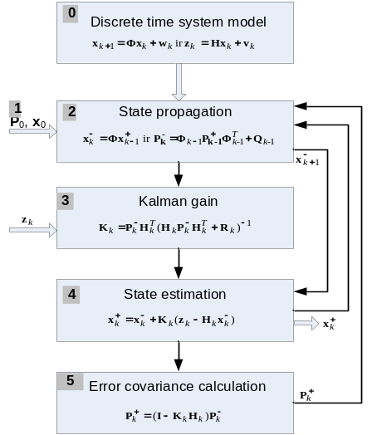
Fig. 1. Algorithm for Kalman Filtering Process

To check the operation of Kalman filter aircraft pitch angle data fusion using measurement data of an accelerometer and gyros sensor are modeled (Fig. 2).
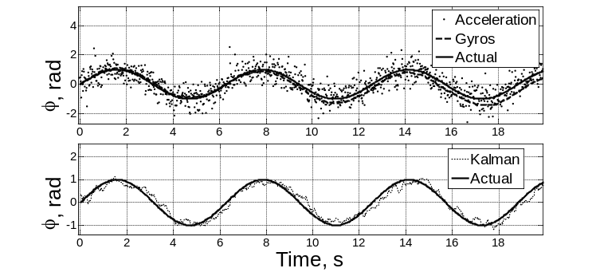
Fig. 2. Pitch estimation using accelerometer and gyros data fusion with Kalman filter

For aircraft pith angle modeling sensor measurement data of accelerometer and gyros were used. The sensor measurement results were influenced only by the white noise that is optimally reduced by the Kalman filter. In the case discussed the measurement system operates without errors of sensors or the system.
In general errors are classified into sensor errors, device errors and process errors.
A network based aircraft operation system with a device operated by a dynamic process, sensors and discrete controllers was designed for error modeling and analysis, the provided system where general equations are (equations (1) and (2)), the general error model is:
$x_{k+1}=\left(Φ+ΔΦ+ΔΦ_{c}\right)x_{k}+\left(B+ΔB+ΔB_{c}\right)u_{k}+E_{1}ω_{k}+Bf_{ak}$ (3)
$z_{k}=\left(H+ΔH+ΔH_{c}\right)x_{k}+\left(D+ΔD+ΔD_{c}\right)u_{k}+E_{2}υ_{k}+f_{sk}+f_{rk}$ (4)

Hereby: $f_{ak}$ are the actuators failures; $f_{sk}$ sensor errors; $f_{rk}$ errors in the communication channel; ∆Φc, ∆Bc, ∆Hc and ∆Dc component error vectors.
One of the main aims of the FDI methods is to generate such residual, which could be insensible to model indeterminacy and external disturbance.
Modeling of three most typical errors – accelerometer measurement data changed by a constant value (Fig. 3 left); measurement data changed by a constant value (Fig. 3 right); measurement data loss in the communication channel (Fig. 3 center).

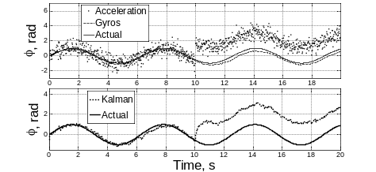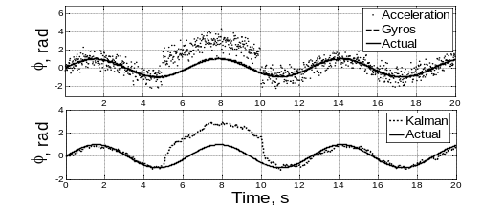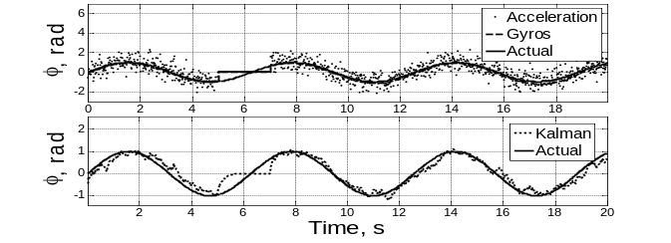
Fig. 3. Modeling of angle of bank with an accelerometer scale error (above left), accelerometer constant deviation error (above right) and accelerometer and gyroscope measurement data loss in the communication channel (center) processing of measurement data with Kalman filter (below) respectively
From the measurement sequence modeling and assessment with a KF it is evident that Kalman filter only performed the measurement data fusion and noise reduction, nevertheless, errors of accelerometer signal changed by a constant value and constant deviation errors were not restored to their previous values. After data processing with KF, it can be seen that at the time of communication channel disturbance the KF cannot recover lost data. Such measurement data distortion can have catastrophic consequences for the aircraft.
The discussed measurement data fusion method is not a valid means to retain data.
In order to avoid unwanted consequences for normal aircraft system operation, the errors mentioned have to be identified and as effectively as possible isolated from having a further impact on the system. To reach this goal error detection, identification and isolation methods have to be applied,.
Further the process of error detection using residual signal analysis will be described in detail.
In general a residual $R_{k}$ is the square difference real sensor measurement $z_{k}$ and its estimate $z_{k}^{+}$ function:
$R_{k}= \sum_{i=1}^{n}{m_{i}{(z_{i}-z_{i}^{+})}^{2}}$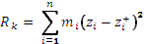 (5)
Hereby $m_{i}$ is the weight coefficient which (according to accumulated experience and knowledge) is described for each error type separately.
Wei and Schwarz presented a detailed Kalman filter strategy, applying it to GPS/INS integration. Edelmayer and Miranda proposed the application of a centralized Kalman filter for systems immune to errors. In the integrated aircraft navigation system, it is proposed to apply a decentralized UKF in a joint form, this way fusing inertial navigation, GPS, Doppler radar or other data.
The advantage of the decentralized system is that it is possible to add more sensors at one time avoiding the loss of general system stability, as the local filters are operating in parallel. Furthermore, in the decentralized system it is easier to detect sensor, device or communication channel errors and isolate them from the system (Fig. 4).

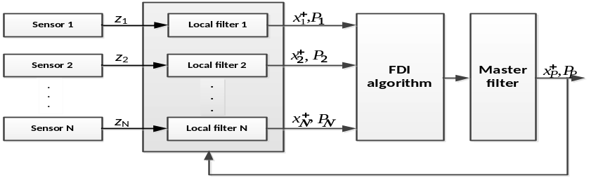
Fig. 4. The structure of the federated filter

In a decentralized FDI system the local filters can be designed using various methods – KF, EKF, UKF or others. Local measurement estimates are transmitted to the main filter, which provides to the system the global estimate:
$x_{P}^{+}= P_{P}\left\{P_{1}^{-1}x_{1}^{+}+P_{2}^{-1}x_{2}^{+}+ ⋯+P_{N}^{-1}x_{N}^{+}\right\}$ (6)
$P_{P}^{-1}= P_{1}^{-1}+P_{2}^{-1}+ ⋯+ P_{N}^{-1}$ (7)
Hereby $x_{i}^{+}$ and $P_{i}$ are local i-th filter estimate and covariation, and $P_{P}^{-1}$ is referred to as information matrix. Global estimate is the sum of local estimates and corresponding weight matrix $P_{i}^{-1}(i=1, 2, … , N)$ and $P_{i}^{-1}$ combination.
The federated filter structure at normal system operation provides more accurate state estimates. Nevertheless, if errors occur in the system, the joint filter structure is disturbed. To solve this problem a federated form FDI algorithm is applied.
Error detection algorithm observes changes in measurement data statistic characteristics.

3. Design and modeling of safety methods for measurement information

This chapter provides measurement information security method design and modeling. The designed measurement information security method is based on measurement information processing methods available in aircraft and their application for measurement information security.
Firs the researched UAV MIS analysis was performed. A small airplane model „Sky Arrow“ (up to 2 kg lifting force) with a code name „AGAI 02“ was chosen. This model has all the equipment needed for a UAV (Fig. 5): an autopilot, sensor unit, telemetry unit, manual control unit and a GPS recipient.
Now the UAV MIS will be analyzed with the focus on information safety (Fig. 5).
The MIS of this aircraft consists of:
- Sensor unit;
- Flight control software;
- Interface units:
- Remote control and telemetry data transmission unit,
- Remote manual control recipient,
- Cable connection to the computer (USB).
In the aircraft information system simple sequential data transmission interface (SPI, RS-232) and impulse width modulated plane and thrust control device control signals are used. All these data transmission methods do not have any security from external disturbance mechanisms. Also used telemetry and manual control systems have no information ciphering schemes. Therefore, such a system needs to take additional measures to ensure measurement information security.

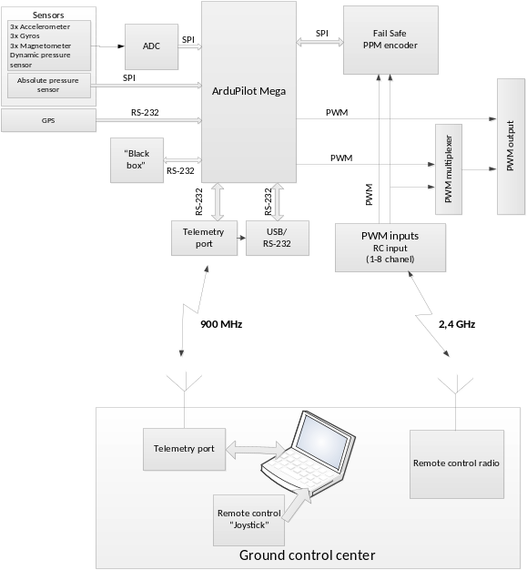
Fig. 5. Structural plan of unmanned aircraft operation system

Afterwards the design of an integrated aircraft diagnostics system measurement information security method will be provided. Available integrated diagnostics systems: designed system models and measurement equations will be applied. The idea for the measurement information security mechanism is the application of available FDI methods for detection and identification of errors that have and impact on measurement information security. To put it differently the solving of this issue is done by designing a specialized filter sensitive to particular types of errors.
A federated configuration filter will be designed for measurement information security. Measurement data of each filter will be filtered by using the Kalman filter (local filter). The estimates of each sensor will be processed with error detection and identification algorithm. The designed filter scheme is provided in (Fig. 6).

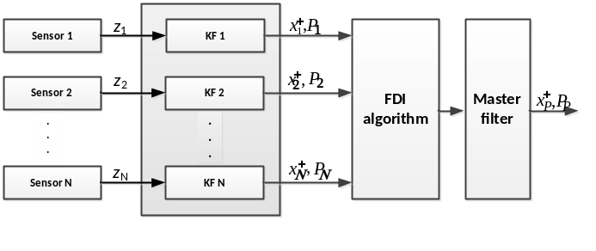
Fig. 6. Scheme of measurement information safety ensuring filter

In the filter scheme local measurement data estimates are found by using a traditional Kalman filter scheme (Fig. 1.), and the main data fusion is made according to equations (6) and (7). This is referred to as a Federated Kalman Filter.
For the system modeling aircraft speed measurements are chosen. Aircraft speed will be measured with two independent sensors v₁ and v₂. Researched error type modeling is done in the aircraft speed measurement system. For the error detection a sensibility factor will be applied:
$S_{i}= {\left(x_{i}^{+}- x_{P}^{+}\right)}^{T}{\left(P_{i}+ P_{P}\right)}^{-1}(x_{i}^{+}-x_{P}^{+})$ (8)
When $S_{i}$ is less than the threshold function limited value, then the i-th sensor is treated as sound, therefore, the sensor outcome can be used for the global estimate $x_{P}^{+}$ and $P_{P}$ calculation. If $S_{i}$ is higher than the threshold function limited value, then it is treated that there has been an fault in the system and the i-th sensor measurement results have to be removed from the global estimate $x_{P}^{+}$ and $P_{P}$ calculations.
Modeling of three sensor measurement data processing with JKF with an error detection and isolation function will be done. The previously described types of errors will be modeled additionally including a forth type of error – measurement data loss of two sensors. Faulty sensor error isolation effectiveness will be measured by calculating the standard deviation before and after error isolation of the joined signal in Fig. 7 below.

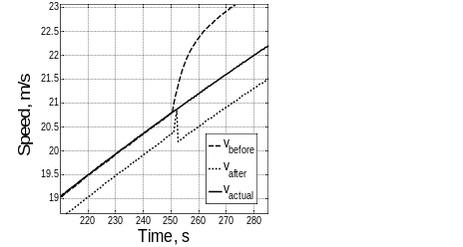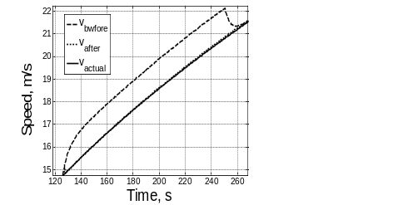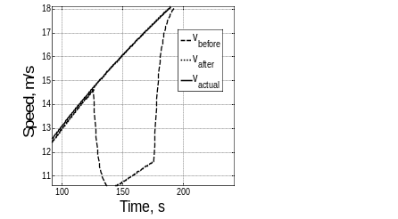
Fig. 7. Results of measurements after the isolation of the faulty sensor

The data on the standard deviation modeling is presented in Table 1

Table 1. Summary of filter efficiency modeling
Type of error | Standard deviation before isolation of error, m/s | Standard deviation after isolation of error, m/s
System without errors | 0,181 | 0,181
Sensor scale error | 0,764 | 0,189
Sensor with constant deviation error | 0,610 | 0,292
One sensor data loss | 1,541 | 0,288
Two sensor data loss | 3,162 | 0,189

The provided modeling results suggest that the occurrence of errors in the MIS has a great impact on general signal characteristics. Analyzing error impact on the standard deviation of the filter outcome, it is evident that the impact of the error, according to the type of error, is from 0,609 m/s up to 3,161 m/s. Error detection and isolation procedure effectiveness is accordingly to the error type from 210 % up to 1681 %, and the restores signal standard deviation in comparison with the system not affected by noise is 3,7 % – 37 %. The efficiency of filter is 63–96,7 %.
4. Experimental research and data analysis

This chapter describes and analyses the experimental analysis of OIDS measurement information data security method application. A few technologies have been chosen for the experiment – “Fly by Wire“ and “Fly by Wireless“. The latter concept for aircraft operation and data transmission among aircraft systems is quite recent and is still in the state of intensive research.
The algorithm for measurement information processing has been investigated by practically performing real flights. During the experiments these flight parameters were measured – aircraft air speed and position in the air space. These flight parameter measurements were executed by using two different aircraft with different equipment:
- Designed wireless sensor network integrated into glider LAK-20T air speed measurement system.
- Radio wave controlled airplane model equipped as a UAV.
The glider speed measurements were chosen for the experiment. MIS is installed in the aircraft speed measurement system (Fig. 8). Aircraft speed measurement system consists of Pitot tube, aircraft speed indicator, two wireless sensors, wireless network sensor coordinator and a laptop with special software.
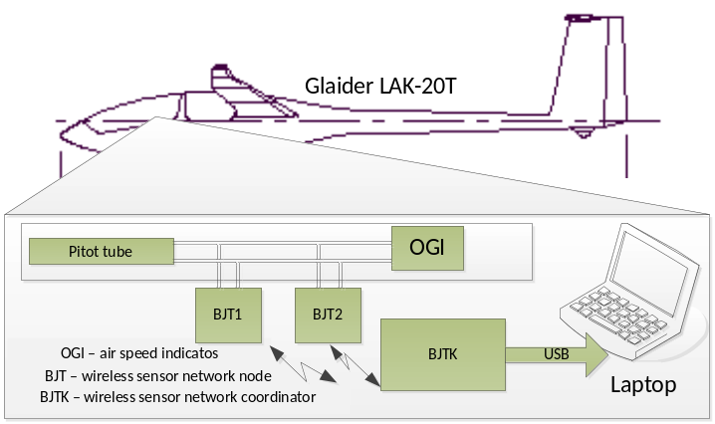
Fig. 8. Deployment of MIS components in aircraft

The maximum measured aircraft speed is up to 300 km/h, therefore a 2 Hz measurement frequency rate was chosen. The results of the measurements and operation of the designed filter are shown in Fig. 9.
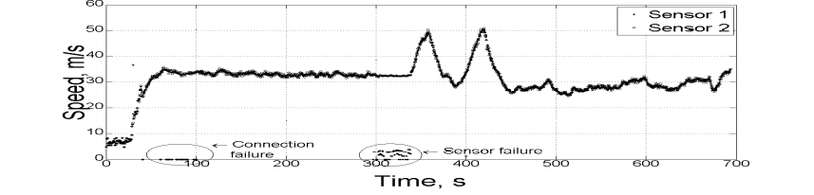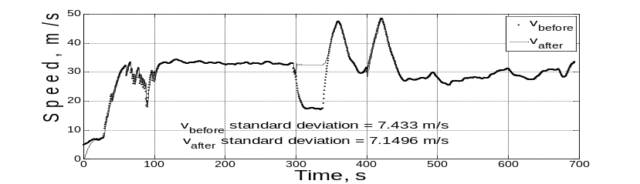

Fig. 9. Speed measurement data collected during glider LAK-20T flight (above) and processing of sensor measurement data with JKF isolating the faulty sensor (below)

Analogical flight parameter measurement experiments were executed with the UAV „AGAI 02“. Three sensors measured aircraft speed – a GPS, aircraft air speed measurement system and a designed wireless sensor network. The sensors were connected to the aircraft air system. The wireless sensor measurement results will be collected in a computer on the ground, GPS and aircraft air speed measurement data in the aircraft flight data recorder. Measurement results and their processing with a JKF are provided in Fig. 10.

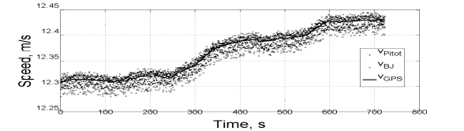
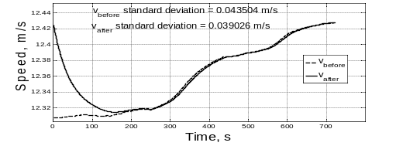
Fig. 10. Aircraft speed measurement information collected in aircraft flight data recorder and wireless sensor (above) and data processing with JKF (below)
After measurement data processing with the JKF with isolation of the faulty sensor, there were the researched errors no longer occurred in the system. The designed filter executed all the measurement data fusion procedure. Standard deviations after data fusion with a JKF without and with sensor error isolation are accordingly 0,043 m/s and 0,039 m/s (difference – 1 %).
The results lead to a conclusion that the designed filter has no negative impact in the overall operation of the system and the accuracy of measurement data processing, and after the occurrence of errors in the MIS the designed error detection, identification and restoring algorithm allows isolating faulty measurements, thus retaining changes of the parameter measurement characteristics.

General conclusions
- While designing an integrated diagnostics system the following five groups of tasks have to be solved:
- diagnostics,
- prognostics,
- condition-based exploitation,
- adaptive control and
- information safety.
- It has been determined that for small UAV‘s considering system reliability, security and limited additional technical device installment possibilities the most appropriate measurement information safety methodology is based on the principle of fault detection and elimination.
- It has been determined that the measurement information transmition safety methodology in UAV integrated diagnostics systems can best be realized by using a recursive filter designed on the basis of Kalman filter.
- Research results show that the suggested methodology successfully solves the task for lost information retaining and recovery in a wireless sensor network when there are at least two data sources.
- It has been determined that the information security system designed on the basis of a federated Kalman filter with an error isolation procedure brings not more than a 4 % useful signal distortion in comparison with a disturbance free system.

List of Published Works on the Topic of the Dissertation

In the reviewed scientific periodical publications

Stankūnas, J.; Rudinskas, D.; Lasauskas, E. 2011. Experimental Research of Wireless Sensor Network Application in Aviation // Electronics and Electrical Engineering – Kaunas: Technologija. No. 5(111). p. 41–44 (Thomson ISI Web of Science).
Rudinskas, D.; Goraj, Z.; Stankūnas, J. 2009. Security analysis of uav radio communication system, Aviation. Vilnius : Technika. ISSN 1648-7788. Vol. 13, no. 4, p. 116–121
Rudinskas, D.; Stankūnas, J. 2009. Analysis of UAV radio communication system. Mokslas – Lietuvos ateitis = Science – future of Lithuania: Transporto inžinerija. Vilnius: Technika. T. 1, nr. 6, p. 125–128. (in Lithuanian). ISSN 2029-2341.

In the other editions

Stankūnas, J., Rudinskas, D. 2010. Wireless technologies to be use for measurement of wing aerodynamic characteristics. Konferencijos „Research and Education in Aircraft Design – READ 2010“ pranešimų medžiaga (kompaktinė plokštelė). Varšuvos technologijos universitetas, Lenkija.
Rudinskas, D. 2008. Šiuolaikinių orlaivių integruotos techninės diagnostikos sistemų kūrimo problemos. AVIACIJOS TECHNOLOGIJOS. 11-osios Lietuvos jaunųjų mokslininkų konferencijos „MOKSLAS–LIETUVOS ATEITIS“, įvykusios Vilniuje 2008 m. balandžio 17 d. Straipsnių rinkinys/ Vilniaus Gedimino technikos universitetas, Vilnius: Technika.
Rudinskas, D., Stankūnas, J. 2008. Analysis of design of integrated health management systems in the small aircrafts. Tarptautinės konferencijos Recent Research and Design Progress in Aeronautical Engineering and its Influence on Education (RRDPAE) įvykusios 2008 m. spalio 17-18 d. Brno technologijos universitete (Institute of Aerospace Engineering) Čekijoje pranešimo medžiaga išleista konferencijos kompaktinėje plokštelėje. ISSN 1425-2104.

About the author

Darius Rudinskas was born on the 2nd of January in 1982 in Rokiskis district, Lebedžiai village.
In 2004 acquired a Bachelor‘s degree in Electronic engineering in the Faculty of Electronics of Vilnius Gediminas Technical University. In 2006 acquired a Master‘s degree in Electronic engineering in the Faculty of Electronics of Vilnius Gediminas Technical University. In the period 2004–2009 worked as a research worker in the public enterprise “State Institute of Information Technology“. In the period 2006–2007 worked in Antanas Gustaitis aviation institute as an aircraft technician – avionic in the Flight training base. Since 2007 and works as assistant in the Department of Aviation Technologies. In the period 2008–2009 worked as the head of the training laboratory of Avionics. In 2007 he was admitted to PhD studies in Measurement engineering. The studies will be finished in 2011.
In 2009 Darius Rudinskas was on an internship in Warsaw University of Technology in the Institute of Aeronautics and Applied Mechanics. Since 2009 has been working as the Director deputy for studies in Antanas Gustaitis Aviation Institute.

Letter of thanks

The author wants to sincerely thank his supervisor Prof Habil Dr Jonas Stankūnas novel scientific advice, comments and suggestions for this dissertation. The author also expresses his greatest thanks to Prof Habil Dr Zdobyslaw Goraj, the Dean of the Institute of Aeronautics and Applied Mechanics of Warsaw University of Technology, for most perfect internship conditions and the possibility to participate in the processes of design and manufacturing of a novel UAV. Lastly great thanks to the staff of Antanas Gustaitis Aviation Institute for conditions provided and continuous support.

BEPILOČIŲ ORLAIVIŲ SKRYDŽIO PARAMETRŲ MATAVIMŲ DUOMENŲ PERDAVIMO SAUGOS METODIKOS SUKŪRIMAS

Tiriamoji problema. Orlaivio sistemų priežiūrai diegiamos integruotos autonominės diagnostikos sistemos, žinomos kaip integruotos transporto priemonės techninės būklės palaikymo sistemos, atliekančios ne tik orlaivio įrenginių, sistemų ar struktūrų stebėseną, bet ir sprendžia jų nepertraukiamo veikimo prognozavimo uždavinius.
Orlaivyje nuolatos atliekami įvairių parametrų (temperatūra, slėgis, vibracija, srautas, greitis, ir kt.) matavimai ir jų apdorojimas. Tokį orlaivį galime laikyti matavimų informacine sistema (MIS). Informacinėse sistemose nuolat susiduriama su informacijos saugumo (patikimumas, vientisumas ir integralumas) užtikrinimo uždavinių sprendimu. Šių uždavinių sprendimui didžiosios orlaivius ir aviacinę įrangą gaminančios kompanijos (Airbus, Boeing, Arinc, Honeywell) atlieka mokslinius tiriamuosius darbus.
Matavimų duomenų saugumui užtikrinti yra taikomi informacijos saugos metodai ir priemonės. Dažniausiai tai yra į ryšio liniją įterptos tam skirtos aparatinės ar programinės priemonės. Šių informacijos saugos priemonių realizavimui reikalingi papildomi aparatiniai ir programiniai sprendimai, kuriuos dėl didelio matavimų duomenų šaltinių skaičiaus dažnai būna sunku įgyvendinti. Taip pat, kaip rodo atlikta informacijos šaltinių apžvalga, geras informacijos saugos sistemas yra brangu įdiegti.
Disertacijoje nepilotuojamas orlaivis analizuojamas kaip informacinė matavimų sistema, kurioje realiu laiku atliekami orlaivio sistemų ir skrydžio parametrų matavimai. Matavimai atliekami sąlygomis, kur veikia natūralus triukšmas ir išoriniai trikdžiai. Trikdžiai yra natūralūs arba sąlygoti žmogaus. Dėl trikdžių galimi matavimų informacijos iškraipymai ar praradimas. Įprastai matavimų informacijos apdorojimui taikomi matavimų informacijos apdorojimo metodai atliekantys triukšmų šalinimo funkcijas.

Darbo aktualumas. Plečiantis aviacijos paslaugų sektoriui, daugėja atliekamų skrydžių skaičius. Kuriami vis sudėtingesni orlaiviai su automatinio valdymo sistemomis, gebančiomis atlikti visus skrydžio etapus (kilimas, skridimas, tūpimas). Greta įprastų orlaivių, kur skrydžiui atlikti reikalingas pilotas, bendrojoje oro erdvėje atsirado bepiločiai (orlaivio valdymas atliekamas iš žemės nuotoliniu būdu) ir autonominiai (skrydis atliekamas autonomiškai pagal iš anksto užduotą programą) orlaiviai.
Pastarųjų metų statistika rodo kompiuteriniams tinklams padidėjusias grėsmes, ypač kompiuterinių tinklų užvaldymo srityje. Reaguojant į šių grėsmių padidėjimą, aviacijoje skiriamas didelis dėmesys orlaiviuose integruojamų sistemų informacijos saugai.

Tyrimų objektas. Orlaivių integruotų diagnostikos sistemų duomenų srautai ir matavimų informacijos apdorojimo metodai.

Darbo tikslas. Sukurti bepiločių orlaivių skrydžio parametrų matavimų duomenų perdavimo saugos metodiką.

Darbo uždaviniai. Darbo tikslui pasiekti darbe reikia spręsti šiuos uždavinius:
- Atlikti bepiločių orlaivių skrydžio parametrų matavimų sistemos ir integruotos diagnostikos sistemų sąsajos apžvalgą
- Atlikti bepiločių orlaivių integruotų techninės diagnostikos sistemų veikimo principo, matavimų rezultatų apdorojimo metodų, taikomų techninių sprendimų analizę.
- Sukurti matavimų informacijos saugaus perdavimo metodiką bepiločio orlaivio integruotoje diagnostikos sistemoje.
- Atlikti sukurtos matavimų informacijos saugos metodikos taikymo eksperimentinius tyrimus bepiločio orlaivio informacinėje sistemoje.

Tyrimų metodika. Darbe naudojami teoriniai ir eksperimentiniai tyrimų metodai.
Teorinių tyrimų dalyje taikomi rekurentiniu Kalmano filtravimo algoritmu grindžiami analitiniai klaidų nustatymo ir identifikavimo metodai.
Eksperimentiniai tyrimai atlikti naudojant suprojektuotą matavimų informacinę sistemą panaudojant bevielių jutiklių tinklą ir sukurtą programinę įrangą. Tyrimai atlikti sklandytuvu „LAK-20“ realaus skrydžio metu ir radijo bangomis valdomu orlaiviu „AGAI 02“ aprūpintu nepilotuojamą skrydį užtikrinančia įranga .

Darbo mokslinis naujumas. Rengiant disertaciją buvo gauti šie matavimų inžinerijos mokslui nauji rezultatai:
- Pasiūlytas matavimo duomenų saugos principas grindžiamas klaidų orlaivio informacinėje sistemoje aptikimo technologija.
- Pasiūlyta orlaivio informacinės sistemos matavimų duomenų saugos metodika grindžiama skirtingų rūšių matavimų rezultatų suliejimu.
- Sukurta metodika nereikalauja papildomos įrangos orlaivio informacinėje sistemoje, tuo prisidėdamas prie sistemos patikimumo ir skrydžių saugos.

Darbo praktinė vertė. Sukurtas orlaivio sistemų klaidų nustatymo bei identifikavimo ir matavimų informacijos saugos metodas tinkamas diegti naujai kuriamose ir jau esamose integruotose diagnostikos sistemose, užtikrinant matavimų informacijos vientisumą.

Ginamieji teiginiai
- Klaidų nustatymu ir identifikavimu pagrįsto metodo taikymas matavimų informacinės sistemos duomenų saugai.
- Matavimų informacijos, esant atsitiktiniams ir neatsitiktiniams trikdžiams, išsaugojimas taikant skirtingų rūšių matavimų duomenis.
- Bepiločio orlaivio matavimų informacinėje sistemoje taikomų matavimų duomenų apdorojimo metodų naudojimas sprendžiant matavimų informacijos saugos uždavinius.
- Kalmano filtravimo metodu paremtas bepiločių orlaivių matavimų informacijos klaidų suradimas ir pašalinimas.

Darbo apimtis. Disertaciją sudaro įvadas, keturi skyriai, rezultatų apibendrinimas, naudotos literatūros ir autoriaus publikacijų disertacijos tema sąrašai ir du priedai.
Darbo apimtis yra 76 puslapiai, neskaitant priedų, tekste panaudotos 33 numeruotos formulės, 48 paveikslai ir 2 lentelės. Rašant disertaciją buvo panaudotas 61 literatūros šaltinis.
Pirmasis skyrius skirtas mokslinės literatūros analizei. Jame nagrinėjami matavimų duomenų apdorojimo bepiločiuose orlaiviuose integruotos diagnostikos sistemos, matavimo duomenų srautai orlaivyje, bei klaidų nustatymo ir identifikavimo metodai
Antrajame skyriuje pateiktas matavimų duomenų apdorojimo metodas grindžiamas Kalmano filtrų taikymu. Atliktas klaidų įtakojančių matavimų informacijos saugai modeliavimas.
Trečiajame skyriuje pateiktas bepiločio orlaivio matavimų informacinės sistemos tyrimas. Sudarytas matavimų apsaugos metodas. Atliktas metodo skaitinis modeliavimas.
Ketvirtajame skyriuje pateiktas siūlomos metodikos eksperimentinis tyrimas.

Bendrosios išvados
- Kuriant bepiločio orlaivio integruotos diagnostikos sistemą būtina spręsti penkias pagrindines uždavinių grupes:
- diagnostikos,
- prognostikos,
- sąlygomis pagrįstos eksploatacijos,
- adaptyvios kontrolės ir
- informacijos apsaugos.
- Nustatyta, kad mažiems bepiločiams orlaiviams tinkama sistemos patikimumo, saugos ir riboto papildomų techninių priemonių diegimo galimybių požiūriu matavimų informacijos saugos metodika paremta klaidų aptikimo ir eliminavimo principu.
- Nustatyta, kad bepiločių orlaivių integruotoje diagnostikos sistemoje matavimų informacijos perdavimo saugos metodiką, optimalu realizuoti panaudojant rekurentinį Kalmano filtro pagrindu sudarytą filtrą.
- Tyrimų rezultate nustatyta, kad siūloma metodika sėkmingai sprendžia prarastos informacijos išsaugojimo ir atstatymo uždavinį bevielių jutiklių tinkle esant ne mažiau dviejų duomenų šaltinių.
- Nustatyta, kad jungtinio Kalmano filtro su klaidų izoliavimo procedūra pagrindu sukurta informacijos saugos sistema įveda ne didesnį nei 4% naudingo signalo iškraipymą lyginant su neveikiama trikdžių sistema.

Trumpos žinios apie autorių

Darius Rudinskas gimė 1982 m. sausio 2 d. Rokiškio raj. Lebedžių km.
2004 m. įgijo elektronikos inžinerijos bakalauro laipsnį Vilniaus Gedimino technikos universiteto Elektronikos fakultete. 2006 m. įgijo elektronikos inžinerijos magistro laipsnį Vilniaus Gedimino technikos universiteto Elektronikos fakultete. 2004–2009 m. dirbo VšĮ „Valstybinis informacinės technologijos institutas“ mokslo darbuotoju. 2006–2007 m. Antano Gustaičio aviacijos instituto Skrydžių praktikų bazės lėktuvų techniku – avioniku. Nuo 2007 m. iki dabar dirba Aviacijos katedros asistentu. 2008–2009 m. Avionikos mokomosios laboratorijos vedėjas. 2007 m. buvo priimtas į matavimų inžinerijos doktorantūros studijas. Studijos baigiamos 2011 m.
Darius Rudinskas 2009 m. stažavosi Varšuvos technologijos universiteto aeronautikos ir taikomosios mechanikos institute. Nuo 2009 m. dirba Antano Gustaičio aviacijos institute direktoriaus pavaduotoju.

Padėkos

Autorius nuoširdžiai dėkoja darbo vadovui prof. habil. Dr. Jonui Stankūnui už originalius mokslinius patarimus, pagalbą bei pastabas ir pasiūlymus rengiant disertaciją. Autorius dėkoja Varšuvos technologijos universiteto aeronautikos ir taikomosios mechanikos instituto dekanui prof. habil. dr. Zdobyslaw Goraj už sudarytas puikias stažuotės sąlygas, galimybę dalyvauti originalaus bepiločio orlaivio projektavimo ir gamybos procesuose. Padėka visam Antano Gustaičio aviacijos instituto kolektyvui už sudarytas sąlygas ir palaikymą.

Darius RUDINSKAS
DESIGN OF AN UNMANNED AERIAL VEHICLE flight parameter data transmission SAFETY method
Summary of Doctoral Dissertation
Technological Sciences, Measurement Engineering (10T)

Darius RUDINSKAS

BEPILOČIŲ ORLAIVIŲ SKRYDŽIO PARAMETRŲ MATAVIMŲ DUOMENŲ perdavimo SAUGOS METODIKOS SUKŪRIMAS
Daktaro disertacijos santrauka
Technologijos mokslai, matavimų inžinerija (10T)

2011 12 29. 1,5 sp. l. Tiražas 70 egz.
Vilniaus Gedimino technikos universiteto
leidykla „Technika“,
Saulėtekio al. 11, 10223 Vilnius,
http://leidykla.vgtu.lt
Spausdino UAB „Ciklonas“
J. Jasinskio g. 15, 01111 Vilnius

