LITHUANIAN UNIVERSITY OF HEALTH SCIENCES
MEDICAL ACADEmy

Solveiga Kelbauskienė

A EVALUATION OF Er,Cr:YSGG
LASER APPLICATION
IN ADDITION TO SCALING AND
ROOT PLANING IN PATIENTS
WITH EARLY – MODERATE PERIODONTITIS

Doctoral Dissertation
Biomedical Sciences,
Odontology (08 B)

Kaunas, 2011
Dissertartion preparation took place in Kaunas University of Medicine and in Medical University of Vienna, Austria during 2005−2010 years.

Scientific Supervisor
Prof. Dr. Vita Mačiulskienė (Lithuanian University of Health Sciences, Medical Academy, Biomedical Sciences, Odontology – 07 B)

CONTENTS

ABBREVIATIONS 5

INTRODUCTION 6

1. AIM OF THE STUDY 8
Originality, novelty and practical importance of the study 8
2. LITERATURE REVIEW 10
2.1. The Melcher Hypothesis: The importance of periodontal
ligament in periodontal healing 10
2.2. Scaling and root planing as traditional treatment of chronic periodontitis 12
2.3. The advent of lasers in periodontal treatment 13
2.4. Studies that used laser as solo modality or as adjunct in the treatment of chronic periodontitis 14
3. MATERIALS AND METHODS 18
3.1.Clinical study 18
3.1.1. Selection of subjects 18
3.1.2. Randomization procedure 19
3.1.3. Study design 19
3.1.4. Scaling and root planing (SRP) 21
3.1.5. Er,Cr:YSGG laser application after SRP (SRP+laser) 21
3.1.6. Clinical measurements and data collection 22
3.2. In vitro study 23
3.2.1. Sudy design in vitro 23
3.2.2. SRP in vitro 23
3.2.3. SRP+laser assisted root surface irradiation in vitro 24
3.2.4. Ctell culture 24
3.2.5. Exposure of teeth specimens to human gingival fibroblasts 24
3.3. Statistical analysis 25
4. RESULTS 26
4.1. A clinical evaluation of different study parameters in response
to periodontal treatment 26
4.1.1. Bleeding on probing 26
4.1.2. Assessment of visible dental plaque level 28
4.1.3. Assessment of gingival recession changes 30
4.1.4. Assessment of probing pocket depth changes 35
4.1.5. Assessment of clinical attachment level changes 41
4.2. Scanning electron microscope (SEM) images examinations 47
4. DISCUSSION 61
5.1. Relevance of the present study in Lithuanian context 61
5.2. The limitations of SRP as a lone modality in the treatment
of chronic periodontitis 62
5.3. The use of lasers in periodontal treatment 63
5.4. Lasers as an adjunctive therapy: improvements in clinical parameters investigated 66
CONCLUSIONS 74
Clinical recommendations 75
REFERENCES 76
APPENDIX 87

DEDICATION 91
ACKNOWLEDGEMENTS 91

ABBREVIATIONS

BOP – bleeding on probing
CAL − clinical attachment level
CI – confidence interval
df – degrees of freedom
EGF-Rs – epidermal growth factors receptors
F – Fisher criterion
GDF – growth differentiation factors
GTR – guided tissue regeneration
LLLT – low level laser therapy
OR – odds ratio
p – level of significance
PDL − periodontal ligament
PHGF − human gingival fibroblasts
PPD − periodontal pocket depth
r – correlation coefficient
ROC curve – receiver operating characteristic curve – graph illustrating relation between classifier sensitivity and specificity
SD – standard deviation
SEM −scanning electron microscope
SRP − scaling root planing
χ² – Chi-square criterion
VPL − visible plaque level

INTRODUCTION

Chronic periodontitis is an inflammation of the supporting tissues of the teeth. It is a painless and gradual progression of attachment loss attended by bone resorption that ultimately leads to tooth mobility and loss [108]. Believed to be initiated by a host’s immunity to a consortium of bacteria rather than by a single microorganism [29], with bacterial plaque gradually accumulating with time causing secondary tissue inflammation known as gingivitis, chronic periodontitis is usually treated by removing subgingival deposits, bacterial biofilm and smear layer [1, 64, 84]. This strategy is aimed at abating, if not eliminating, etiologic agents of the disease, like microbial film and subgingival calculus [29], and restoring periodontal attachment level through the reconnection of periodontal fibers with newly formed cementum [2, 83].
For nonsurgical management of early to moderate chronic periodontitis, scaling and root planing (SRP) remains the traditional initial approach of treatment [12, 13]. Scaling removes plaque, calculus and stain from crown and root surfaces, while root planing entails the complete debridement of cementum or dentin from the root surface for the purpose of smoothing it and displacing calculus [25]. The procedure also extends to adjacent periodontal tissues [1]. Although the positive effects of SRP in chronic periodontitis have been, time and again, validated, i.e., “reduction of clinical inflammation, microbial shifts to a less pathogenic subgingival flora, decreased probing depth, gain of clinical attachment, and less disease progression” [2], this procedure has known drawbacks.
The use of lasers in dental application was first noted in 1964, when ruby laser was first used, unsuccessfully however, on enamel and dentin. There are currently three types of lasers with dental application: gas lasers, such as CO₂; diode lasers, InGaAsP, GaAlAs and GaAs, and; solid-state lasers, e.g., Nd:YAG, Er:YAG and Er,Cr:YSGG [68]. Lasers are designed to ablate or, to vaporize, only the diseased tissue from the inner epithelial lining of a periodontal pocket resulting in a better, more predictable end result to treatment, a process that involves cauterizing blood vessels, nerve endings and lymph glands, providing hemostasis, post operative pain control and rapid healing [24, 68, 82, 89, 126]. Gas and diode lasers are excellent for soft tissue ablation and hemostatic purposes, but often result in carbonization, thermal damage [3, 68, 76, 81, 88] and induced melting when utilized on root surface or alveolar bone [96], limiting their use to soft tissue procedures. As observed by several researchers, neither CO₂, nor diode lasers are effective in removing calculus from the root surfaces [15, 82].
In the present study, comparative therapies were conducted on patients with early to moderate periodontitis. The first therapy was the conventional SRP and the second was SRP with Er,Cr:YSGG laser as adjunct. The study was done for a period of one year and was purposely conducted to engender comparative clinical results between the two modes of therapy.

1. AIM OF THE STUDY

The aim of this study was to assess clinical effectiveness of Er,Cr: YSGG laser application in adjunct to scaling and root planing as compared to scaling and root planing alone, in treatment of patients with early to moderate periodontitis.

The objectives were:

1. To evaluate prevalence of bleeding on probing in patients after scaling and root planing (SRP) and to compare with that in patients treated with Er,Cr:YSGG laser in adjunct to SRP, at different time points after the treatment.
2. To estimate the “visible plaque levels” in patients after the periodontal treatment, and to compare them at different time points during 12 months of follow-up, with respect to the treatment method (scaling and root planing or, Er,Cr:YSGG laser in adjunct to SRP) applied.
3. To compare effectiveness of Er,Cr:YSGG laser application in adjunct to SRP, with that of scaling and root planing alone, in the periodontal pocket depth reduction over 12 months in patients with early to moderate periodontitis.
4. To evaluate development of gingival recession over 12 months in patients after the periodontal treatment, with respect to the treatment method (scaling and root planing or, Er,Cr:YSGG laser in adjunct to SRP) applied.
5. To compare the changes of the clinical attachment level observed during 12 months of follow up in patients subjected to scaling and root planing, or to Er,Cr:YSGG laser application in adjunct to SRP.
6. To describe the appearance of root surfaces and fibroblasts attachment on the root surfaces treated with Er,Cr:YSGG laser in adjunct to scaling and root planing, or with scaling and root planing alone, by means of scanning electron microscope (SEM).

Originality, novelty and practical importance of the study
This study, which has never been done in Lithuania before, is a follow – up to studies published earlier in the world on minimally invasive treatment of periodontitis. Various studies have described conventional scaling and root planing (SRP) as an effective means of treating early to moderate periodontitis. In rapidly increasing numbers, dentists throughout the world are adding lasers to their practices and are using them in the treatment of periodontal disease. Unfortunately, in the field of periodontics only several clinical studies have been reported to the precise effectiveness of dental lasers, and in particular, Er,Cr:YSGG, which can ablate soft tissue by selectively removing only a few cell layers at a time and be used as an adjunct to non-surgical SRP in the treatment of periodontitis [7]. In addition, this is a difficult subject to meta-analyze because there are so many variables. Type of laser, different settings, tips, protocols and angles can significantly alter results.
Consequently there is a great need to develop an evidence – based approach to the use of lasers in the treatment of periodontitis to determine whether or not laser application is superior to conventional periodontal treatment.

2. LITERATURE REVIEW

2.1. The Melcher Hypothesis:

The Importance of PDL in periodontal healing

As far back as 1984, Antony Melcher had already stressed the importance of the periodontal ligament (PDL hereafter) in periodontal healing noting that of the four connective tissues comprising the periodontium, i.e. PDL, cementum, alveolar bone, gingival lamina propia, it is only the PDL that contains all phenotypes of fibroblasts, osteoblasts and cementoblasts [49, 77, 78]. Another way of looking at it, as suggested by other studies, is the existence of a regulatory mechanism that allows PDL fibroblasts to maintain their phenotype as well as differentiate either into cementoblasts or osteoblasts. Choo (1995) conducted an experiment to prove that the presence of epidermal growth factors receptors (EGF-Rs) maintains the undifferentiated state of PDL fibroblasts and their shedding signals the initiation of PDL fibroblast differentiation into either cementoblast or osteoblast. The result of his experiment sustained his hypothesis that the presence of the EGF-Rs in PDL fibroblasts stabilizes this state of the PDL preventing them from differentiating [26].
As a connective tissue, the PDL is characterized by its constant mitosis and high metabolic activity that allows it to constantly adjust itself, width and integrity, to new teeth positions in the jaw caused by various stimuli like trauma from periodontal treatment. The bottom line is that only the PDL has the mechanism to secrete cementum, under certain physiological conditions, that will attach collagen fibers of either PDL or lamina propia to the tooth. It is therefore, crucial in periodontal healing because it has the ability to restore not only the anatomical but also the functional aspects of the periodontal site to its previous state before the onset of periodontitis and any subsequent iatrogenic intervention [78].
Cementum plays a significant role in periodontal regeneration and its formation and synthesis are actually two of the main goals of regenerative periodontal therapy. Periodontal diseases necessarily damage the integrity and composition of cementum because of the presence of toxic bacteria and diseased cementum is removed during periodontal treatment. Without it, there will be failure of collagen fiber attachment. Cementoblasts precede cementum formation and despite various studies and hypothesis on the subject, there is no clear and conclusive information about it. Nevertheless, it is known that cementogenesis is induced by the presence of dental follicle cells during tooth development. It is also widely believed, as earlier discussed, that PDL is one source of cementum progenitor cells. This was sought to be proven by the culture of PDL, which produced cell clones that exhibited “cementum-like mineralized nodules” as well as “cementum-specific markers.” Nonetheless, the problem of identifying the molecules used in the recruitment and differentiation of the cells has not yet been resolved [51].
The colonization of the periodontal site concerned by tissues other than the PDL will result in a kind of healing without restitution of its original form and therefore, its original function. The most common kind of healing in periodontal tissue is epithelialization, which results in the repair of the tissue but not regeneration [71, 100]. Melcher (1985) proposed that to ensure the appropriate periodontal healing, the epithelial cells must be precluded from colonizing the periodontal wound to prevent them from populating periodontal wounds. At that time, Melcher suggested demineralization of the root surface to reveal “the collagen fibers of the organic matrix of the tooth” and initiate interdigitation with newly-deposited collagen fibers of the PDL or lamina propria in the site skipping the need for cementoblasts and their precursors. This would constitute an artificial imposition of directionality in the migration of collagen fibers from birth site to the root surface [78, 79].
The characteristic faster migration of epithelial cells to the periodontal site than mesenchymal tissues often posed hindrance to appropriate periodontal healing. With this concept in mind, the trend in periodontal treatment and healing centers on ways in which PDL can be regenerated and at the same inhibit the migration of epithelial cells from the periodontal site. Various techniques like Guided Tissue Regeneration (GTR) and Growth and Differentiation Factors (GDF) have been recently employed by periodontists and practitioners to ensure the migration of PDL to periodontal sites ahead and/or to the exclusion of epithelial cells. These techniques have been found, however, to be insufficient because they cannot absolutely guarantee appropriate results [22, 25]. GTR, for example, is considered to have erratic results because of the possibility of postoperative infection and its inability to totally close periodontal wounds. On the other hand, GDF cannot guarantee the regeneration of new cementum because of the present lack of accurate knowledge in the precise progenitor cells that need to be stimulated, their stability in the wound area and the length or precise time of their modulation. Periodontal tissue engineering is also being studied taking into consideration three basic components: appropriate signals, guide and stimulate cells to differentiate for the purpose of developing tissues; cells, which are the provider of new tissue-growth and regeneration, and; scaffolds, which form a template structure to guide and facilitate the processes of cell stimulation and regeneration [17].
One of the ideas floated by Melcher back in the 1980s is the notion that the three types of cells populating the PDL may have been originated from a single progenitor or stem cell. Albeit there is no direct link to prove this hypothesis, the fact that periodontal regeneration occurs, which includes “morphogenesis, cytodifferentiation, extracellular matrix production and mineralization,” may give credence to the claim [14, 57, 59, 79, 111]. Recently, a breakthrough in periodontal engineering was made when Benatti et al (2007) were able to isolate PDL (or PDLSCs) in humans [17]. The PDLSCs exhibited the same characteristics for generation as bone marrow stromal stem cells when placed under the same conditions for growth. However, albeit PDLCs, which are postnatal stem cells, have high cloning rates they have limited life span unlike the embryonic stem cells, which are immortal. The implication of this breakthroughs and new-found knowledge relative to the molecular processes of repair and regeneration in periodontics is the development of pertinent tissue engineering that could make possible the replacement of damaged periodontal tissues with fabricated new tissues [14, 52, 61, 107, 110, 111]. This is an area that has potential and promise, and needs further studies.

2.2. Scaling and root planing as traditional treatment

of chronic periodontitis

Various studies have pointed to the conventional procedure of SRP as an effective means of treating early-to-moderate periodontitis, which involves an approximate loss of clinical attachment level (CAL) of at least 5 mm [11]. These studies have proven that root planing alone can diminish periodontal pocket depth (PPD), gain CAL and lessen, if not stop, disease progression. Cobb (1996), for example, conducted a study on the impact of root planing on PPD reduction and on the basis of his findings, determined that root planing reduces PPD by 1.29 mm for sites that had initially 4 to 6 mm in depth and 2.16 mm in sites with 7 mm or greater depth. On the other hand, he calculated the CAL gained on the same sites as 0.55 mm and 1.29 mm, respectively. Cobb’s study showed that PPD reduction was greater in sites with bigger initial depths while CAL gain was expectedly half of the PPD reduction [50].

2.3. The advent of lasers in periodontal treatment

Pending the decisive results of more extensive studies of uses of the PDLSCs in ex vivo periodontal treatment, periodontists and general practitioners are investigating the precise positive effects of using state-of-the-art laser systems in the treatment of chronic periodontitis, either as a solo modality or as an adjunct to conventional treatment. Although lasers were already in existence at the time Melcher crafted his theory, it was only in the 1990s that lasers capable of “flexible-fiber optic delivery system” allowing site-specific perio without thermal effect on teeth structure were introduced [76].
The Erbium family of lasers, i.e, Er:YAG and Er,Cr:YSGG, is a relatively new technology in periodontal treatment having been introduced only in 1990 [28]. Its advent, however, specifically the Er,Cr:YSGG, is significant to periodontists and general practitioners because of its versatility. The Er,Cr:YSGG laser is able to cut through both soft and hard tissues like dentin, enamel and bone, which all play vital roles in periodontics. In addition, this type of laser is reportedly beneficial to patients’ comfort because of lesser trauma and post-operative complications that ensue with their use. Another laser but of the same family, the Er:YAG has similar uses, but has limited coagulative capabilities and is observed to have lesser efficient energy delivery at the surface of the tissue. The Er,Cr:YSGG works by ablating soft tissue layers one at a time unlike the Nd:YAG laser, which penetrates considerably soft tissues all at once. This makes the Er,Cr:YSGG particularly useful in site-specific perio because it allows a periodontist to selectively control tissue interfaces and handle cellular kinetics effectively [42, 120].
Unfortunately, however, not much work had been devoted to the precise effectiveness of lasers in general, and more so of Er,Cr:YSGG, as an adjunct to non-surgical SRP in the treatment of periodontitis. Karlsson et al (2008), for example, was able to retrieve only 25 abstracts, including four randomized controlled clinical trials, which dealt with the effect of lasers (of different type) as an adjunctive therapy published between 1966 and 2008 in PubMed and the Cochrane Central Registry of Controlled Trials [63]. These studies, however, had inadequate number of sample sizes that hindered the generation of acceptable statistical accuracy since a full-size study would require at least 60 subjects with 0.06 mm as the common standard deviation, defining a ± error as 0.05 and a power level of 90%. In addition, they were difficult to subject to meta-analysis because of their fragmented data entries like lack of clinical and radiographic data in relation to chronic periodontitis diagnosis [63].

2.4. Studies that used laser as solo modality or as adjunct in the treatment of chronic periodontitis

With the advent of lasers, research groups began conducting studies that sought to gauge the effectiveness of laser alone in the treatment of chronic periodontitis or comparative studies between SRP and laser treatments, SRP+laser and SRP alone, SRP+laser and laser alone, laser and other modalities aside from SRP, and SRP+laser and other modalities.
Studies concerning the effectiveness of laser in the treatment of chronic periodontitis either as a lone modality or as an adjunctive therapy show discordant findings [6, 48]. As a lone modality in chronic periodontitis treatment, most agreed that laser treatment is effective, but its comparative extent is not a settled issue [7, 16, 27, 31, 101, 121]. Schwarz et al (2001) observed that the use of Er:YAG laser in vivo is effective in calculus removal after the group subjected 80 periodontally diseased teeth surfaces to laser treatment [102]. Several studies observed that a significant PPD reduction and CAL gain were achieved after conducting subgingival debridement procedures employing an Er:YAG laser, leading them to suggest that the use of Er:YAG laser could be considered as a meaningful alternative to hand instruments in the treatment of periodontitis [41, 44, 46, 102, 123]. This observation was shared by Crespi et al (2005) who, after a study of thirty diseased teeth subjected to either SRP or SRP+laser and laser alone, concluded that subject to appropriate parameters, an Er:YAG laser may be used solely as root instrumentation, with positive results, without previous root planing [33].
In 2008, Lopes et al compared treatments using SRP+laser, laser only, SRP only and no treatment using 21 patients with pockets from 5 mm to 9 mm for a period of 30 days. The timepoints for clinical parameters plaque index (PI), GI, BOP were at baseline, 12 and 30 days postoperatively while PPD, GR and CAL were examined at baseline and 30 days thereafter. The study revealed that only in the case of SRP treatment was there a significant decrease in CAL value from baseline to the 30 days timepoint. This led the group to conclude that although laser is effective as an adjunctive therapy to SRP, SRP alone can be more effective in improving CAL [73].
In the succeeding study similar to what the group conducted in 2008, but with a longer period, Lopes and colleagues (2010) diverged a little when it concluded that a laser treatment as a solo modality may validly substitute an SRP treatment in chronic periodontitis. In this study, the group compared Er:YAG laser treatment as an adjunct to SRP and as a solo treatment modality, among others, in chronic periodontitis over a period of 12 months. The results were: gingival index (GI) decreased in “SRP+laser” modality and increased in “laser” modality; bleeding on probing (BOP) and PPD decreased for both treatment modalities, and CAL gain was likewise significant for both. Lopes et al concluded that Er:YAG treatment may be used as an alternative treatment, rather than just an adjunct, in chronic periodontitis [74]. It seems that the implication in the two studies is that Lopes et al are not really impressed with an SRP+laser combination treatment modality, but prefer the solo modalities of either SRP or laser.
The previous observations do not resonate, however, with the findings of Aykol et al (2011), who found that the employment of low level laser therapy (LLLT) as an adjunct to non-surgical treatment yielded better results compared to treatment employing only non-surgical modality. In this study, the test group (LLLT) consisted of 18 patients of mixed smokers and non-smokers while the control group also consisted of 18 patients of mixed smokers and non-smokers, which received only non-surgical therapy. All were suffering from moderate to advanced chronic periodontitis. With PPD, CAL and sulcus bleeding index (SBI) as clinical parameters, among others, the group concluded that the PPD, CAL and SBI levels of LLLT significantly improved especially in smoking patients and overall, promotes better healing than in the control group. Greater reduction in PPD is observed at all timepoints (1, 3 and 6 months) for those with moderate and deep pockets at baseline in the LLLT group [10].
Similarly, Qadri et al (2010) concluded after a study that took about three months involving thirty patients with periodontal inflammation that SRP+laser resulted in better clinical signs that those treated with SRP alone. The test group of SRP+laser had sustained clinical gains than that of the control group of SRP alone. This study, however, was of a short-term nature. Similar results the same group of researches got in another, but the long-term study. Qadri et al (2010) postulated that the rationale for this was the partial removal of epithelial lining that was effective by the use of laser [90].
Schwarz, in combination with various researchers, conducted several studies involving lasers as treatment modality for chronic periodontitis. In most of these studies conducted, Schwarz et al concluded the superiority of laser as a solo modality over SRP in the treatment of chronic periodontitis. In another study, however, the group of Schwarz and Sculean (2004) compared laser treatment with ultrasonic scaling as mono-therapies and found that there were no significant statistical differences between the modes at all timepoints [103, 106]. In a follow-up study to the 2001 study, Schwarz et al (2003) expanded the timepoint to two years. The clinical parameters were PI, GI, BOP, PPD, gingival recession (GR) and CAL. The results reflected the earlier findings where laser treatment yielded a higher improvement in CAL at both 1 and 2 years than in the SRP treatment. The study concluded that CAL gain can be sustained at two years, with no significant statistical differences between the first and second years for both groups [104].
Several groups of researchers also conducted reviews of published clinical studies of other researchers in the treatment of chronic periodontitis using laser as a solo modality or as adjunct to another mode of treatment.
In 2005, Schwarz and Becker from Heinrich Heine University in Germany published a review paper on the potential of Er:YAG laser in the treatment of periodontitis and peri-implantitis. The two reviewed the findings of several controlled clinical trials and case report studies where Er:YAG was used as a sole treatment modality in periodontitis. Among the observed advantages offered by the use of Er:YAG laser in calculus removal is the absence of thermal effects like carbonization on root surfaces as well as the absence of smear layer, detected in hand instrumentation or ultrasonic debridement, which can inhibit periodontal tissue and attachment [65, 124]. The trials and studies reviewed showed that there were significant improvements in PPD reduction and in another, treatment of moderate to advanced periodontitis with Er:YAG resulted in superior CAL gain improvement at deeper pocket of >7 than that of treatment using hand instruments [99].
On the other hand, Slot et al. (2009) pored over articles in the databases of MEDLINE/PubMed and the Cochrane Central Register of Controlled Trials, confining their research to those published prior to May 2008. The group found eight relevant articles in the aforesaid databases that met all previously set criteria, which included the use of Nd:YAG laser either as an adjunct to SRP therapy or as single treatment modality and the use of variables such as bleeding, plaque, gingivitis, PPD, CAL, and gingival recession as clinical parameters. The group reached the conclusion that the use of lasers as a lone modality in the treatment of chronic periodontitis is effective especially in plaque removal and periodontal inflammation reduction, but downplayed the superiority of SRP+laser treatment over traditional SRP in the treatment of chronic periodontitis as unproven by adequate clinical evidence [113, 114].
This study was built over an earlier study conducted by Karlsson et al (2008) that used a similar method of research without, however, confining its search to Nd:YAG lasers, but included other lasers as well. This earlier study also sought to compare treatments employing SRP+laser and SRP alone. Using 25 abstracts that used patients 19 years and older and with follow-up periods of more than 12 weeks, the group concluded that there was an absence of consistent evidence that SRP+laser was effective as treatment to chronic periodontitis [63].
A review of clinical studies published in various electronic databases and other relevant references was likewise conducted by de Paula et al (2010) to determine the effect of laser phototherapy (LPT) or low-power lasers in the treatment of periodontal diseases as well as herpex simplex virus [38].
It was observed, among others, that the Er:YAG laser with 2940 nm, and at a dose of 3.37 J/cm² at single exposure can increase human gingival fibroblasts, thus, aiding in periodontal healing but at lower or higher doses, the laser has no effect on the fibroblasts. In addition, the Er:YAG laser has also been noted to be very useful in the management of dental sensitivity often instigated by periodontal diseases or following non-presumably the Er,Cr:YSGG, act on the tooth surface by increasing its temperature and recrystallizing it and instigating the partial or complete closure of dentinal tubules, which caused the sensitivity [9, 37].
Our study was performed, because there is a limited number of works in the whole world, that actually investigate the clinical effects of Er,Cr: YSGG laser as an adjunct to SRP in the treatment of early to moderate periodontitis.

3. MATERIALS AND METHODS

The study consisted of two parts: in vivo clinical study and in vitro study.

3.1. Clinical study

Clinical study of periodontal response to laser application, in addition to scaling and root planing was conducted at Clinic of Dental and Oral Pathology, Kaunas University of Medicine, during the period from March 2006 to March 2008.
The study protocol was approved by the Ethical Committee of Kaunas University of Medicine, Lithuania (protocol Nr. 135/2006).

3.1.1. Selection of subjects

The study subjects were selected from the patients applying for periodontal treatment at Clinic of Dental and Oral Pathology, Kaunas University of Medicine. Patients were screened using a questionnaire that included a detailed medical history and questions about recent antibiotics use, smoking, family history of diabetes and autoimmune diseases. Patient’s selection was based on the signed informed consent forms, and according to the following criteria:
- No periodontal treatment received within the last 12 months
- No systemic diseases, that could potentially influence the outcome of the therapy (diabetes, immune deficiencies, cancer, haemorragic disorders, epilepsy etc)
- No use of systemic antibiotics at least 6 months prior to, during and 12
months after the treatment
- Non smokers
- No pregnancy

Thus, a total of 30 patients with the diagnosis of early to moderate periodontitis, between 26 and 58 years of age (16 men, 14 women) were included in the study.

3.1.2. Randomization procedure

Random selection was used to determine which side of the mouth had to be treated by scaling root planing (SRP), and which by laser in addition to scaling and root planing (SRP+laser). A total of thirty (30) cards, fifteen (15) marked as Protocol A and fifteen (15) marked as Protocol B, were provided in the envelope. Protocol A was used to determine which quadrant had to be treated by SRP, Protocol B – by SRP+laser. Prior the treatment, the clinician randomly pulled a card from the envelope. The selected card determined which side of the mouth had to be treated as a test group, and which side as a control group. Clinician recorded which protocol was used on the case report forms, and discarded the card after the instrumentation had been completed.

3.1.3. Study design

The study group comprised 30 patients. Their ages ranged from 26 to 58 years. Only 4.5% of all the patients mentioned receiving regular professional tooth cleaning according to their individual needs. The study was performed according to a split-mouth design, on single-rooted teeth (lower or upper incisors and canines, upper second premolars, lower first and second premolars). No difference was found in percentage distribution of treated teeth between upper jaw and lower jaw (x² =3.5; df=17; p=1.0).
A total of 278 teeth (123 in the maxilla and 155 in the mandible) exhibiting gingival inflammation with positive bleeding on probing (BOP), subgingival calculus and a PPD (periodontal pocket depth) more than 3 mm on at least one site of the tooth were selected for examination. Of the total of 1668 sites examined, 1088 sites exhibited the periodontal pocket depth more than 3 mm (range: >3 mm to 6 mm). A detailed description of the study material is presented in Fig. 3.3.1.

30 patients with early to moderate periodontitis

278 single-rooted teeth,
mean 9.3 SD 2.0 teeth per patient.
A total of 1668 examined sites, mean 55.6 SD12.6 per patient
1088 sites included
in analysis,
with PPD>3 mm
„SRP“ quadrants
143 teeth,
mean 8.4 SD1.3 teeth per patient.
A total of 810 sites,
mean 50.6 SD7.6
per patient
“SRP+laser“ quadrants
135 teeth,
mean 9.5 SD2.2 teeth
per patient.
A total of 858 sites,
mean 57.1 SD12.9
per patient
509 sites, of those:
251 vestibular and
258 lingual
579 sites, of those:
293 vestibular and
286 lingual

Fig. 3.1.3.1. Description of study material

Two types of treatment were performed for the study participants:
1. Conventional scaling and root planing (SRP) – ‘control’quadrants (Protocol A).
2. Er,Cr;YSGG laser application, in addition to conventional scaling and root planing (SRP+ laser) – ‘test’quadrants. (Protocol B).
Every participant received both types of treatment using different mouth quadrants, for at least, two quadrants. On one side, the teeth were treated by scaling and root planing only (control method, SRP), whereas the teeth of the contra-lateral side were treated by Er,Cr:YSGG laser immediately after SRP (test method, SRP+laser). Selection of the mouth quadrants to be treated with either test, or control method, was performed randomly. The selected treatment protocols were coded in the patients’ case descriptions, in order to prevent biased measurements of the treatment outcomes. Two weeks prior to treatment, all patients were scheduled for oral hygiene instructions as well as for professional supra-gingival tooth cleaning according to individual needs. The same oral hygiene procedures were performed after 3 and 6 months. The baseline recordings of the clinical parameters and the following treatment procedures were performed by a periodontist (SK), who was unaware of the quadrants’ allocation to be treated by the test method or by the control method. The clinical parameters of periodontal status 2, 3, 6 and 12 months after the treatment were measured by another examiner (IK), who didn’t know what quadrant was treated by SRP alone or, by SRP+laser. The probing measurements were taken after the recording of plaque and of the bleeding scores.
All periodontal treatment procedures were performed under standardized conditions by the same operator (SK).
For all patients, in the control quadrants SRP was performed immediately after the baseline examination, and subsequently, supra gingival scaling and polishing was repeated 3 and 6 months after the initial treatment.
In the test quadrants SRP+laser was performed immediately after the baseline examination. Only supra-gingival scaling and polishing was repeated 3 and 6 months after the initial treatment.

3.1.4. Scaling and root planing

Scaling and root planing (SRP): subgingival instrumentation of the root surfaces was performed using an ultrasonic scaler (Satelec, Acteon, Switzerland) with a sharp-pointed tip. The ultrasonic scaler was conducted by contacting the probe obliquely to the root surface at an angle of approximately 15 degrees and moving the tip in a sweeping motion. The instrumentation was accomplished using Gracey curettes (American Eagle, USA, 5/6). The procedure was finished until the operator felt that the root surfaces were adequately scaled and planed. Approximately 8 strokes were done using gracey currete to remove the residual calculus and to plane the root surfaces.

3.1.5. Er,Cr:YSGG laser application after SRP (SRP+laser)

Er,Cr:YSGG laser application after SRP (SRP+laser): an Er,Cr: YSGG laser device (Waterlase, Biolase, USA) was used in this study. This laser system emits photons at a wavelength of 2.78 µm and has a pulse duration of 140 to 200 µs with the repetition rate of 20 Hz. The average power output can vary from 0 to 6 W (300 mJ/pulse). The delivery system consisted of a fiber-optic tube terminating in a handpiece with a tip bathed in an adjustable air-water spray. A Z-6 series tip of 600 µm in diameter and 9 mm in length, was used to remove the inner epithelial lining (the epithelium inside the periodontal pocket) to the depth of the pocket, and 5 mm of the outer epithelium (oral epithelium near the free gingival margin). This technique allows cells that arise from periodontal ligament and the bone, to repopulate the root surface, while excluding epithelial and gingival cells from the initial wound healing. A 9 mm Z-6 tip marked to the depth of the pocket was used at a setting of 1W, 10% air and 15% water. The treatment was performed from coronal to apical paths parallel to the long axis to the root surfaces. To condition the root surface the laser tip was angled 5–15 degrees toward the root and moved up and down until the root surface was left with an acid-etched appearance. The same procedure was performed once a week for each mm of pocket reduction desired to obtain normal probing depth of 3 mm or less. This required an average of 3 appointments.
At subsequent visits, inner epithelium to the depth of the pocket (1 mm less than at the previous appointment) and 5 mm of the outer epithelium was removed.

3.1.6. Clinical measurements and data collection

The following parameters were recorded before the treatment and 2, 3, 6, 12 months after the treatment: plaque index (PI), bleeding on probing (BOP), gingival recession (GR), periodontal pocket depth (PPD) and clinical attachment level (CAL).
Plaque index was assessed for every tooth examined using the following scale modified from Silness & Löe: 0 – no plaque; 1 – plaque detected by probe only; 2 – visible, average amount of plaque; 3 – a lot of visible plaque near the gingival margin and into the pocket [72]. Plaque distribution was evaluated at a tooth level and was determined by percentages of teeth with different scores recorded. Score 0 and score 1 were added together and were defined as “no plaque”, score 2 and score 3 were added together and defined as “visible plaque level”. Plaques levels were estimated in percentages of teeth presenting scores with “visible plaque level” (VPL).
Bleeding on probing was assessed simultaneously to the periodontal pocket measurements, and the absence or presence of bleeding up to 30 seconds after probing was recorded. Gingival recession (GR) was measured from the CEJ (cemento−enamel junction) to the gingival margin. Periodontal pocket depth (PPD) was measured from the gingival margin to the depth of the pocket. Clinical attachment level (CAL) was measured from the CEJ to the bottom of the probable sulcus. The measurements were made at six sites per tooth: mesio-vestibular (mv), mid-vestibular (v), disto-vestibular (dv), mesio-lingual (ml), mid-lingual (l), disto-lingual (dl) using a manual periodontal probe (PCP 12, Hu-Friedy).

3.2. In vitro study

In vitro study of periodontally involved extracted human teeth was conducted at Department of Conservative Dentistry, Bernhard Gottlieb University Clinic of Dentistry, Medical University of Vienna, during the period from January 2009 to April 2009. The purpose of the present in vitro study was to show the effects of Er,Cr:YSGG laser on periodontally involved root surfaces using SEM observations.

3.2.1. Study design in vitro

Ten human teeth, which had been extracted for periodontal reasons, were used in vitro study. None of the samples had carious lesions, fillings, fractures or root canals treatment. The samples were kept in 0.9% saline solution until the time of instrumentation. A total of 20 root slices were obtained from the selected teeth and were divided into following two groups:
1. Conventional scaling and root planing (SRP) – ‘control’ group.
2. Er,Cr;YSGG laser application, in addition to conventional scaling and root planing (SRP+ laser) – ‘test’ group
Crown and apical part of each tooth were removed and cementum plates were prepared. The right side of the root was prepared for SRP and the left side for SRP+laser instrumentation.

3.2.2. SRP in vitro

SRP on periodontally diseased root surfaces was performed by one examiner using an ultrasonic scaler (Satelec, Acteon, Switzerland). Gracey curret (American Eagle, USA, 5/6 ) was used to remove calculus and diseased cementum layer. The procedure was finished until the operator felt that the root surfaces were adequately scaled and planed. Approximately 8 strokes were done by using gracey currete handling the instrument in the appropriate position, as we used in the clinical study.

3.2.3. SRP+ laser assisted root surface irradiation in vitro

In this group, after conventional SRP, specimens were irradiated by the Er,Cr:YSGG laser. Lasing procedure was conducted with non-contact mode, 1 mm away from the root surface with 20 degree angulations. The choice of laser irradiation parameters in this part of the study was based on our previous clinical study, where we used following settings (1 W, 10% air, 15% water). The procedure was performed with vertical movements from the cemento-enamel junction towards the apex. Every root slice was irradiated 20 seconds. After the instrumentation, specimens were thoroughly rinsed 2 times with distilled water for 60 seconds. In order to evaluate changes of the root surfaces and the adhesion of fibroblasts, 20 fragments (5×5 mm) were prepared, 1 mm apically from cemento−enamel junction. A total of 20 fragments were autoclaved before the cell culture experiment.

3.2.4. Cell culture

Human gingival fibroblasts (PHGF) were cultivated in 175 cm² flasks (Sarstedt, NC, USA) in Dulbecco´s Modified Eagle Medium (DMEM, Sigma, Germany) supplemented with 10% fetal calf serum (PAA Laboratories, Pasching, Austria), 100 U/ml penicillin, 100 mg/ml streptomycin and 2,9 mg/ml glutamine (Invitrogen, Paisley, UK) at 37°C in a fully humidified air atmosphere containing 5% CO_{2.} PHGF were removed from culture flasks by brief incubation in 2,5 % trypsin (Invitrogen).

3.2.5. Exposure of teeth specimens to human gingival fibroblasts

Root fragments were applied in six-well culture plates (Corning, NY, USA) and covered with a cell suspension (5 ml aliquots, containing 5×10⁴ PHGF ml^{–1}) for 24 h at 37°C/5% CO₂. Afterwards supernatant was discarded and fragments were fixed with 4% paraformaldehyde for 30 min, rinsed two times with phosphate-buffered saline with Ca²⁺ and Mg²⁺ (PBS) and covered with PBS until evaluation. Each fragment was photographed at different magnification with scanning electron microscope (SEM) (XL 30, Philips, Eindhoven, Netherlands). SEM analysis was performed to evaluate the surface morphology and attachment of fibroblasts on each root fragment.

3.3. STATISTICAL ANALYSIS

The Statistical Package for Social Sciences program (SPSS 13.0, Chicago III, USA) was used for the data analysis. Statistical significance of difference in proportion was tested by Chi- square test. Differences between dichotomous variables were tested using the McNeamar test. The mean values and standard deviations of the clinical parameters were calculated. Every continuous data set was tested for normality with Kolmogorov-Smirnov test.
Statistical testing between the groups (SRP and SRP+laser) for differences of GR, PDD, CAL was performed using Student’s t test. For the data that were not normally distributed, Mann-Whitney U test was applied. For testing the measurements of dependent variables, the paired t test for the continuous data, and Wilcoxon’s test for the ordinal data were used.
ROC (Receiver Operating Characteristic) test was used to determine the critical value of PPD and CAL. Binary regression analysis was used to test relationship for PPD and CAL gain. Reasonably reject incorrectly hypothesis we estimated the power of the study. P-values less than 0.05 were considered as statistically significant
Calculating the size of the sample, we made an assumption that using SRP+laser treatment method 12 months after the instrumentation we would achieve a 1.3 mm CAL gain, while in SRP-treated quadrants mean change value of CAL gain would be – 1.0 mm, if the standard deviation is 1.0 mm and the first type of error 0.05. Taking this into consideration, we assumed, if the sample size was 1000 tooth surfaces, we would get the power of the study 0.9 with 0.1 second type of error. 12 months after the instrumentation SRP+laser treated quadrants showed 1.68 mm gain of CAL, while SRP- treated quadrants – 0.84 mm. Sample’s standard deviation – 1.37 mm, power of the study >0.9, second type error <0.1, when the first type of error 0.01.
Inter-examiner and intra-examiner reproducibility testing: four patients, everyone presenting two pairs of contra-lateral teeth with the probing depth ≥4 mm on at least one site of the tooth, were examined twice, with an interval of 48 hours to calibrate GR and PPD. Variation between the repeated measurements not exceeding 1 mm was accepted.
Reproducibility testing was performed using a manual periodontal probe (PCP 12, Hu-Friedy). The percentages of inter-examiner and intra-examiner agreements were 93, 8% and 90%, respectively.

4. RESULTS

The study group comprised 30 patients (16 men and 14 women) with a mean age of 39.3 (range 26–58 years). The age was not significantly different between men and women (p=0.9).

4.1. A clinical evaluation of different study parameters in response

to periodontal treatment

4.1.1. Bleeding on probing

In the clinical study group (30 patients), at baseline 79.6% of all the examined teeth exhibited bleeding on probing (BOP). When compared baseline BOP prevalence with the BOP levels at different time points after periodontal treatment, the results have shown significant difference (p<0.001) between the measurements, the consistent reduction of BOP prevalence during 12 months, irrespective of the type of treatment received (Fig. 4.1.1.1).
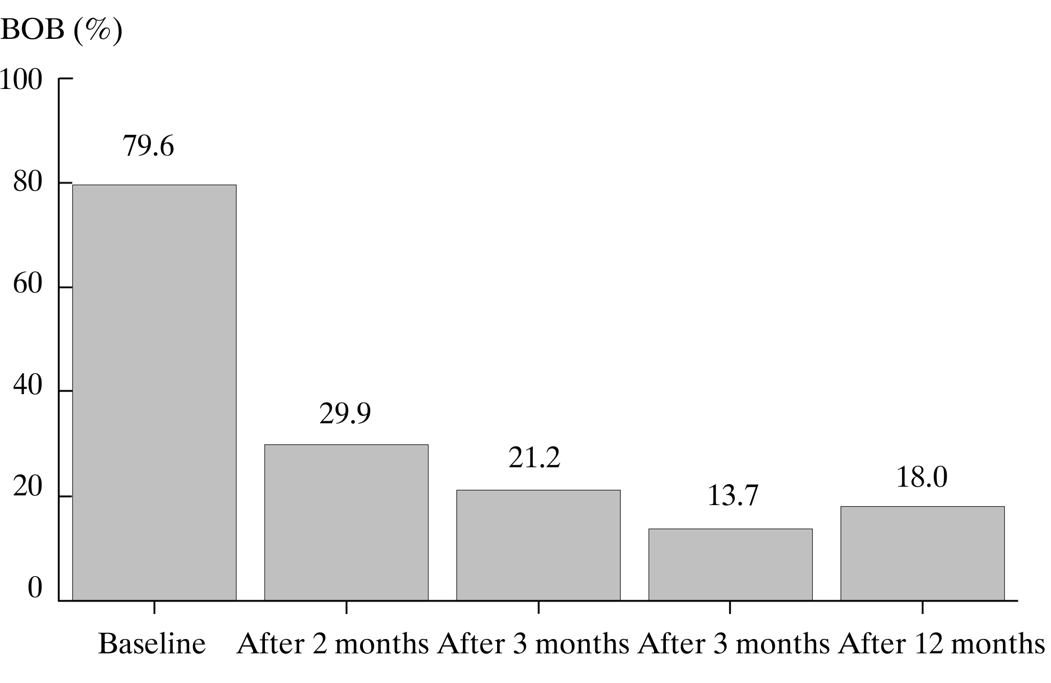
Fig 4.1.1.1. Bleeding on probing levels (%) at different time points
(χ2 =412.8;df=4; p<0.001)

When the data were split into two groups, according to the treatment received, no significant difference was found between SRP and SRP+laser quadrants at baseline and at 2 months after the instrumentation. Hovewer, a significant difference was estimated BOP being significantly lower in SRP+ laser quadrants (p=0.03) (Table 4.1.1.1). Thus, at the final clinical examination, 12 months after the treatment, the difference became even more pronouced: 9.8% and 26.7% of teeth excibited BOP in SRP+laser and SRP-treated quadrants, respectively (p<0.001) (Table 4.1.1.1).

Table 4.1.1.1. BOP levels in SRP and SRP+laser treated quadrants at different time points
Method of treatment | p value
SRP (n=135) | SRP+laser (n=143)
Baseline BOP prevalence (%)
74.1 | 79.0 | 0.3
BOP prevalence (%) after 2 months
32.6 | 27.3 | 0.3
BOP prevalence (%) after 3 months
26.7 | 16.1 | 0.03
BOP prevalence (%) after 6 months
17.0 | 10.5 | 0.1
BOP prevalence (%) after 12 months
26.7 | 9.8 | <0.001

When analysing the BOP changes over time within the group (in SRP and SRP+laser quadrants separately), we found that there was a significant reduction of BOP prevalence during the entire observation period after treatment, both in SRP and in SRP+laser treated quadrants (Fig. 4.1.1.2). However, differently from SRP+laser quadrants, a slight increase of BOP prevalence was observed after 12 months in SRP quadrants, and it became similar to that observed in 2, 3 months after the treatment (Fig. 4.1.1.2).
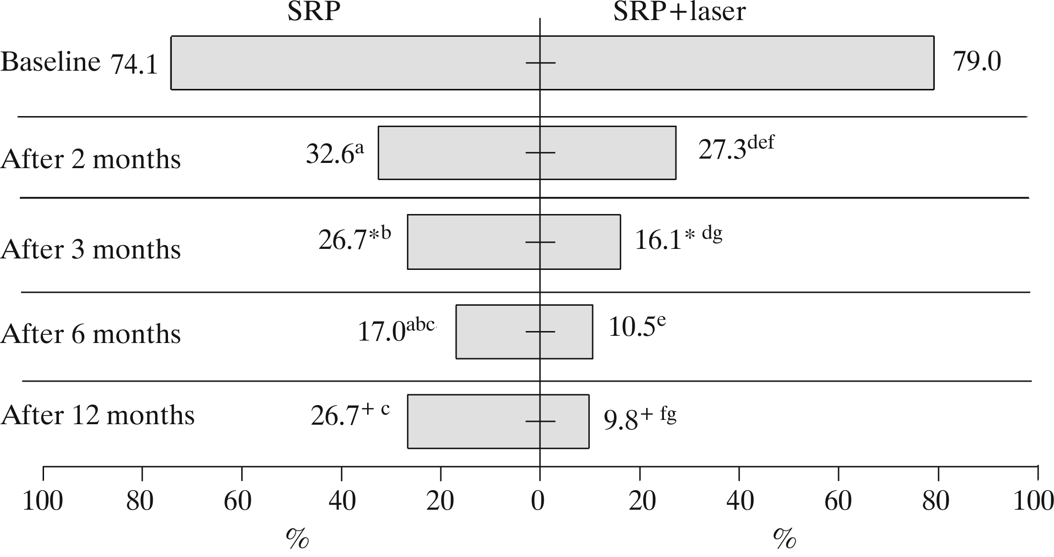
Fig. 4.1.1.2. Changes of BOP prevalence in SRP and SRP+laser quadrants over 12 months after the treatment
*⁺p<0.05 between quadrants; ^{abc}p<0.05 in SRP treated quadrants over 12 months after the treatment; ; ^{defg}p<0.05 in SRP+laser treated quadrants over 12 months after the treatment.

4.1.2. Assessment of the visible dental plaque level

During the entire study period, the status of oral hygiene remained good in all patients. At baseline a “visible plaque level” (VPL) was found in 3.6% of all examined teeth, irrespective of the treatment received (Fig. 4.1.2.1). The VPL increased in all patients after 3 months from baseline. However, during the following period a tendency of VPL to decrease was noted. The VPL values 3 months after the treatment were significantly different when compared with the VPL values obtained in 12 months from baseline (p=0.002).
Table 4.1.2.1 shows the levels of visible plaque, in SRP and SRP+ laser treated quadrants at different time points. VPL increased in both, SRP and in SRP+laser, already after 2 months, but there was no significant difference between the quadrants either at baseline or at different time points after the treatment (Table 4.1.2.1).

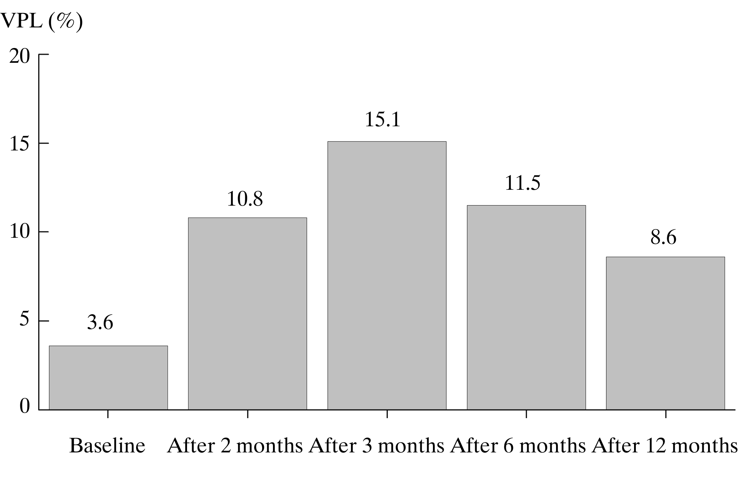
Fig. 4.1.2.1. Mean “visible plaque level” changes (%) in the entire group of patients at different time points
χ²=275.0; df=4; p<0.001.

Table 4.1.2.1. Estimation of visible plaque levels (%) in SRP and SRP+laser treated quadrants at different time points
Method of treatment |  | p value
SRP (n=135) | SRP+laser (n=143) | p value
Baseline % of teeth with visible plaque
3.7 | 3.5 | 0.9
2 months after treatment, % of teeth with visible plaque
10.4 | 11.2 | 0.8
3 months after treatment, % of teeth with visible plaque
13.3 | 16.8 | 0.4
6 months after treatment, % of teeth with visible plaque
14.1 | 9.1 | 0.2
12 months after treatment, % of teeth with visible plaque
8.1 | 9.1 | 0.8
When analysing the VPL changes over time within the group (in SRP and SRP+laser quadrants separately), we found that a significant increase in percentage of teeth with visible plaque was observed after 2, 3 and 6 months from baseline, in SRP quadrants, and after 2 and 3 months in SRP+laser quadrants, respectively. However, the VPL prevalence had a tendency to diminish over time, and became similar to the baseline levels at 6 months post treatment in SRP+laser quadrants, and 12 months after treatment, in SRP quadrants as well (Fig. 4.1.2.2).

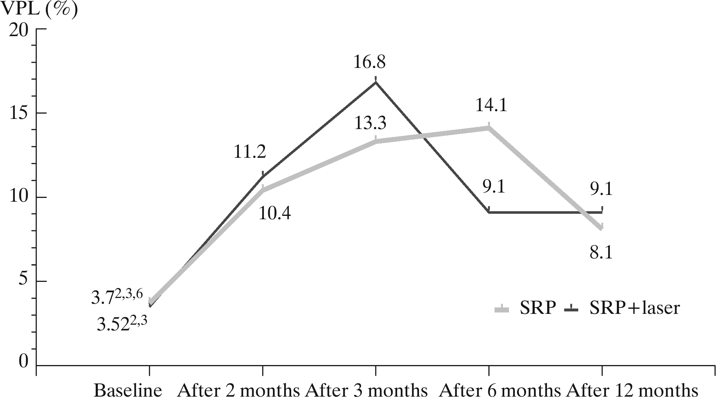

Fig 4.1.2.2. Visible plaque levels (%) on teeth in SRP and SRP+laser -treated quadrants at different time points
p^{2.3.6} <0.05 baseline compared with 2, 3 and 6 months after the treatment;
p^{2.3}<0.05 baseline compared with 2 and 3 months after the treatment.

4.1.3. Assessment of gingival recession changes

Analysis of the data obtained in the whole study group showed that 2, 3, 6, 12 months from baseline the gingival recession (GR) values changed. Thus, the mean baseline GR value was significantly lower when compared with the mean GR values at different time points during follow-up (p<0.001) (Fig 4.1.3.1).

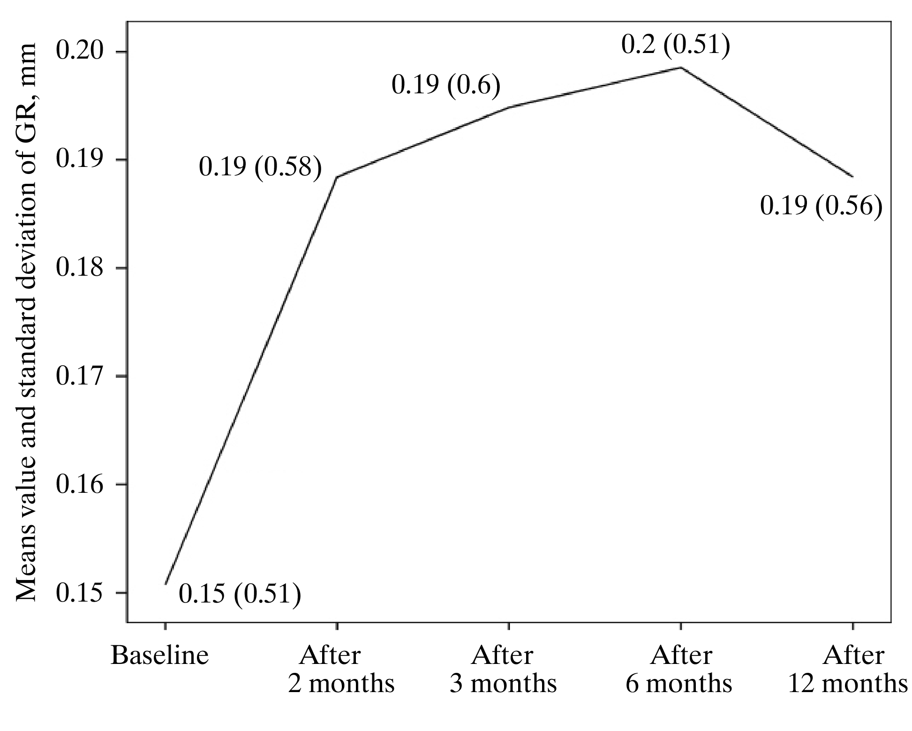
Fig 4.1.3.1. Mean values (SD) of gingival recession (GR) in all study patients at different time points.

Fig. 4.1.3.2 illustrates that in all patients gingival recession (GR) was similar on lingual and vestibular surfaces of the investigated teeth.
When the data were analysed for different quadrants, according to the different treatment method used, it appeared that the mean values of GR for the investigated tooth sites at baseline were 0.16 (SD=0.53) mm and 0.14 (SD=0.5) mm in SRP-treated and SRP+laser-treated quadrants, respectively. They did not differ either at baseline or at the subsequent follow-up points between the quadrants (p>0.05) ( Fig. 4.1.3.3).
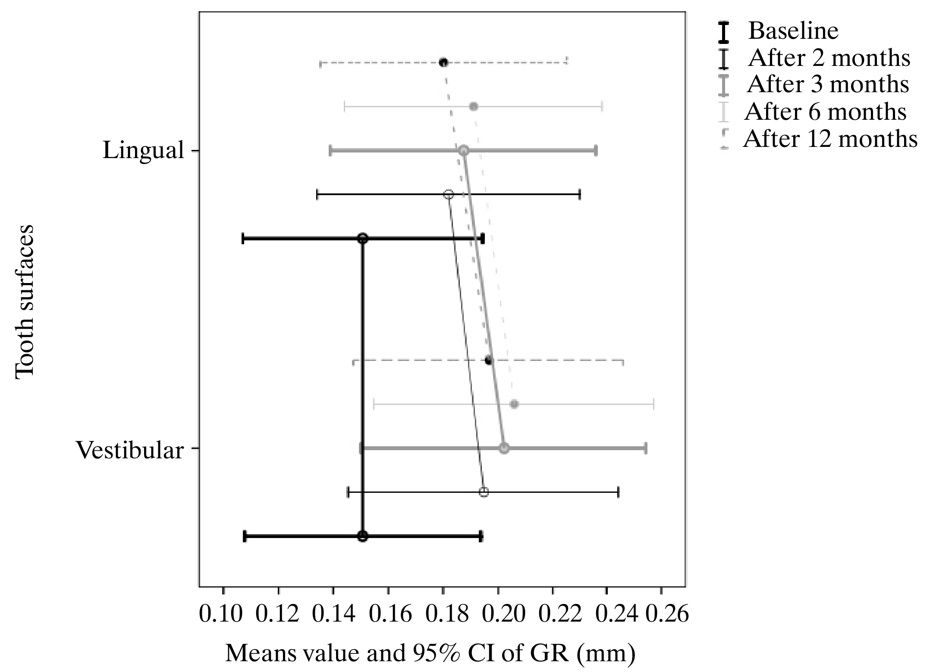

Fig 4.1.3.2. The distribution of GR mean values of lingual and vestibular surfaces at the different time points

The estimated changes of GR in SRP quadrants were significant through the entire study period in both vestibular and lingual surfaces. The most significant mean change value of GR in SRP+laser quadrants was observed 6 months after treatment (Table 4.1.3.1). After 12 months, the mean change value of GR decreased. Thus, at baseline the mean estimated GR value was – 0.14 (SD=0.5) mm, and 12 months after the treatment remained similar to the baseline value: 0.16 (SD=0.49) mm. No significant GR changes in vestibular surfaces were observed already at 3 months after the treatment and GR remained stable during the entire study period (Table 4.1.3.1).

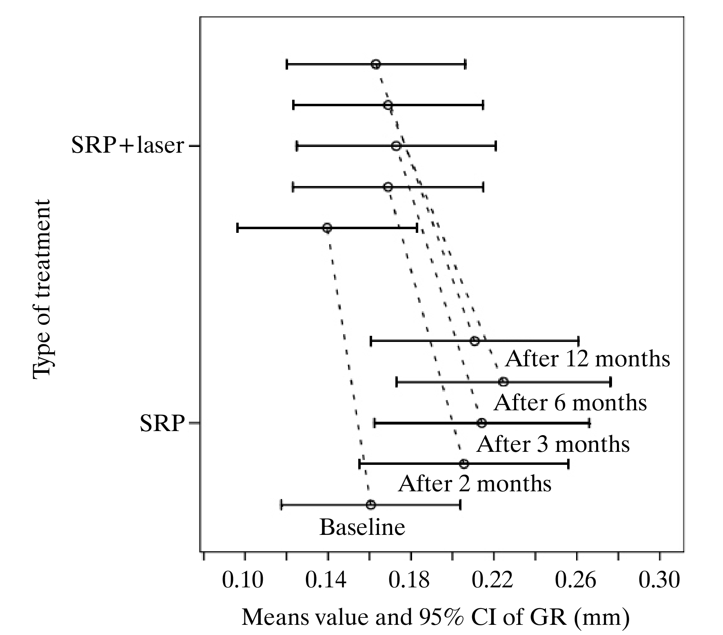

Fig 4.1.3.3. Mean GR values (and CI intervals) at baseline and at different time points estimated in SRP and SRP+laser-treated quadrants

Table 4.1.3.1. Comparison of mean change values of GR at different time points between SRP and SRP+laser quadrants, according to tooth surface type

SRP |  | Method of treatment  significance level (p value) , when compared GI changes obtained in “SRP” and in “SRP+laser”, at different time points | SRP+laser
Mean (SD) change value in the quadrant, as compared to baseline |  |  | Mean (SD) change value in the quadrant, as compared to baseline
p | Mean (SD), mm |  | Mean (SD), mm | p
n=579 |  | All (Lingual and vestibular) surfaces | n=509
<0.001 | 0.05 (0.28) | After 2 months  0.5 | 0.03 (0.2) | 0.001
<0.001 | 0.05 (0.32) | After 3 months  0.5 | 0.03 (0.25) | 0.002
<0.001 | 0.06 (0.32) | After 6 months  0.06 | 0.03 (0.25) | 0.009
0.001 | 0.05 (0.34) | After 12 months  0.2 | 0.02 (0.29) | 0.07
n=286 |  | Lingual surfaces | n=258
0.007 | 0.04 (0.24) | After 2 months  0.4 | 0.02 (0.15) | 0.01
0.02 | 0.04 (0.25) | After 3 months  0.9 | 0.04 (0.23) | 0.007
0.003 | 0.05 (0.29) | After 6 months  0.3 | 0.03 (0.22) | 0.05
0.03 | 0.04 (0.32) | After 12 months  0.3 | 0.02 (0.28) | 0.4
n=293 |  | Vestibular surfaces | n=251
0.005 | 0.05 (0.31) | After 2 months  0.5 | 0.04 (0.24) | 0.02
0.001 | 0.07 (0.37) | After 3 months  0.1 | 0.03 (0.26) | 0.09
<0.001 | 0.08 (0.35) | After 6 months  0.1 | 0.03 (0.28) | 0.07
0.006 | 0.06 (0.36) | After 12 months  0.4 | 0.03 (0.3) | 0.09

4.1.4. Assessment of periodontal pocket depth changes

The mean periodontal pocket depth value (PPD) in all examined patients at baseline was 4.2 (SD=0.95) mm. The mean PPD values in the entire group decreased significantly over the 6 months period and remained lower than 3 mm after 12 months (Fig. 4.1.4.1).

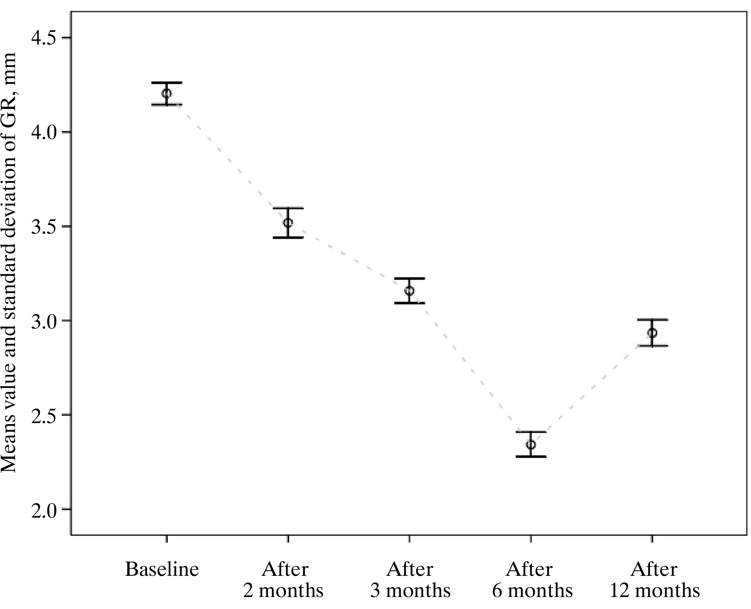
Fig. 4.1.4.1. Distribution of PPD the mean values in all treated quadrants
at different time points

The results of the study showed no significant difference at baseline in PPD between vestibular and lingual surfaces (mean values 4.18 mm, SD=0.98 and 4.21 mm, SD=0.92, respectively) (Fig. 4.1.4.2). However, after 3 months and further on, a statistically significant difference was estimated between the mean values of PPD on vestibular and lingual surfaces, the mean PPD being consistently greater on the lingual surfaces (Fig. 4.1.4.2).

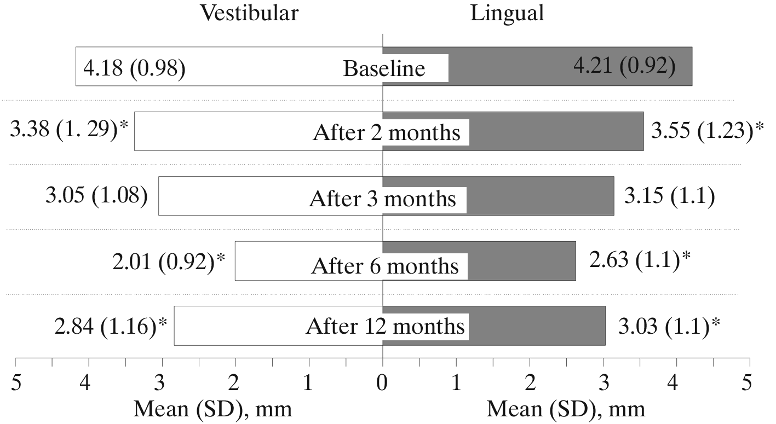

Fig. 4.1.4.2. The mean values of PPD in lingual and vestibular surfaces
at all time points of examination
*p<0.05 between lingual and vestibular surfaces.

Comparison of the mean PPD values between the treated quadrants revealed that at baseline they were significantly higher (p<0.001) in SRP+laser quadrants (Fig. 4.1.4.3). The mean PPD changes from the baseline values, estimated at following time points (3, 6, 12 months) after the treatment, differed significantly between SRP and SRP+laser quadrants, the reduction being greater for the SRP+laser treated sites than for the sites treated by SRP alone (p<0.001) (Fig. 4.1.4.3).
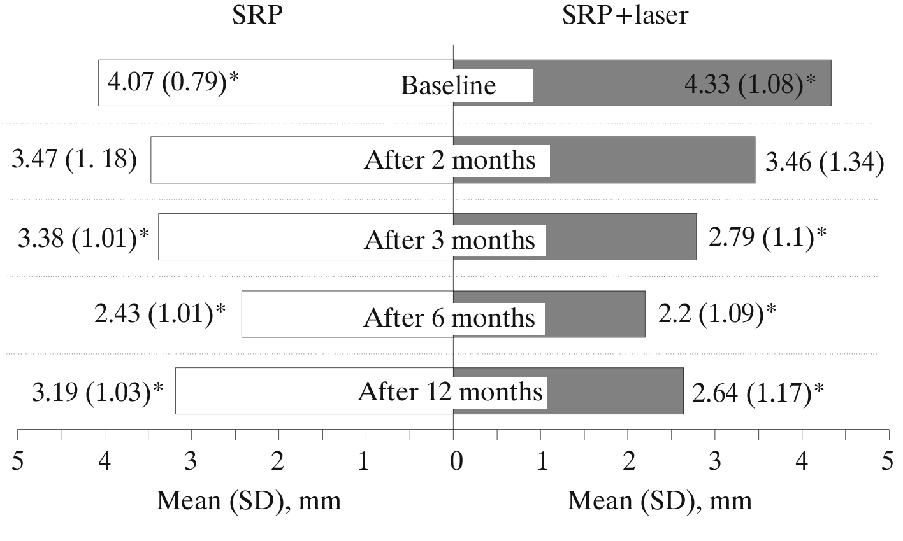
Fig. 4.1.4.3. Mean values of PPD estimated in SRP and SRP+laser quadrants at different examination time points during the study period
*p<0.001, when compared two treatment methods.

Table 4.1.4.1 shows the PPD changes estimated at different time points after baseline in both SRP and SRP+laser quadrants as well as comparison of these changes between SRP and SRP+laser over time. According to our results, the most obvious changes of PPD were achieved in SRP+laser treated quadrants at all examination time points (2, 3, 6, 12 months) after the treatment (p<0.001) (Table 4.1.4.1).
Using ROC analysis we estimated that 1 mm – of PPD mean change value at the decision threshold after 2 months was 27.3 % in SRP treated quadrants, and 41.1% in SRP+laser quadrants: after three months – 24.0% and 59.8%, respectively (p<0.001) (Fig. 4.1.4.4). It showed that using SRP+ laser treatment method, the chance that the mean PPD change value would be greater than 1mm, in 2 months after the treatment would be almost two times higher (OR 1.9 [1.4–2.4], and in three months – almost 5 times higher (4.7 [3.6–6.1] than when using SRP treatment method alone (Fig. 4.1.4.4). Six months after the treatment, the chance to have the mean PPD reduction greater than 2 mm, was two times higher in SRP+laser than in SRP treated quadrants (OR 2.0 [1.5–2.7]) (Fig. 4.1.4.4). Furthermore, in 12 months after the treatment, the chance to have the mean PPD reduction greater than 2.5 mm was almost 7 times higher in SRP+laser than in SRP treated quadrants (OR 6.8 [4.6–10.1]) (Fig. 4.1.4.4).

Table 4.1.4.1. Comparison of mean change values of PPD at different time points between SRP and SRP+laser quadrants, on different tooth surfaces (lingual and vestibular)
SRP |  | Significane level (p value) when compared PPDchanges obtained in “SRP”  and ,,SRP+laser”,  at different time points | SRP+laser
Mean (SD) PPD change value (A). in the quadrant. as compared to baseline |  |  | Mean (SD) PPD change value (A). in the quadrant. as compared to baseline
p | Mean (SD), mm |  | Mean (SD), mm | p
n=579 |  | Lingual and vestibular surfaces | n=509
<0.001 | 0.59 (1.04) | After 2 months  <0.001 | 0.87 (1.37) | <0.001
<0.001 | 0.69 (0.81) | After 3 months  <0.001 | 1.54 (1.09) | <0.001
<0.001 | 1.64 (1.06) | After 6 months  <0.001 | 2.13 (1.24) | <0.001
<0.001 | 0.89 (1.04) | After 12 months  <0.001 | 1.71 (1.35) | <0.001
n=286 |  | Lingual surfaces | n=258
<0.001 | 0.49 (0.95) | After 2 months  <0.001 | 0.84 (1.28) | <0.001
<0.001 | 0.65 (0.8) | After 3 months  <0.001 | 1.5 (1.05) | <0.001
<0.001 | 1.3 (1.02) | After 6 months  <0.001 | 1.88 (1.18) | <0.001
<0.001 | 0.8 (0.97) | After 12 months  <0.001 | 1.64 (1.2) | <0.001
n=293 |  | Vestibular surfaces | n=251
<0.001 | 0.69 (1.12) | After 2 months  0.06 | 0.91 (1.47) | <0.001
<0.001 | 0.73 (0.81) | After 3 months  <0.001 | 1.59 (1.13) | <0.001
<0.001 | 1.96 (1.0) | After 6 months  <0.001 | 2.4 (1.24) | <0.001
<0.001 | 0.98 (1.1) | After 12 months  <0.001 | 1.77 (1.48) | <0.001
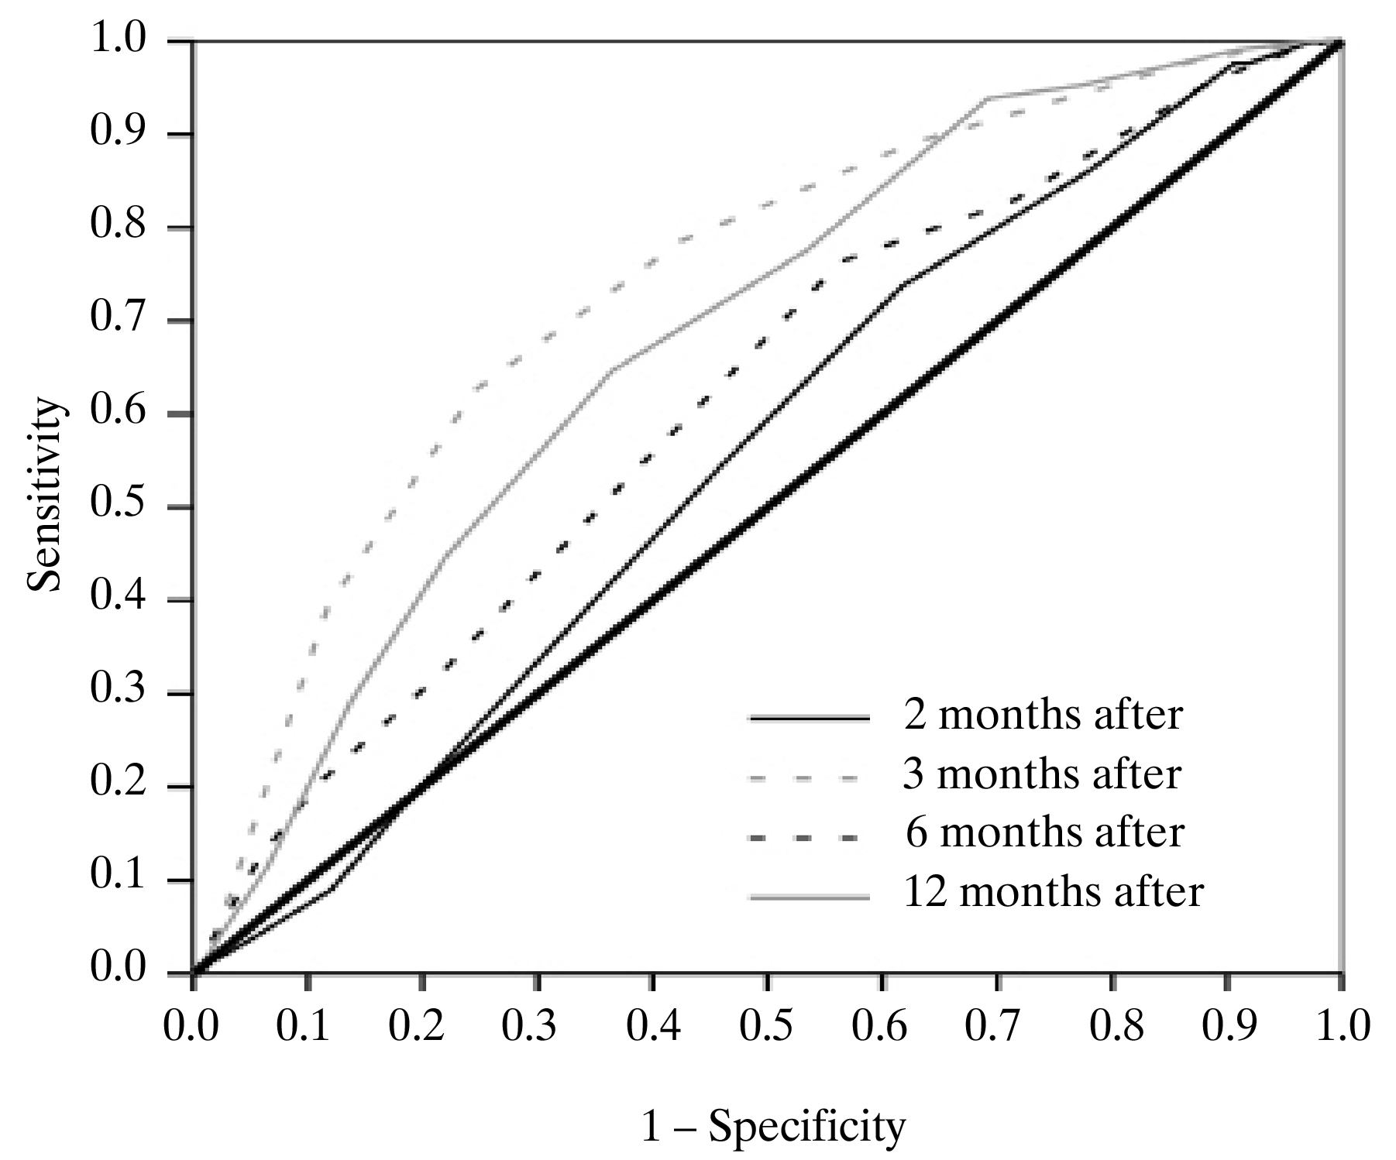

Fig. 4.1.4.4. ROC curves for evaluation of prognostic changes of the mean PPD values in differently treated quadrants

According to the model of binary multiple logistic regression, the likelihood to obtain the PPD change greater than 1mm in two months after the treatment was about 3.5 times higher, in SRP+laser quadrants, compared to SRP quadrants (OR=3.6 [2.7–4.8]). Furthermore, the likelihood to obtain the PPD change greater than 2.5 mm in 12 months after the treatment is 4 times higher in SRP+laser treated quadrants (OR=4.0 [2.6–6.0]) (Table 4.1.4.2).

Table 4.1.4.2. Multivariate logistic regression analysis model of PPD change (reference – <1 mm reduction = 1)
Change of PPD (mm) | SRP+laser quadrants. OR [95% CI]
After 3 months.  > 1mm | 3.6 [2.7–4.8]*
After 12 months.  > 2.5mm | 4.0 [2.6–6.0]*
Constant =–0.842*
*<0.001 OR – odds ratio; CI – confidence interval.

When a threshold of 3 mm of the periodontal pocket depth was chosen (meaning that <3 mm PPD sites were considered as “normal”, and >3 mm PPD sites were considered as “pathology”) it appeared that at baseline all sites in the entire study group had PPD >3 mm. However, by 2 months after the treatment only 46.8 % of the sites remained >3 mm (Table 4.1.4.3). The data showed that 34.4% of the sites 3 months after the treatment still had PPD >3 mm, after 6 months – 13.7% and after 12 months – 31.3% >3 mm, respectively.
Sites with PPD > 3 mm 3 months after the treatment were significantly more frequent in SRP quadrants, and this difference remained significant 6 and 12 months after the treatment (p<0.001) (Table 4.1.4.3). However, according to the test of McNemar for two – significance dependent variables we have found that SRP+laser-treated quadrants this passing was significant already after 3 months, while in SRP-treated quadrants – after 6 months. 3 and 12 months after the instrumentation in SRP+laser treated quadrants this passing did not differ significantly.

Table 4.1.4.3. Comparison of distribution of the sites with PPD >3 mm (%) according to treatment method
Time of examination | Total | Method of treatment |  | p value
Time of examination | Total | SRP | SRP+laser | p value
 | %
After 2 months | 46.8 | 47.7 | 45.8 | 0.5
After 3 months | 34.4 | 45.4 | 22.0 | <0.001
After 6 months | 13.7 | 16.5 | 10.4 | 0.004
After 12 months | 31.3 | 38.8 | 22.7 | <0.001

Analysis of binary regression model (for the total number of correctly classified periodontal pockets – 66.7%) showed that the likelihood to obtain periodontal pocket depth less than 3 mm in 3 months after the treatment was 2.5 times greater and in 12 months after the treatment – 1.5 times greater in SRP+laser treated quadrants than in SRP treated quadrants (OR=2.5 [1.9–3.4]) and 1.5 [1.1–2.1 in three months and in 12 months, respectively]) (Table 4.1.4.4).

Table 4.1.4.4. Multivariate logistic regression analysis for periodontal pocket depth <3 mm after 3 and 12 months. Reference point: >3 mm =1
Periodontal pocket depth  PPD (mm) | OR for SRP+laser [95 %. CI]
After 3 months  >3  <3 | 1  2.5 [1.9–3.4]*
After 12 months  >3  <3 | 1  1.5 [1.1–2.1]*
Constant =-1.043*
* <0.01 OR – odds ratio; CI – confidence interval

4.1.5. Assessment of clinical attachment level (CAL) changes

The mean value of clinical attachment level (CAL) of all examined patients at baseline was 4.34 (SD=1.06) mm. Already after 2 months a significant decrease of the mean CAL value from 4.34 mm to 3.65 mm was noted (p<0.001). The difference of the mean CAL values in all quadrants remained significant throughout the entire study period (Fig. 4.1.5.1).
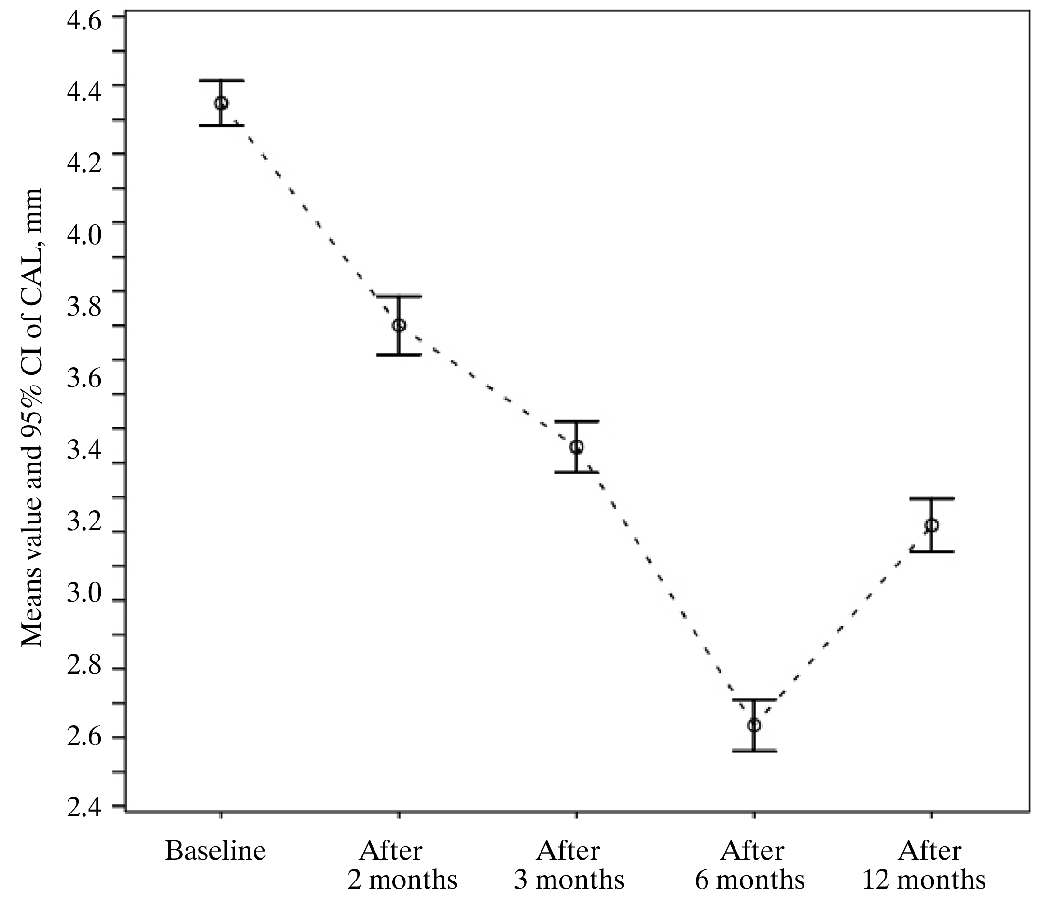

Fig. 4.1.5.1. Means value of CAL of all examinated sites at different time points

The results of the study showed no significant difference at baseline in CAL between vestibular and lingual surfaces (Fig.4.1.5.2). Significant difference between surfaces was estimated only at 12 months examination after the treatment, the mean CAL gain consistently being greater on the vestibular surfaces surfaces (p<0.03) (Fig.4.1.5.2).

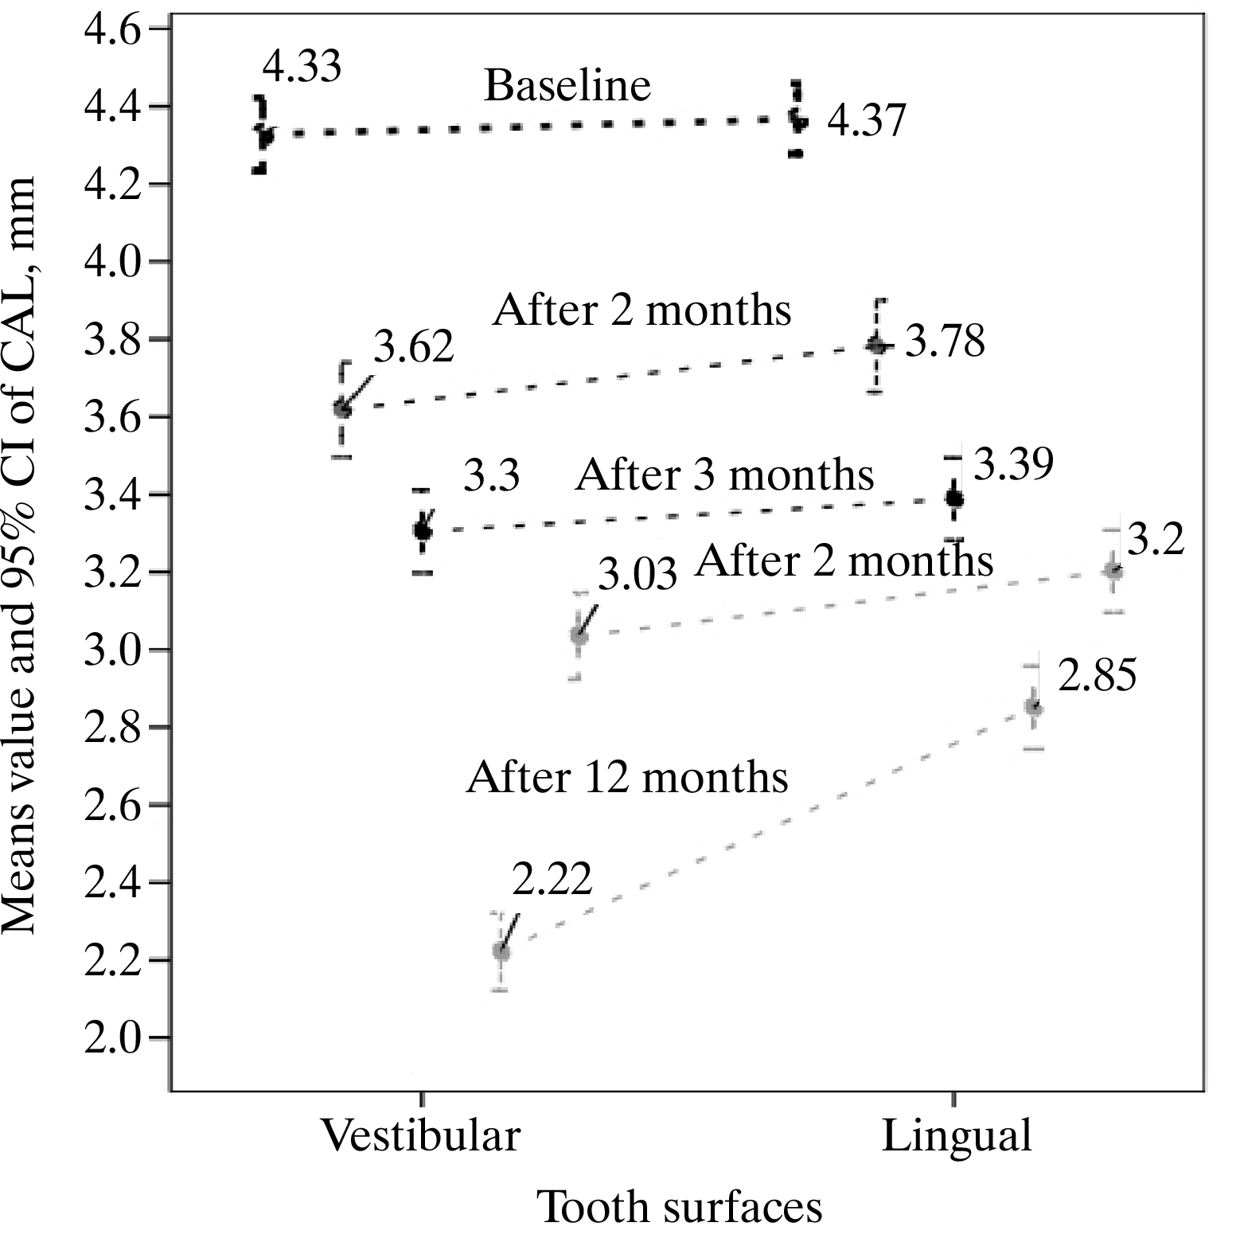

Fig 4.1.5.2. Mean CAL values of lingual and vestibular surfaces
at different examination time points during the study period
*p<0.03 between vestibular and lingual surfaces.

Comparison CAL measurements at baseline between the quadrants showed that CAL was significantly higher in SRP+laser − treated quadrants (p<0.001). After 2 months from baseline, no significant difference of CAL measurements was estimated between quadrants, however, at 3, 6 and 12 months examination points the CAL gain was significantly greater in SRP+laser- treated sites (p<0.001) (Fig. 4.1.5.3).
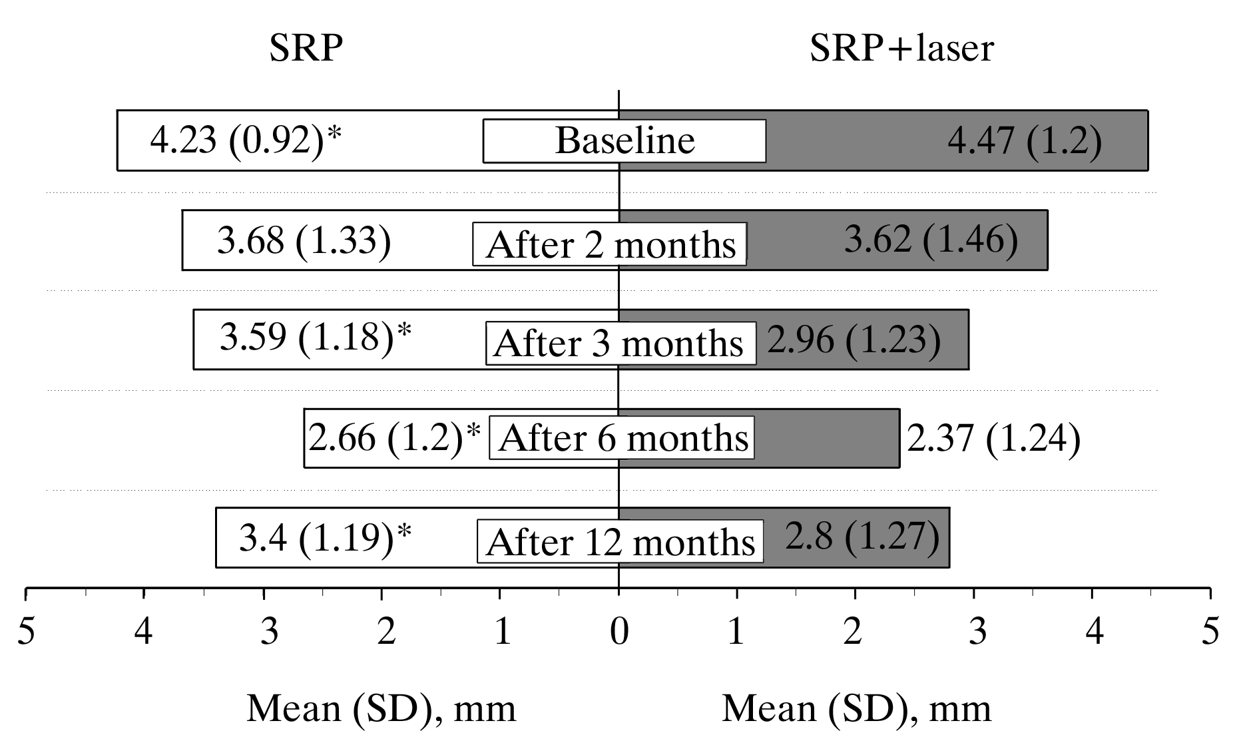

Fig. 4.1.5.3. Mean CAL values in SRP and SRP+laser treated quadrants at different examination time points during the study period
*p<0.001 betweeen SRP and SRP+laser at different time points.

Table 4.1.5.1 shows the gain of CAL estimated at different time points through the study in both SRP and SRP+laser treated quadrants and comparison of the obtained changes between SRP and SRP+laser treated quadrants during the entire study period (p<0.001) (Table 4.1.5.1). In both SRP – treated and SRP+laser – treated quadrants significant gain of CAL was estimated already 2 months after instrumentation. However, significantly greater gain of CAL was estimated in SRP+laser – treated quadrants (p<0.001) through the entire study period (Table 4.1.5.1). When CAL changes were analyzed for lingual and vestibular surfaces separately, the same tendency was observed for all tooth aspects: the significantly greater gain of clinical attachment level was estimated in SRP+laser – treated lingual and vestibular sites through the entire study period (Table 4.1.5.1).
Table 4.1.5.1. Mean values of CAL gain in SRP and SRP+laser treated quadrants estimated at different time points
SRP |  | p value, when compared CAL gain obtained in “SRP” and “SRP+laser” at different time points | SRP+laser
Mean value of CAL gain in the quadrant,  as compared to  baseline (mm) |  |  | Mean value of CAL gain in the quadrant,  as compared to baseline (mm)
p | Mean (SD) |  | Mean (SD) | p
N=579 |  | All surfaces(lingual and vestibular) | N=509
<0.001 | 0.55 (1.08) | After 2 months  <0.001 | 0.84 (1.36) | <0.001
<0.001 | 0.64 (0.86) | After 3 months  <0.001 | 1.51 (1.1) | <0.001
<0.001 | 1.57 (1.11) | After 6 months  <0.001 | 2.1 (1.26) | <0.001
<0.001 | 0.84 (1.09) | After 12 months  <0.001 | 1.68 (1.36) | <0.001
n=286 |  | Lingual surfaces | n=258
<0.001 | 0.46 (0.98) | After 2 months  <0.001 | 0.82 (1.27) | <0.001
<0.001 | 0.62 (0.84) | After 3 months  <0.001 | 1.46 (1.07) | <0.001
<0.001 | 1.25 (1.05) | After 6 months  <0.001 | 1.85 (1.21) | <0.001
<0.001 | 0.76 (1.01) | After 12 months  <0.001 | 1.62 (1.21) | <0.001
N=293 |  | Vestibular surfaces | N=251
<0.001 | 0.64 (1.17) | After 2 months  0.08 | 0.87 (1.46) | <0.001
<0.001 | 0.66 (0.88) | After 3 months  <0.001 | 1.56 (1.13) | <0.001
<0.001 | 1.88 (1.07) | After 6 months  <0.001 | 2.37 (1.26) | <0.001
<0.001 | 0.92 (1.16) | After 12 months  <0.001 | 1.74 (1.5) | <0.001

Using ROC analysis we estimated that 1 mm – CAL gain mean value at the decision threshold after 2 months was 26.3% in SRP treated quadrants and 40.1% in SRP+laser quadrants (p<0.001). It showed that using SRP+ laser treatment method, the possibility that the mean CAL gain value will be greater than 1 mm, in 2 months after the treatment will be two times higher (OR 1.9 [1.5–2.4]), and in 3 months – 5 times higher (OR 4.9 [3.8–6.4]) than in the quadrants treated by SRP only (Fig. 4.1.5.4). Respectively, six months after the treatment, the chance to have the mean gain of CAL more than 2 mm is two times higher in SRP+laser than in SRP treated quadrants (OR 2.0 [1.6–2.6]) (Fig.15). Furthermore, in 12 months after the treatment, the chance to have the mean gain of CAL more than 2.5 mm is three times higher in SRP+laser than in SRP – treated quadrants (OR 3.0 [2.3–3.9]) (Fig. 4.1.5.4).

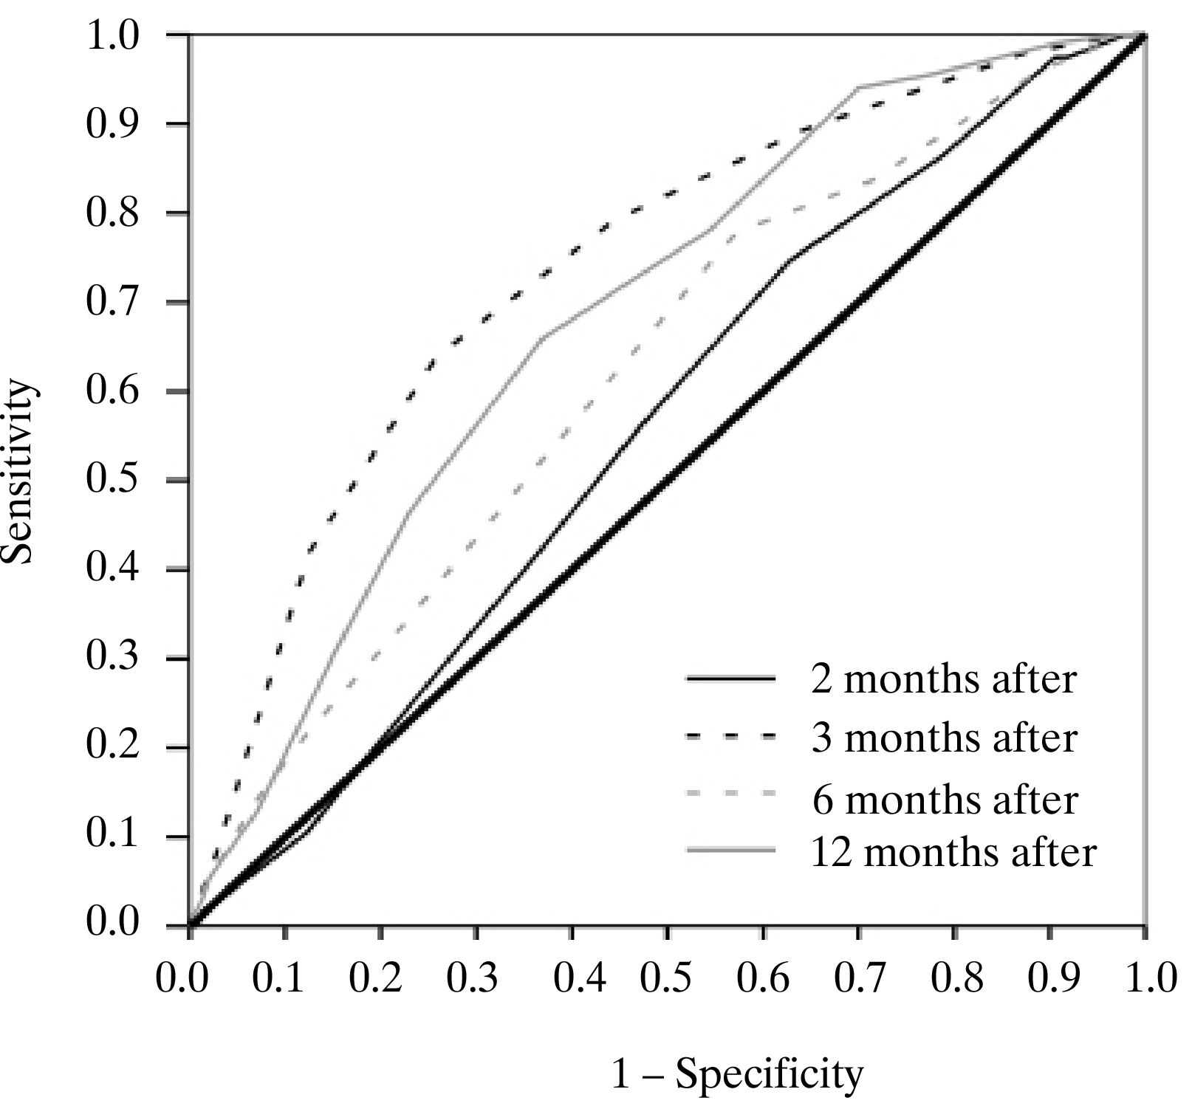

Fig. 4.1.5.4. ROC curves for evaluation of prognostic changes of the mean CAL gain values in differently treated quadrants

According to the model of binary multiple logistic regression, the likelihood to obtain the gain of CAL greater than 1 mm in three months after the treatment is more than 4 times higher in SRP+laser treated quadrants, compared to SRP-treated quadrants (OR=4.2 [3.2–5.6]). Furthermore, the likelihood to obtain the gain of CAL greater than 2.5 mm in 12 months after the treatment is almost 2 times higher (OR=1.8 [1.4–2.4]) (Table 4.1.5.2).

Table 4.1.5.2. Multivariate logistic regression analysis model of CAL gain (reference – <1mm reduction=1)

Gain of CAL (mm) | SRP+laser quadrants  OR [95% CI]
After 3 months  > 1mm | 4.2 [3.2–5.6]*
After 12 months  >2.5 mm | 1.8 [1.4–2.4]*
Constant =–1.136*
*<0.001 OR- odds ratio; CI – confidence interval.

4.2. Scanning electronic microscope (SEM) images examinations

The images of the SEM examinations (Figs. 4.2.1, 4.2.2) demonstrated that untreated root surfaces were rough and covered by calculus and smear layer. Specimens, instrumented by SRP method (Figs. 4.2.3, 4.2.4) showed almost smooth root surface covered by a smear layer, remnants of calculus and contaminated root cementum. Some opened dentinal tubules were observed. Many linear irreagularities, which were considered as result from ultrasonic and manual instrumentation, were present.
Specimens, that had been instrumented using SRP+laser method, showed the homogeneously distributed thin projections on the cementum surface. All specimens displayed no smear layer. No surface alterations, such as crater formation, cracks, cementum meltdown or fractures were observed. Lased root surface produced a rough appearance, which was considered to be more favorable for fibroblast attachment (Fig. 4.2.5). All the specimens that had been subjected to SRP+laser root surface modification showed adherence of flat fibroblasts. The cells looked healthy and were tightly attached to the specimens by wide cytoplasmic projections and numerous of well-developed lamelopodia (Figs. 4.2.6–4.2.10). In the SRP-treated teeth only a few fibroblasts, that were round in appearance and poorly attached to the root surfaces were evident. Cementum surface alterations, calculus, covered by the smear layer were observed (Figs. 4.2.11–4.2.13).

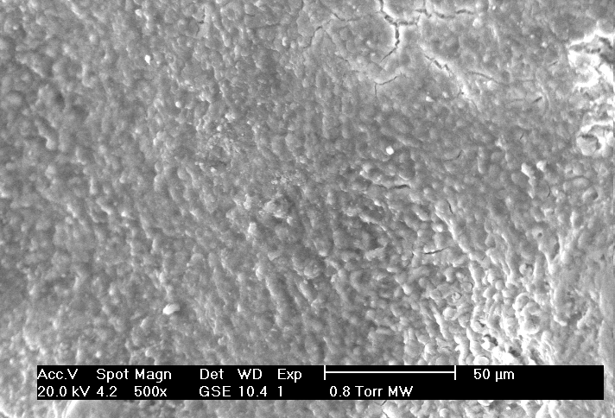

Fig. 4.2.1. Untreated surface of cementum
(original magnification ×500)

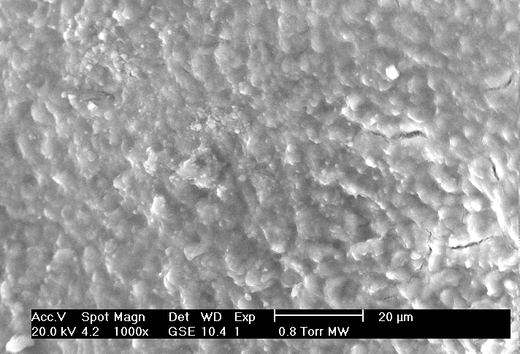

Fig. 4.2.2. Untreated root surface
(original magnification ×1000)

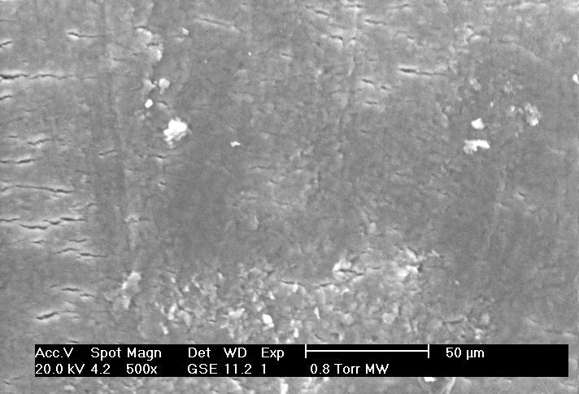

Fig. 4.2.3. Tooth surface after SRP instrumentation

(original magnification ×500)

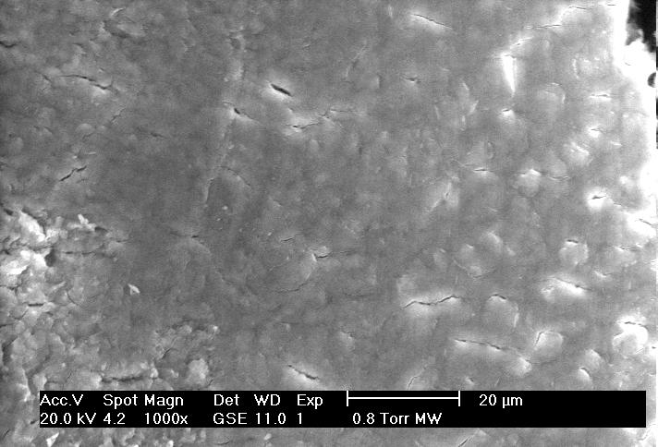

Fig. 4.2.4. Tooth surface after SRP instrumentation

(original magnification ×1000)

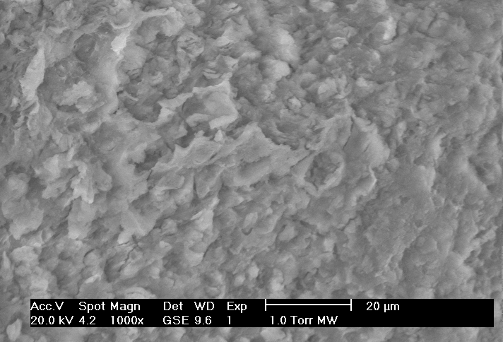

Fig. 4.2.5. SRP+laser irradiated specimen
(original magnification ×1000)

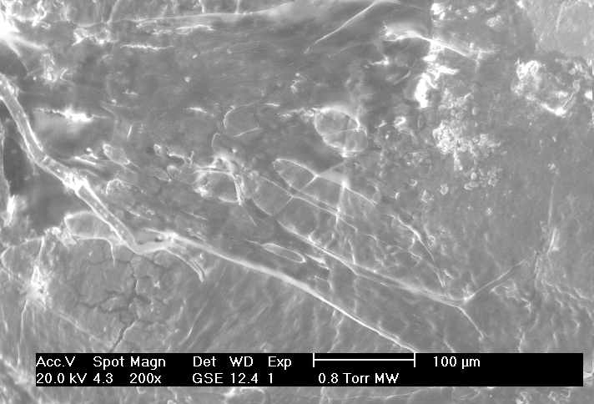

Fig. 4.2.6. Specimen after by SRP+laser instrumentation shows firmly attached numerous flat fibroblasts to the root surface (original magnification ×200)

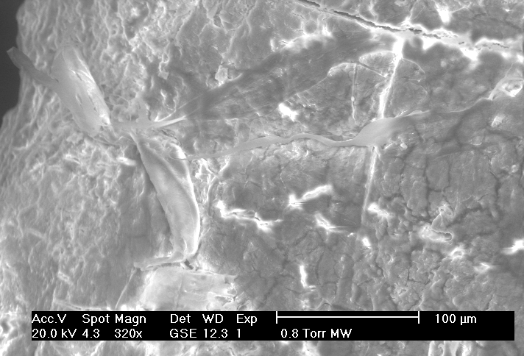

Fig. 4.2.7. Specimen after by SRP+laser instrumentation
(original magnification ×320)

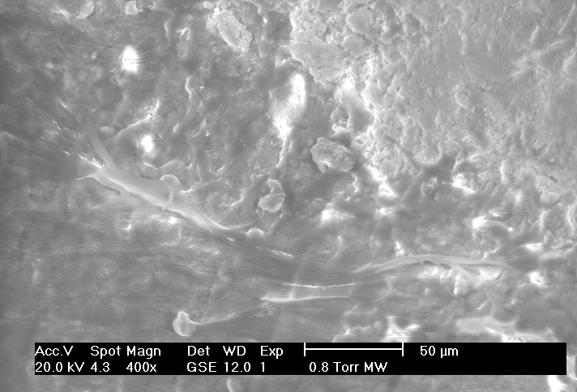

Fig. 4.2.8. Specimen after SRP+laser instrumentation
(original magnification ×400)
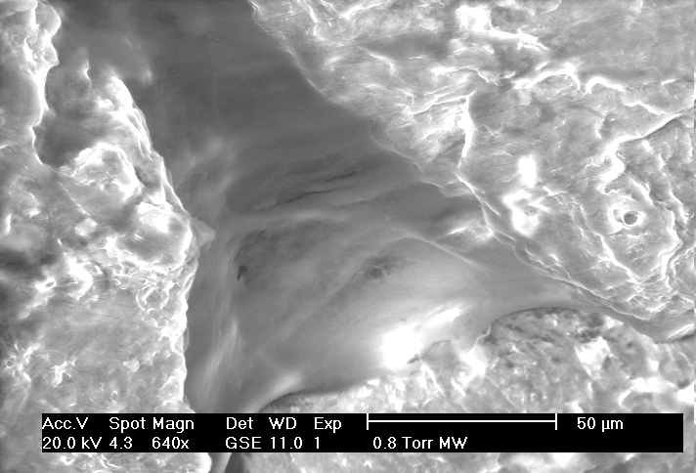

Fig. 4.2.9. Specimen after SRP+laser instrumentation
(original magnification ×640)

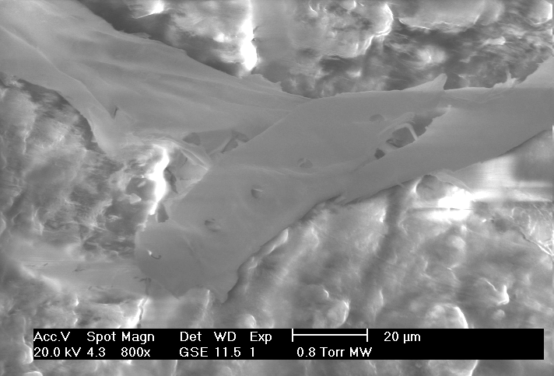

Fig. 4.2.10. Specimen after SRP+laser instrumentation
(original magnification ×800)

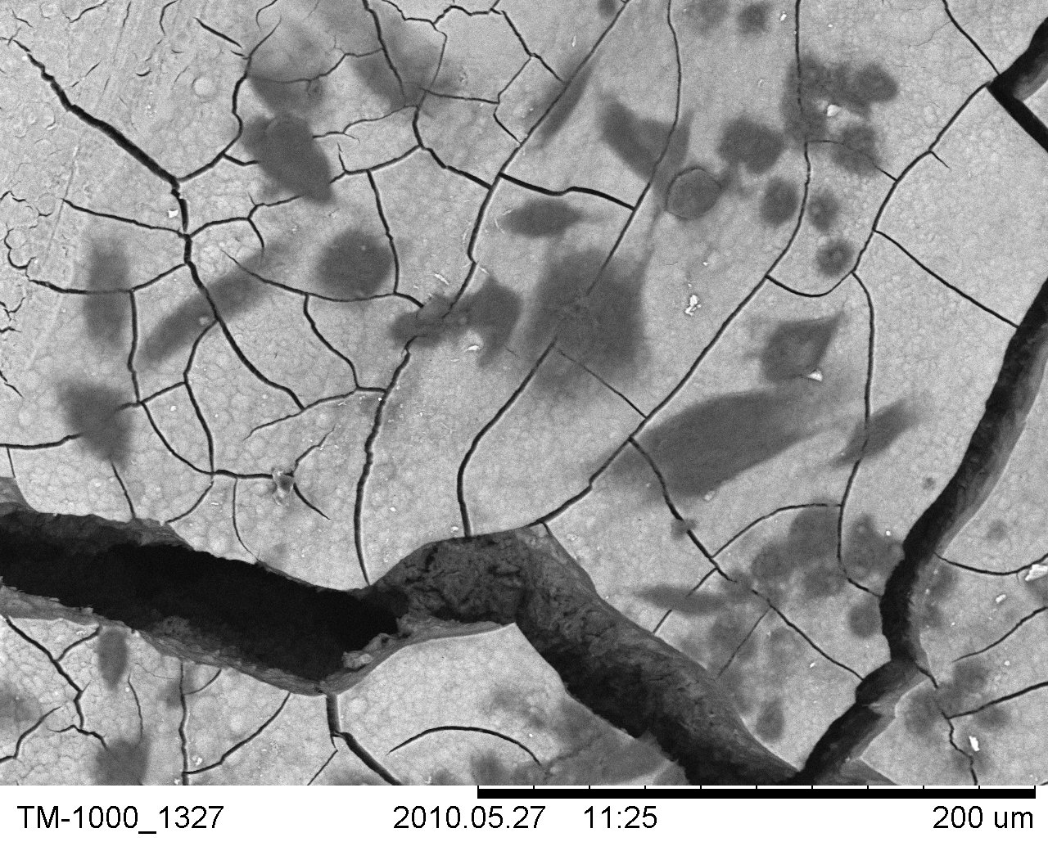

Fig. 4.2.11. Control specimen (SRP) on which only a few round fibroblasts were observed (original magnification ×500)
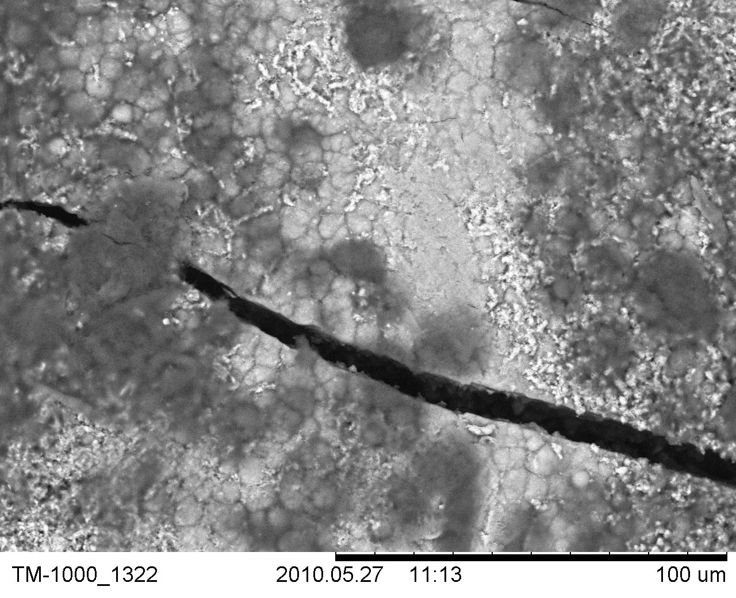

Fig. 4.2.12. Specimen after SRP instrumentation shows numerous round fibroblasts (original magnification ×1000)

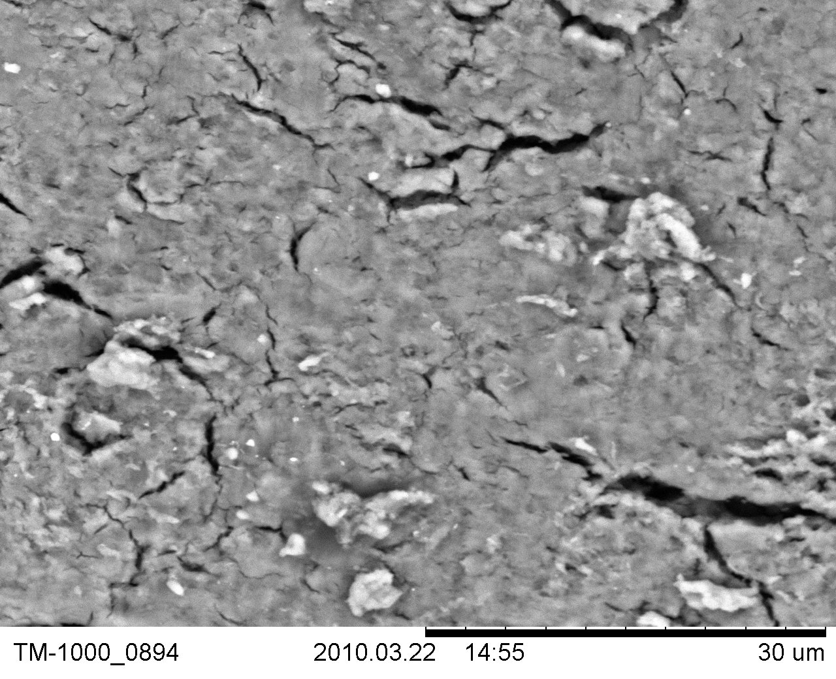

Fig. 4.2.12. Specimen after SRP+laser instrumentation shows couple
of round fibroblasts poorly attached to the root surface
(original magnification ×3000)

5. DISCUSSION

5.1. Relevance of the Present Study in the Lithuanian Context

The present study, which examines the comparative effects of SRP+laser and SRP alone treatments in patients with early to moderate periodontitis and conducted at Kaunas University of Medicine in Lithuania, is especially timely and significant considering that studies of the periodontal profile of Lithuanian adults reveal that periodontal disease is widespread in the country. Skudutyte and others (2003) examined 680 individuals in the rural and urban areas of Lithuania using stratified random sampling selection and found that 47% of adults aged between 35 and 44 years old and 75% of adults with ages between 65 and 74 years old were all suffering from periodontitis, with 6 mm pockets or more [112]. Any data and information gathered towards the prevention and treatment of periodontitis will be especially relevant considering the aforecited condition of the Lithuanian public dental health.
The first attempt to evaluate possible benefits of different treatment modalities was made by performing a pilot study (Kelbauskienė & Mačiulskienė 2007) that used a similar platform and had the same aim as the study described in this dissertation. That study, however, had less patients and was conducted for a far shorter period. The researchers concluded that both SRP and SRP+laser treatments resulted in significant improvements in all investigated clinical parameters with the SRP+laser treatment exhibiting more diminished PPD after 3 months. In the longitudinal study described here, the observation period took one year and involved three times more patients using the same treatment modalities. The clinical examinations were made at baseline and 2, 3, 6, 12 months after the treatment. It had similar findings with the pilot study as to PPD and CAL, but more significantly, it showed that BOP in a significant number of teeth was more reduced in SRP+laser after 12 months than in the control quadrants.

5.2. The Limitations of SRP as a Lone Modality in the Treatment

of Chronic Periodontitis

Scaling and root planing, as shown by various studies, is in itself effective in treating early-to-moderate periodontitis and can effectively reduce PPD and CAL [13, 35]. Considering however, that the primary objective of a chronic periodontitis treatment is the removal of all causative factors such as plaque and calculus that rendered the tooth and gingival area diseased, it is evident that the complex structure of the periodontium will hinder the complete achievement of this objective [56]. The limitations of SRP was the subject of a study by Rabbani et al (1981), who proved that subgingival scaling of root surfaces is often difficult and incomplete. The group subjected 62 teeth to scaling and 57 teeth served as the control group, made appropriate markings and extracted them afterwards.The study established that despite previous SRP treatment, teeth with more than 5 mm pocket depth had residual calculus remaining not accessed by the subgingival scaling [92].
Kaldahl et al (1988), likewise, conducted a split-mouth designed study comparing four modalities of treatment of chronic periodontitis: coronal scaling; root planing; modified Widman surgery, and; flap surgery with osseous resection. It involved 82 patients, which were given supportive maintenance every three months. Although all treatment modalities resulted in reduction of pocket depths, breakdown in sites during the seven-year period of study was noted most in those treated with modified Widman surgery and SRP. The breakdown was noted to have direct relation with increased initial pocket depth [62].
To measure the effectiveness of scaling in calculus removal, Caffesse et al (1986) conducted a study where they subjected diseased teeth of 21 patients to scaling (SO) and scaling after reflection of a periodontal flap (SF). The study revealed that scaling only is as effective as SF only at pocket depth of less than 4 mm, but was only 43% effective as against 76% of SF at pocket depth of 4 to 6 mm, and only 32% effective as against 50% of SF at > 6 mm pocket depth [21].
Thus, despite having undergone a SRP therapy, continued loss of attachment is still possible if the patient has pocket depths of 3 mm or more because subgingival scaling is most likely less effective in probing greater pocket depths and patient plaque control is only effective subgingivally up to 2.55 mm. After 14 days of SRP, the plaque that was not completely removed will begin to grow and repopulate and as it grows deeper, its removal will be more difficult. Moreover, curettage results in the production of attachment apparatus that has long junctional epithelial element, which allows plaque absorption as opposed to that of connective tissue attachment. All of these factors spell continued periodontal breakdown [69, 70].

5.3. The Use of Lasers in Periodontal Treatment

As earlier discussed, there were studies that pointed to the positive role of lasers in conjunction with SRP resulting to more marked improvements in several clinical parameters than the employment of SRP alone in the treatment of chronic periodontitis. Nonetheless, there were also studies that doubted the efficacy of its use as an adjunct to SRP. A Er,Cr:YSGG laser (Biolase, Waterlase, USA ) was used in the present study to complement traditional SRP in the treatment of chronic periodontitis by removing the inner epithelial lining parallel to the depth of the pocket in subject teeth with chronic periodontitis. The rationale of the use of laser following an SRP procedure to remove the inner epithelial lining is underpinned by the mechanism in the cicatrization process of periodontal wounds, which finds basis in the Melcher hypothesis and was proven in histological study done by Yukna et al [127].
In skin wounds or oral mucosa, the normal cicatrization, or healing, process entails a sequence of flawlessly controlled biological process that works to restore, if not regenerate, the tissue that had been subjected to trauma [58]. At once, the blood coagulation process is activated to stop blood extravasation as well as to confine inflammatory cells and preclude their exodus to nearby systems. Within hours, re-epithelialization starts through the migration of adjacent epithelial cells to the wound site and the wound contracts due to activated fibroblasts initiating the “tissue remodeling phase.” Ultimately, a repaired tissue is one that comes to be covered by a fibrous scar [51], while a completely remodeled or regenerated tissue following an injury shows a new epithelium that is not vastly different from the original before injury [58]. Whether cicatrization results in repair or regeneration depends primarily on the availability of cell types. In many cases, only tissue repair ensue because of the absence of appropriate stem or progenitor cells [51].
Cicatrization of periodontal wounds, however, involves a more complex process than of skin wounds or oral mucosa. Unlike skin wound healing, the absence of appropriate stem or progenitor cells does not underpin the failure of proper periodontal healing, since it is believed that periodontal tissue progenitor can be either obtained from multipotential stem cells (as exhibited by PDL progenitor cells) or from various other committed progenitor cells, either present in the local site or systemically triggered by periodontal healing processes [67, 122]. And unlike skin healing, it is precisely the presence of competing types of tissues that may retard or preclude the process of correct and true periodontal healing.
The foregoing observation is based on Melcher’s hypothesis, the current concept of periodontal healing model, which proposes that the nature and quality of attachment between the tooth and periodontal tissue is histologically determined [80]. According to Melcher, four types of connective tissues compete in the process of periodontal healing: “the lamina propia of the gingiva with the gingival epithelium; the PDL; the cementum, and; the alveolar bone”[78]. Subsequent studies made by Karring (1980), Nyman (1980) and Gotlow (1984), collectively point to the veracity of and support Melcher’s position that legitimate and complete periodontal regeneration can be attained only if the repopulating cells originate from the PDL and perivascular bone tissues [80]. After poring over papers, the group of researchers reached the conclusion that LLLT is an effective wound repairing tool in tissue regeneration [11, 19, 86, 87, 91].
Moreover, a study conducted by Schwarz et al (2007) likewise supports the above thesis. The group experimented on five beagle dogs that suffered from chronic periodontitis by treating them with SRP followed by an immunohistochemical exposure to fluorescence controlled Er:YAG laser radiation at 10.2, 12.8, 15.4, 18 and 20.4 J/cm². The group reached the conclusion that the use of the laser helped in the control of inflammatory cell infiltrates and encouraged the formation of new connective tissue attachment [105].
The objective of periodontal treatment, aside from removing the causes of the periodontal disease, is to regenerate the periodontium that has been destroyed by the disease and the process of removal of calculus from root surfaces. The histological involvement and the subsequent cell-type repopulation, controls the kind of periodontal healing that may take any of the following form: long-junctional epithelium (EJL) by the gingival epithelium; resorption by cementum; ankylosis by the alveolar bone, and; regeneration by the PDL [2]. The most ideal type of periodontal healing, even in the case of skin wounds, is regeneration because it reinstitutes not only the original tissue structure but also the function of the damaged and lost periodontal cells, while repair simply involves the fabrication of a new form of non-functional tissue to take the place of the damaged or lost without restoring the latter original functioning or morphology. EJL is characterized as basically a form of repair because it only functionally acts to cover the periodontal wound while resorption and ankylosis as forms of reattachment and new attachment, respectively [58].
Periodontal regeneration (PR), which proceeds from PDL, presupposes true and complete periodontal healing because of the restoration in both height and function of periodontal tissue previously traumatized. This implies the growth of a new alveolar bone, a new network of connective attachment and new cementum. This function is underpinned by PDL’s comparatively higher alkaline phosphatase levels, greater protein and collagen production, and osteoblast-like properties, which accounts for its periodontium regeneration ability [115]. It is therefore imperative that selective repopulation techniques or barriers be adopted to ensure that PDL cells reach the radicular surface first and initiate repopulation before other cells.
A selective repopulation technique against epithelial repopulation is to remove the epithelium within the periodontal pocket to exclude or inhibit epithelial cells, which can migrate three to five times faster than PDL and bar the latter from repopulating from the wound area [40]. The removal of the epithelium from the periodontal pocket allows the PDL cells to immediately stimulate cementoblasts to form the new cementum upon reaching the periodontal wound area and mediate the attachment of the connective tissue and the bone to this cementum. This is a significant phase of periodontal healing because cementum, which is an integral part of a tooth but a functional component of the periodontium, contains both cementocytes and collagen fibers central to primary attachment functions between tooth and alveolar bone [51].
Hayase (2003) suggested that laser irradiation of the epithelium may aid in regeneration of damaged periodontium although offering a caveat that this needs to be subjected to more histologic evaluation. This was after he set out to measure the effects of laser irradiation on epithelium in a study he conducted involving conventional surgery. The conditions present thereat paralleled that of the present study or other studies where chronic periodontitis and its treatment resulted in damaged periodontium. In Hayase’s study, flap procedure caused the increased pocket depth as well as increased loss of attachment and Hayase saw the need to control epithelial migration apically. Working on 77 teeth of 19 subjects suffering from chronic periodontitis with pocket depth of 6mm and more, Hayase subjected the test group with CO₂ irradiation after flap procedure before suturing and left the control group unlased. He reexamined the condition of the teeth at 6 and 12 months and found that the average reduction of PPD 2.79 mm and 2.83 mm, respectively for the test group compared to the 1.88 mm and 2.00 mm for the control group, respectively. As to CAL gain, the test group showed an average improvement of 1.07 mm and 1.23 mm at 6 and 12 months, respectively, while the control group had negligible improvements of 0.30 mm and 0.27 mm at 6 and 12 months, respectively [55].
Maruyama et al (2008) observed a flaw in the use of laser in the regenerative process of the periodontium. While studying the surface morphology of dental root cementum subjected to Er:YAG laser, the group observed that a thin layer with a thickness of 5.7 μm with a superficial microstructure. This layer, according the study affected the early attachment of PDL cells, which could be remedied with the application of chemical and/or mechanical root conditioning. The appropriate chemical can remove the thin layer while the mechanical root conditioning can expose the collagen fibers underneath the layer [19, 75, 85, 109].

5.4. Laser as an Adjunctive Therapy:

Improvements in Clinical Parameters Investigated

The present study subjected a total of 278 teeth with chronic periodontitis to SRP+laser treatment or SRP treatment alone. The SRP+laser teeth underwent scaling and root planing followed by the application of laser to remove the inner epithelial lining up to the depth of the pocket and 5 mm of the outer epithelium. Using the five clinical parameters of PI, BOP, PPD, GR and CAL, the one year study yielded the observation that teeth subjected to SRP+laser treatment exhibited higher improvement in CAL and PPD. Also BOP was less in more teeth that underwent SRP+laser than in the control group.
The present study, which combined conventional SRP treatment with Er,Cr;YSGG therapy, illustrates that PPD and CAL positive benefits are even higher when a combined SRP+laser is employed in the treatment of chronic periodontitis. Although the traditional treatment modality of SRP remains a very important aspect in periodontal treatment, it becomes less effective in increasing periodontal pocket depths or depths greater than 5 mm. At depths greater than that, SRP becomes less effective in the removal of calculus and bacterial plaque. This becomes a problem because persistent calculus and bacterial plaque on the root surface spells failure of non-surgical periodontal treatment [64, 95].
One of the advantages of solid-state lasers, aside from their versatility, is their ability to be highly absorbed by water, which allows them to effectively remove calculus from diseased root surfaces without inflicting thermal damage to adjacent tissues. This capability was illustrated when a tooth subjected to an Er:YAG treatment under in vitro condition was scrutinized by a histological and scanning electron microscope. Albeit the tooth showed ablation not only of the calculus but also the underlying superficial portion of the tooth cementum, leaving an acid-like mark on the surface evident only under the microscope, no cracks or thermal damage like carbonization or melting was detected. Aoki et al, Israel et al, Schwarz et al, Folwaczny et al, among other authors, confirmed this finding in subsequent studies [8, 46, 99].
Similarly, Theodoro et al (2003) tested the effects of the Er:YAG laser on root surfaces and confirmed that it did not cause charring, melting and other undesirable effects nor did it unduly increase pulp temperature [117, 118].
In the present study, epithelial removal was facilitated by the use of the Er,Cr:YSGG laser. The use of Er,Cr:YSGG in non-surgical periodontitis treatment has not been a subject of many researches unlike the earlier solid-state laser model Er:YAG, albeit the former had been cleared for use in hard tissue surgical procedures as early as 2000. In 2007 Ting and colleagues conducted a study to determine the best power output setting for Er,Cr:YSGG in periodontal pocket irradiation and concluded that a 1.0 output power setting, although not the best efficient setting, produces efficient calculus removal without morphologic alterations of the subject teeth [119].
The facilitated process of epithelium removal from the periodontal pockets is clinically deemed to be the major advantage of laser application therapy as an adjunct to the conventional method of SRP as compared to other treatment methods such as plain SRP without laser [31]. The present study has demonstrated that non-surgical periodontal treatment with either combination of a laser and SRP, or scaling and root planing alone lead to clinically and statistically significant improvements in all investigated parameters at 2, 3, 6, and 12 months following the treatment. The observation that in all cases there were no post-operative complications indicates good tolerance of all conservative treatment procedures received.
Aside from epithelium removal, the erbium laser family is also useful for subgingival calculus removal and infected cementum even without prior root planing using hand instrumentation as suggested by Crespi et al [32]. Crespi et al (2005) noted after a study of thirty diseased teeth subjected to either SRP or SRP+laser and laser alone, that Er:YAG laser subjected teeth did not sustain damage from carbonization, or cracking as opposed to teeth subjected to SRP, which showed defects in the form of opened tubules on tooth and root surfaces. The group observed positive histological features in the SRP+laser treated teeth: the presence of rough surface without residual or smear layer deposits, and similar roughness in the tooth surfaces that promote healing and possibly, colonization of fibroblasts [33].
In another study, Crespi et al (2006) reported that Er:YAG treated root surfaces that were roughened promoted fibroblast attachment and contributed to a significant gain of CAL. Removal of the smear layer and etching of the root surface could explain the increased fibroblast attachment, which might be a partial explanation for the improved PPD and CAL observed in laser treated surfaces [18, 19, 34, 102]. In another study conducted by Feist et al, root surfaces treated with 60 mJ/pulse Er:YAG exhibited faster adhesion and growth of cultured human gingival fibroblasts than those subjected to root planing using curets or irradiation at 100mJ/pulse [43].
In the present study, positive outcomes in PPD and CAL were achieved with the use of Er,Cr:YSGG procedure in conjunction with the conventional SRP treatment. Moreover, the most obvious changes in the PPD in quadrants treated with SRP and SRP+laser were achieved 6 months after the treatment. After 12 months, however, the estimated mean PPD reduction values decreased significantly in both treatment groups when compared to the mean PPD reduction values estimated after 6 months from baseline. It appeared that in the SRP treated quadrants the mean PPD value after 12 months was still lower than the respective baseline value, but became indicative for early periodontitis (mean PPD > 3 mm: 4.07 (0.79) – 0.89 (1.04) = 3.19 (1.03). Such tendency, however, was not observed in the SRP+laser treated quadrants (4.33 (1.08) – 1.71 (1.35) = 2.64 (1.17). Considering the fact that at baseline the mean estimated PPD values in SRP quadrants were even lower than in the SRP+laser quadrants, the obtained results suggest that a combined SRP and laser therapy provides better longitudinal results than SRP alone. The observation of the decreased PPD reduction in SRP treated quadrants over time can potentially explain the increase of BOP values in these quadrants, 12 months after the treatment.
Visible plaque level (VPL) values increased in both treatment groups 3 months after treatment compared with baseline (p<0.05), although there were no significant differences between groups throughout the whole study. The possible explanation for this could be that supragingival professional teeth cleaning were performed just two weeks before baseline examination and there was no professional hygiene visit between the baseline appointment and the 3 month follow-up visit. Consequently, the amount of plaque present was dependent completely on the patients' home care compliance.
Comparatively speaking, the use of the Erbium group of lasers as an adjunct to the conventional SRP procedure provides potential advantage over other forms of adjunctive treatment to SRP in chronic periodontitis cases, if some of previous studies are to be relied upon. There are studies that seemed to contradict this finding.
Lin et al (2011), for example, conducted a study where they concluded that the use of diode lasers yielded the same results as hand instrumentation in the treatment of periodontal diseases. Lin et al subjected 18 patients with periodontal diseases, under a split-mouth design, to treatment, done randomly, either by gingival curettage or with diode laser. The results for both modalities were almost similar, with Plaque Index (PI) at one week 1.30±0.73 and 1.50±0.71 for laser and hand instrumentation, respectively and at four weeks, 1.90±0.08 and 1.98±0.9 for laser and hand instrumentation, respectively. Similar results were also observed with respect to changes in periodontal pocket depth (PPD), visual analog scale (VAS), clinical attachment level (CAL), gingival index (GI), and bleeding index (BI) [69]. Nonetheless, a diode laser was particularly employed in that study and diode lasers are comparatively limited in their use as compared to the more versatile Erbium:Yag laser family, used in the present study. Diode lasers are strictly soft-tissue laser with excellent hemostatic capability while the Er:YAG laser family is usable for both soft tissue and hard tissue procedures. [94].
Similarly, De Micheli et al (2011) published recently a study that showed that there was not much statistical difference between the results of treatment using SRP+laser and SRP alone, and on the contrary, the CAL gain in the control group was higher than in the test group. Diode laser was also used in that study as adjunctive therapy to SRP. Employing 27 patients diagnosed with chronic periodontitis with initial clinical PPD of 5 mm, the test used a randomized, split-mouth design and used the CAL gain measurement as the chief parameter. The results, for CAL gain, were as follows: 6.9±1.9 and 6.4±1.5 for SRP and SRP+diode, respectively at baseline; 5.7±2.6 and 4.5±1.8 for SRP and SRP+diode, respectively at 6 weeks. As shown, CAL gain was even higher for the control group [36]. As in Lin et al (2011), the conflict with the present case is not entirely conclusive considering that diode and solid lasers, particularly the Er,Cr:YSSG, have different uses, characteristics and strengths [69].
Likewise, the research conducted by Karlsson et al in 2008 does not concur with the present finding. Using previously published controlled trials employing laser therapy as an adjunctive treatment to SRP in chronic periodontitis cases, Karlsson and company evaluated their respective findings on the basis of CAL, PPD and bleeding on probing. The study, which included 24 abstracts, 4 randomized controlled trials and four different laser methods, concluded that there was no consistent evidence that would prove that laser treatment used as an adjunct to non-surgical SRP treatment in chronic periodontitis is effective, noting that not many researches are devoted to such subject [63]. The Karlsson review, it should be noted, covered all kinds of lasers in studies that rarely used Er,Cr:YSSG.
Nevertheless, there were also studies that pointed to the advantages of using the Erbium laser system over other systems in periodontal treatment, whether as a solo modality treatment or as an adjunct [30]. Ultrasonic debridement, which is employed to alleviate inflammation of adjacent tissues, is found to achieve essentially the same level of PPD reduction, CAL gain and diminished clinical inflammation, with a PPD reduction of 1.70 to 1.9 mm from an initial PPD of more than 4 mm as compared to root planing’s 1.20 to 2.3 mm PPD reduction from the same initial PPD [50]. The disadvantage, however, in the use of ultrasonic debridement is that it results in a smooth surface that brings about a smear layer. A smear layer, which contains bacteria and inflammatory substances, may adversely affect the healing of periodontal tissue. Er:YAG laser does not bring about such a morphological surface condition but rather results into a rough surface topography due to laser-induced glazed microstructures [85].
In addition, ultrasonic debridement results in the development of blood and bacteria-carrying aerosols that float in the air for half an hour within the immediate perimeter of the operator necessitating the use of high-speed suctions and preprocedural rinse for patients to decrease the amount of bacteria in the saliva [50]. It is also reported that the smear layer formed after ultrasonic debridement, and even mechanical SRP, may act to inhibit periodontal healing possibly hampering the reattachment of cells to the surface of the root [99].
The use of the erbium laser family even as a solo treatment modality have been shown to be advantageous as shown by comparative studies like the one conducted by Hakki et al (2010), where the group investigated the differences in the effects of Er,Cr:YSGG on calculus removal from root surfaces with other modalities. Hakki et al (2010) concluded at the end that although all modalities showed significant results in calculus removal, the root surfaces were rougher in the lased group without the carbonization and other thermal changes. In addition, the long pulse laser set-up of Er,Cr:YSGG resulted in greater roughness than the short-pulse setting. The group subjected 32 periodontally diseased teeth to study treated in the following manner: conventional hand instruments; conventional hand instruments plus Tet-HCl; Er,Cr:YSGG irradiation at short pulse; Er,Cr:YSGG irradiation at long pulse. A scrutiny of the results revealed that the CAL and PPD of the lased group was nearer to the control group, which are the healthy teeth, while the results of the group which underwent hand instrumentation and the group subjected to hand instrumentation with additional Tet-HCL treatment were almost similar, with smear layer and surface irregularity found in the hand instrumentation group [53].
As earlier discussed Schwarz et al (2001) published a study that comparatively measured the effect of Er:YAG treatment vis-à-vis conventional SRP. A follow-up study was published in 2003 that sought to expand the measurement of such effect to a two-year period. In both studies, Schwarz et al concluded that the use of the erbium laser can be made an effective option to conventional SRP and that such advantageous effect, i.e., CAL gain, can be maintained over a period of two years. In the first study, the BOP and CAL gains were higher in the group treated with laser after six months. Thus, BOP for laser was 17% and 13% at 3 and 6 months, respectively from a baseline of 56%. The BOP for SRP was 22% and 23% at 3 and 6 months, respectively from a baseline of 52% [104]. The follow-up study to the earlier clinical test showed that the CAL gained in either treatment modality can be sustained over a two year time. Thus, for sites treated with Er:YAG: 4.5±0.4 mm (p<0.001), on the 1st year and 4.9±0.4 mm (p<0.001), on the 2nd year with baseline at 6.3±1.1 mm. For sites treated with SRP: 5.6±0.4 mm (p<0.001), for the 1st year, and 5.8±0.4 mm (p<0.001), for the 2nd year with baseline at 6.5±1.0 mm [104].
In another study, Schwarz and company showed (2005) that the surface morphology of a tooth determines PDL adherence. The researchers proved that the root surface structure produced after an Erbium laser instrumentation treatment promotes better PDL fibroblast adherence than those subjected to SRP alone [99].
This was supported by the study of Galli et al (2009), who reached the same conclusion: laser treated dentin is a good substrate for the growth of periodontal ligament fibroblast (PLFs) as well as alveolar osteoblasts (OBs) but not human primary osteoblastic cells (hOBs). Using commercially available dentin disks, Galli et al lased the same with Er:YAG and seeded them with PLFs, OBs and hOBs. [47].
A study made by Hakki et al also validated this finding, where 30 human teeth, 24 of which are single rooted and the rest healthy pre-molars, were subjected to either non-treatment, hand instrumentation treatment, short pulse Er,Cr:YSGG laser or long-pulse Er,Cr:YSGG laser. The study showed that teeth subjected to laser treatment developed significantly higher cell density and provided a “suitable environment for cell adhesion and growth” as compared to teeth that were not subjected to treatment or were merely subjected to hand instrumentation treatment. It was observed that laser-treated teeth surfaces were rough and irregular as compared to the smoother surfaces of hand instrumentation-treated teeth, where PDL cells were observed to be “disorganized” [54].
Findings from several studies reported a high bactericidal potential of Er:YAG laser [5, 44, 97]. In addition, besides viable bacteria, laser radiation was capable of removing endotoxins from the root surfaces [45]. Mechanical periodontal treatment alone usually improves clinical conditions; however, it is not effective to eliminate all types of bacteria [93, 116]. Furthermore, literature suggests that laser application helps to remove sulcular epithelium more precisely and effectively than the manual instruments; without causing underlying damage to the connective tissue [23, 95]. Consequently, laser de-epithelization blocks the down-growth of epithelium into the healing periodontal pocket, allows cells to arise from the periodontal ligament and so enhances periodontal reattachment [60]. Antimicrobial effects of lasers against periodontopathic bacteria as well as its ability to eliminate lipopolysaccharides from roots surfaces have also been revealed by some studies [20, 98].
The bactericidal effect of the laser Er,Cr:YSGG was likewise proven by Arnabat et al (2010) in a study conducted by the group. Comparing it with the effects of antimicrobial chemicals like sodium hypochlorite (NaOCl) usually used with mechanical instrumentation as disinfectants in endodontic treatments, the group found that the Er,Cr:YSGG (2 W, 60 s) was very effective, without resulting root damage despite temperature increase in the mouth, in the elimination of bacteria from the root canal albeit it only ranked second to NaOCl 5%. Specifically, the study measured the bactericidal effect of the laser inside root canals infected with E. faecalis, known to be the most common bacterium in infections after dental treatment. The bactericidal effect of the Er,Cr:YSGG is characterized as photochemical as opposed to the photothermal bactericidal effect of Nd:YAG laser, which is an inferior mode of killing bacteria because of its dependence on increased temperature alone. Additionally, the study also sought to determine the precise settings at which the laser is at its most effective as a bactericidal agent [4].
Yavari et al (2010) likewise conducted a similar study to gauge the exact anti-bactericidal nature of the Er,Cr:YSGG laser. Using 60 newly extracted teeth deliberately infected with the bacteria E.faecalis, after enlarged chemomechanically and their smear layer removed, the group subjected two sets of teeth with Er,Cr:YSGG irradiation with 2- and 3- output powers, respectively, for 16 s, another set irrigated with 1% NaOCl for 20 min. A last set of teeth served as control group and was left alone. The results showed the laser’s anti-bactericidal effect notwithstanding the fact that the use of 1% NaOCl proved the most effect. This was illustrated in the reduction of bacteria at 2.4% and 1.53% for the 2- and 3- output powers, respectively, and the 0 % growth of bacteria in the 1% NaOCl group [125].
In the present study, GR increased slightly in the SRP-treated quadrants, while remaining stable in the SRP+laser treated quadrants. This explains that the obtained gain of CAL was not related to an increased GR, but was a result of decreased PPD. It is a very positive finding indicating a more efficient outcome of the SRP+laser therapy compared to the scaling and root planing alone, possibly explained by the retarded epithelial migration related with an increased connective tissue formation.

CONCLUSIONS

- Bleeding on probing reduced significantly over the 12 months period in periodontal patients, irrespective of the treatment method used. However, laser application in addition to scaling and root planing was more effective in maintaining the reduced bleeding on probing than scaling and root planing alone.
- Both treatment methods – scaling and root planing with additional laser application as well as scaling and root planing alone, were equally effective in long-term dental plaque reduction in periodontal patients: after 12 months the visible plaque levels were similar to those obtained at baseline, immediately after supragingival cleaning procedure.
- The gingival recession was more pronounced in quadrants treated with scaling and root planing alone during the entire study period. In quadrants treated by scaling and root planing with additional laser application, gingival recession was minimal thorought the entire study: mean gingival recession values after 12 months did not differ from those obtained at baseline.
- Periodontal treatment of early to moderate periodontitis, either by means of scaling and root planing alone or, with an additional application of laser, resulted in a significant reduction of periodontal pocket depth over 12 months.
However, the mean periodontal pocket depth reduction was more pronounced in the quadrants treated by SRP+laser.
- The gain in clinical attachment levels was significantly greater in the quadrants treated with scaling, root planing and laser. Since the changes in gingival recession over 12 months were similar between SRP and SRP+laser treated quadrants, we conclude that the gain of clinical attachment level was a result of decreased periodontal pocket depth and not related to increased gingival recession.
6. Er,Cr:YSGG laser used in combination with scaling and root planing application may offer a promising periodontal therapy for etching root surfaces for better fibroblasts attachment.

Based on our study, we conclude that scaling and root planing alone yield considerable oral health improvement in patients with early to moderate periodontitis, however an additional laser application provides a significantly more stable and long – lasting result.
Clinical recommentations:
For many years conventional treatment of early or moderate periodontitis has consisted of full mouth debridement followed by scaling and root planing with ultrasonic and hand instruments and then osseous flap surgery and possible bone grafting of remaining pockets found on a six to eight week reevaluation. But we are now in the age of minimally invasive therapy in all aspects of dental treatment, including periodontics.
As our study has clearly showed, adding treatment with the Er,Cr:YSGG laser to conventional hygiene affords us the opportunity to often meaningfully treat moderate periodontitis without the need for invasive surgical procedures, with little or no gingival recession and no post operative root sensitivity.
With conventional scaling and root planing we are attempting to shrink inflamed tissue and achieve a long junctional epithelial attachment so we can reprobe in six to eight weeks to see if our goal has been reached. With laser assisted treatment, however, our goal is new bone, new attachment and new cementum, true regeneration of the site. Consequently we recommend waiting at least two months to reprobe so there is time for the regeneration to take place. If at that time one has seen improvement but not yet total resolution of the pocket, it is recommended to redo the laser assisted root planing and wait an additional three months before reprobing again or condemning the site to flap surgery. This conservative, minimally invasive protocol is greatly diminishing the need for flap surgery. It is important for the periodontal community and dentistry at large to more aggressively embrace laser assisted periodontal therapy for the continued advancement of minimally invasive therapies that are changing our profession. By doing so, the result will be better case acceptance due to the less invasive, more comfortable and less expensive treatment and a happier, healthier patient population.

REFERENCES

- Adrians PA, Edwards CA, De Boever IA, Loesche WJ. Ultrastructural observations on bacterial invasion in cementum and radicular dentin of periodontally diseased human teeth. J Periodontol 1988;59:493-503.
- American Academy of Periodontology. Treatment of plaque-induced gingivitis, periodontitis and other clinical conditions. J Periodontol 2001;72:1790-1800.
- Andreana S. The use of diode lasers in periodontal therapy: literature review and suggested technique. Dent Today 2005;24 :130, 132-5.
- Anabat J, Escribano C, Fenosa A, Vinuesa T, Gay-Escoda C, Berini L, et al. Bactericidal activity of erbium, chromium: yttrium–scandium–gallium–garnet laser in root canals. Lasers Med Sci 2010;25:805-810.
- Ando Y, Aoki A, Watanabe H. Bactericidal effect of erbium YAG laser on periodontopathic bacteria. Lasers Surg Med 1996;19:190-200.
- Angelov N, Pesevska S, Nakova M, Gjorgoski I, Ivanovski K, Angelova D, et al. Periodontal treatment with a low-level diode laser: clinical findings. Gen Dent 2009;57:510-3.
- Angelov N, Pesevska S, Nakova M, Gjorgoski I, Ivanovski K, Angelova D, et al. Current status of clinical laser applications in periodontal therapy. Gen Dent. 2008 Nov-Dec;56(7):674-87; quiz 688-9, 767. Review. Erratum in: Gen Dent. 2009 Jan-Feb;57(1):94.
- Aoki A, Miura M, Akiyama F, Nakagawa N, Tanaka J, Oda S, et al. In vitro evaluation of Er:YAG laser scaling of subgingival calculus in comparison with ultrasonic scaling. J Periodontal Res 2000;35:266-77.
- Aranha AC, Domingues FB, Franco VO, Gutknecht N, Eduardo Cde P. Effects of Er:YAG and Nd:YAG lasers on dentin permeability in root surfaces: a preliminary in vitro study. Photomed Laser Surg 2005; 23:504-8.
- Aykol G, Baser U, Maden I, Kazak Z, Onan U, Tanrikulu-Kucuk S, et al. The effect of low level laser therapy as an adjunct to non-surgical periodontal treatment. J Periodontol 2011;82:481-8.
- Apatzidou DA, Kinane DF. Nonsurgical mechanical treatment strategies for periodontal diseases. Dent Clin North Am 2010;54:1-12.
- Badersten A, Nilveus R, Egelberg J. Effect of nonsurgical therapy. III. Single versus repeated instrumentation. J Clin Periodontol 1984;11: 114-24.
- Badersten A, Nilveus R, Egelberg J. Effect of nonsurgical periodontal therapy (VIII). Probing attachment changes related to clinical characteristics. J Clin Periodontol 1987;14:425-32.
- Bartold P, Shi S, Gronthos S. Stem cells and periodontal regeneration. Periodontology 2000 2006;40:164-172.
- Barone A, Covani U, Crespi R, Romanos GE. Root surface morphological changes after focused versus defocused CO₂ laser irradiation: A scanning electron microscopy analysis. J Periodontol 2002; 73:370-373.
- Benhamou V. Photodisinfection: the future of periodontal therapy. Dent Today 2009;28:106,108-9.
- Benatti B, Silverio K, Casati M, Sallum E, Nociti F. Physiological features of periodontal regeneration and approaches for periodontal tissue engineering utilizing periodontal ligament cells. J Biosci Bioen 2007;103:1-6.
- Blomlof JP, Blomlof LB, Lindskog S. Smear removal and collagen exposure after non-surgical root planing followed by etching with an EDTA gel preparation. J Periodontol 1996;67:841-5.
- Blomlof JP, Blomlof LB, Lindskog S. Smear layer formed by different root planing modalities and its removal by ethylenediaminetetraacetic acid gel preparation. Int J Periodontics Restorative Dent 1997;17:242-9.
- Braun A, Dehn C, Krause F, Jepsen S. Short-term clinical effects of adjunctive antimicrobial photodynamic therapy in periodontal treatment: a randomized clinical trial. J Clin Periodontol 2008;35:877-84.
- Caffesse RG, Sweeney PL, Smith BA. Scaling and root planing with and without periodontal flap surgery. J Clin Periodontol 1986;13:205-210.
- Caton J, Zander HA. Osseous repair of an intrabony pocket without new attachment of connective tissue. J Clin Periodontol 1976; 3:54-58.
- Centty IG, Blank LW, Levy BA, Romberg E, Barnes DM. Carbon dioxide laser for de-epithelization of periodontal flaps. J Periodontol 1997;68:763-9.
- Chanthaboury R, Irinakis T. The use of lasers for periodontal debridement: marketing tool or proven therapy? J Can Dent Assoc 2005; 71:653-8.
- Chen S. Atlas of cosmetic and reconstructive periodontal surgery. 3rd ed, PMPH-USA, 2007.
- Choo M. Advances in Dental Research: Periodontal ligament and cementum. Adv Dent Res 1995:9 (3) (Suppl).
- Coleton SH. The use of lasers in periodontal therapy. Alpha Omegan 2008;101:181-7.
- Cobb CM, Low SB, Colluzi DJ. Lasers and the treatment of chronic periodontitis. Dent Clin North Am. 2010;54:35-53.
- Cobb CM. Microbes, inflammation, scaling and root planing, and the periodontal condition. J Dent Hyg 2008;3:4-9.
- Cobb CM. Lasers in periodontics: use and abuse. Compend Contin Educ Dent 1997;18:847-52.
- Cranska JP. LANAP in the general practice: a case report. Dent Today 2009 ; 28:104-108.
- Crespi R, Cappare P, Toscanelli I, Gherlone E, Romanos GE . Effects of Er:YAG laser compared to ultrasonic scaler in periodontal treatment: A 2-year follow-up split mouth clinical study. J Periodontol 2007;78:1195-200.
- Crespi R, Romanos G, Barone A, Sculean A, Covani U. Er:YAG laser in defocused mode for scaling of periodontally involved root surfaces: an in vitro pilot study. J Periodontol 2005;76:686-690.
- Crespi R, Romanos GE, Cassinelli C, Gherlone E. Effects of Er:YAG laser and ultrasonic system on fibroblast attachment to root surfaces: In vitro study. J Periodontol 2006;77:1217-1222.
- D'Ercole S, Piccolomini R, Capaldo G, Catamo G, Perinetti G, Guida L. Effectiveness of ultrasonic instruments in the therapy of severe periodontitis: a comparative clinical-microbiological assessment with curettes. New Microbial 2006;29:101-10.
- De Micheli G, de Andrade A, Alves V, Seto M, Pannuti C, Cai S. Efficacy of high intensity diode laser as an adjunct to non-surgical periodontal treatment: a randomized controlled trial. Lasers Med Sci 2011;26:43-8.
- De Paula Eduardo C, de Freitas PM, Esteves-Oliveira M, Aranha AC, Ramalho KM, Simoes A, et al. Laser phototherapy in the treatment of periodontal disease. A review. Lasers Med Sci 2010;25:781-92. Epub 2010 Jul 17.
- De Paula Eduardo C,Bello-Silva MS, de Freitas PM, Aranha AC, Lage-Marques JL, Simões A. Low- and high-intensity lasers in the treatment of herpes simplex virus infection. Photomed Laser Surg. 2010;28:135-9.
- Dental Association-CERP, ineedce.com. http://www.ineedce.com/ courses/1428/PDF/ConceptsInLaserPerio.pdf. 1-10.
- Dibart S, Dietrich T. Practical periodontal diagnosis and treatment planning. USA: John Wiley & Sons 2009;99-100.
- Eberhard J, Ehlers H, Falk W, Açil Y, Albers H-K, Jepsen S. Efficacy of subgingival calculus removal with Er:YAG laser compared to mechanical debridement: an in situ study. J Clin Periodontol 2003; 30:511–518.
- Eshom DS. The Er, Cr:YSGG laser periodontal surgery. Pract Proced Aesthet Dent 2008;20:433-5.
- Feist I, Micheli G, Carneiro S, Eduardo C, Miyagi S, Marques M. Adhesion and growth of cultured human gingival fibroblasts on periodontally involved root surfaces treated by Er:YAG laser. J Periodontol 2003;74:1368-1375.
- Folwaczny M, Mehl A, Aggstaller H, Hickel R. Antimicrobial effects of 2,94 micron Er:YAG laser radiation on root surfaces: an in vitro study. J Clin Periodontol 2002;29:73-8.
- Folwaczny M, Aggsataller H, Hickel R. Removal of bacterial endotoxin from root surface with Er:YAG laser. Am J Dent 2003;16:3-5.
- Folwaczny M, Mehl A, Haffner C, Benz C, Hickel R. Root substance removal with Er:YAG laser radiation at different parameters using a new delivery system. J Periodontol 2000;71:147-55.
- Galli C, Passeri G, Cacchioli A, Gualini G, Ravanetti F, Elezi E, et al. Effect of laser-induced dentin modifications on periodontal fibroblasts and osteoblasts: A new in vitro model. J Periodontol 2009;80:1648-54.
- Gomez C, Dominguez A, Garcia-Kass AI, Garcia-Nunez JA. Adjunctive Nd:YAG laser application in chronic periodontitis: clinical, immunological and microbiological aspects. Lasers Med Sci 2010; June 10.[Epub ahead of print].
- Gould TR, Melcher AH, Brunette DM. Migration and division of progenitor cell populations in periodontal ligament after wounding. J Periodontal Res 1980;15:20-42.
- Greenstein G. Nonsurgical periodontal therapy in 2000: a literature review. J Am Dent Assoc 2000;131:1580-1592.
- Grzesik W, Narayanan AS. Cementum and periodontal wound healing and regeneration. Crit Rev Oral Biol Med 2002;13:474-484.
- Gronthos S, Athur A, Bartold PM, Shi S. A method to isolate and culture expand human dental pulp stem cells. Methods Mol Biol 2011;698:107-21.
- Hakki S, Berk G, Dundar N, Saglam M, Berk N. Effects of root planing procedures with hand instrument or erbium, chromium: yttrium–scandium–gallium–garnet laser irradiation on the root surfaces: a comparative scanning electron microscopy study. Lasers Med Sci 2010;25:345-353.
- Hakki S, Korkusuz P, Berk G, Dundar N, Saglam M, Bozkurt B, et al. Comparison of Er,Cr:YSGG laser and hand instrumentation on the attachment of periodontal ligament fibroblasts to periodontally diseased root surfaces: An in vitro study. J Periodontol 2010;81:1216-1225.
- Hayase Y. The effect of CO2 laser irradiation on epithelium after flap procedures. International Congress Series 1248, 2003; 339-341.
- Hughes C. Power-driven scalers: a review for practioners. Dent Today 2008;27:52-53.
- Hughes FJ, Ghuman M, Talal A. Periodontal regeneration: a challenge for the tissue engineer? Proc Inst Mech Eng H 2010;224:1345-58.
- Illueca F, Vera P, Cabanilles P, Fernandez V, Loscos F. Periodontal regeneration in clinical practice. Med Oral Patol Oral Cir Bucal 2006;11:382-92.
- Inanc B, Elcin YM. Stem cells in tooth tissue regeneration-challenges and limitations. Stem Cell Rev 2011 Feb 18.[Epub ahead of print].
- Israel M, Rossmann JA, Froum SJ. Use of the carbon dioxide laser in retarding epithelial migration: A pilot histological study utilizing case reports. J Periodontol 1995; 66:197-203.
- Ivanovski S, Gronthos S, Shi S, Bartold PM. Stem cells in periodontal ligament. Oral Dis 2006;12:358-63.
- Kaldahl W, Kalkwarf K, Patil D, Dyer JK, Bates RE. Evaluation of four modalities of periodontal therapy. Mean probing depth, probing attachment level and recession changes. J Periodontol 1988;59:783-793.
- Karlsson, M, Logfren C, Jansson, H. The effect of laser therapy as an adjunct to non-surgical periodontal treatment in subjects with chronic periodontitis: A Systematic Review. J Periodontol 2008;79:2021-2028.
- Kepic TJ, O’Leary TJ, Kafrawy AH. Total calculus removal: An attainable objective? J Periodontol 1986; 57:69-75.
- Kilinc E, Roshkind DM, Antonson SA, Antonson DE, Hardigan PC, Siegel SC, et al. Thermal safety of Er:YAG and Er,Cr:YSGG lasers in hard tissue removal. Photomed Laser Surg 2009;27:565-70.
- Khosravi M, Bahrami ZS, Atabaki MS, Shokrgozar MA, Shokri F. Comparative effectiveness of hand and ultrasonic instrumentations in root surface planing in vitro. J Clin Periodontol. 2004;31:160-5.
- Lanza, R.P. Handbook of Stem Cells, vol. 2. London: Gulf Professional Publishing, 2004;284-285.
- Liu J, Corbet EF, Jin L. Combined photodynamic and low-level laser therapies as an adjunct to nonsurgical treatment of chronic periodontitis. J Periodontal Res 2011;46:89-96.
- Lin J, Bi L, Wang L, Song Y, Ma W, Jensen S, et al. Gingival curettage study comparing a laser treatment to hand instruments. Lasers in Med Sci 2011;26:7-11.
- Lindhe J, Nyman S. Scaling and granulation tissue removal in periodontal therapy. J Clin Periodontol 1979;50:333-344.
- Listgarten MA, Rosenberg MM. Histological study of repair following new attachment procedures in human periodontal lesions. J Periodontol 1979;50:333-344.
- Loë H, Silness J. Periodontal disease in pregnancy. Prevalence and severity. Acta Odontol Scand 1963;21:533-51.
- Lopes BM, Marcantonio RA, Thompson G, Neves L, Theodoro L. Short-term clinical and immunologic effects of scaling and root planing with Er:YAG laser in chronic periodontitis. J Periodontol 2008; 79:1158-1167.
- Lopes BM, Theodoro LH, Melo RF, Thompson GM, Marcantonio RA. Clinical and microbiologic follow-up evaluations after non-surgical periodontal treatment with Erbium:YAG laser and scaling and root planing. J Periodontol 2010;81:682-691.
- Maruyama H, Aoki A, Sasaki KM, Takasaki A, Iwasaki K, Ichinose S, et al. The effect of chemical and/or mechanical conditioning on the Er:YAG laser-treated root cementum: Analysis of surface morphology and periodontal ligament fibroblast attachment. Lasers Surg Med 2008;40:221-22.
- Mavrogiannis M, Thomason JM, Seymour RA. Lasers in periodontology. Dent Update 2004;31:535-8, 541-2, 545-7.
- McCulloch CA. Tony Melcher’s contributions to the regeneration of the periodontium. J Dent Res 1999;78:1292-7.
- Melcher A. Cells of periodontium: their role in the healing of wounds. Annals of the Royal College of Surgeons of England 1985;67:130 -131.
- Melcher A. On the repair potential of periodontal tissues. J Periodontol 1976;47:256-60.
- Melcher A, Mcculloch CA, Cheong T, Nemeth E, Shiga A. Cells from bone synthesize cementum-like and bone-like tissue in vitro and may migrate into periodontal ligament in vivo. J Periodontal Res 1987;22: 246-7.
- Midda M. The use of lasers in periodontology. Curr Opin Dent 1992;2:104-108.
- Moritz A, Schoop U, Goharkhay K, Schauer P, Doertbudak O, Wernisch J, et al. Treatment of periodontal pockets with the diode laser. Lasers Surg Med 1998;22:302-11.
- Nyman S, Lindhe J, Karring T. ‘Reattachment – New Attachment.’ Lindhe J (ed.): Textbook of Clinical Periodontology, Munksgaard, Copenhagen. 1992.
- O’Leary TJ. The impact of research on scaling and root planing. J Periodontol 1986;57:69-75.
- Polson AM, Frederich GT, Ladenheim S, Hanes PJ. The production of a root surface smear layer by instrumentation and its removal by citric acid. J Periodontol 1984;55:443-446.
- Ozcelik O, Cenk Haytac M, Kunin A, Seydaoglu G. Improved wound healing by low-level laser irradiation after gingivectomy operations:a controlled clinical pilot study. J Clin Periodontol 2008;35:250-4.
- Owczarek B, Kiernicka M, Galkowska E, Wysokinska-Miszczuk J. Comparison of the effectiveness of conservative treatment of the periodontal pockets with or without the use of laser biostimulation. Ann Univ Mariae Sklodowska Med 2004;59:488-94.
- Pant V, Dixit J, Agrawal AK, Seth PK, Pant AB. Behaviour of human periodontal ligament cells on CO2 laser irradiated dentinal root surfaces: an in vitro study. J Periodontal Res 2004;39:373-9.
- Pesevska S, Nakova M, Gjorgoski I, Angelov N, Ivanovski K, Nares S, et al. Effect of laser on TNF-alpha expression in inflamed human gingival tissue. Lasers Med Sci 2011 Mar 5[Epub ahead to print].
- Qadri T, Poddani P, Javed F, Tunér J, Gustafsson, A. A short-term evaluation of Nd:YAG laser as an adjunct to scaling and root planing in the treatment of periodontal inflammation. J Periodontol 2010;81: 1161-1166.
- Qadri T, Miranda L, Tuner J, Gustafsson A. The short-term effects of low-level lasers as adjunct in the treatment of periodontal inflammation. J Clin Periodontol 2005;32:714-9.
- Rabbani GM, Ash MM, Caffesse RG. The effectiveness of subgingival scaling and root planing in calculus removal. J Periodontol 1981; 52:119-123.
- Renvert S, Wikstrom M, Dahlen G, Slots J, Egelberg J. Effect of root debridement on the elimination of Actinobacillus actinomycetemcomitans and Bacteroides gingivalis from periodontal pockets. J Clin Periodontol 1990;17:345-350.
- Research, Science and Therapy Committee of the American Academy of Periodontology. Lasers in Periodontics. J Periodontol 2002;73: 1231-1239.
- Romeo U, Palaia G, Botti R, Leoni V, Rocca J, Polimeni A. Non-surgical periodontal therapy assisted by potassium–titanyl–phosphate laser: a pilot study. Lasers Med Sci 2010;25:891-899.
- Rossman JA, Cobb M. Lasers in periodontal therapy. Periodontol 2000 1995; 9:150-164.
- Schoop U, Kluger W, Moritz A, Nedjelik N Georgopoulos A, Sperr W. Bactericidal effect of different laser systems in deep layers of dentin. Lasers Surg Med 2004;35:111-6.
- Schwarz F, Putz N, Georg T, Reich E. Effect of an Er:YAG laser on periodontally involved root surfaces: an in vivo and in vitro SEM comparison. Lasers Surg Med 2001;29:328-35.
- Schwarz F, Becker J. Treatment of periodontitis and peri-implantitis with an Er:YAG laser: experimental and clinical studies. Medical Laser Application 2005;47-59.
- Schwarz F, Sculean A, Nikolidakis D. Regeneration of periodontal tissues: combinations of barrier membranes and grafting materials- biological foundation and preclinical evidence: a systematic review. J Clin Periodontol 2008;35:106-16.
- Schwarz F, Aoki A, Becker J, Sculean A. Laser application in non-surgical periodontal therapy: a systematic review. J Clin Periodontol 2008;35:29-44.
- Schwarz F, Aoki A, Sculean A, Georg T, Scherbaum W, Becker J. In vivo effects of an Er:YAG laser, ultrasonic system and scaling and root planing on the biocompatibility of periodontally diseased root surfaces in cultures of human PDL fibroblasts. Lasers Surg Med. 2003:33:140-47.
- Schwarz F, Sculean A, Berakdar M, Romanos G, Arweiller N, Becker J. Periodontal treatment with an Er:YAG laser compared to ultrasonic instrumentation: A pilot study. J Periodontol 2004;75:966-973.
- Schwarz F, Sculean A, Berakdar M, Georg, T, Reich E, Becker J. Periodontal treatment with an Er:YAG laser or scaling and root planing: A two-year follow-up split-mouth study. J Periodontol 2003; 74:590-596.
- Schwarz, F, Jepsen S, Herten M, Aoki A, Sculean A, Becker J. Immunohistochemical characterization of periodontal wound healing following nonsurgical treatment with fluorescence controlled Er:YAG laser radiation in dogs. Lasers Surg Med 2007;39:428-40.
- Sculean A, Schwarz F Berakdar M, Romanos G, Arweiller N, Becker J. Periodontal treatment with an Er:YAG laser compared to ultrasonic instrumentation: A pilot study. J Periodontol 2004;75:966-973.
- Seo BM, Miura M, Gronthos S, Bartold PM, Batouli J, Young M, et al. Investigation of multipotent postnatal stem cells from human periodontal ligament. Lancet 2004;10-16;364:149-55.
- Shaddox L, Walker C. Treating chronic periodontitis: current status, challenges and future direction. Dove Press Journal: Clinical, Cosmetics and Investigational Dentistry 2010;2:79-91.
- Shetty B, Dinesh A, Seshan H. Comparative effects of tetracyclines and citric acid on dentin root surface of periodontally involved human teeth: A scanning electron microscope study. J Indian Soc Periodontol 2008;12:8-15.
- Shi S, Bartold PM, Miura M, Seo BM, Robey PG, Gronthos S. The efficacy of mesenchymal stem cells to regenerate and repair dental structures. Orthod Craniofac Res 2005;8:191-9.
- Silverio KG, Benatti BB, Casati MZ, Sallum EA, Nociti FH. Stem cells:potential therapeutics for periodontal regeneration. Stem Cell Rev 2008;4:13-9.
- Skudutyte R. Periodontal conditions among Lithuanian adults. Acta Medica Lituanica 2001;8:57-62.
- Slot DE, Kranendonk AA, Van der Reijden WA, Van Winkelhoff AJ, Rosema NA, Schulein WH, et al. Adjunctive effect of a water-cooled Nd:YAG laser in the treatment of chronic periodontitis. J Clin Periodontol 2011;38:470-8.
- Slot D, Kranendonk A, Paraskevas S, Van der Weijden F. The effect of a pulsed Nd:YAG laser in non-surgical periodontal therapy. J Periodontol 2009;80:1041-1056.
- Somerman M.J., Archer S.Y., Imm G.R., Foster R.A. A comparative study of human periodontal ligament cells and gingival fibroblasts in vitro. J Dent Res 1998;67:66-70.
- Takamatsu N, Yano K, He T, Umeda M, et al. Effect of initial periodontal therapy on the frequency of detecting Bacteroides forsythus, Porphyromonas gingivalis and Actinobacillus actinomycetemcomitans. J Periodontol 1999;70:574-580.
- Theodoro LH, Haaypek P, Bachmann I, et al. Effect of Er:YAG and diode laser irradiation on the root surfaces: Morphological and thermal analysis. J Periodontol 2003;74:838-843.
- Theodoro LH, Garcia VG, Haypek P, Zezell DM, Eduardo Cde P. Morphologic analysis, by means of scanning electron microscopy, of the effect of Er:YAG laser on root surfaces submitted to scaling and root planing. J Periodontol 2003;74:838-43.
- Ting C, Fukuda M, Watanabe T, Aoki T, Sanaoka A, Noguchi T. Effects of Er,Cr:YSGG laser irradiation on the root surface: morphologic analysis and efficiency of calculus removal. J Periodontol 2007; 78:2156-64.
- Tracey R. Soft-tissue surgery: use of Er,Cr:YSGG laser. Dent Today 2008;27:156-9.
- Vaderhobli RM, White JM, Le C, Ho S, Jordan R. In vitro study of the soft tissue effects of microsecond-pulsed CO2 laser parameters during soft tissue incision and sulcular debridement. Lasers Surg Med 2010; 42:257-63.
- Wada N, Menicanin D, Shi S, Bartold PM, Gronthos S. Immunomodulatory properties of human periodontal ligament cells. J Cell Physiol 2009;219:667-76.
- Watanabe H, Ishikawa I, Suzuki M. Clinical assessments of the erbium:YAG laser for soft tissue surgery and scaling. J Clin Laser Med Surg 1996;14:67-75.
- Yamaguchi H, Kobayashi K, Osada R, Sakuraba E, Nomura T, Arai T, et al. Effects of irradiation of an erbium: YAG laser radiation on root surfaces. J Periodontol 1997;68:1151-1155.
- Yavari H, Rahimi S, Shahi S, Lotfi M, Barhaghi M, Fatemi A. Effect of Er, Cr: YSGG laser irradiation on Enterococcus faecalis in infected root canals. Photomed Laser Surg 2010;28:S91-S96.
- Yoshino T, Aoki A, Oda S, Takasaki AA, Mizutani K, Sasaki KM, et al. Long-term histologic analysis of bone tissue alteration and healing following Er:YAG laser irradiation compared to electrosurgery. J Periodontol 2009;80:82-92.
- Yukna RA, Carr RL, Evans GH. Histological evaluation of an Nd:YAG laser-assisted new attachment procedure in humans. Int J Periodontics Restorative Dent 2007;27:577-87.

APPENDIX

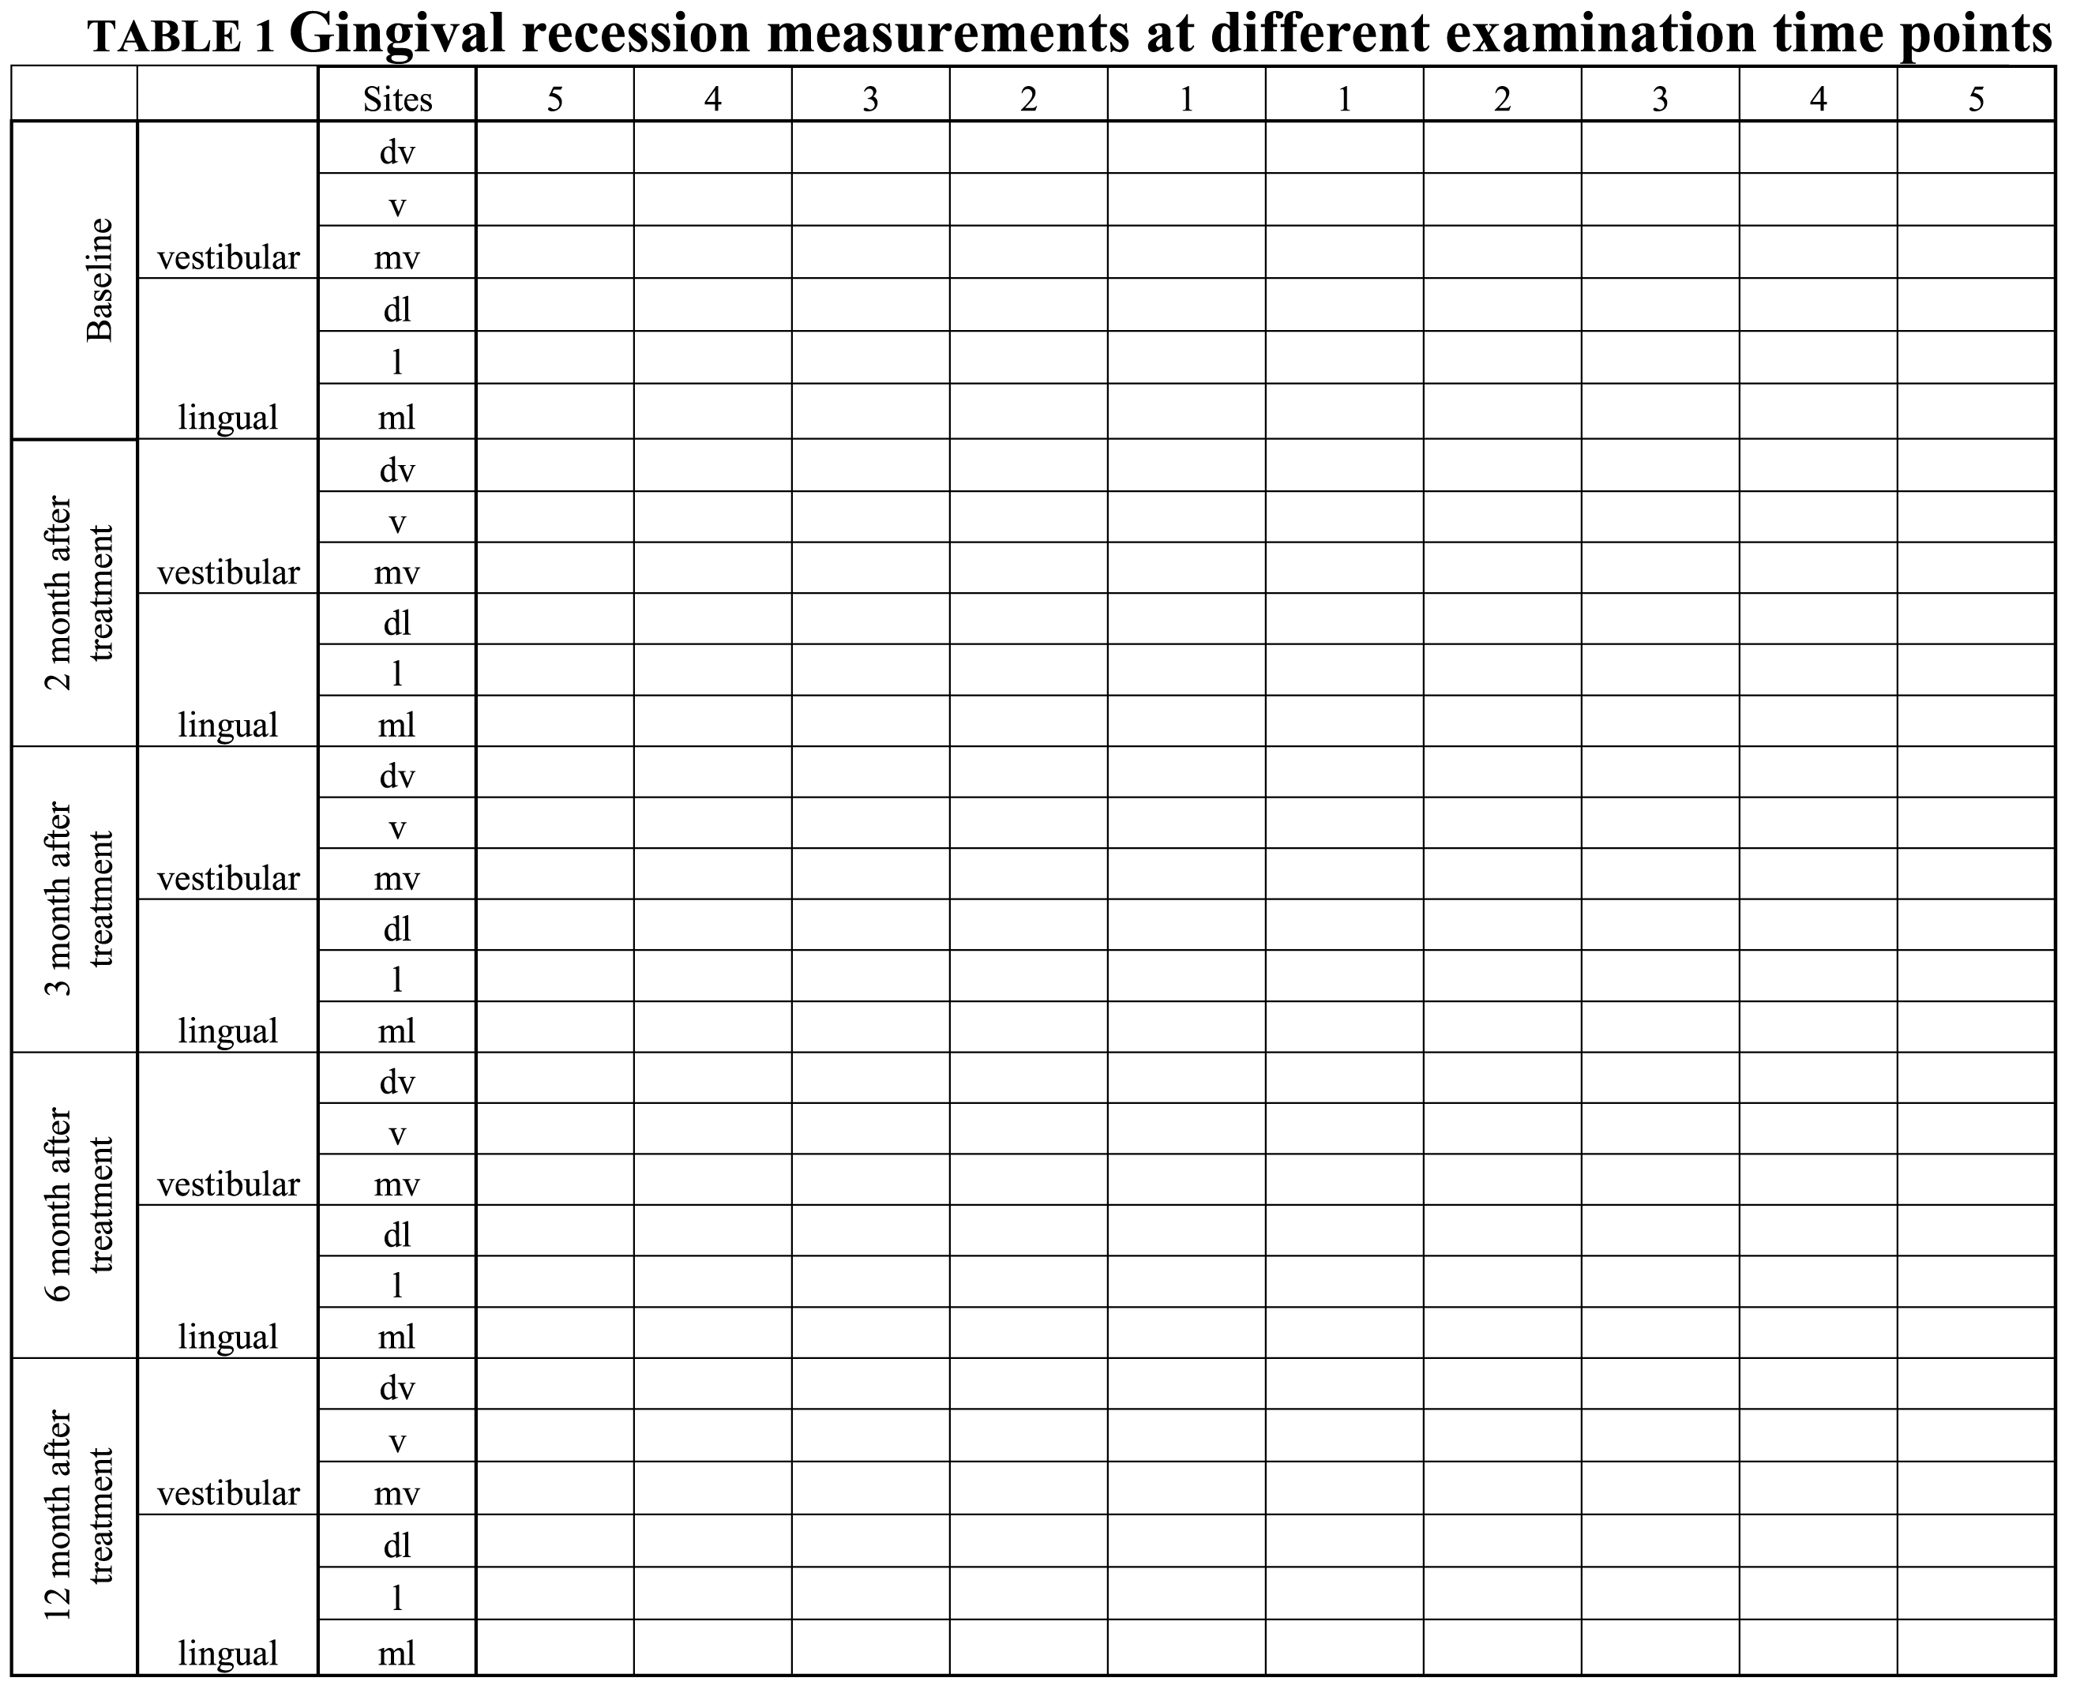

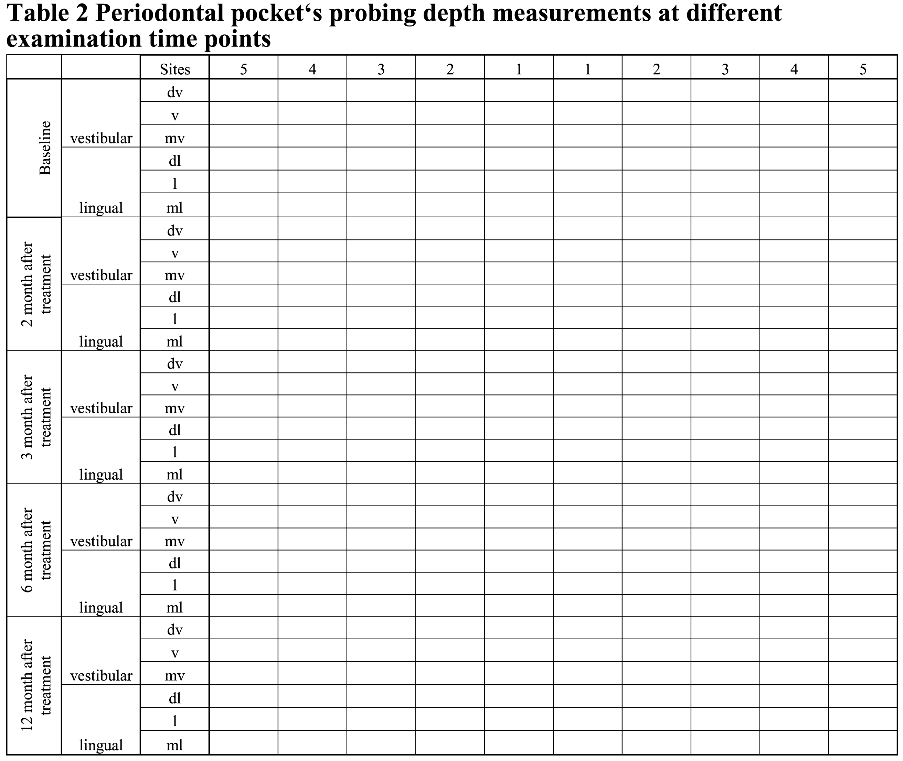

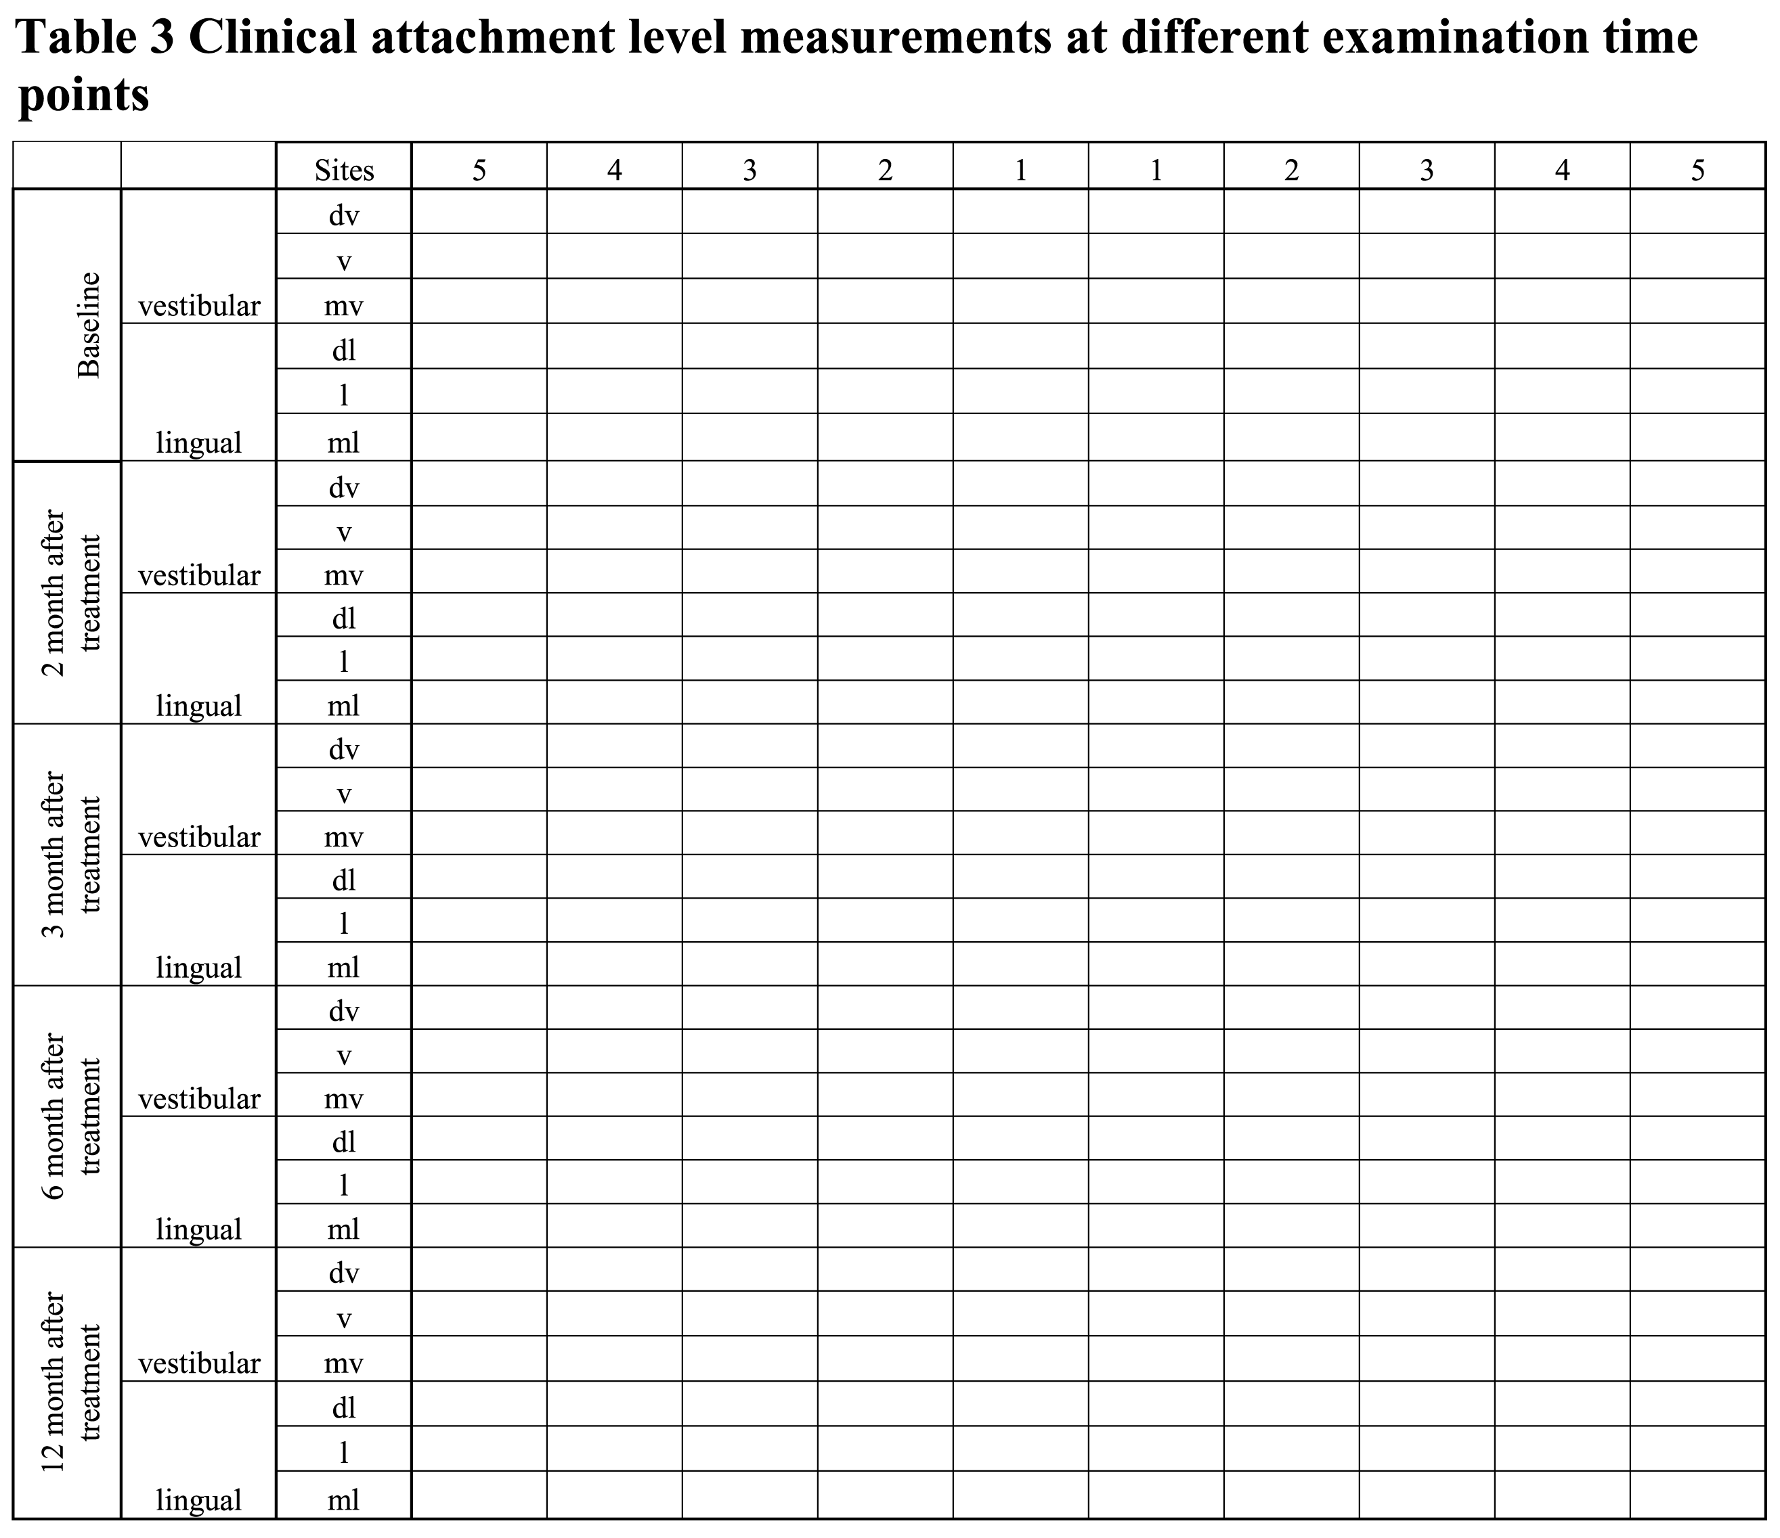
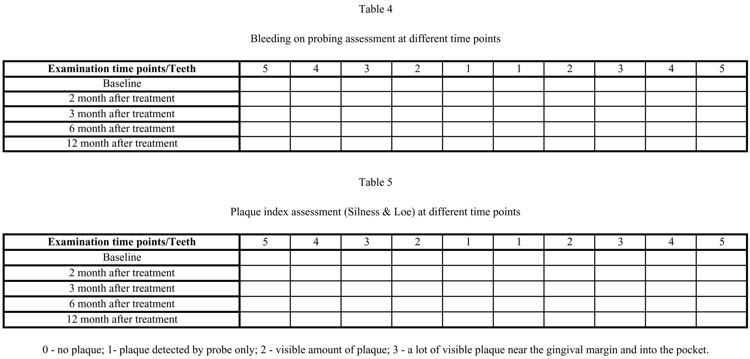

DEDICATION
This dissertation is dedicated to my son Justas and to my daughter Rusne. I give you my deepest expression of love and appreciation for the encouragement that you gave. Thank you for the patience, support and understanding in most of what I was doing and for my late nights of typing.

ACKNOWLEDGEMENTS

The clinical part of this study was done at the Clinic of Dental and Oral Pathology, Faculty of Odontology, Kaunas University of Medicine, Lithuania. The in vitro study and SEM investigations were performed at Department of Conservative Dentistry, Bernhard Gottlieb University Clinic of Dentistry, Medical University of Vienna, Austria.
I want to express my sincere gratitude and thanks to my supervisor Professor Vita Mačiulskienė, DDS, PhD for her huge help and comments concerning this thesis.
I am also very grateful to doctor Stewart Rosenberg, DDS for providing me with his experienced guidance, support and friendship. He has opened to me the doors to the wonderful “lasers world”. His encouragement has been extremely valuable for me along the way.
I am very grateful to Professor Andreas Moritz, MD, DMB, PhD, Medical University of Vienna, for helping me to do in vitro study at this University.
Special thanks goes to Irena Nedzelskienė for her multiple hours spent on statistical calculations, and for taking out of her days to answer my basic questions.
Thanks to Pajauta Paipalienė, DDS, PhD and Nomeda Basevičienė, DDS, PhD for sharing their experience and knowledge.
I want to thank my colleagues and friends for their support and lending a helping hand during these years.
My special thanks to my family for trusting, motivating me to study and never to give up.
I wish to express my appreciation to Biolase Techonology, Irvine, CA, USA and Medical University of Vienna for helping me to do the study.

