
KAUNO TECHNOLOGIJOS UNIVERSITETAS
INFORMATIKOS FAKULTETAS
KOMPIUTERIŲ TINKLŲ KATEDRA

Jurgita Bertulienė

Integruota daugialypė informacinė terpė kalbos mokymosi priemonėms kurti ir palaikyti
Magistro darbas

Recenzentas Vadovas
doc. A.Ostreika doc. B. Tamulynas
2010-05-27 2010-05-27

Atliko
IFT 8 gr. stud.
J. Bertulienė
2010-05-27
KAUNAS, 2010
KAUNAS UNIVERSITY OF TECHNOLOGY
FACULTY OF INFORMATICS
Computer networking department

Jurgita Bertulienė

INTEGRATED MULTIMEDIA ENVIRONMENT FOR design and support of LANGUAGE learning tools
Master Theses

Reviewer Academic advisor:
doc. A.Ostreika doc. B. Tamulynas
2010-05-27 2010-05-27

Student:
IFT 8gr. stud.
J. Bertulienė
2010-05-27
KAUNAS, 2010
SANTRAUKA
Globalizacija bei pakitimai Lietuvos švietimo sistemoje kelia naujus reikalavimus kalbos mokymui(si). Nepakanka vien interaktyvių pratimų ar garso įrašų atsitiktinėmis temomis, reikalinga vientisa sistema apimanti ir tekstą, ir vaizdą, ir garsą, bei turinti bendravimo galimybę. Šio darbo tikslas – integruota daugialypė informacinė terpė skirta kalbos mokymosi priemonėms kurti ir palaikyti. Siekiant tikslo buvo vykdomi išsikelti uždaviniai ir gautos šios išvados:
- Atlikta analizė esamų skaitmenizuotų programų, skirtu anglų kalbos mokymui(si) pagal edukacinius ir technologinius kriterijus bei įvertinta svetimos kalbos mokymo(si) tendencijos Lietuvoje. Tyrimo rezultatai rodo, kad esamos programos neatitinka edukacinių reikalavimų pagal šiuolaikinius kalbų ugdymo standartus. Mokiniai pasigenda e-priemonių ir leksinio bei gramatinio vadovėlių suderinamumo. Mokytojams trūksta naujų privalomų temų pagal atnaujintas Bendrąsias Programas, praktinės užduotys nėra identifikuotos pagal Bendruosius Europos Kalbų Metmenis (CEFR).
- Sukurta integruota daugialypė informacinė terpė kalbos mokymosi priemonėms kurti ir palaikyti (www.bandymas4.us.lt/moodle) remiasi šiais principais:
  - Lanksčia komunikavimo sistema;
  - Patogia prieiga;
  - Lengvu palaikymu, t.y. atnaujinimas, modifikavimas, integralumas;
  - Bendraisiais Europos Kalbų Metmenimis (CEFR);
  - Atnaujintomis Bendrosiomis Programomis;
  - Naujausioji lietuvių autorių vadovėlių serija Early School English.
- Parengta integruotos daugialypės informacinės terpės kūrimo ir palaikymo technologija naudoja šiuos informacinius instrumentus ir priemones:
  - Mokymo turinio valdymo sistema Moodle pasirinkta kaip laisvai platinama, lengvai įsavinama ir populiari Lietuvos mokyklose;
  - Kalbinio bendravimo įrankis (imo.im) suteikia galimybes bendrauti per skirtingas komunikavimo platformas, tai ypač svarbus parametras mokymosi lankstumui užtikrinti;
  - Žodynui naudojama patogi, laisvos prieigos ir nemokama (ImTranslator) priemonė;
  - Užduočių kūrimo priemonės – Microsoft Expression Web 3, Hot Potatoes, Adobe Flash CS4 Professional, PowerPoint, Audacity, Adobe InDesign, CorelDraw, Visio – pasirinktos kaip geriausiai tenkinančios užduočių kūrimo tikslus;
  - Programos integralumas įgyvendinamas Java įskiepių pagalba.
- Sukurti interaktyvūs užduočių rinkiniai (www.bandymas2.projektas.lt, www.bandymas3.projektas.lt), kurie buvo palankiai įvertinti vadovėlių autorių - V.Rupainienės, V.Maksvytienės, N.Sabeckienės. Jų iniciatyva projektas pristatytas Šviesos leidyklai, kuri numato kompleksiškai kompiuterizuoti kalbos ugdymo priemones pagal Early School English vadovėlių seriją.

Darbą sudaro keturios dalys. Pirmoji dalis – Kompiuterizuotų kalbos ugdymo priemonių raida ir perspektyvos – analizuoja esamas kompiuterines anglų kalbos programas ir kalbų ugdymo problemas mokinių bei mokytojų akimis. Antra darbo dalis – Integruotos informacinės kalbos ugdymo terpės struktūra ir technologiniai elementai – skirta informaciniams technologiniams dalykams. Šioje dalyje parenkami ir nustatomi kriterijai integruotai daugialypei terpei kurti ir parenkamos informacinės priemonės jų įgyvendinimui. Trečioje dalyje pristatoma vartotojui svarbi ir būtina dokumentacija – bendrieji ir funkciniai reikalavimai. Ketvirta dalis – Pilotiniai Eksperimentai. Čia pateikti mokymo scenarijų pavyzdžiai naudojant mokymo objektus, kurie sukurti atsižvelgiant į atnaujintas Bendrąsias Programas ir Išsilavinimo Standartus, apklausų duomenis bei Integruotos Daugialypės Informacinės terpės įrankius.

Terms and abbreviations

CEFR – Common European Framework of Reference
FCE - First Certificate Examination
HTML – Hyper Text Markup Language
IM – Instant Messenger
IME – Integrated Multimedia Environment
LO – Learning Objects
LCMS – Learning Content Management System

Table of Contents
Terms and abbreviations 5
the list of the tables 8
the list of the pictures 8
preface 10
1 THE DEVELOPMENT AND THE OUTLOOK OF THE COMPUTER BASED LANGUAGE ACQUISITION MEANS 12
2 THE STRUCTURE AND THE TECHNOLOGIES OF THE INTEGRATED MULTIMEDIA ENVIRONMENT 25
2.1 The Structure of the Environment 25
2.2 The Technologies 27
3 user documentation 35
3.1 General Requirements 35
3.2 Functional Requirements 36
4 Pilot experiments 40
Conclusion 54
Bibliography 56
Appendix 1. QuestionNaire 1 61
Appendix 2. QuestionNaire 2 62
Appendix 3. Cefr 63
Appendix 4. The requirements for language teaching 64
Appendix 5. The features and the types of tasks 65
Appendix 6. the environment 66
Appendix 7. The certificate of publishing company 67
Appendix 8. THE DISTRIBUTION OF FEATURES IN THE PROGRAMS 68
Appendix 9. THE TYPES OF EXERCISES 69
appendix 10. environment.My Family. the dialogue 70
appendix 11. environment.My Family. the quiz ‘mitsy’s family’ (1) 71
appendix 12. environment.My Family. Hot Potatoes tasks (1) 72
appendix 13. environment.My Family. Hot Potatoes tasks (2) 73
appendix 14. presentation. Present Simple 74
appendix 15. Verb to be. short and long forms 75
appendix 16. the agreement of pronouns and verb to be 76
appendix 17. revision exercises (1) 77
appendix 18. revision exercises (2) 78
appendix 19. revision exercises (3) 79
appendix 20. Alphabet tasks (1) 80
appendix 21. Alphabet tasks (2) 81
appendix 22. Alphabet tasks (3) 82
appendix 23. Im QUESTIONNAIRE 83
appendix 24. IM. AIM 84
appendix 25. IM. YAHOO 85
appendix 26. IM. google 86
appendix 27. IM. skype 87
appendix 28. IM. MySpace 88
appendix 29. IM. facebook (1) 89
appendix 30. IM. facebook (2) 90
appendix 31. IMO.IM 91
appendix 32. technologies (1) 92
appendix 33. technologies (2) 93

the list of the tables
Table 1 Criteria and Programs 21
Table 2 IM 30
Table 3 The communication of users among different messengers 31
Table 4 The communication of users among the messengers on imo.im 31
Table 5 Data Flow Directions of IME 36
Table 6 First Functional Requirement 38
Table 7 Second Functional Requirement 38
Table 8 Third Functional Requirement 38
Table 9 The Requirements for the workplace 39
Table 10 Consultation scenario 42
Table 11 Individual lesson scenario 45
Table 12 Group lesson scenario 49
Table 13 Group‘s lesson scenario 51
Table 14 IM Questionnaire 83

the list of the pictures
Picture 1 English+ Millenium CD 14
Picture 2 What is the most difficult to learn at home? 16
Picture 3 What is the most difficult to learn at school? 16
Picture 4 Usage of the interactive programs for learning 17
Picture 5 Finding tasks on the net according to the learning material 17
Picture 6 What is the most difficult for students to learn at home? 18
Picture 7 What is the most difficult for students to learn at school? 18
Picture 8 The Structure of the Integrated Multimedia Environment for Design and Support of Language Learning Tools 25
Picture 9 The structure of the course 26
Picture 10 The Usage of IM 28
Picture 11 The Conceptual Model of the IME 34
Picture 12 The Data Flow Diagram of IME 36
Picture 13 USE CASE Diagram 37
Picture 14 The screenshot of the typical introductory page of the environment 40
Picture 15 The screenshot of the typical environment of the lesson 41
Picture 16 CEFR 63
Picture 17 Theme 64
Picture 18 The screenshot for course of Proficient Users 66
Picture 19 The screen shot of the courses for Basic Users 66
Picture 20 The Distribution of Features in the programs 68
Picture 21 Types of exercises 69
Picture 22 The screenshot of the dialogue 70
Picture 23 The screenshot of the quiz ‘Mitsy’s Family’ 71
Picture 24 The screenshot of Hot Potatoes ‘Mitsy‘s Family‘ 72
Picture 25 The screenshot of Hot Potatoes ‘My Family‘ 72
Picture 26 The screenshot of Hot Potatoes ‘Neighbours‘ 73
Picture 27 The screenshot of Presentation 74
Picture 28 The screenshot of Presentation. Ontology 74
Picture 29 The screenshot of task come on 75
Picture 30 The screenshot of task choose 75
Picture 31 The screenshot of task choose the pair 76
Picture 32 The screenshot of task am or is? 76
Picture 33 The screenshot of task expressions 77
Picture 34 The screenshot of task animals 77
Picture 35 The screenshot of task with promts 78
Picture 36 The screenshot of task with form 79
Picture 37 The screenshot of task alphabet 80
Picture 38 The screenshot of task enjoy 81
Picture 39 The screenshot of task What‘s next? 82
Picture 40 The screenshot of the Vivox Web Voice application 89
Picture 41 The screenshot of Talking Communities voice-chat application dressed in Facebook 90

preface
Communication is the most valuable characteristic which people possess. It lets to express the feelings, thoughts or ideas. Since the beginning of the history of teaching foreign languages, the communication among peoples became possible. The globalization and high-speed communication is impossible without understanding the outlook of the others. This understanding is based on the knowledge of foreign language.
Learning language is very special. It requires a lot of efforts. In all centuries teachers have tried to employ all the possible means to make this process easier, and now when new tools are available, it is time to use them. As Jeremy Harmer in his book ‚The Practice of English Language Teaching‘, says: „The widespread use of the computer – indeed the digital revolution generally...In language teaching, too, things will never be the same again with computer-based materials finding their way into coursebook packages, self-access centres, and classrooms everywhere“ (Harmer, 2002 p. 150). Computers have changed our century and the learning too. This change is of insetimable value.
The software for teaching language is especially in great request, as students understand the importance of the communicating among the different cultures, and English language is the most common language in the world. This demand conditions relative supply, but the requirements change with the changes in Lithuanian educational system. The renewed General Programs (Steponavičius, 2008 p. 267), the European influence (CEFR, 2001), the changes in the compulsory education (2^{d} form) (Steponavičius, 2008 p. 21) and the new Lithuanian course books (Rupainienė V., Druceikaitė V., Sabeckienė N., 2008) for learning language frame the new requirements of the students and teachers. The above statements served the motivation of this paper.
The aim of this paper is to originate the integrated multimedia environment for design and support of language learning tools.
The tasks, to achieve this aim, are:
- Firstly, to analyze and evaluate the situation and the available software for English language acquisition in Lithuania;
- Secondly, to decide on the criteria for the learning environment;
- Thirdly, to choose the technologies for learning environment;
- Lastly, to present the samples of the designing tools.

The structure of the work consists of four parts. The first part analyzes the software for teaching English language and the contemporary education situation for learning foreign language in Lithuania. The second part of this paper is committed to the technical issues. The criteria for the integrated multimedia environment are distinguished there and the information technologies are analyzed. The third part is concentrated on the documentation of the project. The general and functional requirements to the environment are described in this part. The fourth part displays the usage of the project. The pilot experiments are sketched there by the scenarios using sample LO which are designed according to the renewed General Programs, the results of the questionnaires and the tools available in IME.
In concluding the available software for e-teaching/e-learning English language and the situation in Lithuania have been analyzed and evaluated, the users have been questioned and according to the results the solution of the problem has been presented – Integrated Multimedia Environment for Design and Support of Language Learning Tools. The realization tools have been chosen for accomplishing the project. The sample of the project was presented to the publishing company „Šviesa“ and approved by the publishers (See Appendix 7 for the certificate). The idea acquired the commercial side and will be developed in the future.

THE DEVELOPMENT AND THE OUTLOOK OF THE COMPUTER BASED LANGUAGE ACQUISITION MEANS
Nowadays when Information Technologies rules the entire world, it is indispensable to use them in teaching language. Interactive exercises help students to learn subject in an easier way. The opportunity to repeat the activities as many times as you wish prevents learners from the fear of the mistakes. As the software for teaching is so useful, there are a lot of products made to satisfy the growing demand.
According to educational regimentation the programs for teaching language may be set into reference programs, teaching and testing programs, and computer games. Usually these features intercross in the programs.
Reference programs include encyclopedias and dictionaries. There are lots of encyclopedias on various topics. At the moment the most popular is Encarta Encyclopedia. Every year, it was updated and enriched with new and revised articles, media, and features till 2008. The aim of the encyclopedia is to provide a modern learning resource. Though it is discontinued, Encarta is used by people of all ages, at home, in schools and colleges, and at work. (Encarta, 2008) At the top of the dictionaries stays Anglonas (Piesarskas, 2005), which replaced the earlier its version – Alkonas (Piesarskas, 1998).
Language teaching and testing software packages, often supplied on CD/DVD-Rom, offer students the chance to study conversations and texts, to do grammar and vocabulary exercises, and even to listen to texts and record their own voices. There are programs for teaching English language such as Focus on Grammar (Shaw, 2004-2007), TriplePlayPlus (TriplePlayPlus!, 1998), English Plus (twelve levels) (English Plus!, 2005), The FCE Grammar Rom (Ingrid Freebairn and Hilary Rees-Parnall, 2004-2006), Side by Side Interactive (Steven J. Molinsky and Bill Bliss, 2004-2007), etc.
Although some teachers have criticized computer-based programs of this kind as being only dressed-up workbook exercises, it would be unwise to underestimate their usefulness for variety and motivation. Students who have been sitting behind their desks for hours might well find going over to a computer to ‘play’ with exercises a welcome relief. Such programs now include extensive reference resources as well.
A trend which will almost certainly gather pace is the attachment of CD/DVD-Rom-based packages to accompany some course books, full of extra input material and exercises (Eastwood, 2002). Some of these are available, too, on the Internet. There are also web sites where students can sign up for complete self-study courses, which include all regular features of a course book together with the possibility of sending work to a tutor who will monitor progress. A number of language tests have gone or are in the process of going electronic as well.
Computer games are not designed to teach English language, but if they are in English, they can play a role in learning. Games always attracted people from different ages. Computer games are not the exception. There are a lot of computer games nowadays, and the big part of them is in English. So, it is very good idea to apply computer games in foreign language acquisition. While learning languages people have fun playing, so it is the easiest way to learn. The games are much more effective at helping you acquire foreign language skills than other types of exercises.
The software mentioned above may be classified according to the technical features. We can divide the software for teaching according to its storage into portable and non-portable or internet programs. It is important because of the workplace where you are going to use the program.
Portable software includes CDs, DVDs, or any other digital media where the interactive programs are stored. They are perfect if you need to drill certain themes and topics, as they usually involve specific activities based on course books or particular subjects. Their demerits are their permanence, as they are getting out of date; and high price.
The CD-Rom, or DVD-Rom often go with textbooks or grammar books. At the moment the most popular are Round-up (Evans, 2001), English+, Word Bird’s Word Land (Perrett, 2006) and other similar programs. English+ (English Plus!, 2005)and English+ Kids (English + Kids, 2001) are already suffering from the ‘senility’ as they work poor on the computers running the Windows XP and later versions.
1 pic. Round-up, starter – 6 level
Non-portable programs for teaching/learning English language stored on the Internet can carry the same features as portable ones, but they have some merits. They can be updated time to time and present the newest information and up-to-date exercises.
Learning with the help of Internet programs may cost, but the price is much lower than buying CD/DVD-Rom. The time you are permitted to use the course is terminated. The second demerit is the dependence on the internet. You will not be able to use such programs off-line.
Interactive software for teaching English language can also be divided into charged and free of charge. This sorting doesn’t depend on the place of storage: either portable or internet programs may be fee-paying or free of charge. There are free online exercises which anyone can use to improve the skills. There are also some CD-Roms or DVD-Roms which are added for free if you buy a book. But the majority of the educational programs are chargeable.
Prices vary from several litas to some hundreds of litas. Some internet sites for learning English with help of interactive exercises requires only the membership fee, or monthly fee and you may use all the exercises stored there. CD or DVD with interactive exercises and educational games cost more.

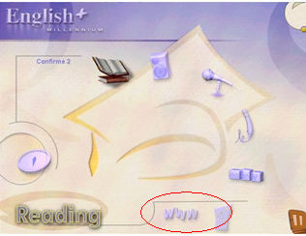
There are also portable programs which include extra option – internet. One of the most popular educational programs with such feature is English+ (English Plus!, 2005) and later its version English+ Millenium (English + Millenium, 2008), issued by Edusoft. Internet connectivity gives students exclusive access to a Community Website. (See picture 1) The publishers declare that students will discover a range of exciting and attractively designed online activities appropriate for their skill level. They claim that the website is constantly updated and includes an instant messaging service and online chat, as well as lots of quizzes to help users improve their English in a stimulating and enjoyable way (Yishay, 2010). I have tried to apply this program in teaching and found some shortages. First, the material is based on the topics which are not relevant to the themes in the coursebooks. This means that you may use this program only for additional learning which is not directly connected with the course. Second, the www option is not supported in the earlier versions of CD, if the new version is presented. I have used this program for some years, but it worked only partly. The internet connection worked only at the beginning, now I cannot connect to the internet with these CDs though the option is still there.
Picture 1 English+ Millenium CD

Educational programs can be also sorted by their readiness to use into fully ready to use programs and programs which are designed to prepare interactive exercises using some simple operations. Educational programs usually are ready to use and require only the installation. The imperfection of such programs is the completeness. No changes are possible. There are limited amount of vocabulary or grammar used in the exercises.
Some educational programs are prepared to create the interactive exercises with the help of simple tools, for example, Hot Potatoes (Holmes, 2009). Such exercises are especially useful as teacher may choose certain vocabulary or grammar which suit to the moment of teaching. Unfortunately, this requires some technical knowledge.
After the exploration of computer based language learning means there were questioned students and their teachers on the issue of learning process. They were asked to answer the questions about the difficulties in learning process and the ability to use the interactive programs for learning. The respondents were divided according to their lever of proficiency in Common European Framework of Reference into two groups:
- Basic and Independent User
- Proficient User
The questionnaires were written in Lithuanian as some of the respondents are not proficient enough to read and respond in English. There were questioned twenty pupils from 2 to 12 forms. The question was: What is the most difficult to learn at home? The survey shows that the most difficult thing to learn at home is the pronunciation. (See picture 2)

Picture 2 What is the most difficult to learn at home?
The same pupils answered into the question: What is the most difficult to learn at school? And this time the results of the survey showed the different thing: the pronunciation from the most difficult became almost the easiest thing to learn. (See picture 3)

Picture 3 What is the most difficult to learn at school?
The question about the interactive programs was very popular among the Basic and Independent Users. Almost all use the internet or other interactive programs for learning. (See picture 4)

Picture 4 Usage of the interactive programs for learning
Next question was: Is it difficult to find the suitable material for learning? Almost all students declared that it is really difficult to find the tasks which would drill the same things as they learn at school. (See picture 5) The Independent Users find more tasks for their learning activities.

Picture 5 Finding tasks on the net according to the learning material

Ten teachers took place in the investigation of the most difficult points of teaching English. The questions were very similar to the questions given in the questionnaire for students, but the point of view differed. So, the first question was: What is the most difficult for students to learn at home? Unanimously teachers decided that pronunciation is the most difficult to learn at home. (See picture 6)

Picture 6 What is the most difficult for students to learn at home?
Next question was about the learning at school: What is the most difficult for students to learn at school? Now teachers distinguished listening and the pronunciation became the easiest activity. (See picture 7)

Picture 7 What is the most difficult for students to learn at school?
The results of the questionnaires served the quidance to prepare the scenarios in the pilot experiments of the integrated multimedia environment. The most difficult spheres of learning were tasked especially.
As the students so the teachers use the Internet and the interactive tasks for acquiring teaching material, but they are not satisfied with the available data. The survey of the software and the questionnaires show that there are a lot of interactive programs for learning/teaching English language, but the demand is not yet satisfied. What do these programs lack? I have done the research and questioned learners and teachers on the issue of the requirements for the language learning/teaching programs. There were questioned 50 pupils and 20 teachers. The learners distinguished next requirements for the program:
- Free
- Possibility to communicate with co-learners
- Possibility to communicate with teacher
- Instant feedback
- Themes coordinated with course books
- Tasks identified by the levels of proficiency stated by CEFR
- Easy to access (not tied to the certain workplace)
The teachers distinguished next requirements for the language teaching program:
- Free
- Updatable
- Possibility to communicate
- Instant feedback
- Themes coordinated with course books
- Tasks identified by the levels of proficiency stated by CEFR
- Tasks prepared according to the renewed General Programs
- Possibility to modify tasks
- Easy to access (not tied to the certain workplace)
- Possibility to integrate in advance prepared tasks
According to the criteria distinguished by the learners and teachers I have analyzed the programs for language learning/teaching. As there are a lot of programs with similar features I have used five main groups according to the technical possibilities: Portable (CD/DVD), Portable with Internet option, Non-portable (Internet programs), Ready to use, Ready to create exercises. Here I present the table where the featured program is marked with plus and non-featured program is marked with minus:

Table 1 Criteria and Programs
Criteria/  programs | Possibility to communi-cate with co-learners | Possibility to communica-te with teacher | Ins-tant feed-back | Themes coordinated with course books | Tasks identified by the levels of proficiency stated by CEFR | Easy to access (not tied to the certain workplace) | Upda-table | Tasks prepared according to the renewed General Programs | Possibility to modify tasks | Possibility to integrate in advance prepared tasks
Portable (CD/DVD) | - | - | + | - | - | - | - | - | - | -
Portable with Internet option | + | + | + | - | - | - | - | - | - | -
Non-portable (Internet programs) | + | + | + | - | - | + | + | - | - | -
Ready to use | - | - | + | + | - | - | - | - | - | -
Ready to create exercises | - | - | + | + | + | - | + | + | + | -

The table shows the distribution of the features in the programs for language learning/teaching. (See table 1) It is obvious that programs acquire only one or some features required by the learners and teachers. The diversity of programs for learning English language does not satisfy the demand of having all features together.
Nowadays the situation is especially complicated as the combination of many factors started to condition the demand of the interactive programs for learning language in Lithuania. When the situation changes worldwide, there is a chance of adoption the solution of the problem from other countries, but now the problem is phenomenally Lithuanian. First, it lies in the variety of programs which suits only partly for drilling the themes which are presented by the course books. These programs are good for deepening the knowledge, but it helps only a little for drilling the certain topic according to the program. The issue is not overpowering for the higher form learners, but it tasks the power of the beginners or weaker learners. Second, the Renewed General Programs issued by Ministry of Education and Science (Steponavičius, 2008) state certain themes for certain forms. The new programs were approved two years ago. They were applied at schools only from this school year (1st of September, 2009). There was no time to rewrite and reissue the course books so the teachers have to look for additional material everywhere. Third, the proficiency of students were stated differently at schools for many years in Lithuania, but now the levels of proficiency defines the Common European Framework of Reference for Languages (CEFR, 2001). It is difficult to identify the activities without trying them if they are not marked according to the CEFR levels. Fourth, the early English learning was supplementary till the September of 2010, but from this school year all pupils begin learning English from the second form (Steponavičius, 2008). It became the part of compulsory education, so the system of planning all the teaching forms has to be changed. This courses the great change in the teaching of English language and requires the appropriate preparation of teaching material. Fifth, the teachers used the course books for teaching language from different authors and countries. The main requirement was the conformation for second language learning. Now the tendency changed – we start using Lithuanian course books. As Jerry G.Gebhard in his book ‚Teaching Enlgish as a Foreign or Second Language’ (Gebhard, 2000 p. 113) demonstrates the importance of cultural understanding in teaching language, so the Lithuanian educators started the new era of Lithuanian course books. This spirit is obvious at schools and the editor-in-chief of the publishing company ‚Šviesa“, Lidija Rasimavičienė claims that the demand of Lithuanian course books grow (Petruškevičiūtė, 2010). The course books written by Lithuanian authors are designed for Lithuanian learners and better correspond their needs.
The first and the fifth issue of course books and the corresponding themes may be solved by the creating the CD-Rom next to the course books, as there was done with some course books in other countries. The application of already existing interactive CD-Rom activities from the other course books is impossible, as the lexical and grammatical units do not match. Designing interactive CD-Rom for the course book has the weakness of portable programs for interactive learning (See table 1). It is getting out of date very quickly, there is no possibility of addition, there is no option of communication, etc. The other solution is the environment for the interactive activities which correspond to the themes of the course books.
The second issue of the absence of certain themes in the course books which are essential according to the Renewed General Programs issued by Ministry of Education and Science (Steponavičius, 2008)may be solved by rewriting course books with some additions of the themes, or issuing the special additional booklet with the missing themes. Both cases require big expenses and time; and there is no guarantee that after couple years the General Programs won’t be renewed again. But if the course book obtains the environment for corresponding interactive activities, the missing themes may be put there without rewriting the entire course book.
The third issue of the difficulty identifying the activities according to the levels of the proficiency may be solved by trying them one by one. This way is tiring and not efficient, but it is the only way for a moment. The interactive programs do not declare the CEFR levels (CEFR, 2001). The environment divided by the CEFR levels where the teachers-experts would recommend the additional tasks for certain levels of proficiency would help students to save time and motivation, as motivation usually disappears when time has been wasted for inefficient searchers.
The fourth issue of the compulsory early learning is extremely complicated. The young learners are very receptive, but also very sensitive. The misfortunes may cause the unimprovable harm on the motivation and later learning. Their ability to imitate and memorize is greater than in the higher forms, but there is no enough time during the lessons to drill all the phonetic, lexical and grammatical units. Some of the units are only mentioned and left for self study. The basis acquired at that stage of learning influence the rest learning process. The better is the beginning, the easier is the further learning. There is no way to multiply language learning lessons, but the environment where pupil can meet and share their learning deeds would help a lot.
Considering the above arguments the best solution for these issues may be the integrated multimedia environment for design and support of language learning tools. This environment should be tied to the course book and divided into sectors by the CEFR levels where the teachers may put the interactive tasks for their students and share their experience. This environment should be corrigible and integratable, so there won’t be a problem to insert or create a new task. The learners should have the ability to communicate among themselves and with the teachers.

THE STRUCTURE AND THE TECHNOLOGIES OF THE INTEGRATED MULTIMEDIA ENVIRONMENT

The Structure of the Environment
Summarizing the aim and the tasks, the cornerstone of the project is the origination of the integrated multimedia environment for design and support of language learning tools. The environment should fulfill the general requirements:
- to integrate and modify the sources of information into the unifying environment and to present friendly interface;
- to identify the users;
- to give instant feedback
- the communicating system between the users should work without the restriction of the communicating platforms;
- the themes should be coordinated with course books
- the tasks should be identified by CEFR standarts
- the tasks should reflect renewed General Programs
- the environment should work at any computer with the internet connection;
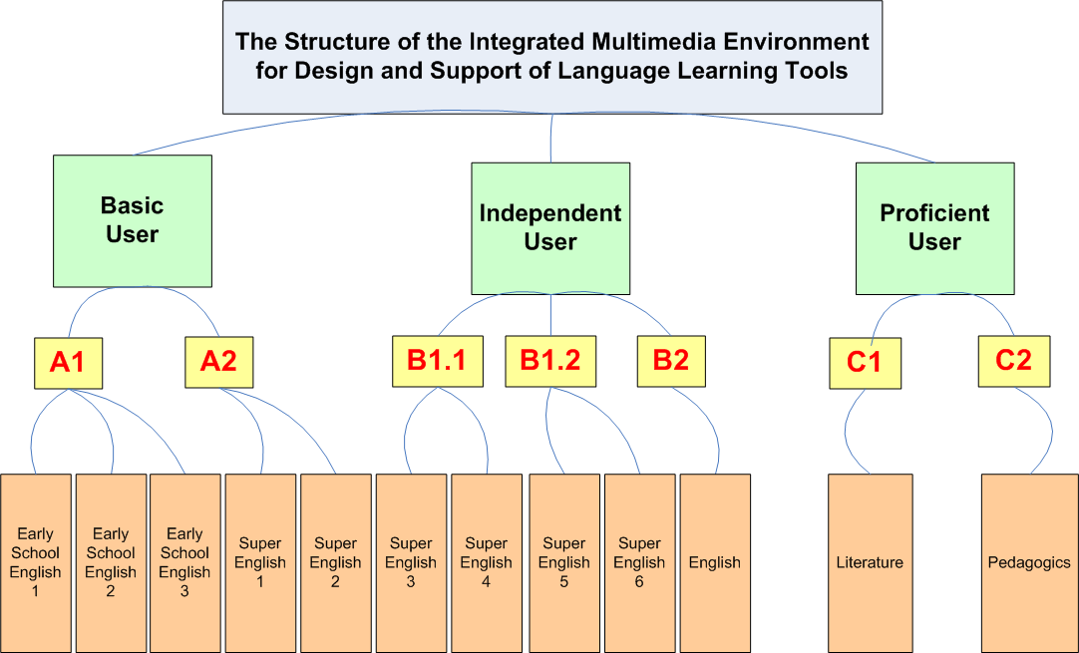
Picture 8 The Structure of the Integrated Multimedia Environment for Design and Support of Language Learning Tools
The structure of the Integrated Multimedia Environment is set according to the requirements mentioned above. (See picture 8) It is uploaded on the server and may be found at the address: www.bandymas4.us.lt/moodle.
There are three main categories in the Integrated Multimedia Environment. Basic and Independent users are the pupils from the second to the twelfth forms. The category of Proficient users is for the teachers; they can share the literature and the pedagogical peculiarities there. Each course category is divided into subcategories which declare the more exact level of proficiency. The CEFR standards are used for the dividing. These subcategories include courses. This kind of structure lets to identify the tasks by the levels of proficiency and simplifies the search. The learning objects (LO) made after the material of the course books are accumulated in the LO base and may be used for creating courses.
The structure of the courses depends on the administrator, but it may acquire certain features or activities. (See picture 9) The LO included in the courses have instant feedback; they are coordinated with the course books and prepared by the renewed General Programs.
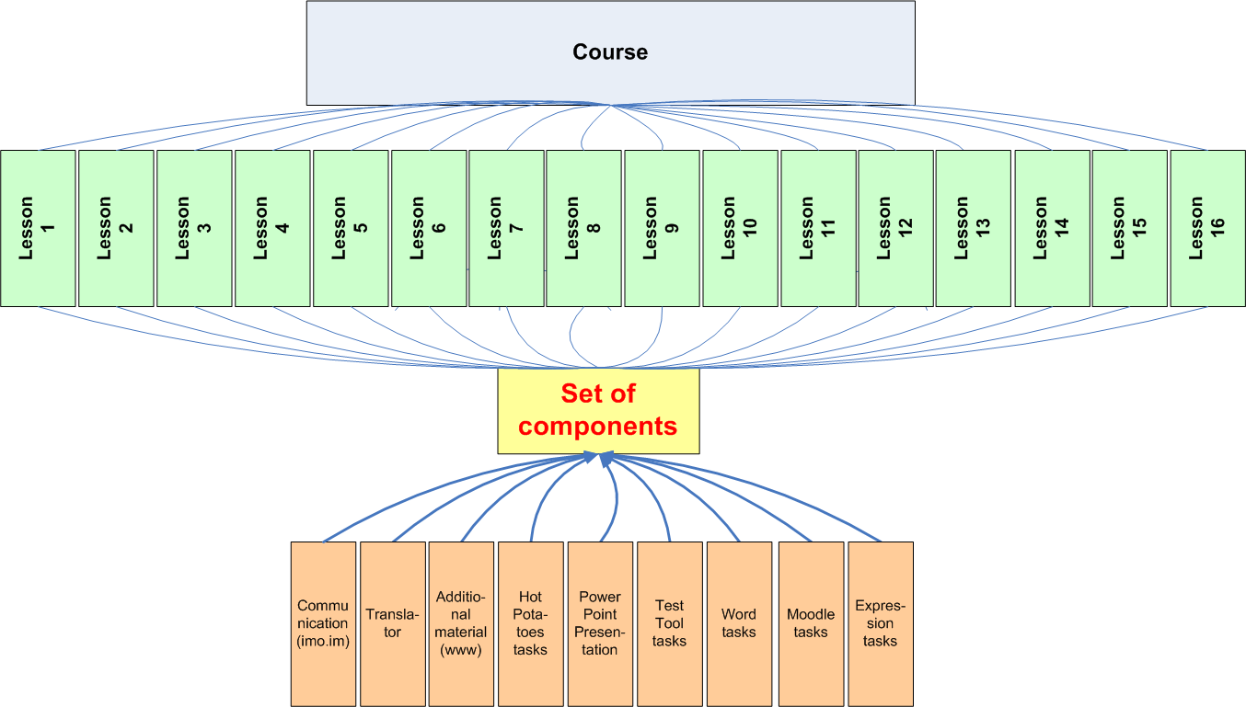
Picture 9 The structure of the course
The feature of communication (Harik R., Harik G., Krishnamurthy P., 2007) and the component of translation (Smart Link Corporation, 1993) are included in every lesson, but the other features may be selected or not by the administrator. Additional material may be included by inserting the hyperlink to the pages or with the help of Java scripts. The exercises created with the programs such as Hot Potatoes (Holmes, 2009), PowerPoint Presentations (Microsoft PowerPoint, 2003), Microsoft Expression (Microsoft Expression, 2009) can be uploaded to the environment as the resources or activities. The students and teachers can use the environment after signing in and identifying themselves. The environment works at any computer with the internet connection.

The Technologies
Integrated Multimedia Environment combines a set of technologies for the design and support of learning contents. The base for the environment was chosen the LCMS. The price of such systems is high, but there are also open source systems. Such systems as OutStart (Alonso, 1999), EZ (EZ, 2008), Joomla (Joomla!, 1991), Absorb (Absorb, 2003) , and Moodle (Dougiamas, 1999) were investigated. They differ one from another in the amount of reports or the extra features such as calendars, meeting rooms, etc. Their main function remains the same – they present the environment for storing material and the tool for manipulating this material. I have chosen to work with Moodle. The choice was based on:
- The price. Moodle is an open source system.
- The location. Moodle is widespread not only in the world, but it is also very common in Lithuania.
- The installation. Moodle is easy to download and start using. The main requirement for the system to have the access to the internet.
- The usage. Moodle is easy to use. The management of the system is simple.
The chosen system had two options for loading it:
- to load the system into the server on the net
- to create local virtual server and to load the system there
First, I have tried to load it on puslapiai.lt server (Puslapiai.lt), but it failed as this server had safe mode on. This server was chosen because of its price: to keep a package of 100 Mb there it costs only 1Lt per month; and it has flexible payment system: you can pay sending a message from your mobile phone, and you don’t need to pay for a year in advance as in other servers. The other commercial servers cost much more and payment may be done only through the bank account. After this failure, I have created the local virtual server and put the Moodle there, as there were no restrictions and enough free space, the system loaded without any trouble. Later the environment was replaced on the net on the Universalūs Sprendimai server with normal mode on (UAB "Universalūs sprendimai", 2005).
Communication and instant feedback is very important in learning pronunciation. The chosen learning management system has got a feature for communication, but it’s restricted to messaging in forums. Learning the pronunciation is impossible without speaking and listening to the co-learners and teacher. This served the deep investigation of communication tools which provide audio/video chat option.
Instant messaging (IM) is a form of real-time direct communication between two or more people. The IM integrated in the learning environment would solve the communication problem. But here I faced the other problem: there are a lot of IM which are used by students and teachers. Which one to choose? For this purpose there was given a questionnaire – to find out which instant messenger is the most popular among the teachers and pupils (Questionnaire ‘Instant Messenger’ See Appendix 23). Fifty people were questioned on that issue. (See picture 10) The results showed that most of them use instant messenger and the option of voice (video) chat keep useful.

Picture 10 The Usage of IM
The respondents mostly use Skype (Skype, 2003), though Google Talk (Google Talk, 2009) and Facebook (Zuckerberg, 2004) are also very popular. Yahoo messenger (Jerry Yang, David Filo, 1994) is used among the teachers and pupils too. The rest use such instant messengers as MySpace (Anderson, 2003) and AIM (Aim, 1997). It is obvious that voice/video chat is basically used in Skype and Google. The rest messengers are used without voice/video chat option. The survey of the questionnaire shows the reason of low interest in voice/video voice chatting on some messengers. Though the questionnaire included open questions, they could be grouped into two parts. The first reason is the simplicity of the usage and the second reason is the absence of demand. (See Appendix 23)
99% of respondents, who don’t use voice/video chat on their messengers, do it because of technical issues. As some messengers require installation they don’t use this option at all. The reasons can be dual: the persistent change of computers, or the lack of knowledge for the installation of the plug-in. Though questionnaire results were summarized into two general answers for not using the voice/video option, but the majority of the respondents declared that know nothing about such a possibility on their messengers. For example, the most users of Facebook were sure that Facebook doesn’t have the function of voice/video chat.
As the messenger is meant to be the tool for the communicating in learning process, it must acquire the best options and will be easy to use. This statement served the reason of the investigation of the messengers mentioned in the questionnaire. The messengers were analyzed under the principals of operation which would be suitable for the web based environment for learning/teaching foreign language. All messengers listed above are free of charge (basic options), so the price doesn’t influence the choice.
Summing-up, the voice/video chat option in instant messengers has got similarities and differences. I have tested all above mentioned messengers and found out that each could be used as a tool for learning the pronunciation of foreign language, but all learners and teachers should sign up as users. The problem is how to find the most suitable for everyone. Questionnaire shows that pupil and teachers use different instant messengers. Although all of the mentioned instant messengers have the option of voice/video chat, there is no one common messenger which could be used for the project as unifying platform. The investigation of the instant messengers revealed that some messengers can be connected with the others, but this connection is mostly for importing buddies and not for chatting. (See table 2)
Table 2 IM
 | Charge | PC based communication for voice/video chat | Web based communication for voice/video chat | Buddies interchange among different IM | Option of communication among different IM (chatting, voice/video calls) | Ability to insert html code for launching IM application from the web page
AIM | - | + | + | + | - | -
Yahoo | - | + | - | - | - | -
Google | - | + | + | - | - | -
Skype | - | + | - | - | - | +
MySpace | - | + | - | + | - | -
Facebook | - | + | + | + | - | -

The investigated messengers have got the voice/video chat option which requires the installation of the plug-ins. Three messengers (Yahoo, MySpace, Skype) cannot be used for chatting and voice/video calls only on the net, as they cannot function without installation. Two instant messengers (Google, Facebook) can partly be used for connecting to chat from different computers. This could happen if the owner of the computer has installed the plug-ins and use them for his/her voice calls. In that case you may connect with your name and password and use messengers as usual. And only one messenger has the express version which supports talking without any installations directly from where you are. The application of AIM works without installing plug-ins. You may connect from any place in the world and talk. The only shortcut of that messenger is that it is poor used by pupils and teachers.

The chosen messenger can be integrated into the page, the html code of voice call to certain messenger can be insert into the page (only one messenger has this option), or messenger and the contacts can be simple written on the page. The last option isn’t very good; it is not acceptable to leave such important sphere as communication for itself. If pupils face any connection problem, they can give up trying and leave the practice of the pronunciation for later.
I have researched the instant messenger’s applications and found that all messengers have shortcomings. First, most of them require the installation. Second, some are poorly used. Third, all they force to quit the activities while talking. But I still found the solution. There is the other option for using instant messenger without installing it on the computer and without unifying all co-learners and teachers under one instant messenger service. It is possible through imo.im (Harik R., Harik G., Krishnamurthy P., 2007). If usually messengers can communicate only among the users of the same service (See table 3), with imo.im the communication widens to multi platform communication. (See table 4)
This served the choice.
Table 3 The communication of users among different messengers
The communication of users among different messengers
 | Skype | Google Talk | Yahoo | AIM | My-  Space | Face-  book
Skype | + | - | - | - | - | -
Google | - | + | - | - | - | -
Yahoo | - | - | + | - | - | -
AIM | - | - | - | + | - | -
MySpace | - | - | - | - | + | -
Facebook | - | - | - | - | - | +
Table 4 The communication of users among the messengers on imo.im
The communication of users among the different messengers on imo.im
 | Skype | Google | Yahoo | AIM | My-Space | Facebook
Skype | + | + | + | + | + | +
Google | + | + | + | + | + | +
Yahoo | + | + | + | + | + | +
AIM | + | + | + | + | + | +
MySpace | + | + | + | + | + | +
Facebook | + | + | + | + | + | +

The chosen communication tool imo.im was integrated into the environment as Google gadget (Google, 2008) with Java scripts. The same way the program for translating ImTranslator (Smart Link Corporation, 1993) was inserted into the environment. The next step was to choose the technologies for the designing of LO. There were analyzed the programs suitable for the designing tasks. The choice was based on the requirements for language teaching (for the requirements see Appendix 4) and the distribution of these features in the programs for designing LO (for the distribution of the features see Appendix 8). There were selected three programs: Expression Web 3 (the renewed Front Page), Hot Potatoes 6, and PowerPoint.
Chosen programs cover the designing of many different exercises. Type of the tasks depends on the program. One program may have the features of creating certain type of objects and another program may have the other features which let run other tasks. This doesn’t mean that one program is better than another. The different options of the programs allow presenting different types of exercising which is useful in language acquisition. (See Appendix 9 for the types of exercises)
The Moodle environment has itself many tools for designing tasks. There are choice, quiz, glossary and other types of tools for designing tasks there. These tools are useful and easy to use, if you create the task at the moment. But if you already have the tasks, the ability of integration of other programs is of great value.
The most popular is the integration of the tasks and tests designed with HTML editors. The tasks were integrated with the help of JavaScript. Interactive web page based exercises are one of the most interesting tasks learning language. For this kind of activity I have tried three HTML editors: Microsoft FrontPage (Microsoft FrontPage, 2003), Microsoft Expression Web 3 (Microsoft Expression, 2009), and Adobe Dreamweaver CS4 (Adobe, 2009). These programs have very similar features; they differ mostly in design and the automation of the functions, though all they have the option of HTML code editing. I have chosen Microsoft Expression for its friendly interface: all the options are located and adjusted for very convenient usage. This renewed version of Front Page suited for my project the best. It has a lot of features for building interactive exercises. (For the features of HTML editor used in the designing tasks see Appendix 5)
Hot Potatoes (Holmes, 2009) is also based on HTML and JavaScript. This program is made for creating exercises without even knowing the code language, the program does it itself. I have used it as a tool for creating exercises with more interactivity and with less effort. While creating is very easy and requires the minimum of knowledge, the edition of these exercises is more convenient with one of the HTML editors (Front Page, Expression, etc.) Outlook (Microsoft Outlook, 2003) was used in the forms for sending tests for the teacher. Power Point (Microsoft PowerPoint, 2003) served for the presentations of the new material.
Design of language learning tools is mainly related with the programs mentioned above, but the full view is impossible without secondary or additional programs. They are not suitable for designing tasks independently, but they provide the essential parts of tasks such as sound, pictures, and animation.
One of the additional programs which were used for creating learning content is the Audacity program (Mazzoni, 1999). This program has been chosen for making records to help learning the pronunciation and to cut the records into pieces. Every word from the vocabulary of the extra themes was pronounced and recorded with the help of this program. The records were saved and linked to the certain pictures with Java scripts.
Files were saved not only in default format (*.aup), as the files of this format are incompatible with many other programs. HTML editors do not support this type of format. I have chosen to export them into WAV. The copy of default saving was left because it has the option of saving sound exactly as it was pronounced and later the more precise edition may be done for it. The cuttings were done with excellent quality, but the recording is the shortage of this program. The program is freeware; this serves the motivation to link to it.
Static and animated pictures are widely used in this e-teaching, so I had to choose several programs to create them. First, I was forced to use Adobe InDesign (Adobe, 2009) as the Early School English course book (Rupainienė V., Druceikaitė V., Sabeckienė N., 2008) is created with the help of this program. CorelDraw (Corel Draw, 2006) helped to make the original pictures for illustrating learning material and Visio (Microsoft Visio, 2003) served in making diagrams. I have tried to use such programs as Paint (Microsoft Paint, 2007), Adobe Photoshop, Adobe Fireworks (Adobe, 2009) which later were changed by more suitable. (for the detailed investigation of the programs see Appendixes 32-33) It seemed that after the experiments I abandon all Adobe programs, but it was true until I have tried to work with Adobe Flash CS4 Professional. This program embodied all my visions. I could use the tool of Photoshop for editing images; I could create animated pictures and export them to the HTML editors. So, at the end of my searchers I have chosen two programs for work: Corel Draw for drawing cartoons and Adobe Flash CS4 Professional for editing them and animating.
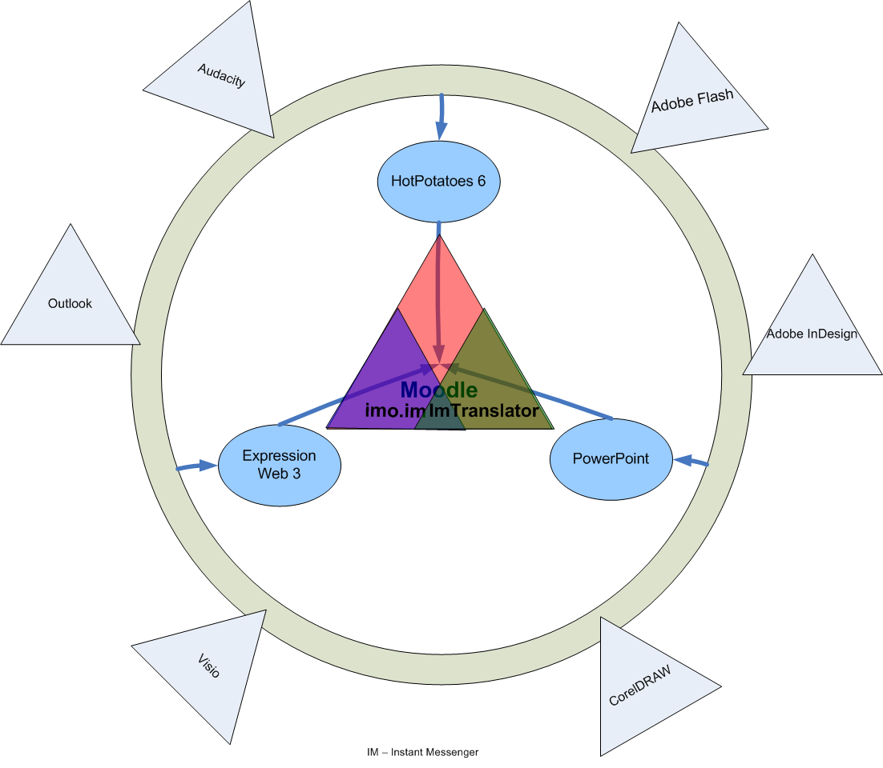
Picture 11 The Conceptual Model of the IME
The picture above shows the conceptual model of the IME – the integration of the programs into the environment. (See picture 11) The extra programs (Audacity, Outlook, Visio, CorelDraw, Adobe InDesign, Adobe Flash) help to create sound, text, animation and test feedback. Integrated in the HTML editors or slides these technologies create LO. The Moodle environment integrates these LO and communicating platform for design and support of language learning.

user documentation

General Requirements
The aim of this document is to specify the requirement for the Integrated Multimedia Environment for Design and Support of Language Learning Tools.
The participants/users fall into next categories: learners, teachers, designers, administrators.
The characteristics of the environment: integrated multimedia environment with the option of communication on different platforms and thematically tied to the Early School English set of course books.
The description of the environment: integrated multimedia environment for design and support of language learning tools.
Analogical systems: there are no analogical environments;
The description of the users: learners and teachers have the basis of computer knowledge, designers and administrators are computer proficient.
The issues of the users: difficult to find the interactive activities which fit for the certain levels of proficiency and the themes by renewed General Programs; there are no the interactive activities tied to the Early School English course book; the communication problems.
The requirements of the users: to find the material quickly, according to the levels of proficiency; to have the ability to drill the lexical and grammatical themes from the course books; to find the interactive activities and the themes which are not set in the course book but are required by the renewed General Programs; to have the ability to consult co-learners and teachers while learning at home; to have the ability to insert or modify LO, to have the easy access and get the instant feedback.

Functional Requirements
In the context of the sphere of activity the data flow diagram was set for analyzing the situation. (See picture 12)
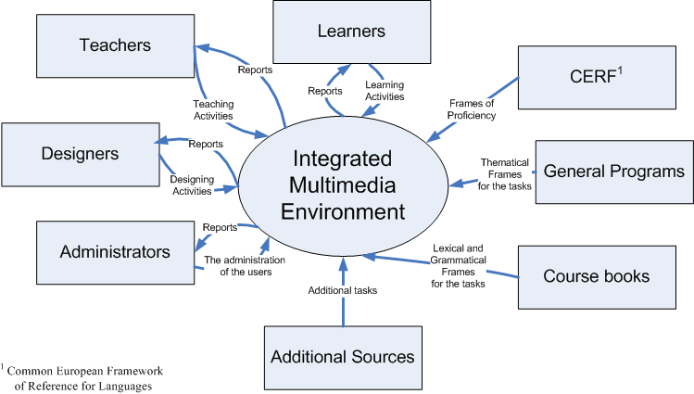
Picture 12 The Data Flow Diagram of IME
In the process of the investigation of data flow and the users’ activities, the table of data flow directions is set. (See table 5)
Table 5 Data Flow Directions of IME
N | Event | The direction of data flow | In/Out data flow
1. | General Programs have been renewed | In | The data of the Renewed General Programs
2. | Common European Framework of Reference for Languages has been changed | In | The data of the Common European Framework of Reference for Languages
3. | Course books have been changed | In | The data of the new course books
4. | Additional programs have been created | In | The data of the additional programs
5. | New users appear | In | The data of the new users
6. | New tasks have been designed | In | The data of the new tasks
7. | New course have been created | In | The data of the new course
8. | The user take a course | Out | The data of the course
9. | The user take a test | In | The data of the test
10. | Viewing the reports | Out | The data of the reports

Analyzing the sphere of activity and the data flow directions the framework for the users is set in the USE CASE diagram (See picture 13):
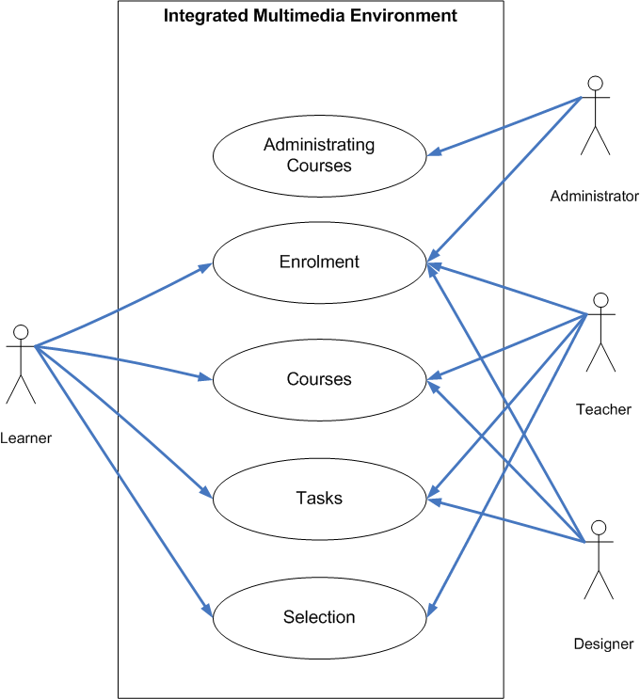
Picture 13 USE CASE Diagram
Considering the sphere of activity, data flow, and the USE CASE diagram next functional requirements have to be distinguished (See pictures 6-8):

Table 6 First Functional Requirement
1st requirement | Enrolment
The description of the requirement | The administrator enrolls the user into the course and manage the account
The influence of the requirement to the system | New user appears
Technical issues | The administrator should be able to make the enrollments at any computerized work place
Connection with other requirements | Other requirements are impossible without the fulfilling the 1st requirement

Table 7 Second Functional Requirement
2nd requirement | Designing the tasks, tests, and courses
The description of the requirement | The designer creates the task, tests, designs the courses
The influence of the requirement to the system | New tasks, tests and courses appear
Technical issues | The designer should be able to work at any computerized work place
Connection with other requirements | Connected with the 1st requirement – only enrolled designers can create tasks, tests, and courses

Table 8 Third Functional Requirement
3rd requirement | Using the environment
The description of the requirement | The non-editing users (learners and teachers) use the prepared courses and choose the tasks according to their needs
The influence of the requirement to the system | New reports appear
Technical issues | The users should be able to work at any computerized work place
Connection with other requirements | Connected with the 1st and 2nd requirements – enrolment and designing – only enrolled users can take a course; the users can choose the course from the designed courses
The integrated multimedia environment for design and support of language learning tools doesn’t require the installation and works with the help of the components which meet the next requirements (See table 9):
Table 9 The Requirements for the workplace
Component | Requirement
Computer and processor | 500 megahertz (MHz) processor or higher
Memory | 256 megabyte (MB) RAM or higher
Hard disk | It doesn’t require the space on the disk for the installation, but only for uploading or downloading the files. It depends on the size of the file.
Drive | CD-ROM or DVD drive
Display | 1024x768 or higher resolution monitor
Operating system | Microsoft Windows XP or later operating system
Others | Communicating functionality requires a microphone and audio output device.  Internet Explorer 6.0 or later.  Internet functionality requires Internet access.

Actual requirements and the functionality of the integrated multimedia environment may vary based on the system configuration and operating system.

Pilot experiments
Integrated Multimedia Environment is arranged for design and support of language learning tools. Thematically it is divided according to CEFR levels. Picture below displays the typical introductory page of the environment. (See picture 14) Lexically it is tied to the set of Early School English course books and includes the dictionary. IME enables the generation of language learning chains: text, pictures/animation, sound and communication through the composition of the learning objects (LO). The feedback is conveyd through the tests and communication tool which combines different communication platforms. LO are accumulated in the LO base. Teachers may use them for the design of teaching scenarios. The integrity of the environment is based on JavaScript.

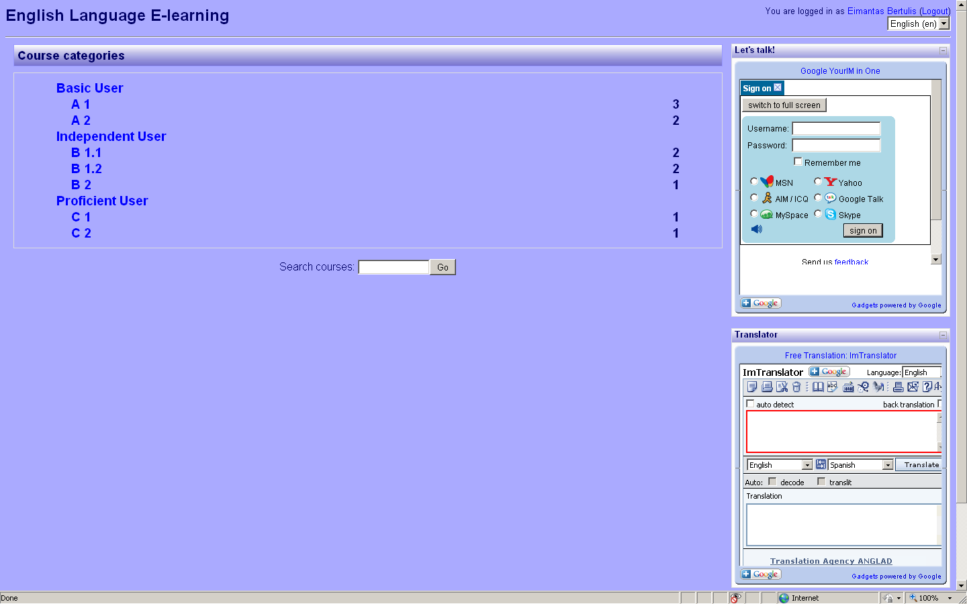
Picture 14 The screenshot of the typical introductory page of the environment

There were made pilot experiments and four sample scenarios were created from the LO of the IME: consultation, individual lesson, group lesson, and groups’ lesson. Next picture shows the typical environment of the lesson. (See picture 15) It was done in one of the pilot experiments, using the below presented teaching scenarious. (For more environment screen shots see Appendix 6)
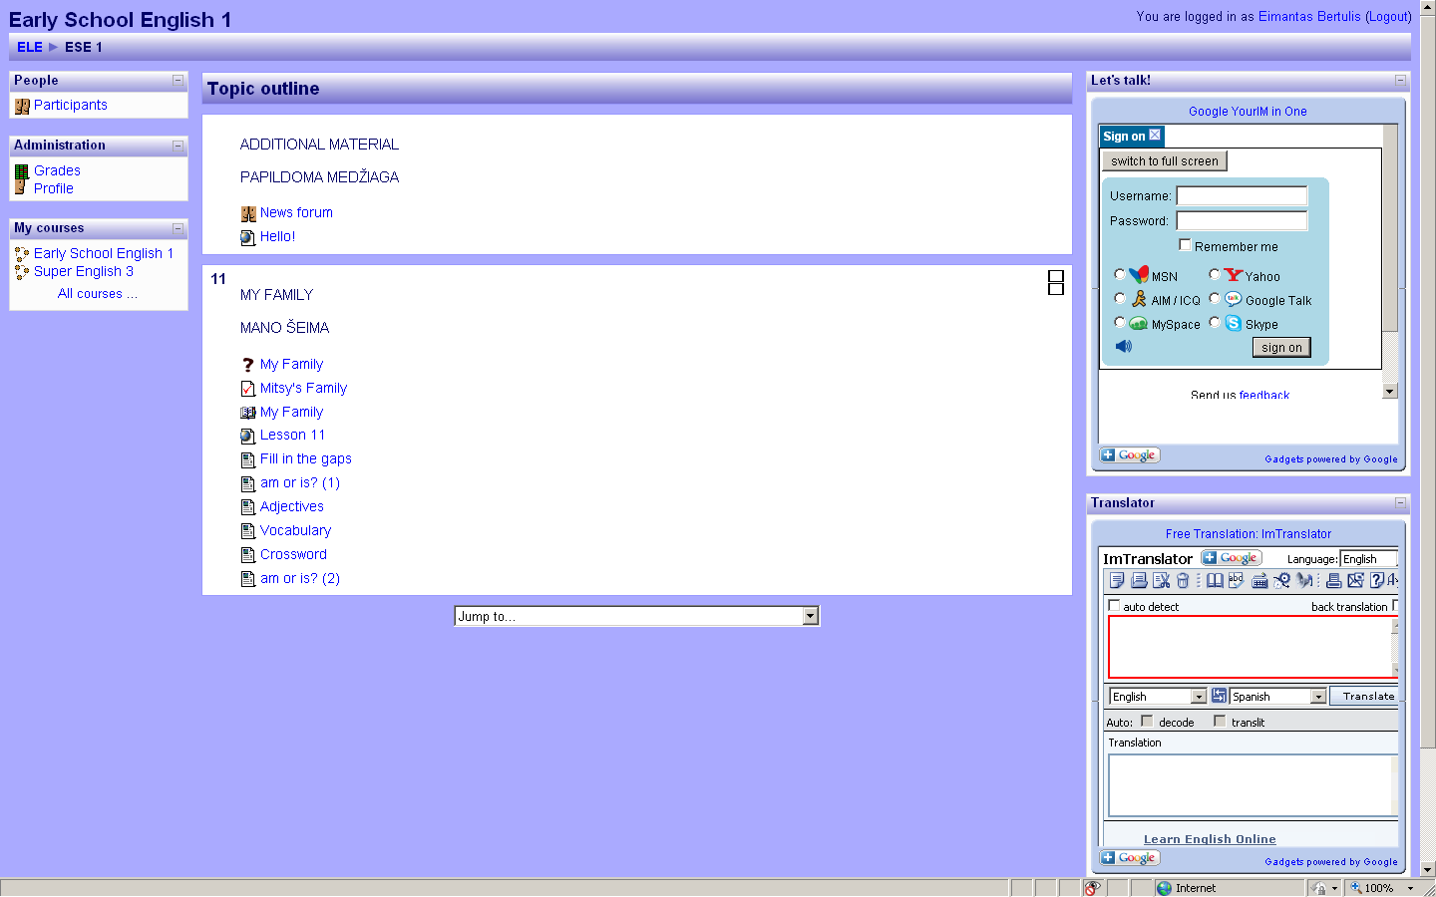
Picture 15 The screenshot of the typical environment of the lesson
The scenarios were prepared by the quidance of the renewed General Programs, Early School Englihs Teacher’s Book (Rupainienė V., Dreceikaitė V., Sabeckienė N., 2009), the results of the questionaries and the tools available in IME. (See tables 10-13)
Consultation scenario
Table 10 Consultation scenario
Type of the lesson | CONSULTATION, when the teacher is ready to help (acts pasively), but he/she is waiting for the questions of the students
Place, conditions | At home; pupils have the task to learn the words of the 11th lesson; teacher is ready to help; they arranged the time for meeting on-line;
Student(s) | Vaida Kaliasaite
Level | A1
Form | 2a
Course book | Early School English 1
Theme | Environment. My Family
Time:  60 min | Stages of the lesson | Process of the lesson |  | Notes | Competences | Technologies and Tasks
Time:  60 min | Stages of the lesson | Teacher’s activity | Learners’ activity | Notes | Competences | Technologies and Tasks
1 |  | 2 | 3 | 4 | 5 | 6
2 min. | The beginning of the lesson | Teacher is watching through communication tool who is logged in and is ready to answer the questions | Vaida (and other students) logs in the environment and signs in the communication tool; |  | General competences:  - Declarative knowledge  - Knowledge of the world  - Sociocultural knowledge (interpersonal relations)  - Intercultural awareness  - Skills and know-how (the ability to act in accordance with the situation)  - ‘Existential’ competence  - Motivations (communicative drive, the human need to communicate)  - Ability to learn  - Language and communication awareness  - General phonetic awareness and skills (ability to distinguish and produce unfamiliar sounds)  - Study skills (ability to use and organize available materials for independent learning)  - Heuristic skills (ability to use new technologies)  Communicative language competences:  - Linguistic competences  - Lexical competence (personal pronouns)  - Grammatical competence (contracted forms of verb to be)  - Semantic competence (translation equivalence)  - Phonological competence (sentence stress and rhythm)  - Orthographic competence (the form of letters; the proper spelling of words, including recognized contracted forms; punctuation marks;)  - Orthoepic competence (ability to produce correct pronunciation)  - Sociolinguistic competences (learner establishes basic social contact by using the simplest everyday polite forms of: greetings (Hello, Hi); saying please, thank you;)  - Pragmatic competences  - Coherence and cohesion (can link words with linear connector ‘and’. | IME  imo.im
7 min. | Presentation | Teacher has prepared thee- tasks for the 11th lesson and has given the task to learn the words with the help of interactive activities; it doesn’t matter the order in which activities should be done; | Vaida chooses to start from the dialogue. She goes to the dialogue page: looks at the pictures and pushes on the callouts with the words; after the push she hears the words pronounced by the characters of the comics; | If she finds the unknown word, she uses the vocabulary; |  | Microsoft Expression Web 3;  Adobe InDesign CS4;  Audacity;  (for detailed description of the tasks and technologies see Appendix 10)
10 min. | Practicing | Teacher has prepared thee- tasks for the 11th lesson and has given the task to learn the words with the help of interactive activities; it doesn’t matter the order in which activities should be done; | Next she takes the quiz ‘Mitsy’s Family”. The quiz is designed to practice the vocabulary of the 11th lesson, and is based on the previous dialogue; the pictures from the dialogue are presented in the quiz; the task is to find the most suitable adjective for the character in the picture; | If the grade of the attempt is not satisfying, the student may re-attempt the quiz; |  | Moodle;  Adobe InDesign CS4;  (for detailed description of the tasks and technologies see Appendix 11)
10 min. | Testing & Practicing (1) | Teacher has prepared thee- tasks for the 11th lesson and has given the task to learn the words with the help of interactive activities; it doesn’t matter the order in which activities should be done; | Then Vaida takes the other Mitsy’s Family quiz. She has to choose the word for ending the sentences. | If she chooses the wrong word, she can choose the other, but the grade will be reduce each time the wrong word is chosen |  | Hot Potatoes;  (for detailed description of the tasks and technologies see Appendix 12)
10 min. | Testing & Practicing (2) | Teacher has prepared thee- tasks for the 11th lesson and has given the task to learn the words with the help of interactive activities; it doesn’t matter the order in which activities should be done; | Next testing exercise is timed. She has to fill in all the gaps in 10 minutes, then press "Check" to check her answers. | She may use the "Hint" button to get a free letter if an answer is giving you trouble. She can also click on the "[?]" button to get a clue. Note that she will lose points if she asks for hints or clues! |  | Hot Potatoes;  (for detailed description of the tasks and technologies see Appendix 12)
10 min. | Testing & Practicing (3) | Teacher has prepared thee- tasks for the 11th lesson and has given the task to learn the words with the help of interactive activities; it doesn’t matter the order in which activities should be done; | Vaida chooses to complete the crossword, after finishing she clicks on "Check" to check her answers. If she is stuck, she can click on "Hint" to get a free letter. | She may click on a number in the grid to see the clue or clues for that number. |  | Hot Potatoes;  (for detailed description of the tasks and technologies see Appendix 13)
10 min. | Communicating | Teacher is waiting and is ready to help with any task. She answers Vaida’s question: | Vaida connects to her teacher through imo.im to ask if she pronounces the word ‘short’correct: | The dialogue usually is half English and half Lithuanian, but students and teacher tries to use as many English words as they can. |  | imo.im
10 min. | Communicating | Vaida: Hello, teacher!  Teacher: Hello, Vaida! May I help you?  Vaida: Yes, please.  Teacher: Pronounce the word you are not sure about!  Vaida: Short.  Teacher: Short. Listen to me and repeat. Short. Short. Short.  Vaida: Short.  Teacher: That’s right. Short.  Vaida: Thank you! Bye!  Teacher: You are welcome! Bye! |  |  |  | imo.im
1 min. | The end of the lesson. | Teacher signs out. | Vaida signs out. |  |  | IME  imo.im

Individual lesson scenario
Table 11 Individual lesson scenario
Type of the lesson | INDIVIDUAL LESSON, when the teacher is actively participarting in the quidance and student is following the instructions
Place, conditions | At home; teacher arranged the time for meeting on-line; student signs in at the lesson time;
Student | Vaida Kaliasaite
Level | A1
Form | 2a
Course book | Early School English 1
Theme | Environment. My Family (with the emphasis on Linguistic competences)
Time:  60 min | Stages of the lesson | Process of the lesson |  | Notes | Competences | Technologies and Tasks
Time:  60 min | Stages of the lesson | Teacher’s activity | Learners’ activity | Notes | Competences | Technologies and Tasks
1 |  | 2 | 3 | 4 | 5 | 6
2 min. | The beginning of the lesson | Teacher logs in and starts the lesson. She/he connects to the student through the communication tool im o.im and stays connected during the lesson | Vaida is loged in the environment, signed in the communication tool; She is waiting for the beginning of the lesson. | Vaida may do extra tasks or chat with co-learner while waiting | General competences:  - Declarative knowledge  - Knowledge of the world  - Sociocultural knowledge (interpersonal relations)  - Intercultural awareness  - Skills and know-how (the ability to act in accordance with the situation)  - ‘Existential’ competence  - Motivations (communicative drive, the human need to communicate)  - Ability to learn  - Language and communication awareness  - General phonetic awareness and skills (ability to distinguish and produce unfamiliar sounds)  - Study skills (ability to use and organize available materials for independent learning)  - Heuristic skills (ability to use new technologies)  Communicative language competences:  - Linguistic competences  - Lexical competence (personal pronouns)  - Grammatical competence (contracted forms of verb to be)  - Semantic competence (translation equivalence)  - Phonological competence (sentence stress and rhythm)  - Orthographic competence (the form of letters; the proper spelling of words, including recognized contracted forms; punctuation marks;)  - Orthoepic competence (ability to produce correct pronunciation)  - Sociolinguistic competences (learner establishes basic social contact by using the simplest everyday polite forms of: greetings (Hello, Hi); saying please, thank you;)  - Pragmatic competences  - Coherence and cohesion (can link words with linear connector ‘and’. | IME  imo.im
7 min. | Presentation | Teacher announces the theme of the lesson (see above) and asks to open the presentation; teacher commnents on slides and asks to follow; | Vaida opens the presentation and follows the instructions of the teacher; she listens to the explanations and follows the slides; | If she doesn’t understand the theory, she asks the questions; |  | Microsoft PowerPoint;  imo.im;  Visio;  (for detailed description of the tasks and technologies see Appendix 14)
10 min. | Practicing (1) | Teacher tells to open the first lesson file and explore the examples of the contractions. | Vaida opens the lesson and explores the example. | If she doesn’t understand, she asks the questions; |  | Microsoft Expression Web 3;  Adobe InDesign CS4;  Audacity;  Adobe Flash CS4 Professional;  (for detailed description of the tasks and technologies see Appendix 15)
10 min. | Practicing (2) | Teacher tells to open the second lesson file and to choose the right picture for the charactors. | Vaida opens the lesson and chooses charactors, trains and lugguges to combine the words into sentences. | If she chooses the wrong word, the sad emoticon appears; if the word is right, the emoticon is happy. (grading according to the second form grading system) |  | Microsoft Expression Web 3;  Adobe InDesign CS4;  Audacity;  Adobe Flash CS4 Professional;  (for detailed description of the tasks and technologies see Appendix 15)
5 min. | Testing & Practicing | Teacher directs the next task for practice – am or is? (1) | Vaida practices. | There are only four options in this exercise. |  | Hot Potatoes;  (for detailed description of the tasks and technologies see Appendix 16)
15 min. | Testing | Teacher tells to take the test – am or is? (2) | Vaida takes the test. | There are a lot of options and the time set up. |  | Hot Potatoes;  (for detailed description of the tasks and technologies see Appendix 16)
10 min. | Communicating | Teacher sums up the lesson and asks few questions: | Vaida answers: | The dialogue usually is half English and half Lithuanian, but students and teacher tries to use as many English words as they can. |  | imo.im
10 min. | Communicating | Teacher: What is English for ‘as esu’?  Vaida: ‘I am’.  Teacher: OK. How can we contract ‘he is’?  Vaida: ‘he’s’.  Teacher: That’s right. Thank you for your answers. The lesson is over. Bye.  Vaida: Thank you for the lesson. Bye. |  |  |  | imo.im
1 min. | The end of the lesson. | Teacher signs out. | Vaida signs out. |  |  | IME  imo.im

Group lesson scenario
Table 12 Group lesson scenario
Type of the lesson | GROUP LESSON, when the teacher is actively participarting in the quidance and the group of the student is following the instructions
Place, conditions | At home; teacher arranged the time for meeting on-line; students sign in at the lesson time;
Students | Vaida Kaliasaite, etc.
Level | A1
Form | 2a
Course book | Early School English 1
Theme | Revision
Time:  60 min | Stages of the lesson | Process of the lesson |  | Notes | Competences | Technologies and Tasks
Time:  60 min | Stages of the lesson | Teacher’s activity | Learners’ activity | Notes | Competences | Technologies and Tasks
1 |  | 2 | 3 | 4 | 5 | 6
2 min. | The beginning of the lesson | Teacher logs in and starts the lesson. She/he connects to the students through the communication tool im o.im and stays connected during the lesson | Students are loged in the environment, signed in the communication tool; they are waiting for the beginning of the lesson. | They may do extra tasks or chat with co-learners while waiting | General competences:  - Declarative knowledge  - Knowledge of the world  - Sociocultural knowledge (interpersonal relations)  - Intercultural awareness  - Skills and know-how (the ability to act in accordance with the situation)  - ‘Existential’ competence  - Motivations (communicative drive, the human need to communicate)  - Ability to learn  - Language and communication awareness  - General phonetic awareness and skills (ability to distinguish and produce unfamiliar sounds)  - Study skills (ability to use and organize available materials for independent learning)  - Heuristic skills (ability to use new technologies)  Communicative language competences:  - Linguistic competences  - Lexical competence (personal pronouns)  - Grammatical competence (contracted forms of verb to be)  - Semantic competence (translation equivalence)  - Phonological competence (sentence stress and rhythm)  - Orthographic competence (the form of letters; the proper spelling of words, including recognized contracted forms; punctuation marks;)  - Orthoepic competence (ability to produce correct pronunciation)  - Sociolinguistic competences (learner establishes basic social contact by using the simplest everyday polite forms of: greetings (Hello, Hi); saying please, thank you;)  - Pragmatic competences  - Coherence and cohesion (can link words with linear connector ‘and’. | IME  imo.im
40 min. | Testing & Practicing | Teacher announces the theme of the lesson (see above) and asks to open the Extra Revision tasks; teacher commnents on the tasks and asks to accomplish them till the end of the lesson; | Students follow the instructions and do the tasks; there are the testing tasks which are delivered to the teacher automatically after submitting the answers; | If they don’t understand the tasks, the teacher is ready to answer their questions; |  | Microsoft Expression Web 3;  Audacity;  Corel Draw; Outlook;  (for detailed description of the tasks and technologies see Appendixes 17-19)
17 min. | Commenting the results | After receiving tests teacher comments on their results individually and to all group if he/she has common notes; | Students listens to the results and ask questions; | If the grades are not satisfying, the teacher and student solves the problem on individual agreement; |  | imo.im;  Outlook;
1 min. | The end of the lesson. | Teacher signs out. | Vaida signs out. |  |  | IME  imo.im

Groups’ lesson scenario
Table 13 Group‘s lesson scenario
Type of the lesson | GROUPS LESSON, when the teacher is actively participarting in the quidance and the groups of the students are following the instructions
Place, conditions | At home/at school; teacher(s) arranged the time for meeting on-line; students sign in at the lesson time;
Students | Vaida Kaliasaite, etc.
Level | A1
Form | 2
Course book | Early School English 1
Theme | Daily life. Learning Alphabet (with the emphasis on Linguistic competences: Orthographic and Orthoepic competences)
Time:  60 min | Stages of the lesson | Process of the lesson |  | Notes | Competences | Technologies and Tasks
Time:  60 min | Stages of the lesson | Teacher’s activity | Learners’ activity | Notes | Competences | Technologies and Tasks
1 |  | 2 | 3 | 4 | 5 | 6
2 min. | The beginning of the lesson | Teacher(s) logs in and starts the lesson. She/he connects to the students through the communication tool im o.im and stays connected during the lesson | Students are loged in the environment, signed in the communication tool; they are waiting for the beginning of the lesson. | They may do extra tasks or chat with co-learners while waiting | General competences:  - Declarative knowledge  - Knowledge of the world  - Sociocultural knowledge (interpersonal relations)  - Intercultural awareness  - Skills and know-how (the ability to act in accordance with the situation)  - ‘Existential’ competence  - Motivations (communicative drive, the human need to communicate)  - Ability to learn  - Language and communication awareness  - General phonetic awareness and skills (ability to distinguish and produce unfamiliar sounds)  - Study skills (ability to use and organize available materials for independent learning)  - Heuristic skills (ability to use new technologies)  Communicative language competences:  - Linguistic competences  - Lexical competence (alphabet)  - Grammatical competence (verb to be)  - Semantic competence (translation equivalence)  - Phonological competence (sentence stress and rhythm)  - Orthographic competence (the form of letters; the proper spelling of words, including recognized contracted forms; punctuation marks;)  - Orthoepic competence (ability to produce correct pronunciation)  - Sociolinguistic competences (learner establishes basic social contact by using the simplest everyday polite forms of: greetings (Hello, Hi); saying please, thank you;)  - Pragmatic competences  - Coherence and cohesion (can link words with linear connector ‘and’. | IME  imo.im
15 min. | Presentation | Teacher announces the theme of the lesson (see above) and asks to open the presentation; teacher commnents on the tasks and asks to follow; the students are asked to view, listen and compare two records of the English alphabet; | Students open the presentation and follow the instructions of the teacher; they listen to the explanations and follow the instructions; | If they don’t understand, they may ask the questions; |  | Microsoft Expression Web 3;  imo.im;  Corel Draw;  Audacity;  Adobe InDesign CS4;  (for detailed description of the tasks and technologies see Appendixes 20-21)
10 min. | Practicing (1) | Teacher divides the students into couples; the task is to spell the words to the co-learner; learners correct each other; | Students connects to their co-learners and start the spelling task:  A: Hello! Guess the word!  B: OK. What is it?  A: It’s – F-A-M-I-L-Y.  B: I know it! It’s ‘family’!  A: What does it mean?  B: I don't know. I need to look it up in the dictionary. (He looks in the dictionary for the meaning of the word)  A: OK.  B: I know! It means ‘šeima‘. | If they do not agree on spelling, they may consult dictionary or teacher. |  | imo.im;  ImTranslator;
10 min. | Practicing (2) | Teacher tells to turn to the next task: to check if students know the neighbours of the letters in the alphabet; | Students open the task; they have to choose the neighbours of the letters according to the alphabet; | If they choose the wrong letter, the sad emoticon appears; if the word is right, the emoticon is happy. (grading according to the second form grading system) |  | Microsoft Expression Web 3;  Adobe InDesign CS4;  Audacity;  (for detailed description of the tasks and technologies see Appendix 22)
1 min. | The end of the lesson. | Teacher(s) signs out. | Students sign out. |  |  | IME  imo.im

Conclusion
The aim of this paper was to originate the integrated multimedia environment for design and support of language learning tools. The tasks were accomplished and these conclusions were reached:
- Digital programs for English language learning/teaching were evaluated according to the educational and technological criteria, and the situation of learning/teaching foreign language in Lithuania was analyzed. The results of the investigation show the huge amount of programs which don’t fulfill the educational requirements by the contemporary education standards for learning foreign language. Learners lack the e-tasks tied to the lexical and grammatical units of the course books. Teachers miss new compulsory themes set by renewed General Programs. Interactive tasks are not identified according Common European Framework of Reference for Languages (CEFR).
- The Integrated Multimedia Environment for Design and Support of Language Learning Tools was originated (www.bandymas4.us.lt/moodle). It is founded on next criteria:
  - Flexible communication system;
  - Easy access;
  - Multiple support: for updating, modifying, integrating;
  - Common European Framework of Reference for Languages (CEFR);
  - Renewed General Programs;
  - Lithuanian series of course books Early School English and Super English for learning English;
- Integrated technology prepared for the design and support of integrated multimedia environment which is based on next information technologies:
  - Learning Content Management System Moodle was chosen as free, easy to use and popular in Lithuania;
  - Communication tool (imo.im)provides the option of communicating through different communication platforms, it is especially important parameter for warranting the flexible learning;
  - Dictionary is formed from convenient, free (ImTranslator) environment;
  - Tools for designing tasks – Microsoft Expression Web 3, Hot Potatoes, Adobe Flash CS4 Professional, PowerPoint, Audacity, Adobe InDesign, CorelDraw, Visio – were chosen as the most suitable for meeting the aims of the tasks.
  - The integrity of the environment is based on JavaScript.
- The sets of interactive activities were created (www.bandymas2.projektas.lt, www.bandymas3.projektas.lt). They were approved by the authors of course books - V.Rupainienė, V.Maksvytienė, N.Sabeckienė. They initiated the presentation of the sets to Šviesa Publishers. They are going computerize language learning tools tied to the set of Early School English course books.

Bibliography
    - Absorb. 2003. Absorb. [Online] Absorb Anywhere LMS, 2003. [Cited: 05 26, 2010.] http://www.blatant.ca, http://www.absorbanywhere.com.
    - Adobe. 2009. Adobe. [Online] Adobe Systems Inc., 2009. [Cited: 05 26, 2010.] http://www.adobe.com.
    - Aim. 1997. Aim. [Online] 1997. [Cited: 05 26, 2010.] www.aim.com.
    - Alonso, John. 1999. OutStart. [Online] OutStart, Inc, 1999. [Cited: 05 26, 2010.] http://www.outstart.com/.
    - Anderson, Tom. 2003. MySpace. [Online] 2003. [Cited: 05 26, 2010.] www.myspace.com.
    - Buys G., Hoffmann S. 2002. Talking Communities. [Online] 2002. [Cited: 05 26, 2010.] http://apps.facebook.com/voice-chat/?ref=appd_my_recent&fa=1.
    - CEFR. 2001. Language Policy Division. A Common European Framework. [Online] 2001. [Cited: 05 25, 2010.] http://www.coe.int/T/DG4/Portfolio/?L=E&M=/documents_intro/common_framework.html.
    - Corel Draw. 2006. Corel Draw. Corel. [Online] Corel Corporation, 2006. [Cited: 05 26, 2010.] http://www.corel.com/servlet/Satellite/eu/en/Content/1150905725000.
    - Dougiamas, Martin. 1999. Moodle. [Online] Free Software Foundation, Inc., 1999. [Cited: 05 26, 2010.] http://moodle.org.
    - Eastwood, John. 2002. Oxford Practice Grammar. s.l. : Oxford Univercity Press, 2002.
    - Encarta. 2008. ENCARTA encyclopedia. s.l. : Microsoft, 2008.
    - English + Kids. 2001. English + Kids. s.l. : Edusoft Ltd., 2001.
    - English + Millenium. 2008. English + Millenium. s.l. : Edusoft Ltd., 2008.
    - English Plus! 2005. English Plus! s.l. : Edusoft Ltd., 2005.
    - European Commission. 2003. Promoting Language Learning and Linguistic Diversity:. COMMISSION OF THE EUROPEAN COMMUNITIES. [Online] 07 24, 2003. [Cited: 05 26, 2010.] http://ec.europa.eu/education/doc/official/keydoc/actlang/act_lang_en.pdf.
    - Evans, Virginia. 2001. Round-Up Grammar Practice Starter. s.l. : Longman, 2001.
    - EZ. 2008. EZ. [Online] Free Software Foundation, Inc., 2008. [Cited: 05 26, 2010.] http://ez.no.
    - Gebhard, J. G. 2000. Teaching Enlgish as a Foreign or Second Language. Michigan : The University of Michigan Press, 2000.
    - Google. 2008. „Google“ mini programos jūsų tinklalapiui. [Online] Google, 2008. [Cited: 05 26, 2010.] http://www.google.com/ig/directory?synd=open.
    - Google Talk. 2009. Google Talk. [Online] 2009. [Cited: 05 26, 2010.] http://www.google.com/talk.
    - Harik R., Harik G., Krishnamurthy P. 2007. imo.im. [Online] PageBites, Inc., 04 07, 2007. [Cited: 05 26, 2010.] https://imo.im.
    - Harmer, Jeremy. 2002. The Practice of English Language Teaching. Malaysia : Longman, 2002.
    - Holmes, Martin. 2009. Hot Potatoes. [Online] Half-Baked Software Inc., 10 08, 2009. [Cited: 05 26, 2010.] http://hotpot.uvic.ca.
    - Ingrid Freebairn and Hilary Rees-Parnall. 2004-2006. FCE Grammar ROM. s.l. : Pearson Education, Inc., 2004-2006.
    - Yishay, Vered. 2010. Edusoft. [Online] 2010. [Cited: 05 26, 2010.] http://www.edusoft.co.il/en/products/apeem.asp.
    - Jerry Yang, David Filo. 1994. Yahoo! [Online] 1994. [Cited: 05 26, 2010.] www.yahoo.com.
    - Joomla! 1991. Joomla! [Online] Free Software Foundation, Inc., 1991. [Cited: 05 26, 2010.] http://www.joomla.org.
    - Mazzoni, Dominic. 1999. Audacity. [Online] 1999. [Cited: 05 26, 2010.] http://audacity.sourceforge.net.
    - Microsoft Expression. 2009. Microsoft Expression. [Online] Microsoft, 2009. [Cited: 05 26, 2010.] http://www.microsoft.com/expression/.
    - Microsoft FrontPage. 2003. Microsoft FrontPage. Microsoft Office. [Online] Microsoft, 2003. [Cited: 05 26, 2010.] http://www.microsoft.com/lietuva/office/frontpage/prodinfo/overview.mspx.
    - Microsoft Outlook. 2003. Microsoft Outlook. Microsoft Office. [Online] Microsoft, 2003. [Cited: 05 26, 2010.] http://www.microsoft.com/lietuva/office/outlook/prodinfo/overview.mspx.
    - Microsoft Paint. 2007. Microsoft Windows XP Professional Product Documentation. Microsoft. [Online] Microsoft, 2007. [Cited: 05 26, 2010.] http://www.microsoft.com/resources/documentation/windows/xp/all/proddocs/en-us/mspaint_overview.mspx?mfr=true.
    - Microsoft PowerPoint. 2003. Microsoft PowerPoint. Microsoft Office. [Online] Microsoft, 05 31, 2003. [Cited: 05 26, 2010.] http://www.microsoft.com/lietuva/office/powerpoint/prodinfo/overview.mspx.
    - Microsoft Visio. 2003. Microsoft Visio. Microsoft Office. [Online] 2003. [Cited: 05 26, 2010.] http://www.microsoft.com/lietuva/office/visio/prodinfo/overview.mspx.
    - Perrett, Jeanne. 2006. WordBird's Word Land. s.l. : Longman, 2006.
    - Petruškevičiūtė, Rasa. 2010. Indigo. [Online] 01 06, 2010. [Cited: 05 26, 2010.] http://indigo.blogas.lt/didziausia-mokomosios-literaturos-leidykla-sviesa-svencia-65-metu-jubilieju-3420.html.
    - Piesarskas, B. 1998. ALKONAS. Vilnius : Fotonija, 1998.
    - —. 2005. ANGLONAS. Vilnius : Fotonija, 2005.
    - Pulver, Jeff. 2005. Vivox Voice. Vivox. [Online] 2005. [Cited: 05 26, 2010.] http://apps.facebook.com/vivoxvoice/?ref=appd_my_recent&fa=1.
    - Puslapiai.lt. Hostingas už 1Lt! [Online] [Cited: 05 26, 2010.] www.puslapiai.lt.
    - Rupainienė V., Dreceikaitė V., Sabeckienė N. 2009. Early School English 1 Teacher's Book. Kaunas : Šviesa, 2009.
    - Rupainienė V., Druceikaitė V., Sabeckienė N. 2008. Early School English 1 Student's Book . Kaunas : Šviesa, 2008.
    - Rupainienė V., Druceikaitė-Maksvytienė V., Sabeckaitė N. 2008. Early English Dictionary. Kaunas : Šviesa, 2008.
    - Rupainienė V., Drucekaitė V., Sabeckienė N. 2008. Early School English 1 Activity Book. Kaunas : Šviesa, 2008.
    - Rupainienė V., Maksvytienė V., Sabeckienė N. 2007. Early English Grammar 1. Kaunas : Šviesa, 2007.
    - —. 2008. Early School English 1 CD. Kaunas : Šviesa, 2008.
    - Shaw, Ellen. 2004-2007. Focus on Grammar Level 1. 2004-2007.
    - Skype. 2003. Skype. [Online] 2003. [Cited: 05 26, 2010.] http://www.skype.com/intl/en/home.
    - Smart Link Corporation. 1993. ImTranslator. ImTranslator.net. [Online] Smart Link Corporation, 1993. [Cited: 05 26, 2010.] http://www.imtranslator.net.
    - Steponavičius, Gintaras. 2008. The decree of supplementary English learning from the second form. [Online] 05 12, 2008. [Cited: 05 26, 2010.] www.smm.lt/ugdymas/docs/aukm/2008-05-12-ISAK-1379.pdf.
    - —. 2008. The Republic of Lithuania Ministry of Education and Science. The renewed General Programs. [Online] 2008. [Cited: 05 25, 2010.] p.267. www.smm.lt/ugdymas/docs/Kalbos.pdf.
    - Steven J. Molinsky and Bill Bliss. 2004-2007. Side by Side Interactive. s.l. : Pearson Education, Inc., 2004-2007.
    - TriplePlayPlus! 1998. TriplePlay Plus! English. s.l. : Syracuse Language Systems, Inc., 1998.
    - UAB "Universalūs sprendimai". 2005. Universalūs sprendimai. [Online] 2005. [Cited: 05 26, 2010.] http://www.us.lt/.
    - Zuckerberg, Mark. 2004. [Online] Facebook Inc., 2004. [Cited: 05 26, 2010.] www.facebook.com.

Appendix 1. QuestionNaire 1
(Mokinių apklausa)
Anglų Kalbos Mokymasis

Ką sunkiausia teisingai atlikti mokykloje mokantis anglų kalbos? Sunumeruokite nuo 1 iki 6 (1 – sunkiausia, 2 – labai sunku, 3 – sunku, 4 – nelabai sunku, 5 – lengva, 6 – lengviausia):
  - Teksto skaitymas
  - Teksto vertimas
  - Žodžių rašymas
  - Žodžių tarimas
  - Žodžių mokymasis mintinai
  - Klausimo pratimai
Ką sunkiausia teisingai atlikti namuose mokantis anglų kalbos? Sunumeruokite nuo 1 iki 6 (1 – sunkiausia, 2 – labai sunku, 3 – sunku, 4 – nelabai sunku, 5 – lengva, 6 – lengviausia):
  - Teksto skaitymas
  - Teksto vertimas
  - Žodžių rašymas
  - Žodžių tarimas
  - Žodžių mokymasis mintinai
  - Klausimo pratimai
Kas jūsų nuomone pagerintu mokymosi kokybę:
_________________________________________________________
Ar naudojatės internetu mokymosi tikslais?
  - Jei taip, tai kodėl _________________
  - Jei ne, tai kodėl _________________
Ar sunku rasti tinkamos medžiagos mokymuisi?
  - Jei taip, tai kodėl _________________
  - Jei ne, tai kodėl _________________

Appendix 2. QuestionNaire 2
(Mokytojų apklausa)
Anglų Kalbos Mokymas
Ką vaikai sunkiausiai teisingai atlieka pamokoje mokantis anglų kalbos? Sunumeruokite nuo 1 iki 6 (1 – sunkiausia, 2 – labai sunku, 3 – sunku, 4 – nelabai sunku, 5 – lengva, 6 – lengviausia):
  - Teksto skaitymas
  - Teksto vertimas
  - Žodžių rašymas
  - Žodžių tarimas
  - Žodžių mokymasis mintinai
  - Klausimo pratimai
Ką vaikai sunkiausiai teisingai atlieka pristatant namų darbus mokantis anglų kalbos? Sunumeruokite nuo 1 iki 6 (1 – sunkiausia, 2 – labai sunku, 3 – sunku, 4 – nelabai sunku, 5 – lengva, 6 – lengviausia):
  - Teksto skaitymas
  - Teksto vertimas
  - Žodžių rašymas
  - Žodžių tarimas
  - Žodžių mokymasis mintinai
  - Klausimo pratimai

Kas jūsų nuomone pagerintu mokymosi kokybę:
_________________________________________________________
Ar naudojatės internetu mokymo tikslais?
  - Jei taip, tai kodėl _________________
  - Jei ne, tai kodėl _________________
Ar sunku rasti tinkamos medžiagos pagal Atnaujintas Bendrąsias Programas ir Išsilavinimo Standartus?
  - Jei taip, tai kodėl _________________
  - Jei ne, tai kodėl _________________

Appendix 3. Cefr
Common European Framework of Reference for level of proficiency. (See picture 16)
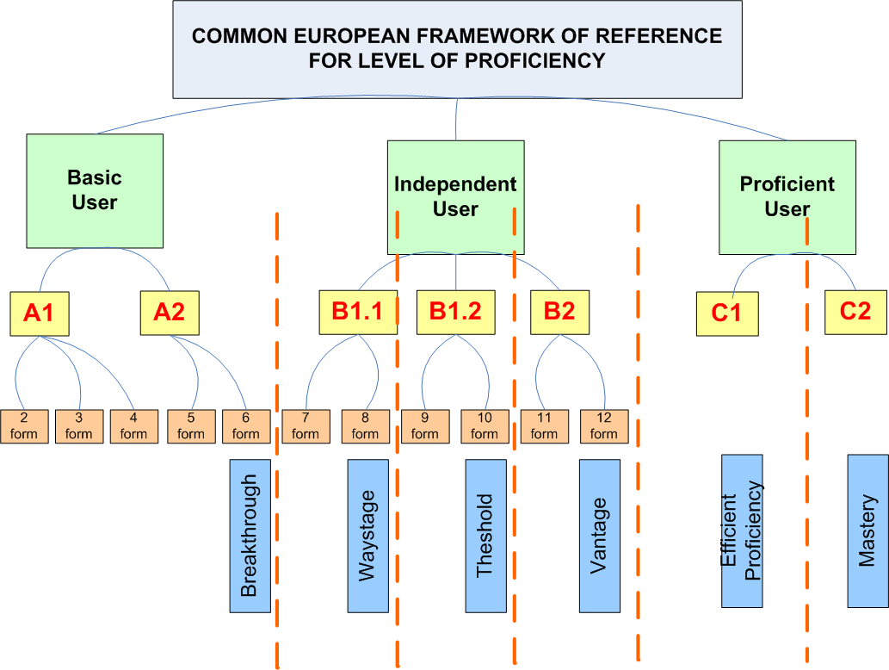
Picture 16 CEFR

Appendix 4. The requirements for language teaching
The European Commission, in the Promoting Language Learning and Linguistic Diversity: An Action Plan 2004-2006 (2003) (European Commission, 2003), has expressed its intent to extend, consolidate and develop the early learning of one or more foreign or additional languages in each of the EU member states. The reason is the capability of young children to acquire and imitate better than in their older age. This served the reorganizing in the teaching process, but the requirements for teaching remain the same: there should be included all four spheres of teaching in each teaching module (See picture 17):
- Reading
- Writing
- Listening
- Speaking
It doesn’t matter if you are teaching grammar or literature, all the spheres should be covered with the difference only in percentage of usage. Each sphere should include three levels of teaching:
- Presentation
- Practice
- Testing

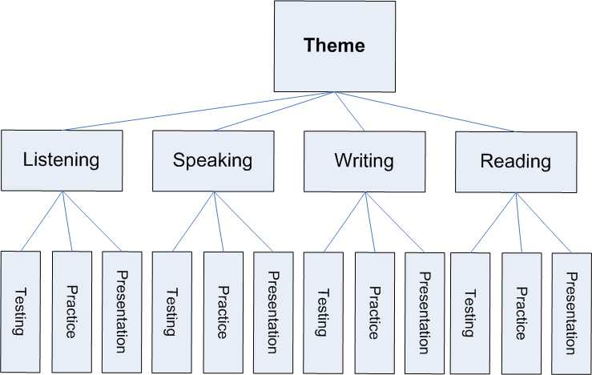
Picture 17 Theme
The spheres and the levels of acquisition can be distinguished or not, but they have to be used in order to teach language efficient. The way of the presenting teaching material depends on the methodology of the certain teacher.

Appendix 5. The features and the types of tasks
which were suitable for the project and which I have used

- Presentations of vocabulary were made with this tool. As for learning language it is essential to hear the pronunciation, the presentation used sound.
- Recording of pronunciation is possible with this program if you add an applet, for example WAV Recording Applet SDK. Recorded file can be uploaded to the form and sent to the teacher for evaluating. (I have resigned this type of task after some experiments and replaced it with on-line communication)
- Script Promts can be used for drilling the material. The function was inserted in the code with the help of JavaScript.
- Communication is also possible to organize with additional programs if the page is published on the web. Here I found an excellent solution: I put a frameset on the main page, and the imo.im website connected to the frame. Students can easily use their logos to communicate in their own environment of desirable program with teacher and classmates (imo.im is also used in the gadgets on moodle)
- Forms carry the most potential of the program creating tasks. Different types of tasks can be inserted in the form:
  - Textbox for typing text in the certain box of limited length
  - Text Area for typing the text in the certain box with unlimited area (there are scrolling option)
  - File Upload for uploading file into the form which later will be sent to the teacher
  - Checkbox for choosing several options from the given ones
  - Option button for choosing one option from the given ones
  - Group Box for grouping
  - Drop-Down Box for choosing options from the drop-down list
Forms have an option of sending the students answers to the teacher. Teacher should configure the e-mail address in the code and Outlook will serve as additional program for transferring the message.

Appendix 6. the environment
The screenshot for course of Proficient Users (See picture 18)
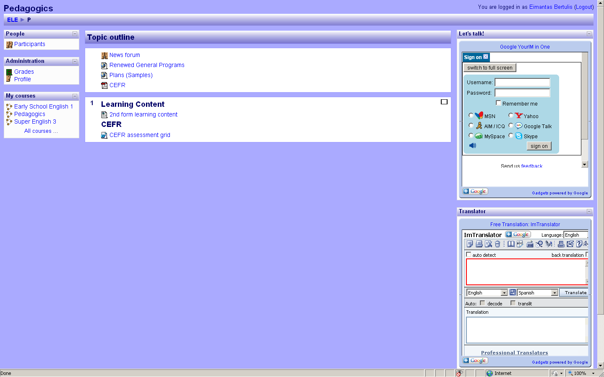
Picture 18 The screenshot for course of Proficient Users
The screenshot of the courses for Basic Users (See picture 19)
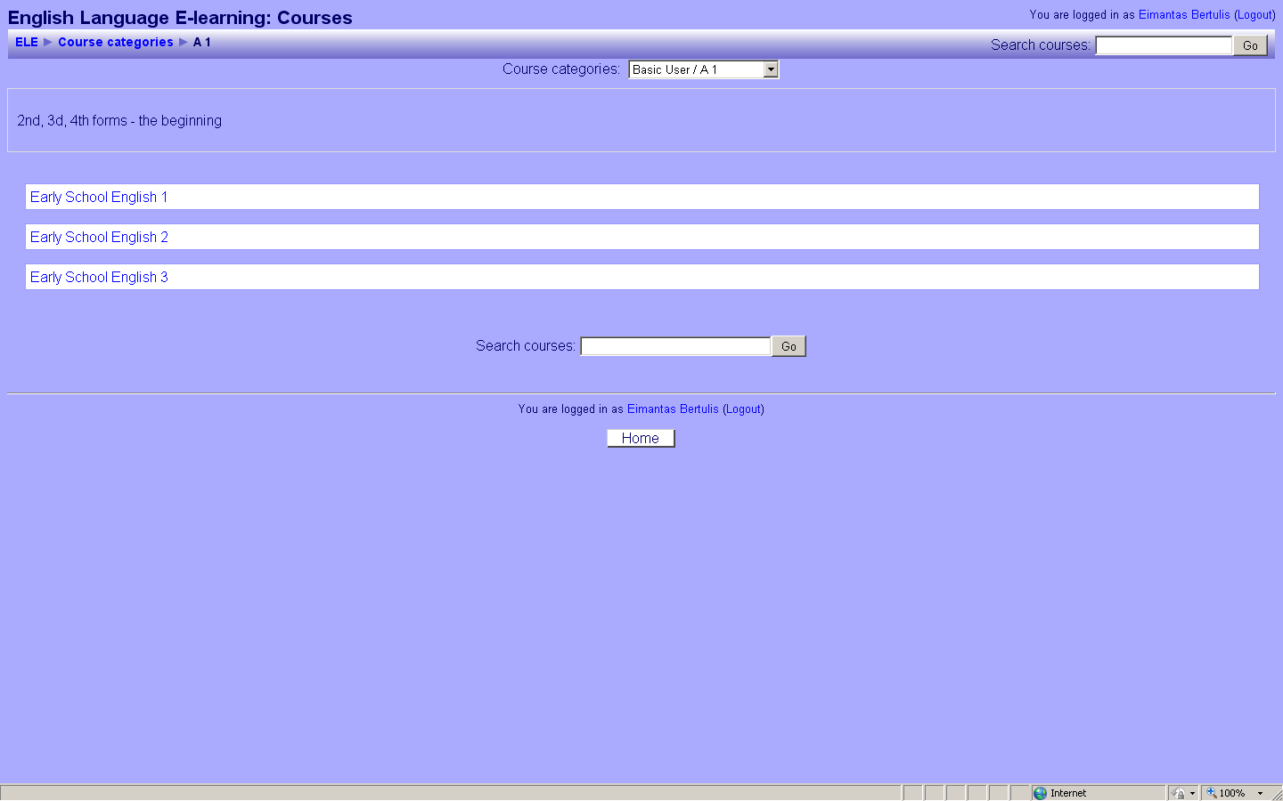
Picture 19 The screen shot of the courses for Basic Users

Appendix 7. The certificate of publishing company

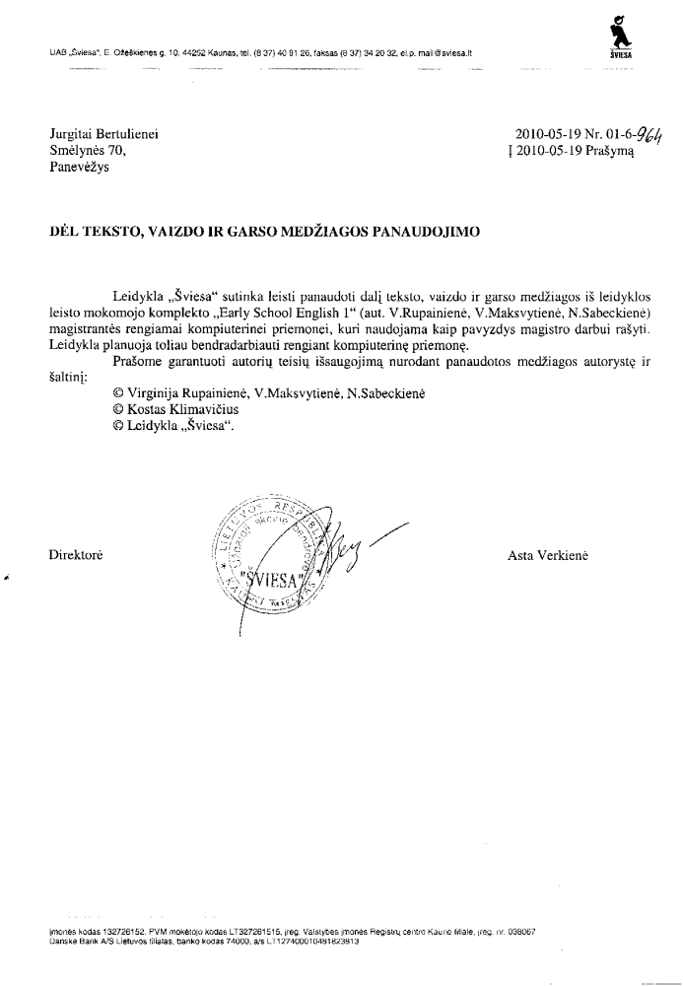

Appendix 8. THE DISTRIBUTION OF FEATURES IN THE PROGRAMS
The table shows the distribution of features for certain spheres and levels of teaching. It displays the most suitable program for three levels of acquisition: presentation, practice and testing. Different spheres (reading, writing, speaking and listening) need different programs for presentation of the material, practicing the theme, and testing the knowledge. (See picture 20)
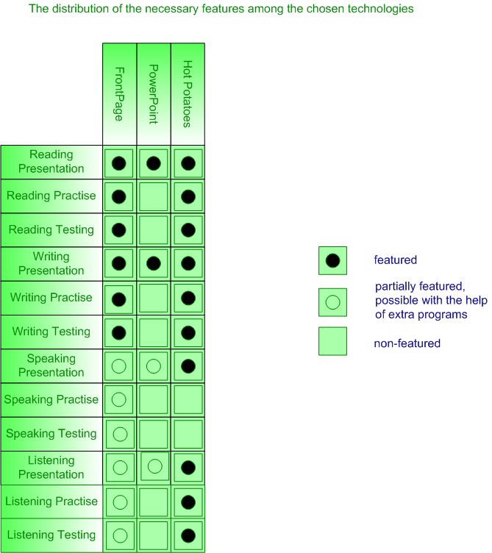
Picture 20 The Distribution of Features in the programs

Appendix 9. THE TYPES OF EXERCISES
The types of exercises used in the work with the chosen programs (See picture 21)

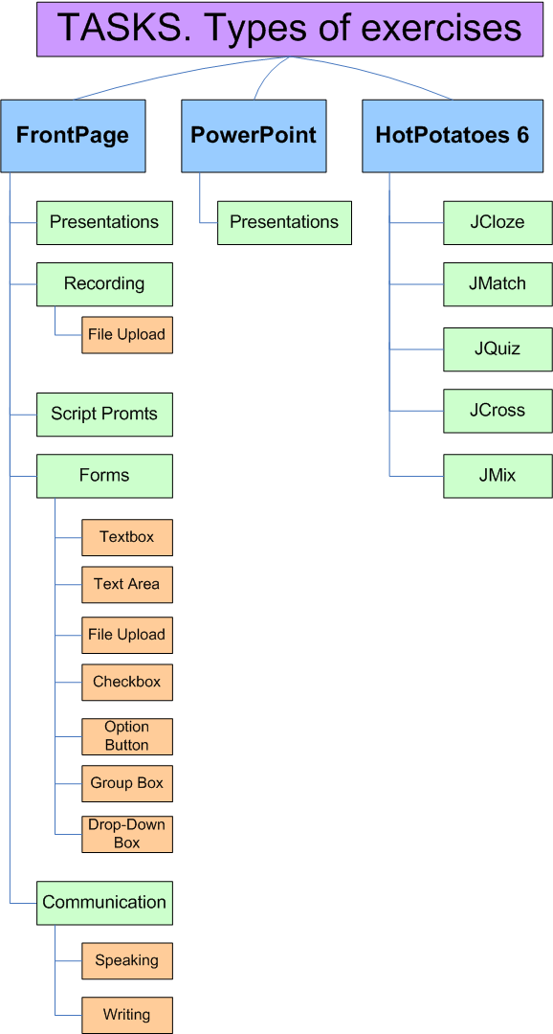
Picture 21 Types of exercises

appendix 10. environment.My Family. the dialogue
The task is created using Microsoft Expression Web 3. The pictures are taken from Early School English course book (Rupainienė V., Druceikaitė V., Sabeckienė N., 2008) saved in the InDesign CS4 program. As *.indd files are incompatible with HTML editing programs, so I had to export pictures into *.jpeg format in order to use them with HTML editors. Later I decided to make the background of the pictures transparent, *.jpeg format doesn’t support transparency. So, I had to convert the pictures into *.gif as there is no direct option to export files from *.indd format to *.gif.
The callouts with words were put in layers in HTML editor. The font and the colours are the same as in the course book. The sounds are taken from the phonogram of Early School English CD (Rupainienė V., Maksvytienė V., Sabeckienė N., 2008). The records are cut with Audacity program and inserted in HTML with the help of Java scripts.
The vocabulary of the lesson is in the right frame. It corresponds to the themes of the lesson (Rupainienė V., Druceikaitė-Maksvytienė V., Sabeckaitė N., 2008). It is designed from one layer and the list of the words. Couple functions in JavaScript help to play sound and display the translation of the word on the click. (See picture 22)
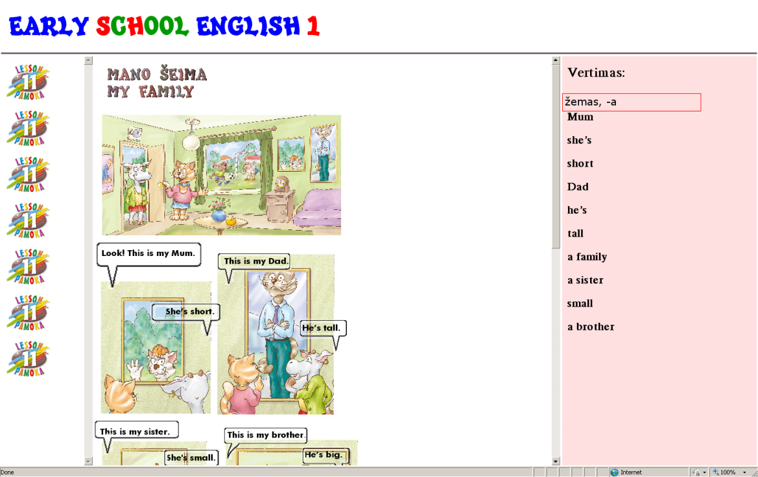
Picture 22 The screenshot of the dialogue

appendix 11. environment.My Family. the quiz ‘mitsy’s family’ (1)

This task is created with the Moodle quiz tool. The pictures are taken from Early School English grammar book (Rupainienė V., Maksvytienė V., Sabeckienė N., 2007) saved in the InDesign CS4 program. The pictures were exported in *.jpeg file format and inserted in the quiz. The right answer should be chosen from the given below. The answer should correspond the picture. (See picture 23)

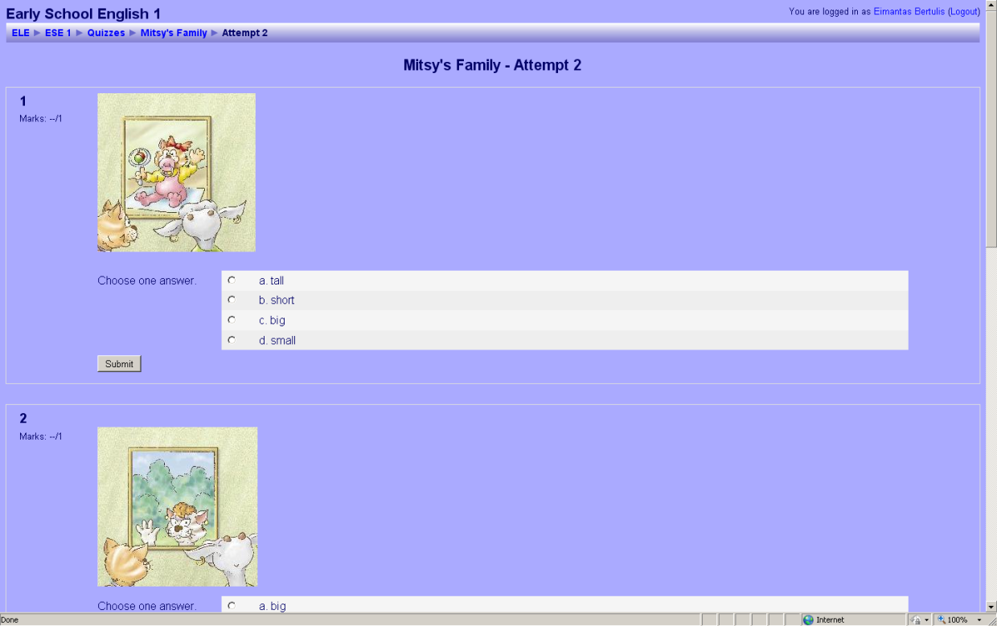
Picture 23 The screenshot of the quiz ‘Mitsy’s Family’

appendix 12. environment.My Family. Hot Potatoes tasks (1)
The first task is made with HotPotatoes, JQuiz program, multiple-choice quiz tool and inserted into the environment as HTML page. (See picture 24) The second task is designed with JClose program, gap-fill tool. The timer is set for this task. (See picture 25) The material is taken from Early School English 1 Activity Book (Rupainienė V., Drucekaitė V., Sabeckienė N., 2008).
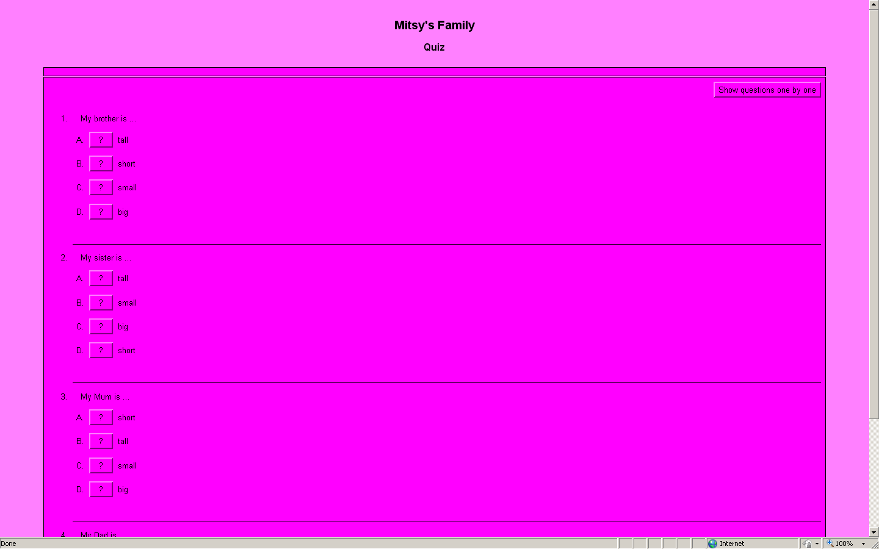
Picture 24 The screenshot of Hot Potatoes ‘Mitsy‘s Family‘

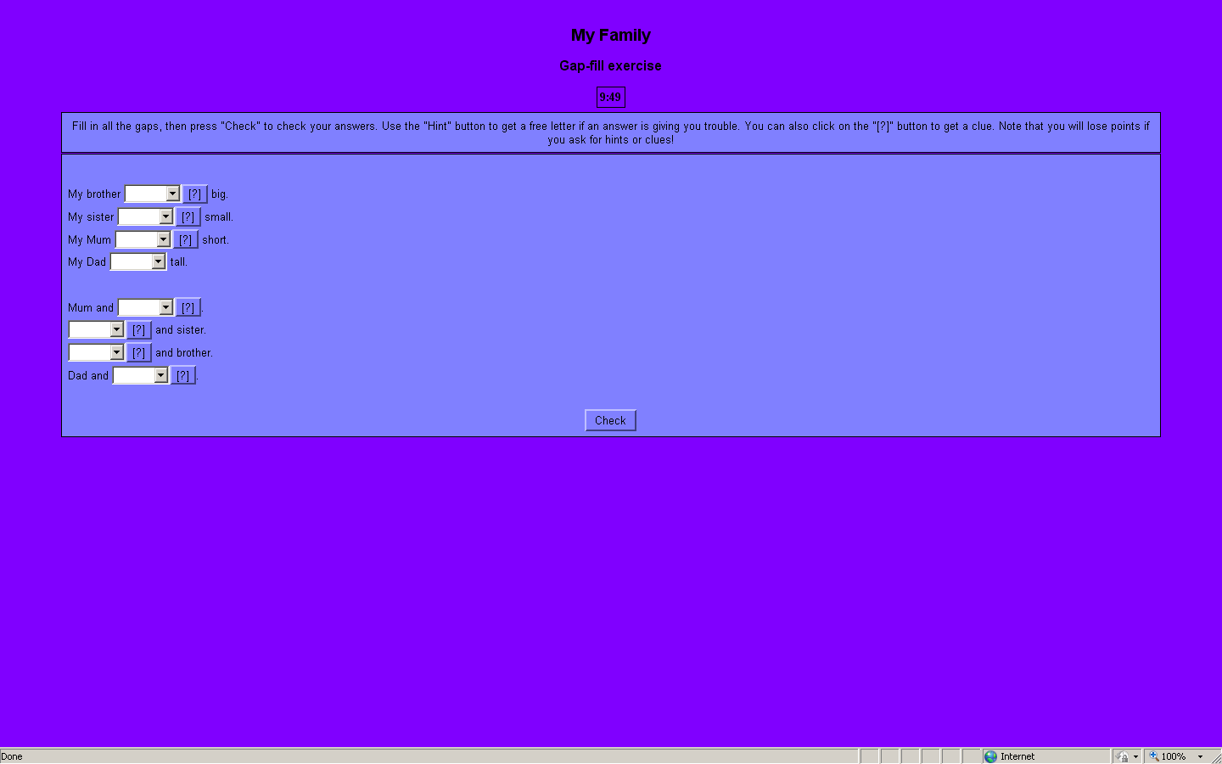
Picture 25 The screenshot of Hot Potatoes ‘My Family‘

appendix 13. environment.My Family. Hot Potatoes tasks (2)

The task is made with Hot Potatoes, JCross program. The clues and answers are set with the help of the program tools. (See picture 26)

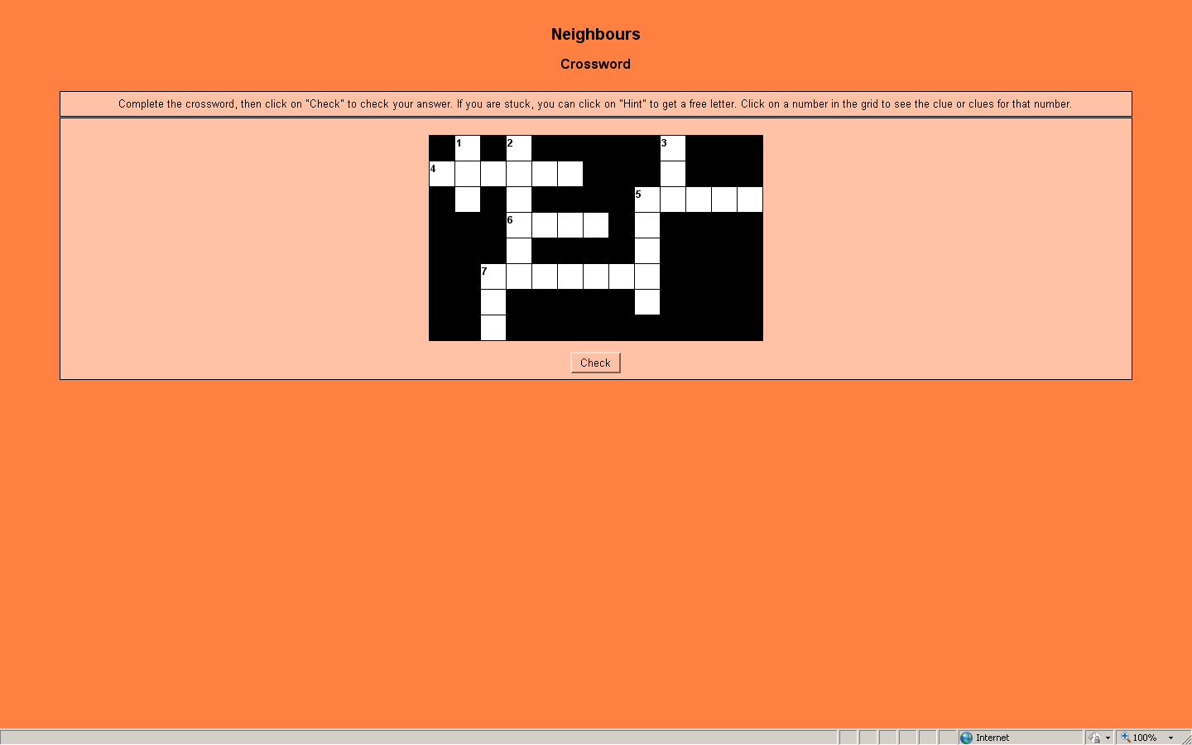
Picture 26 The screenshot of Hot Potatoes ‘Neighbours‘

appendix 14. presentation. Present Simple
This task is designed with Microsoft PowerPoint. The diagrams are made with Visio. It is intended to use for the set of lessons for the illustration of Present Simple Tense. (See pictures 27-28)

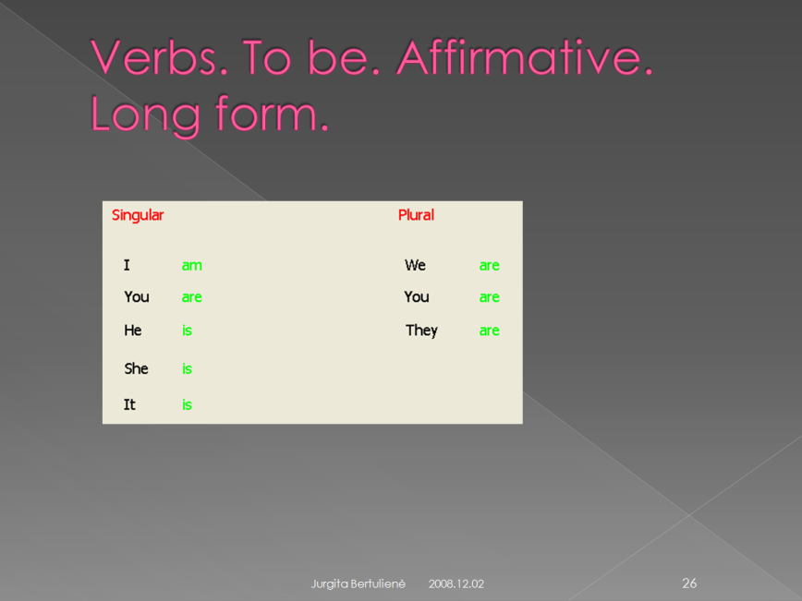
Picture 27 The screenshot of Presentation

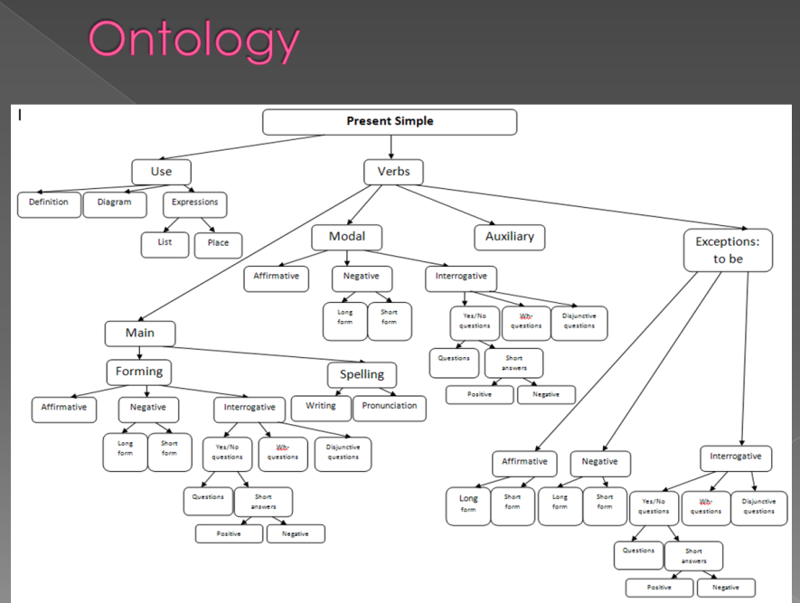
Picture 28 The screenshot of Presentation. Ontology

appendix 15. Verb to be. short and long forms
The task is created using Microsoft Expression Web 3. The pictures are taken from Early School English course book saved in the InDesign CS4 program. They are animated with Adobe Flash CS4 Professional. The rest interactivity is designed with Java sripts: on the click pictures change according to the grammar rules.
The fonts and the colours are the same as in the course book. The sounds are taken from the phonogram of Early School English CD. The records are cut with Audacity program and inserted in HTML with the help of Java scripts.
The vocabulary of the lesson is in the right frame. It is designed from one layer and the list of the words. Couple functions in JavaScript help to play sound and display the translation of the word on the click. (See pictures 29-30)
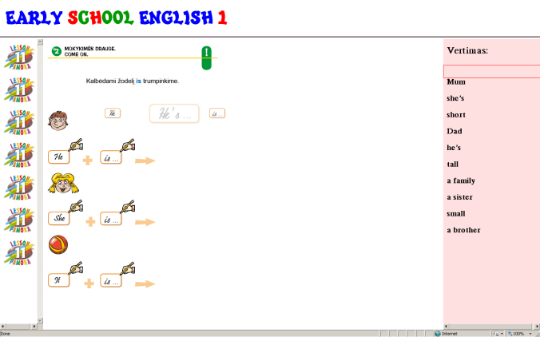
Picture 29 The screenshot of task come on
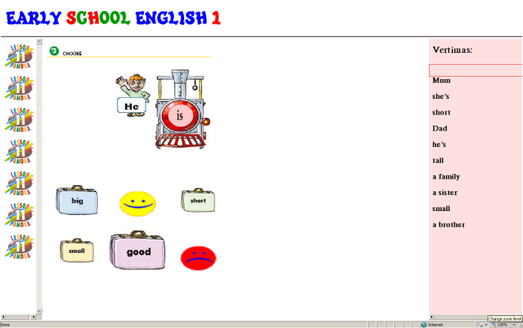
Picture 30 The screenshot of task choose

appendix 16. the agreement of pronouns and verb to be
The tasks are made with HotPotatoes, JMatch program tool and inserted into the environment as HTML page. The difference of the tasks is the amount of the options and the animation in the test. The timer is set in the test. (See pictures 31-32)
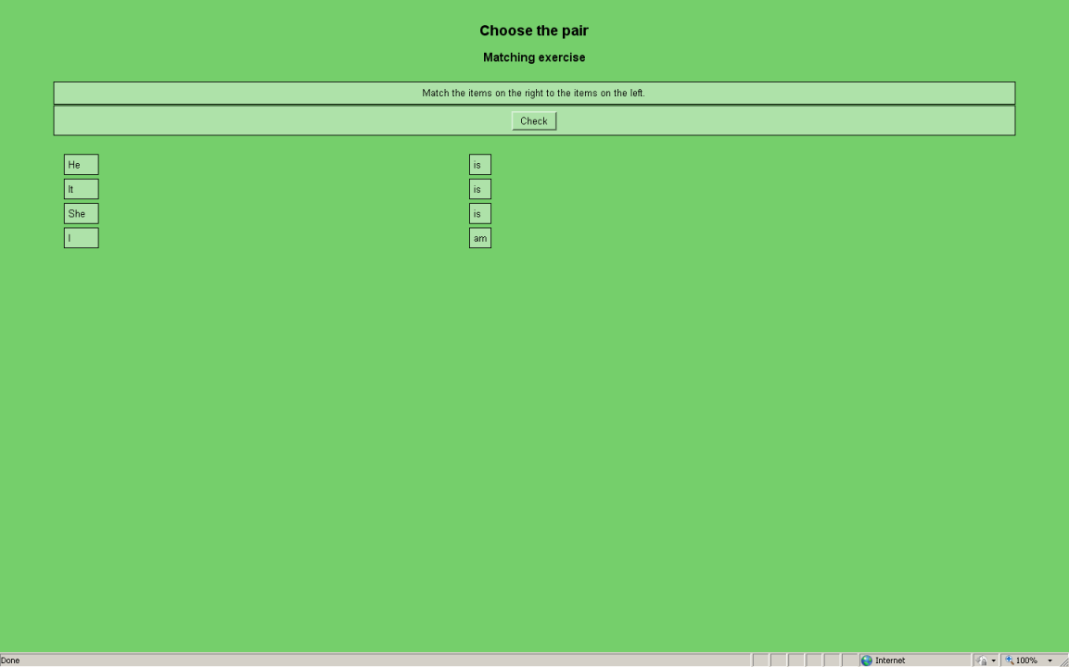
Picture 31 The screenshot of task choose the pair
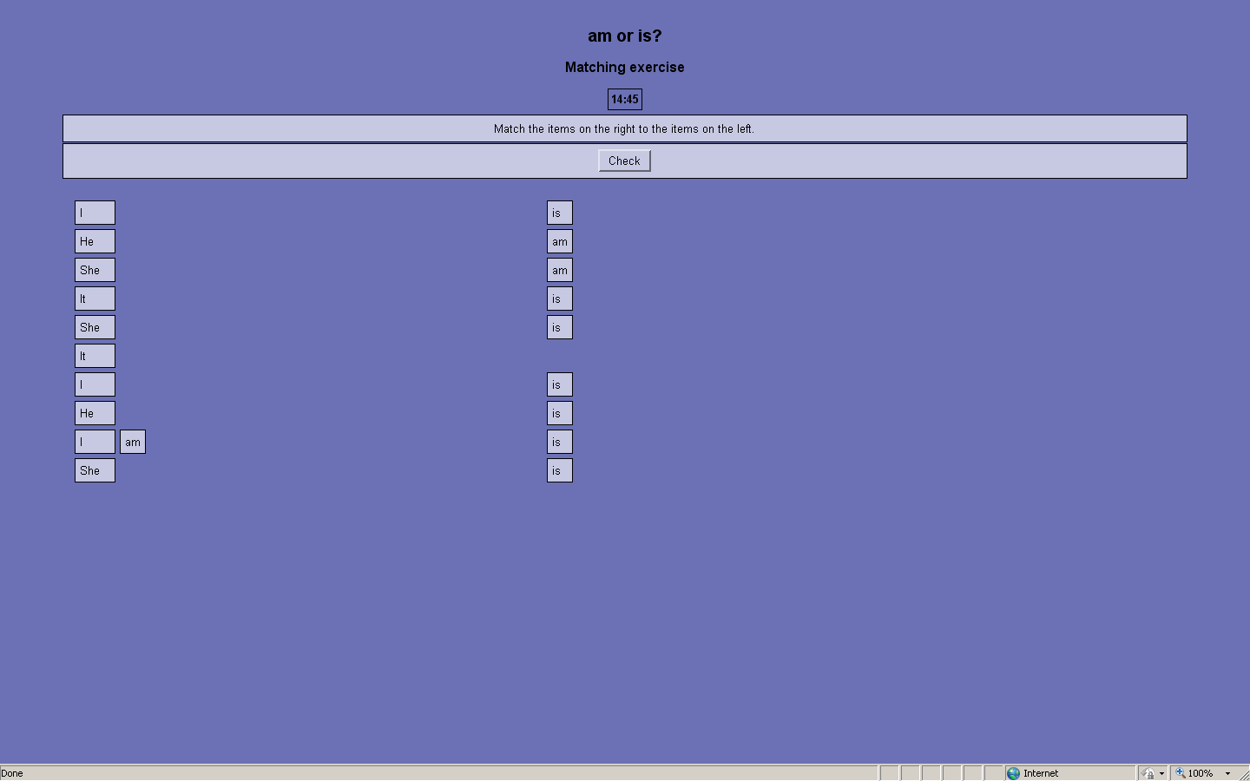
Picture 32 The screenshot of task am or is?

appendix 17. revision exercises (1)
The set of reminding exercises is made with Miscrosoft Expression Web 3. The pictures in all the tasks are drawn with Corel Draw program. Each word in exercises has the sound equivalent which is recorded with the Audacity program and inserted in HTML with Java scripts. (See pictures 33-34)
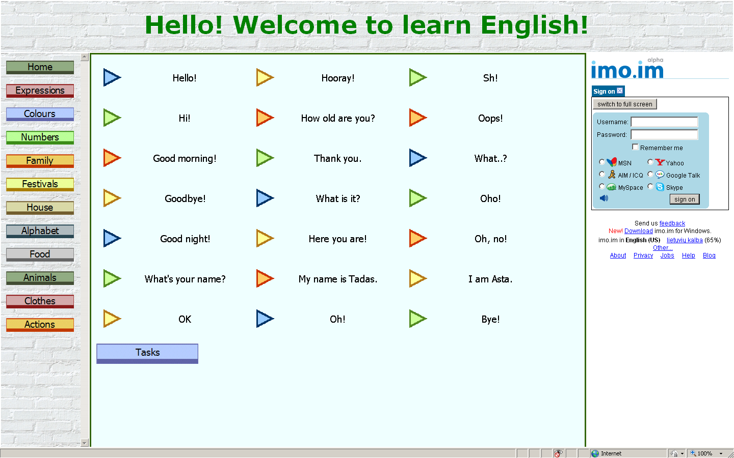
Picture 33 The screenshot of task expressions

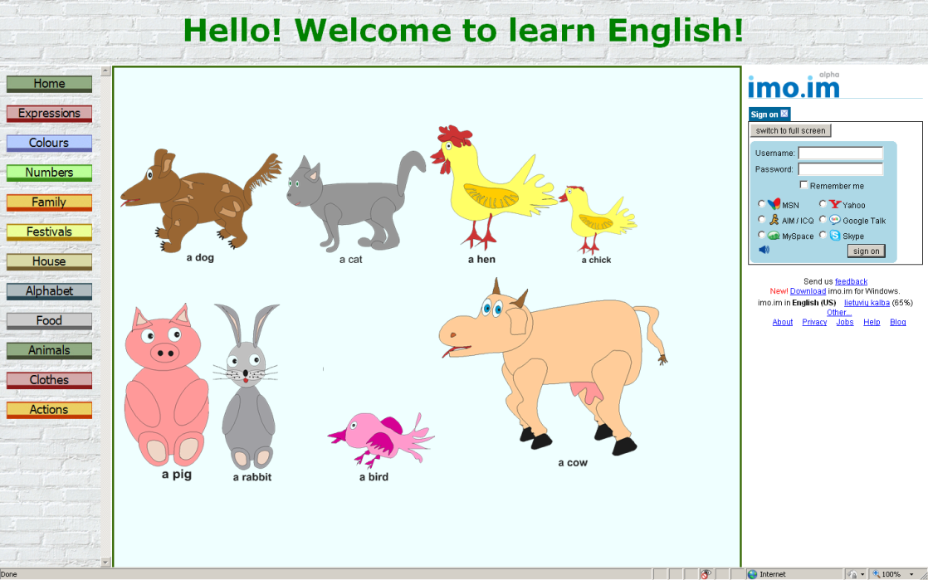
Picture 34 The screenshot of task animals

appendix 18. revision exercises (2)
The set of testing exercises is made with Miscrosoft Expression Web 3. The pictures in all the tasks are drawn with Corel Draw program. Each word in exercises has the sound equivalent which is recorded with the Audacity program and inserted in HTML with Java scripts. The test is based on script prompts. On the button click the prompt table appears and asks to write the word in English. After the writing and submitting the word the next prompt table appears asking if you are sure about your decision. And at the end script promt gives the right answer. (See picture 35)
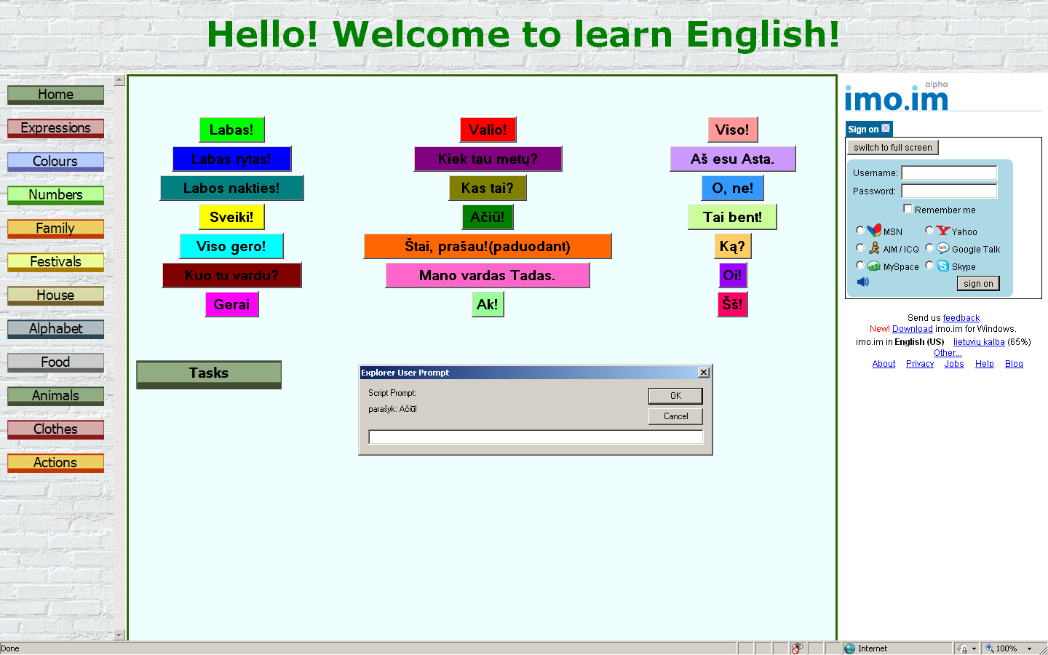
Picture 35 The screenshot of task with promts

appendix 19. revision exercises (3)
The set of testing exercises is made with Miscrosoft Expression Web 3. The tool of making forms served for the base of the test. Outlook e-mails the answers of the students after pushing the button ‘submit’ when the post method is activated. (See picture 36)

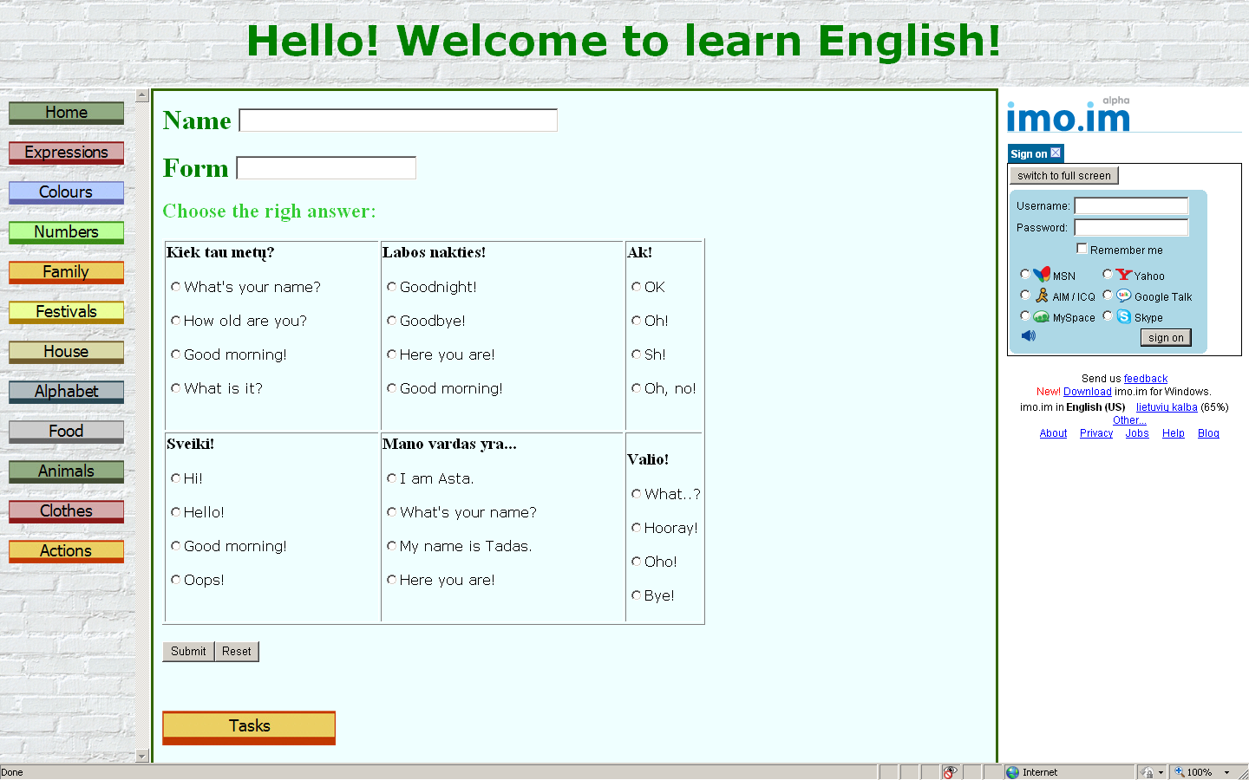
Picture 36 The screenshot of task with form

appendix 20. Alphabet tasks (1)
The task is made with Microsoft Expression Web 3. The signs of alphabet are drawn with Corel Draw X3. The sounds are inserted with the help of Java scripts and recorded with Audacity program. (See picture 37)
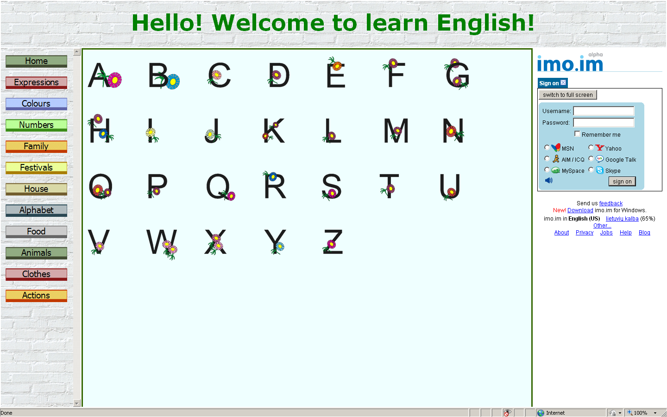
Picture 37 The screenshot of task alphabet

appendix 21. Alphabet tasks (2)
The task is made with Microsoft Expression Web 3. The sounds are taken from the Early School English CD and cut with Audacity program. They are inserted with the help of Java scripts into HTML and load on the click of the mouse. The interaction of letters is set by making the pictures of the letters visible or invisible, replacing the picture of the letter by the bigger its equivalent on mouse over, and on mouse out returning the previous small picture. All these interactivity is done with Java scripts. (See picture 38)
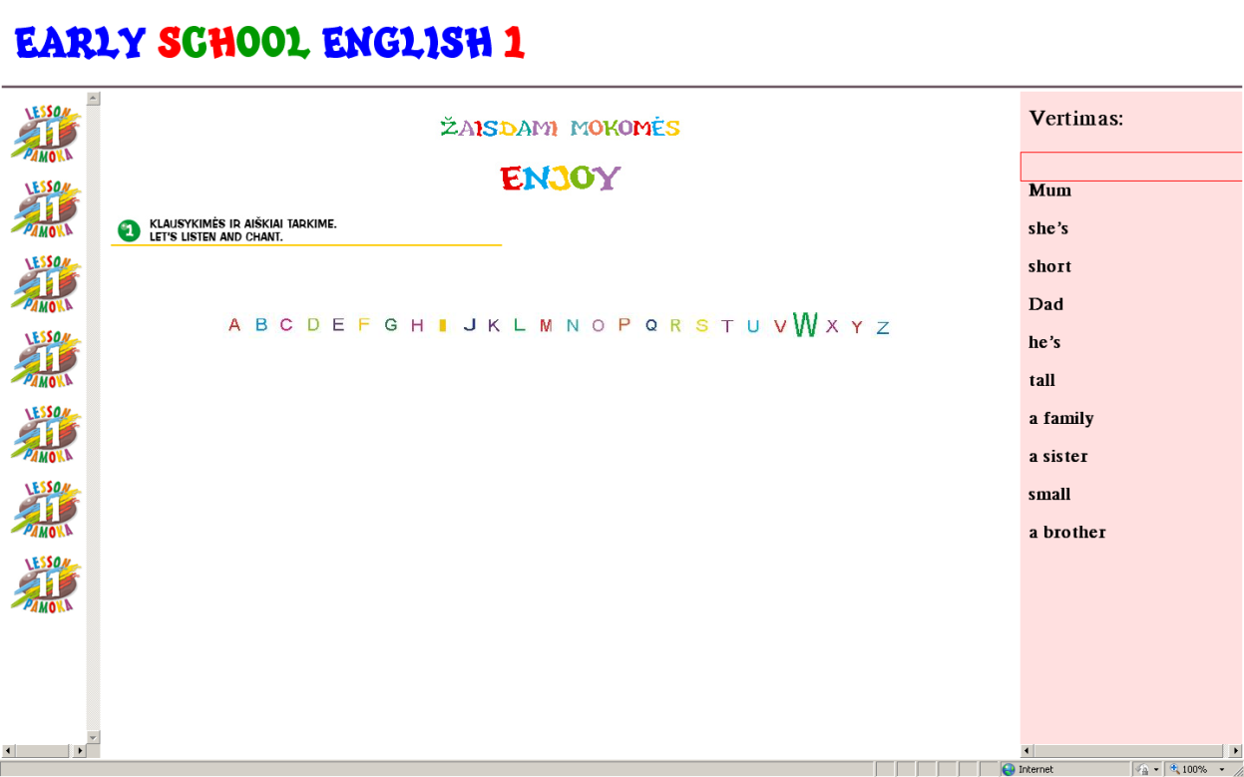
Picture 38 The screenshot of task enjoy

appendix 22. Alphabet tasks (3)
The task is made with Microsoft Expression Web 3. The sounds are taken from the Early School English CD and cut with Audacity program. They are inserted with the help of Java scripts into HTML and load on the click of the mouse. The pictures are taken from Early School English course book, Adobe InDesign CS4 program. In the middle house there is a letter; students have to insert letters into other houses according to the alphabet. If they click on the right letter, the letter goes into the house, the happy emoticon appears instead of the letter and the house goes near the middle house. This is done by making visible and invisible images on the click of the mouse on the letters. If the student clicks on the wrong letter, the sad emoticon changes the letter. The houses don’t move till the right letter will be clicked on. All the letters are tied to the sounds and each time they are clicked, the sound appears. This is done with Java scripts. (See picture 39)
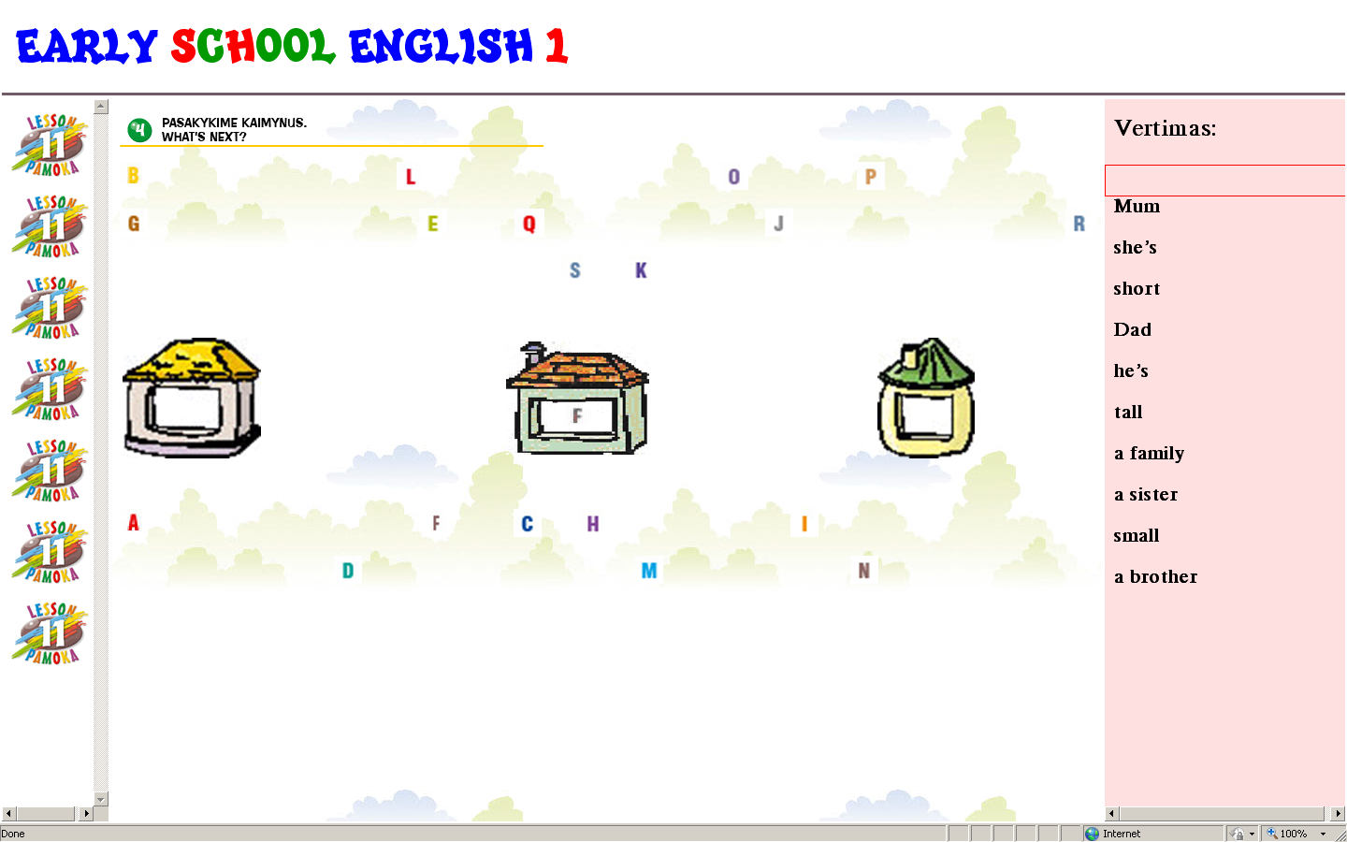
Picture 39 The screenshot of task What‘s next?

appendix 23. Im QUESTIONNAIRE
Questionnaire ‘Instant Messenger’ (See table 14)
Table 14 IM Questionnaire
What instant messenger do you use?  (You may mark more than one) |  | Do you use voice (video) chat on this messenger?  (yes/no) |  | If no, why?
messenger | users | yes | no
AIM | 1 | 1 | -
Yahoo | 15 | 2 | 13 | It requires installation
Google | 36 | 35 | 1 | Don’t need
Skype | 48 | 48 | -
MySpace | 1 | - | 1 | It requires installation
Facebook | 35 | 1 | 34 | It requires installation
… | … | … | … | …

appendix 24. IM. AIM
The questionnaire showed low usage of this messenger, but I found it valuable for my project. AIM has two applications which could be used for communicating. First application is common and similar to other applications of instant messengers (yahoo, Google talk, Skype, etc.). It requires installation and can be used only from your computer.
Second application attracted my attention as it is web based, and it can be used from any computer without any installation. It is AIM.Express. You can sign in and use this instant messenger anywhere. The list of your friends will be acquired automatically.
This messenger could be used for teachers and students’ communication in language learning process on the net, but the usage of this messenger is quite low.
The other great feature of this messenger is that it allows chats with friends who don’t use this messenger. After signing into AIM, ‘Facebook Connect’ button appears. It lets to talk with friends from the Facebook. It’s good as many students use this social community service. After signing into AIM there is an option which let to connect to your Facebook profile (and some others) and export your friends. It is possible to connect these two chat options, but I think it is besides the purpose. It’s only one more option in instant messengers’ world.

appendix 25. IM. YAHOO
Yahoo messenger takes the fourth place in the questionnaire. It is not very popular, but still usable messenger among the pupils and teachers. It could be used for learning foreign language as all the other messengers. As the previous messengers it requires the installation and on-line works only without voice/video chat option which is necessary for improving communication skills while learning language. It acquires picture from yahoo mail and has more interesting options, but they are not helpful in our case.
The distinctive feature of this messenger is web search option. You may type word directly into your yahoo messenger and it will open yahoo search engine with the results. This messenger has also got advertisement option where yahoo puts the constantly changing adds. Actually, the last option of yahoo messenger annoys a lot.

appendix 26. IM. google
Google is in the second place for its popularity according to the questionnaire. It allows two different types of voice/video chat. The first way is to use Gmail and talk directly from it. For this you need to install video chat plug-in. This allows talking on your Gmail, or you may pop out the chat window and operate it separately from mail. All actions are on the web. If the plug-in is installed in the computer you are working on, you may connect to your Gmail and start voice/video chat.
The second option using voice/video chat with Google is to download Google Talk. After downloading this program you’ll have cute messenger which informs about the new events on your Gmail and lets you voice/video chat.
Both installations are free and installs very quickly. It’s good as you can have all your teachers and co-learners near and see if they are on-line. But it has demerits too. First, the installation is required. Second, if you talk you must quit your activities on the learning page, or minimize the windows.

appendix 27. IM. skype
Skype is the most popular messenger according to the results of the questionnaire. It includes voice/video chatting and ordinary instant messaging. It also supports file transfer and video conferencing. The option of showing your screen to the co-talker is the bonus: full screen or only the selection can be shown. It is also possible to install Skype based whiteboard.
There are two possibilities to realize talking sessions with the help of Skype. All options in Skype except of voicemail are free of charge.
The first possibility is to announce teacher’s Skype name on the page and leave the rest to the students. This may cause some problems, as students may not be computer proficient and give up looking for opportunity to communicate. The second possibility is to write Skype links in HTML anchor tags. ()
Everything works perfect if the user has the Skype already installed in his computer. When you push the button, your Skype opens the program and automatically calls to certain person. This option could be used to connect with the teacher in the stage of learning pronunciation. But it also has the demerit, it is impossible to put all the contact in such a way. Only one contact per button can be put.
If the user hasn’t got the Skype, the ugly message appears proclaiming that system doesn’t know anything about the Skype. But there is a solution for this. You may put an extra code into your HTML – reference of redirecting program.
If student learns at home on his personal computer this option is suitable, but if he is not the administrator of the computer the learning stops here. Beside the considerable amount of Skype users we cannot claim that all the students will be able to use Skype for this kind of learning.

appendix 28. IM. MySpace
Social community MySpace has also got the option of voice/video chat, but as Facebook it doesn’t launch it but acquires from the third part. This time it is Skype. You may download the MySpaceIM desktop client and use MySpace messenger. This messenger is very similar to yahoo, as it includes the search engine and advertisement place. It also similar to Skype, as it is based on it. There are only few minor distinctions such as mood identification, constant search presentation, and skin.

appendix 29. IM. facebook (1)
The third place takes Facebook. This social network service is very popular among teachers and pupils, but only few know about the voice/video chat option in it. Actually this option is not powered by Facebook. Voice/video chat is possible only through Vivox (Pulver, 2005). The first option is to install the Vivox Web Voice application and talk on your own channel. You can invite friends to the channel and talk to them. (See picture 40) While talking, you will be disconnected from all other activities. After installing the Vivox Voice Facebook application, you have to install a browser plug-in to integrate voice chat. This lets to chat with friends that have that application too. If the person hasn’t got this application, the communication with him will be impossible.
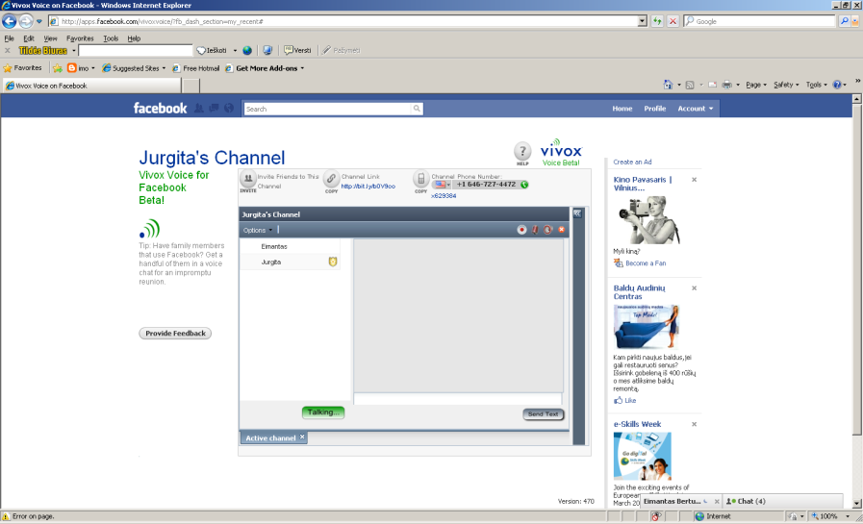
Picture 40 The screenshot of the Vivox Web Voice application
Second option is to use Talking Communities (Buys G., Hoffmann S., 2002) application for talking on Facebook. Talking Communities provides a voice-chat rooms where you can chat with your friends. This application differs from the first one as it lets chatting with friends while working on your projects. Unfortunately this application requires installing a plug-in and has strict limitations:
- 1 room per facebook user
- 5 seats per room (maximum 5 people at one time)
- Currently Windows/PC (Mac coming soon)
- Advanced administrator features such as recording

appendix 30. IM. facebook (2)
This application is in Beta. It doesn’t offer upgrading to increase room size, remove ads, or add recording. You can enter your room as moderator by entering your application page. If you enter your room from other place you enter as participant. Moderators are able to operate more functions as participants, for example, as moderator; you can disconnect or ban users, mute or clearing speakers. Anyone entering your room will act as participant. You may invite participants before entering your voice-chat room by sending them invitations.
Talking Communities voice-chat application dress Facebook in frame based structure where Facebook take the place in the main frame and voice-chat application takes the rest two frames. (See picture 41) You can type your messages on the upper voice-chat application frame. The rest frame is for voice chat only. It shows the participants and moderator, indicates the states of room and the usage of microphone and volume.

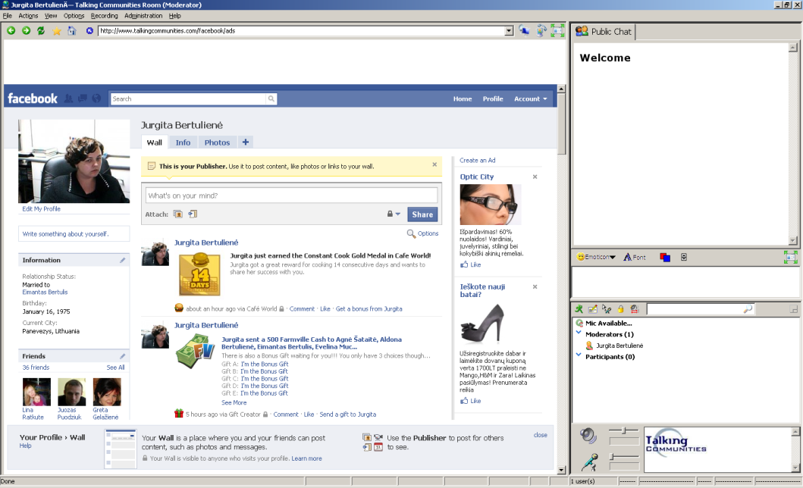
Picture 41 The screenshot of Talking Communities voice-chat application dressed in Facebook
The application has such demerits as the lateness of the voice, complication of usage and only one speaker can speak at the moment. Besides that it is good solution for communicating on Facebook while Facebook launches its own voice/video chat option.

appendix 31. IMO.IM
imo.im is a web-based service that allows users to hold text, voice, and video chats on multiple instant messaging protocols. Currently supported protocols include AIM, Google Talk, ICQ, MSN, MySpace, Skype, and Yahoo Messenger. The service is free and requires no user-registration or sign-up. (Harik R., Harik G., Krishnamurthy P., 2007) This service covers not only the instant messengers mentioned in the questionnaire, but even more. It has all options required for smooth pronunciation learning through instant messenger:
- You can sign in all your accounts in different messengers at a time and see all your friends from different messengers in one list.
- You can communicate to your friends from imo.im even if they don’t have voice/video chat plug in installed
All above mentioned options play important role in learning process based on messenger but the feature of communication among different messenger’s services is especially valuable. If the teacher is sign-in through imo.im, students may be sign in their own messengers and still be connected to one another. Teacher (or student) may call to the students even if their messenger has no option of voice/video chatting or they are working on the computer where they don’t have the rights of administrator and there is no plug-ins installed. They can meet on imo.im and communicated through voice/video application.
imo.im application includes the features necessary for pronunciation learning through instant messenger, that is why, it was chosen for this project to solve the first issue of different communication platforms. The second issue is the ability to continue the work while talking on IM. The solution may be integrating it into learning page with the help of frames (in HTML) or through the html tables with the help of Java scripts as a google gadget (on the moodle).

appendix 32. technologies (1)
Static and animated pictures are widely used in this e-teaching, so I had to choose several programs to create them. First, I was forced to use Adobe InDesign as the Early School English course book is created with the help of this program. The *.indd files are incompatible with HTML editing programs, so I had to export pictures into *.JPEG format in order to use them with HTML editors. But there is one more problem: *.JPEG format doesn’t support transparency! So, I had to convert the pictures one more time into *.gif as there is no direct option to export files from *.indd format to *.gif.
CorelDraw helped to make the original pictures for illustrating learning material. This program has a lot of tools for creating and editing objects. Especially useful was shape tool and elastic mode as they let to edit pictures without restrictions. The pictures made by this program were saved in two ways. The picture saved in CDR format is flexible for editing, but this format is not suitable to insert pictures into HTML. Windows Metafile format was chosen for its compatibility with HTML. At the beginning of the project I used the old version of CorelDraw. This version had no option of exporting files nor into *.gif, nor *.jpg, so I used *.wmf format. Later I have got the CorelDraw X3, and the work became much more easier as this version of Corel has already had the option of exporting files into more formats, including *.gif and *.jpg.
I have used one more minor program in this project – Visio. This program was used for making tables and charts explaining grammar usage in English. This program has ready-to-use shapes which were very helpful and easy-to-use. As some previous programs so the Visio program is incompatible with many others. That is why I have chosen to save files in two formats. The first format is the original visio drawing format which allows further editions; the second format is the Window Bitmap which is compatible with FrontPage and many others.

appendix 33. technologies (2)
At the beginning of the project I have tried to use such programs as Paint, Adobe Photoshop, Adobe Fireworks which later were changed by more suitable. Adobe Fireworks has many tools of Adobe Photoshop plus it allows creating the animated pictures. These pictures I have saved into animated gif and put into the exercises with the help of HTML editors. I have also had a thought of using Adobe Fireworks for creating interactive tasks with the help of the Hotspot tool, but after the experiments I have chosen to use Expression program with the tool of inserting html for certain tasks. My choice was based on the amount of options in each program; inserting html may do more operations depending on what you have written in the code.
Adobe Fireworks includes many interesting features (Adobe, 2009), but I have chosen it for its ability to create animated pictures. Attraction and interactivity gives a lot to the learning process, so I decided to create attractive pictures to explain the material of the themes. I have imported files in JPEG and after editing saved them in animated GIF. These animated files were placed in Microsoft Expresssion Web 3 and designed to explain the topics. For example, the shortening of is in speech is explained through the animation when two tablets, He and is, from different corners moves to one another and disappears in the middle where the third tablet appears with the He’s inscription. This animated picture is created from three different JPEG pictures with the inscriptions (He, is, and He’s). Pictures ‘He’ and ‘is’ are placed proportionately on the left and on the right side of the canvas, the effect of animation is put on both. There were chosen 60 states, 250 moves, and scaling to 0. 60 states indicates the process of animation, every state carries the delay of certain amount of seconds (in this picture 7 seconds for each state), the more states, the smoother movements (it’s the maximum). 250 moves indicate the 250 change of position of the picture. The more moves are used, the stops are more invisible (maximum moves are used). The pictures’ opacity changes from 100 to 0, this means that they became invisible at the end of the performance. The picture with the inscription ‘He’s’ stands in the middle of the canvas all the time. It doesn’t move, but it is also animated. In the beginning it is invisible, but at the end it is visible, as opacity changes from 0 to 100. It also has the option of scaling selected. It scales, so at the end there is visible only the third enlarged picture. This program was my first introduction to animated pictures and I liked it very much. I have created many animated pictures with this program, but the world goes round and I found the replacement for it too.

The publishers claim the feature, but it didn‘t work in experiment
The publishers claim the feature, but it didn‘t work in experiment
Only if they go as extra material to the course book
For the exploration may be used the user name – bandymas4, and pasword – Bandymas_4
Instant Messenger
For the detailed results of the investigation of this IM see Appendix 24
For the detailed results of the investigation of this IM see Appendix 25
For the detailed results of the investigation of this IM see Appendix 26
Works only if there are the plug-ins installed on the computer
For the detailed results of the investigation of this IM see Appendix 27
For the detailed results of the investigation of this IM see Appendix 28
For the detailed results of the investigation of this IM see Appendixes 29-30
Works only if there are the plug-ins installed on the computer
Works only if there are the plug-ins installed on the computer
Common European Framework of Reference for Languages
Learning Objects
Integrated Multimedia Environment
The questionnaires discussed in the 1 part – The Development and the Outlook of the Computer Based Language Acquisition Means p.12-15
Theme according to the General Programs
Adopted to the lesson according to CEFR
Integrated Multimedia Environment
© Virginija Rupainienė, V.Maksvytienė, N.Sabeckienė © Kostas Klimavičius © Leidykla „Šviesa“
© Virginija Rupainienė, V.Maksvytienė, N.Sabeckienė © Kostas Klimavičius © Leidykla „Šviesa“

