KAUNAS UNIVERSITY OF MEDICINE

FACULTY OF PHARMACY

DEPARTMENT OF PHARMACEUTICAL TECHNOLOGY AND SOCIAL PHARMACY

UNIVERSITY OF MONTPELLIER 1

FACULTY OF PHARMACY

INSTITUTE OF NEUROSCIENCES OF MONTPELLIER (U583 INSERM)

AGNĖ KASELYTĖ

FACULTY OF PHARMACY

KAUNAS UNIVERSITY OF MEDICINE

ASSAY OF EPIGENETICS CHANGES IN SFRP2 GENE IN GRADE II AND GRADE III GLIOMAS ABLE TO INFLUENCE DRUG EFFECTS

Master final thesis

Thesis mentors

Prof. Dr. Catherine Goze Prof. Dr. Vitalis Briedis INSTITUTE OF NEUROSCIENCES DEPARTMENT OF PHARMACEUTICAL

OF MONTPELLIER ( U583 INSERM) TECHNOLOGY AND SOCIAL PHARMACY

FACULTY OF PHARMACY FACULTY OF PHARMACY

UNIVERSITY OF MONTPELLIER 1 KAUNAS UNIVERSITY OF MEDICINE

KAUNAS

MONTPELLIER

2010

TABLE OF CONTENTS

1- INTRODUCTION ............................................................................................................... 3

1.1) Hypotheses 3
1.2) Problem Description …………………………………….........................................…4
2- LITERATURE REVIEW 5
2.1) Gliomas ………………………………………………………….………………….... 5
2.1.1) Etiology and epidemiology 7
2.1.2) Classification of gliomas 10
2.1.3) Symptoms of brain tumours 13
2.1.4) Diagnostic …………………………………………………………………………13
2.1.5) Treatment 13
2.2) Epigenetics in cancer 19
2.2.1) DNA methylation ………………………………………………………………... 21
2.2.2) Inheritance of DNA methylation pattern. 22
2.3) Wnt signaling pathway in development ………………………………………….. 23
2.3.1)” Epigenetic gatekeepers” 26
2.4) Secreted Frizzled- related proteins (SFRPs) 27
2.4.1) SFRPs in diseases especially in cancers. 31
2.4.2) Gene SFRP2……………………………………………………………………… 33
2.4.3) IDH1 ( isocitrate dehydrogenase1) mutation in gliomas 35
3- MATERIALS AND METHODS 37
3.1) Analysis of methylation status of grade II and grade III gliomas ……………… 37
3.1.1) Human tissues samples 37
3.1.2) DNA extraction, sodium bisulfite- modification and methylation specific
polymerase chain reaction (MS-PCR) ………………………………………………… 37
3.2) Loss of heterozigosity (LOH) 40
3.2.1) Samples, DNA extraction and dilution. 40
3.2.2) Primers design, polymerase chain reaction (PCR) reaction, sequencing. 41
3.3) Searching for IDH1 mutation ………………………………………………...….... 43
3.3.1) PCR amplification, amplified DNA purification. 44

3.3.2) Preparation of pre-sequencing PCR and automated DNA sequencing. 44
4- RESULTS ……………………………………………………..…………………………..47
4-1) Methylation status of the SFRP2 gene 47
4.1.1) MS-PCR results (agarose gel photos after DNA migration) …………………….. 47
4.1.2) Correlation of SFRP2 promoter methylation and SFRP2 mRNA expression in
glioma samples 51
4-2) Results we obtained after performing LOH for glioma grade III samples. 53
4.2.1) Correlation between methylation level and LOH. 58
4-3) Results from the researches searching IDH1 mutations……………………..…. 59
4.3.1) Correlation between IDH1 occurrence and methylation status. 61
5
- CONCLUSIONS AND RECOMMENDATIONS ...........................................................63
6- REFERENCES……………………………………………………………..………..........65
7- LIETUVIŠKA SANTRUMPA ………………………………………………………......71
Additional file 1 74
Additional file 2 ……………………………………………………………………………... 77
Additional file 3 79
Additional file 4 81

1 - INTRODUCTION

1.1) Hypotheses
Two different mechanisms participate in the loss of SFRPs expression in cancer cells: allelic loss and epigenetic silencing [1]. Methylation status in grade II and grade III glioma differs. From previous studies which were performed in Germany, 2010 by S. Gotze, M. Wolter, G. Reifenberger, O. Muller and S. Sievers [2], it is known that in grade II glioma SFRP2 gene supposed to be methylated (12.5% - 2 samples from 16 were methylated) , while in grade III glioma commonly is unmethylated (0% - from 14 samples no samples were methylated). SFRP2 gene mRNA expression decreases during transformation of grade II to grade III glioma, what’s why our researches were based on idea that SFRP2 expression level decreases because of methylation on this gene.

Grade II
Grade II

SFRP2 Methylation status
mRNA expression of gene SFRP2
in GLIOMA in GLIOMA
Grade III

Grade III

Secondly, another hypothesis we supported that SFRP2 gene could be silenced due to loss of heterozygosity (LOH). IDH1 (isocitrate dehydrogenase1) mutation occurs in tumor tissues while is absent in normal tissue. Third hypothesis which we done, that IDH1 mutation is a common event in malignant glioma tissues, and can be used for glioma diagnostic as biomarker.

1.2) Problem Description

Our object for this master thesis was to find SFRP2 (Secreted frizzled related protein-2) gene promoter methylation level in grade II and grade III gliomas. To compare the results with the results publicated in previous studies.

The main goal of this thesis is to perform methylation study of the promoter region of SFRP2 gene on 86 samples (42 WHO grade II gliomas, 40 WHO grade III gliomas and 4 non tumoral samples), and to achieve a search of SFRP2 allele loss by a Loss of Heterozigosity (LOH) method. To find proportions between samples with and without IDH1 mutations.

The challenges of our project are:

- To control if the methylation occurs during the transformation of grade II to grade III glioma. To find the methylation status in grade II glioma and grade III.

- We next asked whether SFRP2 promoter hypermethylation in grade II is functionally associated with loss of SFRP2 mRNA expression in grade III glioma. To check if there is any correlation between SFRP2 gene methylation and mRNA expression.

- To control LOH of 4q chromosome position in high grade (III) glioma.

- To compare IDH1 mutation occurrence in grade II and grade III glioma samples. To find correlation between methylation status and IDH1 mutation.

2 - LITERATURE REVIEW

2.1) Gliomas

The brain is a soft, spongy mass of tissue. It is protected by the bones of the skull and three thin membranes called meninges. Watery fluid called cerebrospinal fluid cushions the brain. This fluid flows through spaces between the meninges and through spaces within the brain called ventricles. A network of nerves carries messages back and forth between the brain and the rest of the body. Some nerves go directly from the brain to the eyes, ears, and other parts of the head. Other nerves run through the spinal cord to connect the brain with the other parts of the body. Within the brain and spinal cord, glial cells surround nerve cells and hold them in place [3]. The brain directs the things we choose to do (like walking and talking) and the things our body does without thinking (like breathing). The brain is also in charge of our senses (sight, hearing, touch, taste, and smell), memory, emotions, and personality. The three major parts (Figure 1) of the brain control different activities:
Cerebrum - The cerebrum is the largest part of the brain. It is at the top of the brain. It uses information from our senses to tell us what is going on around us and tells our body how to respond. It controls reading, thinking, learning, speech, and emotions. The cerebrum is divided into the left and right cerebral hemispheres, which control separate activities. The right hemisphere controls the muscles on the left side of the body. The left hemisphere controls the muscles on the right side of the body.
Cerebellum - The cerebellum is under the cerebrum at the back of the brain. The cerebellum controls balance and complex actions like walking and talking.
Brain Stem - The brain stem connects the brain with the spinal cord. It controls hunger and thirst. It also controls breathing, body temperature, blood pressure, and other basic body functions.
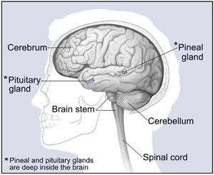
Figure 1. Major parts of brain. ( The internet encyclopedia of science: www.daviddarling.info )
So the central role of the brain in every aspect of bodily function, and the dramatic functional disturbances that arise with minimal disturbance to the neural cytoarchitecture or circuitry, account for the severity of many brain tumors [4]. The location of a tumour within the brain determines which effects it will have. When most normal cells grow old or get damaged, they die, and new cells take their place. Sometimes, this process goes wrong. New cells form when the body doesn't need them, and old or damaged cells don't die as they should. The build-up of extra cells often forms a mass of tissue called a growth or tumour. A tumour is an abnormal mass of tissue that grows on or inside the body. It is known as primary if located where its growth first started, or secondary if it began growing elsewhere in the body and metastasized, or spread, to its present location [5;6]. Most primary brain tumours do not metastasize outside the brain. Inside the skull, tumours can grow almost anywhere: within brain tissue, from the meninges, or inside the ventricular system. They can be encapsulated (self-contained) or interwoven with blood vessels, nerves, or other brain structures from which they cannot be removed without devastating consequences. Metastatic tumours are usually well localized, may occur alone or in clusters, and may spread throughout much of the brain. A benign tumour usually is encapsulated, does not spread to other areas of the body, grows slowly, and often causes problems by compressing brain tissue. A malignant tumour grows uncontrollably, spreads throughout the brain, and destroys brain tissue.
The brain is made up of many supporting cells that are called glial cells. Within the brain and spinal cord, glial cells surround nerve cells and hold them in place. Glial cells support the brain's functioning nerve network and are the site of tumours inside the brain. One type of brain tumours are gliomas [4]. Gliomas constitute a heterogeneous group of brain tumours that are thought to derive from glial cells or their precursors. These tumours exhibit unique biological features. Their precise histogenetic origin has remained obscure. They show a highly infiltrative and invasive growth pattern in the brain but rarely metastasize outside the central nervous system. Glioma cells are paradigmatic for the ability of cancer cells to compromise cellular immune defense mechanisms. These cells are also highly resistant to the induction of apoptotic cell death, rendering futile all current approaches of cancer therapy. Gliomas have thus remained one of the most challenging types of cancer for decades.
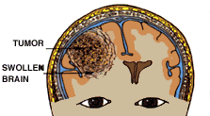
Unlike other cancers, glioma tumours grow in the confined space inside the head (Figure 2A). The "centre" of the glioma may readily be identified (Figure 2B), but because the tumour gradually spreads into surrounding tissue the boundaries of a glioma are harder to identify [4].
Figure 2A. Image of glioma. (www.brainspine.com)

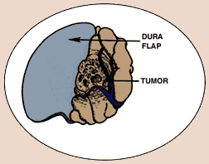
Often when the dura is opened, the brain is swollen but otherwise may appear normal (figure 2B).

Figure 2B. Image of glioma. (www.brainspine.com)

2.1.1) Etiology and epidemiology
About 2% of human cancers are brain tumours [7]. Gliomas represent 64-72% of all primary brain tumours. Primary brain tumours is the leading cause of cancer-related deaths in children. Also the ~4th leading cause of cancer-related deaths in people under the age of 54 [8;9]. Primary brain tumours significant increase in incidence in people over the age of 60 years old [8]. The cause of most gliomas remains obscure. For the vast majority of gliomas, genetic factors seem not to be predisposing factors. Several occupations, environmental carcinogens, and diet (N-nitroso compounds) have been reported to be associated with an elevated glioma risk, but the only environmental factor unequivocally associated with an increased risk of brain tumours, including gliomas, is therapeutic X-irradiation, which may increase the incidence of gliomas 3-to 7-fold. In particular, children treated with X-irradiation for acute lymphoblastic leukemia show a significantly elevated risk of developing gliomas and primitive neuroectodermal tumor (PNET), often within 10 years after therapy. In contrast, no role for cellular phones, high-tension wires, head trauma, or dietary compounds has been demonstrated. A family history of glioma can also be a risk factor, accounting for approximately 5% of patients with malignant gliomas. Some genetic disorders are associated with high risk of glioma development, such as optic nerve gliomas in neurofibromatosis type I, various types of gliomas in neurofibromatosis type II and the Li-Fraumeni syndrome, subependymal giant cell astrocytoma in tuberous sclerosis, and glioblastomas in the Turcot syndrome. These associations provide interesting insights into the biochemistry of gliomagenesis and offer clues to the development of the much more common spontaneous gene. However, the known causes of glioma represent only a small percentage of patients, with most cases arising "spontaneously”. The incidence of all adult primary brain tumours in the United States is 11.8 per 100 000 persons per year. In France there are 3000 new cases of gliomas every year. It is 8 new cases per 100 000 person per year [8;9]. In 2001, the estimated number of new cases of malignant CNS tumours in Lithuania was 247. It was 7.1 per 100 000 person per year [7]. In 2007, occurred 211 new cases of malignant CNS tumours in Lithuania, it was 6.2 per 100 000 Lithuania habitants per year. Between 1998- 2002 the malignant CNS tumours in Lithuania was 7.4 per 100 000 person per year and 75% of malignant CNS tumours was glioma. New researches had demonstrated what primary brain tumours account for 1.4% of all cancers and 2.4% of all death in the United States, and approximately 20.500 newly diagnosed cases and 12.500 deaths are attributed to primary malignant brain tumours each year. The annual incidence of malignant gliomas is approximately 5 cases per 100.000 people.
In children, brain tumours are the cause of one quarter of all cancer deaths. Each year more than 14.000 malignant gliomas are diagnosed in the United States. Glioblastoma account for approximately 60 to 70% of malignant gliomas, anaplastic oligoastrocytomas for 10%; less common tumors such as anaplastic ependymomos and anaplastic gangliogliomas account for the rest. Areas with the highest reported rates of primary malignant brain tumours, such as Northern Europe, the United States, and Israel generally have more accessible medical care than areas with the lowest rates, such as India or the Philippines. This would seem to indicate that the disparity is due to better diagnosis and reporting of brain tumours in more developed countries. However, there is some evidence that ethnic differences do play a role in the disease. For example, the rate of malignant brain tumours in Japan, an economically prosperous country, is less than half the rate of Northern Europe’s. And in the United States, whites have higher rates of glioma, but lower rates of meningioma than blacks. Malignant gliomas are 40% more common in men than in women and twice as common in whites as in blacks. Also, glioma is more common in men, while meningioma is more common in women. This is the most consistent finding in epidemiological studies of brain tumors. Some researches had approved important age role in the development of various brain tumors. As is shown in Figure 3, the high grade gliomas rates are increasing especially in adults over age 65, so the median age of patients at the time of diagnosis is 64 years in the case of glioblastomas and 45 years in the case of anaplastic gliomas. However, the low grade gliomas as splited between various age patients quite the same, just some visible increase is declined in the age of 65 as well.
Among adults one of the most common brain tumors is Astrocytomas. Diffusely infiltrating astrocytomas account for more than 60% of all primary brain tumors [10]. The tumor arises from star-shaped glial cells called astrocytes. It can be any grade. In adultes, an astrocytoma most often arises in the cerebrum. Among children, the most common types are: grade I or II astrocytoma. In children, this low grade tumor occurs anywhere in the brain. The most common astrocytoma among children is juvenile pilocytic astrocytoma. It's grade I. Also, brain stem glioma: the tumor occurs in the lowest part of the brain. It can be a low-grade or high-grade tumor. The most common type is diffuse intrinsic pontine glioma .
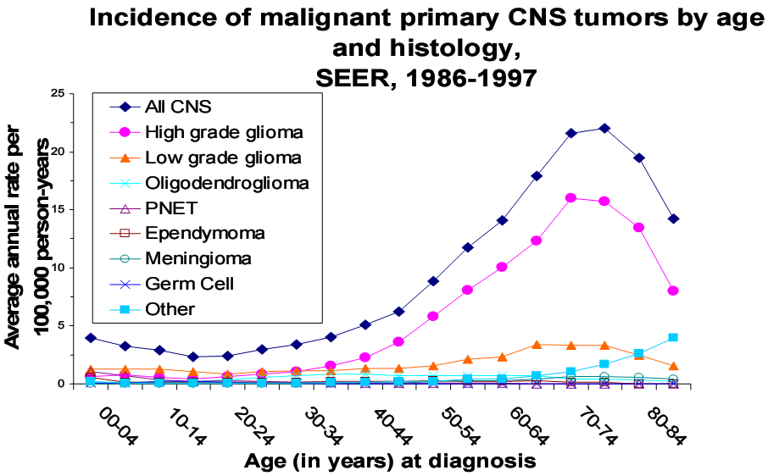
Figure 3. The data was used from University of Texas, M.D. Anderson Cancer Centre, Department of Epidemiology.
2.1.2) Classification of gliomas

Different types of tumor of neuroepithelial origin have been identified and classified according to the cell types that predominate within the tumor mass. Gliomas are classified by neuropathological criteria defined by the World Health Organisation (WHO) [10;11]. The grading of gliomas from low (I) to high (IV) malignancy is a key feature of the WHO classification and has important implication for therapy and prognosis (Table 1). The most common WHO grade I tumour, pilocytic astrocytoma, is a benign lesion and mainly a tumor of childhood and early adulthood [10;11;12]. World Health Organization grade II, III, and IV gliomas are diffusely growing, infiltrative tumors that are distinct entities histopathologically, but can be viewed as distinct stages of malignant progression among a family of related tumours, glioblastomas being the most malignant and the most common variant. Grade I astrocytomas circumscribed, slowly growing tumours with low cellularity. Grade II astrocytomas are well differentiated tumours with a diffusely infiltrative growth pattern. Grade III and grade IV tumours are considered malignant gliomas. Grade III anaplastic astrocytomas show enhanced cellularity, nuclear atypia, and increased mitotic activity. On the basis of World Health Organisation classification, the most common (65%) and most malignant form of glioma is grade IV, which is commonly known as glioblastoma miltiforme [10;13]. Glioblastomas are characterized by such features as grade III plus prominent micro vascular proliferation or areas of necrosis. The Prognosis is still poor (Table 2) less than 3% of glioblastoma patients are still alive at 5 years after diagnosis, higher age being the most significant predictor of poor outcome. In addition, the median survival when radiotherapy and chemotherapy are combined is 14.6 months [14;15]. Oligodendriogliomas are divided by the WHO into two grades: well-differentiated oligodendrogliomas and oligoastrocytomas (WHO grade II), and anaplastic oligodendrogliomas and anaplastic oligoastrocytomas (WHO grade III). So oligodendroglial tumours are graded as II, as III when features of anaplasia are present, or as glioblastomas without further specification if the above- mentioned criteria for glioblastomas are met. Gliomas are graded not according to the predominant grade of malignancy of the resected tissue, but according to the area of highest malignancy; for example, a tumour that for the most part corresponds to grade II astrocytoma will still be classified as glioblastomas should there be a single focal area meeting the criteria for glioblastomas.
The diagnosis of the glial origin of a brain tumor is based on its morphological resemblance to untransformed astrocytes and the common expression of glial fibrillary acidic protein. Gliomas are often heavily infiltrated by host cells, predominantly microglial cells and macrophages, but also reactive astrocytes and fewer lymphocytes.

Table 1. WHO classification of Central Nervous System Tumors. (http://www.encr.com.fr/BRAINTB1.gif)
GLIOMAS |  |  |  |  |  | NONGLIOMAS
 | grade | I | II | III | IV
Astrocytic tumours |  |  |  |  |  | Choroid plexus tumors
Pilocytic astrocytoma |  | *
Pituicytoma (**) |  | * |  |  |  | Neuronal and mixed neuronal-glial tumor
Pilomyxoid astrocytoma (**) |  |  | *
Subependymal giant cell astrocytoma |  |  | * |  |  | Tumors of the pineal region
Pleomorphic xanthoastrocytoma |  |  | *
Diffuse astrocytoma |  |  | * |  |  | Embryonal tumors, including Medulloblastoma
-Fibrillary astrocytoma |  |  | *
-Gemistocytic astrocytoma |  |  | * |  |  | Meningeal tumors
-Protoplasmic astrocytoma |  |  | *
Anaplastic astrocytoma |  |  |  | * |  | Primary CNS Lymphomas
Glioblastoma |  |  |  |  | *
- Giant cell glioblastoma |  |  |  |  | * | Germ cell tumors
- Gliosarcoma |  |  |  |  | *
Gliomatosis cerebri | nd |  |  |  |  | Pituitary adenomas
Oligodendroglial tumours
Oligodendroglioma |  |  | * |  |  | Tumors of cranial and paraspinal nerves
Anaplastic oligodendroglioma |  |  |  | *
Oligoastrocytic tumours |  |  |  |  |  | Tumors of the sellar region
Oligoastrocytoma |  |  | *
Anaplastic oligoastrocytoma |  |  |  | * |  | Metastatic tumors
Ependymal tumours
Subependymom |  | *
Myxopapillary ependymoma |  | *
Ependymoma |  |  | *
- Cellular
- Papillary
- Clear Cell
- Tanycytic
Anaplastic ependymoma |  |  |  | *
nd = not defined

Grade I is assigned to the more circumscribed tumors with low proliferative potential, grade II defines diffusely infiltrative tumours with cytological atypia alone, grade III those also showing anaplasia and mitotic activity and grade IV (Glioblastoma) tumours additionally showing microvascular proliferation and/or necrosis.

WHO II | astrocytoma  (3-10 yrs) | oligo- astrocytoma  (5-12 yrs) | oligodendroglioma  (8-20yrs)
WHO III | anaplastic astrocytoma  (2-5 yrs) | anaplastic oligo- astrocytoma  (2-8 yrs) | anaplastic oligodendroglioma (2-10yrs)
WHO IV | glioblastoma (1-2 yrs)
Table 2. World Health Organization grades are indicated. Under each tumour type are the range of typical survival (in years).

Gliomas can be also classified according to whether they are above or below a membrane in the brain called the tentorium [11;12]. The tentorium separates the cerebrum, above, from the cerebellum, below.
- Supratentorial: Above the tentorium, in the cerebrum, mostly in adults (70%). Senator Edward M. Kennedy’s brain tumor, for example was supratentorial, in the parietal area in the upper part of the left side of his brain, above the ear.
- Infratentorial: Below the tentorium, in the cerebellum, mostly in children (70%)

2.1.3) Symptoms of brain tumours

The symptoms of brain tumours depend on tumour size, type, and location. Symptoms may be caused when a tumour presses on a nerve or damages a certain area of the brain. They also may be caused when the brain swells or fluid builds up within the skull. A brain tumour may at first cause the vague feeling of being "unwell." This may be followed by other, more specific symptoms: dull, persistent headache; nausea or vomiting; generalized weakness; vision problems. Because the left side of the brain governs the right side of the body, and vice versa, a tumour will cause specific weakness or loss of movement on the opposite side of the body. Some symptoms may be caused by the increased pressure inside the skull from brain swelling, which can temporarily be treated with a steroid medication. Because brain tissue is irritated by the tumour, the brain can temporarily "short-circuit" as its normal electrical activity is interrupted. These periods of uncontrolled brain activity can cause seizures, which may be generalized and cause contractions of all parts of the body, loss of consciousness or bladder and bowel function. The seizures may instead be of a focal nature, affecting only one arm, a leg, or part of the face. Seizures usually can be controlled with anticonvulsant medications.

2.1.4) Diagnostic

A detailed history-taking of the patient's symptoms and a physical examination are done first, followed by any of several tests, such as X-ray studies, Computerized Tomography (CT) scans, Magnetic Resonance Imaging (MRI), and angiograms. All findings are used to evaluate the patient's symptoms, determine the tumour's exact location, and provide the physician with a tentative diagnosis of the tumour type. During surgery, ultrasound imaging may be used to pinpoint the tumour's precise location and help the surgeon plan his approach for its removal. If an emergency craniotomy is required, an extensive workup may not be possible.

2.1.5) Treatment

The goals of treatment are to:
- remove as many tumour cells as possible (with surgery)
- kill as many as possible of the cells left behind (with radiation and chemotherapy)
- put remaining tumour cells into a nondividing, sleeping state for as long as possible (with radiation and chemotherapy)
Strategies for the management of low grade gliomas are: observation, surgery, radiation therapy, chemotherapy. Observation may be a reasonable opinion if the patient’s clinical manifestation of low grade glioma is only seizure and seizures are controlled by medication. There are three standart types of treatment for patients with high- grade gliomas: surgery, radiation therapy, and chemotherapy. Nowadays the treatment of grade IV glioma (glioblastomas) remains difficult in that no contemporary treatments are curative; also overall mortality rates remain high [12;14;16].
Surgery. The first step in therapy is maximal feasible removal of tumour tissue. Surgeons believe that patients with smaller amounts of tumour when they start other treatments will have a better prognosis. Also, radiation therapy is more easily tolerated when the pressure from the tumour can be reduced. There is great variability in the amount of tumour that can be safely removed from the brain of a patient. The variability is based mainly on the location of the tumour. For instance, tumours in some brain areas can be removed with very low risk, while in other brain areas surgery is too risky to contemplate. The decision about the benefit and risk of surgical removal is one that experienced brain tumour neurosurgeons make every day. The underlying principle is that the surgery should not worsen the patient’s condition. The goal is for the patient to be the same or better after recovering from brain tumour removal. When a tumour is located in a sensitive area of the brain, a biopsy is performed with a small needle, thereby avoiding further damage to brain function. It is important to remember that gliomas infiltrate into surrounding brain, making complete removal impossible in almost every case. With modern neuro-imaging techniques such as MRI scans, it is possible for doctors to have a high level of confidence that a brain tumour is present prior to biopsy. In that case, it is safe to perform a major surgical resection at the same time as obtaining tumour tissue for the pathologist to examine. In some cases, however, it is necessary to perform a needle biopsy first, and later proceed to a full-scale surgery. A preliminary diagnosis ("frozen section diagnosis") is made by the neuropathologist during the surgery in order to help the neurosurgeon know what type of tumour is present. The patient and their family are informed of this preliminary diagnosis immediately after surgery. However, further recommendations about treatment are not made until the final pathology report is available. The final report requires a minimum of 2 working days after surgery. In difficult cases, the final report can take a week. It is not uncommon for small, but important, changes to be made in the diagnosis once all of the biopsy sections have been examined.
Radiation therapy. Radiation therapy is an important part of the treatment of high-grade gliomas. In typical situations, patients begin radiation treatments within 2 to 4 weeks after tumour resection. A physician who supervises radiation treatments is called a radiation oncologist. Following a "simulation" session in which the radiation oncologist plans the shape of the radiation beam as well as dose, treatments are given daily, Monday through Friday, for 4 to 6 weeks. Each treatment takes only a few minutes. During radiation, patients are seen weekly by the radiation oncologist, and a nurse is available for questions every day. Most patients feel better during radiation therapy if they are taking a small dose of a steroid which reduces brain swelling, called Decadron (also called dexamethasone). There are usually no immediate side effects during each treatment. As the treatment progresses, hair loss will occur over the area where the radiation beam passes into the tumour. Most patients experience some fatigue by the second or third week. For many, a 30 minute nap is helpful every afternoon. There are a number of long-term side effects from radiation therapy, ranging from those that are a minor nuisance to ones that can produce major health problems. Fortunately, serious side effects are rare. Furthermore, the potential risks of radiation therapy are outweighed by the known risk of not treating the tumour. The radiation oncologist will describe these risks prior to starting therapy. An MRI is usually obtained about 2 to 4 weeks after the end of radiation therapy in order to judge the effect of treatment. Most of the time this scan will show no change from the post-operative MRI, which is good. Some shrinkage is even better. Growth during radiation therapy is an unwanted sign of an aggressive tumour.
Chemotherapy. Chemotherapy is helpful in controlling the growth of high-grade gliomas. Several different types of chemotherapy drugs are available. A neuro-oncologist is skilled at recommending these treatments. For most tumours radiation is given prior to consideration of chemotherapy, however, chemotherapy is often administered prior to radiation therapy for patients with anaplastic oligodendrogliomas. Chemotherapy for glioblastoma multiforme raises an important question as to timing. Few agents have been developed specifically for brain tumors, and the nitrosoureas, 1-(2-chloroethyl)-3-cyclohexyl-L-nitrosourea and 1,3-bis(2-chloroethyl)-1-nitrosourea, carboplatin, procarbazine remain the most active antitumor agents available. The chemical class of drugs known as the nitrosoureas are a recently developed group of very active alkylating-agent anticancer drugs. The nitrosoureas covalently deactivate thioredoxin reductase, glutathione reductase and ribonucleotide reductase by alkylating their thiolate active sites. Since thioredoxin reductase and glutathione reductase function as alternative electron donors in the biosynthesis of deoxyribonucleotides, catalyzed by ribonucleotide reductase, the inhibition of these electron transfer systems by the nitrosoureas could determine the cytostatic property of this homologous series of drugs. The nitrosoureas are among the most active, if not the most active, anticancer drugs both quantitatively (log kill of sensitive tumor cells in vivo) and qualitatively (spectrum of mouse, rat, and hamster tumors responding to treatment). Therapeutic anticancer activity of the nitrosoureas has been consistently observed with oral as well as parenteral administration. The nitrosoureas are clearly the most active group of anticancer drugs observed against experimental meningeal leukemias and intracerebrally implanted transplantable primary tumors of central nervous system origin (eg, gliomas, ependymoblastomas, and astrocytomas in mice and hamsters). The nitrosoureas have been observed to be less than additive in lethal toxicity for vital normal cells in the mouse in combination with representatives of the other major classes of anticancer agents, eg, purine antagonists, pyrimidine antagonists, inhibitors of DNA polymerase(s) or ribonucleotide reductase(s), mitotic inhibitors, drugs that bind to or intercalate with DNA, and other alkylating agents. Carboplatin (CBDCA)- [diammine(1,1-cyclobutanedicarboxylato)platinum(II)] is one of the most promising second generation platinum compounds. Carboplatin, an analogue of cisplatinumum, has the same mechanism of action. Its cytotoxic mode of action is mediated by its interaction with DNA to form DNA adducts, primarily intrastrand crosslink adducts, which activate several signal transduction pathways, including those involving ATR, p53, p73, and MAPK, and culminate in the activation of apoptosis. Carboplatin has high stability in infusion fluids in the absence of chloride, but it is less stable in plasma and urine. Protein binding is limited, while the low uptake in red blood cells appears to be species dependent. Commonly, carboplatin is administered intravenously, and its pharmacokinetics are linear up to a dose of 2400 mg/m2. The major types of clinical toxic effects of carboplatin are gastrointestinal, hematopoietic, immunosuppressive, otological and renal. Hearing loss was detected within 4 days after treatment and persisted for up to 6 months in surviving patients. If the toxicity is diagnosed and the drug is continued, clinical hearing loss at the spoken range will occur. Partialy reversible, high frequency nerve deafness is usually the earliest sign of toxicity. Neurotoxic reactions caused by carboplatin are peripheral neuropathies, including paresthesia in both upper and lower frequencies, tremor, leg weakness, loss of taste. Procarbazine (PCB)- is a monoamine oxidase inhibitor. The mechanism by which procarbazine inhibits tumor growth has not yet been determined. Interference with the structure of DNA disorganizes and disrupts the cell. Procarbazine can inhibit RNA, DNA, and protein synthesis in vivo and in vitro, and these may be responsible for the disturbance in cell division. The most common toxic effects include leukopenia, thrombocytopenia, nausea.
One of the newest drugs used in chemotherapy is temozolomide. Temozolomide is an midazotetrazine second-generation alkylating agent, is the leading compound in a new class of chemotherapeutic agents that enter the cerebrospinal fluid and do not require hepatic metabolism for activation. The oral agent was developed by Malcolm Stevens and his team at Aston University in Birmingham. A derivative of imidazotetrazine, temozolomide is the prodrug of MTIC (3-methyl-(triazen-1-yl)imidazole-4-carboxamide). It has been available in the US since August 1999, and in other countries since the early 2000s. Temozolomide has recently been approved by the United States Food and Drug Administration (FDA) in March 2005 for the treatment of adult patients with refractory anaplastic astrocytoma and, in the European Union, for treatment of glioblastoma multiforme showing progression or recurrence after standard therapy. Predictable bioavailability and minimal toxicity make temozolomide a candidate for a wide range of clinical testing to evaluate the potential of combination treatments in different tumor types. MECHANISM OF ACTION: The methylation of DNA seems to be the principal mechanism responsible for the cytotoxicity of temozolomide to malignant cells [15, 17]. Temozolamide spontaneous chemical conversion in the systemic circulation at physiological pH to the active compound, MTIC (monomethyl triazeno imidazole carboxamide) is initiated by the effect of water at the highly electropositive C4 position of temozolomide. Temozolomide exhibits schedule-dependent antineoplastic activity by interfering with DNA replication. The therapeutic benefit of temozolomide depends on its ability to alkylate/methylate DNA, which most often occurs at the N-7 or O-6 positions of guanine residues. This methylation damages the DNA and triggers the death of tumor cells. However, some tumor cells are able to repair this type of DNA damage, and therefore diminish the therapeutic efficacy of temozolomide, by expressing an enzyme called O-6-methylguanine-DNA methyltransferase (MGMT) or O-6-alkylguanine-DNA alkyltransferase (AGT or AGAT). In some tumors, epigenetic silencing of the MGMT/AGT gene prevents the synthesis of this enzyme, and as a consequence such tumors are more sensitive to killing by temozolomide. Conversely, the presence of MGMT protein in brain tumors predicts poor response to temozolomide and these patients receive little benefit from chemotherapy with temozolomide. The cytotoxic mechanism of temozolomide appears to be related to the failure of the DNA. DOSAGE: Temozolomide is available in the United States in 5 mg, 20 mg, 100 mg, 140 mg, 180 mg & 250 mg capsules. Temozolomide is usually given once daily for 5 days. The treatment may be repeated every 28 days. Temozolomide should be administered in the fasting state, at least one hour before a meal. Capsules must not be opened or chewed, but are to be swallowed whole with a glass of water. Antiemetic therapy may be administered prior to, or following, administration of temozolomide. Temozolomide is contraindicated in patients with hypersensitivity to its components or to dacarbazine. The use of temozolomide is not recommended in patients with severe myelosuppression. Temozolomide is genotoxic, teratogenic and fetotoxic and should not be used in pregnancy. Nursing should be discontinued while receiving the drug because of the risk of secretion into breast milk. In male patients, temozolomide can have genotoxic effects. Men are advised not to father a child during or up to six months after treatment and to seek advice on cryoconservation of sperm prior to treatment, because of the possibility of irreversible infertility due to temozolomide therapy. SIDE EFFECTS: Nausea, tiredness, constipation and headache may occur. If any of these effects persist or worsen, notify your doctor promptly. Tell your doctor immediately if you have any of these serious side effects: unusual dizziness or drowsiness, easy bleeding or bruising, persistent sore throat, fever, seizures, unusual weakness, loss of coordination, mental/mood changes, vision changes, swelling, rash, diarrhea, trouble sleeping.Studies have shown that the drug was well tolerated and provided a survival benefit. Laboratory studies and clinical trials are investigating whether it might be possible to further increase the anticancer potency of temozolomide by combining it with other pharmacologic agents. For example, clinical trials have indicated that the addition of chloroquine might be beneficial for the treatment of glioma patients [17]. In laboratory studies, it was found that temozolomide killed brain tumor cells more efficiently when epigallocatechin gallate (EGCG), a component of green tea, was added; however, the efficacy of this effect has not yet been confirmed in brain tumor patients. There are currently limited numbers of prospective studies evaluating chemotherapy for adult low grade glioma (LGG). Because tumor cells that synthesize the MGMT/AGT enzyme are more resistant to killing by temozolomide, it was investigated whether the inclusion of O-6-benzylguanine (O6-BG), an inhibitor of MGMT, would be able to overcome this resistance and improve the drug's therapeutic effectiveness. In the laboratory, this combination indeed showed increased activity in tumor cell culture in vitro and in animal models in vivo. However, a recently completed phase II clinical trial with brain tumor patients yielded mixed outcomes; while there was some improved therapeutic activity when O6-BG and temozolomide were given to patients with temozolomide-resistant anaplastic glioma, there seemed to be no significant restoration of temozolomide sensitivity in patients with temozolomide-resistant glioblastoma multiforme. There are also efforts to engineer hematopoietic stem cells to carry MGMT prior to transplanting them into brain tumor patients. This would allow for the patients to receive stronger doses of temozolomide, since the patient's hematopoietic cells would be resistant to the drug. High - doses of temozolomide in high - grade gliomas yeld low toxicity but the results are comparable to the standard doses. In clinical studies, temozolomide consistently demonstrates reproducible linear pharmacokinetics with approximately 100% p.o. bioavailability, noncumulative minimal myelosuppression that is rapidly reversible, and activity against a variety of solid tumors in both children and adults. Preclinical studies have evaluated the combination of temozolomide with other alkylating agents and inhibitors of the DNA repair protein O⁶-alkylguanine alkyltransferase to overcome resistance to chemotherapy in malignant glioma and malignant metastatic melanoma.
Although chemotherapy is beneficial, it is not known whether the timing of administration is important. Many centers in the United States and Europe now save chemotherapy until there is evidence that the tumour is growing after radiation therapy. This may mean that months or even years could elapse between radiation and chemotherapy. Other specialists prefer to give chemotherapy immediately after radiation therapy and to give different chemotherapy when the tumour starts to grow again. This decision has to be made on a patient-by-patient basis. In addition to standard chemotherapy, there are studies of new drugs which are conducted in major research centres. The possible side effects of chemotherapy will be discussed before beginning treatment. Today, chemotherapy is much less toxic than even a few years ago. Although chemotherapy is targeted against dividing tumour cells, there are normal cells in the body which are also dividing. These normal cells can also be temporarily affected by chemotherapy and may lead to side effects. Specifically, the cells which can be affected are those in the bone marrow and the cells which line the gastrointestinal tract. The cells in the bone marrow form the blood cells that are circulating in the body. These cells include white blood cells which fight infection, red blood cells which carry oxygen, and platelets which prevent bleeding. Two other types of cells which may be affected temporarily or permanently are the female egg cells and those cells which produce sperm in the man. In men, chemotherapy can cause sterility, and therefore may make men unable to father a child. Women of child-bearing years need to use a reliable birth control method for the entire time, including the rest periods, when receiving chemotherapy. The effects of many chemotherapy drugs can be harmful to the growth and development of a fetus, therefore it is crucial to not become pregnant or father a child while receiving chemotherapy.
Stupp protocol as standard treatment in glioblastomas. The preliminary report of Stupp et. al., and the recently published randomized European and Canadian trial has substantially altered the algorithm for initial treatment of glioblastoma. This treatment has become the new standard of care for patients with newly diagnosed glioblastomas, as was safe and well tolerated. Temozolomide (TMZ) given currently with radiotherapy followed by 6 monthly cycles of TMZ. Adjuvant and concomitant temozolomide with radiation was associated with significant improvements in median progression-free survival over radiation alone (6.9 versus 5 months), overall survival (14.6 versus 12.1 months), and the likelihood of being alive in 2 years (26% versus 10%) in patients receiving or not receiving TZM [15;18].

2.2) Epigenetics in cancer

Cancer has been defined in many ways. Starting from Hippocrates observation of angiogenesis, the word cancer itself refers to the thick blood vessels that feed the tumors and that resemble the claws of crab [19]. Since the time of Laenuec, pathologists have viewed cancer as acquiring properties of cells at different development stages, but appearing inappropriately in the tumors. In the past century genetic model of cancer has predominated, beginning with Boveri who first suggested a role for abnormal chromosomes in cancer. In the modern area the diverse molecular changes that occur among cancer types have led to the idea that cancer encompasses many diseases.
Great advances have been made in basic research on cancer and in identifying the genetic changes that underlie tumor cell biology. Similarly, great advances have been made in characterizing epigenetic alterations in cancer [19]. Initiation and progression of human tumors is generally believed to be a result of oncogene activation and tumor suppressor gene inactivation by both genetic and epigenetic means [20;21]. Classic genetics alone cannot explain the diversity of phenotypes within a population. Nor does classic genetics explain how, despite their identical DNA sequences, monozygotic twins or cloned animals can have different phenotypes and different susceptibilities to a disease. The concept of epigenetics offers a partial explanation of these phenomena. Epigenetic research can help explain how cells carrying identical DNA differentiate into different cell types, and how they maintain differentiated cellular states. Epigenetics is thus considered a bridge between genotype and phenotype [20]. First introduced by C.H. Waddington in 1939 to name "the causal interactions between genes and their products, which bring the phenotype into being". Nowadays, the term “epigenetics” refers to a heritable change in the pattern of gene expression that is mediated by mechanisms other than alterations in the primary nucleotide sequencing of a gene [20;21]. It is known these non- genetic alterations are tightly regulated by two major epigenetic modifications: chemical modifications to the cytosine residues of DNA (DNA methylation) and histone proteins associated with DNA (histone modifications). The study of epigenetic mechanisms in cancer, such as DNA methylation, histone modifications, nucleosome positioning and micro-RNA expression, has revealed a plethora of events that contribute to the neoplastic phenotype through stable changes in the expression of genes critical to transformation pathways [21]. As the evidence for genetic changes in cancer cell increased during the 1980s and early 1990s, interest in the contribution of epigenetic changes to neoplasia waned. The situation has changed dramatically in more recent years. Since the first public presentation on cancer epigenetics in 1997, the field has grown exponentially in knowledge, publications, and number of investigators. Most encouragingly, research in epigenetics has led to improved survival of patients with certain forms of lymphoma and leukemias through the use of drugs that alter DNA methylation and histone acetylation [22]. In addition, there are numerous other clinical applications of the field being explored in areas such as cancer screening and early detection, prevention, classification for epidemiology and prognostic purposes, and predicting outcomes after standard therapy.

2.2.1) DNA methylation

DNA methylation the first recognized and most well- characterized epigenetic modification, is linked to transcriptional silencing, and is important for gene regulation, development, and tumorigenesis [23;24;25]. The DNA methylation patterns established during this time remain relatively stable in normal tissue. The target molecules for methylation in mammalian DNA are cytosine bases in CpG dinucleotides. The distribution in the genome of the CpG dinucleotides is unusually asymmetric. In contrast to relative paucity of CpGs in the genome as a whole, these dinucleotides can be clustered in regions of large repetitive sequences such as centromeric repeats or at the 5’ ends of many genes, termed “CpG islands” [26]. These regions are often associated with sites where the transcription of DNA into RNA begins- the promoter regions. Almost half the genes in our genome have such CpG- rich promoter regions. In humans, in the bulk of genome, about 80% of the CpG dinucleotides that are not associated with CpG islands are heavily methylated. In contrast, euchromatic CpG islands remain locally unmethylated, with the exception of genes involved in imprinting [24], X chromosome inactivation, and tissue-specific differentiation. In mammalian cells, DNA methylation occurs at the 5’ position of the cytosine ring within CpG dinucleotides via addition of a methyl group to create a 5- methylcytosine (m⁵C) (Figure 4 ). Methyl group from S-adenosylmethionine (SAM, a universal methyl donor) is added to 5 position of the cytosine pyrimidine ring, this process is catalysed by the enzymatic activity of DNA methyltransferases (DNMTs). To date three enzymatically active DNA methyltransferases have been identified in mammals including DNMT1, DNMT3a and DNMT3b [27]. De novo methylation can occur in early embryonic stem cells and cancer cells. DNMT3a and DNMT3b are de novo methyltransferases [27], preferentially targeting unmethylated CpGs to initiate methylation. The processes that initiate de novo methylation are still unknown. During DNA replication, the methylation patterns on the parental DNA strand is copied onto the newly synthesized strand (daughter strands) mainly by means of the maintenance methyltransferase DNMT1, which recognize and methylate hemimethylated CpGs. DNMTs can function cooperatively to methylate DNA.
Moreover, it has been observed that knockout DNMTs are embryonically lethal in mouse model, this improved the importance of DNA methylation for embryonic development of mammalian cells. Distinctive distribution patterns of CpGs methylation are believed critical for the control of gene silencing and chromosomal stability [28]. In contrast to somatic cells, cancer cells show a dramatic alteration in the distribution of methyl groups [9;17;33;36]. Globally, most human tumors have a significantly reduced frequency of CpG methylation, while CpG islands become hypermethylated. These epigenetic changes contribute to genome instability with increased loss of heterozygosity, activation of oncogenes, silencing of tumor suppressor genes and inactivation of DNA repair systems. When CpG island methylation and transcriptional silencing occurs at tumor suppressor gene loci [30;31], a selective growth advantage is conferred, and cells progress to a more malignant phenotype. Different tumor types have significantly different rates and patterns of epigenetic tumor suppressor gene inactivation [32;33], implying that this process is not random, but is perhaps selected for during neoplastic transformation. The underlying cause of aberrant DNA methylation appears intimately connected with the process of neoplastic transformation, rather than a consequence of transformation, although this is still a subject of intense debate. The events that alter the methylation machinery, and thereby raise the rates of CpG island methylation in most human cancers, remain poorly understood.

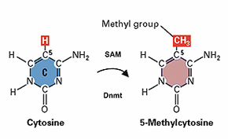

Figure 4. DNA Methylation reaction catalysed by DNA methyltransferases (Dnmt). (Epigenetics mechanisms in development and disease: www.hgu.mrc.ac.uk )

2.2.2) Inheritance of DNA methylation pattern
Any types of cells have their own methylation pattern so that a unique set of proteins may be expressed to perform functions specific for this cell type. Thus, during cell division, the methylation pattern should also pass over to the daughter cell. This is achieved by the enzyme, DNA methyltransferase, which can methylate only the CG sequence paired with methylated CG (Figure5).
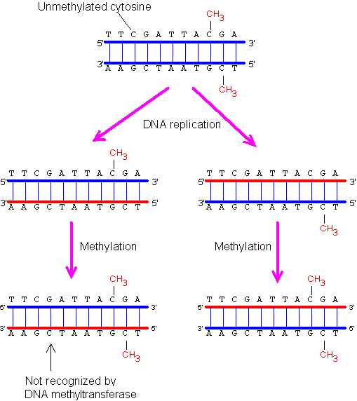
Figure 5. Inheritance of the DNA methylation pattern. (www.web-books.com/MoBio/Free/Ch7F2.htm)
The DNA methyltransferase can methylate only the CG sequence paired with methylated CG. The CG sequence not paired with methylated CG will not be methylated. Hence, the original pattern can be maintained after DNA replication.

2.3) Wnt signaling pathway in development
We know today that Wnt and a hadful of other signalling systems (Notch, Hedgehog, TGFβ (transforming growth factor- β) BMP (bone morphogenetic protein) and receptor tyrosine kinases) are major molecular mechanisms that control embryonic development [34]. The two known Wnt signaling pathways play essential roles in multiple aspects of development, including the regulation of cell proliferation, pattering and fate specification, polarity, and migration of cells [35;36]. The canonical pathway operates by stabilizing β- catenin, whereas the noncanonical pathway does not require β- catenin signaling and controls cell movement during morphogenesis. In addition, mutations in Wnt pathway components lead to specific developmental defects, while various human diseases, including cancer, are caused by abnormal Wnt signaling. This has raised the possibility that the tighly regulated self- renewal mediated by Wnt signaling in stem and progeriton cells is subverted in cancer cells to allow malignant proliferation. Some researches had approved what pathway activation is tumorigenic in colorectal, breast, lung cancer, leukemia, meylonoma and in other human cancers [37]. A simple outline of the current model of Wnt signal transduction is presented in Figure 6 (cononical Wnt signaling pathway). Also very good Wnt signaling patway is demonstrated in this internet page linked: http://faculty.washington.edu/rtmoon/cell.swf. Signaling is initiated when Wnt ligands engage their cognate receptor complex, consisting of a serpentine receptor of the frizzled family and a member of the LDL receptor family, Lrp 5/6. The central player is a cytoplasmic protein called β-catenin, levels are normally kept low through continuous proteasome-mediated degradation, which is controlled by a complex containing GSK-3β/ APS/AXIN. When Wnt receptors are not engaged, two scaffolding proteins in the destruction complex- the tumor suppressors adenomatous polypopsis coli (APC) and axin- bind newly synthesized β- catenin. CKI and GSK-3β, two kinases residing in the destruction complex, then sequentially phosphorylate a set of conversed Ser and Thr residues in the amino terminus of β- catenin. The resulting phosphorylated footprint recruits a β-TrCP-containing E3 ubiquitin ligase, which targets β- catenin for proteasomal degradation. When cells receive Wnt signals, the degradation pathway is inhibated. Receptor occupancy inhibits the kinase activity of the destruction complex by an incompletely understood mechanism involving the direct interaction of axin with Lrp5/6, and /or the actions of an axinbinding molecule, dishevelled. Consequently β- catenin accumulates in the cytoplasm and nucleus. Nuclear β-catenin interacts with transcription factors such as lymphoid enhancer-binding factor 1/t cell- specific transcription factor (LEF/TCF). β-catenin binding to TCF/LEF proteins provides a transcription activation domain so target gene expression is activated [34].

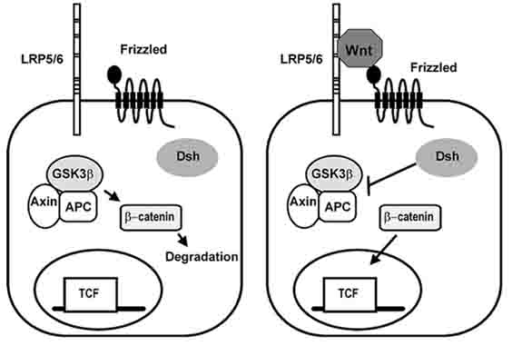

Figure 6. The canonical Wnt signaling pathway. (Specifity of Wnt- receptor interactions: www.bioscience.org/2004/v9/af/1321/figures.htm)
Left, In the absence of Wnt, little beta-catenin is present in the cytoplasm because it is degraded as a result of phosphorylation by the Axin/APC/GSK3beta complex; Right, Interaction of Wnt with Frizzled and LRP5/6 activates Dsh, which in turn inactivates the Axin/APC/GSK3beta complex, allowing beta-catenin to accumulate and enter the nucleus. Upon entering the nucleus, beta-catenin interacts with the transcription factor of the TCF family to activate gene transcription.
Noncanonical Wnt signaling pathways in Drosophila and vertebrates are less well understood, but appear to function in a β-catenin independent manner to regulate processes such as convergent extension during vertebrate gastrulation, and the polarity of hairs, bristles and ommatidia. These noncanonical pathways have also been termed the Wnt/Calcium and Wnt/JNK pathways in vertebrates and the Wnt/planar cell polarity pathway (PCP) in flies. The similarity of these pathways to each other is under intense investigation.

2.3.1)” Epigenetic gatekeepers”
Epigenetic silencing of genes p16, SFRPs, GATA-4 and -5, and APC in stem/precursor cells of adult cell-renewal systems may serve to abnormally lock these cells into stem-like states that foster abnormal clonal expansion. These genes are termed “epigenetic gatekeepers” because their normal epigenetic pattern of expression should allow them to be activated during stem/precursor cell differentiation as needed to properly control adult cell renewal [31]. The repertoire of abnormal gene silencing than allows abnormal gene silencing in the setting of chronic stress, such as inflammation. The resulting preinvasive stem cells become “addicted” to the survival pathways involved so that selection for mutations in genetic gatekeeper genes provide an even stronger stimulus for further tumor progression [34]. The bulk of the resulting tumor is composed of a subpopulation of cancer stem cells and neoplastic progeny.

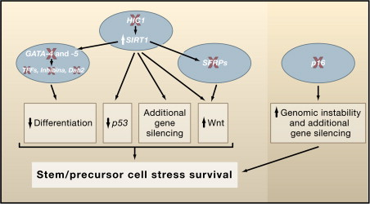
Figure 7. Networks of Gene-silencing events.
Such networks (Figure 7) help to foster early and later steps during neoplastic progression. Examples of early genes silencing (X red) occur at multiple points in key tumor control pathways to allow abnormal cell survival after stress and early clonal expansion. These epigenetic events are shown as provoking disruptive crosstalk between the pathways facilitating this expantion. Examples of gene silencing events are depicted.

How might loss of function for the epigenetic gatekeepers actually foster early abnormal clonal expansion?

Wnt pathway activation may be a striking example where epigenetic events can play important roles [37]. How is showed in Figure 8 uncontrolled Wnt signalling (red arrow) can lead to constitutive renewal and aberrant expansion of the stem cell pool, or confer stem cell behaviour (long-term renewal) on the progenitor cell pool [1;34]. These changes can, in turn, lead to formation of cancerous tissues [38]. The cancerous cells are denoted in red in the schematic diagram.
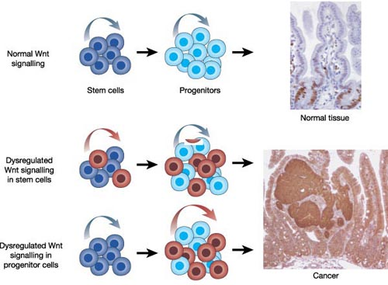
Figure 8. Wnt signalig pathway role in development of cancer. (www.nature.com/.../fig_tab/nature03319_F6.html)

2.4) Secreted Frizzled- related proteins (SFRPs)

One of epigenetic gatekeepers is Secreted Frizzled-related proteins, which are also called secreted apoptosis-related proteins (SARPs) due to their effect on cell sensitivity to pro-apoptotic stimuli. The secreted Frizzled- related proteins (SFRPs) are a family of five soluble proteins that are structurally related to Frizzled (Fz) proteins, the serpentine receptors that mediate the extensively used cell-cell communication pathway involving Wnt signaling. Because of their homology with the Wnt-binding domain on the Fz receptors, SFRPs were immediately characterized as antagonists that bind to Wnt proteins to prevent signal activation [1;39]. The SFRP comprises five members in humans, SFRP1 to SFRP5, in which SFRP3 is the orthologue of the founding member Frzb. Sequence comparison and phylogenetic analysis show that SFRP1, SFRP2 and SFRP5 are closely related, and cluster together in a subgroup that diverges from the one formed by the related SFRP3 and SFRP4. This clustering also reflects a different genomic organization. SFRP1, SFRP2, SFRP5 are encoded by three exons on chromosome 8p12-p11.1, 4q31.3 and 10q24.1, respectively, whereas SFRP3 and SFRP4 are both encoded by six exons- on chromosome 2q31-q33 and 7p14-p13, respectively [1]. SFRPs consist of approximately 300 amino acids containing a signal sequence. They are modulator proteins that fold into two independent domains. The N-terminus contains a secretion signal peptide followed by a CRD (cysteine rich domain). The CRD is characterized by the presence of ten cysteine residues at conserved positions, which form a pattern of disulphide bridges identical to that reported for the extracellular CRD domains of Fz and Ror1. A small hydrophilic C- terminal domain of SFRP proteins is characterized by segments of positively charged residues that appear to confer heparin-binding properties [40], and by six cysteine residues that form three disulphide bridges. Following the discovery of SFRPs biochemical studies established that Wnt proteins and SFRPs interact physically, with the SFRP-CRD postulated to be the binding domain because of its homology with the proposed Wnt-binding region on Fz receptors (Figure 9). SFRPs are extracellular signaling molecules that antagonise the oncogenic Wnt signaling pathway. SFRPs may inhibit Wnt signaling through interactions directly with Wnts and /or through formation of non-functional complexes with the Frizzled receptor. This signalling pathway is strongly implicated in tumorigenesis; indeed, the first mammalian Wnt isoform was identified based on its ability to promote mouse mammary tumorogenesis. Wnt- signalling pathway has been found to assist metastasis of colon cancer [41]. Researches discovered that the same cellular pathway is also responsible for providing lung cancer with an enhanced ability to infiltrate and colonize other organs without delay and with little need to adapt to its new environment. This is a dramatic departure from other cancers, like breast cancer, in which recurrences tend to emerge following years of remission, suggesting that such cancer cells initially lack - and need time to acquire - the characteristics and ability to spread to other organs. Other research groups, only a few months ago, had found evidence of Wnt involvement in a type of brain cancer, though not one due to metastasis from another location [2].
Some evidences suggesting that Wnt signalling is involved simultaneously in the regulation of migration and proliferation of malignant glioma cells.
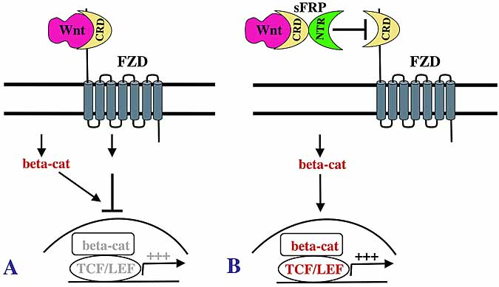
Figure 9. Hypothetical activation of beta-catenin pathway by sFRP. (www.bioscience.org/2006/v11/af/1952/figures.htm)
A. Wnt-5a inhibits beta-catenin transcriptional activity (indicated by gray) elicited by any of multiple ligand/receptor signaling mechanisms that increase soluble beta-catenin concentration (red). B. sFRP binds to Wnt-5a, repressing its inhibition of beta-catenin transcriptional activity.

Since the discovery of SFRPs, interest in this family of molecules has grown progressively, some studies indicate that SFRPs are not only Wnt- binding proteins but can also antagonise one another’s activity: bind to Fz receptors and provide axon-guidance information, can interract with other receptors of matrix molecules and interfere with BMP signalling by acting as proteinase inhibitors. Also, their expression is altered in different types of cancers in bone pathologies, retinal degeneration and homeostasis. For example, Sizzled belongs to the SFRP family, on the basis of its sequence homology with Frizzled receptors, but studies in fish and frog emryos demonstrated that it does not block Wnt signalling in vivo, buth rather acts as a negative-feedback regulator of the bone morphogenetic protein (BMP) signalling pathway [34;42;43]. In vertebrates, a gradient of BMP activity is set by BMP antagonist Chordin which, in turn, is inactivated through cleavage by evolutionarily conserved Tolloid (TLD) metalloproteinases. Sizzled was shown to inhibit Chordin cleavage by binding to TLD-like proteinases [42], leading to Chordin stabilization and a reduction of BMP signalling activity. In a surprising twist, Kobyashi et. al. demonstrate that mammalian SFRP2 functions as an enhancer of collagen processing and cardiac fibrosis by regulating the procollagen- C proteinase activity of Tolloid- like matalloproteinases, but is ineffective in modulating Chordin cleavage (Figure 10). It is well-known that excessive collagen fibre formation results in fibrosis, abnormal tissue growth that may occur during the repair of damaged tissue, and has been linked to human disease.
An example of the damage caused by fibrosis is the effect of myocardial infarction which occurs when the blood supply to part of the heart is interrupted. There are new researches where showed a significant upregulation of SFRP2 and BMP1 expression in the infarcted heart after coronary artery ligation in mice. And there is proposion that SFRP2 inhibitors could constitute an effective therapeutic approach to control fibrosis and improve cardiac function in case of myocardiac infarction, which accounts for about 13% of deaths worldwide, and is the leading cause of death developed countries.

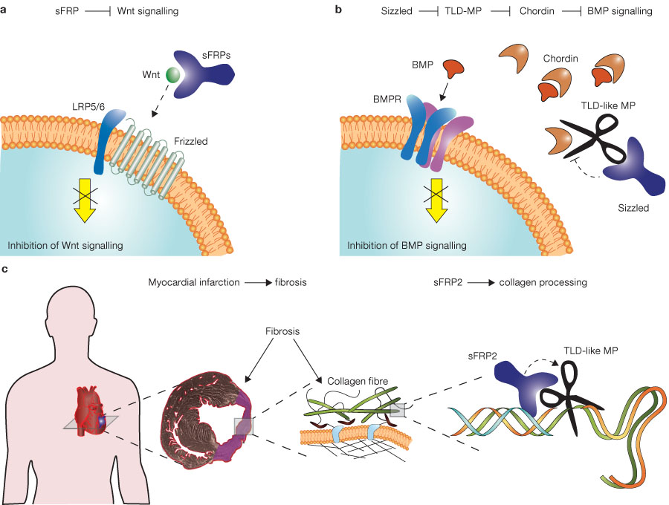Figure 10. The biological versatility of SFRPs. (sFRPS: a declaration of (Wnt) independence: www.bioscience.org/2004/v9/af/1321/figures.htm)

- SFRPs inhibit Wnt signaling by binding to the Wnt ligand, thereby preventing its interaction with the Frizzled receptor and its co-receptors LRP5/6.
- Sizzled blocks BMP signalling by binding to the non-protease domain of the TLD-like metalloproteinase (MP, illustrated as scissors), which subsequently degrades Chordin. By binding to Sizzled, Chordin is stabililized and able to bind to the BMP ligand, which leads to inhibition of BMP signalling.
- Myocardial infarction is characterized by increased fibrosis (shown in purple within the ventricular wall), which markedly reduces cardiac function. The dense, collagenous tissue that characterizes fibrosis results from the release of mature triple-helical collagen molecules into the extracellular matrix. SFRP2 enhance procollagen processing (cleavage) by the TLD proteinases, in vivo and in vitro. SFRP2 binds both the procollagen and the TLD proteinases, thus facilitating the enzymatic reaction by bringing together the proinase and its substrate [43].

2.4.1) SFRPs in diseases especially in cancers

Wnts are required for adult tissue maintenance and perturbations in Wnt signaling promote both human degenerative disease and cancer [34;36]. Epigenetic silencing of tumor suppressor and tumor-related genes in association with promoter CpG island hypermethylation is a frequent event that has been seen in virtually every tumor type. In recent years, accumulating evidence has suggested that SFRPs act as tumor suppressors because their expression is frequently silenced in cancer by promoter hypermethylation [39]. To date, epigenetic silencing of SFRPs have been detected in a variety of malignancies, including cancer of bladder, prostate, lung, breast, gastric, brain, cervical and others.

SFRPs in breast cancer
SFRP1, SFRP2 and SFRP5 have been identified as targets of aberrant epigenetic activation and either promoter methylation was found to be associated with unfavorable patient prognosis. In breast tumor samples a clear SFRP1promoter methylation was found in 61% (79 out of 130) of cases. Also complete SFRP1 promoter methylation was detected in 8 breast cancerous cell lines, whereas no methylation was detectable in the non- malignant cell lines. SFRP 5 is epigenetically silenced in 73% of invasive breast carcinomas [44]. Epigenetic inactivation of SFRP5 is associated with unfavorable prognosis in breast cancer patients, because SFRP5 was first isolated as a gene associated with apoptpsis and because it is more upregulated of any other SFRPs when cell are treated with activators of Wnt signaling. SFRP2 methylation was found in 77% of primary breast carcinomas. SFRP2 methylation was equally prevalent in small sized (pT1) and in large sized (pT2-4) breast carcinomas, suggesting it occurs as early epigentic aberration in breast tumorogenesis with further increase in methylation frequency during tumor progression [38].

SFRPs in colorectal cancer
In primary gastric cancers significant frequencies of SFRP methylation were found: SFRP1- 91%, SFRP2- 96%, SFRP5- 65% [41]. Several line of evidences suggest the Wnt signalling pathway is a major contributor to gastric carcinogenesis [45], over expressed SFRPs reduced colony formation and induced apoptosis in colon cancer cells. And the frequent SFRP methylation seen in non-cancerous gastric musoca from gastric cancer patients suggests that methylation occurs at an early stage of gastric tumorogenesis. Also researches are suggesting what Wnt blockade or restoration of SFRP function may provide a useful new approch to treating gastric cancer [41].

SFRPs in multiple myeloma
Hypermethylation of SFRPs genes are a common event in multiple myeloma cell lines [46], and hypermethylation of SFRP1,-2,-5 is associated with transcriptional silencing. Frequency of methylation: SFRP1- 35.5%, SFRP2- 52.6%, SFRP4- 1.3%, SFRP5- 6.9% [47]. Hypermethylation of SFRP1 and SFRP2 was detected in monoclonal gammopathy of undetermined significance and all MM stages including plasma cell leukemia suggesting that epigenetic dysregulation of these genes is an early event in the pathogenesis of malignant plasma cell disoders. Overexpression of SFRP2 resulted in in inhibition of osteoblastic differentation. As mature osteoblasts have been shown to suppress myeloma growth, so SFR2 might be considered as oncogene favoring myeloma growth by inhibiting osteoblastic differentiation [47].

SFRPs in myeloid leukemia
Hypermethylation of gene promoters frequencies: SFRP1- 41%, SFRP2- 31%, SFRP4- 4%, SFRP5- 22%. SFRP5 methylation was frequently detected in patients with adverse cytogenetics [48]. Because of the role of the Wnt pathway in survival, proliferation and differentiation of hematopoietic stem cells, it has been hypothesized that abnormal Wnt signaling pathway also contributes to the pathogenesis of leukemia [48].

SFRPs in cervical adenocarcinoma
The frequency of SFRP genes promoter hypermethylation in adenocarcinoma of cervix samples was: SFRP1- 52.2%, SFRP2- 82.6%, SFRP4- 65.2%, SFRP5- 73.9% [49]. Clinical stages of adenocarcinoma of cervix had no significant correlation with SFRPs methylation. SFRPs, especially SFRP5, could supress cervical carcinogenesis in vitro and is associated with the development of cervical adenocarcinoma. Also was found what SFRP1 inhibits Wnt signaling through both cononical and noncanonical pathways in cervical squamous cell carcinomas. Furthermore, reexpression of SFRP1 and SFRP2 could suppress tumor cell transformation and invasion.

SFRPs in malignant astrocytic gliomas
Promoter hypermethylation of Wnt pathway inhibitor genes as a rather late event in glioma development that is associated with tumor progression rather than tumor initiation. Epigenetic silencing of SFRP1, SFRP2 genes in glioma progression, as promoter methylation was more common in glioblastomas 53 and 43% respectively, when compared with lower- grade astrocytic tumors [2]. Hypermethylation of SFRP1 was detected in 29%, SFRP2- 24% glioma tumors. SFRP2 gene promoter methylation in grade II gliomas was 12.5%, in grade III- 0% and in grade IV- primary glioblastomas showed promoter methylation of 43% of samples, secondary glioblastoma- 20%. The expression of SFRP1, SFRP2 transcripts was decreased in the methylated tumor samples when compared with the nonneoplastic brain control tissues. The unmethylated genes SFRP2 and SFRP4 were expressed at high levels. Furthermore, since SFRP2 promoter methylation was rare in lower – grade astrocytomas but frequent in glioblastomas, hypermethylation of these genes may be linked to glioma malignancy and thus might be helpful as a prognostic marker in the future [2]. This hypothesis needs to be validated on a large number of glioma patients with well- documented clinical follow-up.

2.4.2) Gene SFRP2
Humans normally have 46 chromosomes in each cell, divided into 23 pairs. Two copies of chromosome 4, one copy inherited from each parent, form one of the pairs. Chromosome 4 spans more than 191 million DNA building blocks (base pairs) and represents more than 6 percent of the total DNA in cells. Identifying genes on each chromosome is an active area of genetic research. Because researchers use different approaches to predict the number of genes on each chromosome, the estimated number of genes varies. Chromosome 4 likely contains between 1,300 and 1,600 genes. These genes perform a variety of different roles in the body.
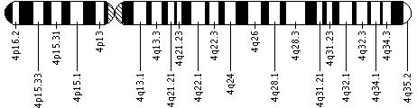
Figure 11. Chromosome 4 ideogram. (wiki.medpedia.com/Chromosome_4)
SFRP2 maps on chromosome 4 (Figure 11), at 4q31.3. It covers about 8.56 kb, from 154929721 to 154921164 on the reverse strand. This gene is expressed at a very high level. The sequence of this gene is defined by 572 GenBank accessions from 533 cDNA clones, some from pancreas (seen 51 times), adenocarcinoma (45), trachea (33), eye (28), small intestine (28), brain (25), heart (16) and 101 other tissues. Roth et al (2000) have reported that SFRP2 is produced by the majority of long-term and ex vivo malignant glioma cell lines. SFRP2 strongly promotes the growth of intracranial glioma xenografts in nude mice. Enhanced expression of SFRP2 inhibits the motility of glioma cells in vitro. SFRP2 mediated effects on glioma cells are accompanied by decrease expression and activity of matrix metalloproteinase – 2 (MMP-2) and decreased tyrosine phosphorylation of beta-catenin [50]. However, in the case of human malignant glioma cells SFRP2 appears to cause increased growth indicating that the activity of SFRP2 are likely dependent on tomor type [51]. To date, from other researches is known that the extent of SFRP expression correlates with cell density in vitro because exponentially proliferating cells produce less SFRPs than confluent cell culture, so SFRP2 gene expression in grade two and grade three gliomas is different. SFRP2 expression in grade II is higher when in grade III [2]. These gene silencing is frequent epigenetic event in glioma, which is associated with promoter methylation or loss of heterozygosity. Loss of heterozygosity (LOH) and deletion of tumor suppressor genes are observed frequently in malignant cells and can be associated with deregulation of cell division and apoptosis [52]. Similarly, amplification of chromosomal regions can increase the expression of oncogenes during tumor progression. Most of low- grade gliomas have no detectable loss of heterozygosity in any of the 11.562 SNP loci, while high grade gliomas have various degrees of LOH affecting 52 to 2.168 SNP loci on various chromosomes [53]. LOH in 4q chromosome position is a genetic even associated with high grade glioma [54].

2.4.3) IDH1 mutation in gliomas
The isocitrate dehydrogenases catalyze the oxidative decarboxylation of isocitrate to alpha-ketoglutarate, generating NADPH from NADP⁺. The mechanism of IDH1 mutations in tumor formation is not known, however actual findings implicate activation of HIF-1.[55] Tumor- derived IDH1 mutations impair the enzyme‘s affinity for its substrate and dominantly inhibit wild-type IDH1 in cultured cells reduces formation of the enzyme product , alpha- ketoglutatre (α- KG) and increases the levels of hypoxia- inducible factor subunit HIF- 1α, a transcriptional factor that facilities tumor growth when oxygen is low and whose stability is regulated by α- KG.
Dang and colleagues [56] reported several findings, showing that cells expressing mutant IDH1 have elevated concentrations of 2-hydroxyglutarate, that the crystal structure of the mutant IDH1 enzyme reveals a distinct and novel active site, that the mutant consequently converts -ketoglutarate to 2-hydroxyglutarate and has diminished ability to convert isocitrate to -ketoglutarate, that levels of 2-hydroxyglutarate are elevated in samples of human glioma, and that the accumulating 2-hydroxyglutarate is the D-2 enantiomer ( Figure 12). Thus, the conclusion that D-2-hydroxyglutarate is the "causative" onco-metabolite in gliomas and secondary glioblastomas warrants further investigation. Because IDH1 mutations occur predominantly in younger patients and are associated with a better prognosis than is the case with tumors that do not carry the IDH1 mutation, D-2-hydroxyglutarate may become a biomarker, serving diagnostic, prognostic, and therapeutical purposes. Sanson et. all (2009) [57] reported that IDH1 codon 132 mutation is closely linked to the genomic profile of the tumor and constitutes an important prognostic marker in grade 2 to 4 gliomas. This mutation was discovered by Parson et all. and researches were published at 2008 in Science, screening the large number of nearly all the known protein-making genes in pancreatic cancers and in the most common form of brain tumors, glioblastomas. Specific mutations in the isocitrate dehydrogenase gene IDH1 at codon 132 were found in 12 percent of the brain tumors. They were found in almost all cases of secondary glioblastomas - developing from lower-grade tumors - but rarely in primary high-grade glioblastomas. They also tended to affect younger patients (average age 33 compared to age 53 for patients without the mutations). Patients whose brain tumors had the IDH1mutation lived significantly longer with their cancer than those who did not. These foundings were confirmed with other studies. [58, 59, 60]
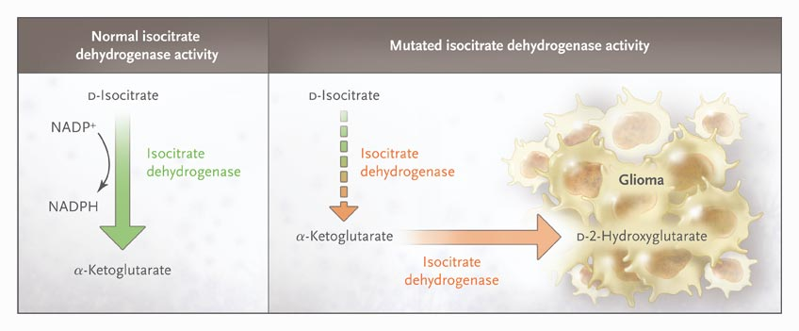
Figure 12. (http://nejm.highwire.org/cgi/content/full/362/12/1144/F1) When Loss Means Gain. When the gene encoding cytosolic isocitrate dehydrogenase (IDH1) is normal, the enzyme shown in green catalyzes the conversion of D-isocitrate to -ketoglutarate (left panel). A specific mutation in the IDH1 gene is associated with susceptibility to glioma with good prognosis. This mutation changes the structure of the enzyme shown in orange, which diminishes its ability to convert D-isocitrate to -ketoglutarate and provides it with a newly acquired ability to convert -ketoglutarate to D-2-hydroxyglutarate.
This mutations were not found in cancer DNR (colorectal, prostate, breast and lung cancer) [58, 61], except in the the brain tumors.[57] Furtermore, it was found that it is specific for gliomas [62]. As well, the IDH1 mutation was inversely correlated with grade, affecting 77% of grade 2, 55% of grade 3, and 6% of grade 4 gliomas [57]. The mutation is early even, associated with a 1p19q codeleted genotype [57, 59]. All mutations identified to date affect a single amino acid located within the isocitrate binding site (R132 of IDH1 and the analogous R172 residue of IDH2) [58].Gliomas are the most common type of brain cancer and approximately 70 percent of lower grade gliomas are known to have the IDH1 gene mutation. Notably, two subtypes of gliomas of WHO grade II or III (astrocytomas and oligodendrogliomas) often carried IDH mutations but not other genetic alterations that are detectable relatively early during the progression of gliomas. This finding suggests that IDH mutations occur early in the development of a glioma from a stem cell that can give rise to both astrocytes and oligodendrocytes [58]. The most recent research from Agios scientists published in Nature [56] suggests that it is activation of a metabolic pathway – rather than inactivation of a tumor suppression function – that is the likely process for oncogene function of IDH1 [63].

3 - MATERIALS AND METHODS

3.1) Analysis of methylation status of grade II and grade III gliomas

3.1.1) Human tissues samples

After informed consent from all patients for retention and analysis of their tissue for research purposes was given, 86 brain tissues samples (42 grade II glioma, 40 grade III glioma, 4 not tumour) were obtained at the time of diagnosis or were obtained from patients by primary surgery for glioma cancer at the Departments of Neurochirurgy at the Hospital A. De Villeneuve, Montpellier and Hospital of Paris, France, between 2007 - 2009. The selection of cases was based on availability of tissues. Cases were not stratified for any known preoperative or pathological prognostic factor. Tumour histology was determined according to the criteria of the World Health Organization Classification of tumours of the central nervous system (WHO 2000) [10]. For epigenetic analysis, we investigated a series of 82 gliomas, including 2 grade II gliomas samples without known histological type, 4 astrocytomas, 27 oligodendrogliomas, 9 oligoastrocytomas (WHO grade II glioma), 6 anaplastic astrocytomas, 17 anaplastic oligodendrogliomas, 14 anaplastic oligoastrocytomas (WHO grade III) and 3 grade III gliomas samples without known histological type. Tumour material after surgery was immediately snap- frozen in liquid nitrogen.

3.1.2) DNA extraction, sodium bisulfite- modification and methylation specific polymerase chain reaction (MS-PCR)
Genomic DNA was isolated from primary tissues using standart methods. Samples were dissolved in lysis buffer followed by DNA isolation using the QIAamp DNA Mini Kit (Qiagen, Hilden, Germany) according to the manufacturer’s recommendations. Patient characteristics and exact DNA isolating protocol are given in additional file 1 and 2, respectively. A purification of DNA was not performed owing to the high sensitivity of the MS-PCR technique [64]. After DNA extraction, bisulfite conversion of all samples DNA was done. Following bisulfite treatment of genomic DNA, all non- methylated cytosine residues are converted into uracil, but whose that are methylated (methylcytosines) are resistant to conversion and remain as cytosine [64, 65]. The schematic picture of this conversion is presented below.
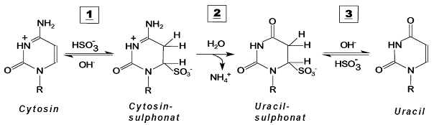
Treatment of DNA with bisulfite for conversion of unmethylated cytosine to uracil was performed with a commercially available kit (EZ DNA Methylation- Gold kit, Zymo Research, U.S.A.). Approximately 500ng of genomic DNA was bisulfite- modified. The final precipitate was eluted in 20 µl Elution Buffer (for bisulfite conversion protocol see additional file 3). Second step which was performed: methylation specific polymerase chain reaction (Figure 13). Methylation specific- PCR is sensitive method which is specific for methylation of virtually any block of CpG sites in a CpG island [64, 65]. For methylation specific PCR, 2 µl of modified DNA was amplified using MS-PCR primers that specifically recognized either the unmethylated or methylated gene promoter sequence after bisulfite-conversion. Each primer pair mapped to nine cytosine- phosphate- guanine dinucleotide (CpG) sites in order to specifically discriminate between methylated and non-methylated DNA. Further 11 non-CpG cytosines within the primer pair specific for methylated DNA and 13 non- CpG cytosines within the primer pair specific for non- methylated DNA guaranteed unequivocal amplification of bisulfite- converted DNA. Primers defined an amplicon between +19 and +163 relative to the transcription start site +1 of the SFRP2 gene (see Additional file 4). Primers were ordered from Erofins MWG Operon company, Ebersberg, Germany.
SFRP2 gene primers sequences were:
unmethylated (product size 145 base pair, annealing temperature 58ºC):
5´- TTT TGG GTT GGA GTT TTT TGG AGT TGT GT-3´ (forward)
5´- AAC CCA CTC TCT TCA CTA AAT ACA ACT CA-3´ (reverse);

methylated (product size 138 base pair, annealing temperature 58ºC):
5´- GGG TCG GAG TTT TTC GGA GTT GCG C-3´ (forward)
5´- CCG CTC TCT TCG CTA AAT ACG ACT CG-3´ (reverse).
MS-PCR mix scheme:
12.75 µl | Water extra purified
2.5 µl | MSP buffer
2.5 µl | MgCl2
1.25 µl | dNTPs
1.5 µl | Primer forward
1.5 µl | Primer reverse
0.5 µl | DMSO
0.5 µl | Taq DNA polymerase
2 µl | Bisulfite modified DNA
Total volume 25 µl

Table 3. MS - PCR mix.
Polymerase chain reaction was performed using PCR mix scheme (see Table 3). In our study we used 1.5µl 10mM concentration of each methylation and non- methylation- specific (forward and reverse) primers for methylated and unmethylated MS-PCR, respectively. MS-PCR reaction volumes of 25µl contained 2.5µl MSP-buffer 10x ( Thermo-Start PCR Buffer, Thermo Scientific, Waltham, MA), 2.5µl 25mM magnesium chloride solution (Thermo Scientific, Waltham, MA), 1.25µl 5mM of dNTPs (Finnzymes, Finland), 0.5µl 5% dimethyl sulfoxide (DMSO) was added to the reaction tube for secondary structures in the DNA template or the DNA primers inhibition. Also 2.5 units Taq DNA polymerase (Thermo- Start DNA Polymerase, Thermo Scientific, Waltham, MA) were added.
The MS-PCR was initiated as “Hot Start” PCR at 95ºC and performed at T3 Thermocycler (Biometra). MS-PCR is performed in thermocycler which can raise and lower temperatures in a heating block to optimal levels for DNA denaturation, primer annealing and strand extension [66]. Cycle conditions were: 95 ºC for 10 min, 40cycles of 95 ºC for 30 s, 60 ºC for 30 s, 72 ºC for 40s and final extension at 72 ºC for 5 min. 4 ºC storage. As a control for methylated and non- methylated MS-PCR were used commercial Cp Genome Universal Methylated and Unmethylated bisulfite converted DNA (Millipore, Temecula, CA). Amplification products were visualized on 4% low range ultra agarose gel (Bio- Rad Laboratories, Hercules, CA) containing ethidium bromide. 10µl of MS-PCR product was mixed with 5 µl 6x DNA Loading buffer (Fermentas, Lithuania) and applied to the gel. 6 µl 100 bp DNA Ladder was used for sizing and approximate quantification of wide range double stranded DNA fragments on agarose. Electrophoresis was performed on Submarine electrophoresis system - Mupid one for 1 hour at 135v. After electrophoresis gel was illuminated under ultraviolet (UV) light using E-Box VX2 system (Vilber Lourmat, Germany). `

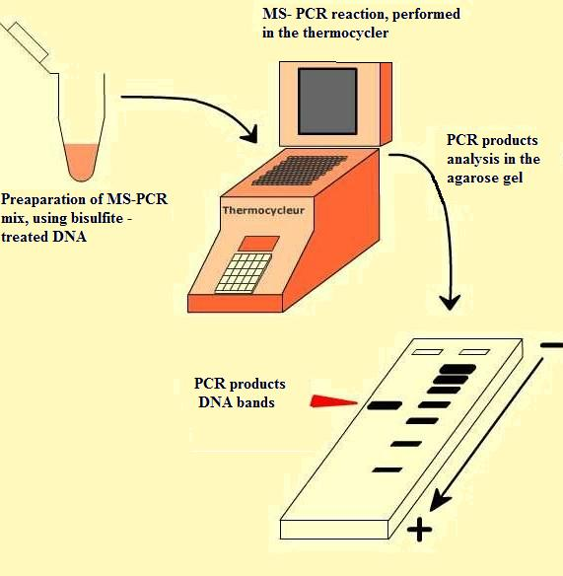
Figure 13. Principe of MS-PCR used to identified SFRP2 gene promoter methylation level.

3.2) Loss of heterozigosity (LOH)

3.2.1) Samples, DNA extraction and dilution

We analysed the same samples we obtained from the Departments of Neurochirurgy at the Hospital A. De Villeneuve, Montpellier and Hospital of Paris, France, between 2007- 2009. 29 grade III samples which contained blood and biopsy were used for these researches. DNA extraction was done using standarts methods as was described before using the QIAamp DNA Mini Kit (Qiagen, Hilden, Germany) according to the manufacturer’s recommendations. Each sample DNA was extracted from blood and tissues as well. After extraction to measure the DNA concentration we used Nanodrop 2000 spectrophotometer (Thermo Scientific). For PCR reaction required DNA amount is 25ng. So all extracted DNA had to be diluted to final concentration 25ng/µl.
For example: glioma number 10: concentration tumour DNA:
531ng/µl ➔
Dilution factor 1/21 ➔ 
Dilute 1µl of mother solution of DNA till 21 µl total volumes adding sterilized water.
Another method to do countings for dilution is using this formula:
V (DNA) = v · a/b
V (DNA) - the amount of DNA with origin concentration.
v- the total volume, which we want to get after dilution.
a- the concentration of solution, which we want to make.
b- the concentration of mother solution of DNA we have.
So let’s say we want to get 20 µl, 25ng/µl Gli 10 solution:
V (DNA) = 20 µl · 25ng/µl : 531ng/µl = 0.094 µl
V( H2O) = 20 - 0.094 = 19.906
To make 20 µl, 25ng/µl Gli 10 solution we need to use 0.094 µl Gli 10 DNA with 531ng/µl concentration, and 19.906 µl of sterilized water.

3.2.2) Primers design, polymerase chain reaction (PCR) reaction, sequencing

Mapping genes by LOH relies on normal DNA being heterozygous for alleles under test. The most commonly used polymorphic markers in mapping and linkage studies are the microsatellites. They are relatively short DNA fragments, usually less than 100 bp. We used 3 microsatellites markers with high degree of heterozygosity. Most patients (80%) are heterozygous. LOH analysis in which normal (blood) DNA is compared with tumor DNA at various loci [53, 54]. At heterozygous loci, the two alleles in normal DNA are observed as separated bands; if an allele has been lost in a tumor, one of the bands is absent in tumor DNA, this global patterns of LOH can be understood through allelotyping of tumors with polymorthic genetic markers. To detect the evidences of loss of heterozygosity on chromosome 4q31.3 position which corresponds to location of SFRP2 gene, the sequences of the forward and reverse primers of the markers were taken from HuRef project.

Using commercial system Linkage Mapping Set version 2.5 we selected 3 flanking the SFRP2 gene microsatellite markers which are listed in Table 4 :
- D4S1586 (position 142508356 – 142508458) panel 42, marker NED, 77%
- D4S2962 (position 146087897 – 146088033) panel 42, marker VIC, 82%
- D4S413 (position 154103952 – 154104202) panel 6, marker FAM, 85%
Markers were ordered from PE Applied Biosystem Company, CA, USA.

Table 4. Microsatellite markers used for LOH studies.
Marker Position Length Bands colour after sequencing
D4S1586 142508356– 142508458 - 102bp yellow
D4S2962 146087897– 146088033 - 136bp green
SFRP2 150433455– 150434063 - 608bp
D4S413 154103952 – 154104202 - 250bp blue

We performed polymerase chain reaction using PCR mix scheme (Table 5).
Table 5. PCR mix.
3 Different PCR reactions were done, using 3 microsatellites primers. First PCR reaction was marked as NED, second as VIC and third as FAM, using corresponding primers, respectively. Each from 29 examined patients had 2 PCR tubes named “S” (sang) - for blood sample and “T” (tumor) – for tumor sample for each PCR reaction. So one patient in total had 6 PCR tubes with patient number (For example: I PCR- gli 10S (used 1µl of blood DNA 25ng) and gli 10T (used 1µl of tumor DNA 25ng) performed with NED primer; II PCR gli 10S and gli 10T performed with VIC primer, III PCR- gli 10S and gli10T performed with FAM primer). BSA- bovine serum albumin is used to stabilize some enzymes during digestion of DNA and to prevent adhesion of the enzyme to reaction tubes and other vessels. This protein does not affect other enzymes that do not need it for stabilization. We used 100X BSA (bovine serum albumin acetylated, Promega, Madison, WI, U. S. A.). The PCR cycling conditions and the annealing temperature were standardized. The PCR was initiated at 95ºC and performed at T3 Thermocycler (Biometra). Cycle conditions were: 94 ºC for 12 min, 10 cycles of 94 ºC for 30 s, 55 ºC for 30 s, 72 ºC for 45s, 25 cycles of 89 ºC for 30 s, 55 ºC for 30 s, 72 ºC for 45s and final extension at 72 ºC for 5 min. 4 ºC storage.
PCR mix scheme :
5.32 µl | Water extra purified
1µl | Buffer ( 10X)
1 µl | MgCl2 ( 25 mM)
0.5 µl | dNTPs ( 5 mM)
0.7 µl | Primer ( 3000 pmol)
0.4 µl | BSA ( 10 mg/ml 100X)
0.08 µl | Taq DNA polymerase 2.5U
1 µl | DNA (25 ng/ µl)
Total volume 10 µl
After PCR we did “poolage” stage for products after amplification. For one patient we used 2 microtubes, one inscribed as “S” (for blood) and other as “T” (for tumor). To the tube marked as “S” we introduced 1 μl of each of 3 patient PCR (NED, VIC, FAM) products marked with “S” and 9 μl of purified water, to have total volume of 12 μl. The same amount of water and PCR products was adjusted to the tube marked “T”, except using 3 patient PCR products inscribed as “T”, respectively.
The same procedure was made for all 29 patients’ samples. Later, 5 μl of every prepared pool mix were inserted to one plate AB1400 Dutscher. To each well containing 5 μl of pool mix, 15,5 μl of formamide and marker ROX mix were added. For formamide and ROX mix we used 15 μl of formamide (Applied Biosystems, Wanigton, UK) and 0,5 μl of ROX marker 400HD (400HD [ROX] Size standard, PE Applied Biosystems, Foster city, CA). Subsequently, protection film (film adhesive PCR film, Thermo scientific) was stuck down and the plate was placed in thermocycler (Gene Amp PCR system, Applied Biosystems 2700). “Denaturation” program was played: 94 º C for 3 minutes, 4º C - pause. Afterward, the plate was immediately placed on ice for 3-5 minutes to stop denaturation process completely. After tearing off the protection film plate was placed to required equipments and placed to the Analyzer (3130xl Genetic Analyzer, Applied Biosystems). The results were analyzed using Gene mapper v4.0 (Applied Biosystems, 2005) program.

3.3) Searching for IDH1 mutation

For IDH1 mutation searching we analyzed 82 brain tumor samples (42 grade II glioma, 40 grade III glioma), including 2 grade II gliomas samples without known histological type, 4 astrocytomas, 27 oligodendrogliomas, 9 oligoastrocytomas (WHO grade II glioma), 6 anaplastic astrocytomas, 17 anaplastic oligodendrogliomas, 14 anaplastic oligoastrocytomas (WHO grade III) and 3 grade III gliomas samples without known histological type. DNA extraction was done using standarts methods as was described before using the QIAamp DNA Mini Kit (Qiagen, Hilden, Germany) according to the manufacturer’s recommendations. For PCR amplification we used 20ng/ μl tumor DNA dilutions.

3.3.1) PCR amplification, amplified DNA purification.

The region of 254bp at exon 4 of IDH1 gene searching for mutation was amplified using the same primers like in previous studies performed by Hartmann et al.,(2009). [67]
IDH1 primer F : M13 ACCAATGGCACCATACGA.
Primer R : TTCATACCTTGCTTAATGGGTGT.
For PCR amplification we used the mix like is shown in Table 6.
Table 6:
PCR conditions were:
PCR mix scheme :
15,5 µl | Water extra purified
2,5µl | Buffer ( 10X)
2,5 µl | MgCl2 ( 25 mM)
1.25 µl | dNTPs ( 5 mM)
1 µl | Primer F ( 10 mM)
1 µl | Primer R (10 mM)
0.25 µl | Taq DNA polymerase 5U/µl
1 µl | DNA (20 ng/ µl)
Total volume 25 µl
96ºC for 5minutes, 35 cycles of 95°C for 30sec, 56°C for 40sec, 72°C for 50sec and final extension at 72 ºC for 10 min. 4 ºC storage. Amplified DNA is purified by filtration, using millipore Multiscreen® d'Euromedex 96µ plate. 25µl of PCR products were added to the plate and 25µl of purified water were annexed to the total 50µl volume for all samples. The plate was placed for filtration. After 8 min of filtration we added 20µl of water to the well and the plate was placed to the shaking block for 10 min to remove the DNA solution. 20 µl of each sample solutions were took off from the well and placed to the tubes which were kept in fridge at -18°C. To validate the PCR reaction 5µl of purified DNA were mixed with 5µl of Orange G and later were placed to the 2% agarose gel and left for 20min performing electrophoresis. Migration was visualizes using UV light, compared with the cell molecular weight marker (1000 Kb to 100 Kb). If the band was obtained between 200Kb and 300Kb, we performed the following steps of analysis. If the band was not correct weight the PCR reaction was repeated again.

3.3.2) Preparation of pre-sequencing PCR and automated DNA sequencing

For DNA sequencing we used automated DNA sequencing which is based on the Sanger-Coulson chain termination method but the 4 different dideoxy nucleotides (ddA, ddC, ddG and ddT) are fluorescently labelled (fluorophores) not radioactively labelled. Since 4 different fluorophores are used, all 4 reactions can be run in the same tube, greatly increasing the speed and ease of sequencing. After restriction, DNA fragments are separated by capillary electrophoresis using small (approx. 100 microns in diameter), gel-filled capillary tubes, clustered together and read with a laser scanning system. The system is not only more accurate than reading a gel, but longer molecules of DNA can be sequenced. Electropherogram: As each capillary tube is moved into the path of the laser beam, fluorescently labelled nucleotides are detected one at a time, producing a coloured electropherogram : The information is then analyzed by a computer to generate the final DNA sequence data (Figure 14).
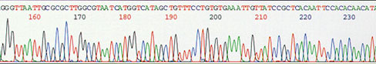
Figure 14. LOH sequencing using special computer programs.

Pre - sequencing PCR preparation (Table 7).
Table 7 :
PCR mix scheme :
2,0µl | Buffer
4.0µl | Purified water
2 µl | Primer F ( the sequencing is performed using only primer F, if the pics is not sure or not interpretable, the sequencing is repeated with primer R )
1.0 µl | Polymerase Big Dye, version 1.1 (containing dNTP, ddNTP, enzyme and enzyme buffer.)
1 µl | DNA purrified
Total volume 10µl

PCR conditions : 96°C for 1min, 25 cycles of 96°C for 30 sec, 50°C for 15 sec, 60°C for 4 min.

DNA purification after pre-sequencing PCR reaction

The filtration gel is prepared with 300µl added to the all walls of the one plate Acropep™ PCRµ96, which is filled with the dry powder Sephadex™ G50 superfine. This plate have to stay 3 hours in the room temperature, or at 4ºC overnight. After the plate is centrifugated to eliminate excess of water. Secondly, 10µl of purified DNA after cetrifugation is added to the plate AB1400 Dutscher and adjusted with water to total 20µl volume. The plate is placed to the sequencing analyser (Applied Biosystems, 3130xl Genetic Analyser). The sequencing analysis is analyzed using Sequencing Analysis program. Whereupon the sequencing with primer F is performed, the mutation is controlled at the possition 107, or in the adjacent area. Two high intensive pics in the same possition represents the mutation at the 4q31.3 chromosome.

4 - RESULTS

4.1 ) Methylation status of the SFRP2 gene in primary glioma and normal brain tissue

To investigate the role of promoter methylation in silencing of SFRP2 gene on chromosome 4q31.1 in human glioma cancer, the methylation status of SFRP2 gene was studied in 82 low grade glioma samples and 4 non- cancer tissues by methylation specific polymerase chain reaction (MS-PCR). Patients who were diagnosed with grade II (4-A, 27-O, 9-OA, 2-II?) and grade III gliomas (6-A, 17-O, 14-OA, 3-III?) were included in this study. MS-PCR was performed with bisulfite – treated DNA. Amplification products were analyzed in 4% agarose gel using ultra violet (UV) light.

4.1.1) MS-PCR results (agarose gel photos after DNA migration)

DNA bands in lanes labelled with U indicate PCR products amplified with primers recognizing unmethylated SFRP2 promoter sequence. DNA bands in lanes labelled with M represent amplification products with methylation- specific primers. Figure 15 part a)introduce the commercial DNA control (Un-unmethylated control, Meth- methylated control). Unmethylated control show signal for unmethylated PCR performed with primers recognizing unmethylated SFRP2 sequence. Signal in methylated control occur in the lane labelled M which represent PCR with methylation specific primers. Parts b), c) and d) show some patients PCR results in the gel after DNA migration analyzed under UV light. Methylation level was indicated as strong one, when signals were as strong as we can see for sample 7 and 248 in the lane labelled with M. Partial methylation we described when signals were weak, like for samples 268 and GB 103 in the line labelled with M. The samples were not showing methylation then were were no signal in the lanes labelled M, such samples 9, 60, 67, 101. All samples were giving signals in the lane labelled as U for unmethylated PCR products.

Figure 15.
a)
Un Meth
U M 100bp U M
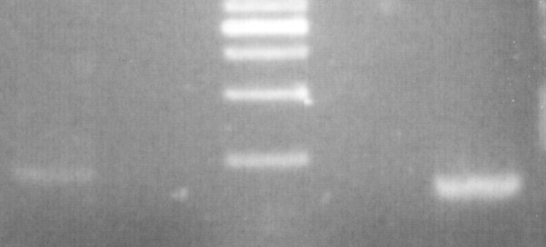

b) c)
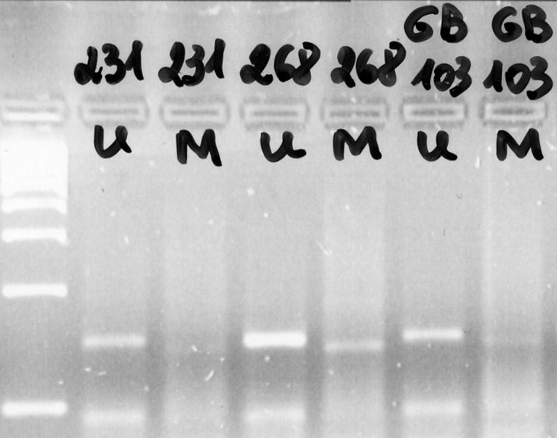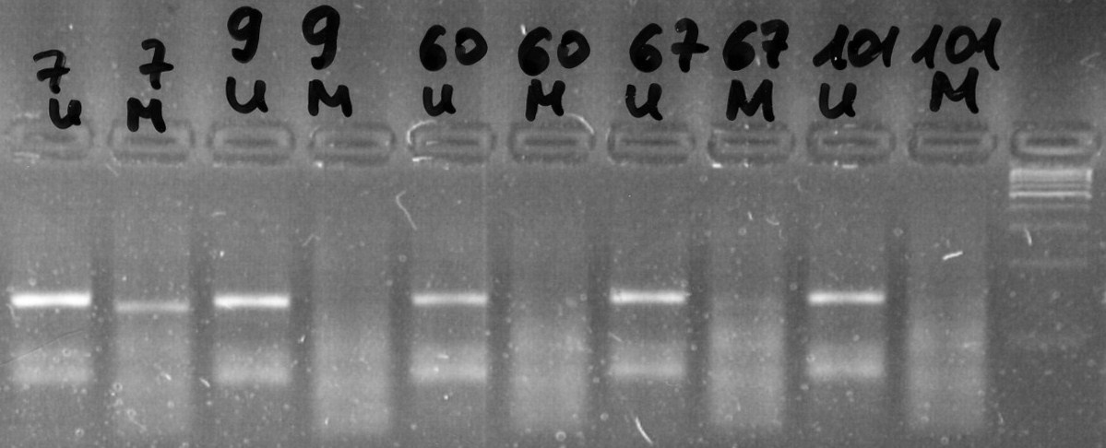
d) 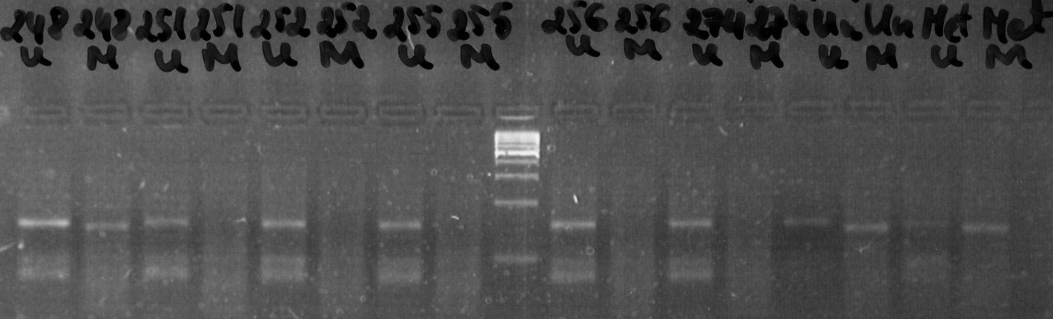

DNA methylation of secreted frizzled- related proteins (SFRPs) can be detected in glioma cancer tissues; wheareas in normal brain tissues, SFRPs genes are unmethylated. The MS-PCR was performed at least twice.

We obtained those results:
Grade II: 42 samples- clearly methylated 6 samples, 2 samples partial methylated, 34 samples unmethylated.
Grade III: 40 samples- 10 samples clearly methylated, 3 samples partial methylated, 27 unmethylated.
Not tumor: 4 samples- all unmethylated.
From 82 samples methylated were found 21 samples, 5 of them not very clear methylated as the signals after migration were weak.

Methylated SFRP2 gene occurs in 19.05 % (8/42), 32.50 % (13/40), 0 % (0/4) of patients with grade II glioma, grade III glioma and healthy patients, respectively (Figure 16).
SFRP2 methylation status
19,05
32,5
0
0
5
10
15
20
25
30
35
Samples
Percentage (%)
% of methylated samples
in grade II
% of methylated samples
in grade III gliomas
% of methylated samples
in not tumor samples
Figure 16. SFRP2 methylation status (%) in grade II, grade III, not tumor glioma samples.

In total- 24.42 % methylated (21/86), 75.58 % of unmethylated samples (65/86). SFRP2 gene methylation level was 25.61% (21/82) in tumour samples. In grade II glioma - 19.05 % of methylated samples (8/42), 80.95 % of unmethylated samples (34/42). In grade III glioma samples - 32.5 % of methylated samples (13/40), 68.5 % of unmethylated samples (27/40) (Table 8).

Grade | Number of samples | Number of methylated samples | Number of unmethylated samples | % of methylated samples | % of unmethylated samples
II | 42 | 8 | 34 | 19.05 | 80.95
III | 40 | 13 | 27 | 32.50 | 68.50
Not tumour | 4 | 0 | 4 | 0.00 | 100.0
Total | 86 | 21 | 65 | 24.42  (9.3%- grade II, 15.11%- grade III) | 75.58  (39.53%- grade II, 31.4%- grade III, 4.65%- healthy patients
Table 8. MS- PCR results

The SFRP2 was hypermethylated in 21 of 82 tumors (25.61%), including 3 of 4 astrocytomas (75%), 3of 27 oligodendrogliomas (11.1%), 1 of 9 oligoastrocytomas (11.1%), 1 of 2 unknown histological type grade II glioma (50%), 3 of 6 anaplastic astrocytomas (50%), 6 of 17 anaplastic oligodendrogliomas (35.29%), 3 of 14 anaplastic oligoastrocytomas (21.43%) and 1of 3 grade III glioma sample with unknown histological type (33.33%) (Table 9, Figure 17).

SFRP2 | Control (n= 4)  5% | A-II  (n= 4)  5% | O-II  (n=27)  31% | OA-II (n=9)  10% | ? - II  (n=2)  2% | A-III (n=6)  7% | O-III (n=17)  20% | OA-III (n=14)  16% | ? – III (n=3)  4%
Methylated | 0 | 3 | 3 | 1 | 1 | 3 | 6 | 3 | 1
Total | 0 (4) | 3 (4) | 3 (27) | 1 (9) | 1 (2) | 3 (6) | 6 (17) | 3 (14) | 1 (3)
Total % | 0% | 75% | 11.1% | 11.1% | 50% | 50% | 35.29% | 21.43% | 33.33%
Table 9. Fractions of tumors showing promoter methylation in SFRP2- Wnt pathway inhibitor gene stratified according to the tumor type. A-II: astrocytoma; O-II: oligodendroglioma; OA-II: oligoastrocytoma; ?- II grade II glioma with unknown tumor type; A-III: anaplastic astrocytoma; O-III: anaplastic oligodendroglioma; OA-III: anaplastic oligoastrocytoma; ?- III: grade III glioma with unknown tumor type.

SFRP2 methylation status
75
11,1 11,1
50
50
35,29
33,33
21,43
0
10
20
30
40
50
60
70
80
Samples
Percentage (%)
A- II
O-II
OA-II
?-II
A-III
O-III
OA-III
?-III
Figure 17. Methylation level of SFRP2 gene promoter (%) in glioma samples, stratified according to tumor type.

4.1.2) Correlation of SFRP2 promoter methylation and SFRP2 mRNA expression in glioma samples

Notably, the mRNA SFRP2 expression in grade II glioma (meant 10.218) is significantly higher than in grade III glioma (meant 4.043) (Figure 18).
SFRP2 mRNA expression correlation between grade II
glioma samples
10,218
4,043
0
2
4
6
8
10
12
Glioma samples
SFRP2 expression meant
in grade II glioma samples
SFRP2 expression meant
in grade III glioma
samples
SFRP2 mRNA expression
Figure 18. SFRP2 expression level in grade II and grade III glioma .

A direct comparison of SFRP2 mRNA expression and SFRP2 promoter methylation indicates that in glioma cancer SFRP2 methylation is correlated with loss of SFRP2 mRNA expression.

 | SAMPLE | METHYLATION LEVEL | SFRP2 EXPRESSION
GRADE II | Gli 7 | Methylated | 0.61
 | Gli 58 | Methylated | 2.48
 | Gli 89 | Methylated | 11.76
 | Gli 99 | Methylated | 0.82
 | Gli 113 | Methylated | 3.09
 | Gli 219 | Methylated | 3.29
 | Gli 256 | Methylated | 2.12
 | Gli 268 | Methylated | 0.08
Total: | 8 samples methylated |  | SFRP2 expression meant 3.03125
 | 32 samples unmethylated |  | SFRP2 expression meant 12.0147
 | Grade II glioma 40 samples |  | SFRP2 expression meant 10.218
GRADE III | Gli 41 | Methylated | 0.93
 | Gli 67 | Methylated | 0.44
 | Gli 248 | Methylated | 1.89
Total: | 3 samples methylated |  | SFRP2 expression meant 1.087
 | 6 samples unmethylated |  | SFRP2 expression meant 5.5217
 | Grade III glioma 9 samples |  | SFRP2 expression meant 4.043
Table 10. Correlation between SFRP2 methylation and SFRP2 mRNA expression.

In our study we obtained that in 40 grade II glioma samples SFRP2 gene is often methylated (7 cases from 8 cases) then the SFRP2 mRNA expression is low. Methylation occurs then SFRP2 mRNA expression reveals from 0.08 till 3.29 (Table 10). Just in one case we found that SFRP2 gene is methylated then expression is 11.76. The median of SFRP2 mRNA expression then gene is methylated is 3.03125, while the meant of SFRP2 mRNA expression for unmethylated samples is 12.0147. Total SFRP2 mRNA expression for all 40 samples is 10.218 (Figure 19).

SFRP2 mRNA expression correlation between grade II
glioma samples
10,218
3,03125
0
2
4
6
8
10
12
Grade II glioma samples
SFRP2 mRNA expression
SFRP2 expression average
in grade II glioma samples
SFRP2 expression average
in grade II methylated
glioma samples
Figure 19. SFRP2 mRNA expression correlation between grade II glioma samples.

For comparison, we hade some grade III glioma samples with known gene SFRP2 mRNA expression. Expression was known for 9 samples from which 3 were methylated. Methylation occured when expression was between 0.93- 1.89. Grade III glioma samples total SFRP2 mRNA expression meant is 4.043, for methylated samples SFRP2 mRNA expression meant is 1.087 (Figure 20), while for unmethylated is 5.5217.

SFRP2 mRNA expression correlation between
Grade III glioma samples
4,043
1,087
0
1
2
3
4
5
Grade III glioma samples
SFRP2 expression
average in grade
III glioma samples
SFRP2 expression
average in grade III
methylated glioma
samples
SFRP2 mRNA expression
Figure 20. SFRP2 mRNA expression correlations between grade III glioma samples.

4.2) Results we obtained after performing LOH for glioma grade III samples

After an inactivating mutation in one allele of a tumour suppressor gene occurs in the parent’s germline cell, it is passed on to the zygote resulting in an offspring that is heterozygous for the allele. In oncology, loss of heterozygosity occurs when the remaining functional allele in a somatic cell of the offspring becomes inactivated by mutation. It is detected when heterozygous markers for a locus appear monomorphic because one of the alleles was deleted. This results in no normal tumor suppressor being produced and this could result in tumorigenesis. For heterozygosity analysis the microsatellite pattern of tumor DNA was compared to its corresponding blood DNA. Only informative (heterozygous) samples were considered for LOH analysis. LOH observed with two- upstream and downstream markers in the tumor was taken as LOH in the tumor at the locus. We analysed 29 grade III glioma samples using Gene mapper v4.0 (Applied Biosystems, 2005) program from which 65,5 % (19 from 29) gave informative results.

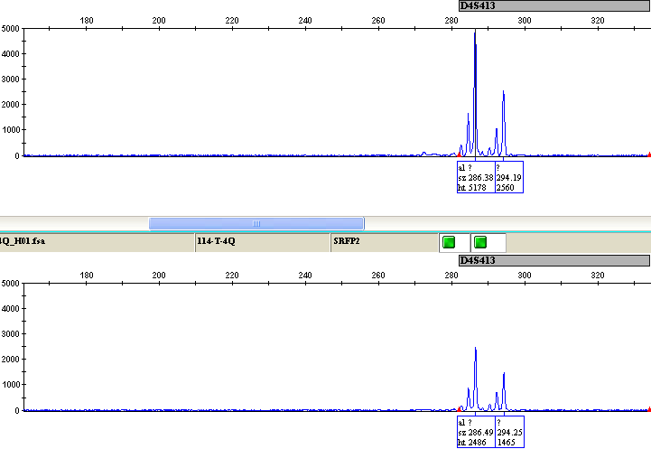
Figure 21. Representive allelic profile of microsatellite stability at 4q31.3 locus (sample Gli 114).

Figure 21 represents sample Gli 114 LOH analysis, with D4S413-FAM (blue- downstream) microsatellite marker. Horizontal- base pairs, vertical-fluorescence scale. Both in normal (blood) cells - upstream part and in malignant (brain) cells- downstream part, the two major peaks are 286 and 294 base pairs long representing the two alleles in microsatelite. No LOH detected in this sample.

Figure 22. Representive allelic profile of microsatellite stability at 4q31.3 (sample gli 189).
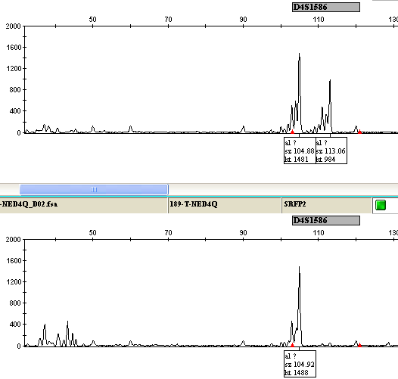

In Figure 22 sample Gli 189 LOH analysis demonstrated by amplification of microsatellite D4S1586- NED (upstream) of blood and brain DNA. Horizontal- base pairs, vertical-fluorescence scale. Normal tissue control (upstream part) shows two allele peaks. They are 104 and 113 base pairs long. Downstream part shows brain DNA, which demonstrare loss of one allele. Second allele 113 base pairs longs is absent.

Figure 23. Sample Gli 189 LOH, demonstrate LOH amplification of microsatellite D4S413- FAM (downstream) of blood and brain DNA.
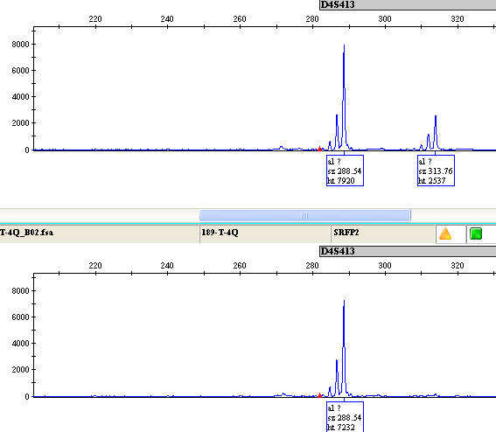
In tomour DNA one allele 313 base pairs long is lost, comparing with blood DNA which shows 2 peaks ; 288 bp and 313 bp long (Figure 23).

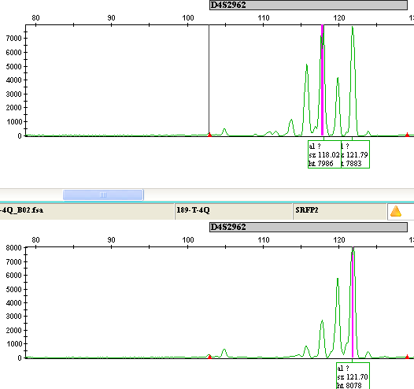
Figure 24. LOH analysis results for sample gli 189, with microsatellite D4S2962- VIC (upstream) marker.
In Figure 24 we can also see loss of allele in brain DNA, as just one main peak (121bp long) is visible. In blood DNA 2 main peaks of 118 bp and 121bp long occurs.
From results we obtained in Figure 22, 23 and 24 we can do the conclussion that sample Gli 189, shows one allele lost with all 3 : D4S1586-NED, D4S413- FAM and D4S2962-VIC microsatellite markers. The same comparison between blood and brain DNA with 3 microsatellite markers was done for all analysed samples. The results we obtained is given in the Table 11.

Results  Clasification | No loss of allele detected | Loss of heterozygosity | Not working samples | Total number | Proportion (%)
A-III | 2 (100%) | 0 (0%) | 0 (0%) | 2 samples | 7%
O-III | 6 (55%) | 2 (18%) | 3 (27%) | 11 samples | 38%
OA-III | 5 (36%) | 3 (21%) | 6 (43%) | 14 samples | 48%
III- ? | 0 (0%) | 1 (50%) | 1 (50%) | 2 samples | 7%
Total grade III glioma samples | 13 (45%) | 6 (20%) | 10 (35%) | 29 samples | 100%
Table 11. The number of LOH at 4q 31.3 locus detected in grade III glioma samples, A-III: anaplastic astrocytoma; O-III: anaplastic oligodendroglioma; OA-III: anaplastic oligoastrocytoma; ?- III: grade III glioma with unknown tumor type.

(%)
LOH in grade III samples
20
45
35
0
20
40
60
80
100
Grade III glioma samples
LOH
No LOH
Not working
Figure 25. LOH in grade III samples

Loss of heterozygosity were obtained in 6 of 29 samples- 20% 2 of them were anaplastic oligodendrogliomas – 33%, 3 of them were anaplastic oligoastrocytomas – 50% and 1 sample was with unknown tumour type- 17%. 13 (45%) samples demonstrated 2 peaks in brain DNA, that means no loss of allele were detected. 10 (35%) samples were not showing clear results, so were considered like not working samples (Figure 25).

4.2.1) Correlation between methylation level and LOH

Methylated samples number | LOH | No LOH | Not clear results
Gli 67 |  | +
Gli 189 | +
Gli 248 | +
Gli 272 |  |  | +
Gli 279 | +
Gli 295 |  |  | +
Gli 332 |  |  | +
Gli 346 | +
Gli 347 |  |  | +
Total | 4 (44%) | 1 (12 %) | 4 (44%)
Table 12. Grade III methylated glioma samples correlation with LOH.

We obtained that 4 (44%) methylated grade III glioma samples were also with one allele lost. 1 (12%) methylated sample had 2 peaks in brain DNA, so no LOH in this sample was obtained. 4 (44%) methylated sample were not showing clear results (Table 11, Figure 26).
Percentage (%)
LOH status in methylated samples
44
12
44
0
5
10
15
20
25
30
35
40
45
50
Grade III methylated samples
LOH
No LOH
Not working
Figure 26. LOH status in methylated grade III glioma samples

  - Results from the researches searching IDH1 mutations

The IDH1 mutation were detected when extra adenin base were find in the sequence between 104 and 105 possition. The view of sequence are demonstrated in Figure 27.

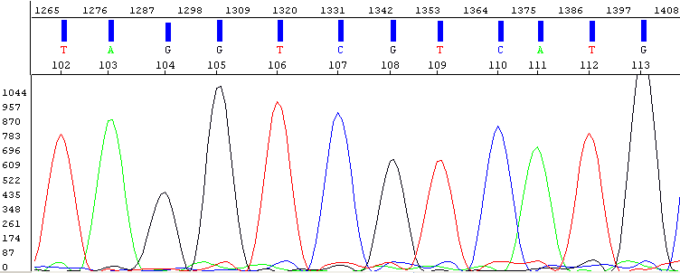
A
B
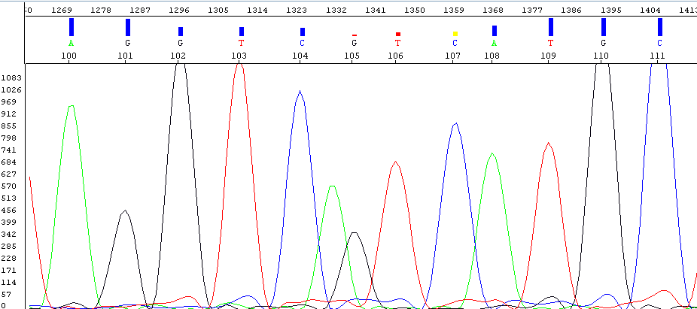
Figure 27. IDH1 mutation results analysed with sequencing analysis program. Panel A shows glioma sample without mutation, panel B shows glioma sample with IDH1 mutation at 4q31.3 chromosome between 104-105 possition (extra adenin base occurs).

Table 13. Global IDH1 status
Number and proportion of mutated samples | Number and proportion of not mutated samples | Number and proportion of not clear results
51 : 62%  (29- grade II, 22-grade III) | 19 : 23%  (11 grade II, 8 grade III) | 12 : 15%  (2 grade II, 10 grade III)

Our studies results shows that 62% of anlysed samples caried IDH1 mutation, 23% were witout IDH1 mutation and 15% of samples were with not clear results (Table 13).

Table 14. IDH1 mutation status and histological glioma types.
Histological type | Number of gliomas | Proportion of gliomas (%) | Number and proportion of mutated samples | Number and proportion of not mutated samples | Number and proportion of not clear results
O- II | 27 | 33% | 17 (63%) | 8 (30%) | 2 (7%)
A- II | 4 | 5% | 4 (100%) | 0 (0%) | 0 (0%)
OA- II | 9 | 11% | 6 (67%) | 3 (33%) | 0 (0%)
Grade II | 40 | 100% | 27 (67,5%) | 11 (27,5%) | 2 (5%)
? – III | 2 | 2% | 2 (100%) | 0 (0%) | 0 (0%)
O- III | 17 | 21% | 11 (64%) | 3 (18%) | 3 (18%)
A- III | 6 | 7% | 3 (50%) | 2 (33%) | 1 (17%)
OA- III | 14 | 17% | 7 (50%) | 3 (21%) | 4 (29%)
? – III | 3 | 4% | 1 (33%) | 0 (0%) | 2 (67%)
Grade III | 42 | 100% | 24 (57%) | 9 (21,5%) | 9 (21,5%)

In grade II gliomas samples IDH1 mutation level was 67,5%, while in grade III was 57%. The most common histological types of gliomas with IDH1 mutation in 4q31.3 chromosome are : in grade II gliomas- astrocytomas (A) 100% (4/4), grade II gliomas with unknown histological type 100% (2/2), oligodendrogliomas (O)- 63% (17/27), oligoastrocytomas (AO)- 63% (6/9). In grade III 64% anaplastic oligodendrogliomas (O) (11/17), the same percentage 50% for - anaplastic astrocytoma (A) and anaplastic oligoastrocytoma (AO) (Table 14).

4.3.1) Correlation between IDH1 occurrence and methylation status.

Results  Samples | Methylated with IDH1 mutation | Methylated without IDH1 | Methylated with not clear results for IDH1 mutation
Grade II gliomas | 6 (75%) | 2 (25%) | 0 (0%)
Grade III gliomas | 7 (54%) | 4 (31%) | 2 (15%)
Total | 13 (62 %) | 6 (29%) | 2 (9%)

Table 15. Methylation and IDH1 mutation status.

We found that 62% (13/ 21) of samples were methylated and with IDH1 mutation (Table 15). 29% of samples were methylated but without IDH1 mutation. In grade II percentage of methylated samples with IDH1 mutation (75%) is significantly higher than in grade III (54%) (Figure 28).

Figure 28. Correlation between IDH1 mutation and methylation level in glioma samples
Methylation level and IDH1 mutation
75
25
54
31
15
0
10
20
30
40
50
60
70
80
Glioma grade II
methylated samples with
IDH1 mutation
Glioma grade II
methylated samples
without IDH1 mutation
Glioma grade III
methylated samples with
IDH1 mutation
Glioma grade III
methylated samples
without IDH1 mutation
Glioma grade III
methylated samples with
not clear IDH1 mutation
results
Samples
Percents (%)

5 - CONCLUSION S AND RECOMMENDATIONS

In general, DNA methylation patterns have been found to be correlated with tumour type and prognosis of various cancers and may therefore be helpful as diagnostic or prognostic marker.

- Our results provide evidences that in 5’- CpG site methylation in SFRP2 gene encoding Wnt pathway inhibitor protein is a more common alteration in grade III gliomas 32.50 % (13/40), compared with grade II glioma 19.05 % (8/42). SFRP2 gene methylation level was 25.61% (21/82) in tumour samples. In contrast, no methylated SFRP2 genes were detected in normal brain tissues. These results are antipathetic to results obtained by S. Gotze, M. Wolter G. Reifenberger, O. Muller and S. Sievers (Germany, 2009). They demonstrated what SFRP2 promoter methylation is more common in grade II gliomas (12.5% - 2 samples from 16 were methylated), while in grade III gliomas SFRP2 gene commonly are unmethylated (0% - from 14 samples no samples were methylated). Furtermore, our data indicated that commonly methylation occurred in 3 of 4 grade II astrocytomas (75%) and frequently grade III gliomas showing SFRP2 promoter methylation were- 3 of 6 anaplastic astrocytomas (50%), 6 of 17 anaplastic oligodendroglioma (35.29%).

- A direct comparison of SFRP2 mRNA expression and SFRP2 promoter methylation indicates that in glioma cancer SFRP2 methylation is correlated with loss of SFRP2 mRNA expression. SFRP2 mRNA expression was decreased in the methylated samples compared with no methylated. As well, both gliomas malignancy grades (grade II and grade III) demonstrated the same decrease of SFRP2 mRNA expression in methylated samples. In grade II gliomas methylated samples SFRP2 mRNA expression average were significantly smaller (3.03125), compared with unmethylated samples (SFRP2 expression average 12.0147). In grade III gliomas for methylated samples SFRP2 mRNA expression average is 1.087, while for unmethylated is 5.5217. In conclussion, these findings support our hypothesis that SFRP2 gene expression decreased due to the epigenetic silencing of this gene caused by promoter hypermethylation. But the SFRP2 promoter methylation can not be characterized like the main reason decreasing the SFRP2 mRNA expression as methylation status is low- 25.61% (21/82) in tumour samples. Otherwise, this conclussion need to be clarified performing the same researches including more patients.

- Approximetely 20% (6 of 29 samples) grade III gliomas demonstrated loss of heterozygosity at the SFRP2 gene locus. Commonly LOH occured in anaplastic oligoastrocytomas – 50%. Also we found correlation between the methylated samples and LOH. 44% methylated grade III glioma samples were with one allele lost. Methylation of SFRP2 promoter and LOH at 4q chromosome are dependent prognostic factors. It is clear that SFRP2 mRNA expression decrease due to methylation, so this support the idea that LOH might, as well decrease the SFRP2 expression. These findings have to be confirmed by comprehensive studies, and could be the good object for future investigations.

- Gliomas frequently carry point mutations of isocitrate dehydrogenase 1 (IDH 1) gene which is clinically important as diagnostic and prognostic markers. Follow-up studies investigating larger series of different types of gliomas and other brain tumours confirmed frequent IDH 1 mutation in secondary glioblastoma but also in diffuse astrocytic, oligodendroglial and oligo- astrocytic gliomas of World Health Organisation (WHO) grades II and III. In our project after performing IDH1 mutation searching method, 62 % of samples showed clear IDH1 mutation in glioma samples, these findings verify recent studies done by Sanson et al.(2009 ) where they found that the majority 62%- 88% of analysed glioma samples carried IDH1 mutation. In grade II glioma IDH1 was found in 67,5% patients malignant brain tissues, and in grade III- 57%. So, the difference between grade and IDH1 mutation occurance is significantly low, just 10,5%. Equally, we might say what IDH1 mutation is strongly associated with SFRP2 methylation, as 75 % methylated grade II samples had IDH1 mutation, and 54 % grade III also had IDH1 mutation. IDH1 mutation findings could be served as a useful tool for early glioma diagnostic, cancer preventions and treatment.

Our project might be served as introduction part for new researches with wide interests. These might help to make the better comparison between the methylation status, LOH, SFRP2 mRNA expression and Wnt pathway activation and its influence for glioma tumorogenesis.

6 - REFERENCES

[1] Paola Bovolenta, Pilar Esteve, Jose Maria Ruiz, Elsa Cisneros, Javier Lopez-Rios. Beyond Wnt inhibition: new functions of secreted Frizzled-related proteins in development and disease. The Company of Biologists 2008; doi: 10.1242/jcs.026096

[2] Silke Gotze, Marietta Wolter, Guido Reifenbeger, Oliver Muller, Sonja Sievers. Frequent promoter hypermethylation of Wnt pathway inhibitor genes in malignant astrocytic gliomas. Int. J. Cancer: 000, 000- 000 (2010), 1-10.

[3] Sh.K. Singh, C. Hawkings, Ian D. Clarke, J. A. Squire, J. Bayani, T. Hide, R. M. Henkelman, M. D. Cusimo, P.B. Dirks. The Arthur and Sonia Labatt. Identification of human brain tumour initiating cells. Nature (2004) Vol. 432, 396-401.

[4] Candece L. Gladson, Richard A. Prayson, Wei Michael Liu. The pathobiology of gliomas tumours. Annu Rev Pathol (2010) Vol. 5: 33-50.

[5] Kirsten Gronbaek, Christoffer Hpther, Peter A. Jones. Epigenetic changes in cancer. Inter science (2007) Vol. 115, 1039-1059.

[6] Peter A. Jones, Stephen B. Baylin. Epigenomics of cancer. Cell (2007) Vol. 128, 683-692.

[7] Inga Gudinaviciene, Darius Pranys, Elona Juozaityte. Impact of morphology and biology on the prognosis of patients with gliomas. Clinic of Pathological Anatomy, Clinic of Oncology, Kaunas University of Medicine. 2002. MEDICINA (2004) Vol. 40, No. 2- http://medicina. kmu.lt

[8] F. Menegoz. Evolution de l’incidence et de la mortalite par cancer en France de 1978 a 2000. Systeme nerveux central. Epidemiol Sante Publique (2003) Vol. 51: 3-30

[9] Agnes Fleury, F. Menegoz, Pascale Grosclonde, Jean- Pierre Daures, Michel Henry-Amar, Nicole Raverdy, Paul Schaffer, Michel Poisson, Jean- Yves Delattre. Descriptive Epidemiology of Cerebral Gliomas in France. Cancer Society. 1997. Cancer March 15, 1997/ Volume 79/ Number 6. 1195-1202.

[10] P Kleihues, WK Cavenee, Burger PC, Collins VP, Newcomb EW, Ohgaki H. Classification of Tumours of the Central Nervous System. World Health Organization. Pathology and genetics of tumors of the central nervous system. Lyon, IARC/WHO, 2000, pp. 6-69

[11] David N. Louis, Eric C. Holland, J. Gregory Cairncross. A Molecular Reappraisal. Glioma Classification. American Journal of Pathology.

Online : http://ajp.amjpathol.org/cgi/content/short/159/3/779

[12] Helmut Kettenmann, Bruce R. Ransom. Gliomas. Neuroglia, second edition. Oxford
University Press, 2005. pp. 521-532

[13] Naoki Oka, Akio Soeda, Shinji Noda, Toru Iwama. Brain tumour stem cells from an adenoid glioblastomas multiforme. Neurologia medico-chirurgica, (2009) Vol. 49, pp.146-151.

[14] Patrick Y. Wen, M. D., Santosh Kesari, M. D., Ph. D. Malignant gliomas in adults. The New England journal of medicine (2008) Vol. 359: 492-507.

[15] Marc. C. Chamberlain, Michael J. Glautz, Lisa Chalmers, Alixis Van Horn, Andrew E. Sloan. Early necrosis following concurrent Temodar and radiotherapy in patients with glioblastoma. J. Neurooncol. (2007) Vol. 82: 81-83.

[16] Peter A. Jones, Stephen B. Baylin. Epigenomics of cancer. Cell (2007) volume 128, 683-692.

[17] Manuela Caroli, Marco Locatelli, Rolando Campanella, Federica Motta, Annarita Mora, Francesco Prada, Stefano Borsa, Filippo Martinelli – Boneschi, Andrea Sladino, Sergio Maria Giani. Temozolomide in glioblastoma: results of administration at first relapse and newly diagnosed cases. Is still proposable an alternative schedule to concomitant protocol? J. Neurooncol. (2007) Vol. 84: 71-77

[18] Roger Stupp Pierre- Yves Dietrich, Sandrine Oster, Maner Kraljevic, Allesia Pica, Yvan Mailland, Philipe Meeder, Reto Meuli, Robert Jouzer, Gianpaolo Pizzolato, Raymond Miralbell, Francois Porchet, Luca Regli, Nicolas de Tribolet, Rene O. Marimanoff, Serge Leyvror. Promising survival for patients with newly diagnosed glioblastoma multiforme treated with concomitant radiation plus temozolomide followed by adjuvant temozolomide. Journal of Oncology (2002) Vol. 20: 1375- 1382.

[19] Andrew P. Feinberg, Rolf Ohlsson, Steven Henihoff. The epigenetic progenitor origin of human cancer. Nature Publishing group (2006) vol. 7: 21-33.

[20] Fred H. Gage, Gerd Kempermann, Hongjun Song. Genetic and epigenetic in adult neurogenesis. Adult Neurogenesis. Cold Spring Laboratory Press, New York 2008. pp. 321- 340.

[21] Manel Esteller, M. D., Ph. D. Epigenetics in cancer. The New England Journal of Medicine (2008) Vol. 358: 1148- 1159.

[22] Esteller, M. DNA methylation and cancer therapy: new developments and expectations. Curr Opin Onco (2005) 17(1): 55-60.

[23] James G. Herman, M. D., and Stephen B. Baylin, M. D. Sidney Kimmel. Gene silencing in cancer in association with promoter hypermethylation. N Engl J Med (2003) Vol. 349(21): 2042- 2054.

[24] Paulsen, M. and A. C. Ferguson- Smith. DNA methylation in genomic imprinting, development and disease. 2001. J. Pathol 195(1): 97-110.

[25] Robertson., K. D. and P. A. Jones. DNA methylation: past, present and future directions. Carcinogenesis 21(3): 461-7.

[26] Patrick Boissean, Philippe Hondy, Marcel Lahmani. Methylation of DNA. Nanoscience. Nanobiotechnology and Nanobiology. Springer- european materials research society. 2010. pp. 17-25.

[27] Bestor, T. H. The DNA methyltransferases of mammals. 2000. Hum Mol Genet 9(16): 2395-402.

[28] Attwood, J.T., R. L. Yung and B. C. Richardson. DNA methylation and regulation of gene transcription. 2002. Cell Mol Life Sci 59(2): 241-257.

[29] Angelo L. Vescovi, Rossella Galli, Brent A. Reynolds. Brain tumor stem cells. Nature (2006), Doi: 10.1038/ncr1889.

[30] Rudolf Jaenisch, Adrian Bird. Epigenetic regulation of gene expression: how the genome integrates intrinsic and environmental signals. Nature Genetics (2003) 33 : 245-254.

[31] Stephen B. Baylin, Joyce E. Ohm. The Sidney Kimmel. Epigenetic gene silencing in cancer- a mechanism for early oncogenic pathway addiction? Nature Reviews Cancer (2006) Vol. 6: 107-116.

[32] Esteller, M. Dormant hypermethylated tumour suppressor genes: questions and answers. 2005. J Patho / 205(2):172-80.

[33] Esteller, M., P. G. Corn, S. B. Baylin and J. G. Herman. A gene hypermethylation profile of human cancer. 2001. Cancer Res 61(8): 3225-9.

[34] Alexandra Klaus, Walter Birchmereir. Wnt signalling and its impact on development and cancer. Nature Reviews Cancer (2008) Vol. 8: 387-398.

[35] Tannishtha Reya, Hans Clevers. Wnt signalling in stem cells and cancer. Nature (2005) Vol. 434: 843-850.

[36] Catriona Y. Logan, Roel Nusse. The Wnt signaling pathway in development and disease. Cell Dev Biol. (2004) Vol. 20: 781-810.

[37] Polakis P., Wnt signaling and cancer. 2000. Genes Dev 14(15): 1837-51.

[38] Carmen J. Marsit, Margaret R. Karagas, Angeline Andrew, Mei Liu, Hadi Danaee, Alan R. Schned, Heather H. Nelson and Karl T. Kelsey. Epigenetic Inactivation of SFRP Genes and TP53 Alteration Act Jointly as Markers of Invasive Bladder Cancer. Cancer Research (2005) 65, 7081-7085.

[39] Shi, Yihui, H.E., Biao, You, Liang, JABLONS, David M. Roles of secreted frizzled-related proteins in cancer. Acta Pharmacologica Sinica, Volume 28, Number 9, September 2007 , pp. 1499-1504(6).

[40] Aykut Üren, Frieda Reichsman, Vasiliki Anest, William G. Taylor, Kanae Muraiso, Donald P. Bottaro, Susan Cumberledge and Jeffrey S. Rubin. Secreted frizzled protein-1 binds directly to Wingless and is a biphasic modulator of Wnt signaling. Journal of Biological Chemistry (2000), 275, 4374-4382.

[41] Nojima M, Suzuki H, Toyota M, Watanabe Y, Maruyama R, Sasaki S, Sasaki Y, Mita H, Nishikawa N, Yamaguchi K, Hirata K, Itoh F, Tokino T, Mori M, Imai K, Shinomura Y. Frequent epigenetic inactivation of SFRP genes and constitutive activation of Wnt signaling in gastric cancer. Oncogene. 2007 Jul 12;26(32):4699-713.

[42] Koichi Kobayashi, Min Luo, Yue Zhang, David C. Wilkes, Gaoxiang Ge, Thomas Grieskamp, Chikaomi Yamada, Ting-Chun Liu, Guorui Huang, Craig T. Basson, Andreas Kispert, Daniel S. Greenspan & Thomas N. Sato. Secreted Frizzled-related protein 2 is a procollagen C proteinase enhancer with a role in fibrosis associated with myocardial infarction. Nature Cell Biology 11, 46 - 55 (2008).

[43] Elisha Nathan & Eldad Tzahor. SFRPs: a declaration of (Wnt) independence. Nature Cell Biology 11, 13 (1 January 2009).

[44] Veeck J, Noetzel E, Bektas N, Jost E, Hartmann A, Knüchel R, Dahl E. Promoter hypermethylation of the SFRP2 gene is a high-frequent alteration and tumor-specific epigenetic marker in human breast cancer. Mol Cancer. 2008 Nov 6;7:83.

[45] Hiromu Suzuki, Edward Gabrielson, Wei Chen, Ramaswamy Anbazhagan, Manon van Engeland, Matty P. Weijenberg, James G. Herman & Stephen B. Baylin. A genomic screen for genes upregulated by demethylation and histone deacetylase inhibition in human colorectal cancer. Nature Genetics 31, 141 - 149 (2002).

[46] Chim CS, Pang R, Fung TK, Choi CL, Liang R. Epigenetic dysregulation of Wnt signaling pathway in multiple myeloma. Leukemia. 2007 Dec;21(12):2527-36.

[47] Jost E, Gezer D, Wilop S, Suzuki H, Herman JG, Osieka R, Galm O. Epigenetic dysregulation of secreted Frizzled-related proteins in multiple myeloma. Cancer Lett. 2009 Aug 18;281(1):24-31.

[48] Valencia A, Román-Gómez J, Cervera J, Such E, Barragán E, Bolufer P, Moscardó F, Sanz GF, Sanz MA. Wnt signaling pathway is epigenetically regulated by methylation of Wnt antagonists in acute myeloid leukemia. Leukemia. 2009 Sep;23(9):1658-66.

[49] Lin YW, Chung MT, Lai HC, De Yan M, Shih YL, Chang CC, Yu MH. Methylation analysis of SFRP genes family in cervical adenocarcinoma. J Cancer Res Clin Oncol. 2009 Dec;135(12):1665-74.

[50] Sareddy GR, Challa S, Panigrahi M, Babu PP. Wnt/beta-catenin/Tcf signaling pathway activation in malignant progression of rat gliomas induced by transplacental N-ethyl-N-nitrosourea exposure. Neurochem Res. 2009 Jul;34(7):1278-88.

[51] Roth W, Wild-Bode C, Platten M, Grimmel C, Melkonyan HS, Dichgans J, Weller M. Secreted Frizzled-related proteins inhibit motility and promote growth of human malignant glioma cells. Oncogene. 2000 Aug 31;19(37):4210-20.

[52] Lengauer C.,Kinzler KW, Vogelstein B. Genetic instabilities in human cancers. Nature 1998; 396: 643- 9.

[53] Wong KK, Tsang YT, Chang YM, Su J, Di Francesco AM, Meco D, Riccardi R, Perlaky L, Dauser RC, Adesina A, Bhattacharjee M, Chintagumpala M, Lau CC. Genome-wide allelic imbalance analysis of pediatric gliomas by single nucleotide polymorphic allele array. Cancer Res. 2006 Dec 1;66(23):11172-8.

[54] Eric C. Wooten, Dan Fults, Ravindrannath Duggirala, Kenneth Williams, Athanassias P. Kyritsis, Melissa L. Bondy, Victor A. Levin, and Peter O’Connell. A study of loss of heterozygosity at 70 loci in anaplastic astrocytoma and glioblastoma multiforme with implications for tumor evolution. Neuro Oncology 1, 169-176; 1999.

[55] Zhao S, Lin Y, Xu W et al (2009) Glioma-derived mutations in IDH1 dominantly inhibit IDH1 catalytic activity and induce HIF- 1alpha. Science 324:261–265

[56] Dang et al. Cancer-associated IDH1 mutations produce 2-hydroxyglutarate. Nature 2009;In press. DOI: 10.1038/nature08617

[57] Sanson et al. Isocitrate deshydrogenase 1 codon 132 mutation is an important prognostic biomarker in gliomas. Journal of Clinical Oncology, 2009, 27(25):4150-4154

[58] Hai Yan, M.D., Ph.D., D. Williams Parsons, M.D., Ph.D., Genglin Jin, Ph.D., Roger McLendon, M.D., B. Ahmed Rasheed, Ph.D., Weishi Yuan, Ph.D., Ivan Kos, Ph.D., Ines Batinic-Haberle, Ph.D., Siân Jones, Ph.D., Gregory J. Riggins, M.D., Ph.D., Henry Friedman, M.D., Allan Friedman, M.D., David Reardon, M.D., James Herndon, Ph.D., Kenneth W. Kinzler, Ph.D., Victor E. Velculescu, M.D., Ph.D., Bert Vogelstein, M.D., and Darell D. Bigner, M.D., Ph.D. IDH1 and IDH2 mutations in gliomas. 2009, The New England Journal of medicine , volume 360: 765-773.

[59] Watanabe et al. IDH1 mutations are early events in the developpement of astrocytomas and oligodendrogliomas. 2009, Am J Pathol 174(4):1149-1153

[60] Nobuwasa S. IDH1 Mutations as Molecular Signature and Predictive Factor of Secondary Glioblastomas, 2009, Clin Cancer Res.

[61] Bleeker FE, Lamba S, Leenstra S et al (2009) IDH1 mutations at residue p.R132 (IDH1(R132)) occur frequently in high-grade gliomas but not in other solid tumors. Hum Mutat 30:7–11.

[62] Balss J et al., Analysis of the IDH1 codon 132 mutation in brain tumors. 2008, Acta Neuropathol, 116(6):597-602

[63] Parsons DW, Jones S, Zhang X, et al. An integrated genomic analysis of human glioblastoma multiforme. Science 2008;321:1807-1812.

[64] J G Herman, J R Graff, S Myöhänen, B D Nelkin, and S B Baylin. Methylation-specific PCR: a novel PCR assay for methylation status of CpG islands. Proc Natl Acad Sci USA, September 3, 1996 vol. 93 no. 18 9821-9826.

[65] Masahiro Sasaki, Jason Anast, William Bassett, Toshifumi Kawakami, Noriaki Sakuragi and Rajvir Dahiya. Bisulfite conversion-specific and methylation-specific PCR: a sensitive technique for accurate evaluation of CpG methylation. Biochemical and Biophysical Research Communications,Volume 309, Issue 2, 19 September 2003, Pages 305-309.

[66] James E. Griffin, M. D., Sergio R. Ojeda, D. V. M. Polymerase chain reaction (PCR). Textbookof Endocrine Physiology. Fifth Edition. Oxford university press, 2004. pp. 28-31.

[67] David Capper, Hanswalter Zentgraf, Jorg Balss, Christian Hartmann, Andreas von Deimling. Monoclonal antibody specific for IDH1 R132H mutation. Springer Berlin volume: 118, number 5/November 2009.

7 - LIETUVIŠKA SANTRAUKA

Centrinės nervų sistemos (CNS) gliomos yra navikai, kilę iš paraminio nervinio audinio, esančio smegenyse. Yra keletas skirtingų rūšių paraminio nervinio audinio ląstelių: astrocitų, oligodendrocitų ir ependimocitų. Pirminiai centrinės nervų sistemos navikai sudaro apie 2 % visų vėžių atveju. Tuo tarpu gliomos sudaro 64-72% visų pirminių smegenų vėžių.
Pirminiai CNS navikai yra lyderiaujanti priežastis, sukelianti vaikų mirtis ir ketvirtoje vietoje pagal svarbą įtakojanti suaugusiųjų (virš 54 metų) mirtis. Kasmet Jungtinėse Amerikos valstijose yra registruojama apie 14 000 naujų gliomų atveju, t.y. 5 nauji atvejai/ 100 000 gyventojų. Prancūzijoje šis skaičius yra 3000 naujų gliomų per metus, t.y. 8 nauji atvejai 100 000 gyventojų. Pagal statistinius duomenis, Lietuvoje 2001 metais buvo užregistruota 247 nauji pacientai sergantys gliomomis ( 7.1 nauji atvejai / 100 000 gyventojų), o 2007 metais 211 naujų susirgimų gliomomis ( 6.2 / 100 000 gyventojų).
Pagal Pasaulinės Sveikatos Organizacijos (PSO) priimtus kriterijus (pyktibiškumo laipsnį) gliomos yra skirstomos į keturias stadijas : I- policitinė astrocitoma ; II- astrocitoma, oligo-astrocytoma, oligodendroglioma ; III- anaplastinė astrocitoma, anaplastinė oligoastrocitoma, anaplastinė oligodendrolglioma ; IV- glioblastoma. Daugumos atliktų studijų metu nustatyta, jog gyvenimo prognozė labai priklauso nuo piktybiškumo laipsnio. I stadijos gliomos nėra pavojingos, po sėkmingo gydymo sergantieji išgyvena daug metų. II stadijos pacientai išgyvena nuo 3 iki 20 metų priklausomai nuo histologinio gliomų tipo ir kitų įtakojančių faktorių, tuo tarpu III stadijos gliomomis sergantieji išgyvena nuo 2 iki 10 metų. Blogiausiomis prognozėmis pasižymi glioblastomos, ( PSO- IV) kuomet prognozės yra 1-2 išgyvenimo metai.
Nors ir sergamumas yra sąlyginai mažas, labai svarbu kiek galima anksčiau nustatyti prognostinius faktorius, taikinius medikamentiniam gydymui, kurie padėtų užkirsti kelią gliomų plitimui. Šiame darbe norėjome ištirti II ir III stadijos gliomas. Mūsų studijų objektas buvo SFRP2 (Sectreted frizzled related protein-2) geno aktyvatoriaus metilinimo lygio nustatymas antroje ir trečioje gliomų stadijoje. SFRP2 genas randamas 4q31.3 chromosomos padėtyje. SFRP2 genas yra charakterizuojamas kaip Wnt sistemos inhibitorius, įtakojantis šios sistemos aktyvaciją. Studijų metu yra nustatyta, jog Wnt sistema lemia vėžinių ląstelių vystymąsi leukemijos, skrandžio vėžio, krūtų vėžio ir kitais atvejais. 2010 metais publikavus S. Gotze studijas, buvo pristatyta Wnt sistemos įtaka gliomų vystymuisi. Šios sistemos aktyvacija yra neigiamas faktorius, lemiantis gliomų piktybiškumo didėjimą.
Mes tyrėme 86 pacientų, kurie buvo hospitalizuoti A. De Villeneuve ligoninėje, Monteljė, Prancūzijoje navikus. 42 gliomos buvo II stadijos, 40 pacientų navikų buvo III stadijos gliomos ir 4 pacientų smegenų ląstelės buvo be vėžinių susirgimų. Histologiškai didžiąją dalį – 27 (32,9 %) gliomų sudarė IIº oligoastrocitomos, 17 (20,73%) – IIΙº anaplastinės astrocitomos, 14 (17%) – III° anaplastinės oligoastrocitomos. Pritaikius polimerazės grandinės reakcijas, vadovaujantis tiksliais protokolais ir naudojant atitinkamus reagentus, nustatėme jog SFRP2 aktyvatoriaus metilinimas yra dažnesnis III stadijos gliomose 32.50 % (13/40), lyginant su II stadijos gliomomis 19.05 % (8/42). SFRP2 geno metilinimo lygis 25.61% (21/82) gliomų navikų pavyzdžiuose. Tuo tarpu, sveikose smegenų ląstelėse, kurios buvo naudotos kontrolei, neaptikome SFRP2 geno metilinimo.
Gauti rezultatai yra skirtingi lyginant su S. Gotze, M. Wolter G. Reifenberger, O. Muller ir S. Sievers (Vokietija, 2009) publikuotomis studijomis, kuomet metilinimo lygis buvo didesnis II stadijos gliomose (12.5% - 2 pavyzdžiai iš 16 metilinti), kuomet III stadijos gliomose SFRP2 genas buvo nemetilintas (0% - iš 14 pavyzdžių nei viename nebuvo nustatytas metilinimas). Mūsų projekto rezultatai parodė, jog dažniausiai metilinimas pasireiškė 3 iš 4 IIº astrocitomose (75%), 3 iš 6 anaplastinėse astrocitomose (35.29%), 6 iš 17 anaplastinėse oligodendrogliomose (pagal PSO IIIº) (50%).
Taip pat nustatėme, jog metilinti pavyzdžiai pasižymėjo mažesne SFRP2 geno mRNA ekspresija. IIº gliomose metilintų pavyzdžių SFRP2 mRNA ekspresijos vidutinė vertė ženkliai mažesnė (3.03125), lyginant su nemetilintais pavyzdžiais (12.0147). IIIº gliomose metilintų pavyzdžių SFRP2 mRNA ekspresijos vidutinė vertė- 1.087, kai neemetilintų pavyzdžių- 5.5217. Mokslininkų nustatyta, jog SFRP2 ekspresija labai sumažėja didėjant gliomų piktybiškumui, mes taip pat pagrindėme šiuos įrodymus.
Sekantis tikslas mūsų studijose buvo nustatyti SFRP2 geno heterozigotiškumo netekimą, kuris taip pat gali įtakoti mRNA ekspresijos sumažėjimą. Tyrėme tik III stadijos pacientus, kadangi IIIº gliomose mRNA ekspresija yra labai sumažėjusi (4.043) lyginant su IIº (10,218). Nustatėme jog LOH- heterozigotiškumo netekimas pasireiškė 6 pavyzdžiuose, tai sudarė 20% tiriamųjų. Iš jų 4 pavyzdžiai (67%) buvo metilinti.
Taip pat ištyrėmė IDH1 (izokrito dehidrogenazės1) mutaciją 82 pacientuose ( 42 IIº gliomos, 40 IIIº). Nustatėme jog IDH1 mutacija buvo būdinga 51 tiriamajam pavyzdžiui, t.y. 62 % tiriamųjų, iš kurių 29 II stadijos gliomos ir 22 III stadijos gliomos. 23% - 19 pavyzdžių mutacijos neaptikome ir 15%- 12 pavyzdžių gauti rezultatai buvo nepakankamai aiškūs vertinti. Pagal histologinį tipą dažniausiai IDH1 mutacija pasireiškė II stadijos gliomose- astrocitomose ( 4/4 – 100%), oligodendrogliomose ( 17/27- 63%), oligoastrocitomose ( 63%- 6/9), ir III stadijos gliomose- anaplastinėse oligodendrogliomose ( 64% - 11/17), anaplastinėse astrocitomose ir anaplastinėse oligoastrocitomose nustatytas IDH1 mutacijos pasireiškimas sudarė vienodą dalį procentų, t.y. 50%. Taipogi, 62% ( 13/21) metilintų pavyzdžių buvo su IDH1 mutacija. II gliomų stadijoje 75 % metilintų pavyzdžių turėjo ir IDH1 mutaciją, o III gliomų stadijoje 54%.
Išvados. Metilinimas SFRP2 geno aktyvatoriuje yra blogos prognozės požymis. Dažniau pasireiškiantis III gliomų stadijoje ir įtakojantis SFRP2 geno mRNA ekspresijos sumažėjimą. Heterozigotiškumo netekimas yra sąlyginai nedidelis III stadijos gliomose, tačiau akivaizdžiai susijęs su SFRP2 geno aktyvatoriaus metilinimu ir mRNA ekspresijos sumažėjimu. IDH1 mutacijos pasireiškimas yra dažnas įvykis vėžinėse ląstelėse, o taip pat ir analizuojant II ir III stadijos gliomas. Dažniau nustatomas pavyzdžiuose, kuriems būdingas ir SFRP2 geno metilinimas. Svarbu ir toliau atlikti išsamesnius, didesnės apimties tyrimus, įtraukiant kiek galima daugiau pacientų, kadangi kolkas daugumoje mokslo literatūros šaltinių pateikiami duomenys yra skirtingi dėl nedidelio skaičiaus ligonių juose. Epigenetiniai tyrimai yra svarbūs siekiant nustatyti pakitimus, vykstančius vėžinio proceso metu, rasti faktorius, lemiančius prognozę, padedančius parinkti gydymo taktiką, nuspėti atsaką į gydymą. Genų ištyrimas, jų mutacijų ir pakitimų nustatymas yra naudingas siekiant sudaryti schemas, kuriomis remiantis būtų galima parinkti tinkamiausią ir efektyviausią gydymą, taip pat žinant daugeliui pacientų būdingus pakitimus, genų mutacijas būtų galima lengviau diagnozuoti vėžinius susirgimus, nustatyti išgyvenamumo prognozes, bei koncentruotis į naujų vaistų taikinių paieškas. Epigenetiniai tyrimai tai yra pradinis žingsnis vaistų taikinių paieškoje ir naujų vaistų kūrime, kadangi sintezė yra neatsiejama nuo analizės. Tik tobulėjimas moksliniuose tyrimuose ir tuo pačiu epigenetikos srityje gali mums suteikti papildomas galimybes siekiant sukurti efektyvius gydymo būdus ir sumažinti mirtingumą, sergančiujų gliomomis.

Additional file 1

Patients list

Nº | GRADE | CONCENTRATION Tumour [ng /µl] | CONCENTRATION  Blood [ng /µl]
Gli 4 | OAII | 640.23
Gli 5 | OII+ | 3221.47
Gli 7 | II | 957.87
Gli 9 | OII | 273.13
Gli 57 | OII | 1941
Gli 58 | OII+ | 478.34
Gli 59 | II | 626.17
Gli 60 | OII | 405.6
Gli 79 | OII+ | 1706.5
Gli 87 | OII | 648.2
Gli 89 | AII | 2295.74
Gli 90 | OII | 484.4
Gli 99 | OAII | 4145.97
Gli 101 | OII | 1065.6
Gli 102 | OII | 1485.371
Gli 113 | AII | 142.15
Gli125 | OAII | 1265.6
Gli 136 | OII | 2002.42
Gli 156 | OII | 874.9
Gli164 | OII+ | 2329.8
Gli 168 | OII | 1644
Gli 171 | OII | 2993.3
Gli175 | OII | 1452.8
Gli 194 | OII | 464.82
Gli 195 | OII | 921
Gli 197 | OII | 310
Gli 217 | OII | 3434.17
Gli 218 | OII | 358
Gli 219 | OII | 1122
Gli 221 | OAII | 467.8
Gli 240 | OAII | 4986.6
Gli 245 | OII | 1011
Gli 246 | OAII | 873
Gli 251 | AII | 1840
Gli 252 | OAII | 1960.4
Gli 256 | AII | 1015.35
Gli 268 | OII | 437
Gli 276 | OAII | 73.6
Gli 281 | OII | 250
Gli 287 | OII | 439.1
Gli 299 | OAII | 1197.5
Gli 309 | OII | 606.4
Gli 10 | AIII | 531 | 138.25
Gli 34 | OIII | 810.29 | 208
Gli 41 | OIII | 725.4037
Gli 67 | OIII | 4434.5 | 325.7
Gli 114 | OIII | 2983.6 | 339.6
Gli 189 | III | 2762 | 150.5
Gli 199 | OIII | 540 | 183
Gli 212 | OAIII | 755 | 21.8
Gli 214 | OAIII | 346 | 39.5
Gli 223 | OIII | 1596 | 110.9
Gli 228 | OAIII | 1419.5 | 121.3
Gli 231 | III | 1427.5
Gli 233 | OAIII | 1789 | 113
Gli 242 | AIII | 976 | 26.7
Gli 248 | OIII | 2446.8 | 193.5
Gli 254 | OAIII | 949 | 64.10
Gli 255 | OIII | 1324.3 | 66.5
Gli 272 | OIII | 498 | 186
Gli 274 | OAIII | 193 | 121
Gli 278 | OIII | 2325 | 173.5
Gli 279 | OAIII | 278 | 131.8
Gli 293 | OIII | 134 | 148
Gli 294 | OIII | 162
Gli 295 | AIII | 355 | 100
Gli 296 | OAIII | 346 | 132.5
Gli 332 | OAIII | 1161 | 141
Gli 340 | OAIII | 218 | 145
Gli 346 | OIII | 763 | 117
Gli 347 | OAIII | 244 | 172
Gli 354 | OAIII | 728 | 138.9
Gli 363 | OAIII | 546 | 116.1
Gli 365 | OAIII | 759 | 149
Gli 375 | III | 574
GB74 | OIII | 22.2
GB76 | OIII | 30
GB78 | OIII | 34.6
GB82 | OIII | 35.2
GB103 | AIII | 25.9
GB104 | AIII | 32.2
GB105 | AIII | 15.35
GUI | Not tumour | 1380
MIC | Not tumour | 3361
VAG | Not tumour | 1587
SOL | Not tumour | 1257

TOTAL :

Not tomour- 4 samples

Grade II – 42 samples
GRADE II:
A (astrocytoma) - 4
O (oligodendroglioma)- 27
AO (oligo-astrocytoma) - 9
II? – 2

Grade III- 40 samples
GRADE III:
A (anaplastic astrocytoma) - 6
O (anaplastic oligodendroglioma) - 17
AO (anaplastic oligo-astrocytoma) – 14
III? - 3

Additional file 2

Protocol: DNA Purification from Tissues (QIAamp DNA Mini Kit)

This protocol is for purification of total (genomic, mitochondrial, and viral) DNA from tissues using the QIAamp DNA Mini Kit.
Important points before starting
■ All centrifugation steps are carried out at room temperature (15–25°C).
■ Use carrier DNA if the sample contains <10,000 genome equivalents
■ Avoid repeated freezing and thawing of stored samples, since this leads to reduced DNA size.
■ Transcriptionally active tissues, such as liver and kidney, contain high levels of
RNA which will copurify with genomic DNA. RNA may inhibit some downstream
enzymatic reactions, but will not inhibit PCR. If RNA-free genomic DNA is
required, include the RNase A digest, as described in step 5a of the protocol.
Things to do before starting
■ Equilibrate the sample to room temperature (15–25°C).
■ Heat 2 water baths or heating blocks: one to 56°C for use in step 3, and one to 70°C for use in step 5.
■ Equilibrate Buffer AE or distilled water to room temperature for elution in step 11.
■ Ensure that Buffers AW1 and AW2 have been prepared according to the instructions on page 17.
■ If a precipitate has formed in Buffer ATL or Buffer AL, dissolve by incubating at 56°C.
Procedure
1. Excise the tissue sample or remove it from storage. Determine the amount of tissue. Do not use more than 25 mg (10 mg spleen).
Weighing tissue is the most accurate way to determine the amount. If DNA is prepared from spleen tissue, no more than 10 mg should be used. The yield of DNA will depend on both the amount and the type of tissue processed. 1 mg of tissue will yield approximately 0.2–1.2 μg of DNA.
2. Cut up (step 2a), grind (step 2b), or mechanically disrupt (step 2c) the tissue sample.
The QIAamp procedure requires no mechanical disruption of the tissue sample, but lysis time will be reduced if the sample is ground in liquid nitrogen (step 2b) or mechanically homogenized (step 2c) in advance.
2a. Cut up to 25 mg of tissue (up to 10 mg spleen) into small pieces. Place in a 1.5 ml microcentrifuge tube, and add 180 μl of Buffer ATL. Proceed with step 3.
It is important to cut the tissue into small pieces to decrease lysis time. 2 ml microcentrifuge tubes may be better suited for lysis.
2b. Place up to 25 mg of tissue (10 mg spleen) in liquid nitrogen, and grind thoroughly with a mortar and pestle. Decant tissue powder and liquid nitrogen into 1.5 ml microcentrifuge tube. Allow the liquid nitrogen to evaporate, but do not allow the tissue to thaw, and add 180 μl of Buffer ATL. Proceed with step 3.
2c. Add up to 25 mg of tissue (10 mg spleen) to a 1.5 ml microcentrifuge tube containing no more than 80 μl PBS. Homogenize the sample using the TissueRuptor or equivalent rotor–stator homogenizer. Add 100 μl Buffer ATL, and proceed with step 3.
Some tissues require undiluted Buffer ATL for complete lysis. In this case, grinding in liquid nitrogen is recommended. Samples cannot be homogenized directly in Buffer ATL, which contains detergent.
3. Add 20 μl proteinase K, mix by vortexing, and incubate at 56°C until the tissue is completely lysed. Vortex occasionally during incubation to disperse the sample, or place in a shaking water bath or on a rocking platform.
Note: Proteinase K must be used. QIAGEN Protease has reduced activity in the presence of Buffer ATL. Lysis time varies depending on the type of tissue processed. Lysis is usually complete in 1–3 h. Lysis overnight is possible and does not influence the preparation. In order to ensure efficient lysis, a shaking water bath or a rocking platform should be used. If not available, vortexing 2–3 times per hour during incubation is recommended.
4. Briefly centrifuge the 1.5 ml microcentrifuge tube to remove drops from the inside of the lid.
5. If RNA-free genomic DNA is required, follow step 5a. Otherwise, follow step 5b.
Transcriptionally active tissues, such as liver and kidney, contain high levels of RNA which will copurify with genomic DNA. RNA may inhibit some downstream enzymatic reactions, but will not inhibit PCR.
5a. First add 4 μl RNase A (100 mg/ml), mix by pulse-vortexing for 15 s, and incubate for 2 min at room temperature. Briefly centrifuge the 1.5 ml microcentrifuge tube to remove drops from inside the lid before adding 200 μl Buffer AL to the sample. Mix again by pulse-vortexing for 15 s, and incubate at 70°C for 10 min. Briefly centrifuge the 1.5 ml microcentrifuge tube to remove drops from inside the lid.
It is essential that the sample and Buffer AL are mixed thoroughly to yield a homogeneous solution. A white precipitate may form on addition of Buffer AL. In most cases it will dissolve during incubation at 70°C. The precipitate does not interfere with the QIAamp procedure or with any subsequent application.
5b. Add 200 μl Buffer AL to the sample, mix by pulse-vortexing for 15 s, and incubate at 70°C for 10 min. Briefly centrifuge the 1.5 ml microcentrifuge tube to remove drops from inside the lid.
It is essential that the sample and Buffer AL are mixed thoroughly to yield a homogeneous solution. A white precipitate may form on addition of Buffer AL, which in most cases will dissolve during incubation at 70°C. The precipitate does not interfere with the QIAamp procedure or with any subsequent application.
6. Add 200 μl ethanol (96–100%) to the sample, and mix by pulse-vortexing for 15 s. After mixing, briefly centrifuge the 1.5 ml microcentrifuge tube to remove drops from inside the lid.
It is essential that the sample, Buffer AL, and the ethanol are mixed thoroughly to yield a homogeneous solution. A white precipitate may form on addition of ethanol. It is essential to apply all of the precipitate to the QIAamp Mini spin column. This precipitate does not interfere with the QIAamp procedure or with any subsequent application.
Do not use alcohols other than ethanol since this may result in reduced yields.
7. Carefully apply the mixture from step 6 (including the precipitate) to the QIAamp Mini spin column (in a 2 ml collection tube) without wetting the rim. Close the cap, and centrifuge at 6000 x g (8000 rpm) for 1 min. Place the QIAamp Mini spin column in a clean 2 ml collection tube (provided), and discard the tube containing the filtrate.
Close each spin column to avoid aerosol formation during centrifugation. It is essential to apply all of the precipitate to the QIAamp Mini spin column. Centrifugation is performed at 6000 x g (8000 rpm) in order to reduce noise. Centrifugation at full speed will not affect the yield or purity of the DNA. If the solution has not completely passed through the membrane, centrifuge again at a higher speed until all the solution has passed through.
8. Carefully open the QIAamp Mini spin column and add 500 μl Buffer AW1 without wetting the rim. Close the cap, and centrifuge at 6000 x g (8000 rpm) for 1 min. Place the QIAamp Mini spin column in a clean 2 ml collection tube (provided), and discard the collection tube containing the filtrate.
9. Carefully open the QIAamp Mini spin column and add 500 μl Buffer AW2 without wetting the rim. Close the cap and centrifuge at full speed (20,000 x g; 14,000 rpm) for 3 min.
10. Recommended: Place the QIAamp Mini spin column in a new 2 ml collection tube (not provided) and discard the old collection tube with the filtrate. Centrifuge at full speed for 1 min.
This step helps to eliminate the chance of possible Buffer AW2 carryover.
11. Place the QIAamp Mini spin column in a clean 1.5 ml microcentrifuge tube (not provided), and discard the collection tube containing the filtrate. Carefully open the QIAamp Mini spin column and add 200 μl Buffer AE or distilled water. Incubate at room temperature for 1 min, and then centrifuge at 6000 x g (8000 rpm) for 1 min.
12. Repeat step 11.
A 5 min incubation of the QIAamp Mini spin column loaded with Buffer AE or water, before centrifugation, generally increases DNA yield. A third elution step with a further 200 μl Buffer AE will increase yields by up to 15%. Volumes of more than 200 μl should not be eluted into a 1.5 ml microcentrifuge tube because the spin column will come into contact with the eluate, leading to possible aerosol formation during centrifugation. Elution with volumes of less than 200 μl increases the final DNA concentration in the eluate significantly, but slightly reduces the overall DNA yield. Eluting with 4 x 100 μl instead of 2 x 200 μl does not increase elution efficiency.
For long-term storage of DNA, eluting in Buffer AE and placing at –20°C is recommended, since DNA stored in water is subject to acid hydrolysis. Yields of DNA will depend both on the amount and the type of tissue processed. 25 mg of tissue will yield approximately 10–30 μg of DNA in 400 μl of water
25–75 ng/μl), with an A260/A280 ratio of 1.7–1.9.

Additional file 3
Bisulfite conversion using EZ DNA Methylation-Gold Kit

Protocol:

1. Add 130 μl of the CT Conversion Reagent to 20 μl of your DNA sample in a PCR tube. If the volume of the DNA sample is less than 20 μl, make up the difference with water. Mix the sample by flicking the tube or pipetting the sample up and down, then centrifuge the liquid to the bottom of the tube.
2. Place the sample tube in a thermal cycler and perform the following steps:

98°C for 10 minutes
64°C for 2.5 hours
4°C storage up to 20 hours.

3. Add 600 μl of M-Binding Buffer to a Zymo-Spin™ IC Column and place the column into a provided Collection Tube.
4. Load the sample (from Step 2) into the Zymo-Spin™ IC Column containing the MBinding Buffer. Close the cap and mix by inverting the column several times.
5. Centrifuge at full speed (>10,000 x g) for 30 seconds. Discard the flow-through.
6. Add 100 μl of M-Wash Buffer to the column. Centrifuge at full speed for 30 seconds.
7. Add 200 μl of M-Desulphonation Buffer to the column and let stand at room temperature (20°C – 30°C) for 15 - 20 minutes. After the incubation, centrifuge at full speed for 30 seconds.
8. Add 200 μl of M-Wash Buffer to the column. Centrifuge at full speed for 30 seconds. Add another 200 μl of M-Wash Buffer and centrifuge for an additional 30 seconds.
9. Place the column into a 1.5 ml microcentrifuge tube. Add 10 μl of M-Elution Buffer directly to the column matrix. Centrifuge for 30 seconds at full speed to elute the DNA. The DNA is ready for immediate analysis or can be stored at or below -20°C for later use. For long term storage, store at or below -70°C. We recommend using 1 - 4 μl of eluted DNA for each PCR, however, up to 10 μl can be used if necessary. The elution volume can be > 10 μl depending on the requirements of your experiments, but small elution volumes will yield more concentrated DNA.

Additional file 4
NCBI Reference Sequence: NM_003013.2
Homo sapiens secreted frizzled-related protein 2 (SFRP₂), mRNA

ORIGIN
1 caacggctca ttctgctccc ccgggtcgga gccccccgga gctgcgcgcg ggcttgcagc
61 gcctcgcccg cgctgtcctc ccggtgtccc gcttctccgc gccccagccg ccggctgcca
121 gcttttcggg gccccgagtc gcacccagcg aagagagcgg gcccgggaca agctcgaact
181 ccggccgcct cgcccttccc cggctccgct ccctctgccc cctcggggtc gcgcgcccac
241 gatgctgcag ggccctggct cgctgctgct gctcttcctc gcctcgcact gctgcctggg
301 ctcggcgcgc gggctcttcc tctttggcca gcccgacttc tcctacaagc gcagcaattg
361 caagcccatc cctgccaacc tgcagctgtg ccacggcatc gaataccaga acatgcggct
421 gcccaacctg ctgggccacg agaccatgaa ggaggtgctg gagcaggccg gcgcttggat
481 cccgctggtc atgaagcagt gccacccgga caccaagaag ttcctgtgct cgctcttcgc
541 ccccgtctgc ctcgatgacc tagacgagac catccagcca tgccactcgc tctgcgtgca
601 ggtgaaggac cgctgcgccc cggtcatgtc cgccttcggc ttcccctggc ccgacatgct
661 tgagtgcgac cgtttccccc aggacaacga cctttgcatc cccctcgcta gcagcgacca
721 cctcctgcca gccaccgagg aagctccaaa ggtatgtgaa gcctgcaaaa ataaaaatga
781 tgatgacaac gacataatgg aaacgctttg taaaaatgat tttgcactga aaataaaagt
841 gaaggagata acctacatca accgagatac caaaatcatc ctggagacca agagcaagac
901 catttacaag ctgaacggtg tgtccgaaag ggacctgaag aaatcggtgc tgtggctcaa
961 agacagcttg cagtgcacct gtgaggagat gaacgacatc aacgcgccct atctggtcat
1021 gggacagaaa cagggtgggg agctggtgat cacctcggtg aagcggtggc agaaggggca
1081 gagagagttc aagcgcatct cccgcagcat ccgcaagctg cagtgctagt cccggcatcc
1141 tgatggctcc gacaggcctg ctccagagca cggctgacca tttctgctcc gggatctcag
1201 ctcccgttcc ccaagcacac tcctagctgc tccagtctca gcctgggcag cttccccctg
1261 ccttttgcac gtttgcatcc ccagcatttc ctgagttata aggccacagg agtggatagc
1321 tgttttcacc taaaggaaaa gcccacccga atcttgtaga aatattcaaa ctaataaaat
1381 catgaatatt tttatgaagt ttaaaaatag ctcactttaa agctagtttt gaataggtgc
1441 aactgtgact tgggtctggt tggttgttgt ttgttgtttt gagtcagctg attttcactt
1501 cccactgagg ttgtcataac atgcaaattg cttcaatttt ctctgtggcc caaacttgtg
1561 ggtcacaaac cctgttgaga taaagctggc tgttatctca acatcttcat cagctccaga
1621 ctgagactca gtgtctaagt cttacaacaa ttcatcattt tataccttca atgggaactt
1681 aaactgttac atgtatcaca ttccagctac aatacttcca tttattagaa gcacattaac
1741 catttctata gcatgatttc ttcaagtaaa aggcaaaaga tataaatttt ataattgact
1801 tgagtacttt aagccttgtt taaaacattt cttacttaac ttttgcaaat taaacccatt
1861 gtagcttacc tgtaatatac atagtagttt acctttaaaa gttgtaaaaa tattgcttta
1921 accaacactg taaatatttc agataaacat tatattcttg tatataaact ttacatcctg
1981 ttttacctat aaaaaaaaaa aaaaa

Primers of methylation- specific PCR
- SFRP₂ unmethylated

Forward : TTTTGGGTTGGAGTTTTTTGGAGTTGTGT
Reverse : AACCCACTCTCTTCACTAAATACAACTCA

1 caacggctca ttctgctccc ccgggtcgga gccccccgga gctgcgcgcg ggcttgcagc
61 gcctcgcccg cgctgtcctc ccggtgtccc gcttctccgc gccccagccg ccggctgcca
121 gcttttcggg gccccgagtc gcacccagcg aagagagcgg gcccgggaca agctcgaact
181 ccggccgcct cgcccttccc cggctccgct ccctctgccc cctcggggtc gcgcgcccac
241 gatgctgcag ggccctggct cgctgctgct gctcttcctc gcctcgcact gctgcctggg
301 ctcggcgcgc gggctcttcc tctttggcca gcccgacttc tcctacaagc gcagcaattg
361 caagcccatc cctgccaacc tgcagctgtg ccacggcatc gaataccaga acatgcggct
421 gcccaacctg ctgggccacg agaccatgaa ggaggtgctg gagcaggccg gcgcttggat
481 cccgctggtc atgaagcagt gccacccgga caccaagaag ttcctgtgct cgctcttcgc
541 ccccgtctgc ctcgatgacc tagacgagac catccagcca tgccactcgc tctgcgtgca
601 ggtgaaggac cgctgcgccc cggtcatgtc cgccttcggc ttcccctggc ccgacatgct
661 tgagtgcgac cgtttccccc aggacaacga cctttgcatc cccctcgcta gcagcgacca
721 cctcctgcca gccaccgagg aagctccaaa ggtatgtgaa gcctgcaaaa ataaaaatga
781 tgatgacaac gacataatgg aaacgctttg taaaaatgat tttgcactga aaataaaagt
841 gaaggagata acctacatca accgagatac caaaatcatc ctggagacca agagcaagac
901 catttacaag ctgaacggtg tgtccgaaag ggacctgaag aaatcggtgc tgtggctcaa
961 agacagcttg cagtgcacct gtgaggagat gaacgacatc aacgcgccct atctggtcat
1021 gggacagaaa cagggtgggg agctggtgat cacctcggtg aagcggtggc agaaggggca
1081 gagagagttc aagcgcatct cccgcagcat ccgcaagctg cagtgctagt cccggcatcc
1141 tgatggctcc gacaggcctg ctccagagca cggctgacca tttctgctcc gggatctcag
1201 ctcccgttcc ccaagcacac tcctagctgc tccagtctca gcctgggcag cttccccctg
1261 ccttttgcac gtttgcatcc ccagcatttc ctgagttata aggccacagg agtggatagc
1321 tgttttcacc taaaggaaaa gcccacccga atcttgtaga aatattcaaa ctaataaaat
1381 catgaatatt tttatgaagt ttaaaaatag ctcactttaa agctagtttt gaataggtgc
1441 aactgtgact tgggtctggt tggttgttgt ttgttgtttt gagtcagctg attttcactt
1501 cccactgagg ttgtcataac atgcaaattg cttcaatttt ctctgtggcc caaacttgtg
1561 ggtcacaaac cctgttgaga taaagctggc tgttatctca acatcttcat cagctccaga
1621 ctgagactca gtgtctaagt cttacaacaa ttcatcattt tataccttca atgggaactt
1681 aaactgttac atgtatcaca ttccagctac aatacttcca tttattagaa gcacattaac
1741 catttctata gcatgatttc ttcaagtaaa aggcaaaaga tataaatttt ataattgact
1801 tgagtacttt aagccttgtt taaaacattt cttacttaac ttttgcaaat taaacccatt
1861 gtagcttacc tgtaatatac atagtagttt acctttaaaa gttgtaaaaa tattgcttta
1921 accaacactg taaatatttc agataaacat tatattcttg tatataaact ttacatcctg
1981 ttttacctat aaaaaaaaaa aaaaa

Primers of methylation- specific PCR
- SFRP₂ methylated

Forward : GGGTCGGAGTTTTTCGGAGTTGCGC
Reverse : CCGCTCTCTTCGCTAAATACGACTCG

