VILNIUS UNIVERSITY
CENTER FOR PHYSICAL SCIENCES AND TECHNOLOGY
INSTITUTE OF PHYSICS

Mindaugas Mačernis

ENVIRONMENTAL EFFECTS ON PHOTOINDUCED PROCESSES IN ORGANIC MOLECULES

Summary of doctoral dissertation
Physical sciences, Physics (02P)

Vilnius, 2011
Doctoral dissertation was prepared in 2006-2010 at Vilnius University.

Scientific supervisor:
prof. habil. dr. Leonas Valkūnas (Vilnius University, Physical sciences, Physics – 02P)

Scientific advisor:
doc. dr. Juozas Šulskus (Vilnius University, Physical sciences, Physics – 02P)

Doctoral Dissertation will be defended in the Council of Physics of Vilnius University:
Chairman:
prof. habil. dr. Vytautas Balevičius (Vilnius University, Physical sciences, Physics –02P).
Members:
prof. habil. dr. Albertas Malinauskas (Center for Physical Sciences and Technology, Institute of Chemistry, Physical sciences, Chemistry – 03P).
prof. dr. Gintaras Valušis (Center for Physical Sciences and Technology,
Semiconductor Physics Institute, Physical sciences, Physics – 02P).
prof. dr. Valdas Šablinskas (Vilnius University, Physical sciences, Physics – 02P).
prof. dr. Darius Abramavičius (Vilnius University, Physical sciences, Physics – 02P).

Opponents:
dr. Kęstutis Aidas (University of Copenhagen, H. C. Ørsted Institute ,
Physical sciences, Physics – 02P).
dr. Valdas Jonauskas (Vilnius University, Physical sciences, Physics – 02P).

The official defense of Dissertation will be held at 3 p.m. on 10 February 2011 in 510th
auditorium at Physics Department of Vilnius University, Saulėtekio ave. 9, bldg 3, LT-10222 Vilnius, Lithuania.

Summary of the Doctoral Dissertation has been distributed on 10 January 2011.
The Dissertation is available at the libraries of Vilnius University and Institute of Physics of Center for Physical Sciences and Technology.
VILNIAUS UNIVERSITETAS
FIZINIŲ IR TECHNOLOGIJOS MOKSLŲ CENTRO
FIZIKOS INSTITUTAS

Mindaugas Mačernis

APLINKOS POVEIKIS FOTOINDUKUOTIEMS REIŠKINIAMS
ORGANINĖSE MOLEKULĖSE

Daktaro disertacijos santrauka
Fiziniai mokslai, fizika (02P)

Vilnius, 2011
Disertacija rengta 2006 – 2010 metais Vilniaus universitete.

Mokslinis vadovas:
prof. habil. dr. Leonas Valkūnas (Vilniaus universitetas, fiziniai mokslai, fizika – 02P)

Konsultantas:
doc. dr. Juozas Šulskus (Vilniaus universitetas, fiziniai mokslai, fizika – 02P)

Disertacija ginama Vilniaus universiteto fizikos mokslo krypties taryboje:
Pirmininkas:
prof. habil. dr. Vytautas Balevičius (Vilniaus universitetas, fiziniai mokslai, fizika – 02P).
Nariai:
prof. habil. dr. Albertas Malinauskas (Fizinių ir technologijos mokslų centro
chemijos institutas, fiziniai mokslai, chemija – 03P).
prof. dr. Gintaras Valušis (Fizinių ir technologijos mokslų centro puslaidininkių fizikos institutas, fiziniai mokslai, fizika – 02P).
prof. dr. Valdas Šablinskas (Vilniaus universitetas, fiziniai mokslai, fizika – 02P).
prof. dr. Darius Abramavičius (Vilniaus universitetas, fiziniai mokslai, fizika – 02P).
Oponentai:
dr. Kęstutis Aidas (Kopenhagos universitetas, H. C. Ørsted Institute,
fiziniai mokslai, fizika – 02P).
dr. Valdas Jonauskas (Vilniaus universitetas, fiziniai mokslai, fizika – 02P).

Disertacija bus ginama viešame Fizikos mokslo krypties tarybos posėdyje
2011 m. vasario 10 d. 15 val. Vilniaus universiteto Fizikos fakulteto 510-oje auditorijoje.
Adresas: Saulėtekio al. 9, 3 rūmai. LT-10222 Vilnius, Lietuva.

Disertacijos santrauka išsiuntinėta 2011 m. sausio mėn. 10 d.
Disertaciją galima peržiūrėti Vilniaus universiteto bei Fizinių ir technologijos mokslų centro Fizikos instituto bibliotekoje.
Acknowledgment
I would like to thank my supervisor prof. Leonas Valkūnas for ideas, remarks, excellent leadership and patience.
I would like to express my gratitude to doc. Juozas Šulskus for consultations, suggestions and recommendations for this work.
I am thankful to doc. Bronius Povilas Kietis for his interest and advise. I am also thankful to all coworkers and coauthors: R. Karpicz, . Gulbinas, C. D. P. Duffy, A. V. Ruban, S. H. Lin, M. Hayashi, A. Gruodis, A. Lewanovicz, M.P. Johnson, W. Barford.
I would like to thank the Department of Theoretical Physics at Vilnius University for highest level theoretical physics school in Lithuania.
I am particularly thankful to my family and friends for strong moral support.

Table of Contents
Introduction and aims of the study 7
Main goals and objectives of the thesis 11
The novelty of the study 11
The defended propositions 12
Outline of the thesis 13
List of publications 22
Presentations at conferences 23
Author and coauthors contributions 24
Reference 25
About the Author 26
Santrauka 27

Introduction and aims of the study
Active ion translocation across the biological membranes is the key feature of living organism sustaining the interior content of the cell different from the extracellular side. The maintenance of ionic gradients and membrane potentials is one of the biochemical functions performed by the transmembrane ion transfer. Adenosine triphosphate (ATP), one of the main compounds regulating the energy exchange in the cell, is comprised due to transmembrane proton (H⁺) gradient generated in the course of photosynthesis [1,2], respiration [2] or other biological reaction. Protons are also involved in vision regulation due to the presence of a special membrane protein rhodopsin. Similar photoinduced proton translocation is fulfilled by bacteriorhodopsin [3], yellow or green proteins [4]. The active center of bacteriorhodopsin consists of the retinal chromophore connected to the protein via the protonanted Schiff base with bound water molecules in the local environment [5]. Retinal (a variant of vitamin A) is synthesized from β-carotene in living organisms [2]. The latter corresponds to the type of carotenoids, which also play an important role in photosynthesis [1]. In addition to the light-harvesting function together with chlorophyll molecules, carotenoids also perform a protective role as antioxidants [6]. However, all these mechanisms fulfilled by carotenoids are not fully understood [1,7]. Despite of the similarity of structural arrangements this type of molecules accomplishes different functions in different systems.
Modeling of biological systems and processes is complex and often limited to an individual molecule estimating its energy states only. For carotenoid (Car) molecules such estimation is not an easy task, to achieve a desired accuracy the electronic correlation has to be necessarily taken into account [1,6,8]. It is noteworthy that Cars present in photosynthetic antenna of plant photosystem II, so-called LHCII, are involved in the Non-Photochemical Quenching (NPQ) taking place at high light conditions [8]. To determine the mechanism responsible for NPQ it is not enough to model the electronic structure and spectra of individual molecules, their mutual interactions as well as their interactions with a surrounding environment have to be taken into consideration. Exact calculations and simulations of an individual molecule are often possible only with accurate ab initio methods, which require large computing resources: supercomputers and computing clusters. However, it is well-known that various properties of molecules are influenced by the environment. To understand aspects of such influence, simplified methods of calculation should be developed and used.
Bacteriorhodopsin (BR) is the membrane protein implementing the active proton pumping through the purple membrane (PM) of Halobacterium salinarum after the green light absorption by retinal [9]. Site directed mutagenesis combined with various spectroscopic methods, crystallographic studies, and molecular dynamic simulations revealed many details of the structure and its changes in the course of the BR photocycle. However, a number of questions concerning electrodynamics and electrostatics of this photoactive protein, which is believed to be of a particular technological interest, are still unanswered [10]. Membrane proteins are asymmetric in most cases due to the presence of surface electric charges and dipoles. This electric asymmetry seems to be responsible for the driving force of the proton translocation across the membrane [11]. Moreover, the photoelectric response is usually defined from relevant measurements of the dried films, thus, the calculated dipole moment (DM) should be compared with the value deduced from the experimental measurements of the dried films.
Inter- and intra-molecular proton transfer is among the main critical reactions, which take place in BR and in other complex molecules and biological systems. The intra-molecular reaction usually is coupled to molecular twisting and/or changes in a molecular solvent shell as a result of the charge redistribution caused by the proton transfer and the sterical hindrance [12]. The inter-molecular proton transfer as a rule follows the proton pathways predetermined by the hydrogen bonding network. The nature of hydrogen bonding is an open question partly due to a large variety of such networks in different systems. The origin of the proton driving force in this type of reactions remains still to be disclosed. For this purpose studies of numerous model systems constituting intramolecular hydrogen bonds are of large importance by searching for their thermodynamic and structural stability. Moreover, some molecular structures could also resemble the BR active center or other proteins. It is demonstrated that the environment and its structural arrangement play the dominant role by determining the driving force for the proton translocation through the hydrogen bond network [13]. However, detailed studies of the possible role of polar solvents, such as, for instance, the external water present in the vicinity of the molecule performing the intramolecular proton transfer, the possible effect of the external electric field on the photoinduced proton transfer are still lacking. Sensitivity of these results on the approach of the quantum chemical calculations is also not considered yet. Here such type of studies will be presented.
Functional groups, such as –OH or –NH2 in combination with –CO, −N=N− or =NH groups, are known by their ability in constructing pathways of inter- and intra-molecular proton transfer. This type of reactions plays important role in chemical physics and biophysics. Imine is a typical moiety present in molecular compounds containing the Schiff base as a functional group [14]. Aromatic anils corresponding to the imine type formation derived from aniline with phenyl or substituted phenyl moieties, are well-known by their photo- and thermochromic properties.
Intramolecular proton transfer in anils is associated with enol-keto tautomerization. The tautomerization reaction makes anils interesting for their possible applications in photochemical energy conversion, photoprotection, and other photochemical applications. Such tautomerization reaction in the excited state has been observed in a vide variety of anil molecules, however still remains not clear how this reaction depends on the molecular structure and environment conditions.
A photoresponsive chemical system is essential to their possible biological functions. It is interest to mimic such photobiological systems for the purpose of the relevant artificial construction. Stilbazole is a chromophore, which can be used as a photoswitch, having double bond between two carbons. Stilbazole structures may be used for a molecular monolayer formation. However, stilbazoles are sensitive to environment and quantum chemical studies are needed for better understanding of their photoswitching abilities.
The process of photosynthetic light-harvesting is highly flexible to enable photosynthesis to function optimally at fluctuating light intensities. In higher plants the major light-harvesting antenna is LHCII, trimeric arrangement of three near-identical monomeric subunits. Each monomer binds a total of fourteen chlorophyll and four Car (xanthophyll) molecules. The LHCII monomer consists of eight chlorophyll-a and six chlorophyll-b molecules. The xanthophylls have been identified as two lutein molecules, occupying two sites at the centre of the LHCII monomer, a neoxanthin molecule and a fourth xanthophyll occupying a site, labeled V1, of the trimer. In vivo the major, rapidly-reversible component of NPQ, known as qE, is driven by the formation of the trans-membrane proton gradient (ΔpH) which leads to the protonation of the PsbS protein, LHCII proteins and the activation of the violaxanthin de-epoxidase enzyme, triggering the conversion of LHCII-bound violaxanthin into zeaxanthin at the V1 site (known as the xanthophyll cycle). NPQ is correlated with a number of alterations in LHCII-bound pigments, the most famous of which is the appearance of a particular red-shifted band in the NPQ related absorption difference spectra. The exact origins of it however remain less clear [1,7,15].
The electronic excited state level structure and the excited state relaxation processes in Cars are not quite good understood. Cars are pigments in which the linear polyene chain is primarily responsible for the absorption in the UV, visible and near IR spectral region. The lowest lying excited state, S₁, is of the same symmetry as the ground state (2¹A_{g}⁻), therefore, the S₀ → S₁ transition is optically forbidden. The transition to the second excited state, which is of the 1¹B_{u}⁺ symmetry, is optically accessible. Strong electron correlation in the conjugated chain of Cars plays a decisive role by determining positions of the excited states and oscillator strengths of the corresponding optical transitions. Because of that the electronic spectra of Cars are expected to be very sensitive to any type of deformation caused by their protein/pigment surrounding. A detailed knowledge of the electronic spectra of Cars is required for understanding their light-harvesting functions and, in particular, for identification of their possible role in NPQ. That can only be achieved by means of the extensive quantum mechanical calculations taking the potential configuration changes of Cars into account and considering a likely impact of the protein/pigment environment on their electronic spectra.
Variability of the molecular properties depending on their environmental surrounding is considered in this work. We model the systems, which have the biological relevance. The discussion of the results is mainly rest on the experimental observations.

Main goals and objectives of the thesis
The main objectives of the thesis are based on results, which follow from computational quantum chemistry methods. They are:
- to study main spectral features of 2 - (N-methyl-α-iminoethyl)-phenol molecular structure and their dependence on molecular environment (solvent molecules) due to a possible hydrogen-bond network formation;
- to investigate the possible conformational changes in the N-triphenylmethylsalicylidene iminie molecule due to the presence of the hydrogen-bond network of the solvent molecules;
- to determine the dipole moment of the bacteriorodopsin protein;
- to study the influence of the solvent molecules on the stilbazole structure;
- to analyze the lowest electronic excited state properties of carotinoids: the first excited state of a single molecule (lutein), the allowed the lowest states of dimers (zeaxanthin, violaksantin).

The novelty of the study
- For the first time it is shown that the polar solvent molecules responsible for the hydrogen-bond network formation and zero point vibrational energy have to be taken into account by estimating the potential energy surfaces responsible for the proton transfer pathways.
- It is shown that the formation of conformational states of anil molecules competes with formation of the solvent clusters depending on polarity of the solvent. Calculations results explain the experimental observations of the spectral evolution.
- The dipole moment of bacteriorhodopsin was identified to be mainly determined by the dipole moment values of cytoplasmic and extracelullar coils. These results allow us to explain the experimental data obtained by electro-acoustic and photoresponse measurements and to postulate the origin of the proton driving force.
- As follows from calculations the stilbazole molecules could be found in two conformations depending on the presence of the solution. These discoveries allowed us to explain the experimental results.
- The excited electronic states of carotenoids are sensitive to the environmental conditions and their excited electronic states are modulated as a result of the protein environment.

The defended propositions
The following conclusions of the thesis are proposed for the defense:
- Intra- and intermolecular proton transfer of anil class molecules are determined by the hydrogen-bond network arranged by the solute and the solvent molecules.
- Proton transfer in membrane proteins is driven and controlled by bound water molecules and the electric field of the membrane.
- Stability of benzenoid and quinone forms of cyanine molecules is defined by interaction with polar molecules present in the solution.
- Biological activity of photosynthetic light-harvesting complexes is caused and/or reflected by mutual interaction between carotenoid molecules and their environment of pigment-proteins.
In practical terms, the significance of the thesis is defined by its main task – the study of the possible influence of the environment on the specific molecules of biological relevance. The obtained results are used for interpretation of various experimental results.

Outline of the thesis
The thesis consists of seven chapters and the list of references.
The introduction to the possible impact caused by environment of organic molecules is given in the first chapter. The biological relevance of the problem as well as the main tasks, objectives and practical novelty are also briefly outlined.
The second chapter describes the computational methods and working methodology of the thesis. Theories, methods and software packages, which so far are available, are introduced and described. Theoretical approaches, which should be chosen for simulation of the energy spectra of various molecular structures and possible external influences on the system under consideration, are discussed. For simulations and modeling several quantum chemistry computational and molecular mechanics packages, such as Gaussian 03, NwChem, Orca, Gamess US, Gamess PC, Molpro, Molcas, Amber, Mopac, etc. Computational packages based on ab initio, DFT, MM semi-empirical methods are presented.
Problem considering the possibility to trigger the ground-state and photoinduced proton transfer by the hydrogen-bond network is described in the third chapter. For this purpose the quantum chemical calculations of the potential energy surfaces of the 2-(N-methyl-α-iminoethyl)-phenol molecule (Fig. 1) are fulfilled at presence of additional water or ethanol molecules.
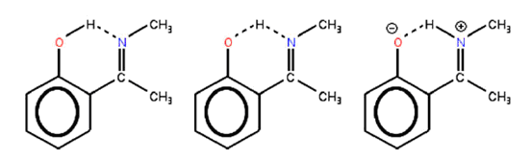
A | B | C
Fig. 1 Different configurations of 2-(N-methyl-α-iminoethgyl)-phenol molecule: MIEP-OH (A), MIEP-OHN (B) and MIEP-NH (C) structures.

The first task in the chapter was to determine the most “economic” basis set providing us with reliable results for relative stability of the structure and with the corresponding energy barriers. The results practically do not change at computation levels B3LYP/6-311+G(2d,p) and B3LYP/6-311++G(2d,p).
In order to expose the influence of the surrounding environment on the proton localization in the 2-(N-methyl-α-iminoethyl)-phenol molecule the relative stabilities of the structures containing water molecules as shown in Fig. 1 A, B, C were analyzed. In vacuum the proton is predominantly localized at the oxygen atom, while the proton transfer to the nitrogen atom is substantially enhanced with the amount of water or ethanol molecules as a result of the hydrogen bond network (Fig. 2). Additional external perturbation by the applied electric field does not make any substantial influence on the structural arrangement and the potential energy surface.
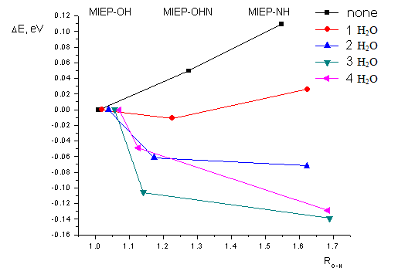
Fig. 2 The relative total energy of 2-(N-methyl-α-iminoethyl)-phenol molecules for MIEP-OH, MIEP-OHN ir MIEP-NH structures (Fig. 1) without water and with water molecules. Zero point energies are also taken into account.

Effects caused by water environment in the photoinduced proton transfer are considered. The quantum chemical calculations of the potential energies surface of the 2-(N-methyl-α-iminoethyl) phenol molecule at presence of additional water molecules are fulfilled. It is demonstrated that the presence of the polar solvent molecules essentially changes the photoinduced proton redistribution. In the first excited electronic state the proton is localized at the nitrogen atom resulting in protonation of the Schiff base and, thus, increasing the distance to the oxygen atom and even leading to non-planar structure if the polar solvent molecules are absent. At the presence of three water molecules the Schiff base is deformed arranging the dihedral angle with the phenol ring. On the basis of our data we can conclude that the Schiff base being deprotonated in the ground electronic state or having possibility to be protonated in polar solvents tends always to be protonated in the first excited electronic state.
It was shown that in order to obtain the correct qualitative and quantitative intermolecular proton transfer the zero point energy and the polar solvent molecules must be taken into account. The dominant effect of the latter is a possibility to create the hydrogen bond network in the environment. Thus, the intra- and intermolecular proton transfer of aryl class molecules and its possible modulation by the solvent molecules is considered in the third chapter.
Next chapter (chapter four) is about relaxation pathways of excited
N-triphenylmethylsalicylidene imine (MS1) in solutions using the approach developed in the third chapter. As follows from the quantum chemical calculations the hydrogen-bonded ethanol molecules facilitate formation of cis-keto tautomers, and are responsible for their different relaxation pathways in comparison with relaxation of excited enol-closed tauromers (Fig. 3). The time dependent DFT (TD-DFT) with the same exchange-correlation functional and basis set was used for evaluation of singlet excitation energies. The Gaussian 03 quantum chemistry package was used for calculations of electronic structures of different tautomers and their complexes with ethanol molecules. The influence of nuclear vibrations through zero point energies was taken into account by considering the relative stability of the structures under consideration in some particular cases. The hydrogen-bond formation is expected to change the enol-closed tautomer, which is the most energetically favorable in isolated molecules, to the cis-keto tautomer in the complex of MS1 and two ethanol molecules.
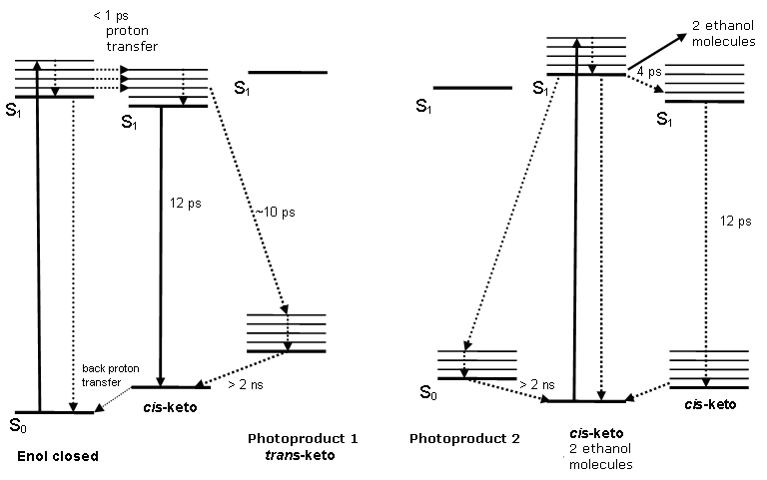
Fig. 3 Relaxation model for enol-closed (left side) and cis-keto (right side) of MS1 molecules tautomers.

The results obtained from quantum chemistry calculations are compared with the experimentally obtained spectroscopic data. Excited state relaxation of MS1 in protic and aprotic solvents has been investigated by means of absorption pump-probe spectroscopy with femtosecond time resolution and fluorescence spectroscopy with picosecond time resolution. Short-lived excited states and long-lived photoproducts have been identified from the differential absorption spectra. Excited states and photoproducts were obtained being different under excitation of enol-closed and cis-keto tautomers. As a result, the commonly accepted excited state relaxation model of aromatic anils, which assumes an ultrafast transformation of excited enol-closed tautomers into cis-keto tautomers has been modified. Fluorescence decay on a nanosecond time scale was attributed to aggregated MS1 molecules. Based on the quantum chemistry calculations it was suggested that the difference in the excited state properties of the excited enol-closed and cis-keto molecules is related to the hydrogen bonded ethanol molecules.
The problem related to the proton driving force in bacteriorhodopsin is considered in the fifth chapter. For this purpose estimations of the permanent dipole moment of bacteriorhodopsin is carried out by means of QM/MM calculations for the known structures of the ground and intermediate states of bacteriorhodopsin. According to these calculations it is obtained that the dipole moment is mainly determined by the cytoplasmic and extracellular coils, while the contribution from the transmembrane helices and the value corresponding to the active center are smaller (Fig. 4).
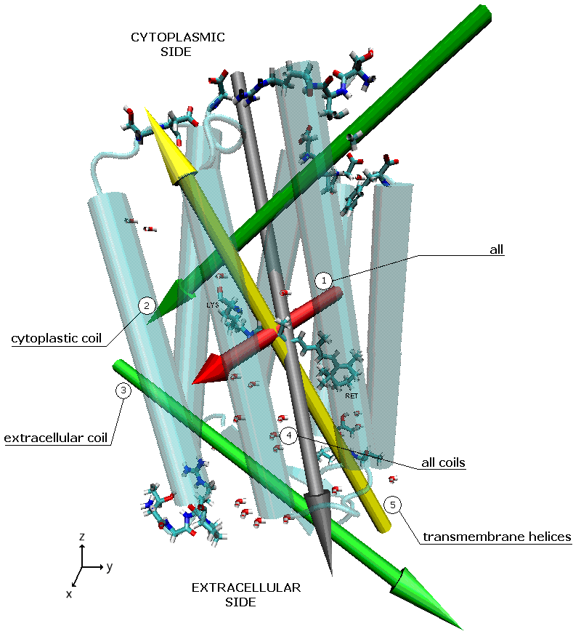
Fig. 4 The DM values defined for the bactiorodopsin (PDB code 1C3W) structure. Arrows indicate the DM values corresponding to BR (1), cytoplasmic coil (2), extracellular coil (3), extracellular coil (4), all coils (5).
The calculated value of the dipole moment in the ground state of bacteriorhodopsin is comparable with the value defined from the experimental estimations. The static electric dipole moment persisting in bacteriorhodopsin was defined from electro-acoustic measurements of the dried films of purple membranes [11]. The projection of this value normal to the membrane surface is estimated to be equal to 40 D and is oriented from the cytoplasmic side to the extracellular side of the membrane. According to QM/MM calculations conformational changes are initiated by isomerization of retinal after its photoexcitation. The isomerization of retinal should induce stretching in the transmembrane helices, which in their turn initiate the conformational changes in the cytoplasmic and extracellular coils. The obtained strained conformation corresponds to the L intermediate state, which further on should relax, resulting in the M intermediate state formation. Thus, the driving force for the proton transfer is a result of relaxation of the strained conformation of the protein in the L state. The calculated values of the dipole moment of bacteriorhodopsin in the intermediate states K, L and M provide understanding about the origin of the driving force for the proton pumping. The low pH had no qualitative effect on the internal dipole moment of bacteriorhodopsin in the dried PM film indicating a different origin of this value from that detected in aqueous suspensions. Employing the values of the dipole moments corresponding to the ground and intermediate states of BR defined by means of QM/MM calculations the experimentally defined photoelectric response of the dried films is explained.
The sixth chapter content is about determination of stable stilbazol structures from high performance quantum chemical computations. Stilbazol is candidate for a chromophore that can be used as a photoswitch and is relevant to the behavior of retinal. Also stilbazol structures (Fig. 5) may be used for molecular monolayer formation. Stilbazol molecules in solution are usually positively charged, while the negative charges are related to anions (Cl atoms in our case). Formation of dimers may influence the chemical processes and electronic spectrum. For determination of stable structures of the dimer the computation chemistry software Gaussian 03 with WebMo was used and the method of computations was chosen B3LYP/6-311G(d,p). The computations showed that positively charged stilbazol dimers do not form stable dimers and influence of anions could be decisive. Results demonstrate that the stilbazole molecule should be deformed thus making new conformers (explained in the presence of two forms) only when the solution environment is taken into consideration. The experimental results are explained in this way.
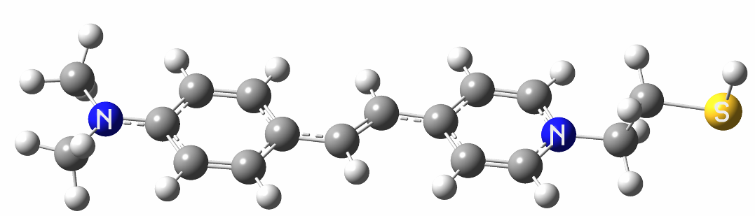
Fig. 5 Stilbazole structure.

The seventh chapter describes electronic spectra of structurally deformed carotenoids. The semiempirical method within the MNDO Hamiltonian (MNDO-CAS-CI) have been employed for quantum chemical calculations of the lowest electronic excited states of caroteinoids (lutein and zeaxanthin), which are present in light harvesting antenna complexes (LHCII) of higher plants. Comparative analysis of the spectra defined by those different methods was employed for various length of polyene chains. It was disclosed that variation in the lengths of the C-C valence bonds of the polyene chains is the dominant factor responsible for changes in the spectral characteristics of the xantophylls due to their structural deformation (Fig. 6). The ground state energy of specific xanthophylls is also sensitive to deformation of the carotenoid structure pushing it up by the order of several electronvolts. The excited state levels, are in the following order 2¹A_{g}⁻ < 1¹B_{u}⁻ < 1¹B_{u}⁺ < 3¹A _{g}⁻ for polyene chain and the same order for caroteinoids except that the transition into the 1¹B_{u}⁻ state turns to have an additional HOMO-LUMO contribution. It was shown that even small changes of the lengths of C-C valence bonds in the polyene chain, which causes deformations of the order of thermal energies, together with disturbance of the hydroxyl of carbonyl group in the β-ring lead to change weights of main configuration of 1¹B_{u}⁻ state.

ε-ring | β-ring
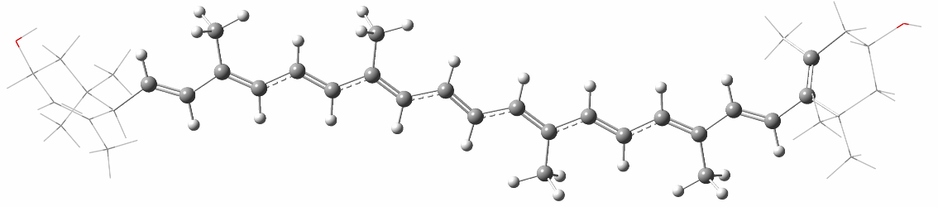
Fig. 6 Structure of lutein. ε-ring is on left side and β-ring on the right side.

To explain the experimentally observed spectral changes the xanthophyll (zeaxanthin and violaxanthin) dimers are also analyzed in chapter seven. Spectroscopic measurements of Arabidopsis leaves have shown that the onset of Non-Photochemical Quenching (NPQ) is associated with an absorption changes at 535 nm. Identical measurements on the zeaxanthin-deficient mutant npq1 reveal a similar spectroscopic signature at 525 nm. We investigated whether these red-shift arise from excitonic interactions between homodimers of xanthophylls, zeaxanthin and violaxanthin, bound at the peripheral V1 binding site on adjacent LHCII trimers. Estimates of the relative geometries of theses pigment pairs were obtained from the structure of LHCII. The excitonic couplings of zeaxanthin and violaxanthin dimers were probed using the time-dependent density functional theory method (TD-DFT). The method of choice was TD-DFT with the asymptotically correlated CAM-B3LYP exchange-correlation functional and the correlation consistent cc-pVDZ basis set. Calculations indicated that dimers formed between zeaxanthin or violaxanthin molecules using the published LHCII structure resulted in absorption blue shifts, typical of H-type geometry. In contrast, if the volume of the LHCII structure was modified to reflect the change in membrane thickness that occurs upon NPQ formation then both zeaxanthin and violaxanthin dimers adopted J-type (collinear) geometry and the resulting spectral shift was to the red. The magnitudes of these predicted red-shifts are in good agreement with the experimentally obtained magnitudes (Fig. 7).
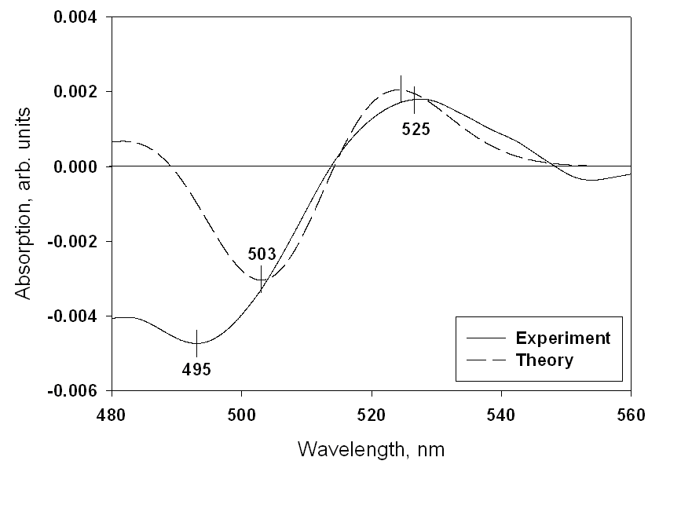
A
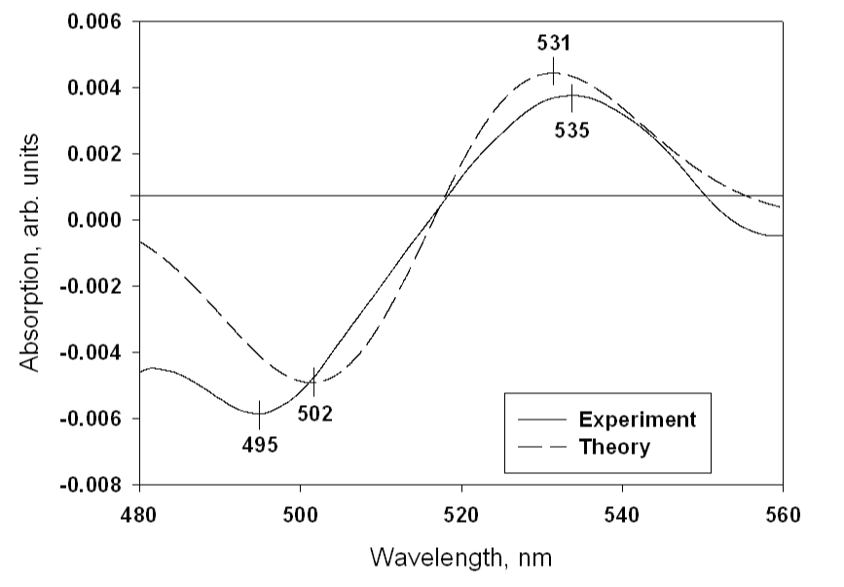
B
Fig. 7 The theoretically predicted absorption difference spectra superimposed over the experimentally measure absorption difference spectra for violaxanthin (A) and zeaxanthin.

We therefore conclude that the observed xanthophyll redshift results from the combination of LHCII aggregation, which is influenced by changes in membrane thickness during NPQ. Thus, the excited electronic states of carotenoids are important for searching the possible environment influences resulting in deformation.
All chapters describing the results have similar structure. First, there is an overview of the literature related to the research material. Further results of theoretical calculations and corresponding analysis are presented. At the end of every section conclusions are formulated. The reference list is presented at the end of the thesis.

List of publications
- M. Macernis, B.P. Kietis, J. Sulskus, S.H. Lin, M. Hayashi, L. Valkunas Triggering the proton transfer by H-bond network. Chem Phys Lett 466, (2008) 233-226.
- C.D.P. Duffy, M.P. Johnson, M. Macernis, L. Valkunas, W. Barford and A.V. Ruban. A Theoretical Investigation of the Photo-physical Consequences of Major Plant Light-Harvesting Complex Aggregation within the Photosynthetic Membrane. J Phys Chem B 114,
(2010) 15244-15253.
- B. P. Kietis, M. Macernis, J. Sulskus, L. Valkunas. Estimation of the
Permanent Dipole Moment of Bacteriorhodopsin. Lith J Phys 50
(2010) 451-462.
- R. Karpicz, V. Gulbinas, A. Lewanowicz, M. Macernis, J. Sulskus, L. Valkunas. Relaxation Pathways of Excited N-Triphenylmethylsalicylidene
Imine in Solutions. J Phys Chem (2010) in press.
- M. Macernis, J. Sulskus, L. Valkunas. Triggering the photoinduced proton transfer by H-bond network. Chem Phys (2010) submitted.

Presentations at conferences
- Mindaugas Mačernis, Bronius Povilas Kietis, Juozas Šulskus, Leonas Valkūnas, Proton transfer modeling in biological molecules. 37-oji Lietuvos nacionalinė fizikos konferencija, 2007, Lithuania
- Mindaugas Mačernis, Juozas Šulskus. Parallel computing system for molecular quantum mechanical modeling. Vilniaus Verslo Kolegija, 2008, Lithuania
- Mindaugas Macernis, Leonas Valkūnas, Juozas Šulskus, Renata Karpič, Vidmantas Gulbinas. Spectral variations of photoactive model molecules. 38-oji Lietuvos nacionalinė fizikos konferencija, 2009, Lithuania
- Mantas Kelminas, Alytis Gruodis, Juozas Šulskus, Mindaugas Mačernis. DFT calculations and analysis of vibrational spectra of the stilbazol derivatives. 38-oji Lietuvos nacionalinė fizikos konferencija, 2009, Lithuania
- Jelena Strelcova, Juozas Šulskus, Mindaugas Mačernis, Leonas Valkūnas. Electronic spectra of deformated carotenoids. 38-oji Lietuvos nacionalinė fizikos konferencija, 2009, Lithuania
- Mindaugas Macernis, Juozas Sulskus, Leonas Valkunas. Spectral modulation of carotenoids by the protein environment. Workshop on Quantum Effects in Biological Systems – QuEBS 09, 2009, Portugal
- Mindaugas Macernis, Juozas Sulskus, Leonas Valkunas. Spectral variations of photoactive biologcal molecules and related model compounds. 13th edition of the International Conference on the Applications of Density Functional Theory in Chemistry and Physics, 2009, France
- Juozas Šulskus, Mindaugas Mačernis. Determination of stable stilbazol structures from high performance quantum chemical computations. 3rd international conference innovative information technologies IIT-2209. Vilniaus Verslo Kolegija, 2009, Lithuania
- R. Karpicz, M. Macernis, J. Šulskus, Lewanovicz A., L. Valkunas, V. Gulbinas. Ultrafast spectroscopic studies of N-triphenylmethylsalicylidene imine tautomeric forms. 8th international conference on electronic processes in organic and inorganic materials. “Synyogora residence”, 2010, Ukraine.

Author and coauthors contributions
Computer calculations have been carried out by the author of the thesis. The problem was formulated by the scientific supervisor and the scientific advisor. The obtained results were also discussed together with them. The experimental results were obtained other contributors. Collaboration with scientists is as follows:
S.H. Lin¹, M. Hayashi², C.D.P. Duffy³ , J. Šulskus⁴, W. Barford⁵ A. Gruodis⁴,
L. Valkūnas^{4,6}– theoretical analysis of the experimental data.
B. P. Kietis⁶ R. Karpicz⁶ V. Gulbinas⁶ M.P. Johnson³, A. V. Ruban³,
A. Lewanovicz⁷– experimental results and theoretical analysis.

¹ Institute of Atomic and Molecular Sciences, Academia Sinica, Taipei 106, Taiwan, Republic of China
² Center for Condensed Matter Sciences, National Taiwan University, Taipei 106, Taiwan, Republic of China
³ Department of Chemistry, Physical & Theoretical Chemistry Laboratory, University of Oxford, South Parks Road, Oxford, OX1 3QZ, United Kingdom
⁴ Theoretical Physics Department, Faculty of Physics, Vilnius University, Saulėtekio 9, LT-01222 Vilnius
⁵ chool of Biological and Chemical Sciences, Queen Mary University of London, Mile End Road, London, E1 4NS, United Kingdom
⁶ Center for Physical Sciences and Technology, Institute of Physics, Savanoriu 231, LT-02300 Vilnius, Lithuania
⁷ Wrocław University of Technology, Institute of Physical and Theoretical Chemistry, Wybrzeże Wyspiańskiego 27, 50-370 Wrocław, Poland

Reference
[1] van Amerongen H , Valkunas L , van Grondelle R (2000) Photosynthetic excitons, World Scientific, Singapore
[2] Praškevičius A, Ivanovienė L, Stasiūnaitė N, Burnevkienė J, Rodovičius H, Lukoševičius L, Kondratas D (2003) Biochemija, KMU publishing, Kaunas
[3] Oesterhelt D., Stoeckenius W. (1971) Nature 233:149
[4] Zimmet, M. (2002) Chem. Rev. 102:759
[5] Lanyi, J.K. (2000) J. Phys. Chem. B 104:11441
[6] Demmig-Adams B, Adams W (2002) Science 13 298:2149
[7] Holt NE, Zigmantas D, Valkunas L, Li XP, Niyogi KK, Fleming GR (2005)
Science 307:433
[8] Ahn TK, Avenson TJ, Ballottari M, Cheng YC, Niyogi KK, Bassi R, Fleming GR (2008) Science 9 320:794
[9] Neutze R, Pebay-Payroula E, Edman K, Royant R, Navarro J, Landau EM, (2002) BBA 1565:144
[10] Lanyi, J. K. (1998) J. Struct. Biol. 124:164
[11] Kietis P, Vengris M, Valkunas L (2001) Biophys J 80:1631
[12] Subramaniam S, Henderson R. (2000) Nature 406:653
[13] Hayashi S, Tajkhorshid E, Schulten K(2003) Biophys J 85:1440
[14] Sliwa M, Mouton N, Ruckebusch C, Poisson L, Idrissi A, Aloise S, Potier L, Dubois J, Poizat O, Buntinx G (2010) Photochem Photobiol Sci 9:661
[15] Liu Z, Yan H, Wang K, Kuang T, Zhang J, Gui L, An X, Chang W (2004)
Nature 428:287

About the Author
Mindaugas Mačernis − born 1982 in the west part of Lithuania. He graduated Computational Physics (program code 61202P109) of Bachelor studies at Vilnius University (Faculty of Physics) in 2004. In 2006 he graduated Physics, Theoretical Physics and Astronomy (program code 62102P116) at Vilnius University (Faculty of Physics) and after graduation he has been admitted as a PhD student at Vilnius University. Current research interests include quantum chemistry, biophysics and information technology. Positions: a lecturer and supercomputer engineer in Vilnius University (Faculty of Physics) from 2006.

Santrauka
Aplinkos poveikis fotoindukuotiems reiškiniams organinėse molekulėse
Biologijoje vienas pagrindinių ląstelės makroenergetinių junginių yra adenozintrifosfatas (ATP), kurio sintezei reikalingi protonai (H⁺). Biologinės molekulės yra nuolatos sintetinamos ląstelėje, pasitelkiant ATP mainų reakciją, kuri, kaip biochemijoje žinoma, yra stimuliuojama fotosinteze arba ląsteliniu kvėpavimu. Ląstelinio kvėpavimo mechanizme yra panaudojamas elektrocheminis protonų potencialas, kurį užtikrinti padeda protonų siurbliai. Vienas iš tipinių tokių modelinių siurblių yra bakteriorodopsinas, kurio aktyviajame centre yra atskiriamas protonas. Bakteriorodopsiną sudaro per protonuotą Šifo bazę su baltymu sujungtas retinalis. Visgi protonovaros jėgos prigimtis bakteriorodopsine nėra iki galo aiški. Beto, skirtingose aplinkose panašių vidinių struktūrų molekulių savybės kinta. Šiame darbe nagrinėjami aplinkos nulemiamos molekulių elektroninės struktūros ir elektroninių spektrų pokyčiai.
Biologinių sistemų modeliavimas yra sudėtingas ir dažnai apsiribojama tik atskirų molekulių būsenų energijų skaičiavimais. Dažnai tik labai tikslūs ab initio kvantinės chemijos metodai leidžia pasiekti reikiamą tikslumą. Tai pareikalauja didelių kompiuterinių resursų: superkompiuterių bei lygiagrečių skaičiavimo klasterių.
Naudojant kompiuterizuotus kvantinės mechanikos metodus ištirtos
2-(N-metil-α-iminoethyl)-fenol molekelulių struktūros, esančios poliniame tirpiklyje, struktūros pagrindinėje ir sužadintose elektroninėse būsenose. Pirmą kartą parodyta, kad, norint gauti teisingą kokybinį ir artimą kiekybiniam vidujmolekulinės protono pernašos potencinės energijos paviršių, būtina atsižvelgti į polinių tirpiklio molekulių kuriamą vandenilinių ryšių tinklą protono pernašos aplinkoje bei į nulinių svyravimų energijas.
Kvantinės mechanikos metodus ištirti N-triphenylmethylsalicylidene iminie molekulės elektroniniai spektrai, stabilių struktūrų susidarymas priklausomai nuo vandenilinių ryšių su polinio tirpiklio molekulėmis. Parodyta, kad anilo molekulių konformerų susiformavimas priklauso nuo polinio tirpiklio ir tuo pačiu konkuruoja su klasteriais, kurie susiformuoja iš tirpiklio molekulių. Tokiu būdu paaiškinami eksperimentiniai rezultatai.
Atlikti AMBER parametrizavimo darbai nebaltyminėms įvairių būsenų bakteriorodopsino molekulių dalims. Molekulių mechanikos metodais apskaičiuoti bakteriorodopsino dipolinių momentų kitimas pradinėse būsenose (iki būsenos M). Pirmą kartą parodyta, kad dipolinio momento vertė bakteriorodopsine yra nulemnta išorinėse pusėse esančių radikalų ir tokiu būdu paaiškinami eksperimentiniai rezultatai.
Tankio funkcionalo metodais ištirta tirpiklio molekulių įtaka skirtingų stilbazolio molekulės formų susidarymui. Pademonstruota, kad stilbazolio molekulė deformuojasi ir sudaro naujus konformerus (paaiškintas dviejų formų buvimas) tik tada, kai aplinkoje yra tirpiklio molekulių. Tokiu būdu paaiškinami eksperimentiniai rezultatai.
Apskaičiuotos ir išanalizuotos sužadintos elektroninės būsenos: pavienės Luteino molekulės pirma draustinė būsena; Violaksantino ir Zeaksantino dimerų leistina žemiausia būsena. Parodyta, kad karotinoidų sužadintoms elektroninėms būsenoms yra svarbios aplinkos įtakotos deformacijos.
Praktiniu požiūriu disertacija yra reikšminga tuo, kad joje ištirta aplinkos įtakos svarba molekulinėms sistemoms. Be to, remiantis tyrimo rezultatais galima labiau suprasti polinės aplinkos svarbą ir jos įtaką. Rezultatai leidžia interpretuoti eilę eksperimentinių rezultatų.
Trumpos žinios apie autorių. Mindaugas Mačernis gimė 1982 metais Mažeikiuose. 2004 metais baigė baigė Vilniaus universiteto pagrindinių studijų kompiuterinės fizikos programą (kodas 61202P109), ir jam buvo suteiktas fizikos bakalauro kvalifikacinis laipsnis. 2006 baigė teorinės fizikos ir astronomijos programą (kodas 62102P116) ir jam buvo suteiktas fizikos magistro kvalifikacinis laipsnis Vilniaus universitete. Nuo 2006 iki 2010 metų dirbo Vilniaus universiteto Fizikos fakultete lektoriumi ir superkompiuterių inžinieriumi.

